Perioperative Analgesia in Rodents

The Public Health Service Policy on Humane Care and Use of Laboratory Animals states that procedures on animals that may cause more than momentary or slight pain or distress should be performed with appropriate sedation, analgesia or anesthesia. Procedures that cause pain or distress in human beings are now considered to cause pain or distress in animals. While NCI-Frederick fully recognizes the difficulties in objectively assessing perioperative pain in rodents, the NCI-Frederick Animal Care and Use Committee [ACUC] has taken the position that rodents undergoing major surgical procedures must routinely receive the benefit of perioperative analgesic administration unless justified. In general, major surgery includes any surgery that penetrates and exposes a body cavity or produces substantial impairment of physical or physiologic functions [such as laparotomy, thoracotomy and craniotomy]. Minor surgery includes procedures such as skin biopsy, castration, subcutaneous tumor removal, etc. In this case, animals will be monitored for signs of pain or distress, and if found; post-operative analgesia will be administered. Signs of pain and distress include: decreased movement, aggression when handled, failure to groom, ruffled coat, and abnormal posture.

In adopting this position, the NCI-Frederick ACUC recognizes that there may be occasions when analgesic use would interfere with the scientific objectives of a study. In such cases, the Principal Investigator can request an exception to the ACUC guideline by including a written scientific justification [e.g., study involves the liver and analgesic is metabolized by the liver] in the animal study proposal for review and approval by the NCI-Frederick ACUC.

The analgesic agents listed below have been used successfully in rodents. The selected analgesic should be administered before the animal recovers from anesthesia, depending on the compound. While a single dose of a relatively long-acting analgesic is expected to alleviate the pain and distress associated with the immediate post-operative period, this initial dosing should be followed by an evaluation of the animal at the expected end of the analgesic’s duration, to see if subsequent dosing is required. If you have any questions regarding appropriate analgesia, contact the Laboratory Animal Medicine veterinary staff at 301-846-5195.

Agent | Species | Recommended Administration | Notes
Bupivicaine [Marcaine] | Mouse and Rat | 1-3 drops [appx one drop for each centimeter of the incision size] of 0.25% bupivicaine placed on the incision site at the time of closure | Related chemically and pharmacologically to the aminoacyl local anesthetics. It is a homologue of mepivacaine and is chemically related to lidocaine. Local anesthetics block the generation and the conduction of nerve impulses, presumably by increasing the threshold for electrical excitation in the nerve, by slowing the propagation of the nerve impulse, and by reducing the rate of rise of the action potential. Systemic absorption of local anesthetics produces affects on the cardiovascular and central nervous systems. At normal therapeutic doses, changes on the heart are minimal. The onset of action with bupivicaine is rapid and there is a long period of analgesia following administration. Depending on the route of administration, local anesthetics are distributed to some extent to all body tissues, with high concentrations found in highly perfused organs such as the liver, lungs, heart and brain. Metabolism occurs in the liver and the kidney is the main excretory organ. When administered in recommended doses and concentrations, bupivicaine does not ordinarily produce irritation or tissue damage.
Acetaminophen | Mouse | 300mg/kg, PO, 6-8 hour duration | Has similar analgesic efficacy to aspirin but has little anti-inflammatory activity. It is rapidly absorbed from the upper gastrointestinal tract with peak plasma levels occurring between 30 and 60 minutes after therapeutic doses. The parent compound, which is nontoxic is extensively metabolized in the liver to form principally the sulfate and glucuronide conjugates which are also nontoxic and are rapidly excreted in the urine. A small fraction of an ingested dose is metabolized in the liver by the cytochrome P-450 mixed function oxidase enzyme system to form a reactive, potentially toxic, intermediate metabolite which preferentially conjugates with hepatic glutathione to form nontoxic cysteine and mercapturic acid derivatives which are then excreted by the kidney. Ingestion of a large overdose saturates the glucuronide and sulfate conjugation pathways, resulting in a larger fraction of the drug being metabolized via the P-450 pathway. This increase may deplete hepatic stores of glutathione, resulting in cellular necrosis. Acetaminophen does not affect platelet count.
Acetaminophen | Rat | 100-300mg/kg, PO, 4-6 hour duration
Ibuprofen | Mouse | 7.5mg/kg, PO, 4-6 hour duration | A nonsteroidal anti-inflammatory drug that possesses anti-inflammatory, analgesic and antipyretic activity. Its mode of action is not completely understood, but may be related to prostaglandin synthesis inhibition. Ibuprofen is well absorbed orally, with peak plasma levels usually occurring within 1-2 hours. Following oral administration, the majority of the dose was recovered in the urine within 24 hours. The remainder of the drug was found in the stool as both metabolites and unabsorbed drug. It is rapidly metabolized and eliminated in the urine. The excretion of ibuprofen is virtually complete 24 hours after the last dose. We suspect that it might reduce the platelet count as it does in humans.
Ibuprofen | Rat | 10-30mg/kg, PO, 4-6 hour duration
Aspirin | Mouse and Rat | 100-300mg/kg, PO, 4-6 hour duration | Sometimes known as acetylsalicylic acid inhibits cyclooxygenase [prostaglandin synthetase] thereby reducing the synthesis of prostaglandins and thromboxanes. It causes an irreversible effect on platelet aggregation. Aspirin is rapidly absorbed from the stomach and proximal small intestine in monogastric animals. Highest levels may be found in the liver, heart, lungs, renal cortex and plasma. Salicylate is metabolized in the liver primarily by conjugation with glycine and glucuronic acid via glucuronyl transferase. The kidneys rapidly excrete salicylate and its metabolites by both filtration and renal tubular secretion.
Flunixin | Mouse and Rat | 2.5 mg/kg, SC BID, 3-4 hour duration | A nonsteriodal anti-inflammatory agent that is a highly substituted derivative of nicitonic acid. It is a very potent inhibitor of cyclooxygenase and like other NSAIDS, it exhibits analgesic, anti-inflammatory and antipyrexic activity. It should be used with caution in animals with pre-existing GI ulcers, renal, hepatic or hematologic diseases.
Ketoprofen | Mouse and Rat | 1 mg/kg SC | A proprionic acid derivative nonsteroidal anti-inflammatory agent. Like other NSAIDS, ketoprofen exhibits analgesic, anti-inflammatory and antipyrexic activity. Its purported mechanism of action is the inhibition of cyclooxygenase catalysis of arachidonic acid to prostaglandin precursors [endoperoxides], thereby inhibiting the synthesis of prostaglandins in tissues. Ketoprofen purportedly has inhibitory activity on lipoxygenase.
Carprofen | Mouse and Rat | 5 mg/kg SC  2 mg/5mg tablets | A proprionic acid derivative nonsteroidal anti-inflammatory agent. Like other NSAIDS, carprofen exhibits analgesic, anti-inflammatory and antipyrexic activity probably through its inhibition of cyclooxygenase, phospholipase A₂ and inhibition of prostaglandin synthesis.  Carprofen is supplied as bacon flavored tabs. These are usually highly palatable to the mice, however a trial feeding will help to determine if the strain of mice in question will consume them. Typically, the feed is removed from the hopper and one tab per mouse is placed on the floor of the cage at least four hours prior to surgery, which provides food and carprofen for 24 hours.
Buprenorphine [Buprenex] | Mouse | 0.5-2.5 mg/kg, SC, 3-8 hour duration | A thebaine derivative, buprenorphine is a synthetic partial opiate agonist. It has partial agonist activity at the mu receptor and is considered to be 30 times as potent as morphine and exhibits many of the same actions as the opiate agonists. The cardiovascular effects of buprenorphine may cause a decrease in both blood pressure and cardiac rate. It concentrates in the liver, but is also found in the brain, GI tract and placenta. It is metabolized in the liver by N-dealkylation and glucuronidation. These metabolites are then eliminated by biliary excretion into the feces [70%] and urinary excretion [27%]. It has been reported that use of buprenorphine can cause a decrease in IL2 and IL18 production. **Note: Please consider the use of other analgesics for rats due to the fact that the use of buprenorphine can lead to pica in this species.
Buprenorphine [Buprenex] | Rat | 0.25-1.6 mg/kg, SC, 6-8 hour duration

NOTES: All drugs given PO [Per OS] can be administered in water bottles or in nutritional Jell-O supplements. 1-2 cc of warm sterile NaCL [0.9%] or Lactated Ringer’s Solution [SQ or IP] will speed recovery and help prevent post-operative complications.

Here is an overview of the common surgical procedures conducted at the NCI-Frederick with the LAM veterinary staff’s recommendations for analgesics. Please contact the LAM veterinary staff for additional analgesia guidance as it pertains to your specific research requirements.

Procedure | Recommendations
Tumor Excision | Bupivicaine [Marcaine]
Skin Incision or Biopsy | Bupivicaine [Marcaine]
Laparotomy | Bupivicaine [Marcaine]
Laparotomy | Bupivicaine [Marcaine] and Buprenorphine
Laparotomy | Bupivicaine [Marcaine] and Carprofen Tabs
Mammary Transplant or Fat Pad Removal | Bupivicaine [Marcaine]
Mammary Transplant or Fat Pad Removal | Buprenorphine
Mammary Transplant or Fat Pad Removal | Carprofen Tabs
Intracranial Injections | Bupivicaine [Marcaine]
Intracranial Injections | Buprenorphine

Reference: NCI-Bethesda Postoperative Analgesic Recommendations for Mice

Note: See attached suggested methods of documenting analgesia use on cage cards.

EXAMPLE

FRONT OF CAGE CARD
If analgesia administration details [procedure, analgesic, and range of administration] are not included on the front of the cage card, a black mini dot “•” label on the lower right hand side of the cage card will flag the veterinary staff and/or inspectors that the animals in the cage received analgesia
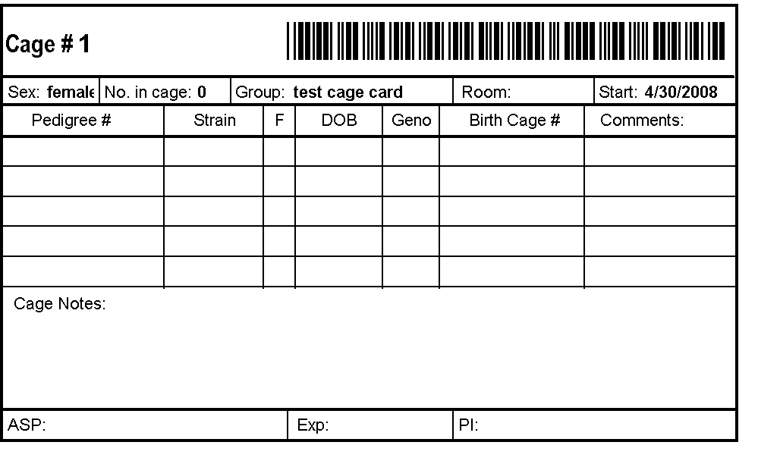
•

BACK OF CAGE CARD

A return address label [1/2” x 1-3/4”] can be placed on the right hand side [horizontal or vertical] to include [at a minimum]: [1] an abbreviation of the procedure performed; [2] the analgesic name and [3] the date/range of administration. The labels can be pre-printed and made available to the technical staff in the animal rooms.

This side of the card can be used
for any of the following:

TECHNICIAN NOTES

TESTING NOTES

PHL LABEL

MISCELLANEOUS

Mam Fat Pad Clear
Tylenol
______ to _______

NOTES

- For cages where a cage card is maintained for each individual animal [i.e., 5 individual animal cards placed inside a cage card holder on a single cage], only the front cage card is required to maintain the analgesia information for the cage [and should be placed in front for easy identification]
- The cage cards are only required to be maintained while the animal is alive … once euthanized; the cage cards may be disposed [unless otherwise specified by the investigator for his/her research needs].
- When an animal is removed/separated and a new cage card created, a duplicate label should be applied to the new cage card.

