Veterans Health Administration Warning System
Published by VA Headquarters

January 7, 2003

Item: Connection tubing set (see attached for identifiers) used with the Sequential Compression Device (SCD), models 6235,7325,5320 and 5325 manufactured by Kendall (Tyco Healthcare). SCDs are used to limit deep vein thrombosis and peripheral edema in immobile patients through sequential pressure exerted within a sleeve placed around an extremity.

Specific Incident: 1. Kendall (Tyco Healthcare) recalled connection tubing sets in June and July 2001 used with the above referenced models of SCDs. The recalled tubing sets have a reversed connector and pose a serious hazard. The reversed connector changes the sequence of inflation and connects the cooling feature to the calf chamber. When the cooling feature is activated under this condition the SCD becomes a tourniquet applying up to 200 mmHg pressure around the extremity. This condition can persist even after the machine is turned off and in a pain-controlled patient, could go unnoticed for several hours, leading to permanent tissue damage.
2. Kendall reports that nearly all of the recalled connection tubing sets were recovered, but some may remain in hospitals, as did the one involved in a recent VA patient incident.

Action: 1. Notify staff to observe for normal inflation on the SCD sleeves when first applied to a patient. In particular, activate the cooling button for 30 seconds to ensure that no observable over-inflation occurs.
2. Inspect all Kendall SCD tubing sets to confirm that none of the recalled sets remain on site (identification instructions are attached). Either positively identify “blank” (no lot number label) tubing sets for proper connectors or treat them as suspect.
3. Contact Kendall to obtain replacement connection tubing sets. The contact at Kendall is Karen Tabaczynski; she can be contacted at (508) 261-8037.

Source: VA Center for Engineering and Occupational Safety & Health (CEOSH), Manufacturer and FDA.

Contact: For additional information, please contact Paul Sherman at CEOSH, (314) 543 6700.

Identifying Affected Tubing Sets

If tubing has a sticker on it at the "T" connector, compare that number with the recalled lot numbers listed below:

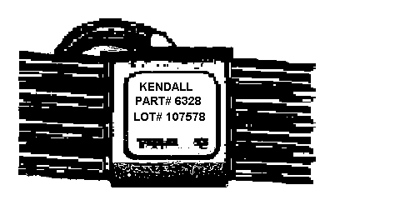
Tubing

Part # Color Lot #

6328 clear 118761

6328 clear 118762

6328 clear 118763

6328 clear 119574

For tubing sets with missing stickers, identify the correct tubing set orientation:

