Veterans Health Administration Warning System
Published by VA Central Office

Sequence # 02 - 001 February 27, 2002

Item: Potential for incorrectly attaching Allegiance Irrigation Kit (Catalog # 3T4121) caps to Foley catheters

General Information: The tubing cap of the Allegiance irrigation kit is small enough to fit into a Foley catheter, resulting in an obstructed Foley catheter. The manufacturer of the kit informed us by letter that they “designed the cap to cover the tip of the syringe when the syringe is not in use. Any other use of the cap is neither recommended nor endorsed”. Refer to the attached photographs for further clarification and information.

Specific Incident: Several close call reports where users incorrectly left the cap on the tubing of the urinary bag and actually attached it to the Foley catheter.

Suggestion: 1. Use only standardized irrigation kits identified by the Medical /Surgical Users Group; acquire from LSL Industries purchased under (BPA) Blanket Purchase Agreement
# VANAC90NP-00-035 with Foley catheters.

- Check with Materials Management to determine if Allegiance Irrigation kits are present in your facility. If so, alert all clinical staff of this possible problem and the manufacturer’s intended use and design of the cap. Make copies of the attached WARNING sheet and distribute with Allegiance irrigation kits. Place signs in areas where this product is used to remind staff to remove cap from urinary bag tubing (if it is their practice to cap the bag tubing), prior to reinsertion to Foley catheter.

Source: VISN 3

Contact: For additional information, please contact Mr. Bryanne Patail.
At: National Center for Patient Safety (NCPS).
Phone: 734 930 5890. Fax: 734 930 5877.
E-mail: Bryanne.Patail@med.va.gov

Standardized LSL Bedside bag with large cap
Non-Standardized Allegiance Irrigation tray (Cat. # 3T4121)

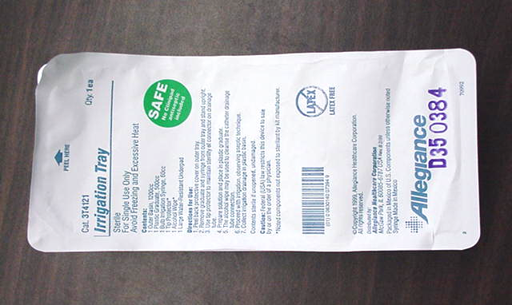
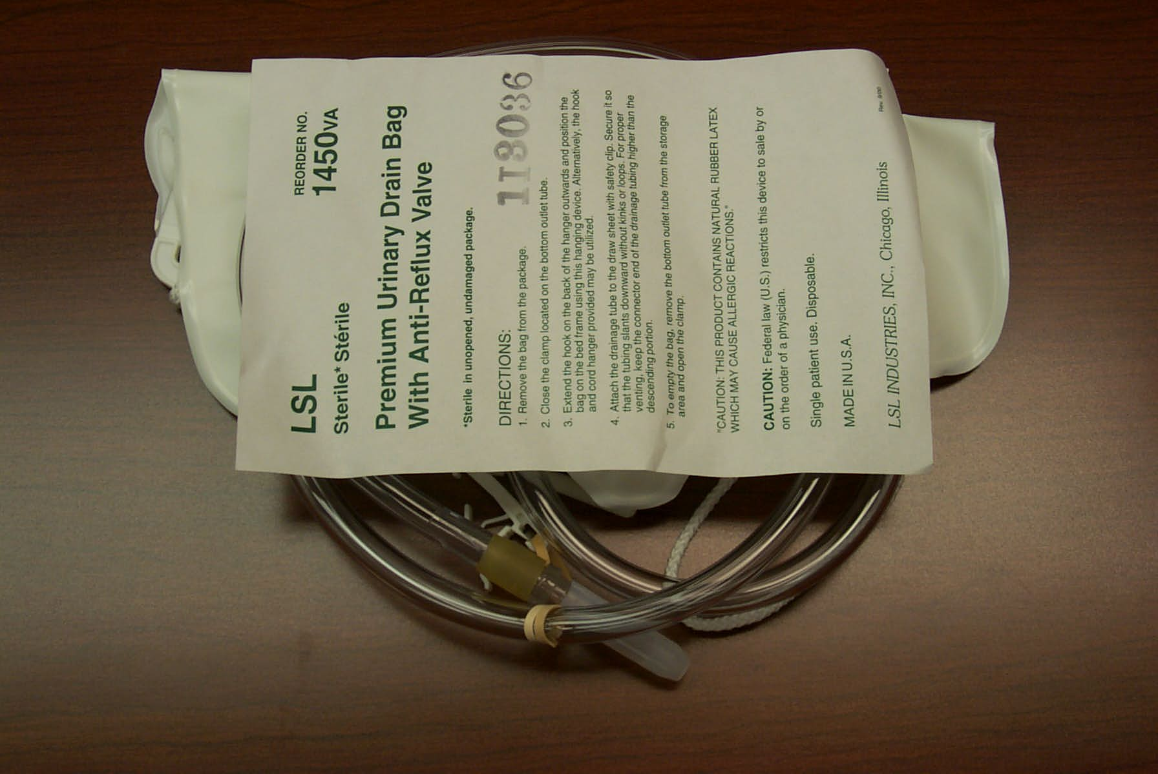

Cap packed with LSL kit cannot be accidentally inserted into
Foley
Cap packed loose in Allegiance Irrigation tray can be incorrectly inserted into Foley causing blockage
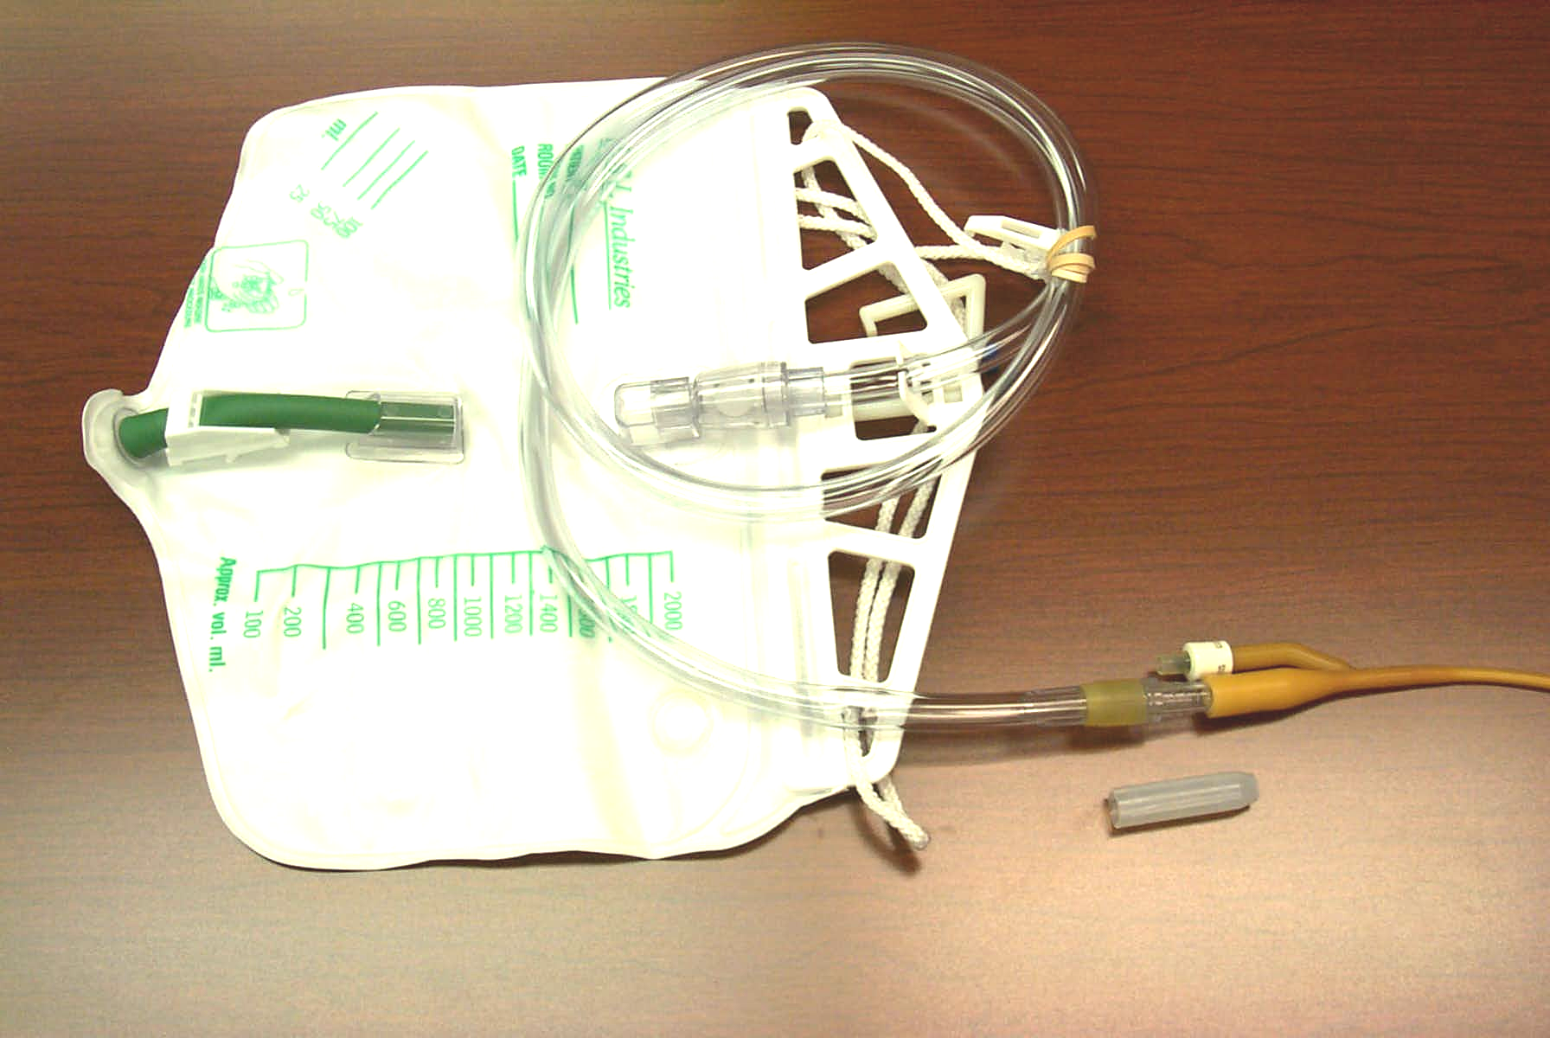
Large cap forces one to remove cap prior to insertion
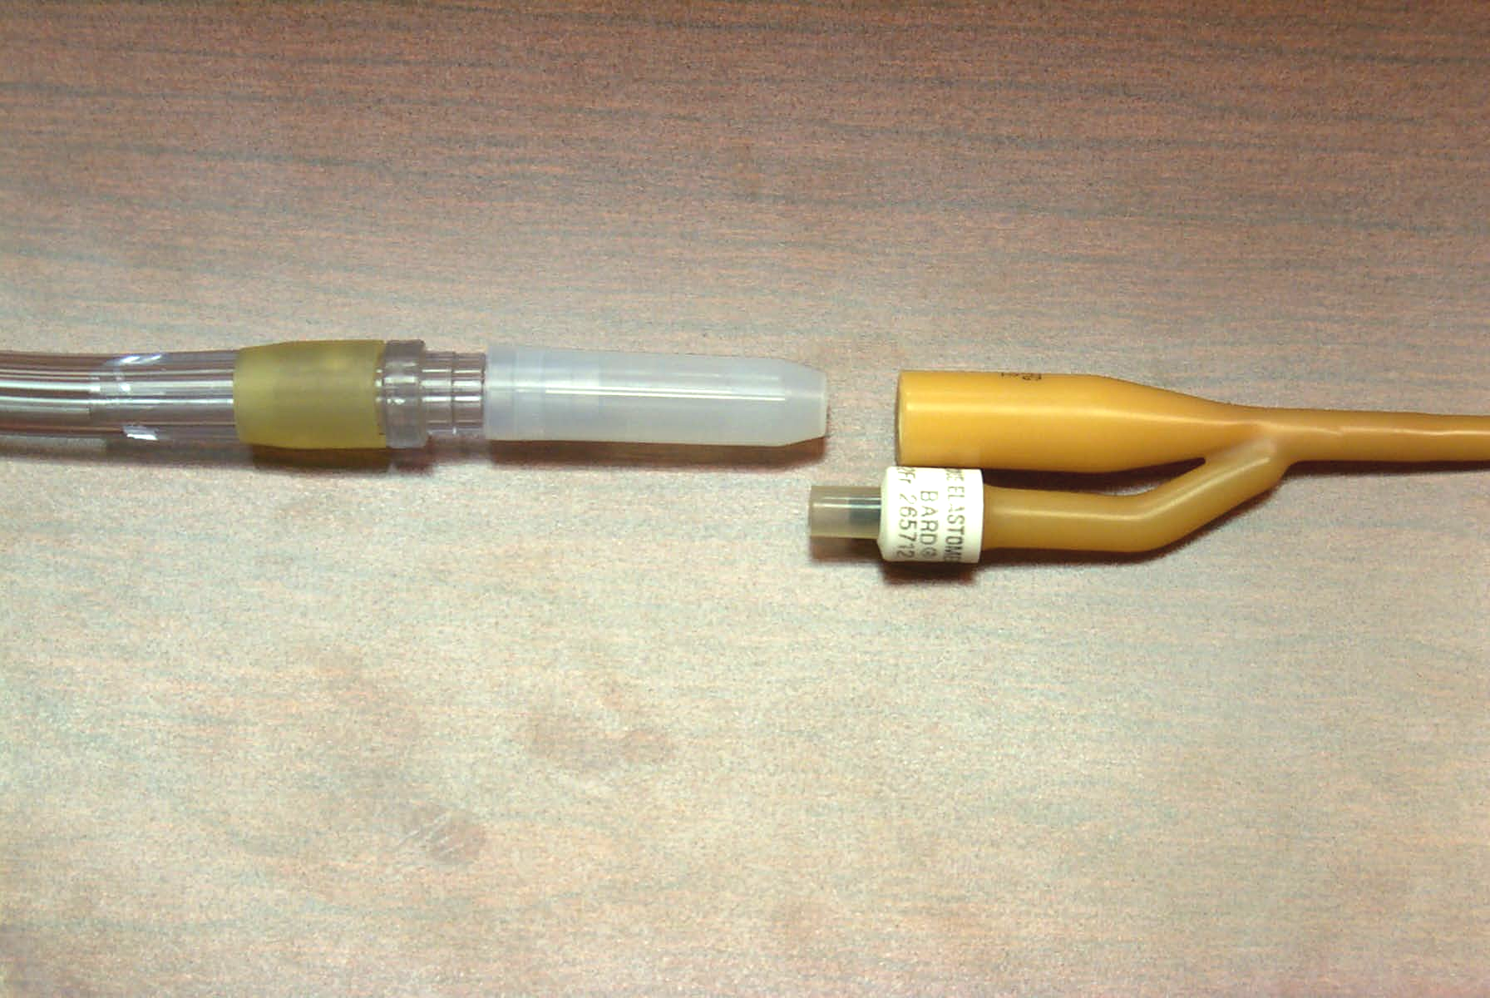

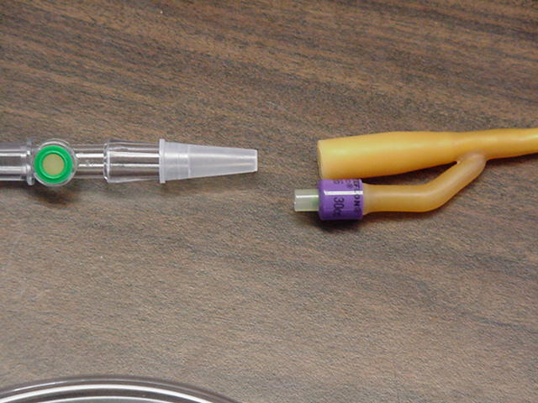
Note: Cap fits inside the Foley. Do not insert with cap in place.

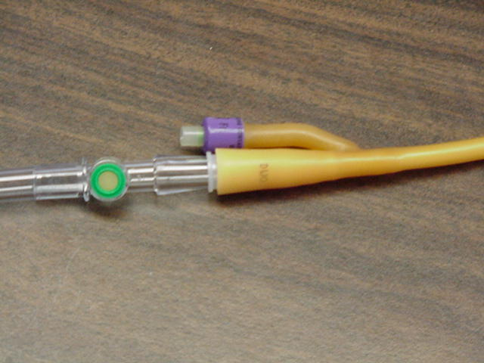

WARNING

CAP IN KIT IS DESIGNED TO CAP THE SYRINGE WHEN THE SYRINGE IS NOT IN USE.

DO NOT
CAP TUBING OF DRAINAGE BAG OR THE FOLEY CATHETER.

