PIH Information Center (PIC)

Table of Contents:
System Information WASS Login
New Security Screen
PIC Maintenance
User Profile
Reference
Security Administration

PIH Information
Event Tracking System
SEMAP
Risk Assessment

Housing Inventory
Housing Authority
Development (Building and Unit)
Demolition–Disposition
Database Maintenance–Building and Unit Data

Executive Summary Form 50058
Submission
Report
Viewer
MTCS Transaction Report
MTCS HA Query Report
MTCS VO Iss/Exp Report
Reports
Delinquency
Reexam
Deconcentration
KMI
EOP
Mobility and Portability
Budget Related Averages
RCR
Rent Calculation
HQS
SEMAP
New Admissions
Rent and Rent Burden
Income
Alt ID

Ad HOC PIC Downloads PIC TIPS
- 2 -
PIC FAQs
QUICK REFERENCE GUIDE

WASS LOGIN
You will enter PIC through the WASS Login page; enter first your username which will start with an M (or H) and then your password. Please remember that your password will only be valid for 21 days and cannot be reused for the next ten password changes. After successful login you will encounter the Privacy Act page. You will have to agree to the conditions of the Privacy Act before you can continue. If you have questions about the requirements of the Privacy Act, ask your PIC Coach. Once you have successfully logged in then you will see the main WASS system menu screen under which your unique menu items will appear. Please refer to the Security Administration Module user guide for more information on this topic.

PRIVACY ACT SECURITY SCREEN
You will now encounter the Privacy Act security screen in various points throughout PIC. The Screen looks like this:
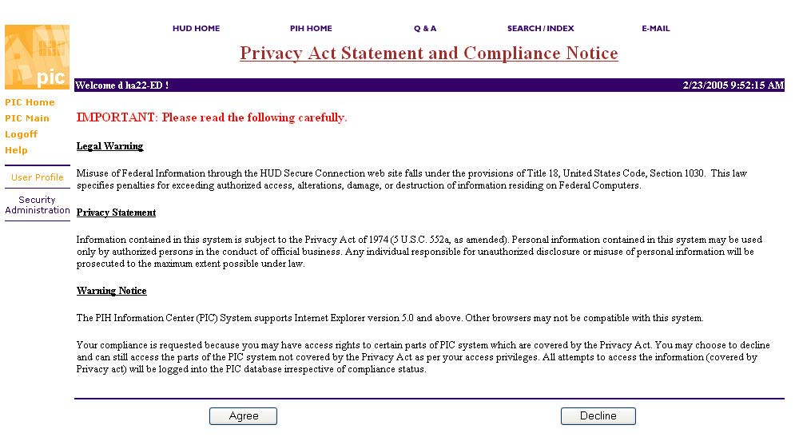
You will have to choose "Agree" in order to continue with your work. If you Decline you will not be allowed to proceed into any area covered under the Privacy Act until you agree. You will encounter this screen at least once during your session but your every movement will be logged each time you access privacy data. The system coordinator will be able to pull a report that shows each section of privacy data that you have accessed. Once you have agreed to the privacy act statement you will not have to agree again during the same logon session.
- 4 -
PIC Maintenance USER PROFILE
The User is responsible for maintaining the information on their user profile page. The information includes the address, phone number, email address and other information about the user. If you change your contact information you need to change it here as well as the Executive Summary Section in the Housing Authority Module so HUD has an updated method of contacting you.
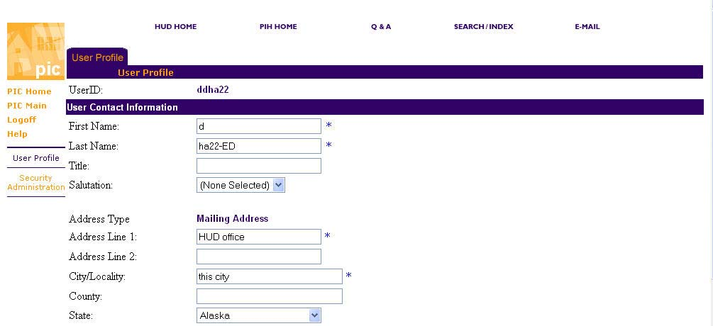

PIH Information SEMAP
The SEMAP module under PIH information is where PHAs perform their annual certification under SEMAP, review past certification and also review their scores and any changes made to their scores.
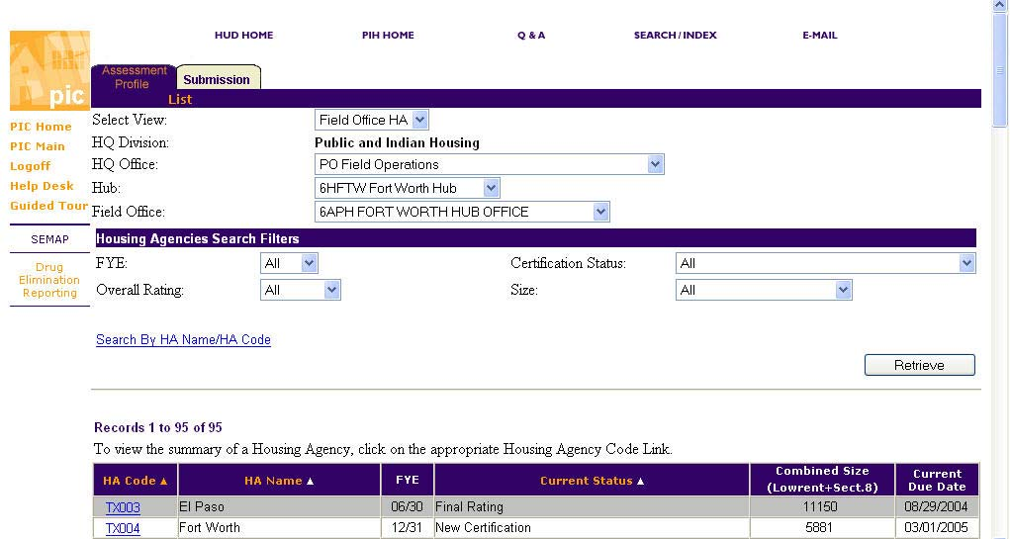
HOUSING INVENTORY DATABASE MAINTENANCE–BUILDING AND UNIT DATA HOUSING AUTHORITY
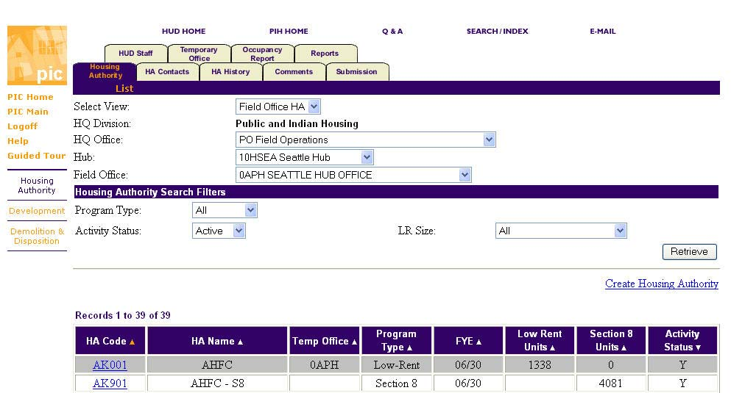
The Housing Authority section includes List, Details, Address, Inventory, Performance, and Funding information. The Housing Authority section allows the user to update information at any time. The HA Contacts section includes List, Details, and Address information. The HA Contacts section allows the user to update information at any time. The user can navigate between the three sections by selecting the section name from the secondary navigation bar. The HA Contact List section is the first page that appears. The Occupancy Report List page provides a summary of a particular Housing Authority's unit occupancy information sorted by development. The user may create a report to submit or modify particular entries of previously submitted reports.

DEVELOPMENT (BUILDING AND UNIT)
The Development Summary Report page displays a consolidated view of all B and U information relevant to the Development selected. This page can be accessed by Housing Authority or Field Office users at any point in the formula characteristics verification business cycle.
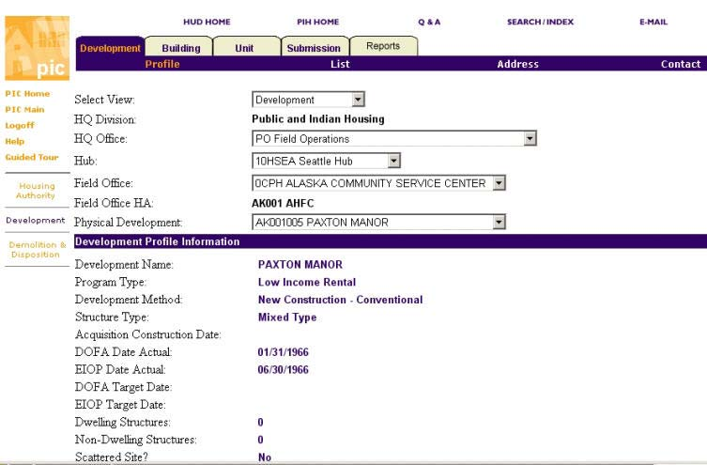
Choosing a Building Type in PIC Development
Remember: “Physical address” is the address you give to police; “mailing address” is the address put on things mailed to you.
The key to choosing which type of building you have in PIC is to answer the following questions:
1. Does the building have more than one unit?
- a. Yes: Go to question 2.
- b. No: Go to Example A” (Single Family).

2. Does the physical address use an apartment or unit number?
- a. Yes: Go to question 3.
- b. No: Go to question 5.

3. Does the building have one outside front entrance to the units?
- a. Yes: Go to question 4.
- b. No: Go to question 6.

4. Does the building use an elevator for tenants?
- a. Yes: Go to Example “E” (Elevator Structure).
- b. No: Go to Example “D” (Multi-family/Walkup).

5. Does the building have more than two units?
- a. Yes: Go to Example “C” (Row/Townhouse).
- b. No: Go to Example “B” (Semi-Detached).

6. Does the building have more than two units?
- a. Yes: Go to Example “G” (Row/Townhouse with unit numbers).
- b. No: Go to Example “F” (Semi-Detached with unit numbers).

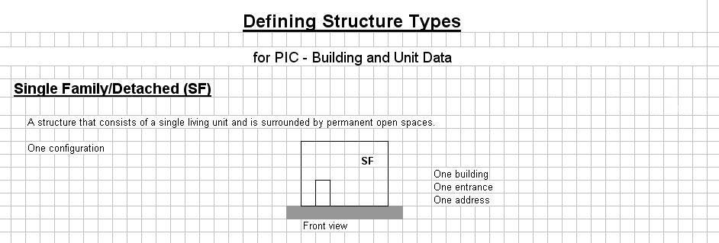
Example A (SF - Single Family Home) Example B (SD – Semi-Detached/Duplex/2-Flat) Example C (RW – Row or Townhouse) Example D (WU -Multifamily or Walkup: no elevator) Example E (ES – Multifamily Elevator Structure) Example F (SD – Semi-Detached with “apartment” numbers) Example G (RW – Row or Townhouse with “apartment” numbers)
# of bldgs | # entrances | Units/entrance | Use door no in unit table? | Example of an address
1 | 1 | 1 | N | 202 Fir St
A single family structure will have one building with one entrance in the building table and one unit in the unit table. Leave door number blank in the unit table (it will be ignored in addresses).

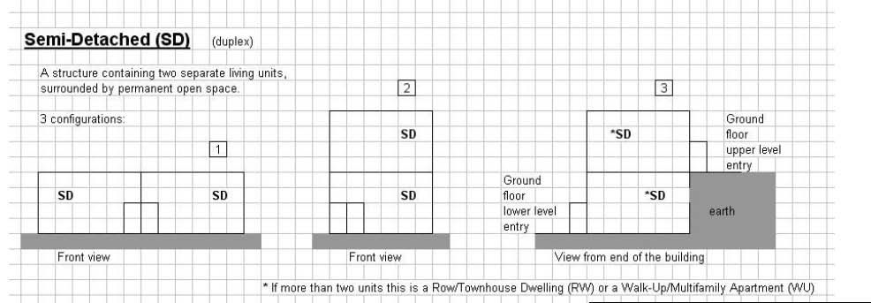
# of bldgs | # entrances | Units/entrance | Use door no in unit table? | Example of 2 addresses
1 | 2 | 1 | N | 202 Fir St, 204 Fir St
A semi-detached structure will have one building with two entrances in the building table and one unit in the unit table for each entrance. Leave door number blank in the unit table (it will be ignored in addresses).

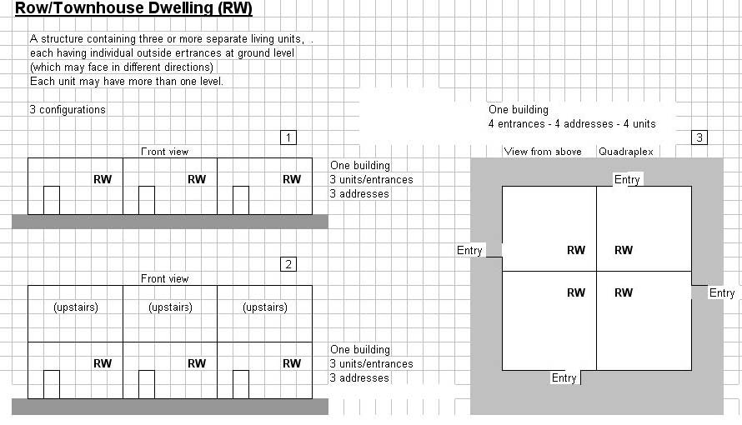
# of bldgs | # entrances | Units/entrance | Use door no in unit table? | Example of 3 addresses
1 | More than 2 | 1 | N | 202, 204, 206 Fir St
A row or townhouse structure will have one building with more than two entrances in the building table and one unit in the unit table for each entrance. Leave door number blank in the unit table (it will be ignored in addresses).

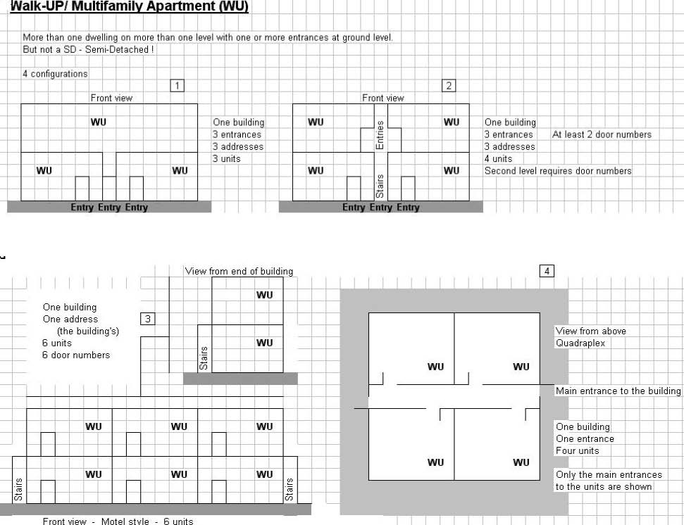
# of bldgs | # entrances | Units/entrance | Use door no in unit table? | Example of a unit address
1 | 1 | More than 1 | Y | 202 Fir St 3B
A multifamily or walkup structure will have one building with one outside entrance and more than one unit per entrance in the building table. It will have the same number of units listed in the unit table for that entrance. Fill in “door number” in the unit table with the apartment number; it will be added to the end of the physical street address in the building table.

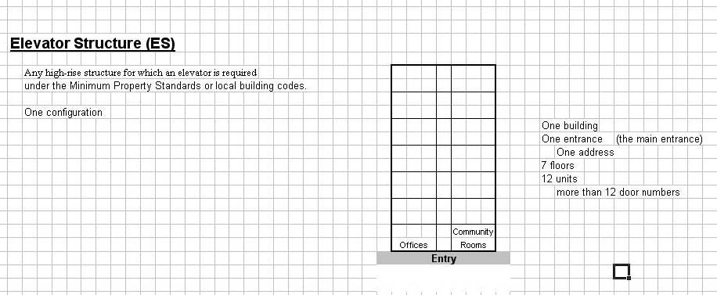
# of bldgs | # entrances | Units/entrance | Use door no in unit table? | Example of a unit address
1 | 1 | More than 1 | Y | 202 Fir St 3B
An elevator structure (a multifamily or walkup structure with an elevator) will have one building with one outside entrance and more than one unit per entrance in the building table. It will have the same number of units listed in the unit table for that entrance. Fill in “door number” in the unit table with the apartment number; it will be added to the end of the physical street address in the building table.

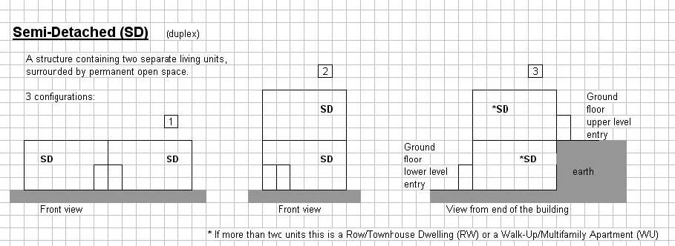
# of bldgs | # entrances | Units/entrance | Use door no in unit table? | Example of an address
1 | 2 | 1 | N | 202 Fir St
A semi-detached structure will have one building with two entrances in the building table and one unit in the unit table for each entrance. Leave door number blank in the unit table (it will be ignored in addresses). (If units use a unit number, put it in address line 2 for the entrance.)

# of bldgs | # entrances | Units/entrance | Use door no in unit table? | Example of an address
1 | 2 or more | 1 | N | 202 Fir St
A row or townhouse structure will have one building with two or more entrances in the building table and one unit in the unit table for each entrance. Leave door number blank in the unit table (it will be ignored in addresses). (If units use a unit number, put it in address line 2 for the entrance.)

DATABASE MAINTENANCE–BUILDING DATA AND UNIT
The Unit List page displays a summary listing of all the units associated with a particular building selected on the Building Detail page. In addition to viewing the list, the user may add units to the list or modify the existing information.
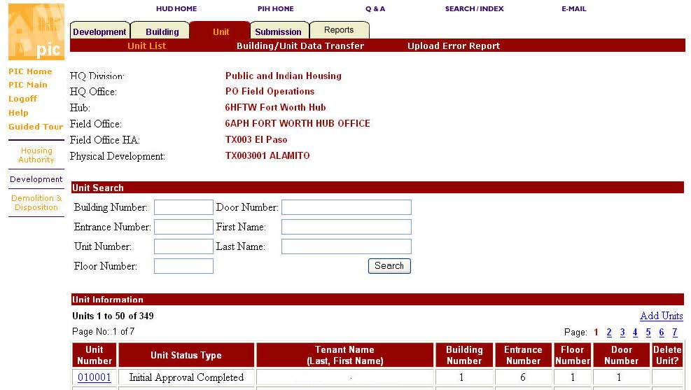

DEMOLITION-DISPOSTITION
In order to remove units from the official approved inventory:
- 1. The PHA initiates an application to remove units and buildings.
- 2. The PHA chooses a removal method and designates specific buildings and units to be removed.
- 3. The PHA submits the completed application to the Special Application Center (SA).
- 4. The SAC reviews and approves the application, which locks the application and the associated buildings and units.
- 5. When the units have been removed, the PHA inputs the removal dates and the Executive Director submits them to the HUD field office for approval.
- 6. All B & U totals and subtotals are recalculated when the Field Office approves the removal data.

The Application List page allows the user to select from a list of applications to complete or to create a new application. Application List Table: Table displays applications according to the selected criteria. The table columns are as follows: Application Number, HA Code displayed in SAC DD Application View, Received date, Application Type, Processor, Status, Status Date.
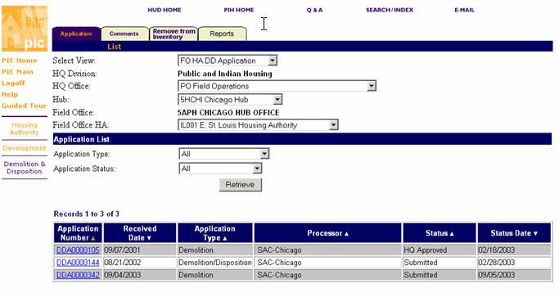
EXECUTIVE SUMMARY
The HA Executive Summary page displays detailed information about the selected Housing Authority. The executive summary is exactly as the name implies; a concise high level summary of information about the agency. The information display includes: HA Code, HA Program Type, HA Formal Name, HA Fiscal Year End, Permanent Field Office, and Temporary Field Office; HA Staff information; this includes: Mayor, Mayor Phone & Extension, Mayor Email, Board Chairperson, Board Chairperson Phone & Extension, Board Chairperson Email, Executive Director, Executive Director Phone & Extension, and Executive Director Email. Users can email HA Staff members by clicking on the Email link. Review the HA Inventory table information; this includes: Low Rent Funding Information and Section 8 Funding Information. Review the HA Funding Information; this includes: Low Rent Funding Information and Section 8 Funding Information and Review the HA Comments.
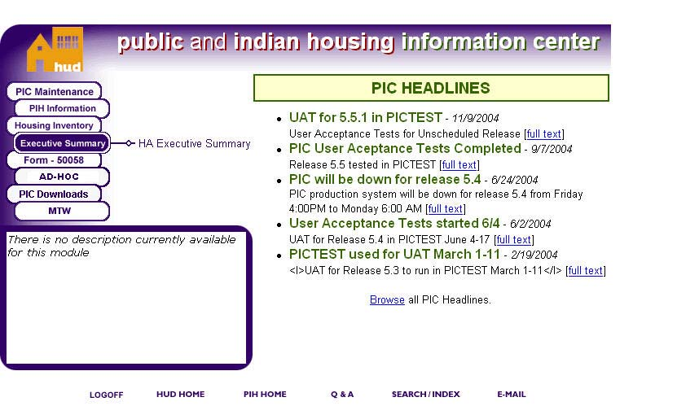
FORM 50058 SUBMISSION UPLOAD
After you have completed a tenant file either using your FRS software or Vendor Based software, you will click on the PIC 50058 submission module to submit your file(s) to PIC. You will click on browse to choose the file to be transmitted and then click on transmit to transmit the data to PIC. Please record your ticket number for later use to pull your error reports from or if needed to report problems with the transmission with. Please refer to the 50058 Transmission module user guide for more information on this topic.
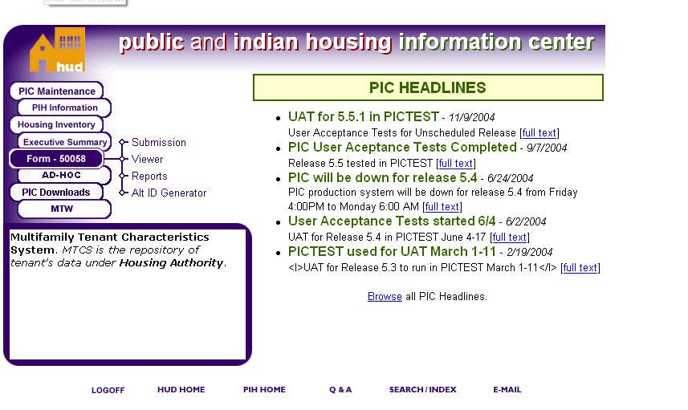
ERROR REPORT
After successful transmission of your data, you can go to the PIC submission reports tab, click on the link for your ticket number and view the transmission errors. It is best to save this as a file for printing and sorting later. To save as a spreadsheet file, click on the file save icon in the top right hand corner of the screen, choose your location and then click on save; the file will be transferred to your computer. It is advisable but not required that you keep a copy of this for future reference either in electronic or paper format. Once you have identified the errors, use the Error Code Table to determine the error, you might also have to refer back to your vendor instructions to determine where to correct the error in your software. If you have errors, you must correct these errors before you transmit any other data and try to retransmit the file with the corrected errors prior to the end of the month. Please remember that only correct data counts in PIC.
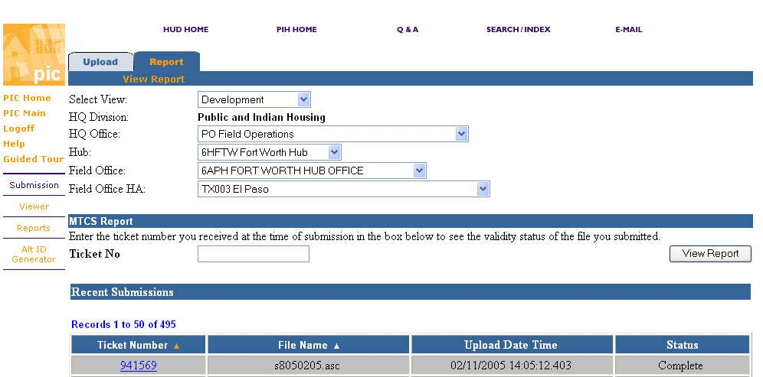
VIEWER
VIEWER
The Form 50058 viewer submodule contains a Search Tab that allows you to search for a family for whom a PHA submitted a Form HUD-50058 and view the information. It contains two sections, one, a Search section, and two, a Housing Authorities Search Filters section.
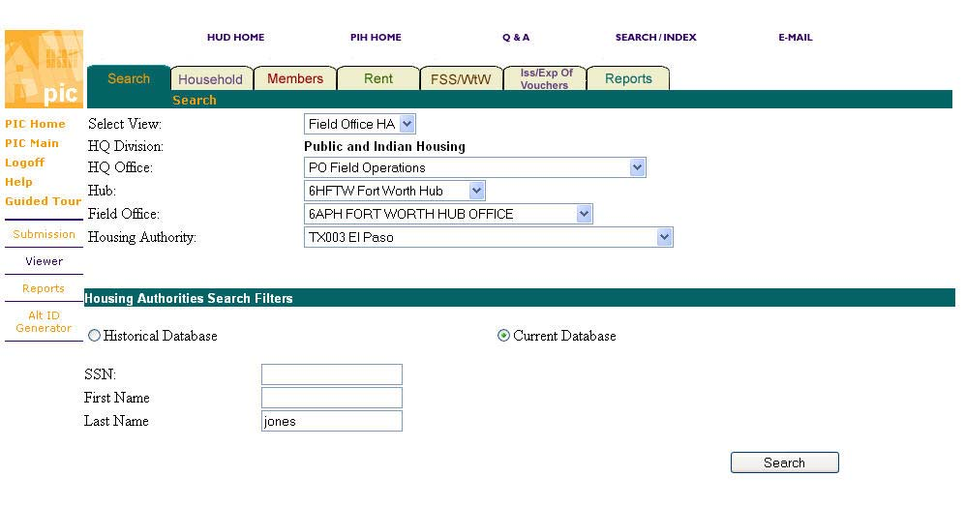
MTCS TRANSACTION REPORT
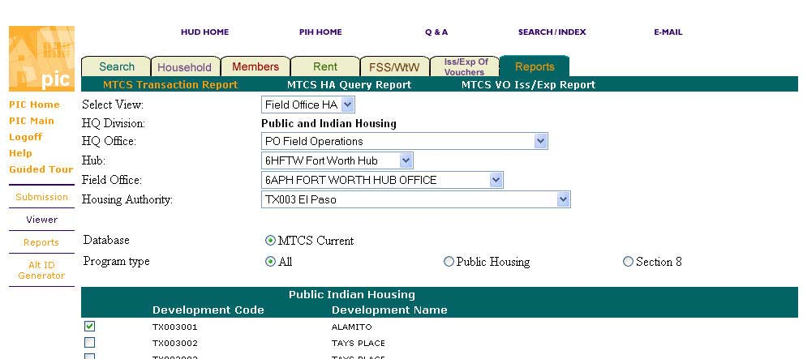
MTCS PHA QUERY REPORT
This report allows a PHA to obtain data on up to 14 tenants at a time, such as where they where
before, what their last status was,
etc.
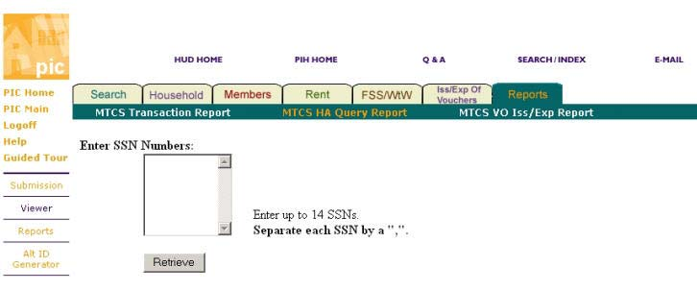
MTCS VO ISS/EXP REPORT
This report allows a PHA to see what vouchers have been issued and of those which ones have expired.
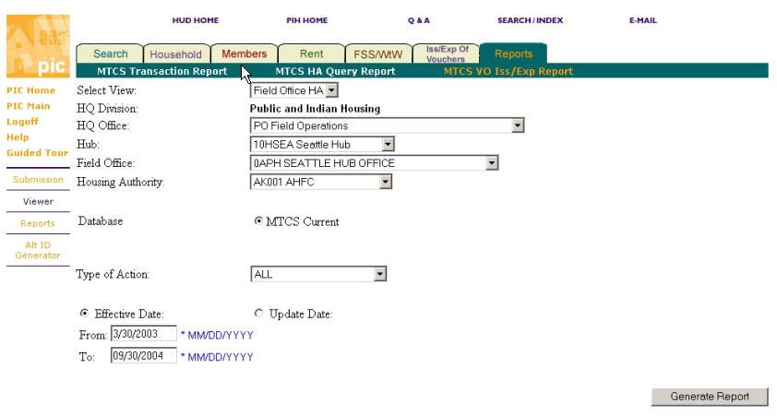
REPORTS DELINQUENCY
The Housing Agency (PHA) Delinquency Report summarizes information on the units and 50058 forms submitted for the selected Field Office. The information is provided for individual PHA codes within the selected field office as well as on an aggregate level. This report is used to establish the discrepancy in the “Number Administered / Number Occupied” and “Number Reported” fields for each individual PHA.
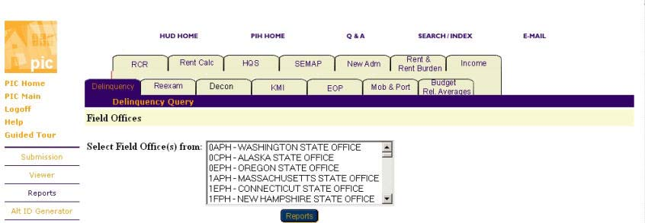
REEXAM
The Reexamination Report provides a list of families for whom the PHA did not submit a reexamination, flat rent reexamination, or flat rent annual update in time. This report also provides the projected date of the next reexamination or flat rent annual update.
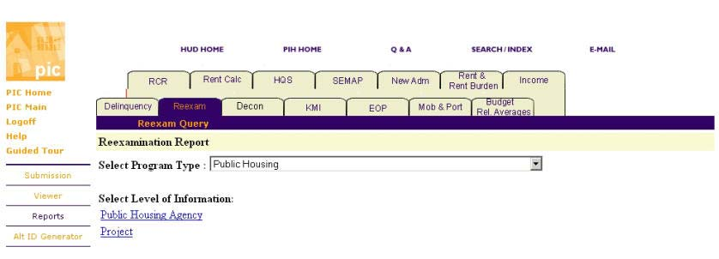
DECONCENTRATION
The Section 8 Deconcentration Analysis Report displays data on families receiving Section 8 tenant-based assistance (Section 8 Certificates and Vouchers).The Deconcentration Report can be used to examine the economic environments where Section 8 families live. The report provides data on tenant-based and HUD-based assisted families in a geographical area.
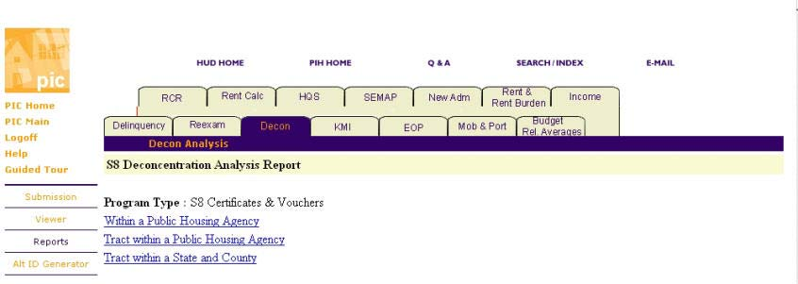
KMI
The KMI Report provides information on the volume of PHA activity, identifies possible
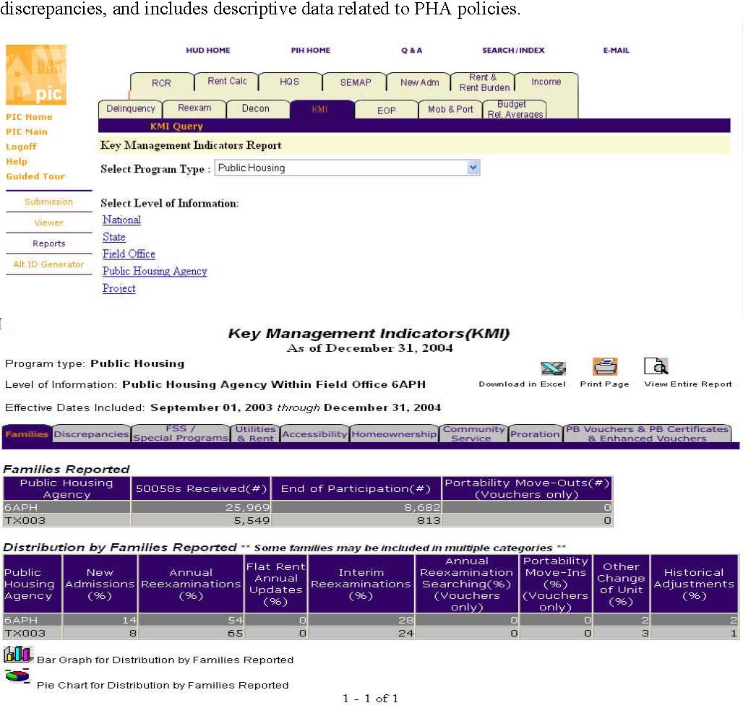
EOP
The End of Participation (EOP) report provides demographic and income information about families who end their participation in housing assistance programs, or leave assisted housing.
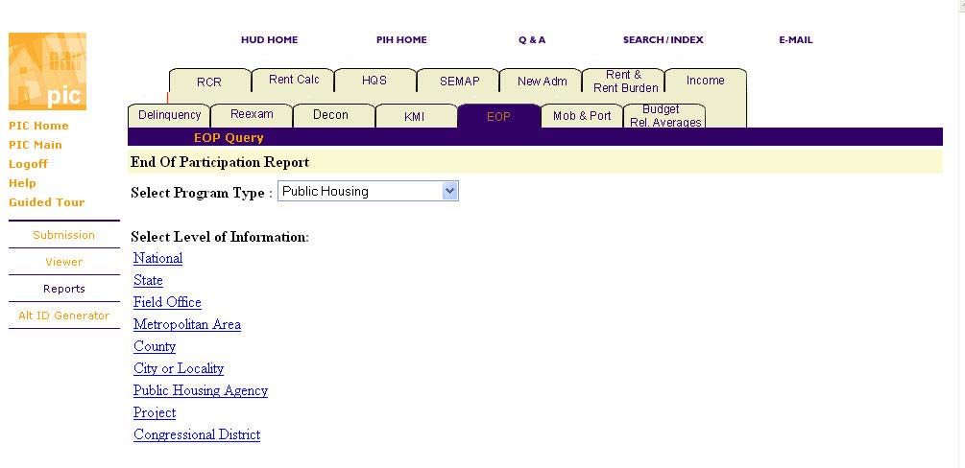
MOBILITY AND PORTABILITY
The Mobility and Portability Report profiles families who moved within the PHA’s jurisdiction (mobility) or from a unit in another PHA’s jurisdiction (portability).
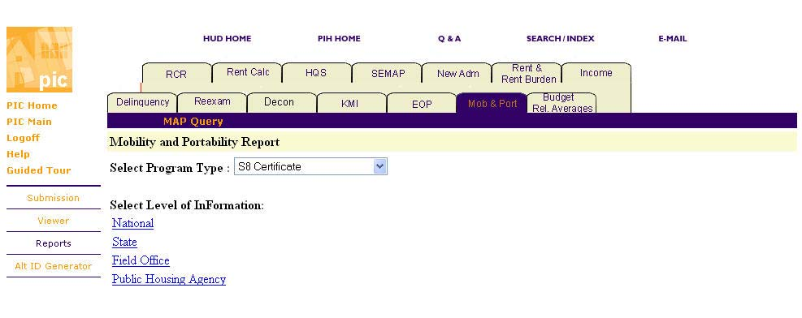
BUDGET RELATED AVERAGES
The Budget Related Rent Averages report displays averages for gross rents, total tenant payments, and assisted payments by unit size.
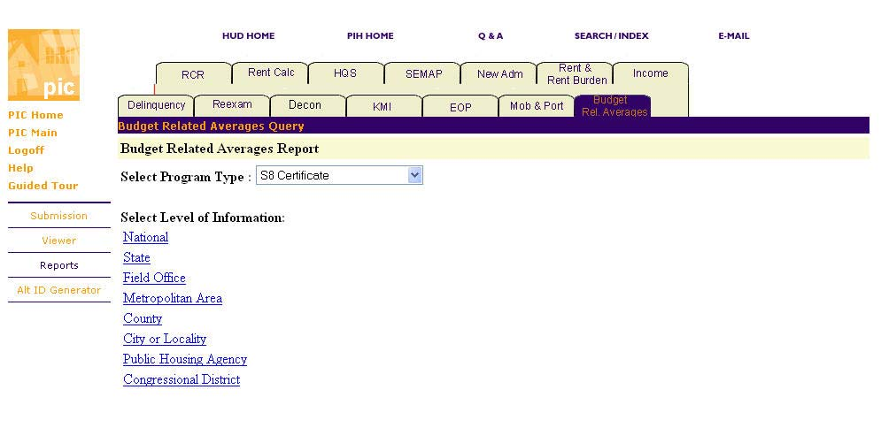
RCR
The Resident Characteristics Report provides demographic and income information for families currently served by PIH including the tenant based Section 8 housing programs. This report gives information about tenants who are in assisted housing.
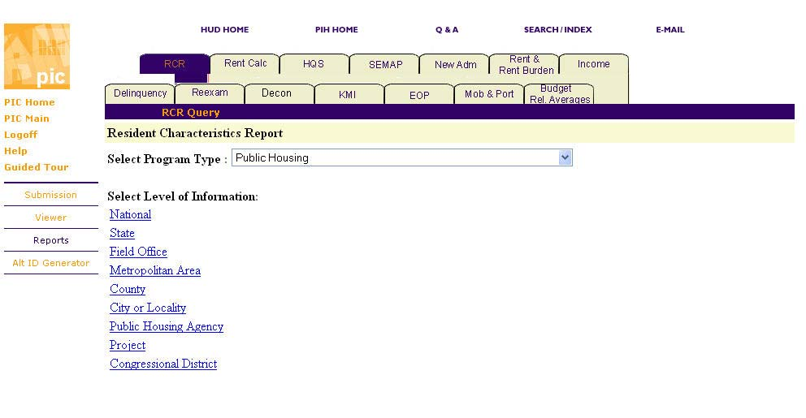
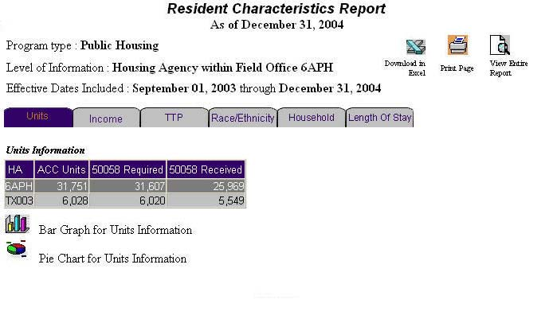
RENT CALCULATION
The Tenant Rent Calculation Discrepancy Report provides a list of families where the PHA reported rent and the system-calculated rent differ by more than $10 per month. The system-calculated rent, the reported rent, and the difference are shown for each family.
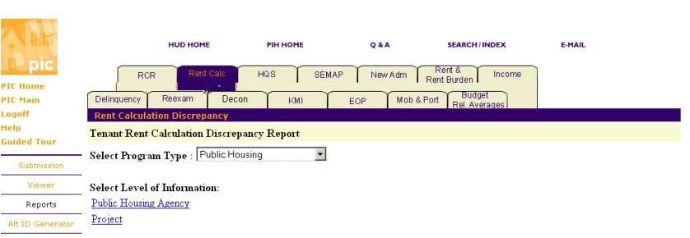
HQS
The Housing Quality Standard (HQS) Inspection Report is applicable to families with an HQS inspection that is three months or more than three months overdue. Housing Quality Standards (HQS) are a set of guidelines that describe minimum health and safety requirements to ensure that tenants have safe and decent housing. Section 8 program rules require that all Section 8 units meet Housing Quality Standards. HQS Inspections are due at least once every year. Program administrators inspect all units before the initial lease and then at least annually to verify HQS compliance. The HQS inspection schedule may or may not run on the same schedule as that of annual reexamination.
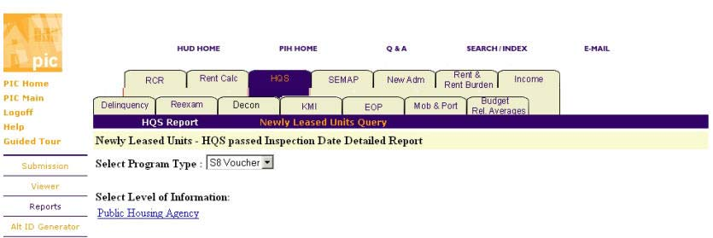
SEMAP
SEMAP is the monthly extraction of the data that would be used for a SEMAP assessment if it were done that month. PHAs can track their probable score on a monthly basis to note negative or positive trends.
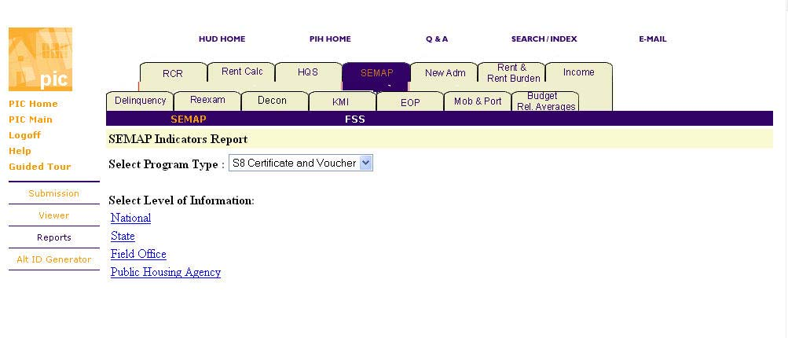
NEW ADMISSIONS
The New Admissions Report provides demographic and income information for households admitted and includes information on average wait time by race, ethnicity, and household type.
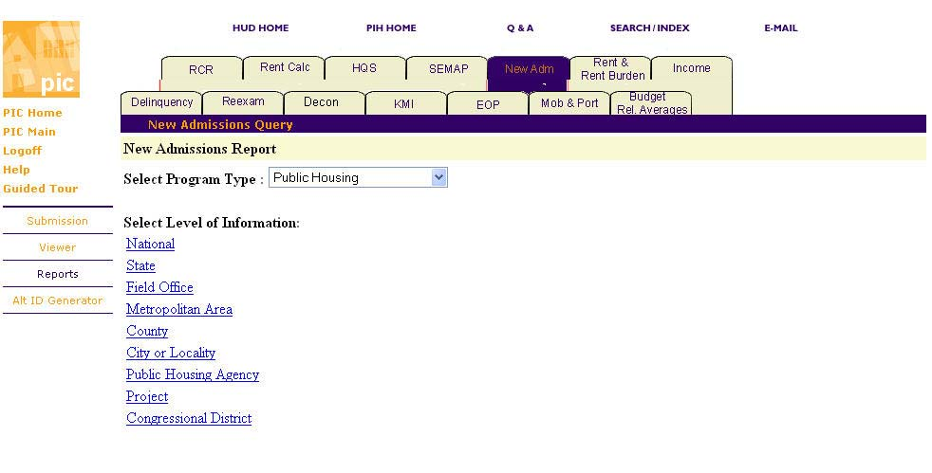
RENT AND RENT BURDEN
The Rent and Rent Burden Report summarizes information about rents relative to the Fair Market Rent (FMR) and each family’s rent burden in relation to their income.
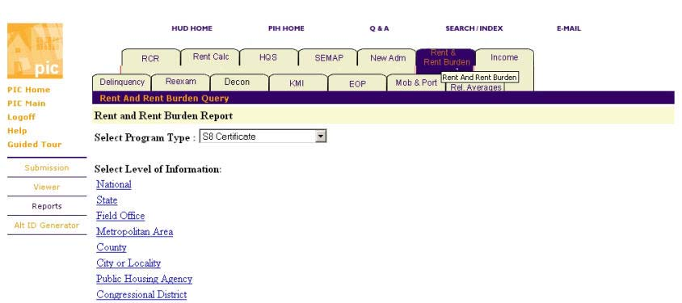
INCOME
The Income Report summarizes information about income distributions for all families, new admissions, and end of participation. The Changes in Income report helps users identify families with variations in income. This report summarizes information on income, general assistance, and earned wages on a quarterly basis.
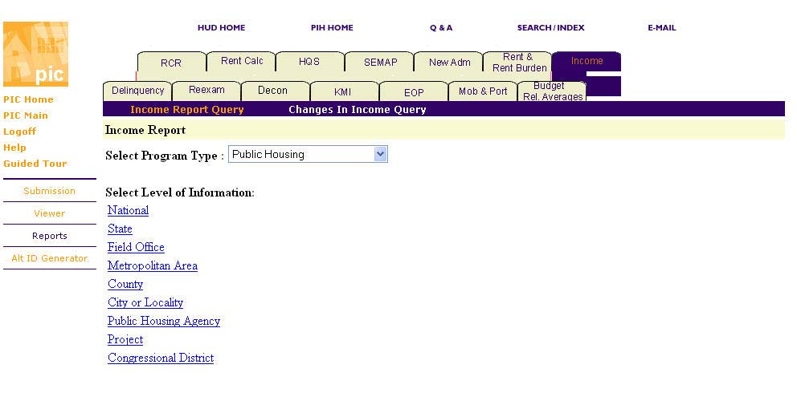
ALT ID
The Alternate ID. Module was changed significantly in the February 2005 release. The Alt. ID module allows a PHA user to obtain a unique Identification number to be used in lieu of a Social Security Number for household members (regardless of age) who have either misplaced their SSN or have never been issued an SSN. It only generates numbers and assigns
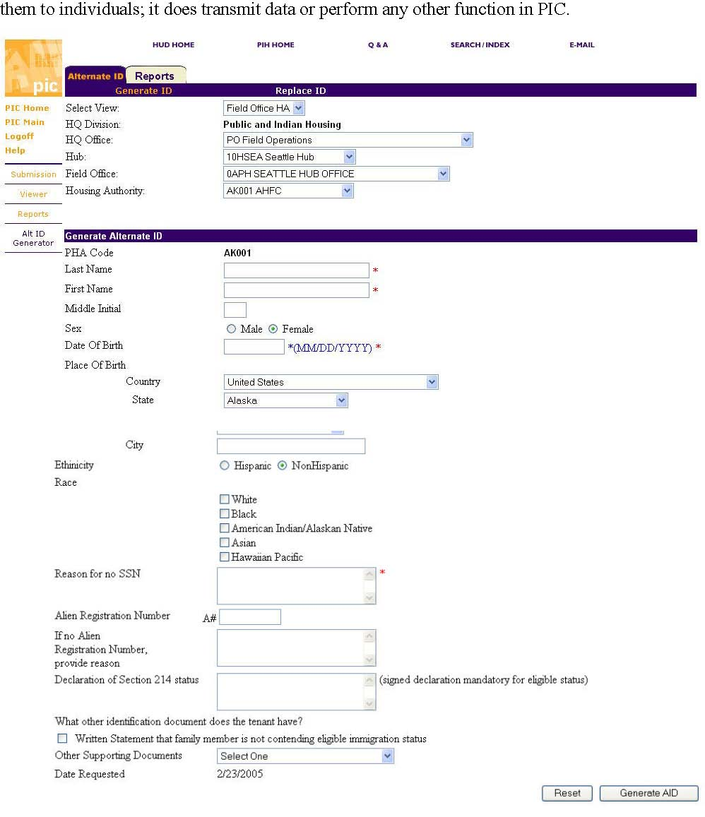
ALT ID REPORTS:
There are two new reports in the Alt ID Report menu as of the February 2005 release. The first report is the AID report that shows all of the ALT. IDs generated for your PHA.
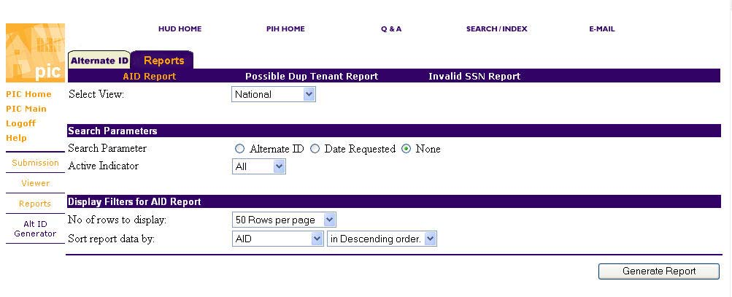
POSSIBLE DUPLICATE TENANT REPORT:
This report will show if one or more individuals are also listed at another project or at another PHA.
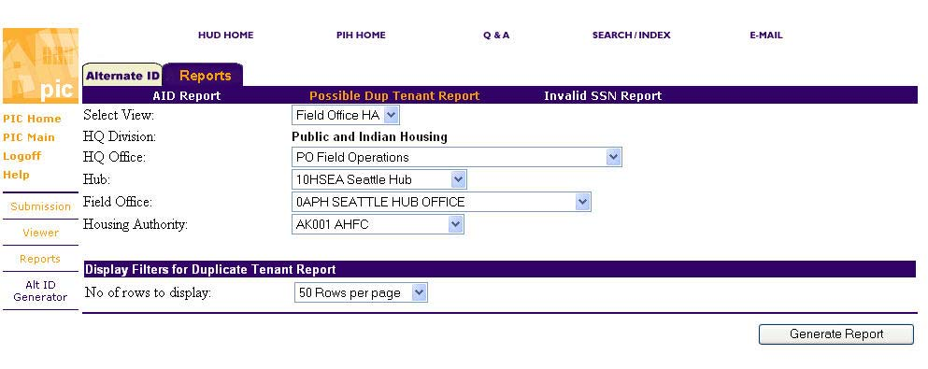
INVALID SSN REPORT
The invalid SSN report shows all of the invalid SSNs that are on file with PIC for your PHA, such as 999’s, and in the future, SSNs that cannot be valid due to data matching with the SS administration.
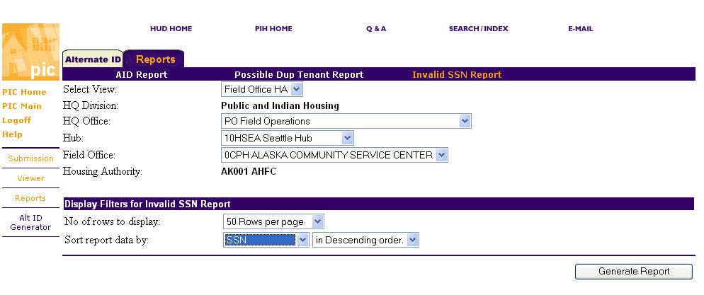
AD-HOC REPORTS
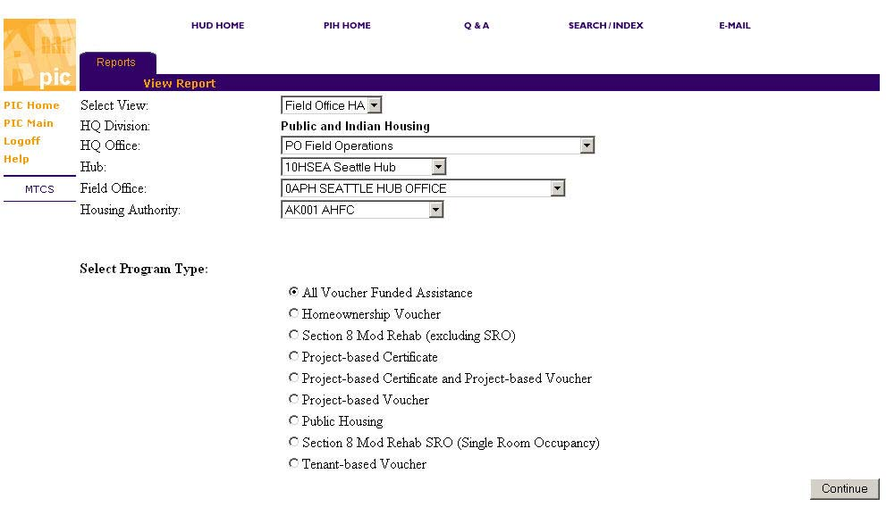
PIC DOWNLOAD
PIC Download permits a PHA to download its building & unit data from PIC in (more or less) the same format it would be uploaded. It is a periodic batch process that prepares any requested download once every 15 minutes. Hence, a user must wait until the file is available for download. A PHA can only download its own data. Downloading does not change the status of the building and unit approval status.
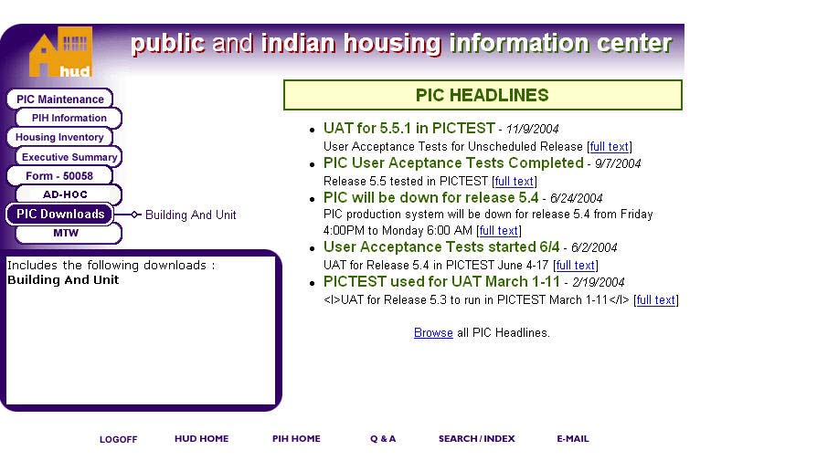
PIC TIPS
  - • User Profile
    - • WASS Passwords must be 6-8 characters, are case sensitive and are good for 21 days.
    - • Good passwords mix upper and lower case letters, numbers and special punctuation characters.
    - • Good passwords are not proper names, birthdays or words that can be found in a Dictionary.
    - • Good passwords use upper and lower case letters in non-standard ways (e.g. "weNSday").
    - • Examples of Poor Passwords: "11-22-1963" or "RingoStarr" or "Password" or "Wednesday" or "July4th".
    - • Examples of Better Passwords: "jULy4t#" or "bEEtles%4" or "gunZ4mi$$iLes" or "wedNESday-21!".
    - • WASS password resets must be requested from the WASS Administrator...
  - • SECURITY ADMINISTRATION:
    - • "HUD User" accounts in WASS are only created by the LAN Interface under WASS.
    - • Matching user accounts (same ID) must exist in WASS and in PIC.
    - • PIC Security Coordinators can create "Guest User" and "HA User" accounts in PIC.
    - • All user accounts must have written authorization on file.
    - • All changes and additions to user access must have written authorization on file.
    - • All user accounts must be recertified quarterly or else they are inactivated.
    - • The PIC Data Page has a report that lists all new accounts created within the past 30 days.
  - • PIH DERS
    - • Report cannot be submitted until all relevant sections are marked "Yes" in "Is this section ready for submission?" (bottom of page)
    - • After the final semi-annual report is submitted for a grant and a pre-audit end date is entered in LOCCS, the final close-out report must be completed.
    - • The submission screen has a Question: "Is this the final semi-annual report for this grant?" (Default answer is "No").
    - • If the user marks "Is this the final semi-annual report?" as "Yes", the system asks him/her "Are you sure? (Chance to correct wrong answer).
    - • FO staff can reject all sections individually but not the overall report.
    - • If a section is rejected, the PHA must correct, mark again as ready for submission and re-submit the report.
    - • PHAs cannot do the 6/30/03 report until they submit the 12/31/02 and it is approved.
    - • The HQ Program Office has reduced the priority for correcting DERS errors.
  - • PIH SEMAP
    - • In current configuration, user can delete an appeal, once started before submission.
    - • PHAs that had less than 250 vouchers under contract and were not troubled were able to choose not to submit a certification for FYEs 9/30/03 through 6/30/04 and for 9/30/05 through 6/30/06 but, if they do submit a certification, it counts and is scored.
    - • Sometime after the end of the submission period, we request confirmation of all the small PHAs that (1) did not submit and (2) were permitted to do so. Then we run the "Overdue Batch Process" for that FYE and give a "zero-score" profile to all that did not submit unless they are on the list of small PHAs to be excluded from the overdue batch.
  - • PIH RISK ASSESSMENT
    - • The five Risk Assessment quarters are normally set up with field edit access as shown below. Risk Assessment provides these quarters so that, as the office's plans change due to new information, the field staff can record changes to the plans without wiping out the previous version of the plans. (This provides an audit trail of the planning process). At the start of each quarter's editing, PIC pulls new data from the various sources used by Risk Assessment (PHAS, SEMAP, HUDCAPS and LOCCS/PAS) and calculates a new risk score based on the information available when that quarter is opened for editing. If a PHA is under the RPS/TARC staff when the quarter is opened, it will remain there until the next quarter is opened following its transfer back to the field office in PIC.
    - • Mgmt Planning Quarter Starts: as dir. by Dir Field Ops Ends: as dir by Dir Field Ops
    - • First Quarter Starts: at end of Mgt Planning Quarter Ends: Dec. 31 (automatic)
    - • Second Quarter Starts: In January (ASAP) Ends: Mar. 31 (automatic)
    - • Third Quarter Starts: In April (ASAP) Ends: June 30 (automatic)
    - • Fourth Quarter Starts: In July (ASAP) Ends: in Oct. as dir by Dir Field Ops
  - • HA INVENTORY—HOUSING AUTHORITY
    - • The PHA is responsible for maintaining the accuracy of the contact information in PIC.
    - • The Field Office is responsible for maintain the HUD Contacts.
    - • The PHA is responsible for maintaining agency address, phone, FAX, and email information.
    - • The PHA should enter a physical address and mailing address (if different); both are important.
    - • The physical address is the address for visitors and overnight express packages (which cannot use P.O. Boxes).
    - • In HA Contacts, HAs may put any and all contacts they want to list:
    - • HAs MUST put at least one executive director in HA Contacts
    - • HAs MUST put the governing board members in HA Contacts.
    - • HA contacts have start dates and end dates which correspond to terms for board members and contract periods of employment for staff.
    - • HA Contact end dates may be blank for staff members; HA Contact start dates may not be blank.
    - • One HA Contact may have more than one Contact Role (e.g. Board Chair + Board Member) with different end dates.
    - • To remove an Executive Director from HA Contacts, enter an end date for the E.D.'s employment.
    - • Add the new (or acting) Executive Director in HA Contacts with a start date at least one day later than the previous E.D.'s end date.
  - • PIH searches for a valid email address for the PHA in the following order:
      - 1. Executive Director,
      - 2. Acting Executive Director,
      - 3. Housing Director,
      - 4. Section 8 Director, or
      - 5. HA General Email Address
    - • Failure to maintain a valid email address is not an acceptable excuse for missing an important communication from PIH-REAC; the PHA is responsible for maintaining a valid email account and keeping it emptied.
  - • HA Contacts have the following data fields (asterisk indicates a required field):
      - 1. First Name*
      - 2. Last Name*
      - 3. Salutation* (from pull-down list)
      - 4. Phone Number*
      - 5. FAX Number
      - 6. TTY Number
      - 7. Email Address
      - 8. Contact Role* (from pull-down list)
      - 9. Effective Date* ("Start" date)
      - 10. Effective End Date
      - 11. Physical Address
      - 12. Mailing Address
    - • "HA Contacts" in PIC is now the PIH-designated official source of data about HA contacts for PIH and REAC.
    - • PIC Housing Authority is the designated PIH source for all email addresses used by PIH (including REAC).
  - • HA INVENTORY - DEVELOPMENT
    - • The RASS Report displays the actual physical and mailing addresses for public housing units.
    - • The RASS Report displays the address data exported the previous night to REACRASS.
    - • The Building Detail Report does not properly list buildings that are "Demo-Dispo Approved" for buildings with multiple entrances.
  - • HA INVENTORY – DEMO-DISPO
    - • "IBS" demo-dispo applications may now be processed by PHA and FO to complete removals.
    - • Any data entry that cannot be completed in the PIC system should be reported as part of the demo-dipso reconciliation process directly tot he SAC for resolution (until the reconciliation period ends in early 2005).
    - • Only the National Demo-Dispo report is installed in PIC at this time. All other Demo-Dispo reports are available in prototype spreadsheet format on the PIC Demo-Dispo web page.
  - • FORM 50058 SUBMISSION
    - • PHAs should always review the error reports for each submission ticket and correct the problems in each ticket before sending additional data for the same tenant.
    - • A Job Aid called "PIC Essentials - Form 50058 Submission" is available for
download (PIC Job Aids web page)
  - • FORM 50058-VIEWER
    - • You can bring up all tenants whose names start with "Sm" by typing "sm" into the Last Name field in "Search".
    - • Searching the "Current" database brings up the most recent data for the household(s) specified.
    - • Searching the "History" database brings up prior transactions for the household that are in the system.
    - • If an entry is not in history, it may be because it occurred before PIC Form 50058 took over and the data did not successfully transfer from MTCS.
  - • FORM 50058-MTCS REPORTS
    - • All MTCS reports are undergoing redesign by an integrated project team involving field staff, HQ and contractors.
    - • Two MTCS reports were changed for Release 5.5 (Sept).
    - • Four more MTCS reports will be ready for Release 5.6 (February 2005).
  - • FORM 50058-ALT. ID
    - • Beginning in February 2005, Alternate ID numbers are for any family members, regardless of age, if they do not have an SSN.
    - • The system will permit replacing an SSN or Alt ID with another SSN or Alt ID.
    - • Since release 5.3, only children under age six may receive subsidy without an SSN; all other family members over the age of six must have a valid SSN to be eligible for subsidy. (With release 5.6, the cutoff age for subsidy with no SSN drops to two.)
  - • AD HOC-- REPORTING-MTCS
    - • Since Release 5.3, users were able to download all of the Head of Household (HOH) demographic data from section 3 of Form 50058.
    - • Users may choose a data range for their ad hoc data query based on either "Effective Date of Action" (line 2b of the Form 50058) or "Update Date of Action" (data uploaded to PIC).
  - • PIC DOWNLOAD BUILDING AND UNIT
    - • There is a 15-20 minute time lag between when the download is requested and when the data may actually be downloaded.
    - • Users may only download their own data that they requested. Therefore, please note the ticket number and time data was requested.

PIC FAQS
Q: How can I get access to PIC data?
A: Level and type of access to PIC varies depending on whether you are HUD Public Housing staff, other HUD staff, PHA staff, or other individuals such as tenants and taxpayers.  HUD Public Housing staff members may be granted full “edit” access to PIC as
needed to carry out their responsibilities (requires a User ID and password).
 Other HUD staff members may be granted “read-only” access to PIC when requested as needed to carry out their responsibilities (requires a User ID and password).
 PHA staff members may be granted full “edit” access to PIC by their Executive Director as needed to carry out their responsibilities (requires a User ID and password).
 Other individuals (such as tenants and taxpayers) can obtain limited access to PIC data via the “HA Profile” link on the PIC Web page located at http://www.hud.gov/offices/pih/systems/pic/ which does not require a User ID or password).
 Researchers may request specific data from PIC using a “Freedom of Information Act” request to the HUD FOIA Officer in each HUD Field Office, provided the request does not constitute a violation of the privacy rights of tenants and staff.
Q: How do I add a development in PIC?
A: Housing Authority users may not add developments in PIC.  Normally, adding a development to the Housing Authority’s inventory will involve some development or property acquisition process, such as HOPE VI.
 To add a development in PIC, you must submit a written request to HUD through your Field Office specifying the name, address(es), type of structure(s), number of units planned, and funding source or funding method.
 After the HUD Field Office adds the development, the PHA must provide the building and unit data for that development, either by direct input to PIC or as an upload. Please note that the ACC document or amendment is normally the justification to add a development.
Q. What is the difference between a physical address and a mailing address?
A: “Physical address” refers to the address given to emergency services agencies such as police, fire or ambulance services.
Q: What items in “Housing Authority” does the PHA input (and when)?
A: Note: PIC is a shared access database and the content is maintained wherever the content is generated (i.e. PHA generated information is input by the PHA, HUD generated information is input by HUD).
The following items in “Housing Authority” are input by the PHA:
 PHA mailing and physical addresses and phone/FAX/TTY numbers (initially and whenever changes occur).
 HA web page address and organizational email address (initially and whenever changes occur).
 HA Contacts’ names, roles, mailing and physical addresses, and their phone/FAX/TTY numbers, email address, and role effective dates and role effective end dates (initially and whenever changes occur).
 HA Contacts must include the Executive Director, the Board Chairperson, Board Members, Board Member (Resident) and Local (Appointing) Official and may include others such as: (HA) attorney, financial officer, resident leader, congressional staff, formula characteristics (coordinator), etc. at the PHA’s option.
 Occupancy Report (electronic version of HUD Form 51234) annually within 30 days of the effective date which is 6 months before the PHA’s fiscal year end.
The following items in Housing Authority are input by HUD Staff:
 HUD Staff (initially and as changes occur).
 Temporary Office (as changes occur).
 HA History and Reports are maintained automatically by the PIC system
Q: How do I add a new HA Contact?
A: Note: HA Contacts must include the HA Executive Director and all Board members, including the chairperson and may include others as determined by the Housing Authority.
 Select “HA Information” and “Housing Authority”.
 Click on “HA Code” link (blue, left side of screen).
 Select “HA Contacts” tab.
 Click the “Create contact” Link (blue, right side of screen).
 Input the various items: first and last names; phone, FAX and TTY number;
salutation (use the salutation pull-down list); email address and then choose the appropriate role (from the role pull-down list).  All fields with a blue asterisk are required fields (you must fill them out).  You must enter the start date in the “Effective Date” field.  You may also enter an “Effective End Date” if it is a role with a defined term (such as a Board member. (This date can be changed later.)  Click “Save” to complete the process.
 Note: If a person has an additional role, you must repeat the process above and select the other role. People may have multiple roles at the same time (e.g. Board member and Board chairperson, if the local appointing official does not appoint the Board chairperson directly).
Q: How do I change the role of an HA Contact?
A: Note: HA Contact roles cannot be changed; they are made inactive by setting the effective end date to a date that has already occurred and then replaced with other roles as required. Contacts may have as many roles as required to describe their relationships to the agency.
 Select “HA Information” and “Housing Authority”.
 Click on “HA Code” link (blue, left side of screen).
 Select “HA Contacts” tab.
 Click the desired “Contact” Link (blue, left side of screen).
 Click “Modify Contact Details” (blue, upper right of screen).
 (You can update any contact details in this screen.)
 To end the role, click the role name link (blue, left side of screen)
 Enter an “Effective End Date”. (If you want to end the role immediately, enter a
date that is before today).
 Click “Save” to complete the role inactivation process.
 Note: If you enter a wrong Effective End Date and “save” it or need to change one
after it has taken effect, you can do so in the same manner by returning to the “HA Contacts” screen and changing the “Contact Status to “Inactive” or “All” which will display the inactive contacts. Then, select the inactive contact in the same way then proceed to change the effective end date as described above.
Q: How do I end the role of an HA Contact?
A: Note: HA Contacts are never deleted from PIC; they are made “inactive” by setting the role effective end date to a date that has already occurred.  Select “HA Information” and “Housing Authority”.  Click on “HA Code” link (blue, left side of screen).  Select “HA Contacts” tab.  Click the desired “Contact” Link (blue, left side of screen).
 Click “Modify Contact Details” (blue, upper right of screen).
 (You can update any contact details in this screen.)
 To end the role, click the role name link (blue, left side of screen)
 Enter an “Effective End Date”. (If you want to end the role immediately, enter a date that is before today).
 Click “Save” to complete the process.
 Note: If you enter a wrong Effective End Date and “save” it or need to change one after it has taken effect, you can do so in the same manner by returning to the “HA Contacts” screen and changing the “Contact Status to “Inactive” or “All” which will display the inactive contacts. Then, select the inactive contact in the same way then proceed to change the effective end date as described above.
Q: How do I change the role of a Board Member to Chairperson (or staff member to Executive Director)?
A: The new role of “Chairperson” is normally in addition to the role of “Board Member” and the roles may have different End Dates. For example, a Board Member may have a 3-year term from April 1, 2001 to March 31, 2004 then be elected Chairperson for a one-year term from July 1, 2002, to June 30, 2003. HA Contacts may have multiple roles. However, make sure the Chairperson and Executive Director roles have only one incumbent at a time. (Start a new incumbent the day after the predecessor’s Effective End Date for the same role.)
 Select “Housing Inventory” and “Housing Authority”.
 Select the “HA contacts” tab.
 Click the desired “Contact” Link (blue, left side of screen).
 Click “Modify Contact Details” (blue, upper right of screen).
 If you want to add the “Chairperson” role (without removing a role),
- o Click “Add a Role” (blue, lower right corner below the existing role).
- o From the pull down list of roles, select “Chairperson”.
- o Type an “Effective Date” in that field. (In the example above, the Effective Date would be 07/01/2002, and the Effective End Date would be 06/30/2003).

oClick “Save” to save your; the screen will return to the list of contacts.  If you want to “deactivate” the “Board Member” role first,
- o Click the desired “Contact” Link, and then click “Modify Contact Details”.
- o Double click the role name (blue) to open up access to the Effective End Date field and enter an Effective ending date, then click “Save”.

Q: How can I remove a user from PIC?
- 44 -
A: Note: Once users have been added to PIC, for accountability reasons they may not be deleted. Instead they are made “inactive” which completely removes their access.
 Select “PIC Maintenance” and “Security Administration”.
 Click on the User ID link for the individual you want to be made inactive.
 Click “Modify User”.
 Under “User Details,” click the “No” button beside “Active Indicator”. This makes the User’s account inactive. (The process can be reversed by changing it back to “Yes” to make the user active again.)
 A user can also be made inactive by changing the “Expiration Date” to a date before today’s date. (This can also be reversed by changing the Expiration Date to a date later than today.)
o Failure to certify a user account quarterly within 15 days of the end of the quarter will also deactivate the user.
Q: How can I change a user’s access rights in PIC?
A: Note: New users have no rights in PIC submodules until the Security Coordinator specifically assigns rights to them.  Access the PIC Security Administration submodule.  Select applicable module and submodule (from pull down lists).  Choose “Add or delete role”.  To add a role, select the appropriate role from the pull down list.  Select Security Type (“Field Office HA” for HA users and guest users).  Highlight in blue the HA Code and HA Name by clicking it.  Click “Save” to complete adding the role.  Repeat for any remaining submodules that are needed.  To remove a role, put a check mark in the box under “Remove” then click “Remove role” and confirm it when asked.
 We recommend that every PIC User have at least “General read” access to the Executive Summary module for the HA.
Q: How can I add a user in PIC?
A: Note: HUD Public Housing users are put in as PIC users automatically from the HUD LAN Security System; all other users must be added by a PIC Security Coordinator (there is one or more assigned at every PHA and Field Office).
 Select “PIC Maintenance” and “Security Administration”.
 Select “HA User” (PHA staff only) or “Guest User” (All other PHA contacts and contractors).
 Enter user information (Last name, First name, Middle Name or Initial).
 User ID (system generated) = first initial, middle initial (or “x”) and first six or less letters of user’s last name in lower case (if same User ID exists, system will add “01” or next sequential number to ID when saving).
 If user does not have an e-mail address, enter “none@email.com”.
 Initial password should ALWAYS be “Password” (note upper/lower case).Note: Once the user account has been created, regardless of user type, the Security Administrator must grant access rights in individual PIC submodules before the user can access any useful information or do work in PIC.
Q: When does my WASS password expire?
- A: Your WASS password expires and must be changed to a different one at least once every 21 days for security reasons. Passwords must be at least six and not more than eight characters long. They are case-sensitive and you must use a mixture of upper and lower case letters and numbers. Do not choose obvious passwords that can be easily guessed like your name or your children’s names or your street address or birthday. A nonsense word or intentionally misspelled word with non-standard capitalization and at least one special character (%$#@*) is best. For example, “mTbaG89?” (without the quotation marks) would be a good password because it follows the rules, is not a word found in a dictionary, and uses non-standard capitalization.
- Q. How can I change my WASS password?
- A. If you are an HA user, in the WASS menu under “System Administration”, click on the link “Change Password” and follow the prompts. The password must be 6-8 characters long with at least one upper and one lower case character and one numeral and should not be obvious.

If you forget your password and receive an “Invalid password” response, you must call the PIH Technical Assistance Center (TAC) at 888-245-4860. To prove who you are, you will be asked your “SSN” and your “mother’s maiden name” which you provided when you registered for your “M” ID. If you provide the same answers that you originally provided, your password will be reset. If you can not correctly answer the TAC question, the TAC will mail your new password to your agency.
Q: What does it mean when my User ID says it is “expired?
A: The “Expiration Date” for your PIC account has passed. This means that you cannot access PIC unless the Security Coordinator changes your “Expiration Date” under “User Details” to a later date. This can be done by either the PHA’s PIC Security Coordinator or the HUD PIC Security Coordinator in the Field Office.

