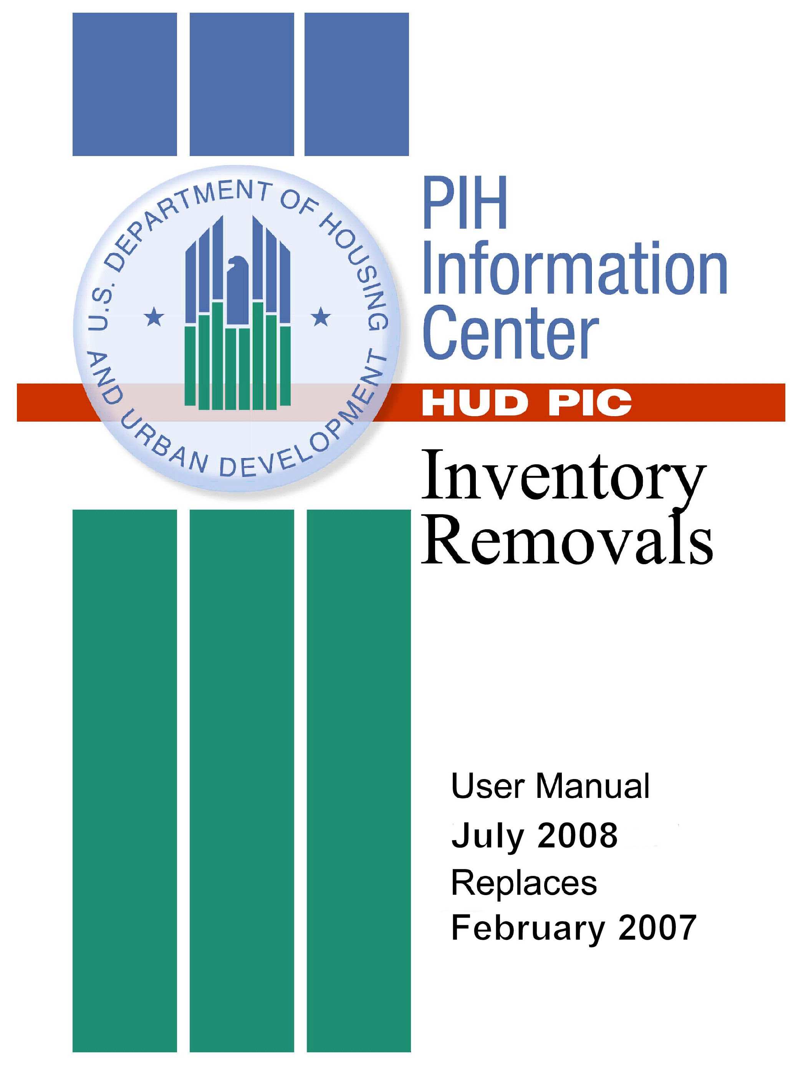

Table of Contents

1.Introduction
Preliminary Steps…………………………………………………1-1
Revised HUD-52860 2-3

2. Objectives 2-3

3. What is Inventory Removals Submodule? 3-1
Submission Process 3-2

4. Logging On to PIC 4-1

5. Navigating to the Inventory Removals Submodule 5-4

6. The Application Tab 6-1

7. The Application List Page 7-1
The Create an Application Page 7-6

8. The Form HUD-52860 (Application Index) Page 8-1
The Add/Remove Development Page 8-2

9. Verifying or Modifying Application Sections 9-1
Section 1 9-2
Section 2 9-4
Section 3 9-6
Section 4 9-8
Section 5 9-10
Section 6 9-19
Section 7 9-20
Section 8 9-22
Section 9 9-24

10. The Supporting Documents Page 10-1

11. The Application Submission Page 11-1
The Quality Checklist Page 11-3

12. The Remove from Inventory Function Tab 12-1
The Task List Page 12-3
Unit Transaction Page 12-4
The Add Transaction Page 12-7
The Remove from Inventory Submission Page 12-10
The Review Page 12-12
The Approval Page 12-14

13. The Inventory Removals Sub-Module Reports Tab 13-1
Generating a Report 13-2
Information Presented in the Report 13-3

14. The Development Sub-Module Reports Tab 13-1
Building Reports and Unit Report 13-2
Statuses of Units and Buildings in PIC 13-3

The User ID and Password needed for access to PIC are assigned rights to a set of actions that can be performed within PIC modules. Persons authorized t create applications should be assigned the appropriate rights for the Inventory Removals sub-module of the PIC Housing Inventory module.

These rights will allow users to see and carry out actions under, for example, the: ●Application Function Tab ●Form 52860 Page ●Supporting Documents Page ●Quality Checklist Page ●Submission Page ●Remove From Inventory Function Tab

Preliminary Steps:

Obtaining User ID and Password
Contact the PIC Security Coordinator within your PHA to get instructions on how to obtain a User ID and Password.

Introduction

Experiencing Technical Difficulties Contact
PIC Help Desk at: (888) 245-4860, 7 a.m. to 8:30 p.m. EST on business days or send an e-mail to: REAC_TAC@hud.gov.

Experiencing Program Difficulties Contact
Ainars Rodins: (312) 886-9754 ext 2816, ainars.rodins@hud.gov
Tamara Gray: (312) 886-9754 ext 2306, tamara.s.gray@hud.gov

Assembling Data
Identify the buildings and units proposed for removal, and the total acres of the development. If land is being proposed for removal in association with units or without units, assemble the number of acres to be proposed:
Example: “Request for disposition of 180 units and 24 acres at HUD project number CT006000002”.

Validating PHA Contact Information in Housing Authority Sub-module
In order to change PHA contact data it is necessary to go to the Housing Authority Sub-module in PIC to update the contact information pre-populated in the Inventory Removals Sub-module.

Validating Unit and Building Data is correct
If the building and unit data in PIC is not correct, it is necessary to go to the Development Sub-module of the Housing Inventory module in order to update the PHA unit and building data available for selection in applications in the Inventory Removals Sub-module. Changes to a PHA’s building and unit inventory in PIC are typically submitted to HUD Field Offices for approval. Buildings and units in “Submitted” status can not be added to removal applications until they are put in “Approved” status.

Gathering Attachments
  - Acceptable file extensions, .doc, .pdf, .xls, .ppt, .pps)
  - System will usually not attach filenames longer than 50 characters, (including the drive letter and folder path).
  - If necessary, use the underscore or some other character in place of blank spaces when naming files. Example: PIC_Example.doc
It is very useful to print out a hard copy of form 52860, which is available on the Special Application Center website, to serve as a guide, before entering data into the PIC sub-module. This form was revised significantly and went into effect April 1, 2008, but the electronic form in PIC will not be fully revised to incorporate these changes until autumn 2008. Appendix B to this user guide will provide a correspondence between the lines in each section of the PIC form as they currently exist and the lines in the new form 52860.

The new 52860 form is in effect, and may require some additional attachments, depending on the type of application being submitted. The electronic PIC version is the same for all application types. Questions that may not be relevant to the type of a particular application can be skipped (e.g. the cost of demolition should be skipped in applications that do not involve demolition). The url address of the SAC web page is:

(http://www.hud.gov/offices/pih/centers/sac/)

A copy of the revised HUD-52860 is available in electronic format as a
Word document on the following webpage:
http://www.hud.gov/offices/pih/centers/sac/exp52860.cfm
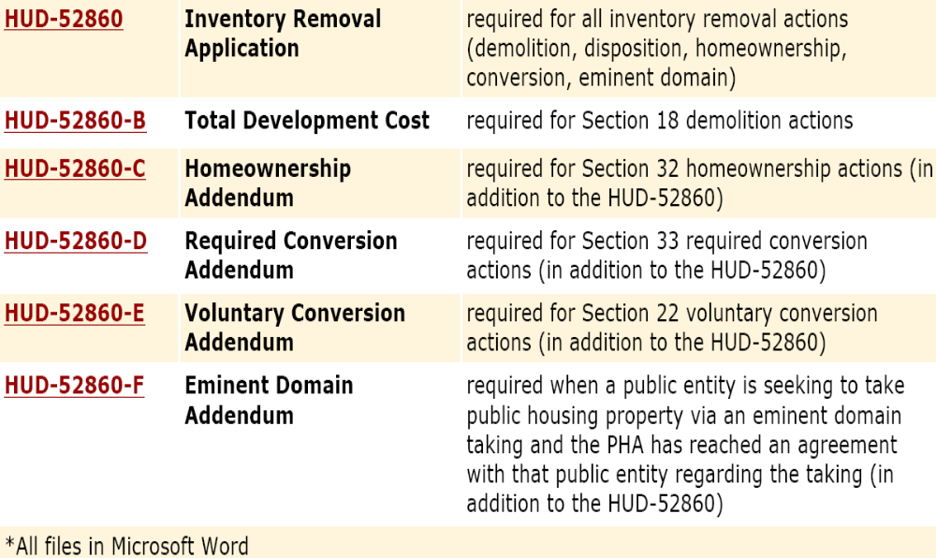

Figure 1-1
The document HUD-52860 includes instructions at the back, including a
Detail Matrix by application type showing which data is needed in each
type of application, and which data is automatically pulled into inventory
removals applications from elsewhere in the Housing Inventory module.

Objectives
The PIC Inventory Removals Sub-module assists the Special Applications Center (SAC) with its review of the required Inventory Removals application submissions. This sub-module is also used to change the status of units in PIC to Removed from Inventory after they are demolished, sold, leased, or otherwise conveyed out of the public housing inventory.

(http://www.hud.gov/offices/pih/centers/sac/)

The sub-module is easily accessible and an efficient system that allows HUD’s program and oversight staff to review electronically Inventory Removals application submissions on line via HUD’s Internet site (http://pic.hud.gov/).

Business Rules
Each submission must pass HUD’s business rules. In PIC, certain checks and validations are performed prior to application submission. These checks help to validate the accuracy and completeness of the Inventory Removals application. Then when the application is submitted, it is ready for review by the Special Applications Center.

Objectives
With this Guide you will be able to:

- Navigate to the Inventory Removals Sub-module.
- Complete an application to remove units from the public housing inventory
- Upload Attachments.
- Report dates in PIC when Buildings/Units and/or land have been removed from inventory.
- Generate Inventory Removals Reports presenting the number of units approved and the number demolished and sold/leased on the national level and at the level of the PHA and application number.

Note: Appendix A contains a quick reference guide for use as a sub-module refresher.

The IMS-PIC system enables Housing Authority users and Department personnel to access a common database of Housing Authority information. IMS-PIC is responsible for maintaining and gathering data about all of PIH’s inventories of HAs, Developments, Buildings, Units, HA Officials, HUD Offices and Field Staff and IMS-PIC Users.

What is the Inventory Removals
Sub-module?

The Inventory Removals Sub-module is the means used by HUD to approve removing units, buildings, and land from the inventory of public housing property under ACC contracts, and to record the change in status of such property in PIC to “Removed from Inventory”.

Prior to the development of the Inventory Removals Sub-module, applications were submitted via hard-copy format. The HUD Public and Indian Housing (PIH) Office developed this sub-module in the PIH Information Center (PIC) system to improve the availability of Inventory Removals data, and reduce error rates. This is aligned with the processes employed to deal with other housing projects funded through HUD.

Furthermore, the property information in PIC is used to assess requests by Housing Authorities (HAs) to demolish or dispose of an entire development, or a portion of a development, for a variety of reasons.

The sub-module enables users to:

- Automatically display submissions to field office staff.
- Display detailed compliance, performance, and unit information.
- Maintain reviewer comments.
- Provide authorized PIC users the ability to allow resubmission of applications.
- Allow HAs, Field Offices, SAC, and Headquarters users online access to Inventory Removals applications and schedules.
- Share information with the public after proper approval.
- Keeps the unit counts in the development module up to date so subsidy and capital fund grants can be accurately calculated.

Submission Process
In the Inventory Removals Sub-module, the SAC analyst can review Inventory Removals submissions for accuracy and compliance. The overall process begins with the HAs.

An HA enters and validates an application in PIC. Once validated, the HA submits the data via PIC to SAC, where the application is processed.

Application processing includes compliance checks in accordance with the Code of Federal Regulations (CFR) and statutes, taking account of the condition of the property.

The application is also made available to HUD Field Office analysts, who are familiar with the property and where it is located, who provide input on its condition based on monitoring data and performance indicators. The Field Office will agree or disagree that the removal action should take place, and make a recommendation to the Special Applications Center.
Follow these steps to log on to PIC:

Logging On to PIC

Step | Action/Result
- Start at http://www.hud.gov. | On the left side of the page, groups of hyperlinks are categorized under headings.
- Click the About HUD hyperlink under the HUD News heading. | The About HUD page is displayed. Hyperlinks to HUD’s program offices are listed on the right side.
- Click the Public/Indian Housing hyperlink under the HUD Offices heading. | The PIH page is displayed.  A Quick Find list of items is shown in alphabetical order on the bottom right side of the PIH Home Page.
- Scroll to the “PIC – PIH Information Center” entry (see Figure 4-1).

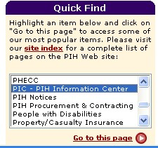
Figure 4-1: The Quick Find list on the PIH Home Page.

Step | Action/Result
- Click PIC – PIH Information Center with your mouse pointer.
- Click the hyperlink titled Go to this page. | The PIH Information Center home page is displayed.
- Click the hyperlink titled Logon to PIC, located in the center of the screen (see Figure 4-2). There are separate login links for HA Users and HUD Users. | The PIH Information Center logon screen is displayed. .
- The first step is to log into the WASS system. Type in your user ID and password in the boxes on the screen. | If you do not have a user ID, please contact your executive director.
- After the Legal Warning Notice screen is acknowledged, the WASS Main Menu screen is displayed (Figure X). Under Systems Click “PIH Information Center (PIC)”. | The PIC Main Navigation page is displayed.
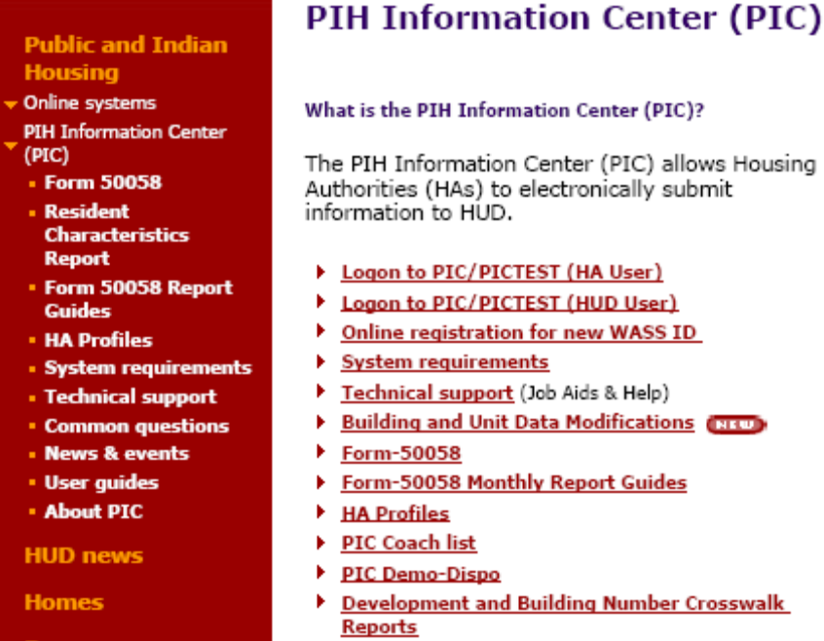

Figure 4-2: The PIC Home Page

Figure 4-3: WASS Login Page.
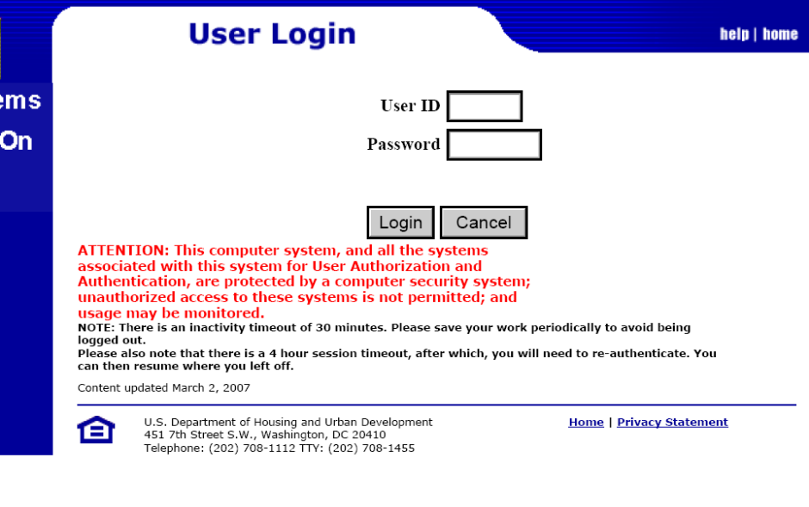

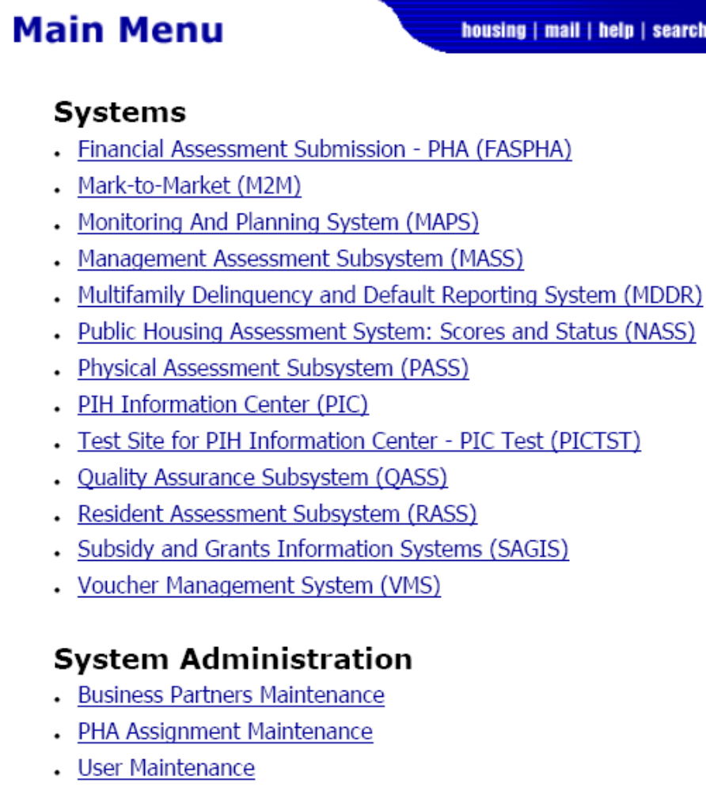
Figure 4-3: The WASS menu page
Follow these steps to access the Inventory Removals Sub-module from the
PIC Main Navigation page (shown below):
-7-

Step | Action/Result

Navigating to the Inventory Removals Sub-module
- Move your mouse cursor over the Housing Inventory Module button. | Three sub-modules are displayed (see Figure 5-):  - Housing Authority  - Development  - Inventory Removals  Note: Access to the other sub-modules depends on the role(s) assigned to you.
- Click the Inventory Removals hyperlink. | PIC displays the Application List page.

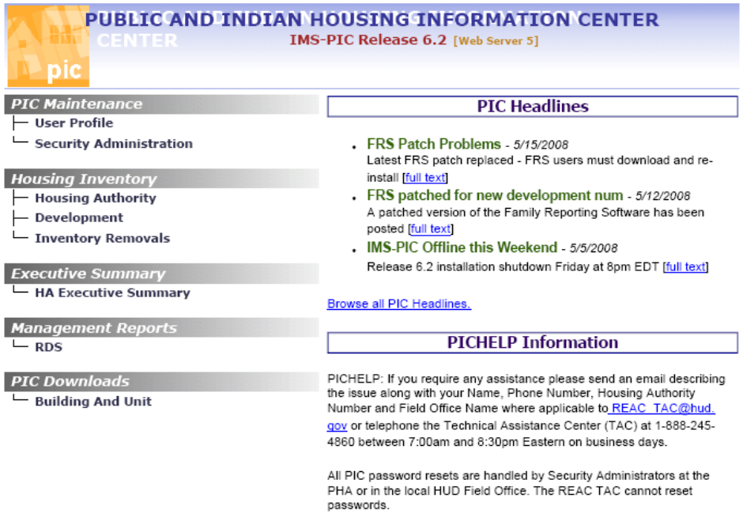

Figure 5-2: The PIC Main Navigation page with the
Housing Inventory sub-modules displayed.

Upon entering the Inventory Removals Sub-module, the first page displayed is the Application List page. This is one of several pages contained in the Application tab (see ).

The Application Tab
Figure 6-4: The subtabs available in the Application tab.
There are four other pages under the Application tab. They include the:

- Form HUD-52860 (Application Index) page
- Supporting Documents page
- Quality Checklist page
- Submission page

Click one of the sub-tabs shown to access a page.

The Application List page allows you to create an application or select from a list of previously created applications in order to modify or complete them.

Information Presented in an Application List
The Application List is displayed in a table on the Application List page. (see Figure 7-5).

The Application List Page

The table contains the following information:

- Application Number: The entries in this column are hyperlinked. Click an Application Number hyperlink to view the information for the selected application.
- Received Date: The date HUD received the application.
- Application Type: See page 3 for more information.
- Processor: SAC-Chicago is the only processor currently listed.
- Status: The status of the current application.
- Status Date.
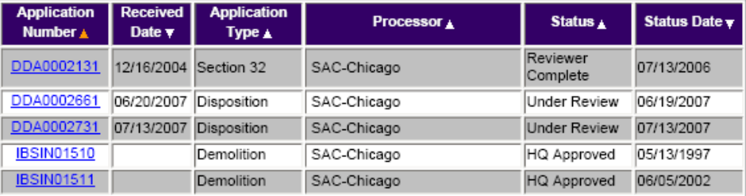

Figure 7-5: An example of an Application List.
The table can be sorted in the following ways:

- Click an Up Arrow button next to the Application Number column heading to sort the list by alphanumeric order from lowest to highest. This is the default list presentation.
- Click an Up Arrow button next to the Application Type or Status column headings to sort the table in alphabetical order from A – Z by the selected topic.
- Click the Down Arrow button next to the Received Date and the Status Date column headings to sort the table in chronological order from most recent to least recent.

Note: An Application List Table displays 100 applications at a time. If there are more that 100 application in the list, PIC displays a Next hyperlink. Click the hyperlink to view the next 100 records. After clicking the Next hyperlink, you can also click the Previous hyperlink to go back to the previous page.
The Application List can be narrowed by selecting filters for application types and statuses.

Follow these steps to narrow the application list by application type and status:

Step | Action/Result
- Select the appropriate application type from the Application Type dialog box (see page 3 for more information on application types).
- Select the appropriate application status from the Application Status dialog box (see Figure 7-6).
- Click the Retrieve button (see Figure 7-7). | The Application List is filtered to display applications based on the selections made from the dialog boxes.

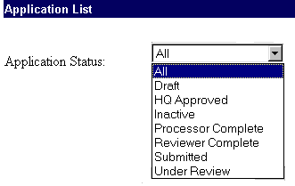
Figure 7-6: The statuses available in the Application Status
dialog box.

Figure 7-7: The Retrieve button.

Application Types
The different application types (see Figure 7-8) are described below:
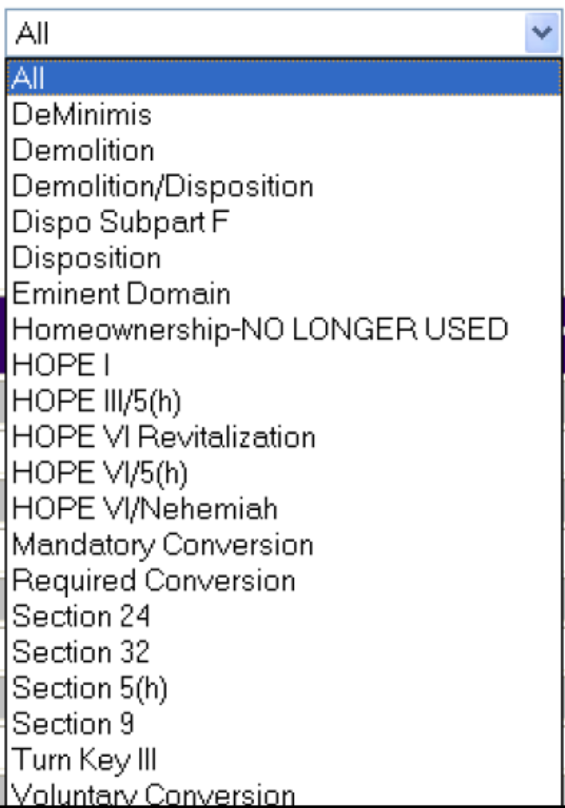

Figure 7-8: The application types available in the
Application Type dialog box on the Application List page.

DeMinimis: PHAs may demolish units without requesting approval from HUD, when the number of units within a 5-year period is not more than the lesser of 5 dwelling units or 5% of the total public housing dwelling units administered by the PHA . This should occur only if the space is used for service or other needs of the public housing residents or the demolished project piece is beyond repair.

Demolition: The destruction, in whole or in part, of one or more permanent buildings or units in a public housing project, in cases where HAs retain the underlying land.

Demolition/Disposition: Cases involving both the demolition of units and the sale or transfer of public housing land and/or units.

Disposition: The conveyance or transfer by the PHA, by sale, lease, or other transaction, of any interest in the real estate of a public housing project, subject to the exceptions stated in Sec.970.3.

Dispo Subpart F
Dispositions for mixed finance housing developed in accordance with 24 CFR 941 (Subpart F), which is eligible for streamlined processing under Section 18.

Eminent Domain: Power of the government to take private property for public use upon compensating the owner.

Homeownership: NO LONGER USED (homeownership applications now have individual application types instead (e.g. Section 32).

HOPE 1: Earlier homeownership program for multifamily public housing buildings of 5 units or more. No funds have been appropriated for

HOPE 1 since the mid-1990s.

HOPE III/5h:
HOPE 3 was an earlier single-family homeownership program covering public housing and many other types of structures of 4 units or less. No funds have been appropriated for the HOPE 3 program since the mid-1990s.

HOPE VI Revitalization: Demolition as part of Revitalization of Severely Distressed Public Housing. In a HOPE VI Revitalization, the demolition is not required to meet the provisions of Section 18 of the act or the corresponding regulations, 24 CFR Part 970. PHAs are unable to create applications with this application type. The HOPE VI grant manager provides data to enable these applications to be created at the Special Applications Center.

HOPE VI/5(h)
Section 5(h) public housing homeownership programs that were part of HOPE VI projects. Section 5(h) has been superseded by Section 32 homeownership. Applications are not being submitted for additional units under Section 5(h).

HOPE VI/Nehemiah
Currently this type of unit is not typically tracked in PIC.

Mandatory Conversion: Public housing buildings mandated to be demolished or otherwise removed from the public housing inventory under the Section 202 of the 1996 Appropriations Act. In lieu of this public housing, Section 8 assistance is provided. Section 202 was replaced by the Required Conversion program in the Quality Housing and Work Responsibility Act of 1998 (QHWRA) legislation.
Required Conversion Section 33 of the U.S. Housing Act of 1937:
Program recently implemented under which clusters of public housing units with persistently high vacancy rates are required to be taken out of public housing inventory under ACC, where it is more cost-effective to provide Section 8 vouchers. Enacted in the QHWRA legislation.

Voluntary Conversion, Section 22 of the U.S. Housing Act of 1937:
This program was recently implemented under QHWRA. It applies to certain cases where a PHA may remove units from the public housing stock, in circumstances where Section 8 vouchers are more cost-effective, and the loss of the public housing units will not adversely affect the availability of affordable housing in the area.

Section 24: This application type is not currently used in PIC

Section 32: Under this homeownership program authorized by Section 32 of the U.S. Housing Act of 1937, the PHA may sell newly constructed, rehabilitated, or existing public housing and other acquired units to public housing residents and other low-income buyers. All new homeownership applications that currently come to the Special Applications Center for approval are for Section 32 programs.

Section 5(h): In this program, a PHA could sell all or a portion of a public housing development to eligible residents (including units acquired for this purpose and put under ACC), under the pre-QHWRA version of § 906.8 of 24 CFR, according to a homeownership plan approved by HUD. Superseded by Section 32, but programs previously approved for Section 5(h) units may be carried out until the sale of units is complete. No increases in the number of units in Section 5(h) programs are being approved.

Section 9
This application type is not currently used in PIC.

Turn Key lll
Homeownership units in housing unit initially financed and constructed by private sponsors and purchased by PHA. These typically were approved years ago, although some such units are still being sold. This application type in PIC is used just to change the status of units to approved or removed from inventory. There are no new Turn Key III applications being submitted for approval.

The Create Application Page
Click the Create Application hyperlink on the Application List page to access the Create Application page. It allows HAs to create an Inventory Removals application.

Note: The Create Application hyperlink is available only for users with proper security access roles (see Figure 7-9).

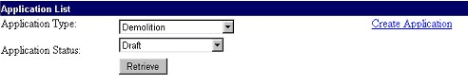
Figure 7-9: The Create Application hyperlink on the Application List page.

Follow these steps to create an application:

Step | Action/Result
- Click the Create Application hyperlink on the Application List page. | The Create Application page is displayed.
- Select the appropriate application type from the Application Type dialog box.
- Select the appropriate primary contact's name from the Primary Contact's Name dialog box (see Figure 7-10).
- Click the Create button to create a new application.  Note: If you click the Cancel button  (ref Figure 7 - 11). | PIC displays the Application List page. The list contains the new application.  Note: Then PIC returns to the previous Application List page.

Figure 7-10: The Primary Contact’s Name dialog box on
the Create an Application page.

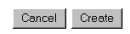
Figure 7 - 11: The Cancel and Create buttons
on the Create an Application page.

Click an application number in an Application List to access the Form HUD-52860 (Application Index) page (see Figure 8-12).

The Application Index page contains a table that displays the following information:

- Section (of the application)

The
Form HUD-52860
(Application Index) Page
- Section Type (“Required” or “Not Required”)
- Section Status
- Status Date

Note: Initially applications have Draft status until they are submitted to the Special Applications Center or until the SAC enters a submission date.

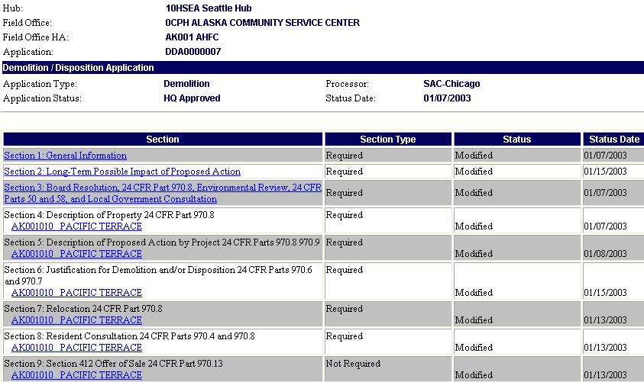
Figure 8-12: An example of an Application Index page.

You may modify or complete a section within an application by clicking the hyperlinked section entries on the page.

The Add/Remove Development Page
Click the Add/Remove Development hyperlink on the Application Index page (see Figure 8-13), to access the Add/Remove Development page.

Note: The availability of this hyperlink depends on your security access role.

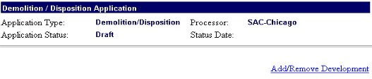
Figure 8-13: The Add/Remove hyperlink on the Application Index page.
The Add/Remove Development page enables you to add developments to, or remove developments from, the selected application.

Follow these steps to add a development to an application using the Add/Remove Development page:

Step | Action/Result
- Select the appropriate available development number from the Available Development dialog box. | Note: Hold down the control key to move multiple developments from the Available Development box to the Proposed Development box.
- Click the Greater Than Arrow (>) button to add the selected development to the application (see Figures 8-14). | The development is displayed in the Proposed Development dialog box.
- Click Save  Note: If you click Cancel then | Saves information. PIC returns to the newly modified Application Index page.  Note: PIC returns to the previous Application Index page.

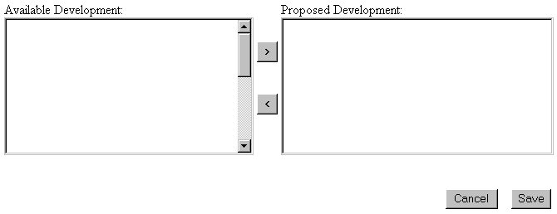

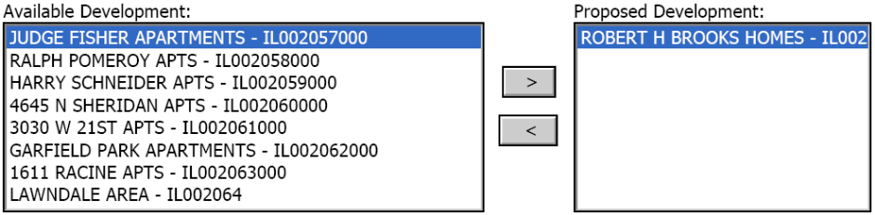
Figures 8-14: The Available Development and Proposed Development dialog boxes on the Add/Remove Developments page.

In order to remove a development from an application using the Add/Remove Development page, the same steps are followed in reverse:

Step | Action/Result
- Select the appropriate proposed development from the Proposed Development dialog box. | Hold down the control key to move multiple developments from the Proposed Development box
- Click the Less Than (<) Arrow button to remove the selected development from the application (see Figures 8-14). | The development is displayed in the Available Development dialog box.
- Click Save  Note: If you click Cancel, PIC returns to the previous Application Index page with no action. | If you click Save, PIC saves the information and returns to the newly modified Application Index page. The status in PIC of the units taken out of the application then reverts to what it was prior to when they were initially selected in the application.

From the Application Index page, click on the specific Section hyperlink to access an application section.

Verifying or Modifying Application Sections

HAs can access an editable copy of their application if it has not been submitted to SAC. A read-only copy of their application is provided after submission.

Contact your SAC reviewer if changes are necessary after the application has been submitted. The name of the reviewer assigned is available within Section 1 of PIC applications and in the Assignment Planning System data, which is available on the SAC website at:
http://www.hud.gov/offices/pih/centers/sac/index.cfm.

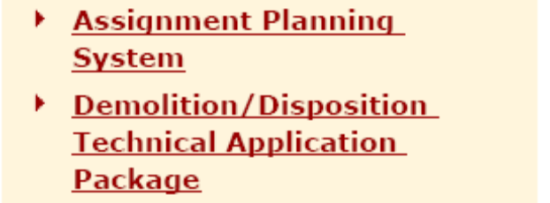
Under “Helpful Tools”, click on Assignment Planning System, and follow the instruction to display assignments alphabetically by organization, with the name of the SAC reviewer.
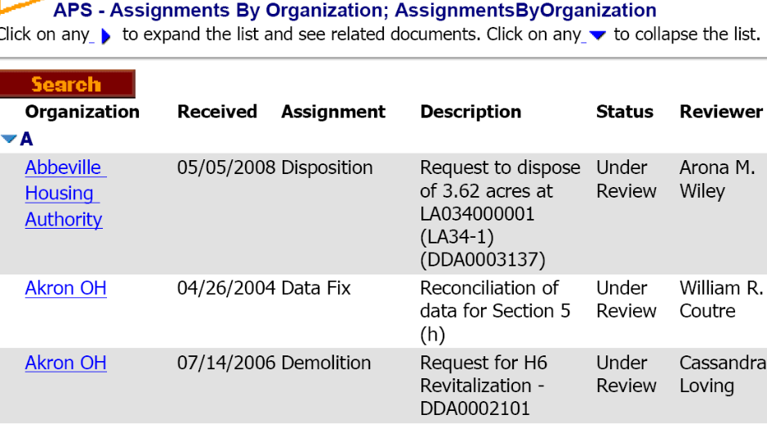

For newly created applications, only sections 1-3 will be hyperlinked. Sections 4-5 will not be active until one or more developments have been added to the application (see Figure 9-15). Section 6 becomes active after Section 5 is modified.

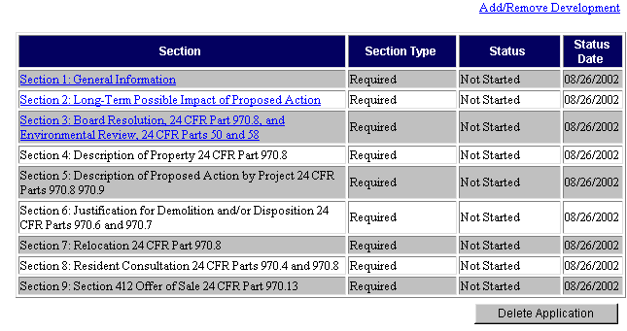
Figure 9-15: The Section table on the Application Index page.
Note: Sections 1-3 cover all developments within an application. Sections 4-9 have entries for each individual development in the application.

The following pages describe the information presented in each section of an application, and how to edit it before the application is submitted for approval.

Section 1
Click the Section 1: General Information hyperlink on the Application Index page to access Section 1 data.

This section enables you to:

- Read the Inventory Removals application statement.
- Verify that the pre-populated Public Housing Authority contact information is correct. To update the contact information displayed in Section 1, the changes must be made within the Housing Authority Sub-module.
- Within the Housing Authority sub-module the HA name, HA address, HA telephone number, fax number, email address, the HA Executive Director information, and the primary contact data can be updated.

After reviewing the statement and modifying or verifying the contact information in Section 1 of the application, click the Return to Application Index hyperlink to return the Application Index page (see Figure 9-16).

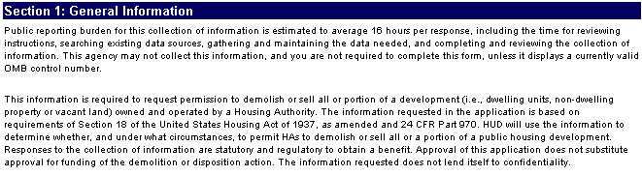
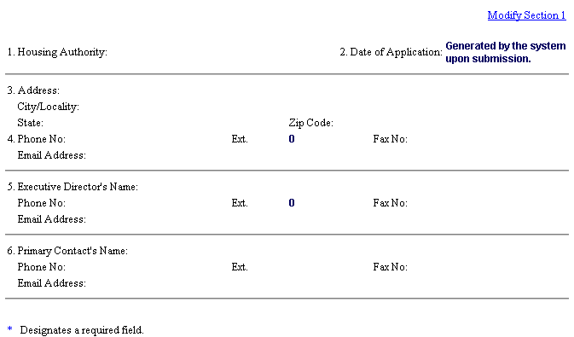
Figure 9-16: An example of the Section 1 display.

Modifying Section 1
The only modifications that can by made by the HA within Section 1 of an inventory removals application is the selection from a drop-down menu of the primary contact for the particular application (as well as selection the Executive Director when the corresponding menu has more than one name). Follow these steps to modify the primary contact person displayed on the page:

Step | Action/Result
- Click the Modify Section 1 hyperlink.  If you do not have access this hyperlink, please contact your PIC coach. | This allows you to edit portions of section one.
- Select the appropriate primary contact's name from the Primary Contact's Name drop-down menu.
- Click the Save button to save the information or the Cancel button to undo the modifications. | If you click Save, the application is modified. This is reflected in the “Status” column of the Application Index page (see Figure 9-17).  If you click Cancel, the application is not changed and PIC returns to the Application Index page.

Figure 9-17: The Section table on the Application Index page
after Section 1 has been modified.

Section 2
Click the Section 2: Long-Term Possible Impact of Proposed Action hyperlink on the Application Index page to access Section 2 data.

This section displays the amount of Operating Subsidy and Capital funding the HA received in a selected fiscal year (see Figure 9-18), and calculates an estimate of the long-run impact of the removal of the units on the PHA’s annual funding under these programs.

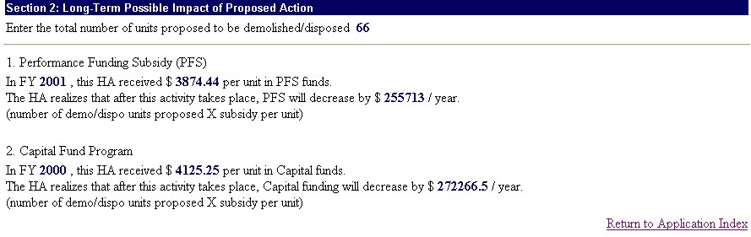
Figure 9-18: The Section 2 display

Modifying Section 2
If the application has not been submitted, HAs can edit the Section 2 information. Follow these steps:

Step | Action/Result
- Click the Modify Section 2 hyperlink. | A modifiable section of the application is displayed.
- Enter the total number of units proposed in the Units Proposed to be Demolished/Disposed text box (see Figure 9-19).
- Select the appropriate Fiscal Year from the Performance Funding Subsidy FY dialog box.
- Enter the amount received by the HA per unit in the Performance Funding Subsidy $ text box.
- Select the appropriate fiscal year from the Capital Fund Program FY dialog box.
- Enter the amount received by the HA per unit in the Capital Fund Program $ text box.

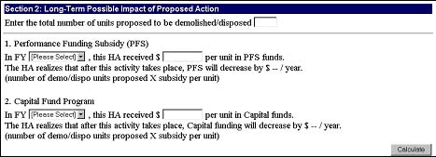
Figure 9-19: The Modify Section 2 page.

Step | Action/Result
- Click the Calculate button. | The decrease in Performance Funding Subsidy and Capital Funds per year will be automatically calculated and will appear next to the Performance Funding Subsidy $ and Capital Fund Program $ text boxes.
- Click the Save button to save the information or Cancel to undo the edits. | If you click Save, the application is modified. This is reflected in the “Status” column of the Application Index page.  If you click Cancel, the application is not changed and PIC returns to the Application Index page.

This information is included in the application to ensure that the HA is aware of the potential funding implications of the actions it is proposing.

After verifying the data in this section, click the Return to Application Index hyperlink to return to the Application Index page.

Section 3
Click the Section 3: Board Resolution, Environmental Review and Local Government Consultation hyperlink on the Application Index page to access the Section 3 data.

This section displays the following sections (see Figure 9-20):

- Board Resolution
- Environmental Review information
- List of jurisdictions covered by the PHA
- Local Government Consultation

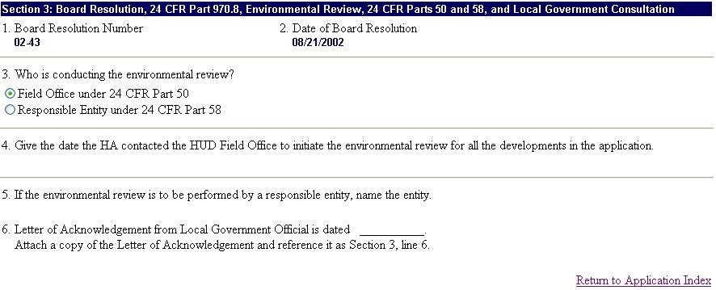

Figure 9-20: The Section 3 display.

Modifying Section 3 Information
If the application has not been submitted, HAs can edit the Section 3 information. Follow these steps to edit the data:

Step | Action/Result
- Click the Modify Section 3 hyperlink. | A modifiable section of the application is displayed.
- Enter the appropriate Board Resolution Number in the line item 1 text box.
- Click the Attach Document hyperlink to attach a copy of the Board Resolution. Reference it as Section 3, line 1. | This completes line item 1.
- Enter the Date of Board Resolution in the line item 2 text box. Use the MM/DD/YYYY format. | This completes line item 2.
- A. Click the appropriate option button in line item 3 to indicate who is conducting the environmental review. There are two choices:  - Responsible Entity 24 CFR 58  - HUD Field Office 24 CFR 50 | .  Note: The HA is prohibited from using responsible entities if they are applying for a HOPE VI-funded demolition.

Note: Refer to page 1 for more information on how to attach documents.

Step | Action/Result
- B. Enter the name of the responsible entity performing the environmental review in the line item 5 text box. (Only applicable if the Responsible Entity option button is selected in line item 3.) | This completes line item 3.
- Attach a narrative describing the PHA’s consultation with all Appropriate Government Officials (AGOs) and reference it as Section 3, line 4 | This completes line item 4.
- Enter the date of the local Appropriate Government Officials’ Letters of Support in the line item 6 text box. Use the MM/DD/YYYY format (see Error: Reference source not found).
- Click the Attach Document hyperlink to attach a copies of the letter(s). Reference it as Section 3, Line 5. | This completes line item 5.
- Click the Save button to save the information or the Cancel button to undo the edits. | If you click Save, the application is modified. This is reflected in the “Status” column of the Application Index page.  If you click Cancel, the application is not changed and PIC returns to the Application Index page.

After verifying the data in this section, click the Return to Application Index hyperlink to return to the Application Index page.

Section 4
Click a Development hyperlink under the Section 4 heading on the Application Index page to access Section 4 data (see Figure 9-).

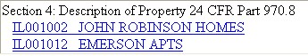
Figure 9-7: An example of the Development hyperlinks
under Section 4 of an Application Index page.

This page contains the following information:

- Description of Property
- Existing Unit Distribution
- Total Acres in the Development

The Description of Property data contains 11 line items (see Figure 9-). Only lines 10 for the total acres under the development number, and line 8 on the distribution of single family properties by the number of units can be modified directly in Section 4.
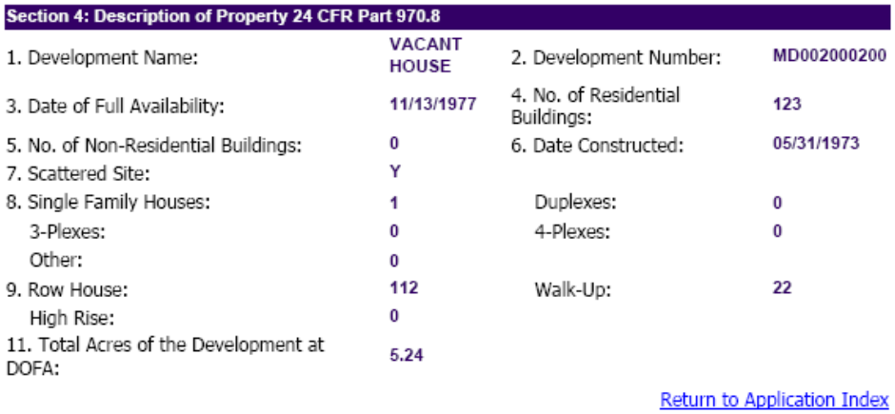
Figure 9-8: An example of the Section 4 Description of Property.

The Existing Unit Distribution data is displayed in a table (see Figure 9-9). The data is pulled from Development Sub-module in PIC.
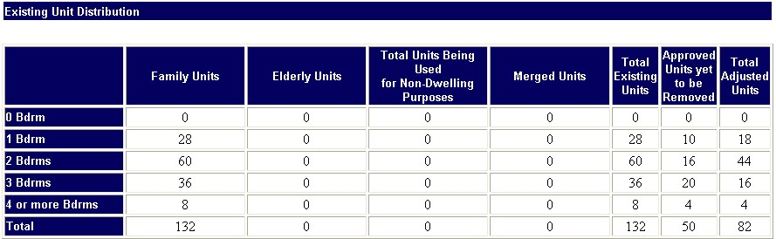
Figure 9-9: An example of the Existing Unit Distribution table in Section 4.

.

Modifying Section 4 Information
If the application has not been submitted, HAs can edit parts of Section 4. Follow these steps to edit the data:

Step | Action/Result
- Click the Modify Section 4 hyperlink. | A modifiable section of the application is displayed. It contains the pre-populated description of property information.
- Enter the correct information in the Single Family Houses, Duplexes, 3-Plexes, 4-Plexes, and Other text boxes. | This populates line item 8.
- Enter the correct information in the Total Acres of the Development text box. (This text box goes out 2 decimal places.) | This populates line item 10.
- Click the Save button to save the information or the Cancel button to undo the edits. | If you click Save, the application is modified. This is reflected in the “Status” column of the Application Index page.  If you click Cancel, the application is not changed and PIC returns to the Application Index page.

Note: The Inventory Removals Sub-module does not offer the functionality to edit the rest of the information in Section 4, including that presented in the Existing Unit Distribution table. The data is generated by interfacing with the Development Sub-module in PIC. Please contact your field office if a unit is not in the Development Sub-module.

After verifying the data in this section, click the Return to Application Index hyperlink to return to the Application Index page

Section 5
Click a Development hyperlink under the Section 5 heading on the Application Index page to access Section 5 data for the selected development.

This section includes 12 line items that describe the proposed project in detail.
This is the section where the building and unit numbers in PIC for what is being proposed are identified and saved to the application, changing their status in PIC.

Modifying Section 5
HAs can edit the Section 5 of applications that are in Draft status.
Note: Contact the SAC reviewer assigned for the application if changes are necessary after the application has been submitted.

Follow these steps to edit Section 5 data:

Step | Action/Result
- Click the Modify Section 5 hyperlink. | A modifiable section of the application is displayed.
- Enter the correct information in the dialog and text boxes provided.
- Click the Save button to save the information or the Cancel button to undo the edits. | If you click Save, the application is modified. This is reflected in the “Status” column of the Application Index page.  If you click Cancel, the application is not changed and PIC returns to the Application Index page.

The following pages of this Guide describe each line item, and how to edit them (if necessary).

Section 5: Line Item 1

Applications in which all of the units at a building entrance are being proposed for removal are handled differently from those in which a portion of the units are being proposed. In the latter circumstance, line item 2 is used to select the buildings and units, otherwise line item 1 can be used. Line item 1, Proposed Action By Building Type, and Line item 2, Proposed Action by Unit Designation are alternatives. A unit can be selected by means of one or the other, but not both.

Line item 1, Proposed Action By Building Type, lists the buildings, building entrances, and street address locations available for selection in the application under the development number link used to open Section 5. In some cases the available selections are at the level of the building entrance number, in other cases they may be at the level of the building number.

If selections are saved to the application under line 1 by building type, all of the units contained within the selected buildings/building entrances are thereby selected at the same time as well. If only a portion of the units under a building entrance/building number are being proposed in the application, the units should be selected instead under line item 2, Proposed Action By Unit Designation. Line 2 can also be used if a portion of the units within the same building/building entrance number are proposed for removal in different years, or a portion are proposed for demolition and another part for disposition within an application that is for both demolition and disposition.

Follow these steps if you are proposing action by building entrances:

Step | Action/Result
- Click the Modify Section 5 hyperlink. | A modifiable section of the application is displayed.
- Select the appropriate available building entrance from the Available Buildings dialog box on the left. | Note: Use the Ctrl key to select more than one at the same time.
- Click the Greater than Arrow (>) button (see Figure 9-) for the intended action. | The selected available building will be moved to the Proposed Buildings dialog box on the right.

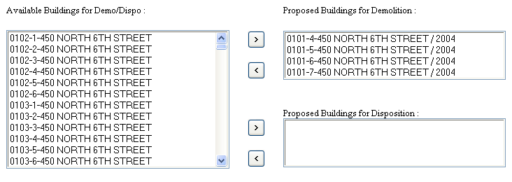
Figure 9-10: The Available Buildings and the Proposed Buildings dialog boxes
on the Modify Section 5 page.

Step | Action/Result
 | Note: Non-Dwelling buildings with building numbers in PIC, but with zero units, can be selected at this point in the application. They are flagged with a # sign after the building number.
- Enter the calendar year in which the proposed building entrance(s) being saved to the application will be demolished and/or disposed in the Calendar Year text box (see Figure 9-). Hit the Save button at the bottom. | Saving too many building and units at the same time may overtax the PIC system. If that occurs, break them up into smaller groups to save together. Saving less than 100 units at once usually does not cause a volume problem.

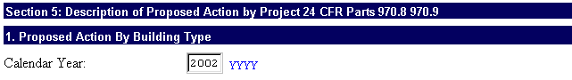
Figure 9-11: The Calendar Year text box on the Modify Section 5 page.

Section 5: Line Item 2
Line item 2, Proposed Action By Unit Type, may be used to make selections by unit. If all of the units at a building entrance are moved to the Proposed Action by Unit Type dialog box under line 2, the effect is the same as selection of the building entrance in line 1, by building type. Line 2, by Unit Designation, should be used instead in cases where some of the units at a building entrance are being proposed and some at the same building entrance are not being proposed in the application. .
There is a drop-down menu of building entrances (or in some cases buildings) under line 2, by Unit Designation. Selecting the building entrance from this menu will display the unit numbers it contains.

Follow these steps to propose action by unit designation:

Step | Action/Result
- Select the appropriate building and entrance number from the Building Number(s) dialog box drop-down list. (see Figure 9-).  Note: If a building is proposed in another Inventory Removals application or removed from inventory, it will not appear in the drop-down menu. If the building/entrance is proposed under line 1, by Building Type, in the same application, it will appear in the drop-down menu with an “@” sign. If some of the units at the building entrance are selected in the application there will be an “*” sign next to it on the drop-down menu. | The unit numbers in this building entrance are displayed in the Available Units box on the left. See figure below.
- Select the appropriate available unit in the Available Units dialog box. | Note: Use the Ctrl key to move multiple units at once from the Available Units dialog box to the Proposed Units dialog box.
- Click the Greater than Arrow button (>). | The selected available unit will be moved to the Proposed Units dialog box.
- Enter the calendar year in which the proposed unit number(s) being saved to the application will be demolished and/or disposed in the Calendar Year text box (see Figure 9-). Hit the Save button at the bottom of Section 5. | Note: When selecting units under Line item 2, By Unit Designation, it is necessary to save the units for one building entrance (or building) number, before selecting another building entrance from the drop-down menu in order to list its available unit numbers. Otherwise, selections under the previous building entrance will be cancelled.
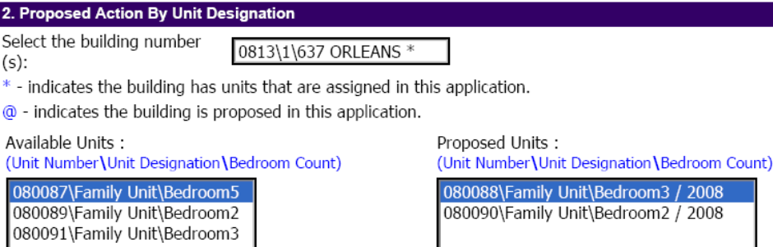
Figure 9-12: Line item 2 on the Modify Section 5 page.

Section 5: Line Items 3
Section 5, Line 3, Proposed Action for Non Residential Inventory, is where the number of acres of land proposed for sale or lease is entered into the application, and the number of any non-residential buildings that do not have building numbers in PIC are proposed.
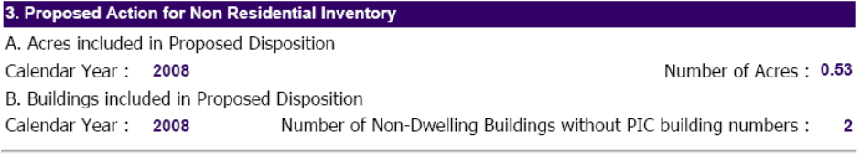
Figure 9-13: Line item 3, Non-Residential, on the Modify Section 5 page
Follow these steps to fill out line items 3 of Section 5:

Step | Action/Result
- Enter the calendar year when the proposed action for non-residential inventory will take place in the Acres included in the Proposed Disposition CY text box.
- Enter the number of proposed acres in the Number of Acres text box. The number of acres proposed in Section 5 must be equal to or less than the total acres in the development entered into Section 4, line 10. If they are not, it is necessary first to correct Section 4, line 10. | This completes line item 3 A.  Note: The HUD data systems track this in acres. The system recognizes up to two decimal places (4.56).
- Enter the calendar year when the proposed action for non-residential inventory will take place in the Buildings included in the proposed disposition Calendar Year text box. | Note: Non-residential buildings with PIC building numbers should be selected under Line 1, Proposed Action by Building Type. Non-dwelling buildings shouldn’t be counted both in  Lines 1 and 3.
- Enter the number of buildings in the Number of Non-Residential Buildings Without PIC Building Numbers in the text box. This should only count the number of non-residential buildings that do not have building numbers in PIC. Those with building numbers should instead be selected under Line 1 above. | This completes line item 3 B.

Section 5, Lines 5 and 6, Site Map, Partial Removal of a Development
- Click the Attach Document hyperlink to include a site map as an attachment, if the proposed action is a partial removal of a development. | Note: A site map is critical in examining partial Inventory Removals requests. Please mark clearly the units and buildings proposed for demolition or disposition on the site map.  A copy of a site map for each development must be attached to the application.
- Click the Attach Document hyperlink to upload an attachment containing a description of the property and a narrative explaining why the PHA is proposing to remove the particular units and buildings, in the case of proposed partial removal. For example, in the case of demolition of a section of the development, clearly explain why the HA is proposing to demolish this section over another, and why the section that will remain in inventory will then be viable. Reference the attachment as Section 5, line 6. | After a partial demolition application is approved by the SAC, the HA cannot change units in the approval without HUD’s approval.  If the PHA is proposing disposition of vacant land at the development, attach the legal description of each parcel of vacant land.

After all building/acre selections are made, hit the “Submission” subtab on the Application tab to see if what has been saved to the application corresponds to what the PHA proposes to do.

Section 5: Line Items 7, 8, and 9
Follow these steps to fill out line items 7 and 8 of Section 5:

Step | Action/Result
- For dispositions, mark the check boxes to indicate which method of sale is proposed: A. At Fair Market Value, B. At less than Fair Market Value, or C. Exchange of Property. | If B or C is checked, attach a narrative providing a justification which evidences commensurate public benefits, and reference it as Section 5, line 7.
- In disposition applications, use the text box provided to enter the appraised value. | Attach documentation verifying the value, such as summary of an appraisal, and reference it as Section 5, line 8.
- If an appraiser was used to determine the value of the property, provide the name of the appraiser and the date of the appraisal. | This completes Section 5, line 9.

Where HUD approves the disposition of real property of a project, in whole or in part, the PHA shall dispose of it promptly by public solicitation of bids for not less than fair market value, unless HUD authorizes negotiated sale for reasons found to be in the best interests of the PHA or the Federal Government, or sale for less than fair market value (where permitted by State law), based on commensurate public benefits to the community, the PHA or the Federal Government justifying such an exception. Reasonable costs of disposition, and of relocation of displaced tenants allowable under §970.9, may be paid by the PHA out of the gross proceeds, as approved by HUD.

Section 5: Line Items 10 and 11
Follow these steps to complete line items 10 and 11 of Section 5.

Step | Action/Result
- Enter the Estimated Sales Price, Debt, and Cost & Fees in the respective text boxes (see Figure 9-21).  The Center will update the debt amount at the time of application review. | The Estimated Net Proceeds text box will populate automatically.  This completes line item 10.  Refer to 24 CFR Part 970.19 for more information. Determination of net proceeds for scattered sites are calculated differently.
- Attach an itemization of costs and fees for relocation to be paid out of gross proceeds and reference it as Section 5, Line 10
- Attach a narrative providing details concerning the use of Net Proceeds and reference it as Section 5, line 11. | The use of proceeds must be approved by HUD. The activities proposed should generally relate to housing services and should be approvable under the Comprehensive Improvement Assistance Program (CIAP) or the Capital Fund program.

Note: The HA’s first priority is to retire outstanding debt with the proceeds of sale unless waived by the Department. If an HA has bonded debt that cannot be forgiven, proceeds must be used to make payment on the remaining debt. If the HA has proceeds after payment of debt, its second priority is to ensure that those proceeds are used for the provision of housing assistance to low-income families, e.g., the modernization of another development or building low-income housing.

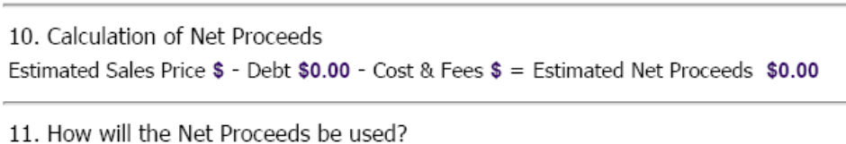
Figure 9-215: Line items 10 and 11 of the Modify Section 5 page.
Section 5: Line Items 12 and 13
Line items 12 and 13 apply to Demolition applications. (see Figure 9-16)

Follow these steps to complete line items 12 and 13 of Section 5:

Step | Action/Result
- Enter the estimated cost of demolition in the (a) $ text box.

- Enter the source of funds that will pay for the demolition in the (b) Indicate source of funds text box.  Identify the source(s) of funding for the demolition with the fiscal year (e.g., Operating Funds, CFP, CDBG, Other.) | If another source of funds will be used, attach a narrative explaining how the PHA will fund the demolition and reference as Section 5, Line 12.
- Enter the year funds are available in the Year text box. | This completes line item 12.
- In Section 5, Line 13, provide a timetable based on the number of days after approval of the application that the following major actions will occur:  - Begin relocation of residents  - Complete relocation of residents  - Execution of contract for removal action (e.g. sales contract or demolition contract).  - Actual removal action (e.g. demolition or sale closing) | The number of days after the approval date entered into Box A is the “Relocation Date” referred to in 24 CFR 990.190 of the Operating Fund rule, so it is important that HAs exercise care in determining this estimate.

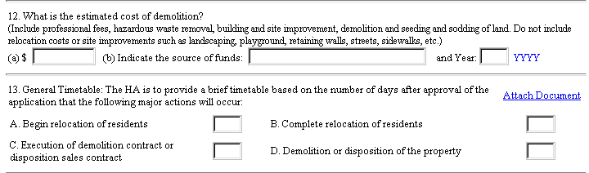
Figure 9-16: Line items 12 and 13 of the Modify Section 5 page.

Section 6
In the revised form 52860, Section 6 on Justifications has been replaced by an addendum attachment covering Total Development Costs, and by Exhibit A of the certification attachment required under Section 9 for Section 18 actions.
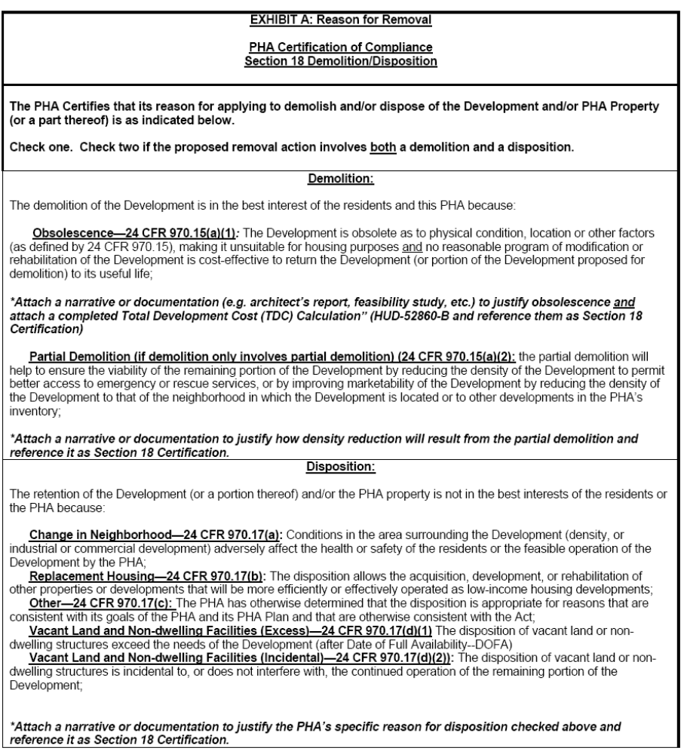
Figure 9-17: Exhibit A to Section 18 Certification
For all Demolition actions and for all Disposition actions where the justification is obsolescence, the following additional form must be attached to the electronic submission of form 52860:
HUD-52860-B: Total Development Cost (TDC) Calculation.

For some applications types other than Section 18 demolition or disposition, the following additional forms must be attached to the submission of form 52860:
HUD-52860-C Homeownership
HUD-52860-D Required Conversion
HUD-52860-E Voluntary Conversion
HUD-52860-F Eminent Domain
These forms can be found on the Special Applications Center website at the following address: http://www.hud.gov/offices/pih/centers/sac/exp52860.cfm

Section 7
Click a Development number hyperlink under the Section heading on the Application Index page to access Section number data. Section 7 on Relocation in PIC has been renumbered Section 6 on the revised 52860 Form.

Based on the data on proposed units from Section 5, and the data on existing units pulled into Section 4 from the development sub-module, the system will display the number of units which are proposed for removal that are occupied when the application is submitted. It will also display the number of units that are occupied out of the total remaining units in the development after the proposed removal.

A narrative should be attached to the application explaining the circumstances that resulted in the units becoming vacant before the application submission, and describing the relocation of the residents, and reference it as Section 6,
line 1(a).

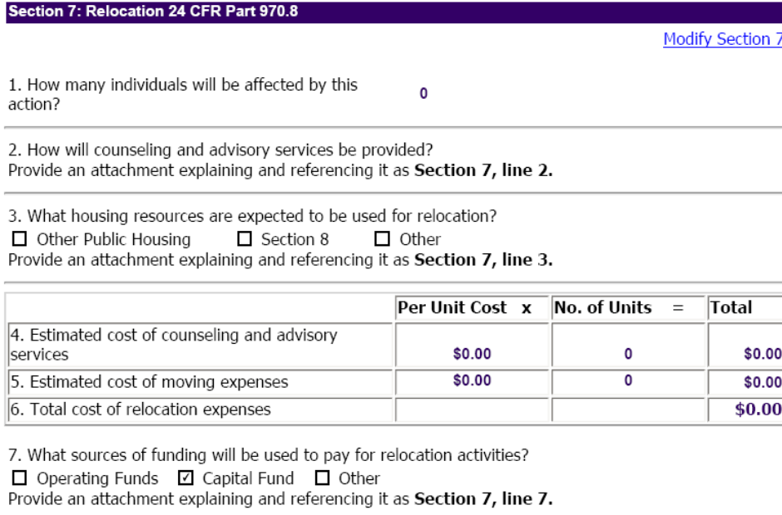

Figure 9-18: An example of the PIC Relocation Section display.

Modifying Section 7 Information
If the application has not been submitted, HAs can edit the Section 7 information. Follow these steps:

Step | Action/Result
- Click the Modify Section 7 hyperlink. | A modifiable section of the application is displayed.
- Enter the number of individuals affected (including children) by the inventory removal in the text box.
Provide an attachment explaining how counseling and advisory services will be provided. Reference it as Section 6, line 3.
- Click the appropriate Housing Resource check box to specify what housing resources are expected to be used for relocation (see Error: Reference source not found).
- Provide an attachment explaining the housing resources expected to be used for relocation. | The narrative to be attached explaining how the PHA plans to provide relocation housing should be referenced as Section 6, line 4.
- Enter the estimated cost of counseling and advisory services in the line 5 Per Unit Cost text box. Also, enter the total number of units this cost will be applied to in the No. of Units text box. | PIC automatically displays an amount in the Total text box.
- Enter the estimated cost of moving expenses in the line 6 Per Unit Cost $ text box. Also, enter the number of units this cost will be applied to in the No. of Units text box. | PIC automatically displays an amount in the line 5 and line 6 Total text boxes.
Step | Action/Result
- Click the appropriate Source of Funding check box to identify what sources of funding will be used to pay for relocation activities.
- If funding for relocation expenses will come from sources other than Operating Funds and the CFP, attach a narrative explaining how they will be funded, referenced as Section 6, line 8.
- Click the Save button to save the information or the Cancel button to undo the edits. | If you click Save, the application is modified. This is reflected in the “Status” column of the Application Index page.  If you click Cancel, the application is not changed and PIC returns to the Application Index page.
After verifying the data in this section, click the Return to Application Index hyperlink to return to the Application Index page.

Section 8
Click a Development hyperlink under the Section heading on the Application Index page to access the data on Resident Consultation. This has been under Section 8 in PIC, but has been moved to Section 7 of the 2008 52860 form.

Modifying Resident Consultation Information in Section 8
If the application has not been submitted, HAs can edit this Section by following these steps:

Step | Action/Result
- Click the Modify Section 8 hyperlink. | A modifiable section of the application is displayed.
- Provide an attachment describing the consultation process with residents of the affected development and reference it as Section 7, line 1. | This completes line item 1. The remaining parts of the Section on Resident Consultation (lines 2-5) apply only to demolition and/or disposition removals (i.e., under Section 18 of the Act).
- Provide the name of the Resident Council representing residents of the affected development. If there is no Resident Council at this development, indicate this by clicking the appropriate option button. | This is required if the application type selected was Demolition, Disposition, or Demolition/Disposition.
- Attach a document with a narrative explaining consultation with the resident organization(s) at the development and reference it as Section 7, line 2. | This completes line item 2.
- Provide the name of the Resident Council representing residents of the developments under the PHA’s jurisdiction. If there is no PHA-wide Resident Council, indicate this by clicking the appropriate option button.
- Attach a document with a narrative explaining the consultation with the HA-wide resident organization(s) and reference it as Section 7, line 3. | This completes line item 3.
- Attach a narrative about the PHA’s consultation with the Resident Advisory Board (RAB) (as defined by 24 CFR 903.13). Reference the attachment as Section 7, line 4. | This completes line item 4.
- Click the appropriate option button to specify whether or not there were any written comments received from the residents or Resident Council of the affected development, the HA jurisdiction-wide Resident Council, or the RAB.
- Attach copies of those written comments received along with any evaluation by the HA of the comments. Reference the attachment as Section 7, line 5. | This completes line item 5.
- Click the Save button to save the information or the Cancel button to undo the edits. | If you click Save, the application is modified. This is reflected in the “Status” column of the Application Index page.  If you click Cancel, the application is not changed and PIC returns to the Application Index page.

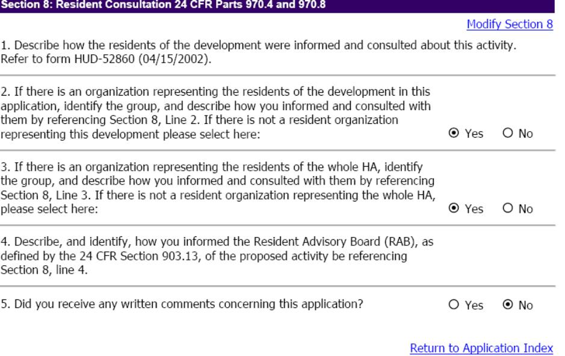
Figure 9--19: The Resident Consultation Section page.

After verifying the data in this section, click the Return to Application Index hyperlink to return to the Application Index page.

Section 9
Click a Development hyperlink under the Section heading on the Application Index page to access the data on Offer of Sale. This has been under Section 9 in PIC, but has been moved to Section 8 of the 2008 52860 form.

This section must be completed for all Section 18 Dispositions, including dispositions in connection with Voluntary or Required Conversion that are subject to Section 18 requirements. For other application types, it can be skipped.

Modifying Section 9 Information
If the application has not been submitted, HAs can edit the Section 9 data.

Follow these steps:

Step | Action/Result
- Click the Modify Section 9 hyperlink. | A modifiable section of the application is displayed (see Figure 9-20).
- Click the appropriate option button to specify whether or not the HA is exercising any of the exceptions to the offer of sale requirements permitted by 24 CFR 970.9(b)(3).
- If so, select the option button for the exception under 24 CFR 970.9(b)(3): (i)local/state government acquisition of less than 2 acres of land (ii)property to be used for other housing or facilities benefiting low-income families (iii)units were legally vacated in accord with HOPE VI, 24 CFR 971, or Required Conversion under 24 CFR 972. (iv)units are distressed units converted to tenant-based assistance under Section 33 of the Act (v)disposition of non-dwelling buildings and facilities
- Attach Documentation supporting the selected exception and reference it as Section 8, line 2 | If the last three exceptions have not yet been added to PIC, indicate their selection in the attachment instead.

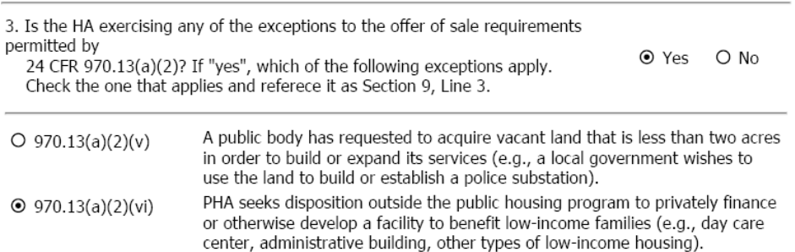

Figure 9-20: The Offer of Sale Section page.

Step | Action/Result
- If the PHA is not exercising an exception to the offer of sale requirement, click the option button to indicate if any of the following Established Eligible Organizations exist, and if so provide their names: 1)Resident Council at the development 2)Resident Management Corporation 3)Outside Organization acting on behalf of the development residents, where the PHA has received notification of its partnership with the Resident Council. | Note: Until these options are added to PIC applications, include this information in the attachment for Section 8, line 3.
- Attach a narrative explaining how the PHA determined that the above named organizations are all of the Established Eligible Organizations representing the residents at the development, and reference it as Section 8 line 3,
- Enter the date (mm/dd/yy) the PHA sent an initial written notification of the sale of the affected development to each Established Eligible Organization. Click the option indicating whether the notification was sent by regular mail or certified mail. | Note: Until this is added to the PIC application form, include this information with the attachments to Section 8, line 4
- Attach a copy of each signed and dated initial written notification letter provided to Established Eligible Organizations and reference them as Section 8, line 4.
- Did the PHA receive a written initial expression of interest (24 CFR 970.11(b)) from notified Eligible Established Organization(s) within 30 days after it sent the notification of sale. Click the option for Yes or No. | Note: Until this option is added to the PIC application form, include the information as an attachment to Section 8, line 5.
- Attach a copy of each initial expression of interest that the PHA received and reference it as Section 8, line 5
- Did the PHA receive a proposal to purchase from an Eligible Established Organization within 60 days of when it provided it with all necessary terms and information? Click the option for Yes or No. | Note: Until this option is added to the PIC application form, include the information as an attachment to Section 8, line 6.
- If Yes, attach a copy of the proposals to purchase and reference them as Section 8, line 6.
- Click the option button to indicate whether the PHA 1)Rejected or 2)Accepted a proposal to purchase the affected development.
- Click the Save button to save the information or the Cancel button to undo the edits. | If you click Save, the application is modified. This is reflected in the “Status” column of the Application Index page.  If you click Cancel, the application is not changed and PIC returns to the Application Index page.

After verifying the data in this section, click the Return to Application Index hyperlink to return to the Application Index page.

New Section 9
[to be added to PIC]
A new Section 9 will be created in PIC to provide a place for attaching the certifications needed, depending upon the application type selected when an application is created.

These certifications are available for downloading as Word documents at the following location on the Special Applications Center website:
http://www.hud.gov/offices/pih/centers/sac/phacrtcmp.cfm
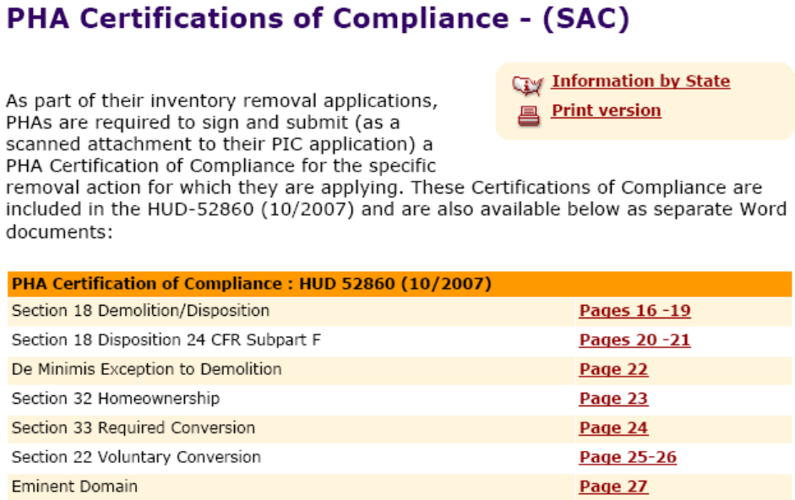

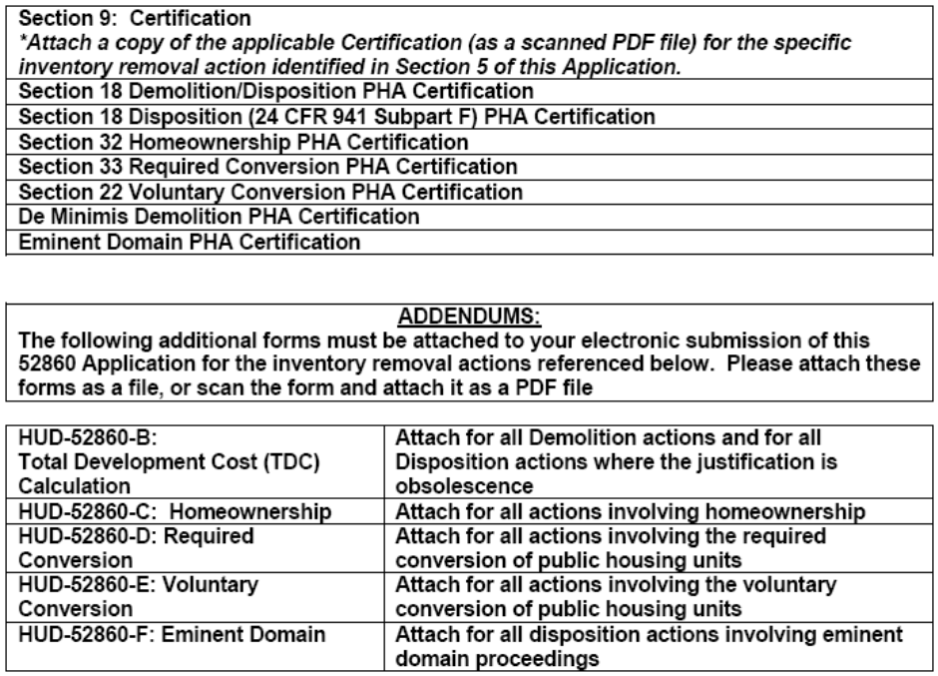

Figures 9-21: Certifications and Addendums
You can access the Supporting Documents page by click an Attach Document hyperlink in one of the pages within the Application section.

This page enables you to upload files to attach to an application. You can attach only the following files:

- Bitmap

The Supporting Documents Page

- Text
- Rich Text
- Microsoft® Excel
- Microsoft® Word
- Microsoft® Project
- Microsoft® PowerPoint
- Adobe Acrobat Reader .pdf files

The expectations is that most attachments will be scanned into .pdf extension files before attachment to the application.

The Supporting Documents page is available on the Application tab
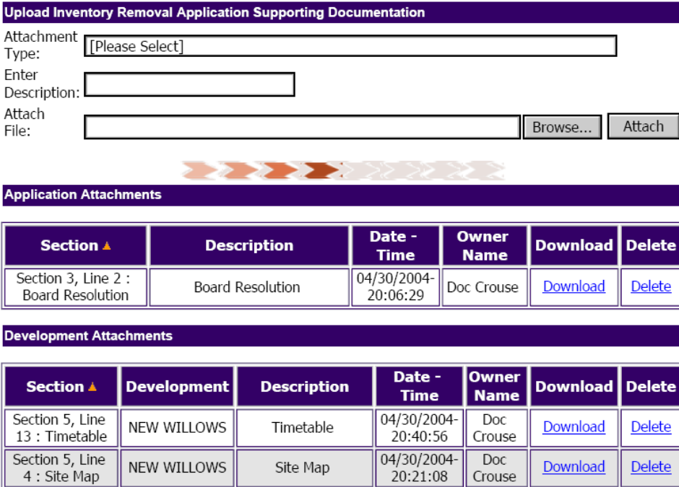
Figure 10-1: Supporting Documents Page
Follow these steps to upload an attachment:
Step | Action/Result
- Click a specific Attach Document hyperlink within an Application Section or go directly to Supporting Documents page.. | If an Attach Document link is used with an application Section, PIC automatically displays the corresponding attachment type on the Supporting Documents page
- Select the appropriate type from the Attachment Type drop-down menu dialog box. | If the Attach Document link is clicked within Section 5 for the Site Map, the Supporting Documents page opens up with Section 5, Line 4 Site Map as the Attachment Type. [Under the revised HUD-52860, the Site Map is Section 5, line 5.]
- Select the appropriate development from the Select Development drop-down menu dialog box, which lists the development numbers saved to the application.
- Enter a description for the attachment in the Enter Description text box. Note: The description cannot be more than 255 characters long.
- Click the Browse button. | The “Files” window appears.
- Select the appropriate file and click the Open button.  Note: A filename usually cannot be more than 50 characters. The 50-character limit currently applies to not just the filename but the whole path to the file including subfolders (e.g., “C:\folder1\folder1A\filename”. | If a file fails to attach to the application, try shortening and simplifying the filename, such as by replacing any spaces in the filename by the underscore “_” or another character.
- Click the Attach button. | The File Upload window is displayed and the selected file is attached to the application.

The Attachment Type menu includes
1)attachments identified by line number and name
2)attachments identified by name (e.g. approval letter)
3)a “Miscellaneous” attachment type and
4)20 additional generic categories identified as “attachment hook 1”, etc.

Some attachments, like the Board Resolution, are on the application level, others in Sections 5-9, like the appraisal summary, are attached on the development number level.

The HUD Staff can download and view and print the attachments to the application.
Click the Submission subtab to access the Submission page.

This page enables you to view summary information for each of the developments included in an application. It also is the place where a PHA is able to submit an application to the SAC.

The Application Submission Page

This page has presented conditions for which a PHA certification needs to be sent to the SAC, when an application is submitted. Under the new HUD-52860 form in effect, the required certifications are to be submitted as attachments under what will be a new Section 9. The certifications presented on the application Submission page will be removed from PIC. The certifications required now differ according to the application type.
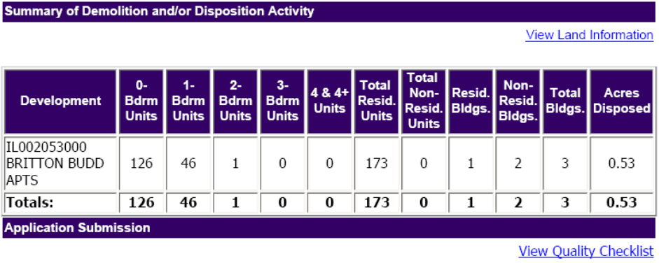
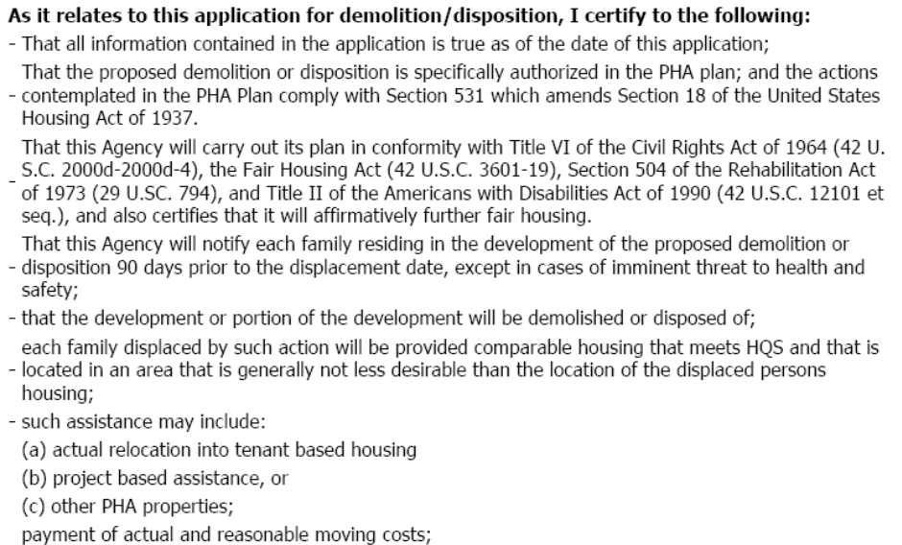
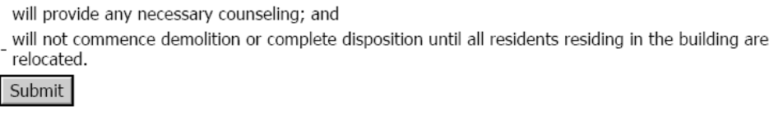
Figure 11-22: The Summary of Demolition and/or Disposition Activity information
on the Submission page.

Follow these steps to submit an application in Draft status:

Step | Action/Result
- Access the Application Submission page by clicking on the word Submission on the blue bar towards the top of the screen.. | PIC displays a summary of Inventory Removals information.
- Review the Summary of Demolition and/or Disposition Activity information | This provides a check that the number of dwelling and non-dwelling buildings and units, and the number of acres saved to the application is correct and complete.
- Click the View Quality Checklist hyperlink to see what information is missing. | PIC displays the Quality Checklist page. If items appear in the list, they represent instances where the application may potentially be incomplete. Not all items listed are mandatory.  See page Error: Reference source not found for more information.

Step | Action/Result
- Return to the application Submission page and click the Submit button pictured above. | The application is submitted for SAC approval. Its status is changed from “Draft” to “Submitted” on the Application List page (see Figure 11-23).  Note: Upon the submission of an application, HAs will not be able to modify the application. Only the SAC processor has edit access for submitted applications. SAC staff have the capability to return applications to PHAs in Draft status, so that they can make further changes to them at the PHA.
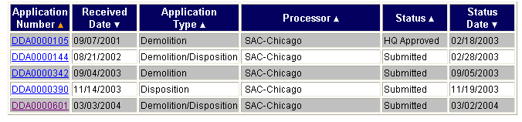
Figure 11-23: The Application List page. Note that the status reads
“submitted” for several applications.
Whenever possible, certifications should be scanned into an electronic format, such as Adobe .pdf extension files, and attached to the application. If it is necessary to send further materials after an application has been submitted, they should be sent as attachments via e-mail to the SAC reviewer. SAC staff e-mail addresses are available on the SAC website at the following address: http://www.hud.gov/offices/pih/centers/sac/about/staff.cfm

Where it is infeasible to scan documents, they may be sent via
FAX to (312) 886-6413.

If it is necessary to send materials by mail, the SAC address is:

Special Applications Center
US Department of Housing and Urban Development
77 West Jackson Boulevard, Room 2401
Chicago, IL 60604-3507

The name of the SAC reviewer assigned to an application is available on the SAC website through the link to the Assignment Planning System, and in Section 1 within PIC applications, as explained above on page 9-1.

For all supplemental information provided separately, send it to the attention of the reviewer assigned to the application and note the application number (e.g. DDA0000601 shown in Figure 12-2)

The Quality Checklist Page
Click the View Quality Checklist hyperlink on the Submission page to access the Quality Checklist page (see Figure 11-24).

Figure 11-24: The View Quality Checklist hyperlink on the Submission page.

This page displays a list of all the missing fields for the required sections based on the application type of the selected application.

Follow these steps to use the Quality Checklist:

Step | Action/Result
- Access the Quality Checklist page. | PIC displays the Quality Checklist for the first development listed in the application.
- Select the appropriate Development Number from the Development Number dialog box. | PIC displays a list of Line Item hyperlinks to the possibly incomplete line items for the selected development’s application.
- Click a specific Line Item hyperlink in the table (see Figure 11-25). | PIC displays the incomplete line item.
- Complete the suggested section. | When you return to the checklist, the hyperlink to the line item will no longer appear.

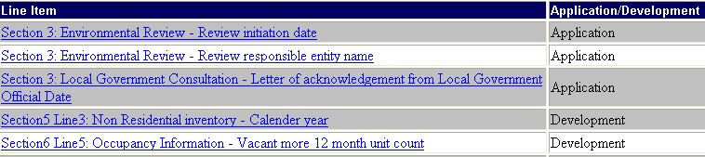
Figure 11-25: An example of the Line Item hyperlinks presented
on the Quality Checklist page.

Through the Removal from Inventory process, the status of buildings and units in PIC is changed to Removed from Inventory, and the date of removal from the public housing inventory is recorded.

The Remove from Inventory Function Tab

The Remove from Inventory tab
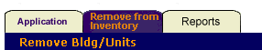
Figure 12-26: The Remove from Inventory tab.

The Remove from Inventory Tab (see Figure 12-26) in the Inventory Removals Sub-module is where the entire process is performed. The tab contains the following pages (see Figure 12-27):

- The Task List page
- The Unit Transaction page
- The Add Transaction hyperlink
- The Submission page: For HA use.
- The Review page: For HA executive director use.
- The Approval page: For field office use only.

Figure 12-27: The subtabs available under the Remove from Inventory tab.

Note: Access to these pages, and the functions they contain, depends on your security access role. If you cannot access the pages in this tab, or use the features contained in them, contact your HA executive director.

Removal from Inventory Process Overview
After SAC approves an application, there is a submission and approval process used to remove units from the PIC inventory. This process involves the creation, submission, and approval of transactions.

PHA staff start the process by entering the dates on which approved units were removed from inventory. The status of this information is then displayed as “Draft.” There are two further levels of review in PIC at the PHA before the transaction is forwarded within PIC to the HUD Field Office.

The next level of review is under the word “Submission” on the blue bar on the unit transaction screen. This is where HA supervisory staff submit the information to the HA executive director, or the designated final reviewer at the PHA. The status becomes “Submitted for Review” (see page 10 for more information).

It is then the decision of the HA executive director or their designee under the word “Review” on the blue bar whether to reject the transaction or submit it to the field office for approval. If the HA executive director rejects the transaction, it receives a “Rejected” status. If approved, the transaction receives a “Submitted for Approval” status (see page 12) for more information).

The HUD Field Office may approve or reject the transaction. If the field office rejects the transaction, the status becomes “Rejected.” In this situation, the HA has the capability to modify the information in the transaction (see page 14 for more information). After a change has been made and saved, the status of the rejected transaction is reset to “Draft.”

If the Field Office approves the transaction, the status in PIC permanently becomes “Removed from Inventory. (RMI)”

The Development List (Task List) Page
Click the Remove from Inventory tab to access the Task List page.

This page presents every development with units, buildings, and/or land approved for removal. . It also presents the number of those approved in a development that have already been reported as Removed from Inventory, and those that are still waiting to undergo the Removal from Inventory process.

The Development List (see Figure 12-3) contains the following categories for each development included in a Inventory Removals application:

- Development Number: Entries in this column are hyperlinked. Click a hyperlink to see a list of transactions for the selected development.
- Development Name
- Total Approved Units: The total number of units approved in PIC applications for the development listed.
- Total Removed Units: The total number of units that completed the Removal from Inventory process, and are no longer visible in the Development Sub-module (except in Reports).
- Total Remaining Units: the remaining units that have been approved in an application process but have yet to undergo the Remove from Inventory process.
- There are also Total Approved, Total Removed, and Total Remaining columns for non-dwelling structures and acres of land.

Follow these steps to select a development to enter dates of removal from inventory, or to review RMI transactions:

Step | Action/Result
- Click the desired development number hyperlink. | PIC displays a list of all RMI transactions for the selected development in the Unit Transaction page.

Unit Transaction Page
The Unit Transaction page enables you to view all of the transactions for a development.

It also provides the Add Transaction hyperlink to users with the proper security access role. The Add Transaction page enables the PHA to remove particular units cited in an approved application from the PIC database of units “in inventory”, and change their status to Removed from Inventory (RMI). This is accomplished by the entry of the date buildings and units (and land) is demolished, sold, leased, or otherwise removed from the public housing inventory. The date of removal is called the “action date” in PIC. (see page 7 for more information).

Information Presented on the Unit Transaction Page
Transactions are divided into two separate groups:

- Proposed Transactions
- Actual Transactions

On the Unit Transaction page, the Unit Summary table (see Figure 12-28) contains both types. The proposed transactions are highlighted in gray. They represent an approved action that has not yet occurred.
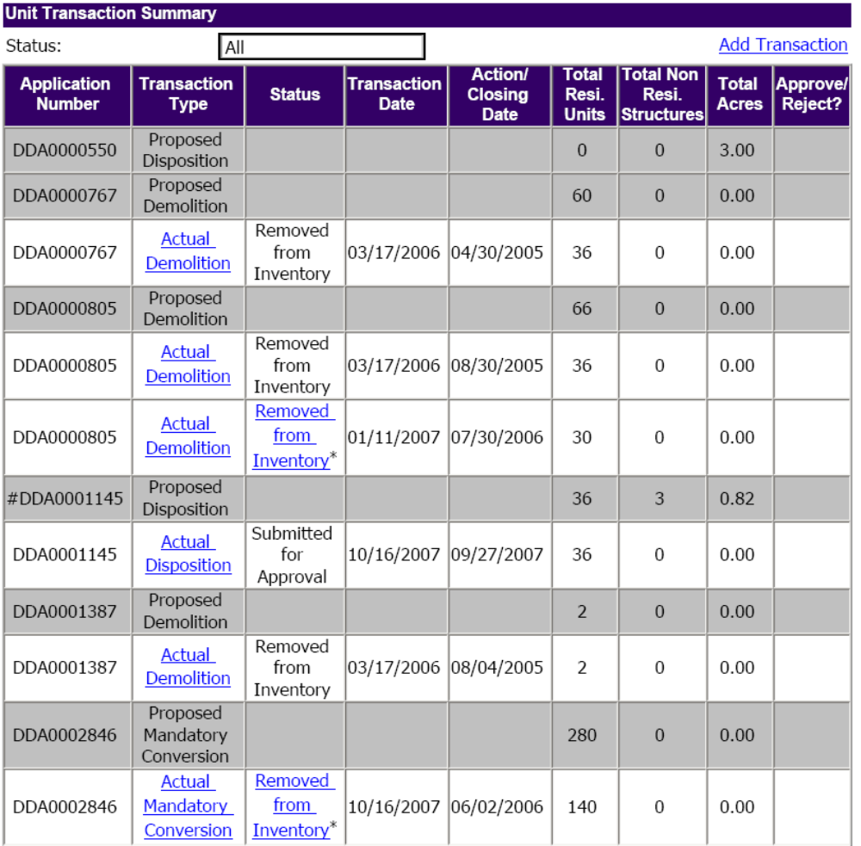
Figure 12-28: The transaction table on the Unit Transaction page.

Actual transactions are listed with white backgrounds. These types of transactions represent approved units after the dates of removal have been entered by the HA.

Each summary record presented on the Unit Transaction page will detail the different transactions associated with the approved application.

Note: You can review HA executive director or Field Office comments by clicking on the Rejected hyperlink (see Figure 12-29).

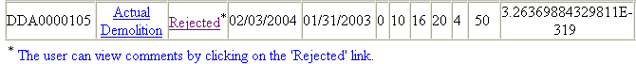
Figure 12-29: The transaction table containing a rejected transaction.
A Unit Transaction Summary table record includes the following information:

- Application Number
- Transaction Type
- Actual Transactions
- Proposed Transactions
- Status (Actual Transactions Only)
- Draft
- Submitted for Review
- Submitted for Approval
- Removed from Inventory
- Rejected
- Transaction Date that the PHA entered the Action Date (Actual Transactions Only)
- Action/Closing Date of removal from inventory (Actual Transactions Only)
- Total Resi Units: The total Number of Units approved and reported removed in the Applications.
- Total Non Resi Structures: approved and reported removed in the applications
- Total Acres: The total acres approved and removed in the applications.

If a record is an actual transaction, its entry in the Transaction Type column will be hyperlinked. Click the hyperlink to view existing transaction information for the selected record, or to modify transactions in Rejected status.
The Status filter can help you limit the records displayed in the Unit Transaction Summary table. Follow these steps to use the filter:

Step | Action/Result
- Click the Status dialog box. | PIC displays a list of options (see Figure 12-30).
- Select the desired status. | The page refreshes to display only the transactions in the selected status.  Note: The default display shows all statuses.

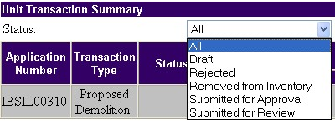
Figure 12-30: The Status filter options on the Unit Transaction page.

The Add Transaction Page
Click the Add Transaction hyperlink on the Unit Transaction page to access the Add Transaction page (see Figure 12-31).

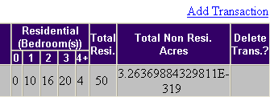
Figure 12-31: The Add Transaction hyperlink.

From this page, you can associate a proposed transaction to an actual transaction. By performing this action, the Development Sub-module can be updated to display the most current unit information.

Note: An actual transaction should only be created after the building has officially undergone the action specified in the application. For example, if a Demolition application has been approved, you will only create an actual transaction after the building has actually been demolished. For actual transactions, the database needs to be updated to accommodate this change in information.
If a unit that has been approved for disposition was instead demolished, or visa versa, it should not be removed from inventory under an application type that differs from what actually happened.

Please note that HUD considers a unit to be removed on:
The date a contract of sale was executed for a homeownership unit,
The date a deed contract of sale or lease was executed for a disposition,
The date the last payment was made to the demolition contractor or the final funds were expended if demolition was performed with Force Account, for demolition, DeMinimis or Mandatory/Voluntary Conversion,
The date the property is transferred to the taking agency in Eminent Domain.

These are the dates that should be used in the Action Date column.

As when the units are selected and saved to an application, when they are reported removed from inventory, sometimes it is done by Building and sometimes by Unit.

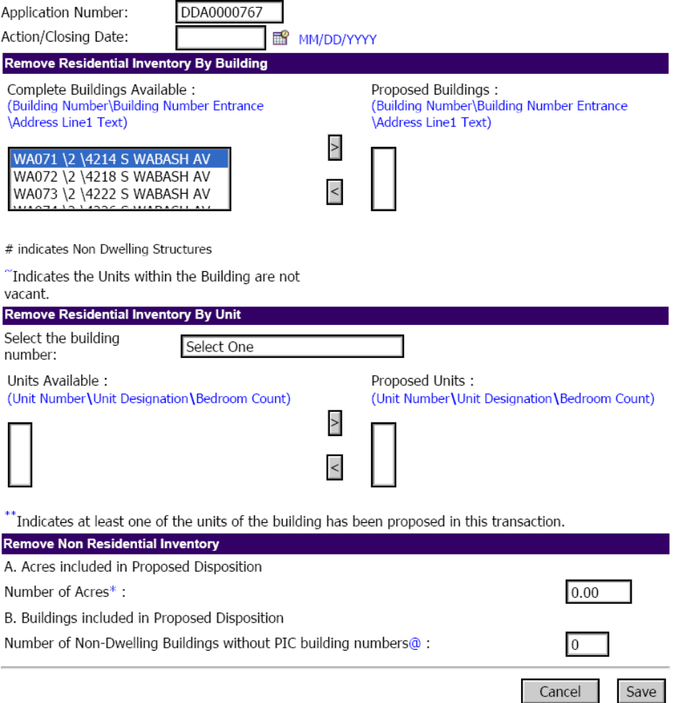
Figure 12-32: The Complete Buildings Available and
the Proposed Buildings dialog boxes.

Adding Building Transactions
Follow these steps to add a transaction for a building:

Step | Action/Result
- Access the Add Transaction page. Select the application number from the drop down menu (if the development was included in more than one application with units not yet Removed from Inventory in PIC). | A page with several dialog boxes and text boxes is displayed.
- Enter the action date signifying when the action has taken place in the Action/Closing Date text box.  Use the MM/DD/YYYY format. | Note: It is important to understand that the action indicated here should only be what was specified in the approved application number displayed on the screen.
- Select the desired building(s) in the Complete Buildings Available dialog box. The buildings listed are those approved in the application selected.  Note: Only vacant buildings can be removed from inventory.  The symbol ~ next to a building in the Available box indicates when a building or building entrance is not reflected as vacant in PIC. | Use the Ctrl key to move multiple buildings at the same time.  Non-residential buildings with building numbers in PIC should be selected here in the “Remove Residential Inventory by Building” section.
- Click the Greater Than Arrow button (>) to move the building(s) to the Proposed Buildings dialog box. | This populates the Propose Buildings dialog box with your selections. These buildings are then proposed as having been removed from inventory.
- Enter the actual acreage of land removed from inventory on the same date as units or on a separate date without units. Enter the number of non-dwelling buildings without building numbers removed on the action date.
- Click the Save button to save the information, or click Cancel to undo the entry. Note: If units were sold or demolished on more than one date, it is necessary to save separately the units removed on each of the action dates. The number of transactions added should not be less than the number of actual action dates. | If you click Save, PIC identifies the building(s) as “proposed for removed from the inventory.” The transaction is updated and posted to the Unit Transaction page.  If you click Cancel, PIC returns to the previous Unit Transaction page.

Adding Unit Transactions
Follow these steps to add a unit transaction:

Step | Action/Result
- Enter the action date signifying when the action has taken place in the Action/Closing Date text box.  Use the MM/DD/YYYY format. | Note: It is important to understand that the action indicated here should only be what was specified in the approved application number displayed on the screen.
- Select each desired building in the under the remove by unit section in the “Select One” drop-down menu (Figure 12-10), in order to display the approved units in the building in the Units Available box | Once the building or building entrance is selected, the units approved in the selected application for that building or entrance will be displayed in the Units Available box.
- Select the units removed on the particular action date from the Available box to the Proposed Units box. Only units vacant in PIC can be moved to Proposed Units box.
- Click the Greater Than Arrow button (>) to move the unit(s) to the Proposed Units dialog box. | This populates the Proposed Units dialog box with your selections.
- Enter the approved actual acreage amount that was removed on the action date, if any, using the text box provided.
- Click the Save button to save the information, or click Cancel to undo the entry. | The status of the units in PIC then changes from “DemoDispo-Approved” to “Proposed for Removed from Inventory”.The transaction is updated and posted to the Transaction Summary page.  If you click Cancel, PIC returns to the previous Transaction Summary page.

The Remove from Inventory Submission Page
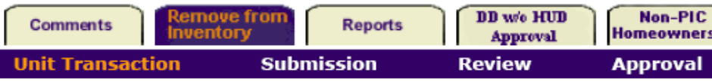
Figure 12-9: Remove from Inventory Subtab Bar
Click the Submission subtab bar under the Remove from Inventory tab to access the Submission page. The Submission page will display all transactions in Draft status, where an action date of removal has been saved.

From this page, HAs can submit transactions for final review at the HA.
Step | Action/Result
- Select the transaction(s) to submit by checking the Approve/Reject? check box(es) (see Figure 12-10).
- Click the Submit button to submit the transaction to the HA executive director. | After the transaction is submitted, the status of the transaction becomes “Submitted for Review” (see Figure 12-11) on the Unit Transaction page. The transaction becomes non-editable to the HA.

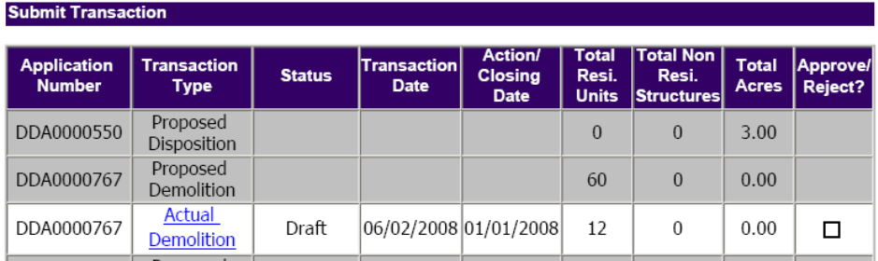
Figure 12-10: The SubmitTransaction check box

After the transaction is submitted, the status changes to Submitted for Review below.

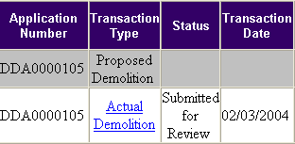
Figure 12-11: A transaction table entry noting that
the transaction is in the “Submitted for Review” status.

The Review Page
Click the Review subtab bar under the Remove from Inventory tab to access the Review page.

From this page, the HA executive director or their designee can submit a transaction to the Field Office or send the transaction back for editing by HA staff.

Follow these steps to submit a transaction for field office review:

Step | Action/Result
- Click the Accept/Reject dialog box for the desired transaction. | PIC displays two options (see Figure 12-13): Approve or Reject.
- Select the “Approve” option.
- Click the Submit button to submit the transaction to the filed office. | The transaction receives a status of “Submitted for Approval” on the Unit Transaction page. It becomes non-editable to the HA and the HA executive director. (unless rejected by the HUD field office)
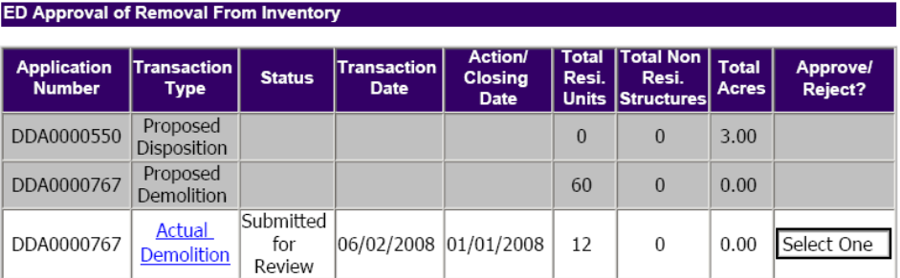
Figure 12-12: Review page

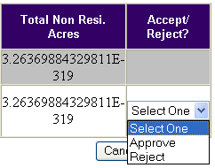
Figure 12-13: The Accept/Reject dialog box.

Follow these steps for HA Executive Directors to reject a submission and send the transaction back to the HA staff for editing:

Step | Action/Result
- Click the Accept/Reject dialog box for the desired transaction. | PIC displays two options: Approve or Reject.
- Select the “Reject” option.
- Click the Submit button. | The transaction receives “Rejected” status on the Unit Transaction page. The HA regains the ability to edit the transaction.  After the HA makes a change, the transaction regains “Draft” status.

The Approval Page
HUD field office staff click the Approval subtab under the Remove from Inventory tab to access the Approval page.

This page enables HUD Field Office personnel to approve or reject a transaction, and change the status of units to Removed from Inventory in PIC.

Step | Action/Result
- Click the Accept/Reject dialog box for the desired transaction. | PIC displays two options (see Figures 12-14): Approve or Reject.
- Select the “Approve” option.
- Click the Submit button to submit the transaction to the filed office. | The status of the buildings and units in PIC becomes Removed from Inventory and the transaction receives a status of “Removed from Inventory” on the Unit Transaction page. The units and buildings specified in the transaction are no longer visible in the Development Sub-module (except under Reports).
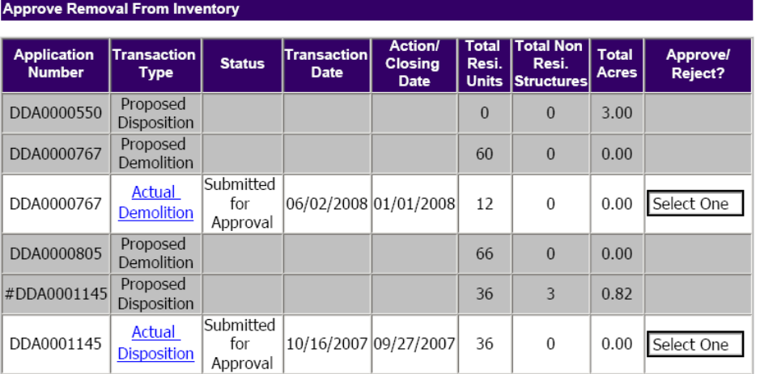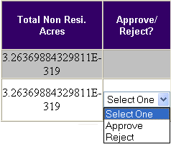
Figures 12-14: The Approval Page and Approve/Reject dialog box.
Follow these steps to reject a submission and send the transaction back to the HA for editing:

Step | Action/Result
- Click the Accept/Reject dialog box for the desired transaction. | PIC displays two options: Approve or Reject.
- Select the “Reject” option.
- Click the Submit button. | The transaction receives “Rejected” status on the Unit Transaction page. The HA regains the ability to edit the transaction.  After the HA makes a change, the transaction regains “Draft” status.

Click the Inventory Removals Reports tab to access the Reports page

The Inventory Removals Reports Tab
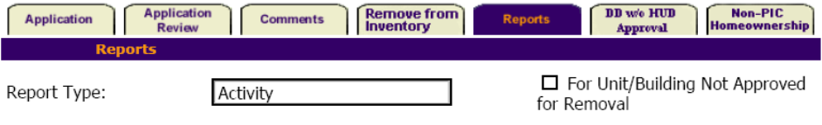
Figure 13-33: The Reports page.
This page enables you to create a report detailing the number of approved units for an Inventory Removals action and the number of actual units that have undergone the Inventory Removals action in a given fiscal year. There are two main types of reports, Activity reports and National reports. The Activity report is broken down by application number for each PHA.

Activity reports can be run for all application types, or for selected application types. The following report is for the Demolition and Demolition/Disposition.
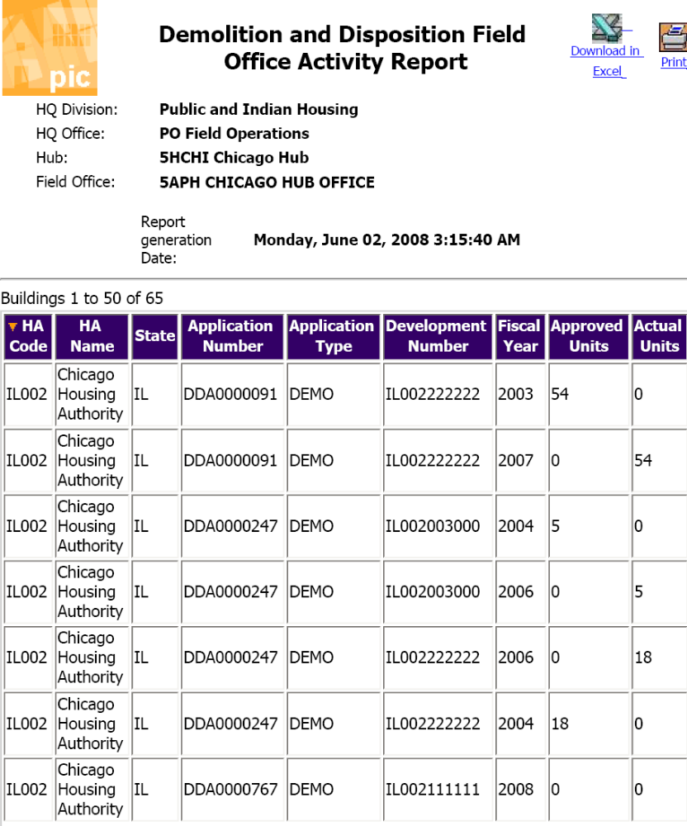
Figure 13-2: Activity Report example.
For each of the the PHA’s application numbers, the Activity Report shows how many units were approved, by fical year, and how many were removed, by fiscal year.
Note: Availability of the Reports page is determined by security access role. If you would like access to the page, contact your HA executive director.

Generating a Report
Follow these steps to generate a report:
Step | Action/Result
- Access the Reports page.
- Select “National” or “Activity” using the Report Type drop-down dialog box. | PIC displays two more dialog boxes: Application Type and Federal Fiscal Year.
- Select the type of application to display in the report using the Application Type dialog box (see Figure 13).
- The National Report offers the option using the Federal Fiscal Year dialog box to limit the report to one or more recent years. PIC offers the following choices:

- All (default): Every year there is data for the selected action.
- 2008
- 2007
- 2006
- 2005
- 2004
- Click the Generate Report button. | PIC opens a new window containing the report.
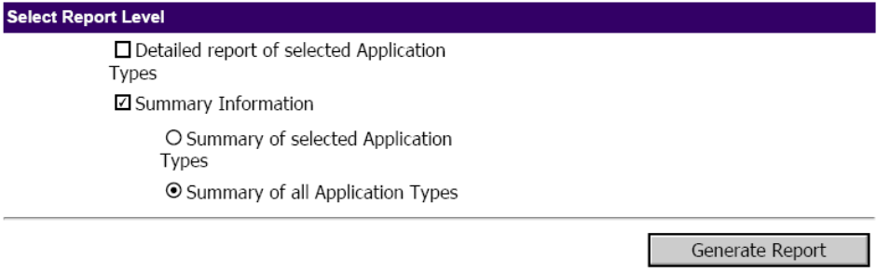Figure 13-3: Selection of Application Types and Level of Detail
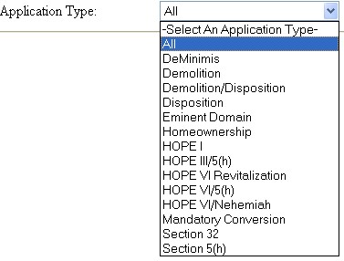
Figure 13-4: The Application Type dialog box options.

Information Presented in the Report
The National report consists of tables containing the following information (see Figure 13-5 for an example, where the application type selected was “All”):

The totals for each category are presented in the bottom row of the table.

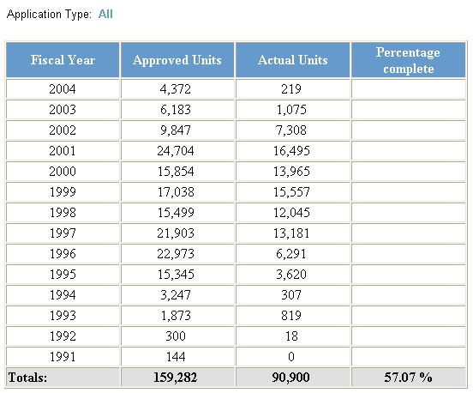
Figure 13-5: An example of a report.
In addition, the application type selected on the previous page is listed above the table.

Note: Unless you select to display a specific fiscal year, PIC displays data for all fiscal years pertaining to the selected application type. The years included in the report vary depending on the application type selected.

The report contains two options for further use of this data (see Figure 13-6). The following options are displayed as icons on the upper right side of the report:

- Download in Excel: The report downloads into an Excel spreadsheet for further data manipulation.
- Print Page: The report prints as a Web page.
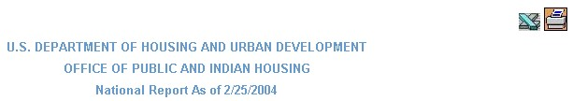
Figure 13-6: The options available for further use of a report.

The Development Sub-module Reports Tab

The Building Reports and Unit Reports under the Development Sub-module display the demolition/disposition status of units as indicated in the drop-down menu pictured below, with a sequence of 8 statuses:
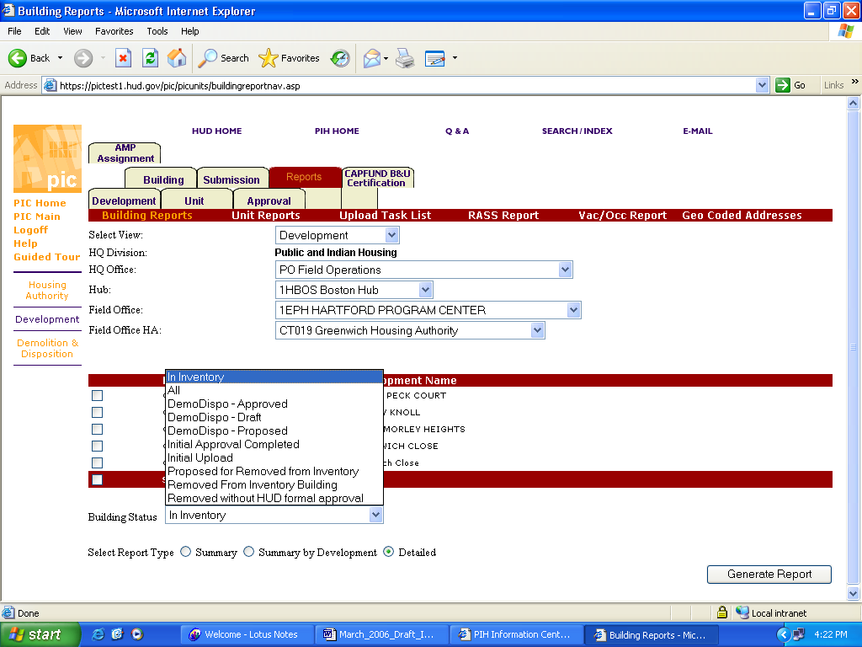
The following is an excerpt from a sample report.
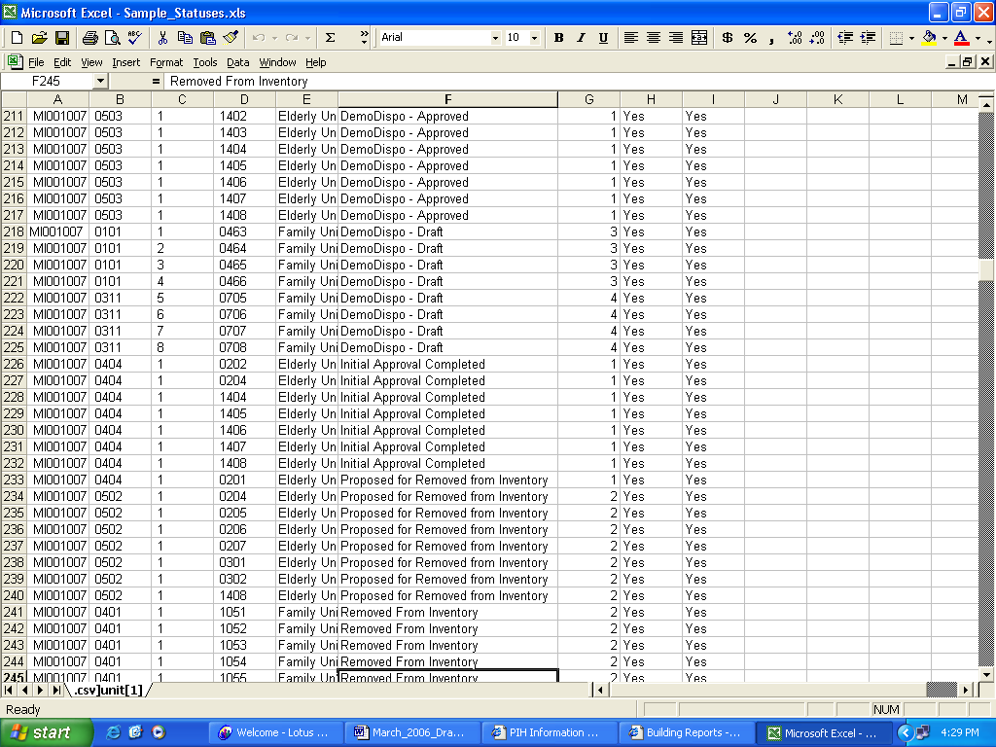
Figures 14-1: Reports tab Status filter and sample Unit Report.
The sequence of the statuses is as follows:
1)Initial Upload
Building and unit data uploaded to PIC by the HA and not yet approved by the HUD field office.
2)Initial Approval Completed
HA building and unit data in PIC approved by the field office
3)DemoDispo-Draft
Units saved by the HA to an inventory removal application not yet submitted to the SAC
4)DemoDispo-Proposed
Units in an inventory removal application submitted to the SAC
5)DemoDispo-Approved
Units in an application approved by the SAC and available under the Remove from Inventory tab for the HA to enter in PIC dates of demolition, sale or other removal from the public housing inventory
6)Proposed for Removed from Inventory
Units for which the HA has entered the dates of removal from the public housing inventory
7)Removed from Inventory
Units for which the HUD field office has approved in PIC the dates on which they were demolished, sold, or otherwise conveyed out of the public housing inventory.
8)Removed without HUD Approval
Units that were removed from inventory that were not in an approved application.

Stage of Building and Unit Status Action
Initial Upload | Building and unit (B&U) data for a development initially submitted in PIC by PHA to a HUD Field Office for inclusion in PIC.
Initial Approval Completed | B&U data after approval by HUD Field Office in PIC for inclusion.
DemoDispo-Draft | Units in all inventory removal applications created by the PHA but not yet submitted to the Special Applications Center, or returned to “Draft” status by the SAC after submission.
DemoDispo-Proposed | Units in Inventory removal applications that have been submitted to the SAC by the PHA or created at the SAC. Then the application status is “Submitted”. After a SAC reviewer is assigned to it, the status changes to “Under Review”. When the reviewer finishes, the application status becomes “Processor Complete”.
DemoDispo-Approved | Units in all inventory removal applications (including homeownership) in which the approval date has been entered by the SAC. The status of the application becomes headquarters approved “HQ Approved”, and the buildings and units are available for the PHA to enter actual dates of removal into PIC.
Proposed for Removed from Inventory | Buildings and units for which the PHA has entered the dates of removal in PIC. The buildings and units with entered dates of removal are then submitted in PIC for final review at the PHA. Then this data is sent in PIC to the HUD Field Office for approval.
Removed from Inventory | The HUD Field Office has acknowledged that the approved units have been removed from the public housing inventory (demolished, sold, leased, etc.) on the dates indicated in PIC.
Removed without HUD Formal Approval | SAC has changed the status in PIC of units that were removed from inventory without being in an approved application.

