Appendix A

Inventory Removals Submodule

Quick Reference Guide

Revised 11/17/2007
Appendix A

Quick Reference Guide (HA Submission)

- Log on to PIC. | 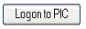
- Access the Inventory Removals Submodule. | 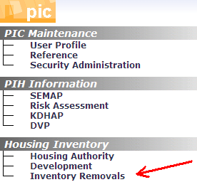
- Create/Complete an application. | 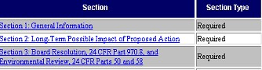
- Attach Supporting Documents. | 
- Review Quality Checklist.
- Submit application for SAC approval.

After SAC Approval and Completion of the Action:

- Go to the Remove from Inventory tab in the Inventory Removals Submodule. | 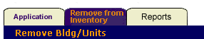
- Select the appropriate development. | 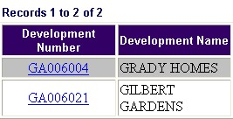
- Add a transaction to propose the removal of buildings/units from inventory. | 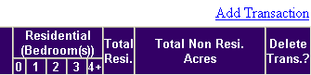
- Select the application number from the drop-down menu. Enter the date that buildings or units were demolished, sold, or otherwise removed from the public housing inventory in the “Action/Closing Date” box. | 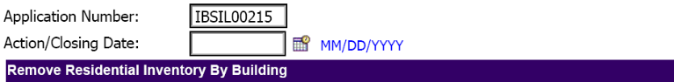
- Select the buildings/units to include with the transaction from the Available list of those approved in the application, and move them to the Proposed box. Hit the Save button.  Note: The system enables you to save multiple buildings/units that were removed from inventory on the same date to a transaction. You do not have to select the buildings/units individually, unless they have different dates of removal. | 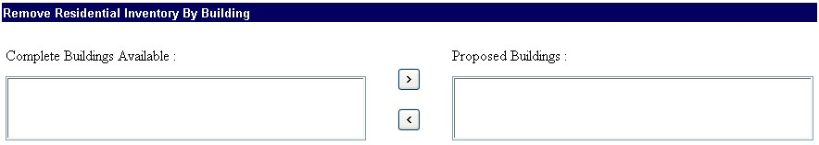  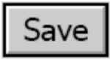
- Click the Submission subtab. | 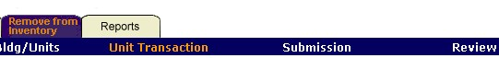
- Submit the transaction for review.  After submitting the transaction, you cannot edit it unless it gets rejected by the HA Executive Director or the field office. | 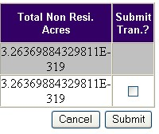

Appendix A

Quick Reference Guide (HA Review)

After SAC Approval and Completion of the Action:

- Log on to PIC.
- Access the Inventory Removals Submodule.
- Click the Remove from Inventory tab.
- Select a development.
- Click the Review subtab.
- Select a transaction to review. | 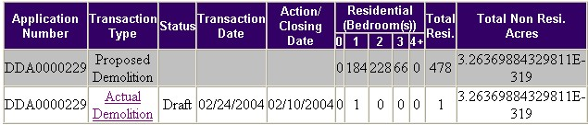
- Approve/Reject the transaction(s) for submission to the field office.  After you approve the transaction for field office submission, you cannot edit it.  If you reject the transaction, the HA regains the ability to edit the submission. | 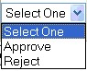

Appendix A

Quick Reference Guide (Field Office Review/Approval)

After SAC Approval and Completion of the Action:

- Log on to PIC.
- Access the Inventory Removals Submodule.
- Click the Remove from Inventory tab.
- Select a development.
- Click the Approval subtab.
- Select a transaction to review.
- Review the proposed transaction(s) and decided whether to approve or reject.

If you approve the transaction, the building/units included are given Removed fromIinventory status in PIC..

If you reject the transaction, the HA regains the ability to edit the submission.

