Table of Contents

The Viewer Submodule 1
Navigating to the Viewer Submodule 2
The Search Tab: Accessing Form-50058 Data 3
The Household Tab 7
The Members Tab 8
The Rent Tab 9
The FSS/WtW Tab 10
Reports Tab 13
The Reports Tab: MTCS Transaction Report 14
Information Presented in an MTCS Transaction Report 18
The Reports Tab: MTCS Voucher Issued/Expiration Report 21
Information Presented in the MTCS Voucher Issued/Expiration Report 23
The Reports Tab: HA Query Report 25
Information Presented in the HA Query Report 26

The Viewer Submodule is used to retrieve specific Form-50058 data for tenants or their households. The information provided in this submodule is taken directly from forms submitted by PHAs. Refer to Appendix C for a quick reference guide on how to use this submodule.

The Viewer Submodule

Note: A PDF version of the Form-50058 is available on the PIC Web site. To view this information from the PDF file:

Step | Action/Result
- Go to the Public and Indian Housing home page. | This is located in: http://www.hud.gov/offices/pih/index.cfm
- In the Quick Find list, scroll to Form HUD-50058 Documents in the dialog box. | The Quick Find list is located toward the bottom right corner of the page. Items are listed in alphabetical order.
- Click the linked titled Go to this page. | The Forms, Guidebooks, and Tools page appears.
- Click the red link titled Form HUD-50058. | The PDF File Request notice appears.
- Select the first link to Open the PDF File. | Form-50058 is presented in PDF form. Officially this is titled the “U.S. Department of Housing and of Urban Planning, Office of Public and Indian Housing, Family Report.”

Navigating to the Viewer Submodule
To access the Viewer Submodule:
Step | Action/Result
1. Move your cursor over the Form–50058 button on the PIC main page. | A link appears to the right of the button that reads Viewer (see Figure 1).
2. Click the Viewer hyperlink. | This displays the Viewer submodule page.

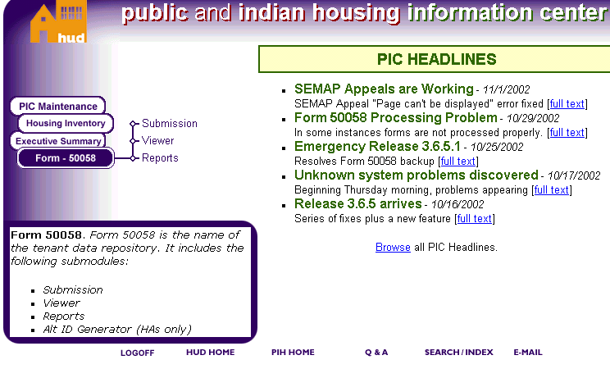
Figure 1: The PIC main page.

The Search Tab: Accessing Form-50058 Data
Accessing the data contained within the Viewer Submodule is achieved by clicking on tabs at the top of the Viewer Submodule start page.

- Household
- Members
- Rent
- FSS/WtW (Family Self-Sufficiency/Welfare-to-Work)
- Issuance/Expiration of Vouchers
- Reports

Start with the Search page (see Figure 2). From here you will type in the criteria that enable you to find the tenant data you want.

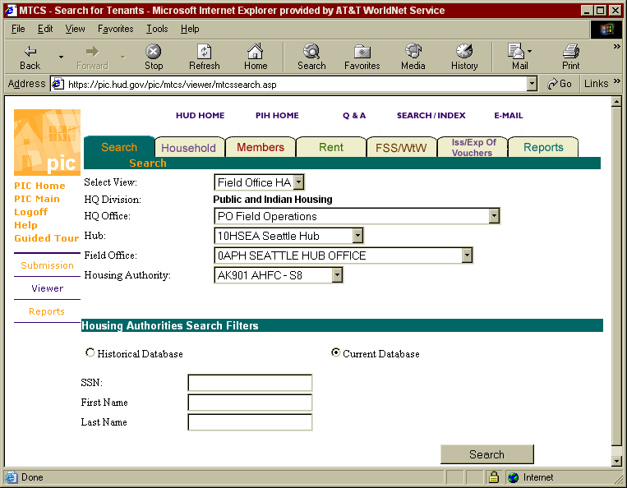
Figure 2: The default search page.

If you want to locate information on a person in a specific housing authority:

Step | Action/Result
- Click Field Office HA in the Select View dialog box.
- Click PO Field Office Operations from the HQ Office dialog box | PO Field Operations is the default and agency code for Field Office Operations.
- Click the Hub containing the PHA you are looking for. | If you do not have this information, refer to Appendix B.
- Click the Field Office containing the PHA you are looking for. | If you do not have this information, refer to Appendix B.
- Click the Housing Authority you want. | If you do not have this information, refer to Appendix B.
- Select the radio button for Historical or Current database. | - Historical Database: includes all tenant data forms past and present.  - Current Database: includes only the most recent tenant forms submitted.
- Type in an SSN, if known. | This option displays data information specific to the Social Security Number.
- Type in the First Name, if known. | Clicking Search displays a list of all tenants whose first names begin with the one entered.
- Type in a Last Name, if known. | Clicking Search displays a list of all tenants whose last names match the criteria entered.
- Click the Search button. | Names matching the first name, last name, or SSN criteria entered are displayed. The display shows:  - A list of first or last names  or  - Data that is specific to the SSN you entered (see Figure 3).

To locate information on a person in a specific TARC HA:

Step | Action/Result
- Click TARC Development from the Select View dialog box.
- Click PB Office of Troubled Agency Recovery from the HQ Office dialog box. | PB Office of Troubled Agency Recovery is the default choice and the agency code for TARC operations.
- Click the TARC you want. | If you do not have this information, refer to Appendix B.
- Click the Housing Authority you want. | If you do not have this information, refer to Appendix B.
- Select the radio button for Historical or Current Database. | - Historical Database: includes all forms past and present.  - Current Database: includes only the most recent forms submitted.
- Type in an SSN, if known. | This option displays data information specific to the Social Security Number.
- Type in the First Name, if known. | Clicking displays a list of all tenants whose first names begin with the one entered.
- Type in a Last Name, if known. | Clicking Search displays a list of all tenants whose last names match the criteria entered.
- Click the Search button. | Name matching the first name, last name, or SSN criteria entered are displayed. The display shows:  - A list of first or last names  or  - Data that is specific to the SSN you entered (see Figure 3).

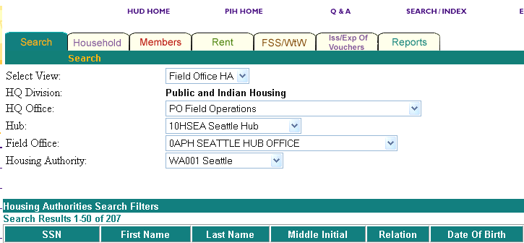
Figure 3: Column data headings for search results.

After you have reached the search results page, click the SSN hyperlink of the person you are looking for on the list presented.

The Household tab data of this tenant is displayed. From this Household page you will access the additional tabs to view further Form-50058 data for this person (see Figure 4).

The Household Tab
From the Household tab, you can access data that corresponds to Sections 1, 2, 4, and 5 of the Form-50058. Select the SSN of the tenant you are looking for and the Household Tab page displays Action data. From this first page of Form-50058 data, you can also access additional information on this tenant through the following three subtabs:

- Agency Information
- Background at Admission
- Unit to be Occupied

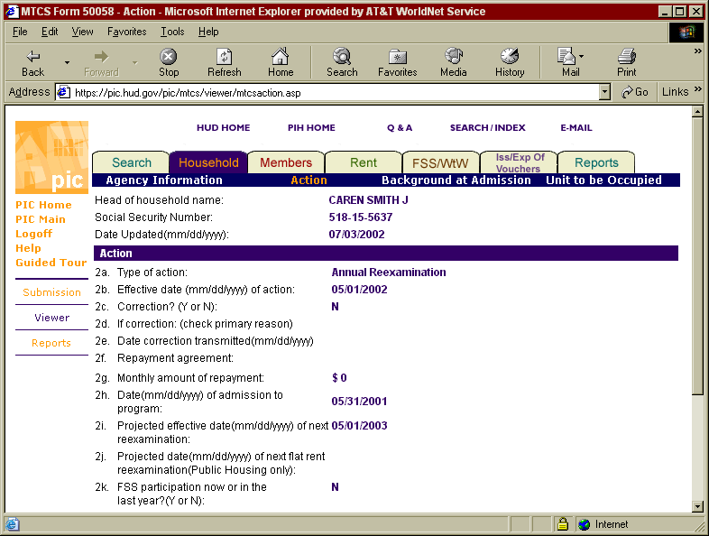
Figure 4: The Household Tab and subtabs.

For easy reference, the Head of Household name, SSN, and the Date Updated for this person’s file is in the first tier.

The first page of this Household tab displays Action data, which corresponds to Section 2 of the Form-50058.

To retrieve additional data from the subtabs:

Step | Action/Result
- Click the Agency Information subtab. | Data that corresponds to Section 1 of Form-50058 is displayed.
- Click the Action subtab. | Data that corresponds to Section 2 of Form-50058 will be displayed.  Note: The Action subtab is the default page for the Household tab.
- Click the Background at Admission subtab. | Data that corresponds to Section 4 of Form-50058 is displayed.
- Click the Unit to be Occupied subtab. | Data that corresponds to Section 5 of the Form-50058 is displayed.

The Members Tab

From the Members tab you can access data that corresponds to Sections 3, 6, and 7 of the Form-50058. The data is found within the following three subtabs (see Figure 5):

- Members
- Assets
- Income

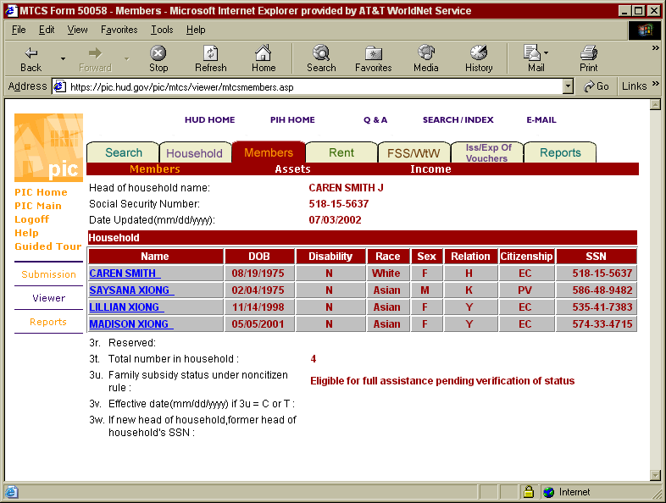
Figure 5: The Members Tab Page and subtabs.

For easy reference, the Head of Household name, SSN, and the Date Updated for this person are shown in the first tier.

The first page of the Members tab displays Members data, which corresponds with Section 3 of the Form-50058.

To access data from the other two subtab items:

Step | Action/Result
- Click the Assets subtab. | Data that corresponds to Section of 6 of Form-50058 is displayed.
- Click the Income subtab. | Data that corresponds to Section 7 of Form-50058 is displayed.

The Rent Tab

From the Rent Tab you can access data that corresponds to Sections 8, 9, and 10 of the Form-50058. The data is found in four subtabs (see Figure 6):

- Expected Income Per Year
- TTP (Total Tenant Payment)
- Rent Calculation (Program Type)
- Manufactured Home

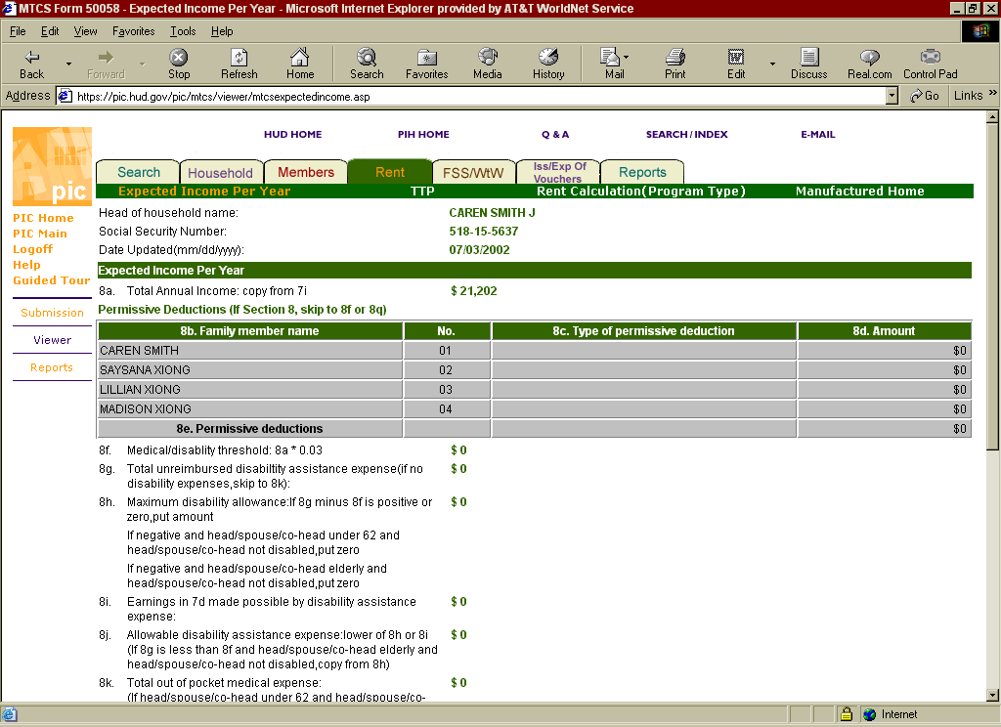
Figure 6: The Rent Tab Page and subtabs.

For easy reference, the Head of Household name, Social Security Number, and the Date Updated are shown in the first tier of this page.

The first page of the Rent tab displays Expected Income per Year data. The data in this page corresponds with Section 8 of the Form-50058.

To access data from the additional subtabs:

Step | Action/Result
- Click the TTP subtab. | Data that corresponds to Section 9 of Form-50058 is displayed.
- Click the Rent Calculation (Program Type) subtab. | Data that corresponds to Section 9 of Form-50058 is displayed.
- Click the Manufactured Home subtab. | Data that corresponds to Section 10 of Form-50058 is displayed.

The FSS/WtW Tab
This FSS/WtW tab enables you to view household information regarding participation in family self-sufficiency and welfare-to-work programs. The data is found within the following four subtabs (see Figure 7):

- General
- Services
- FSS
- WTC

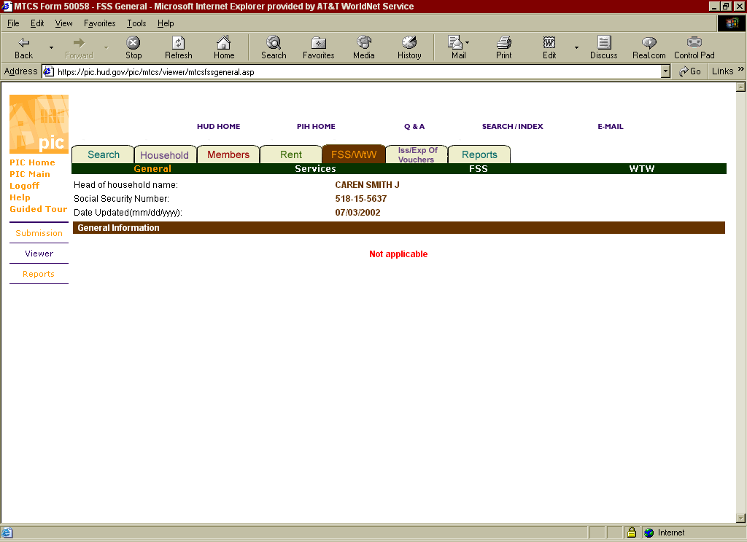
Figure 7: The FSS/WtW Tab Page and its subtabs.

The first page of this FFS/WtW screen displays General subtab information, and corresponds to data in Sections 17a through 17h of the Form-50058.

To retrieve additional data from the other subtabs:

Step | Action/Result
- Click the Services subtab. | Data that corresponds to Family Services Table of Section 17 of Form-50058 is displayed.
- Click the FSS (Family Self-Sufficiency) subtab. | Data that corresponds to Sections 17j –17m of Form-50080 is displayed.
- Click the WTW subtab. | Data that corresponds to Section s 17n –17q of the Form –50058 is displayed.

.

The ISS/Exp Vouchers Tab
From this tab, you can access tenant data related to the date of the voucher issuance and the expiration date.

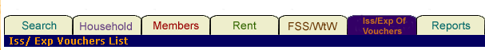
Figure 8: The ISS/Exp Vouchers Tab Page and its subtabs.

Note: Due to ongoing construction, you must navigate to the ISS/Exp Vouchers tab from the Search page.

To view issuance and expiration of voucher information:

Step | Action/Result
- Go to the Search tab on the Viewer Submodule.
- Click Field Office HA in the Select View dialog box..
- Click PO Field Office Operations from the HQ Office dialog box | PO Field Operations is the default and agency code for Field Office Operations.
- Click the Hub you are looking for. | If you do not have this information refer, to Appendix B.
- Click the Field Office you are looking for. | If you do not have this information refer, to Appendix B.
- Click the Housing Authority you are looking for. | If you do not have this information refer, to Appendix B.
- Click the radio button for Historical or Current database. | - Historical Database: includes all forms past and present.  - Current Database: includes only the most recent forms submitted.
- Type in the SSN, First Name, or Last Name. | This option displays data information specific to the Social Security Number.
- Click the Search button. | Results of the SSN criteria entered are displayed.
- Click the hyperlink ISP/Exp Records, located in the second tier. | A narrowed list of SSNs is displayed.
- Click the hyperlink SSN of the tenant you want. | The Iss/Exp Vouchers List page with Voucher Issuance and Expiration data is displayed. Column data includes:  - Update date  - Participant Code  - Type of Action taken
- Click the Update Date hyperlink. | Data from Sections 1, 2, 4, 5, 7, and 3 of the Form-50058 is displayed (see Figure 9).

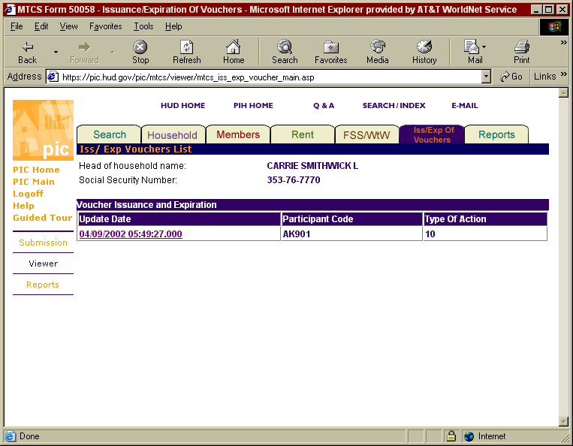
Figure 9: The Voucher Issuance and Expiration Data.

Reports Tab

From the Reports Tab, you can either view detailed action type and voucher information, or generate a report. The reports generated retrieve information from several different areas of the Form-50058.

Three types of reports that can be generated (see Figure 10):

- MTCS Transaction Report
- MTCS Voucher Issued/Expiration Report
- HA Query
These report options are located under the main tabs for the Viewer Module. To go to one of these reports, click on a report with your mouse.
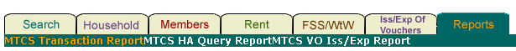
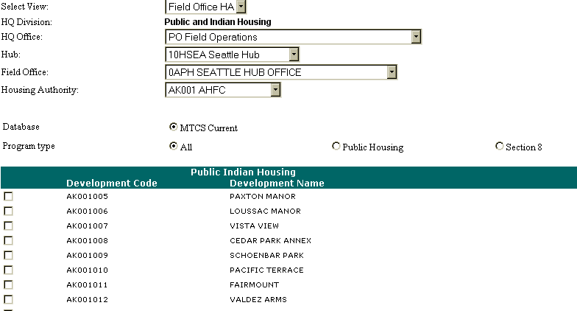
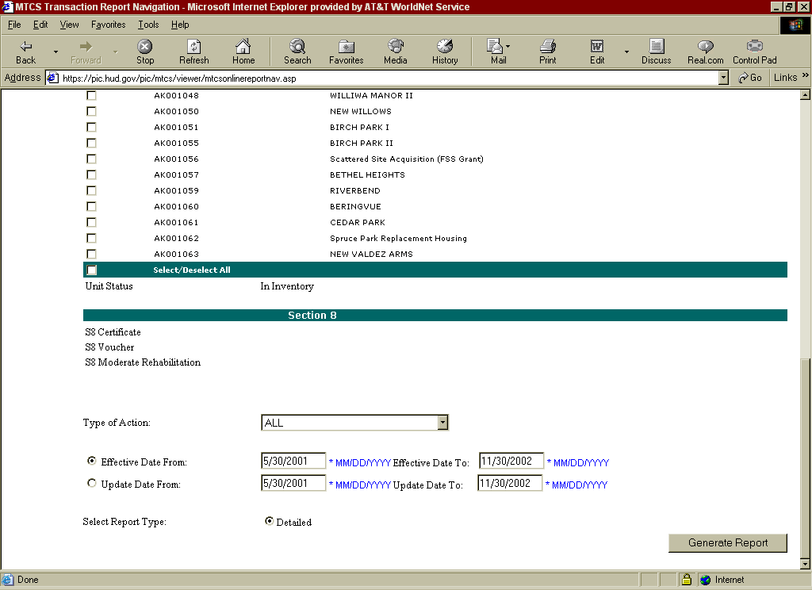

Figure 10: The Reports Tab Page.

The Reports Tab: MTCS Transaction Report
This is the default page for accessing reports. To access an MTCS Transaction Report, set the dialog boxes to the criteria of the report you need.

To find a field office PHA:

Step | Action/Result
1. Click Field Office HA in the Select View dialog box. | PO Field Operations is the default and agency code for Field Office Operations.
2. Click PO Field Office Operations from the HQ Office dialog box. | PO Field Operations is the default and agency code for Field Office Operations.
3. Click the Hub you want. | If you do not have this information refer, to Appendix B.
4. Click one Field Office you want. | If you do not have this information refer, to Appendix B.
5. Click the Housing Authority you want. | If you do not have this information refer, to Appendix B.

To find a TARC HA:

Step | Action/Result
1. Click TARC Development from the Select View dialog box.
2. Click PB Office of Troubled Agency Recovery from the HQ Office dialog box. | PB Office of Troubled Agency Recovery is the default choice and the agency code for TARC operations.
3. Click the TARC you want. | If you do not have this information refer to Appendix B.
4. Click the TARC HA you are looking for.

Choose from the following three program type options:

- All
- Public Housing
- Section 8

All

If you select All, follow these steps to generate a report:

Step | Action/Result
1. Click the All radio button. | Screen displays Development Code and Names of all Public Indian Housing projects.
2. Click the box for the Development Code and Development Name box. | Select more than one development by clicking the boxes in the far left column of the list. To select all the developments, or to clear the list of unwanted selections, click the box next to Select/Deselect all.
3. Select the Type of Action. | - All  - New Admission  - Annual Reexamination  - Interim Reexamination  - Portability Move-In  - Portability Move-Out  - End of Participation  - Other Change of Unit  - FSS/WtW Addendum Only  - Annual Reexamination Searching  - Flat Rent Annual Update  - Annual HQS Inspection Only  - Historical Adjustment Only
4. Click the Effective Date From or Update Date From radio button. | Type in the exact dates into the respective fields
5. Click the Generate Report button. | An MTCS Transaction Report is generated (see Figure 11).

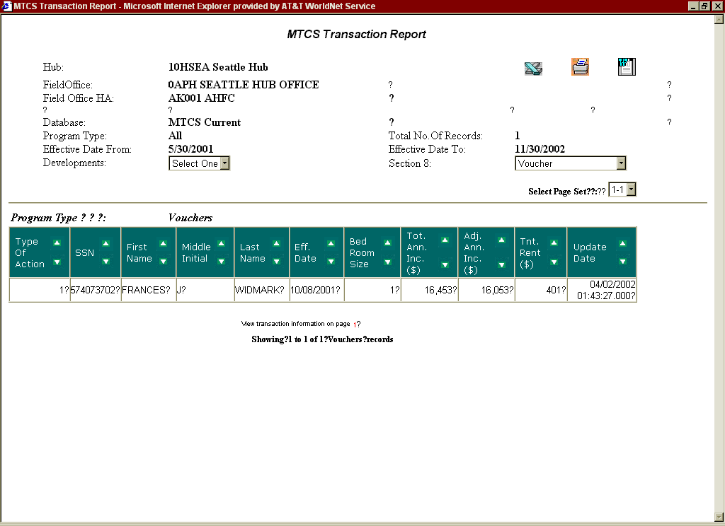
Figure 11: The All MTCS Transaction Report.

Public Housing

To generate a report solely on public housing:

Step | Action/Results
1. Click the Public Housing radio button. | The screen displays Development Code and Names of all Public Indian Housing projects.
2. Click the box for the Development Code and Development Name box. | Select more than one development by clicking the boxes in the far left column of the list. To select all the developments or to clear the list of unwanted selections, click the box next to Select/Deselect all.
3. Select the Type of Action. | - All  - New Admission  - Annual Reexamination  - Interim Reexamination  - Portability Move-In  - Portability Move-Out  - End of Participation  - Other Unit Changes  - FSS/WtW Addendum Only  - Annual Reexamination Searching  - Annual HQS Inspection Only  - Historical Adjustment Only
4. Click the Effective Date From or Update Date From radio button. | Type in the exact dates into the respective fields.
5. Click the Generate Report button. | A Public Housing MTCS Transaction Report is generated (see Figure 12).

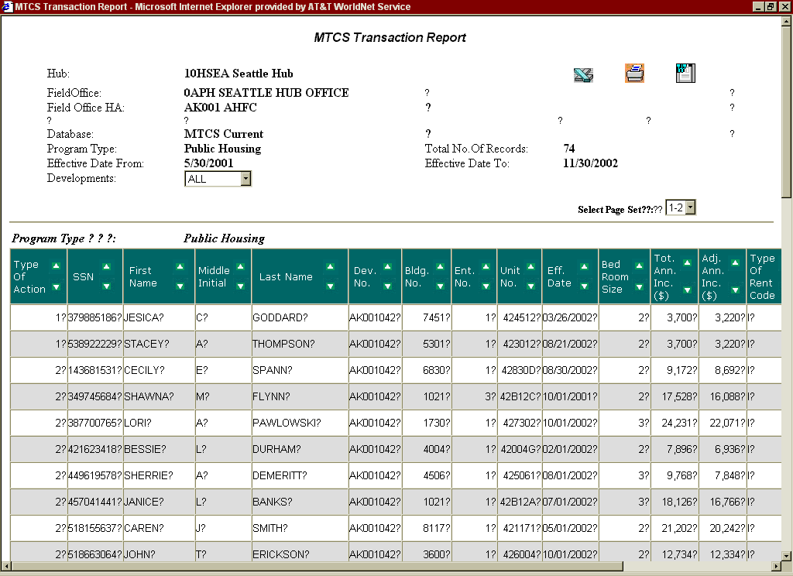
Figure 12: The Public Housing MTCS Transaction Report.

Section 8

To generate a report for Section 8 participants:

Step | Action
1. Click the Section 8 radio button.
2. Select the type of Section 8 housing radio button. | - All  - S8 Certificate  - S8 Voucher  - S8 Moderation Rehabilitation
3. Select the Type of Action. | - All  - New Admission  - Annual Reexamination  - Interim Reexamination  - Portability Move-In  - Portability Move-Out  - End of Participation  - Other Unit Changes  - FSS/WtW Addendum Only  - Annual Reexamination Searching  - Annual HQS Inspection Only  - Historical Adjustment Only
4. Click the Effective Date From or Update Date From radio button. | Enter the exact dates into the respective fields.
5. Click the Generate Report button. | A Section 8 MTCS Transaction Report is generated.

Information Presented in an MTCS Transaction Report

Reports for Public Housing and Section 8 programs contain the same information:

- ID information from the previous screen, including Effective or Update dates
- Total number of records retrieved
- Program type being viewed
If the developments selected contain Section 8 programs, manipulate the report to display data for a specific program.
Step | Action/Result
1. Click one program in the Section 8 dialog box. | - Certificate  - Voucher  - Moderate Rehabilitation  The report automatically displays data related to this tenant.

Data in this MTCS Transaction Report includes:

Table | Information Presented
Public Housing | A Transaction Report for a PHA contains one table that presents the following information:  PHA Transaction Report  - Type Action  - SSN  - First Name  - Middle Initial  - Last Name  - Development number  - Building number  - Entrance number  - Unit number  - Effective Date  - Bedroom Size  - Total Annual. Income ($)  - Adj. Annual Income ($)  - Type of rent Code  - Tenant Rent  - Tenant Type Code  - Update Date
S8 Certificates, Vouchers, Moderate Rehabilitation | A Transaction Report for a S8 program contains one table that presents the following information:  S8 Transaction Report  - Type of Action  - SSN  - First Name  - Middle Initial  - Last Name  - Effective Date  - Bedroom Size  - Total Annual. Income ($)  - Adj. Annual Income ($)  - Tenant Rent  - Update Date

View report information in ascending or descending order by clicking the up or down arrow in the column.

This report screen contains three options for further use of the data. The options are located on the top right side of the report screen.

Select one of the following:

- Download in Excel: The Report downloads into a Microsoft Excel spreadsheet for further data manipulation.

- Print Page: The report prints the screen as a Web page.

Note: For best results, print in landscape orientation.

- Download in Word: The report downloads into a Microsoft Word file.

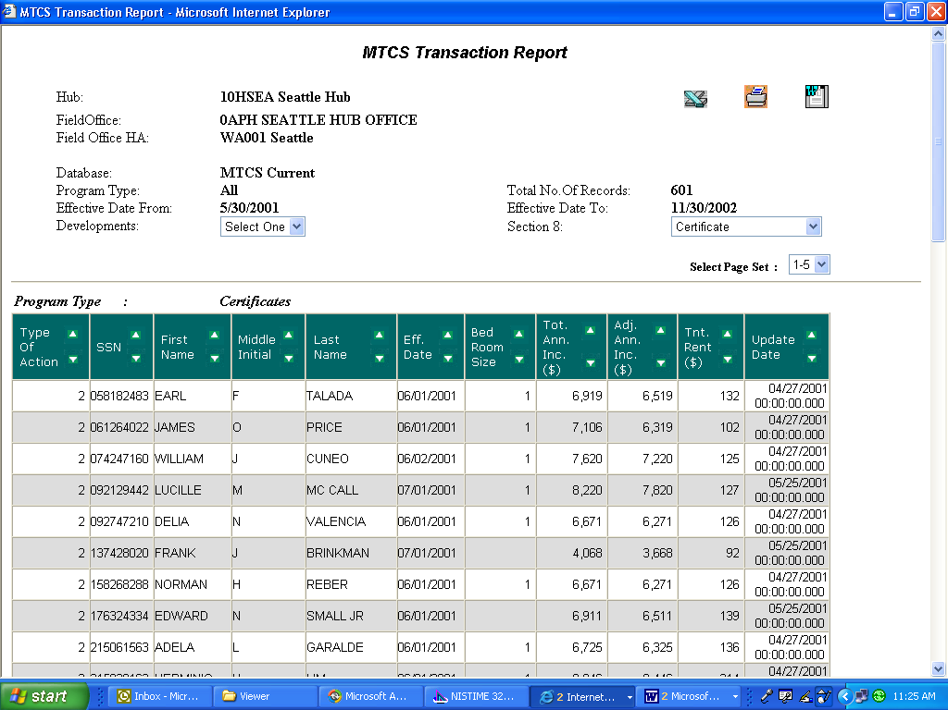
Figure 13: Additional options available
for a Transaction Report.

The Reports Tab: MTCS Voucher ISS/Exp Report
This report provides data taken from a Form-50058 of those in the selected PHA who have been issued vouchers, and when those vouchers expire.

In order to access this report, identify the HA or TARC HA you are looking for.

To find a field office PHA:

Step | Action/Results
1. Click Field Office HA in the Select View dialog box. | PO Field Operations is the default and agency code for Field Office Operations.
2. Click PO Field Office Operations from the HQ Office dialog box. | PO Field Operations is the default and agency code for Field Office Operations.
3. Click the Hub containing the PHA you want. | If you do not have this information refer, to Appendix B.
4. Click the Field Office containing the PHA you want. | If you do not have this information refer, to Appendix B.
5. Click the Housing Authority you are looking for. | If you do not have this information refer, to Appendix B.

To find a TARC HA:

Step | Action/Result
1. Click TARC Development from the Select View dialog box.
2. Click PB Office of Troubled Agency Recovery from the HQ Office dialog box. | PB Office of Troubled Agency Recovery is the default choice and the agency code for TARC operations.
3. Click one TARC. | If you do not have this information refer, to Appendix B.
4. Click one Housing Authority.

After the Field Office PHA or TARC is found:

Step | Action/Results:
1. Select the Type of Action from the dialog box. | - All  - Issuance of voucher  - Expiration of voucher
2. Click the Effective Date From or Update Date From radio button. | Enter the exact dates into the respective fields.
3. Click the Generate Report button. | An Issuance and Expiration Voucher Report displays (see Figure 16).

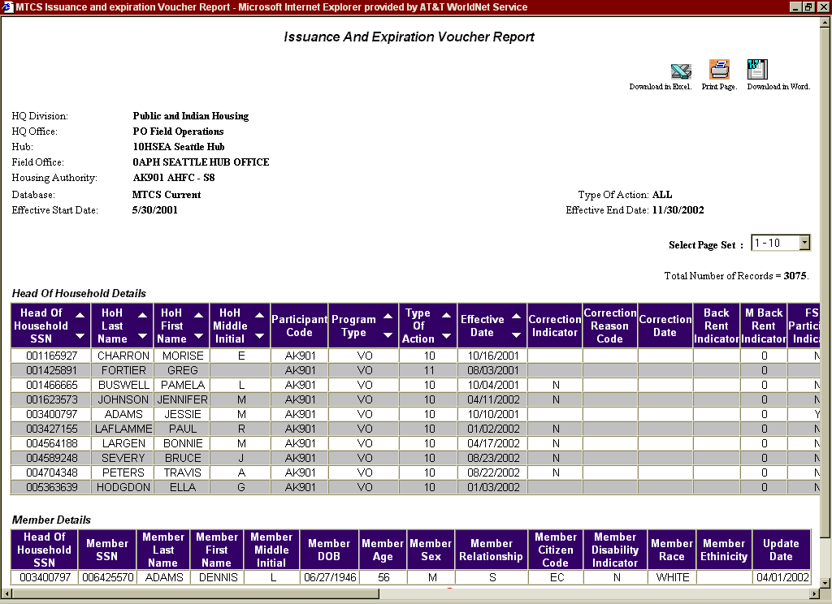
Figure 14: The MTCS Voucher Issued/Expiration MTCS Report.

Information Presented in the MTCS Voucher Issued/Expiration Report

Reports for the MTCS Voucher Issued/Expiration Report contain data that includes all selection information from the previous page, the total number of records retrieved, and the following tables:

Table | Information Presented
HOH Details | The default order for this table is descending SSN. It contains the following information:  - Head of Household SSN  - Last Name  - First Name  - Middle initial  - Participant Code  - Program Type  - Type of Action  - Effective Date  - Correction Indicator  - Correction Reason Code  - Correction Date  - Back Rent Indicator  - M Back Rent Indicator  - FSS Participant Indicator  - Voucher Special Program  - Special Program Code 1  - Special Program Code 2  - Special Program Code 3  - Special Program Code 4  - Special Program Code 5  - Total Household Members  - Zip Code  - Homeless Indicator  - Total Annual Income  - Number of Bedrooms  - HOH DOB  - HOH Age  - HOH Sex  - HOH Citizen code  - HOH Disability Indicator  - HOH Race  - HOH Ethnicity  - Date Modified  - Update Date
Member Details | The following table appears only for the HOH records that report details of other household members  - Head Of Household SSN  - Member SSN  - Member Last Name  - Member First Name  - Member Middle Initial  - Member Date of Birth  - Member Age  - Member Sex  - Member Relationship  - Member Citizen Code  - Member Disability Indicator  - Member Race  - Member Ethnicity  - Update Date

If the report contains more than 10 pages of data, navigate to another group of pages with the Select Page Set dialog box, as follows:

Step | Action/Result
1. Click the page set from the dialog box. | PIC presents the first page of the page group selected.

This report screen contains three options for further use of the data (see Figure 15). The options are located on the top right side of the report screen.

Select one of the following:

- Download in Excel: The Report downloads into a Microsoft Excel spreadsheet for further data manipulation.

- Print Page: The report prints the screen as a Web page.

Note: For best results, print in landscape orientation.

- Download in Word: The report downloads into a Microsoft Word file.

Figure 15: The options available
for further use in a Transaction Report.

The Reports Tab: HA Query Report
An HA Query Report details the last Form-50058 submitted for a specific person, what the action was, and the day that it occurred.

To generate an HA Query Report:

Step | Action/Result
- Type in a tenant’s SSN or alternate ID. | Type in up to 14 numbers. Separate each number with a comma.
2. Click the Retrieve button.

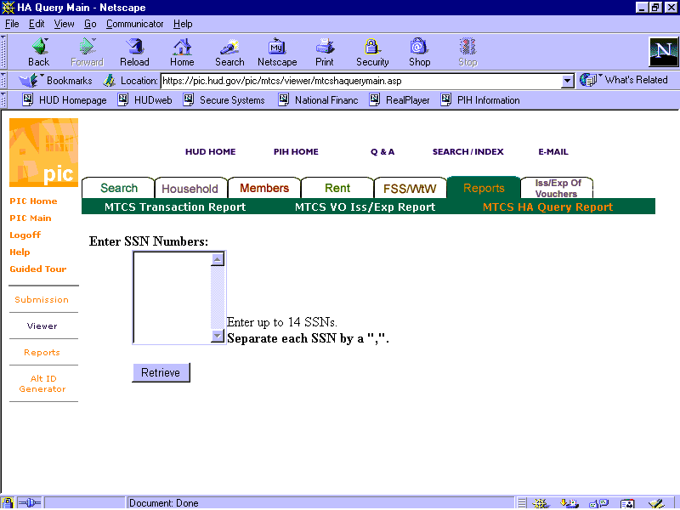
Figure 16: The HA Query Report Home Page.

Information Presented in the HA Query Report

An HA Query Report displays one table containing the following information:

- Tenant SSN number
- Program Type
- Participant Code
- Participant Name
- Type of Action
- Effective Date

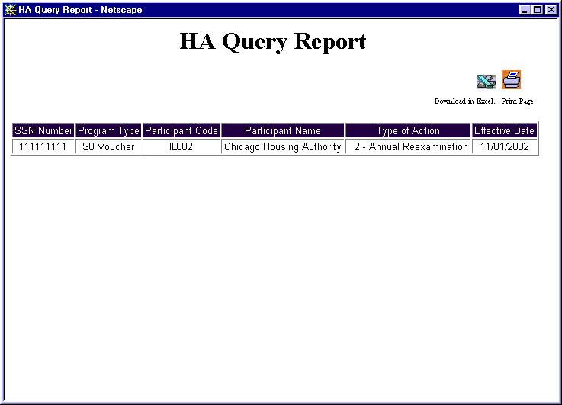
Figure 17: The HA Query Report.

The HA Query report screen contains two options for further use of the data. The options are located on the top right side of the report screen.

Select one of the following:

- Download in Excel: The Report downloads into a Microsoft Excel spreadsheet for further data manipulation.

- Print Page: The report prints the screen as a Web page.

Note: For best results, print in landscape orientation.

Figure 18: Additional options available
for use in a Transaction Report.

