Table of Contents

Alternate Identification Generator submodule 1
Navigating to the Alternate ID Generator Submodule 1
Generating an Alternate ID 2
Generating an Alternate ID Report 5
Information Presented in an Alternate ID Report 6
Updating an Alternate ID 8

Access the Alternate Identification Generator submodule to assign an alternate ID for a head of a household that does not possess a Social Security Number (SSN). This submodule generates a temporary ID until an SSN is issued. Upon receipt of the head of household’s SSN, you can return to this submodule to replace the temporarily generated ID with the new SSN. Refer to Appendix C for a quick reference guide on using this submodule.

The Alternate ID Generator Submodule

Note: PHA employees with administrative rights are the only employees allowed to access this section of the PIC system.

Navigating to the
Alternate ID Generator Submodule
To navigate to the Alternate ID Generator Submodule:

Step | Action/Result
- Move the cursor to click on the Form-50058 button on the PIC main page. | A list of submodules is displayed (see Figure 1).
- Click the Alternate ID Generator link. | The Alt ID page appears. Other available reports are listed in tabs at the top of the page.

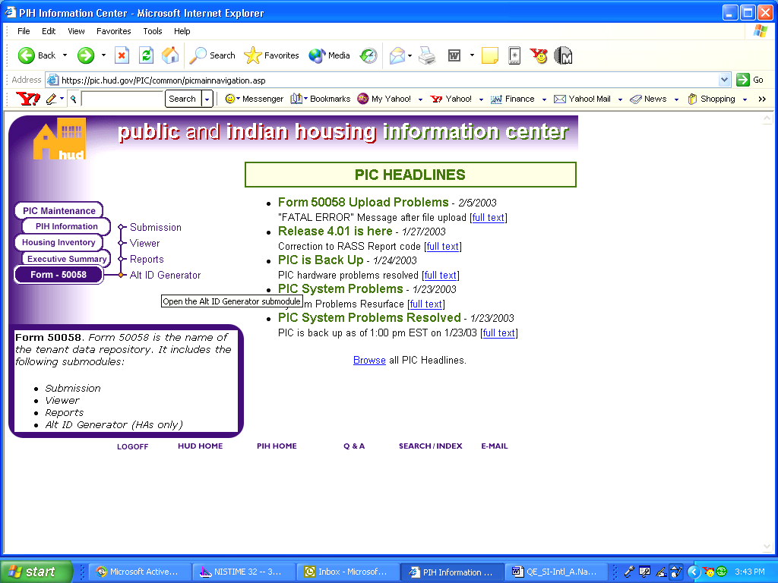
Figure 1: The PIC main page displaying all four Form-50058 submodules.

Generating an Alternate ID
The Alternate ID start page submits the information needed to create an Alternate ID for a resident (see Figure 2). On the start page, the Select View and the Hub fields are populated with the default locations for your housing authority.

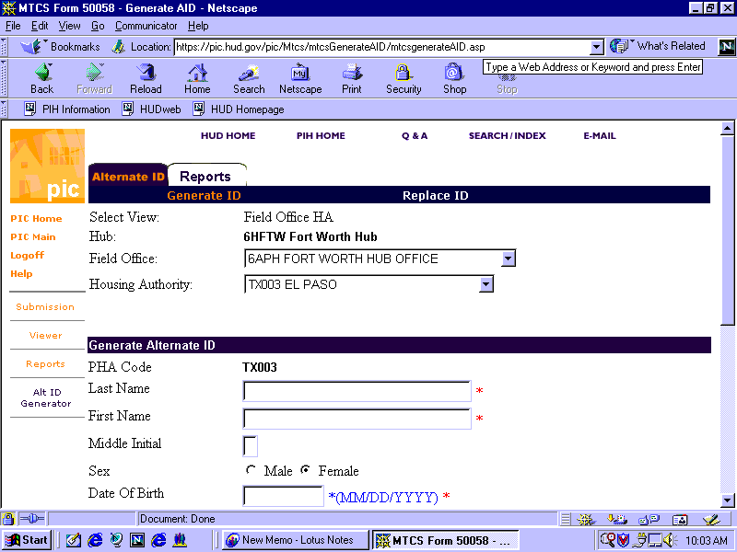
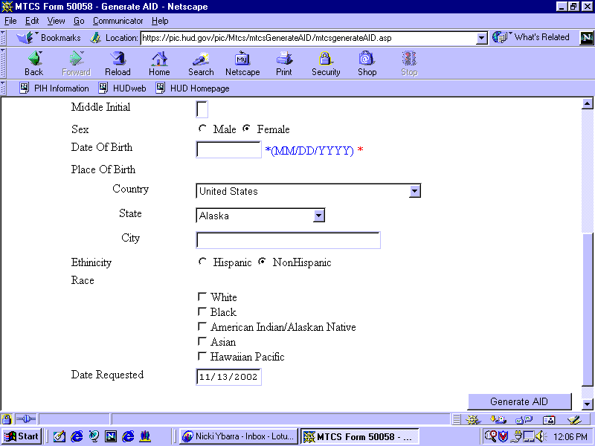
Figure 2: The Alternate ID Start Page.

To generate an Alternate ID:

Step | Action/Results
1. Click one Field Office in the dialog box.
2. Click one HA in the Housing Authority dialog box. | Note: Due to security clearance limitations, some PHA and HUD users have limited access to hub, field office, and housing authority options. If you are unable to locate your housing authority branch, contact your executive director. If you are a HUD user, contact your PIC coach.
3. Type in the Last Name, First Name, and Middle Initial of the person to receive the alternate ID in the appropriate dialog boxes.
4. Click the appropriate radio button for Sex.
5. Type in the Date Of Birth (MM/DD/YYY).
6. Type in the Place of Birth data | - Click the country where the resident was born in the Country dialog box.  - Click the state where the resident was born in the State dialog box if the resident was born in the United States.  - Type in the City where the resident resides in the City dialog box.
7. Click the appropriate radio button for Ethnicity.
8. Check the boxes that apply to Race. | - White  - Black  - American Indian/Alaskan Native  - Asian  - Hawaiian Pacific
9. Enter the Date Requested.
10. Click the Generate AID button. | Another screen displays the generated alternative ID. Depending on the result, you will see one of two screens (see Figures 3 and 4).

If successfully generated, you receive the new number, in red letters, and the status of the action, Success, in green letters (see Figure 3).

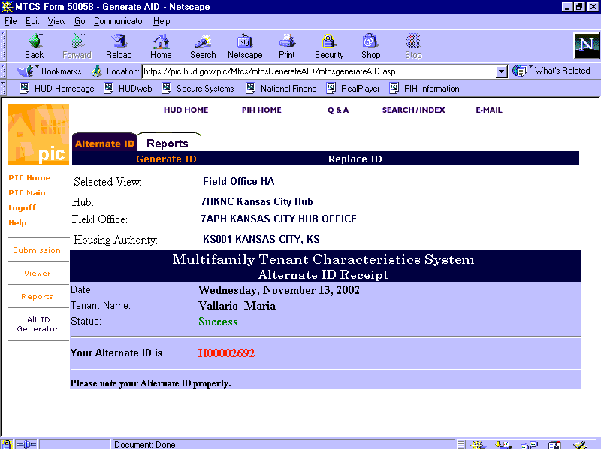
Figure 3: The Status Page (Success).

For further actions associated with this number, write down the generated alternate ID.
If the ID was unsuccessfully generated, you receive the Failed status in red letters and the following corresponding message: Alternate ID already replaced or ID does not belong to this participant (see Figure 4).

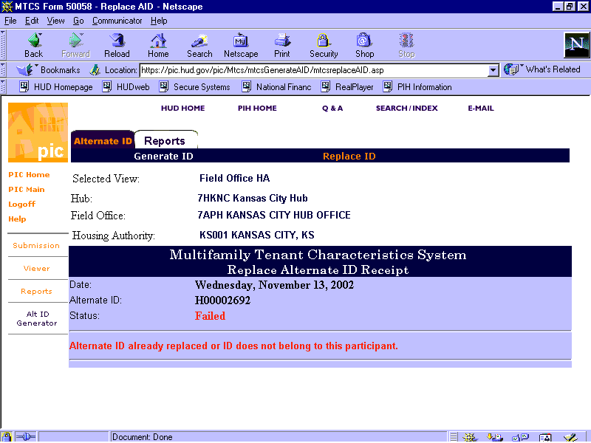
Figure 4: The Status Page (Failure).

Return to the Alternate ID homepage and verify the data entered, or resubmit the data and again select the Generate ID button.

Generating an Alternate ID Report
Access the Alternate ID Report screen if you possess an Alternate ID for a head of household and wish to view data or details associated with the ID.

To get to the Report start page:

Step | Action/Result
1. Click on Alt. ID Generator from the Form-50058 submodule list on the PIC main page. | The Alternate ID Generator start page appears
2. Click the Reports Tab on the top of the screen (see Figure 5). | The Reports start page appears.

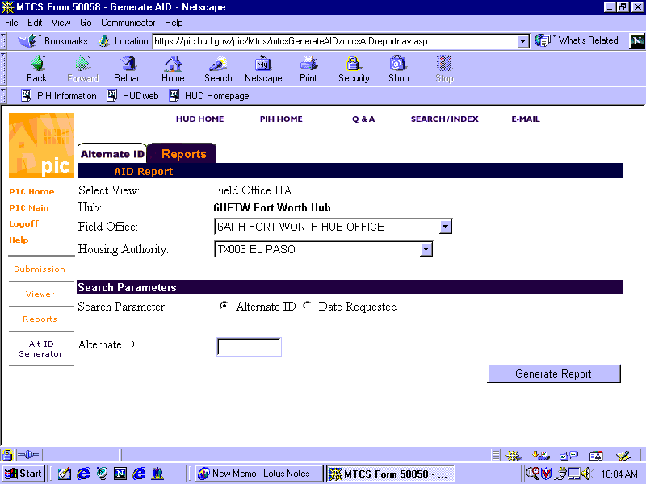
Figure 5: The Generate Alternate ID screen.

The Select View and Hub fields are populated with the default locations of your housing authority.

To Generate and Alternate ID Report:

Step | Action/Result
1. Select the appropriate Field Office from the dialog box | If you are an HA user, you only have access to the field office associated with your HA.
2. Select the appropriate number and city for the Housing Authority. | HA users only have access to their own Housing Authority.
3. Select the radio button that applies to your search parameter. | - Alternate ID  - Date Requested
4. Type in the Alternate ID that was generated from the previous page, or type in the Date that the ID was initially requested
5. Click the Generate Report button. | The Alternate ID report is displayed (see Figure 5).

Information Presented in an Alternate ID Report

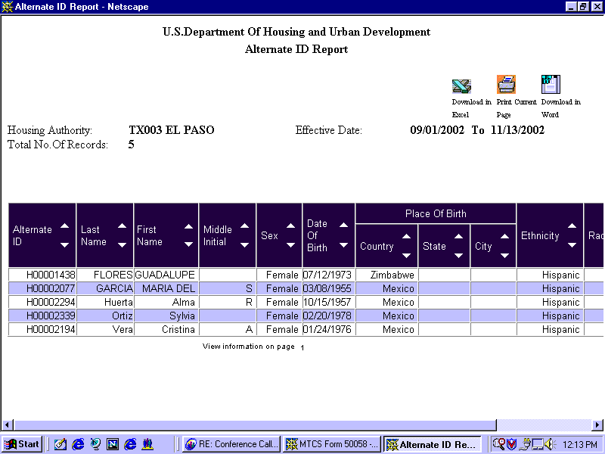
Figure 6: The Alternate ID Report screen.

The Alternate ID Report displays all records associated with the specified ID. The report heading displays (see Figure 6):

- The HA selected
- The Effective Date selected
- Total number of records.

The report is made up of one table that contains the following information:

- Alternate ID
- Last Name
- Middle Initial
- Sex
- Date of Birth
- Place of birth including country, state and city
- Ethnicity

The screen contains three options for further use of this data (see figure 7). The options are located on the top right side of the report screen.
Select one of the following:

- Download in MS-Excel: The report downloads to an Excel spreadsheet for further data manipulation.

- Print Current Page: The report prints as a Web page.

Note: For best results, print this report in landscape orientation.

- Download in Word: The report prints in an MS Word document.

Figure 7: The options for further use
of report data.

To generate another report, repeat the process by returning to the previous Reports screen and enter the ID of the next head of household report.

Updating an Alternate ID
When the head of household Social Security number is issued, HA administrators can return to this screen to update the new number.

To perform this task, go to the Replace ID subtab:

Step | Action/Result
1. Click the Alt. ID Generator link from the Form-50058 list on the PIC main page. | The Alt. ID Generator start page appears.
2. Click the Replace ID subtab. | It is located to the right of the Generate ID subtab at the top of the submodule (see Figure 8).

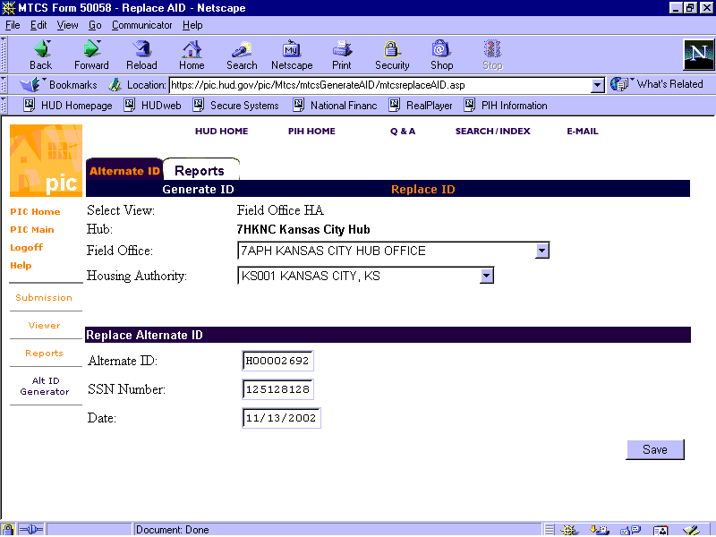
Figure 8: The Updated Alternate ID Screen.

The Select View and Hub fields are populated with the default locations of your housing authority.
To update an Alternate ID:

Step | Action/Result
1. Click the appropriate Field Office from the dialog box. | If you are an HA user, you only have access to the field office associated with your HA.
2. Click the appropriate HA for the Housing Authority dialog box. | HA users only have access to their own Housing Authority.
3. Type in the Alternate ID generated for the person in question.
4. Type in the newly issued SSN Number for the head of household.
5. Type in the Date on which the update was created (for example, the current date).
6. Click Save. | This new ID will be updated in the HUD database.

