Table of Contents

Logging on to PIC 1

The Executive Summary Module 4

What Is the Executive Summary Module? 4
Objectives 4

Navigating to the Executive Summary Module 5

Selecting a Public Housing Authority 6
Finding a Field Office PHA 7
Finding a Troubled Recovery Center PHA 8

Selecting a Filter 9

Generating and Using the Report 13

Logging
on to PIC

To log on to the Public and Indian Housing (PIH) Information Center (PIC), you need a user ID and password. If you are a PHA employee and do not have a user ID or password, please contact your executive director. If you are a HUD employee, contact your PIC coach.

To access the system:

- Go to the PIH home page at: http://www.hud.gov/offices/pih/.
A Quick Find List is at the bottom right of the PIH home page. Items are listed in alphabetical order.

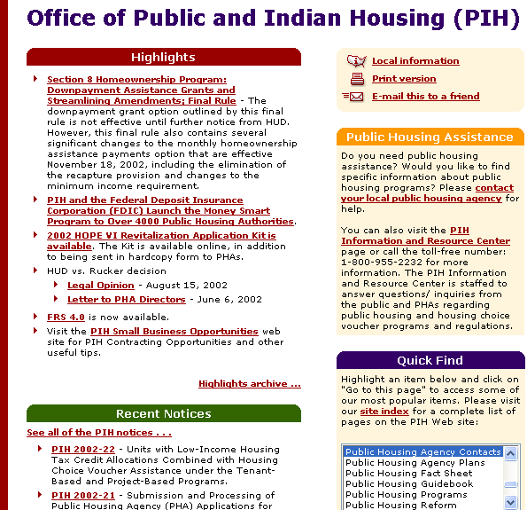
This graphic displays the PIH home page.

- Scroll to PIC – PIH Information Center.

- Select PIC – PIH Information Center with your mouse.

- Click the link titled Go to this page.
The PIH Information Center home page appears.
- Click the link titled Logon to PIC. It is located in the center of the screen. You can also click the link titled Logon to the PIC System in the Quick Access box.
The PIH Information Center logon screen appears.
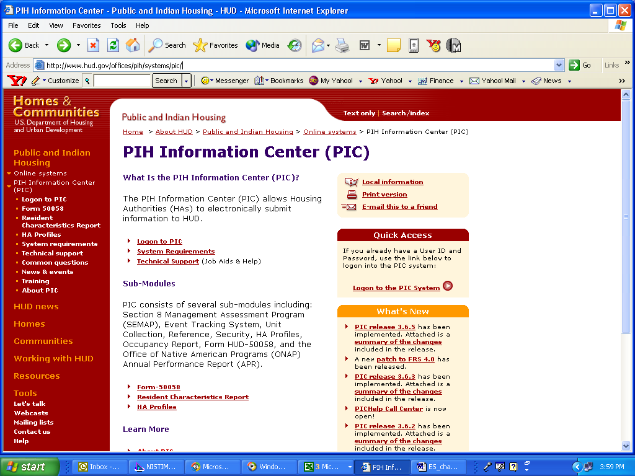
This graphic displays the PIC home page.

- Enter your user ID and password in the boxes on the screen.

- Click the button titled Logon to PIC.
The PIC main page appears.

When you first log on to PIC, the User Profile screen appears. You need to confirm the information on the page.
To confirm the information:

- Verify the information in the dialog boxes. Fill in any blank spaces.

- Click the Save button on the bottom right side of the screen.
You are now on the PIC main page.

Note: The only time you have to verify your User Profile is the first time you log on to PIC.

The Executive Summary Module

What Is the Executive Summary Module?
Every Public Housing Agency (PHA) is unique. With thousands in existence, getting up-to-date, customized information on a particular PHA can be challenging.

Through the Executive Summary Module, you can locate the latest address, contact information, performance scores, funding data, and inventory statistics for a particular PHA. By generating one of these summaries, anyone from a PHA staffer to a senior HUD manager can gain an accurate PHA snapshot 24 hours a day, 7 days a week.

The information in the summaries is provided directly by the PHAs through the Housing Authority (HA) Information Submodule. The exception is the PHA’s performance scores, which are posted by the Real Estate Assessment Center (REAC). Updates occur in real time. After a PHA changes the input, the Executive Summary for that PHA displays the new information.

Objectives

In this manual, we show you how to:
- Navigate to the Executive Summary Module.
- Select the PHA that interests you.
- Request the information you need via filters.
- Generate an Executive Summary report.

Navigating to the Executive Summary Module

In order to access the information you need, you first must find the Executive Summary Module page. This section takes you through the navigational steps.

After you log on to the PIC system and verify your User Profile (see the Logging on to PIC section of this manual), the PIC main page is displayed. The modules available to you are listed on the left side of the page.

To access the Executive Summary Module:

- Move your mouse over the Executive Summary button.
A link appears just to the right of the button that reads HA Executive Summary.

- Click the link to go to the module page.
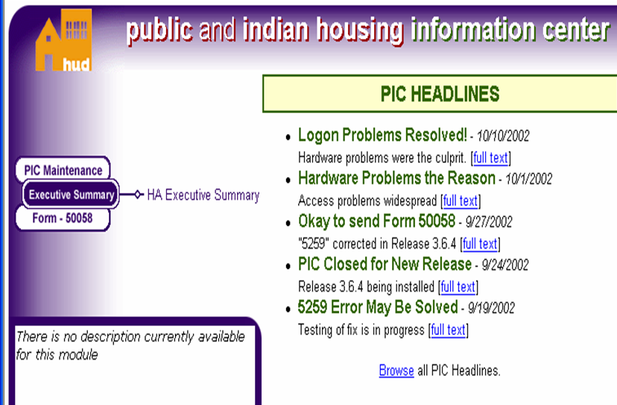
This graphic displays the PIC main page.

Note: A summary of the PIC modules is in Appendix A. If you are a PHA employee and want to gain access to more modules, contact your executive director. If you are a HUD employee, contact your PIC coach.

Selecting a Public Housing Authority

The Executive Summary Module enables you to find information on all field office PHAs, including those associated with Troubled Agency Recovery Centers (TARCs). These centers are located in Cleveland, OH, and Memphis, TN. They help PHAs designated as “troubled” under the Public Housing Assessment System (PHAS), or Section 8 Management Assessment Program (SEMAP), improve performance and achieve sustainable recovery.
To obtain information about a particular PHA, you first must identify the PHA you are looking for. The PIC system presents a series of dialog boxes at the top of the module to make the selection process fast and easy. These options are designed to locate the exact PHA you are looking for by identifying the hub and field office associated with that PHA.

To select an option:

- Click the box containing a down arrow on the right side of the dialog box.
A list of options appears.
- Click the option you want from the list. You can also use the up and down arrows on your keyboard to select the option you want from the list.
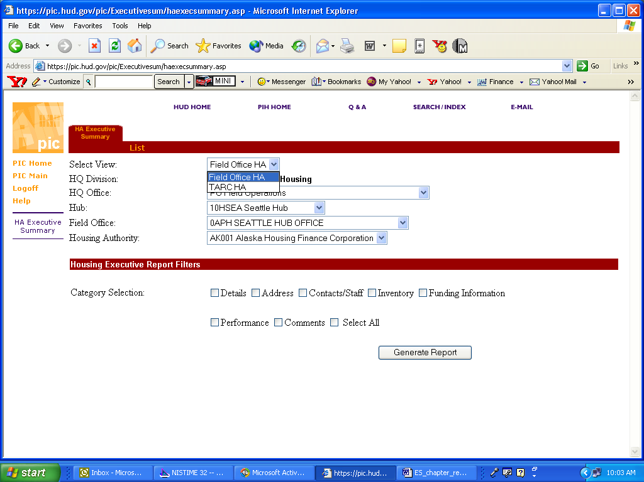
This graphic displays an example of the list that appears
when you click the down arrow on a dialog box.

Note: Access to any HA Executive Summary is determined by security clearance. For example, PHA users have access only to their own Executive Summary. Some HUD users can look only at the summaries for their particular state.

Finding a Field Office PHA
The following steps demonstrate how to select a particular field office PHA. Refer to Appendix B if you do not know the hub or field office information needed to find a particular field office PHA. It contains a complete list of PHA names, associated hubs and field offices, and HA codes.

To find a field office PHA:

- Click Field Office HA in the Select View dialog box.
The module formulates the rest of the search criteria to present only Field Office HA options.

Note: Field Office HA is the default option for the Select View dialog box.

- Click PO Field Office Operations in the HQ Office dialog box. (PO is the agency code for Field Office Operations.)
If the Select View box reads Field Office HA, the HQ Office box defaults to PO Field Operations. This selection allows you to select the hub, field office, and PHA you want.

Note: There are several other options listed in the HQ Office dialog box. These exist for system expansion purposes and, if selected, result in the following message: There are no Hubs for the currently selected HQ Office. Please select a different HQ Office.

- Click the hub, in the Hub dialog box, in the closest geographic proximity of the PHA you want. If you do not know this information, refer to Appendix B.

- Click the field office, in the Field Office dialog box, in the closest geographic proximity of the PHA you want.
The Field Office dialog box appears only if there is more than one field office associated with the hub you have selected.

- Click the desired PHA from the Housing Authority dialog box.

Note: Depending on security clearance, certain PHA and HUD users have limited access to hub, field office, and housing authority options. If you are a PHA user unable to locate the housing authority you are looking for, contact your executive director. If you are a HUD user, contact your PIC coach.
Finding a Troubled Agency Recovery Center PHA
The following steps demonstrate how to select a particular TARC PHA. Refer to Appendix B if you do not know the hub or field office information needed to find the TARC PHA you are looking for. Appendix B contains a complete list of PHA names, associated hubs and field offices, and HA codes.

To find a Troubled Agency Recovery Center (TARC) PHA:

- Click TARC HA in the Select View dialog box.

- Click PB Office of Troubled Agency Recovery in the HQ Office dialog box. (PB is the agency code for the Office of Troubled Agency Recovery.)
The module automatically enters the HQ Office entry as PB Office of Troubled Agency Recovery. This selection allows you to find the TARC PHA you are looking for.

Note: There are several other options listed in the HQ Office dialog box. These exist for system expansion purposes and, if selected, result in the following message: There are no Hubs for the currently selected HQ Office. Please select a different HQ Office.

- Click either Memphis, TN, or Cleveland, OH, in the TARC dialog box.
Choose the TARC that administers the PHA you are looking for. If you do not know the information, refer to Appendix B.

- Click the selection you want from the Housing Authority dialog box.

Selecting
a Filter

After choosing the PHA, you need to select the type of information the report will contain. The Housing Executive Report Filters are actually topics you can include in an Executive Summary report.

The following table shows what filters are available and what they do.

Filter | Information Presented | Examples and Notes
Details | - HA code
 | - HA program type | Low-rent, Combined, or Section 8
 | - Assigned HUD office
 | - Formal name of HA
 | - HA FY Year end
Address | - Physical address
 | - Mailing address
Contacts/ Staff | - Title and name of HA contacts | PHA mayor, PHA board chair-person, and PHA executive director
 | - Telephone numbers and extensions
 | - Email addresses
Inventory | - An HAs low rent development totals
 | - An HAs low rent unit totals
 | - Section 8 information (if available) | Increments and units
Funding Info | - The different types of formula grants | Capital Fund Grants (CFP), Competitive Grants (Comp Grants), HOPE VI, Operating Subsidies, Economic Development and Supportive Service Grants (EDSS), Public Housing Development Grants (PDEV)
 | - Grant funding going back 5 years | Fiscal years the grants were awarded, amount authorized, amount disbursed, amount obligated, amount expended
 | - Section 8 funding | Certificates and vouchers, fiscal years the grants were awarded, amount authorized, amount disbursed
Performance | - Public Housing Assessment System (PHAS) score | Individual PHAs are responsible for submitting performance criteria to the Real Estate Assessment Center (REAC) for scoring in the PHAS system. REAC then posts the scores to a database. The module draws the performance scores from this database. Unavailable scores in an Executive Summary can be due to several factors, including:  - REAC has not posted them yet  - Criteria are not submitted for the FY yet  - The evaluation is ongoing.  - PHA has requested a waiver
 | - Section 8 Management Assessment Program (SEMAP) score | The SEMAP score is generated by PIC’s SEMAP Certification Module

Filter | Information Presented | Examples and Notes
Comments | - Any information the PHA deems important to the Executive Summary, including the last five “executive” comments for the PHA
Select All | - Puts a check by all the filters

To select a filter, click the box next to the label. A check appears in the box.

For instance, if you want to view only the current funding information and inventory statistics for the PHA you are interested in:

- Select the PHA you want to view. For more information, see the Selecting a Housing Authority section.
- Click the boxes to the left of the inventory and the funding information filters.

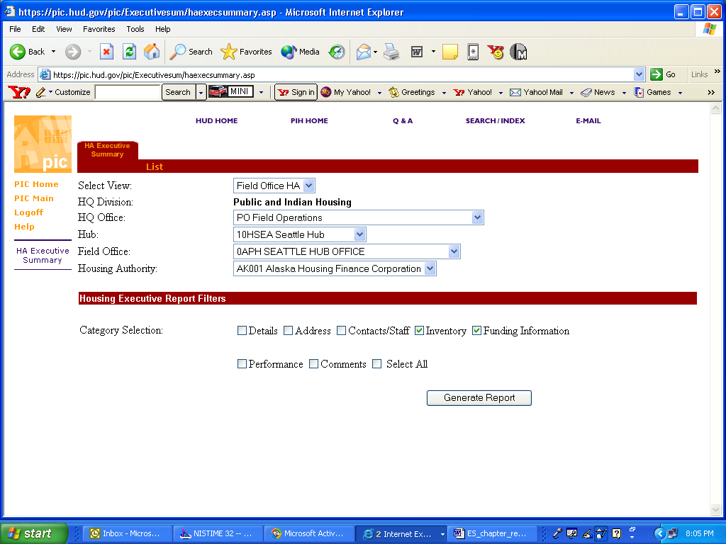
This graphic demonstrates the filter selection with the
Inventory and Funding Information options checked.
- Click Generate the Report.
(See the next section for more information on this step.)
- The final step in the process is to generate the report.

Click the button labeled Generate Report on the bottom right side of the
module. .

A new screen appears and display the Executive Summary for the PHA you have selected.

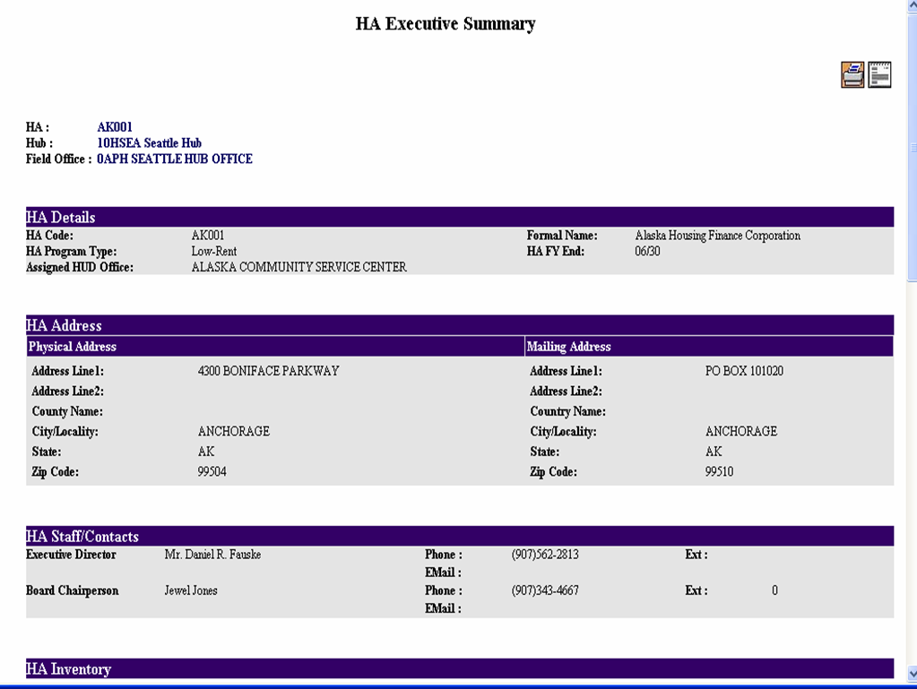
This graphic displays an Executive Summary report.

Generating
and Using
the Report
The Executive Summary screen provides two options for further use. These are located on the top right of the summary screen.

Select one of the following two options:

- Print the Report.
Prints the report as a Web page.

- Download to Text.
Downloads the report as a text file onto your computer.

To generate another report, repeat the process by returning to the module page and selecting the PHA you want to view. For your review, a quick reference guide to using this module is in Appendix C.

