General Instructions to the Teacher:
- This task took 4th grade students approximately two 35 minutes to complete.
- Students may work individually, or in groups. If group work is the norm for your classroom, it is recommended that the final question be assigned as an activity for individual students.

Advanced Preparation and Set Up:

Each item in a GLOBE Classroom Assessment begins with an assessment framework statement / goal that cues the student and teacher to the critical features of the item. If this information is not useful to your students, remove the bold parenthetical statement at the beginning of each item.

It is critical that the students work with colored pictures. Here are some suggestions for dealing with this if you do not have access to a color printer/copier:

make one classroom copy of the pictures (laminate them for future use); display the pictures in a prominent place in the classroom where all students will be able to view them

take photographs of your site throughout the year and use these
(Given data from the GLOBE data archives)
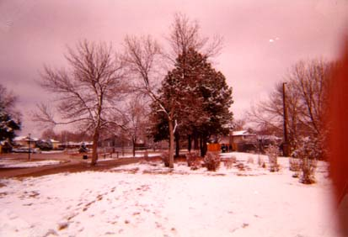
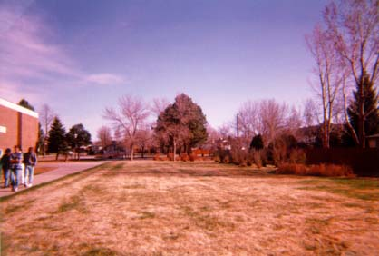
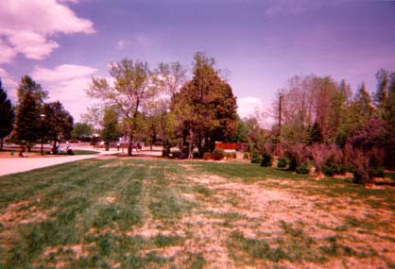
April 23rd
The students in your classroom are GLOBEpals with students at another school. You like to print out the pictures and data measurements taken from your GLOBEpal school. It helps you imagine what is happening at their school so that you can write more interesting notes to them. In this activity you will look at some pictures and data measurements made by your GLOBEpals.
April 3rd
May 13th

- (Take GLOBE Measurements: Make cloud observations that are accurate and appropriate) Look at the 3 pictures taken from your GLOBEpal school. Next to each picture write the name of the clouds you see.

The clouds on April 3rd look like they are altostratus clouds.
The clouds on April 23rd look like they are cirrostratus clouds.
The clouds on May 14th look like they are cumulus clouds.

- (Take GLOBE Measurements: Make cloud observations that are accurate and appropriate) Look at each picture and estimate the amount of cloud cover on each of the days. Write your estimate under the name of each cloud type.

answers will vary and the following are estimates only:

The clouds on April 3rd look like they cover 90% of the sky.
The clouds on April 23rd look like they cover 20% of the sky.
The clouds on May 14th look like they cover 20% of the sky.

- (Interpret GLOBE data: Infer patterns / trends; Explain the relationship between cloud type and precipitation) Look again at the clouds in each picture. Do you think that any of these clouds produced rain or snow later in the day? How can you tell?

The altostratus clouds on April 3rd could produce rain or snow. These clouds are grey which means lots of water in them.

Sometimes it is easier to find a pattern when you look at the data in a different way. In this next activity you will draw a graph of the average temperature between April 3rd and May 14th.

4) (Interpret GLOBE Data: Create multiple formats to represent data) First draw a box around the days in the data table that stand for week 1, week 2, etc. (HINT: all data is missing from week 4).

Table 1: Air Temperature Information
 | DATE | Current temperature
*Day 42 | May 13 | 24.0°C
Day 38 | May 10 | 13.0°C
Day 37 | May 9 | 11.0°C
Day 36 | May 8 | 20.0°C
Day 34 | May 6 | 15.0°C
Day 33 | May 5 | 22.0°C
Day 31 | May 3 | 7.0°C
Day 30 | May 2 | 11.0°C
*Day 21 | April 23 | 11.0°C
Day 20 | April22 | 1.0°C
Day 16 | April 17 | 21.0°C
Day 14 | April 16 | 15.0°C
Day 13 | April 15 | 15.0°C
Day 11 | April 13 | 0.0°C
Day 6 | April 8 | 10.0°C
*Day 1 | April 3 | 0.0°C

- (Interpret GLOBE Data: Create multiple formats to represent data) Next find the average temperature for each of these weeks. Record the information in the data table below. The calculations for the first week have been done for you.

Table 2: Calculations for Average Weekly Temperature
Week | TOTAL = add temperature  for each day of that week | AVERAGE = TOTAL divided by the number of days the temperature was recorded that week | Average weekly temperature at mean solar noon
1 | 0 + 10 = 10 | 10 ÷ 2 = 5°C | 5°C
2 | 0 + 15 + 15 = 30 | 30 ÷ 3 = 10°C | 10°C
3 | 21 + 1 + 11 = 33 | 33 ÷ 3 = 11°C | 11°C
4 | 11 + 8 + 22 + 15 = 56 | 56 ÷ 4 = 14°C | 14°C
5 | 20 + 13 + 11 + 20 = 64 | 64 ÷4 = 16°C | 16°C

- (Interpret GLOBE Data: Create multiple formats to represent data) Use the data in Table 2 to make a bar graph of the average weekly temperature on the graph below. Data from the first week has been graphed to show you what to do.

Figure 2: Air Temperatures & Weekly Averages for April 3 to May 14

- (Interpret GLOBE Data: Explain data & relationships) Look at the bar graph that you just completed. Tell what is happening to the average weekly temperature from April 3rd until May 14th.

The average weekly temperature from April 3rd to May 14th is going up little by little.

- (Interpret GLOBE Data: Explain data & relationships) Predict the weekly air temperature for the three weeks after the last photo was taken at this school. Draw your predicted weekly temperature on the graph in Figure 2.

see bars with dots added on the graph on previous page

- (Communicate: Compose reports to explain or persuade) Write a GLOBEmail to your GLOBEpals. Tell them about your air temperature predictions. Tell them how you made the predictions by explaining to them about the graph you made. Ask them to write back and tell you about the temperatures that they actually measured on these days.

Answers will vary. Possible suggestions may include: more frequent temperature readings, daily temperature readings, averaging the temperatures on some basis (every couple of days, every week etc.), recording high and low temperatures rather than just one temperature.

