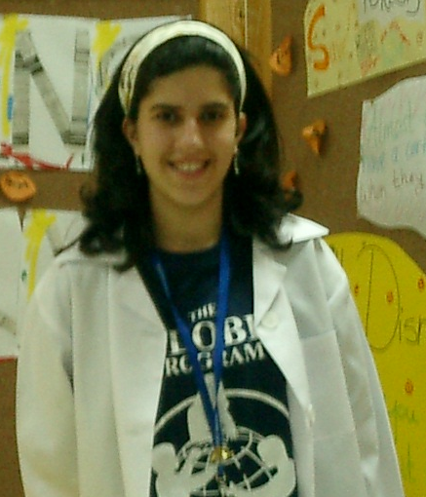

“Save our forests by recycling paper”

Done by

Eman Y. Abdulkarim
P. O. Box 40138, Hamad Town, Kingdom of Bahrain
Home phone: 00973 17422022
Cell phone: 00973 39810565
E-mail address: emanbre90@hotmail.com
School: Yathreb Intermediate Girls' school

Recycling paper

Everything started when I decided to clean up my room. After a few hours of doing that I found a big pile of paper in front of me. At this moment my imaginations took me to another world. In this world I found the machine I wanted. It's a machine for recycling paper at our homes. Another reason that made me want to invent such a machine was after I had a telephone call with one of the employees at "The United Paper Industries" in Bahrain. I spoke to "Elva Yab" who gave me some information about this industry. I was told that they get the paper from the United States of America and Europe, and turn the paper they get into cardboard. They produce 50 tons of cardboard everyday. When I asked them if they recycle paper, they answered with a 'no'.
Everyone would ask me: why do you think recycling paper is so important? I would say: we are cutting hundreds and thousands of trees and forests everyday to produce paper. If we recycled paper at home, fewer trees and forests would be cut down, and I am sure that we all know how important trees are. If we think about all the factories that produce paper and especially in the Arabian Gulf we will find out that they use a lot of petrol to make these factories work. If we recycled paper at home, we wouldn’t lose the big amounts of petrol which is very important these days. Another point to mention is the air pollution that these factories cause. If we recycled paper at home, we would cause less air pollution than usual.
All I am trying to say is the more we recycle paper, the less we need to produce new paper. All these reasons are driving me to this invention or this machine which makes us able to recycle paper at different places such as schools, kindergartens, science centers, local libraries or maybe even at our own homes.

Material needed

- A big rectangular plastic box which is similar to a small copy machine in its size
- Electrical wires or springs
- A metal box or container
- Sharp blades
- A blender with its sharp blades
- A coat hanger or a simple photo frame
- Gauze
- Water
- White Glue
- An electric iron
- Two small dryers (similar to hair dryers)

Abstract

This machine is a composition of familiar or every-day equipment that has been designed to work together smoothly.
It is a recycling machine that has a rectangular shape and it consists of three divisions: shredding / blending / drying.
First, users have to feed the machine with scrap papers. The horizontal input opening on the right side of the machine shall take care of this.
Next, the shredding process begins when sharp blades cut the paper and shred them into small pieces. The small paper pieces fall into a box or container. The container is connected to an electrical spring. The spring compresses when the container is filled. The shredding process shall last five minutes which actually depends on the amount of paper that is pushed into the machine. Therefore, a digital watch is fixed at the top of the machine to check the time.

Then, the container is emptied out into the blending division through an automatic door. After that, water is poured through the water inlet funnel (the amount of water depends on how much paper is pushed into the machine, every 25 grams of paper need 400 ml of water). The water funnel is placed at the top of the machine. Then, two table spoons of white glue are poured into the machine through the white glue funnel which is placed next to the first funnel.
After that, the blending process begins. The digital watch counts 5 minutes. Then, an automatic door opens and the mixture is pushed into the drying division. The mixture will flow on a frame. The frame is made of a coat hanger which we bend into a square shape with gauze (you could use a pantyhose) pulled over it. The frame is connected to another electrical spring which will compress once the complete amount of mixture is spread over the frame. Dryers that are placed in the upper corners of the division will take care of drying the mixture. The drying process shall take 15-20 minutes before the mixture turns into a recycled paper and comes out through the out-put opening.
All you need to do now is to iron the paper in case it is not flat enough and cut the edges. Write on the paper and see how strong and good it is!

Results expected

Less new paper will be produced which has many advantages such as:
- Fewer trees and forests will be cut down.
- Less petrol will be used in the factories that produce paper and especially in the Arabian Gulf.
- Less air pollution will be caused. Then, we will be able to breathe fresh air.

Limitations

The machine is difficult to build but once it is produced, the results make up for the effort.
It may also be too expensive to build, or too expensive for people to buy and keep at their homes. Therefore, it is suggested to buy the machine and keep it in kindergartens, schools, universities or some local libraries and make it available to the people living nearby.

References

Websites:

www.google.com
www.bonus.com Beakman and Jax by Jok Church

Other:

Microsoft Encarta 97 Encyclopedia
The United Paper Industries in Bahrain

