Introduction

The National Aeronautics and Space Administration (NASA) invites you to submit a response to this inquiry to assist in finalizing planning for the Constellation Program ground processing, assembly, integration, test, launch and recovery services acquisition development. Ground processing will provide important services at the Kennedy Space Center to support the Ares I Crew Launch Vehicle (CLV), the Ares V Cargo Launch Vehicle (CaLV), and the Orion Crew Exploration Vehicle (CEV) beginning with the Constellation Program Flight Tests and continuing through the International Space Station (ISS) and Lunar missions. The intent of this Request for Information (RFI) is to obtain information from industry to assist NASA in the planning for the Ground Processing Services acquisition development. NASA reserves the right to share all information received in response to this RFI throughout NASA and to use all information submitted in response to this RFI in NASA’s formulation of one or more solicitations seeking competitive proposals on contracts for or related to the requirements described herein. However, any competition sensitive data should be clearly marked. Although information contained herein represents current program content and acquisition planning, it is subject to change. Response to this RFI is requested within the context of the general approach described in the following paragraphs.

Tentative Acquisition Schedule:

Industry Day - April 07
Draft Request for Proposal (RFP) – March 08
RFP – September 08
Award – July 09

Constellation Architecture

The Constellation Program is responsible for developing the Orion Crew Exploration Vehicle (CEV), the Ares I Crew Launch Vehicle (CLV), the Ares V Cargo Launch Vehicle (CaLV), the associated Ground Systems and related exploration architecture systems that will provide capabilities necessary for human space flight and exploration of the solar system as illustrated in Figure 1. The CEV is the space vehicle that NASA plans to use to send humans and cargo items into space and to return them safely to Earth. The human-rated CLV will deliver the Crew Exploration Vehicle (CEV) to low-Earth orbit early in the next decade and is an in-line configuration with a Space Shuttle legacy 5-segment Reusable Solid Rocket Motor (RSRM) as the First Stage and a new Upper Stage powered by a liquid hydrogen / liquid oxygen J2X engine, an evolution from the Apollo program’s Saturn IB and Saturn V. The Ares V consists of two 5-segment Solid Rocket Boosters (SRB), a 33ft. diameter LOX/LH2 Core Stage with 5 modified RS68 engines. Additionally, an Earth Departure Stage (EDS) of LOX/LH2 with a single J2X engine is integrated with the Core Stage. NASA plans to perform the final assembly, test, integration, launch and recovery of the Ares I/Orion and Ares V/Lunar Surface Access Module (LSAM) mission elements at the Kennedy Space Center (KSC) in Florida.

The Ground System Operations Concepts established in this document are based on the Constellation flight vehicle configurations depicted in Figure 1.

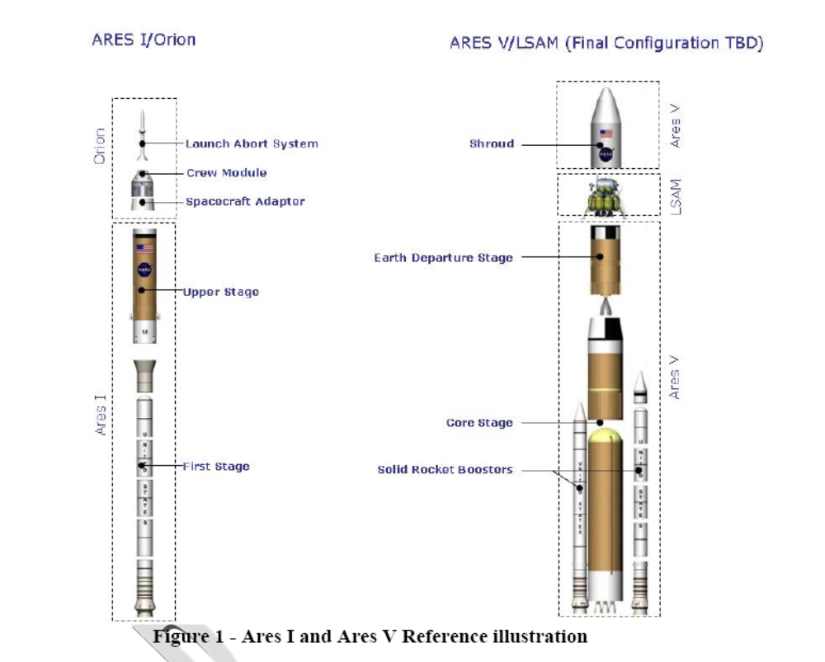

NASA plans to have delivered the following at KSC by its planned element design and production contractors:
- CEV Orion Lockheed Martin: an assembled Crew Module (CM) and Service Module (SM) ready for its final cargo installation, flight emulator testing as required, hazardous servicing, launch and CM recovery. The Launch Abort System (LAS) will be delivered to the Rotation Processing and Surge Facility (RPSF) and then integrated during stacking and element integration in the Vehicle Assembly Building (VAB).
- CLV Ares I First Stage ATK Thiokol for Design, Development, Test and Evaluation (DDT&E) flights, Ares 2, Orion 3 and Orion 4: aft booster assembly, Solid Rocket Motor (SRM) segments and forward assembly ready for final stacking in the VAB. The First Stage DDT&E operations concept and interface with the ATK and the Ground Processing Services contractor are depicted in Figure 2.

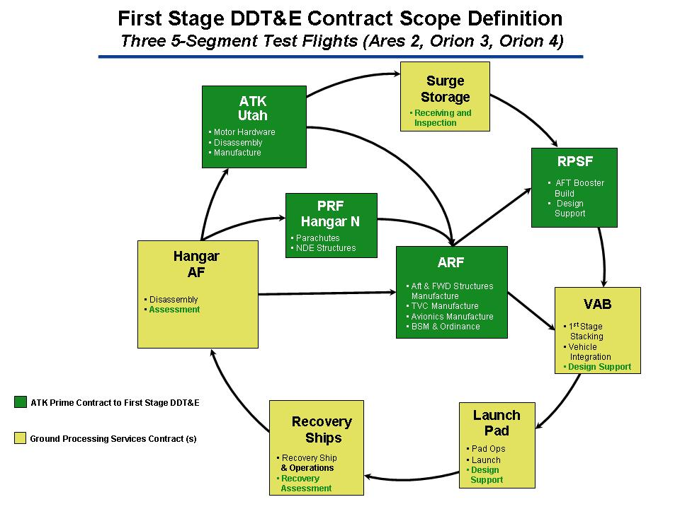

Figure 2

- CLV Ares I First Stage production post-Orion 4: Solid Rocket Motor hardware is delivered to the RPSF by the production contractor ready for final offline processing and aft booster buildup. The First Stage operations concept post-Orion 4 is depicted in Figure 2b. The empty segments will be returned to production contractor for propellant loading. Note: This requirement has not had a formal procurement strategy meeting.

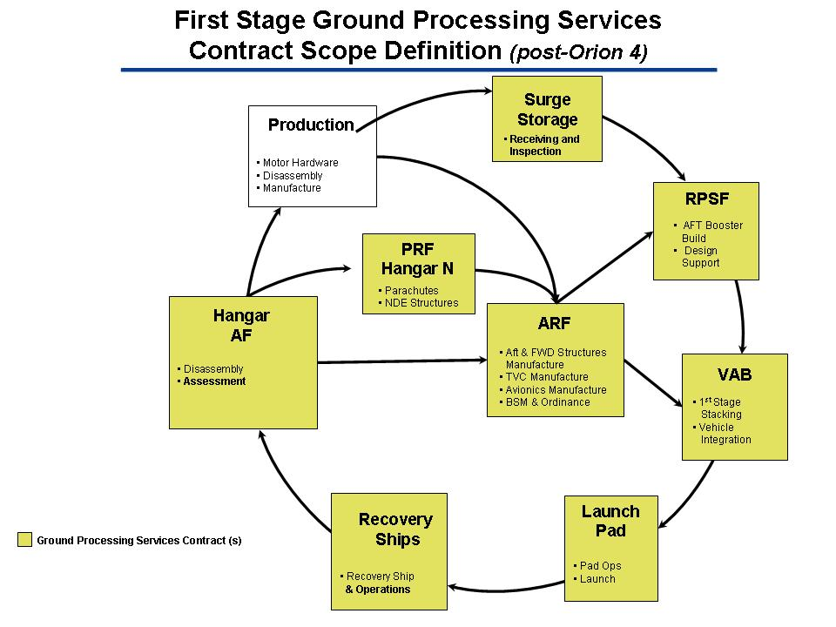

Figure 2b

- CLV Ares I Upper Stage production contractor will deliver an integrated Upper Stage including its engine for final integration with the First Stage and CEV elements. Note: This requirement is being competed with a RFP release date of Feb 23, 2007.
- Ares V SRB is consistent with item 3 above.
- Ares V Core Stage production contractor will deliver an integrated Core Stage including its engines for final mating with the SRB stack.
- Earth Departure Stage and LSAM operations concepts are still under review, however the delivery relationship between the production and Ground Processing Services contractor functions are anticipated to be similar with Ares I and Orion services mentioned above.
- NASA intends to procure, through Indefinite Delivery/Indefinite Quantity (IDIQ) contracts with the prime design contracts, support for sustaining engineering during operations.

While each of these flight hardware elements will play a major role in the execution of the nation’s Vision for Space Exploration, this RFI will focus solely on the acquisition of the services required to assemble, integrate, test, launch, and recover the Constellation Program’s flight elements, including refurbishment of the launch vehicle booster elements. Additional information describing the Vision for Space Exploration and its plans for the acquisition and development of each major element can be found on the Exploration Systems Mission Directorate website (http://exploration.nasa.gov).

The KSC Operations Flow for the aforementioned hardware is depicted in Figure 3.

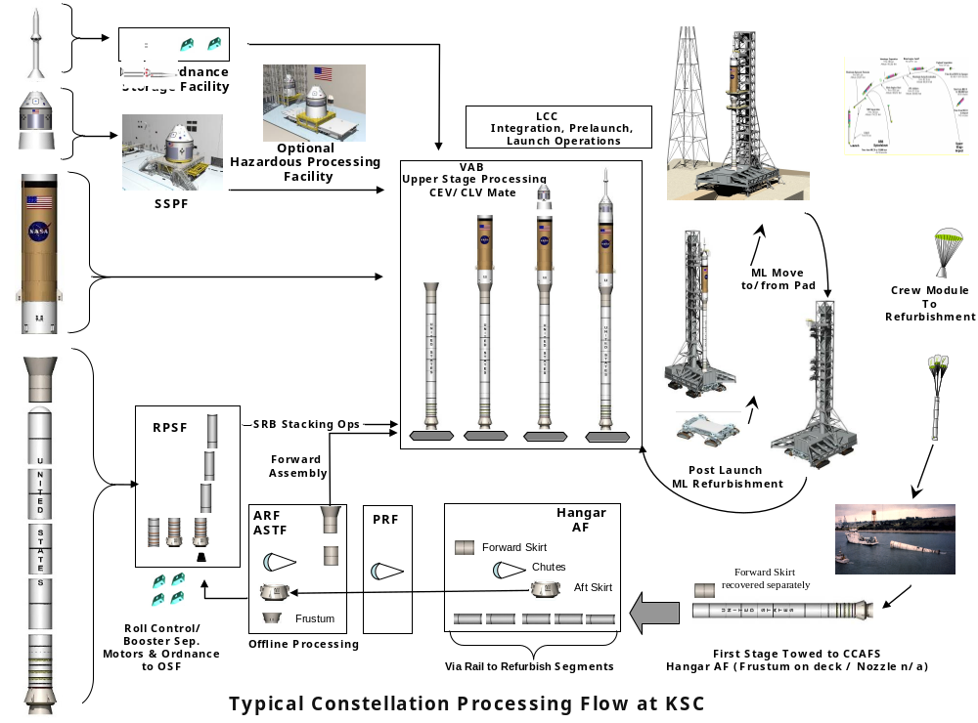

Figure 3 KSC Ground Processing Flow

NASA plans to issue a competitive solicitation for proposals and award a contract or multiple contracts to perform the following in support of the final assembly, test, integration, launch, recovery and post-flight turnaround of Constellation Program hardware:

(1) CEV (Orion) Spacecraft Processing:
- CM/SM to ISS emulator testing
- First Element Integration Test (FEIT) and Multi-Element Integration Test (MEIT)
- Cargo integration and de-integration/return
- System servicing (propellant, Active Thermal Control System (ATCS) fluids, Environmental Control and Life Support System (Subsystem) (ECLSS) fluids, etc)
- Command Module Reaction Control System Gaseous Oxygen (GOX)/Methane propellant servicing and small ordnance installation
- Service Module main propulsion and Reaction Control System (RCS) hypergolic servicing
- Verification of Spacecraft separation systems
- CM Recovery (land landing is nominal; water recovery is contingency)
- Transportation of CM to manufacturer
- Activation, validation, operations and maintenance of spacecraft processing ground systems

(2) CLV (Ares I) and Integrated Operations:
- Stacking of the booster segments in the VAB
- Integration and stacking of the Upper Stage and Interstage
- Flight Termination System (FTS) installation
- Loading of RCS (Reaction Control System) and RoCs (Roll Control System) modules (First Stage Roll Control System and Upper Stage Reaction Control System)
- Integration of CM/SM, Launch Abort System (LAS) onto the Ares I
- Interface verification of Orion/Ares I
- CM GOX/Methane final servicing/pressurization
- Ordnance installation and connection
- Launch operations
- Recovery of Ares I boosters and parachutes
- Individual segment cleaning and preparation for shipment to TBD production contractor
- Activation, validation, operations and maintenance of Launch Vehicle and Integrated Operations ground systems
The following functions are included in the Ground Processing Services scope after Orion 4:
- Post-flight turnaround of recovered parachutes
- Post-flight turnaround of the aft skirt with new rise off umbilical, frustum, and forward skirt (including avionics). The following hardware is planned to be refurbished by the Ground Processing Services contractor based on anticipated First Stage redesign concepts: parachute/recovery system, aft skirt assembly, and the forward assembly
- Aft Booster buildup and assembly
- Segment offload and inspection

- CaLV (Ares V) and Integrated Operations
- Similar to items in #2 for Ares I processing services
- Stack encapsulated payload onto EDS/Core Stage

(4) LSAM
- Similar to items in #1 for CEV(Orion) spacecraft processing
- Fairing encapsulation for LSAM

Manifest Assumptions

The first Constellation Program Test Flight (Ares 1) is planned for April 2009, utilizing current shuttle legacy hardware, ground infrastructure with minor modifications and the current shuttle processing contractor. Additional Test Flights are planned beginning in 2012 and continuing until the Initial Operational Capability is achieved no later than 2014. A planning manifest is provided in Figure 4 for reference.

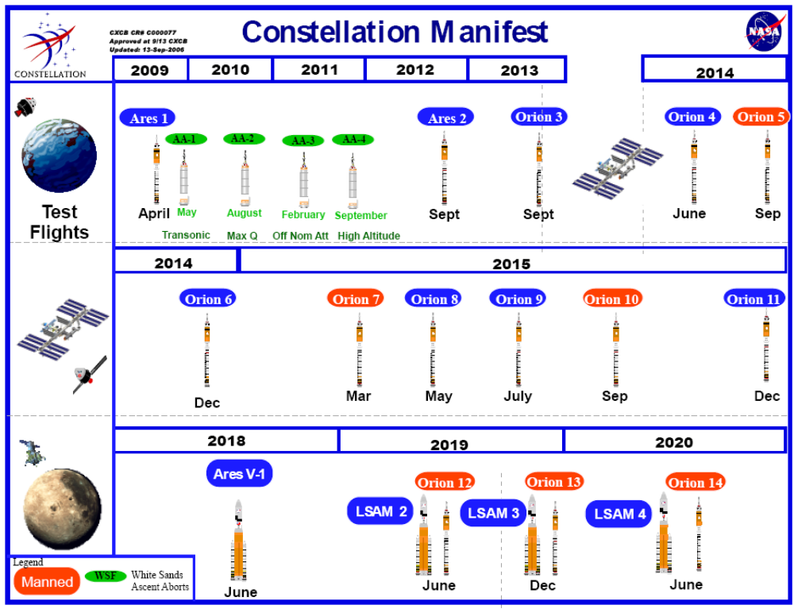

Figure 4 Reference Planning Constellation Manifest

The scope of contractual activities in this RFI are planned to commence starting in the fiscal year 2009 timeframe with the activation, validation and maintenance of the newly developed ground systems and infrastructure (Figure 5); element integration, testing, servicing, launch, and recovery of the DDT&E Test Flights starting with Ares 2 in 2012 through Orion 4 in 2014. Beginning with Orion 5, offline pre-flight aft skirt and forward assembly integration in the ARF, RPSF and Parachute Refurbishment Facility (PRF) is included.

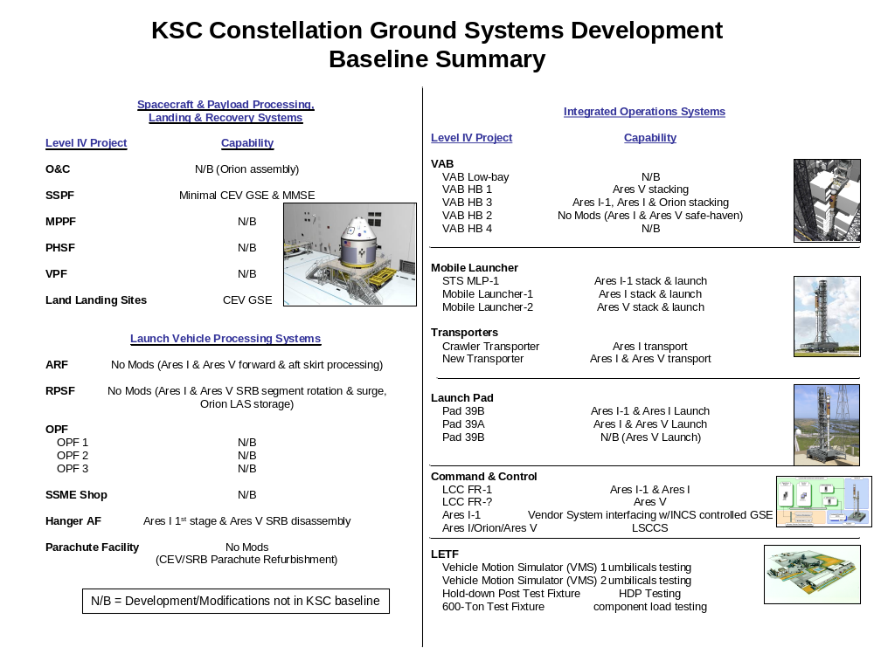

Figure 5 Major Constellation Ground Systems

Acquisition Approach

NASA will lead the assembly, test, integration, launch, recovery and post-flight turnaround of the Constellation hardware, including the sustaining engineering of its Ground Systems. NASA requires a contractor or multiple contractors to perform identified ground processing services for the Orion, Ares I, Ares V and LSAM elements as well as to operate and maintain the supporting ground systems and infrastructure.

NASA may award a single Ground Processing Services contract or multiple contracts for the requirements described in this RFI based on the best competitive solution provided by industry.

NASA plans to provide institutional services using resources internal to the government as well as through contracts outside of this planned Ground Processing Services contract. These services will be geared to providing the institutional support at KSC that would allow for the provider under this acquisition to focus on their mission of ground processing. Some examples of typical institutional services include communication and computer services, fire and security support, medical and environmental support, utilities, various laboratory services, and center move modification support. A complete list of institutional provided services will be identified in a solicitation.

NASA plans to award Mission Operations contracts outside of this planned Ground Processing Services contract.

RFI Requested Response Topics

The specific objective of this RFI is to solicit information within the context of the approach herein that may potentially enhance NASA’s planned approach for the Ground Processing Services acquisition. Comments are requested but not limited to any of the following topics:

(1) Shuttle-to-Constellation Transition

It is a primary goal of the Agency to successfully complete the remainder of the shuttle manifest through its planned retirement in 2010 and support the International Space Station through 2016. The Ground Processing Services contractor(s) will support the infrastructure development contractors in the activation and validation of newly designed ground systems, for example the Mobile Launcher and its systems, Launch Pad and its systems, etc.
- Discuss any technical, programmatic, or contractual risks and potential mitigation options that you foresee in transitioning from NASA’s current shuttle (Space Program Operations Contract) and ISS (Checkout, Assembly and Payload Processing Services) processing contract(s) to the Ground Processing Services contract(s).
- Cite any specific recommendations you have regarding transitions of this nature.
- Key areas of interest include, but are not limited to, the following:
  - Transition of critical skills to support the Constellation activities while maintaining the shuttle processing manifest commitments
  - Transition of critical skills to support the Constellation spacecraft processing activities while maintaining ISS and cargo manifest commitments as well as Launch Services Program support
  - Relationship with existing processing contractors during any period of performance overlap
  - Effective transfer of assets and infrastructure from legacy shuttle and spacecraft and cargo processing systems
  - Configuration control ownership during the transition
  - Relationship with hardware and design contractors

(2) Certification of Flight Readiness (COFR)

Accountability of the flight hardware assets from each phase of development, processing, test, servicing and integration is a fundamental requirement of human spaceflight programs. It is also necessary to ensure accountability of the hardware in the most efficient method consistent with minimizing life cycle costs for the Constellation architecture. Some of the objectives being contemplated regarding certification include finite accountability and turnover between the NASA and contractor entities responsible for specific work functions. For instance, the NASA and contractor design elements will certify the design and delivery of the flight hardware to the Ground Processing Services contractor(s). The NASA and Ground Processing Services contractor (s) will certify all work performed after hardware receipt from the design and/or production contractor through launch, recovery and refurbishment if planned for the flight hardware element. It is NASA’s intent to have a clear and systematic approach to flight hardware certification in order to eliminate duplication and redundancy in the certification from its design and processing contractors. Similarly, NASA intends to procure, through Indefinite Delivery/Indefinite Quantity (IDIQ) contracts with the prime design contracts, support for sustaining engineering during operations. NASA plans to utilize a number of contract incentives to ensure accountability of the hardware during the test flight and nominal Ares and Orion operations phase. NASA seeks responses in the following areas:

- Cite any specific examples or lessons learned you have with launch flight hardware certification and considerations regarding the accountability objective between the flight hardware design entity and the production, ground processing and operations entities.
- Describe the technical and programmatic challenges foreseen with the processing, assembly, integration, launch and recovery of the Constellation elements with respect to accountability given that there will be multiple design contractors.
- Cite any specific technical, programmatic and life cycle considerations regarding NASA’s planned approach for acquiring sustaining engineering through IDIQ contracts during operations.
- Provide recommendations to strengthen and enable the unique roles of operations and sustaining engineering; provide innovative processes and systems to ensure efficiencies. Cite examples, tools and capabilities to improve interfaces and reduce historically resource intensive processes.
- Describe any recommended relationships or contract mechanisms required to ensure accountability and readiness of the hardware.
  - Describe any unique relationships required with existing Constellation Design contractors supporting DDT&E Tests Flights.
- Provide recommendations for achieving NASA’s goal of clearly and systematically defining the certification process.
- Interoperable data systems between design, production and operations. Describe any unique relationships or contract mechanisms required to ensure efficient data management and exchange.
- Provide recommendations and discussion about what measures or combination of measures would eliminate or reduce a contractor’s ongoing oversight subsequent to turnover. Such measures might include assurances, releases, warranties, insurance, cross-waivers, indemnification, surety agreements, performance bonds, or a combination of these and other mechanisms furnished by the Government or third parties to clearly define and limit a contractor’s accountability and liability.

(3) Contract Type and Terms

NASA’s goal is to award a Ground Processing Services contract(s) that properly balances risk and rewards excellent contractor performance.

Inputs should cover, but are not limited to, the following areas:

- Make recommendations and provide supporting rationale for contract structure, contract type, fee approach, and period of performance. NASA intends to periodically recompete the services acquired under this/these contract(s). NASA envisions the award of a long-term contract(s) with a performance period up to 10 years. Comments are requested on the timeframe, as well as, any alternative recommendations based on the current Constellation Manifest where a more logical breakpoint exists that would allow recompetition of the services acquired under this contract. Suggest traditional and non-traditional incentive approaches that would achieve NASA’s goal to properly balance risk and reward contractor performance. Additionally, due to the number of contractors involved in the Constellation Program, it will be essential for contractors to work together closely. Present advantages and disadvantages to teaming arrangements and associate contractor agreements. Identify potential organization conflicts of interest and propose solutions thereto. Provide recommendations on how the contract structure, incentive approaches, and terms and conditions could facilitate establishing these critical relationships.

- NASA’s long-term goal is to obtain all or some of these services under a fixed price contract. Address any known or potential risks associated with a fixed price contract arrangement, and recommend any appropriate mitigation techniques. Identify any steps that may be taken in the near-term contract to achieve the long-term fixed price goal.

Response Instructions

The requested responses are for information and planning purposes only. NASA does not intend to post information or questions received to any website or public access location. NASA does not plan to respond to the individual responses, but will provide an update to the Ground Processing Services acquisition plan at the upcoming Industry Day. The Industry Day, jointly hosted by the ESMD and SOMD, is tentatively planned for April 2007 at the Kennedy Space Center in Florida. A detailed announcement will be posted on the NASA Acquisition Internet Service (NAIS) at http://prod.nais.nasa.gov/cgi-bin/eps/bizops.cgi?gr=D&pin=76 and FedBizOpps at http://www.fedbizopps.gov/ containing registration information and Industry Day agenda.

All responses should be provided in MS Word document format, both hard copy and electronic media. Font should be Times New Roman, size 12. Responses should not exceed 30 pages and should reference “RFI-KSC-GPS”. Please submit responses no later than March 8, 2007, to NASA/KSC Procurement Office, Attn: OP-MS/Tammy Burlein, Contracting Officer, Kennedy Space Flight Center, FL 32899. Additional questions should be provided to Tammy Burlein via e-mail: Tammy.S.Burlein@nasa.gov.

This preliminary information is being made available for planning purposes only, subject to FAR Clause 52.215-3, entitled “Solicitation for Information and Planning Purposes”. It does not constitute a Request for Proposal, Invitation for Bid, or Request for Quotation, and it is not to be construed as a commitment by the Government to enter into a contract. Moreover, the Government will not pay for the information submitted in response to this RFI, nor will the Government reimburse for costs incurred to prepare responses to this RFI.

No solicitation exists; therefore, do not request a copy of the solicitation. If a solicitation is released it will be synopsized in the FedBizOpps and on the NASA Acquisition Internet Service (NAIS). It is the potential offeror’s responsibility to monitor these sites for the release of any solicitation or synopsis.

Points of Contact

Contracting Officer
Tammy Burlein
NASA/KSC Procurement Office
321-867-3484

