NCUA LETTER TO CREDIT UNIONS

NATIONAL CREDIT UNION ADMINISTRATION
1775 Duke Street, Alexandria, VA

DATE: September 2003 | LETTER NO.: 03-CU-13

TO: Federally Insured Credit Unions

SUBJ: Credit Union Financial Trends for the First Half of 2003

ENCL: Financial Trends in Federally Insured Credit Unions -
January 1, 2003 to June 30, 2003

DEAR BOARD OF DIRECTORS:

Enclosed is a report highlighting credit union financial trends for the first half of 2003. We based our analysis on data compiled from the midyear 2003 call reports submitted by all federally insured credit unions. We are providing this information to keep you informed of current conditions and trends in the credit union industry.

Thank you for your cooperation in providing this data.

Sincerely,

/S/

Dennis Dollar
Chairman

Enclosure

Financial Trends in Federally insured Credit Unions
January 1, 2003 to June 30, 2003

HIGHLIGHTS

This report summarizes the trends of all federally insured credit unions that reported as of June 30, 2003.

Key financial indicators are noted below:¹

♦ Assets increased $42.1 billion or 7.56%.

♦ Capital: Net worth increased $3.0 billion or 5.01%, while the net worth to assets ratio decreased to 10.46%.

♦ Loans increased $11.1 billion or 3.25%.

♦ Shares increased $37.0 billion or 7.63%. The loan-to-share ratio decreased to 67.88%.

♦ Cash management accounts (cash on hand, cash on deposit, cash equivalents) plus short-term investments (less than 1 year) increased $14.2 billion or 13.69%.

♦ Long-term investments (over 1 year) increased $15.8 billion or 18.77%.

♦ Profitability decreased with a 1.04% return on average assets ratio.

♦ Delinquent loans as a percentage of total loans declined from the yearend 2002 level of 0.79% to 0.74%, while net charge-offs increased from 0.51% to an annualized 0.55% of average loans.

CAPITAL

Total net worth increased $3.0 billion or 5.01% during the first half of 2003, compared to $2.6 billion or 4.85% during the same period last year. The aggregate net worth to total assets ratio decreased from 10.72% at the end of 2002 to 10.46% as of June 30, 2003, as asset growth outpaced net worth growth. The average net worth ratio among individual credit unions decreased from 13.50% at the end of 2002 to 13.09% as of June 30, 2003.

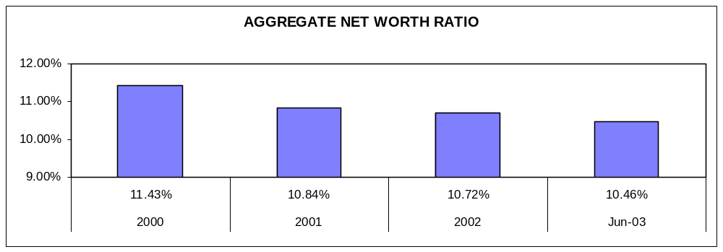

ASSET QUALITY

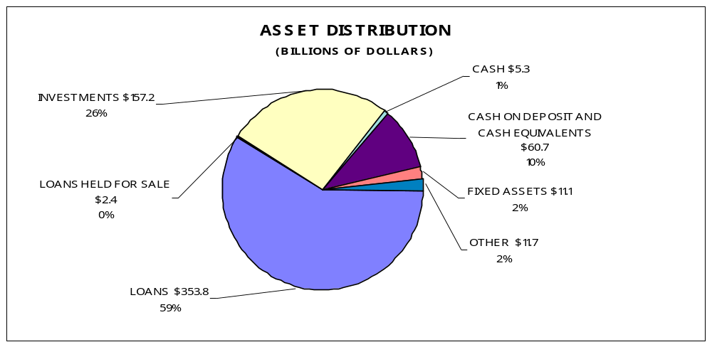

LOAN TRENDS: Total loans increased $11.1 billion or 3.25% through the first half of 2003. Changes in the various categories were as follows:

- Unsecured credit card loans decreased $1.1 billion or 5.00%;

- All other unsecured loans decreased $0.7 billion or 3.35%;

- New auto loans decreased $0.2 billion or 0.33%;

- Used auto loans increased $5.1 billion or 7.01%;

- First mortgage real estate loans increased $7.2 billion or 7.12%;

- Other real estate loans increased $0.3 billion or 0.74%;

- Leases receivable decreased $33.6 million or 2.22%; and
- All other loans increased $0.6 billion or 3.03%.

First mortgage real estate loans are the largest single asset category with $107.9 billion accounting for 30.50% of all loans. Of these, $79.0 billion or 73.18% are fixed rate. Federally insured credit unions granted $36.0 billion in fixed rate and $6.8 billion in adjustable rate first mortgage real estate loans through June 30, 2003. On an annualized basis, the amount of first mortgage loans granted exceeds the amount granted in 2002 by $24.6 billion or 40.18%. Credit unions also report $19.5 billion of first mortgages sold (includes both fixed and adjustable rates) or 45.51% of the first mortgages granted during this period.

Annualized loan growth is 6.50% while shares grew at an annualized rate of 15.27%, resulting in a loan-to-share ratio of 67.88%.

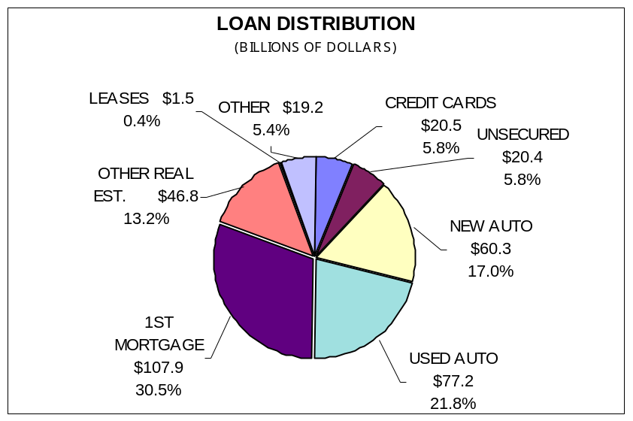

DELINQUENCY TRENDS: Delinquent loans decreased $106.0 million or 3.89% through June 30, 2003, and the delinquent loans to total loans ratio declined from 0.79% at the end of 2002 to 0.74%.

The net charge-off loans to average loans ratio increased from an annualized rate of 0.49% to 0.55%, compared to the same period last year. Charge-off loan dollars increased 17.35% over the same period last year, and recoveries increased 8.94%.

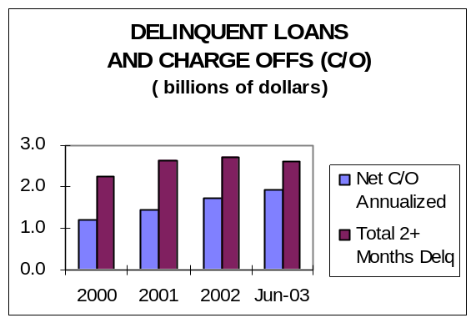

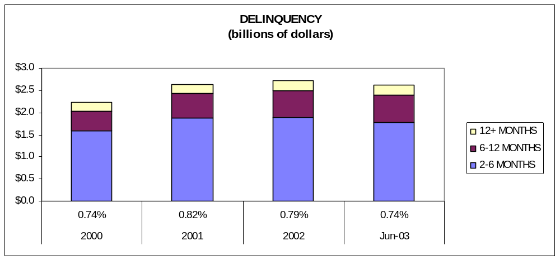

Federally insured credit unions reported $1.1 billion of outstanding loans subject to bankruptcy. In addition, $413.3 million of bankruptcy loans were reported as charged off during the first half of 2003. This accounts for 36.79% of all loans charged off this year. The number of members filing bankruptcy increased 15.98% compared to the number reported the same period last year, with 0.18% of all members reporting bankruptcy though the first half of 2003.

INVESTMENT TRENDS: Total investments increased $17.0 billion or 12.12% through the first half of 2003. All investment categories displayed growth.

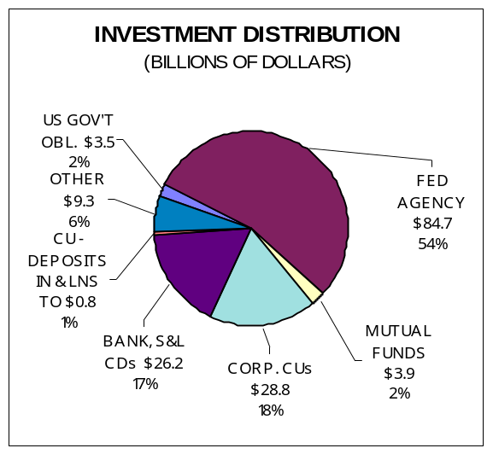
Cash management accounts increased $12.3 billion or 22.92%. The combined categories of cash management accounts plus investments with maturities of less than one year, increased $14.2 billion or 13.69% through the first half of 2003.

Investments with maturities greater than a year increased $15.8 billion or 18.77%.

The investment category noting the largest dollar growth is Federal Agency Securities, which increased $10.1 billion or 13.59%. U.S. Government Obligations noted the largest rate of growth at 26.24% or $0.7 billion.
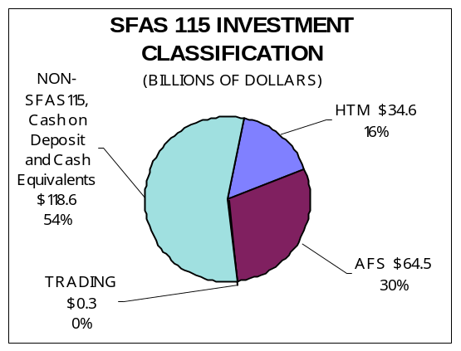

Non-SFAS 115 Investments increased from $100.2 billion to $118.6 billion ($18.4 billion or 18.34%). Held to Maturity investments increased from $32.2 billion to $34.6 billion ($2.4 billion or 7.22%). Available for Sale investments increased from $55.2 billion to $64.5 billion ($9.3 billion or 16.85%). Trading Securities increased from $253.5 million to $261.5 million ($8.0 million or 3.17%).

As of June 30, 2003, Held to Maturity and Available for Sale investments made up 46% of the investment portfolio (16% and 30%, respectively), non-SFAS 115 Investments, Cash on Deposit, and Cash Equivalents accounted for 54% of the portfolio and less than 1% was classified as Trading.

The following table compares the changes in the maturity structure of the investment portfolio in the past year. The majority (52.78%) of investments are over 1 year in maturity.

Investment Maturity or Repricing Interval | % of Total Investments June 2002 | % of Total Investments June 2003
Less than 1 year | 55.08% | 47.22%
1 to 3 years | 32.03% | 23.32%
3 to 10 years | 11.74% | 27.27%
Greater than 10 yrs | 1.15% | 2.19%

EARNINGS

The large growth in deposits and modest loan growth experienced since 2001, coupled with a low interest rate environment, has significantly reduced the gross income to total assets ratio compared to the same period last year. Reductions in the cost of funds, operating expenses, and provision for loan and lease losses, along with an increase in non-operating income (primarily gains on investments) in relation to average assets, maintained the return on average assets as noted in the following table.

Ratio | As of 06/2002 | As of 06/2003 | Effect on ROA
Gross Income | 7.00% | 6.26% | - 74 bp
- Cost of Funds | 2.40% | 1.77% | + 63 bp
- Operating  Expenses | 3.23% | 3.18% | + 5 bp
- Provision for Loan & Lease Losses | 0.35% | 0.32% | + 3 bp
+ Non-  Operating Income | 0.02% | 0.05% | + 3 bp
= Return On Assets | 1.04% | 1.04%
ASSET/LIABILITY MANAGEMENT

LONG-TERM ASSET TRENDS: Long-term assets as a percentage of total assets continue the upward trend noted at the end of 2001. Long-term assets, which are primarily investments having maturities or repricing intervals greater than 3 years and real estate loans having maturities or repricing intervals greater than 5 years, equaled 23.68% of total assets as of June 30, 2003, compared to 23.09% for the same period last year. The increase in long-term assets is primarily due to an increase in real estate loans and longer term investments.

SHARE TRENDS: Total shares increased $37.0 billion or 7.63% through the first half of 2003. Growth rates for the various share categories are as follows:

- Share drafts -- increased $6.1 billion or 10.46%;

- Regular shares -- increased $16.8 billion or 9.78%;

- Money market shares -- increased $8.4 billion or 9.68%;

- Share certificates -- increased $2.0 billion or 1.73%;

- IRA/Keogh accounts -- increased $2.5 billion or 5.76%;

- Other shares -- increased $1.2 billion or 22.41%; and

- Non-member deposits -- decreased $9.3 million or 0.77%.

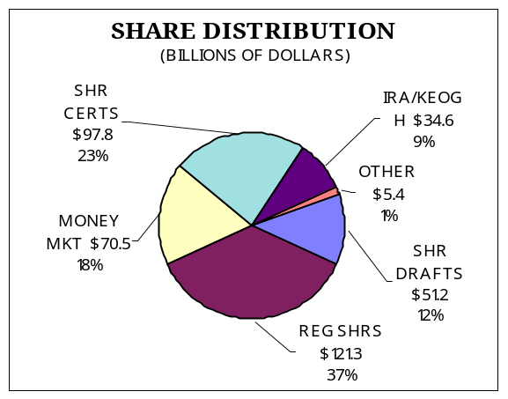Compared to the same period last year, the largest increase in share dollars is in the less than one-year maturity category, which is consistent with the large dollar growth in share draft, regular share, and money market accounts.

Share Maturity or Repricing Interval | Shares  June 2002 (Billions) | Shares  June 2003 (Billions)
Less than 1 year | 427.2 | 465.9
1 to 3 years | 34.0 | 39.8
3 or more years | 9.4 | 15.5

Shares with maturities greater than one year experienced the highest rate of growth as noted by their percent of total shares increase in the following table.

Share Maturity or Repricing Interval | % of Total Shares  June 2002 | % of Total Shares  June 2003
Less than 1 year | 90.77% | 89.39%
1 to 3 years | 7.23% | 7.64%
3 or more years | 2.00% | 2.97%

OVERALL LIQUIDITY TRENDS: At the end of the first half of 2003, credit unions held 20.51% of total assets in cash and short-term investments. This remains near the credit unions’ average historic level of approximately 20% of assets. Notes payable increased from $6.2 billion at the end of 2002 to $7.4 billion at June 2003.

Annualized Share growth of 15.27% was over two times that of annualized loan growth of 6.50%. This continues the reversal noted during 2001.

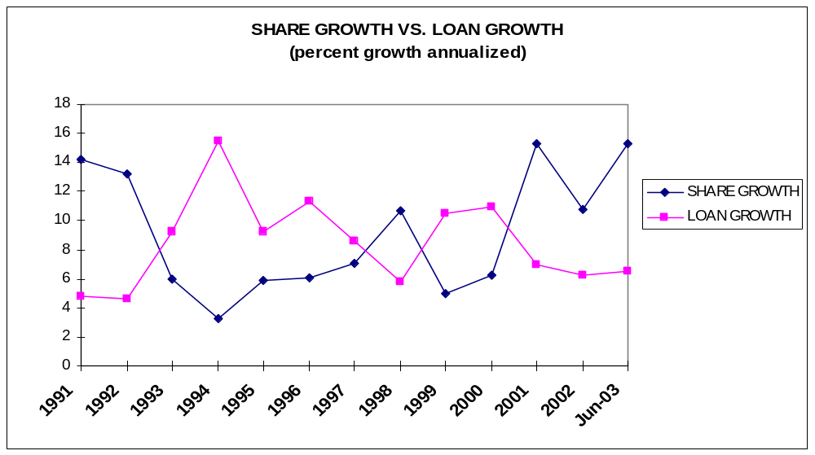

The significant share growth trend that began in 2001 has continued into the first half of the year. Loan growth remains modest in comparison resulting in increased levels of cash and investments. These trends resulted in a decline in the loan-to-share ratio from 70.77% at year-end to 67.88%.

Although lending is growing at a slower rate than savings, the 3.25% increase in loans is noteworthy given the challenging economic period as well as today’s competitive rate environment. Return on assets remains strong and credit unions continue to build net worth; however, the net worth ratio decreased slightly due to significant asset growth. The midyear numbers are solid and credit unions performance remains strong. Maintaining vigilant balance sheet management will ensure the continued success of the credit union industry.

