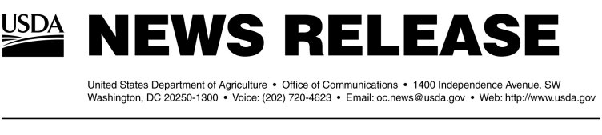
Release No. 0157.04
April Demert (202) 720-9113
Steven Cohen (202) 720-9113

USDA OPENS NEW BIOSAFETY LEVEL 3 FACILITY

WASHINGTON, April 22, 2004—Agriculture Secretary Ann M. Veneman today announced the opening of a new $1.65 million Food Safety and Inspection Service (FSIS) Biosafety Level 3 (BSL-3) facility in Athens, Ga. that will conduct analyses on a wide range of potential biological threat agents.

“As part of the Bush Administration’s efforts to enhance homeland security, USDA has implemented an extensive program to secure American agricultural production and protect consumers,” Veneman said. “This new lab will enhance our surveillance program, while expanding our nation’s capability to respond quickly to unforeseen events.”

“FSIS has been testing for a variety of threat agents as part of its extensive microbiological sampling program to combat foodborne illness,” said USDA Under Secretary for Food Safety Dr. Elsa Murano “This facility creates the capacity to test for additional substances and to test in higher volumes when necessary.”

Facilities with the designation BSL-3 use pathogens in research and diagnostic activities that could constitute a threat to either human health or productivity of the agriculture system. Laboratory personnel at BSL-3 facilities have specialized training in handling pathogens and toxins and are supervised by scientists experienced in working with these agents.

The new BSL-3 facility in Athens uses state-of-the-art technology to maintain a high level of containment and control. BSL-3 facilities prevent contamination using a broad range of techniques and barriers, including tightly controlled and restricted access to facilities, techniques that require handling of infectious materials in sealed containers or biosafety cabinets, special clothing and advanced training.

Funding for the new laboratory was provided in the 2002 Department of Defense and Emergency Supplemental Appropriations for Recovery from and Response to Terrorist Attacks on the United States Act.

To outline many of the Agency’s accomplishments in food security, Dr. Murano also released a document entitled, “Protecting America’s Meat, Poultry and Egg Products: A Report to the Secretary on the Food Security Initiatives of the Food Safety and Inspection Service” at the laboratory opening today.

In addition to the new BSL-3 facility in Athens, FSIS has four laboratories staffed by approximately 200 microbiologists, chemists and veterinary pathologists. Three of the labs, located in Athens, Ga., St. Louis, Mo. and Alameda, Calif., conduct continuous regulatory testing on meat, poultry, and egg products. Additionally, the Microbial Outbreaks and Special Projects Laboratory (MOSPL), also located in Athens, Ga., performs analyses related to foodborne illness outbreaks and conducts special projects for the agency.

#
NOTE: Access news releases and other information at the FSIS Web site at www.fsis.usda.gov

