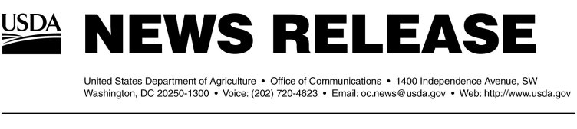

Release No. 0221.02

Alisa Harrison (202) 720-4623

Johna Pierce (202) 720-4623

USDA RELEASES NEARLY $2.3 MILLION TO GEORGIA FOR STRENGTHENING AGRICULTURE HOMELAND SECURITY PROTECTIONS

ATLANTA, Ga., May 31, 2002—Agriculture Under Secretary for Marketing and Regulatory Programs Bill Hawks today announced that the U.S. Department of Agriculture is releasing $2,261,764 to the state of Georgia to bolster food and agricultural homeland security protections, out of a total of more than $43 million being provided to states. The resources are part of $328 million approved by President Bush and the Congress earlier this year to strengthen USDA’s homeland security preparedness.

“These grants are an important component of the Administration’s continued efforts to strengthen homeland security protections for America’s food and agriculture,” said Hawks. “States, local communities, academia and the private sector are all critical partners in making sure we are prepared in the event of an emergency.”

The $43 million will provide funding to support critical efforts to strengthen the food supply infrastructure. Of that, $20.6 million will be provided to our state and university cooperators to be used to establish a network of diagnostic laboratories disbursed strategically throughout the nation to permit rapid and accurate diagnosis of animal disease threats; $14 million will be used to strengthen state capabilities to respond to animal disease emergencies, primarily by helping every state to meet the national standards of emergency preparedness established by the National Animal Health Emergency Management System; $4.5 million will be used to strengthen state-level surveillance for animal disease; and $4.3 million will be used to assist states to improve their capability to detect plant pests and diseases.

Under Secretary Hawks was joined by Rep. Saxby Chambliss in making the announcement. This week, Agriculture Secretary Ann M. Veneman and Hawks, along with several USDA subcabinet members, are traveling to nearly a dozen states to discuss the importance of homeland security with Congressional, State and local officials and actions that federal, state, private sector and academia are taking to improve agriculture protection systems.

The state of Georgia will receive $2,261,764 in funding. Of that, $2 million will be used for rapid detection and diagnostics network, $133,669 will be for animal disease response, $75,000 will be for plant pest and disease detection, and $53,095 will be for animal disease surveillance.

-more-
-2-

Earlier this year, USDA also announced additional homeland security allocations which include:

- $177 million to make physical and operational security improvements at key USDA locations. This provides $64 million at the animal disease center in Ames, Iowa to relocate labs from leased space into the main Ames campus and includes funds for a new facility for sensitive diagnostic work, which will be completed in 18 months.

- $23 million for USDA’s Plum Island laboratory, pending an independent review of the critical needs and options for the facility.

- $35 million to strengthen the Agricultural Quarantine Inspection program to exclude agricultural pests and diseases at the borders. These funds are being used to expedite development of an automated system of inspections in coordination with the U.S. Customs Service. In addition, USDA is purchasing 100 rapid pathogen identification devices and hiring additional inspection personnel.

- $16.5 million for the Food Safety and Inspection Service to increase monitoring, provide training to inspectors and expand technical capabilities. $1.5 million of these funds are being used to hire additional inspectors for imported meat and poultry.

- $15.3 million for the Agricultural Research Service to improve rapid detection technologies for foot and mouth diseases as well as other animal diseases.

Additional information on homeland security is available from www.usda.gov/homelandsecurity.

In USDA’s FY 2003 budget request, more than $150 million is being requested for additional homeland security protections. As well, if the budget is approved by Congress, it would bring food safety and pest and disease protection spending to the highest levels ever at USDA.

#

