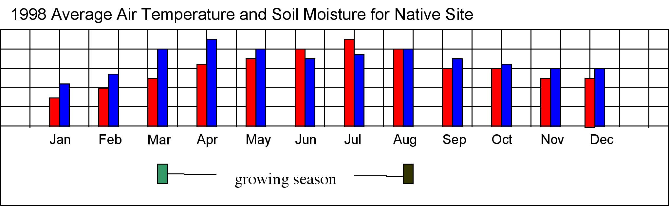
Green up
Brown down
Key
Soil moisture
Air temperature

A group of crop scientists is studying if they can grow a food crop from one area in a different part of the world. The place where the crop grows now, is called the "native area". To begin their studies, the scientists are looking for areas that have similar growing seasons. The growing season is the time period from the plant is actively growing. The environment and climate conditions must be just right.. "Green-up" is the time when plants begin to grow. "Brown-down" is the time when plants stop growing for the season. To begin their studies on the growing season in different areas, scientists are looking at air temperature and soil moisture.

In this activity you will compare the growing season in several areas.

- (Plan Investigations: Pose relevant questions) Use information from the graph on page 1 to help you fill in the table below:
How is this native area  LIKE  the area where you live? | How is this native area  UN-LIKE  the area where you live?
- (Answers will vary but should include information about current temperature and temperature patterns) | - (Answers will vary but should include information about current temperature and temperature patterns)

- (Interpret GLOBE Data: Infer patterns, trends) Before you can look for areas with similar growing seasons, you need to study the growing season in the native area more. Look at the graph on page 1. Mark the beginning of each season on the graph. Write S for Spring, Su for Summer, F for Fall and W for Winter. What clues did you use to help you decide when each season begins?

Answers will vary.
Students may use the traditional dates of the equinox and solstice to signify the beginning of seasons.
OR
Students may recognize that the equinox and solstice fall mid-season and correspondingly identify each season as beginning 6 – 7 weeks prior to the equinox / solstice.
OR
Students may tie the Spring and Fall seasons directly to “green-up” and “brown-down” and place Summer half way between Spring and Fall and Winter half way between Fall and Spring.

The crop scientists have found three other areas they would like to study more. The growing season graphs for all of the study areas are shown below.
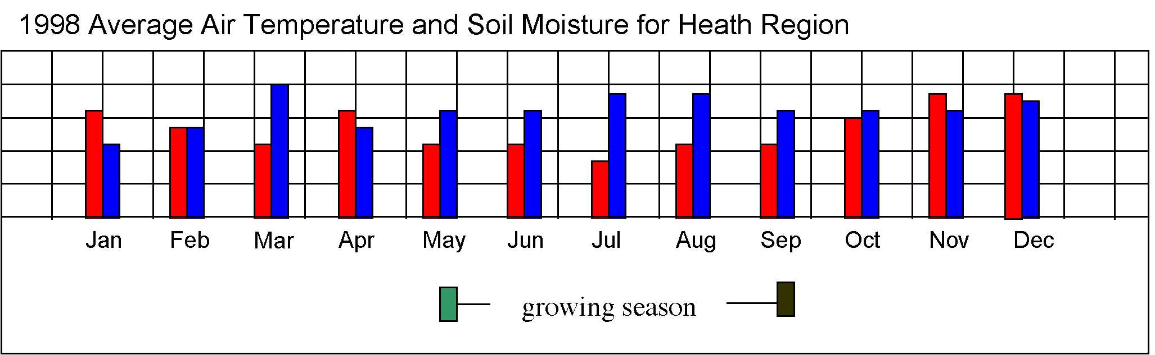

Green up
Brown down
Key
Soil moisture
Air temperature

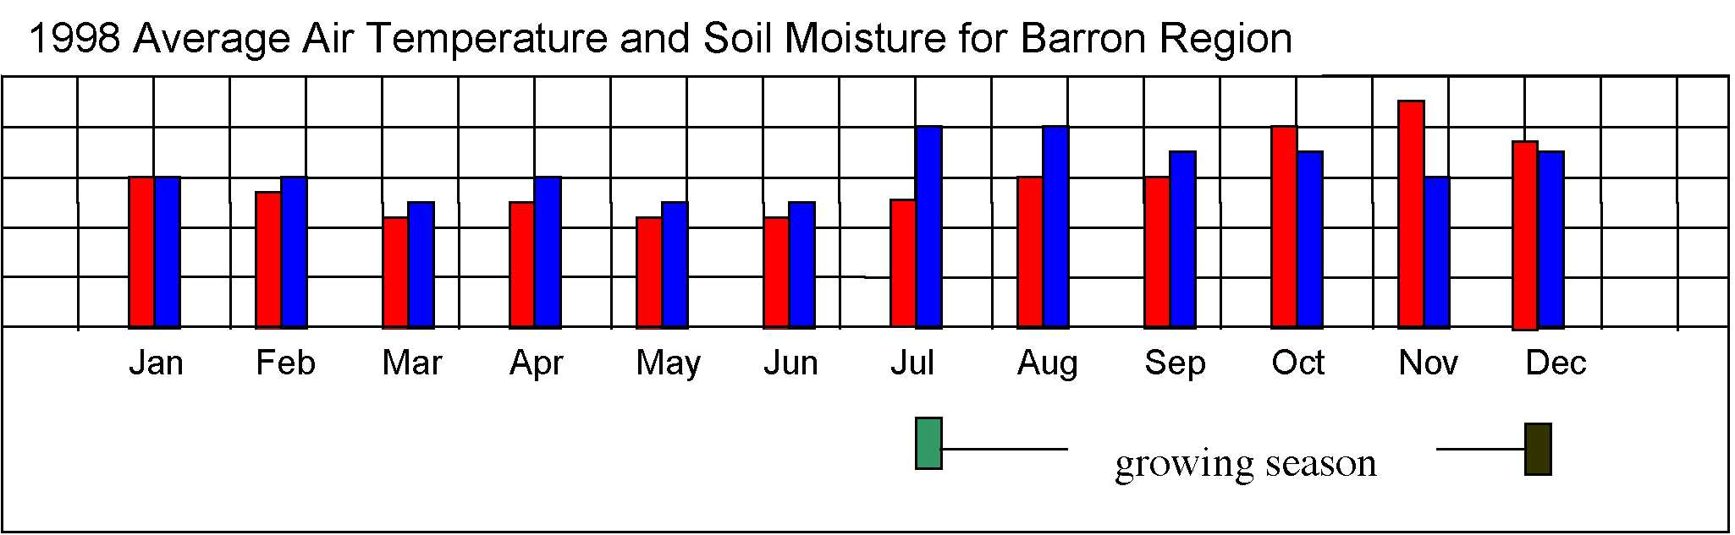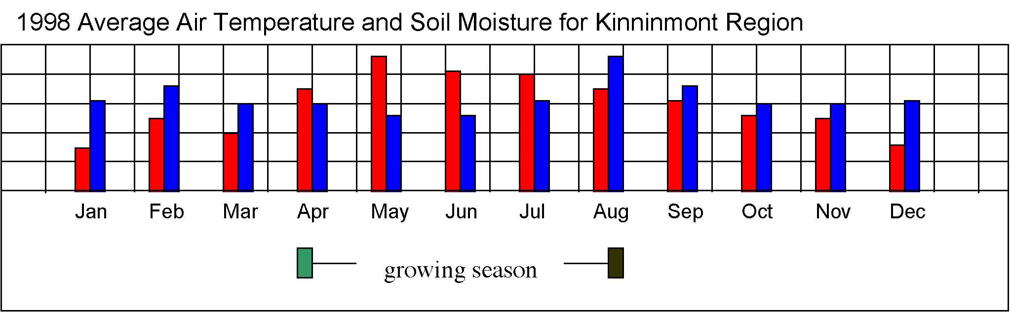

3) (Interpret GLOBE Data: Infer patterns, trends) Look at the bar graphs on page 3. Copy the season information from page 1 onto the native site graph on page 3. Then mark where you think each season begins for Heath Region, Barron Region and Kinnimont Regions.

Answers will vary. Some students might note that the Barron region is in the Southern Hemisphere and other three regions are in the Northern Hemisphere.
4) (Interpret GLOBE Data: Explain data and relationships) Use the information in the graphs on page 3 to collect more information about the regions. You will compare the new regions to the native site. Write "+" if the measurement at the new site is more than the measurement at the native site. Write "-" if the measurement is less than the measurement at the native site.
Region | Beginning  of growing season  (Green-up) |  | End  of growing season  (Brown-down)
Region | Temp | Soil | Temp | Soil
Heath | - | - | - | -
Barron | same | same | - | -
Kinninmont | + | - | - | +

- (Analyze GLOBE Data: Identify similarities and differences) Use the information in the table you just made to help you decide which of the new sites is MOST like the native site? What information helped you decide?

The Barron site is most like the native site. Out of four comparisons, two are exactly the same as the native site. At the Heath site, all the comparisons are lower and at the Kinnimont site, two of the comparisons are lower and two are higher. (At this point, some students may mention the Southern / Northern Hemisphere difference of the two sites.)

6) (Plan Investigations: Specify measurements to investigate) The graphs on page 3 all show how "green-up" and "brown-down" are related to the temperature and soil moisture. Think about and write down two other factors might affect when "green-up" and "brown-down" occur.

Answers will vary but additional factors may include: soil temperature, overall moisture, type of crop planted, amounts of nutrients in the soil.

7) (Communicate: Compose reports to explain or persuade) Write a one-page letter to the crop scientists. Include these 3 things in your letter:
- Use your own words to write a summary of how you analyzed the information in the graphs that they gave you. Be sure to include your conclusions also.
- Tell the scientists what new graphs do you suggest they get from the GLOBE databank that will help them make more comparisons of these study sites. Explain why you think each graph will give helpful comparisons.
- One question you would like to ask the crop scientists about this study and why you are interested in the answer

Answers will vary but should include summaries and information from the questions in this activity.

