(Present problem requiring use of GLOBE data archives)
The students in your classroom are GLOBEpals with students at another school. You like to print out the photographs taken from your GLOBEpal school. It helps you imagine what is happening at their school so that you can write more interesting notes to them. In this activity you will look at some photos made by your GLOBEpals.

1) (Take GLOBE Measurements: Measurements are accurate and appropriate) & (Interpret GLOBE Data: Create multiple formats to represent data) Look at the photograph labeled April 3rd and the photograph that was taken three weeks later on April 23rd. Think about all the things that are happening in this photograph, even if you can't see them. For example: Where are the animals? What are they doing? What is happening inside the soil? Make a list of all the things that are different about the environment at these two times. Decide if your observation is about "air" "water" "soil" or "living things" and write it in the correct column in Table 1. One example is included in the Table.

Table 1: Differences Between April 3rd and April 23rd photograph
Air | Water | Soil | Living Things
There are more clouds on April 3rd.  The clouds on April 3rd are stratus clouds and the clouds on April 23rd are cirrus clouds.  The sky is mostly blue on the 23rd but mostly cloudy and grey on the 3rd.  Accept any reasonable observation. | The precipitation that happens on April 3rd is in the solid form. It is snow. The precipitation that happens on April 23rd is in the liquid form. It is rain.  Accept any reasonable observation. | The ground is probably still frozen under the snow on the 3rd.  The ground is probably starting to warm up and is not frozen on the 23rd.  The ground looks wet where the footprints have melted the snow on the 3rd.  The ground looks dry on the 23rd.  Accept any reasonable observation. | Only the evergreen fir trees have leaves and you can’t see any grass on the 3rd.  On the 23rd, it looks like there is some green grass starting to grow.  Accept any reasonable observation.

(Given data from the GLOBE data archives)
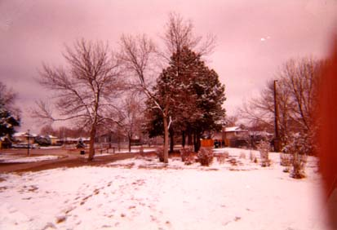
April 3rd
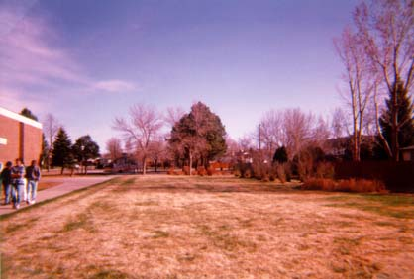
April 23rd

2) (Take GLOBE Measurements: Measurements are accurate and appropriate)
Now look at the photograph labeled April 23rd and the photograph that was taken three weeks later on May 14th. Think about all the things that are happening in this photograph, even if you can't see them. For example: Where are the animals? What are they doing? What is happening inside the soil? Make a list of all the things that are different about the environment at these two times. Decide if your observation is about "air" "water" "soil" or "living things" and write it in the correct column in Table 2. One example is included in the Table.

Table 1: Differences Between April 3rd and April 23rd photograph
Air | Water | Soil | Living Things
Now the clouds are cumulus on the May 14th picture.  Accept any reasonable observation. | Both of the pictures show nothing about water. We can’t tell if it rained by looking at the pictures.  Accept any reasonable observation. | The roots of grass are growing deeper and deeper into the soil on May 23rd.  Accept any reasonable observation. | On April 23rd, the students walking on the sidewalk are maybe cold - they have hands in pockets or are holding their arms around themselves.  On May 14th, the kids in the back are just standing around talking under the tree – they must not be too cold.  There is a lot more grass in the May picture compared to the April picture.  The trees have a lot more leaves in May.  Accept any reasonable observation.

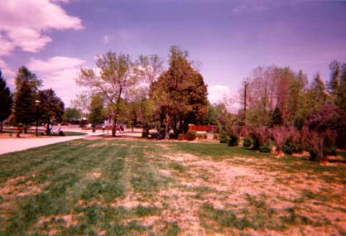
April 23rd

May 14th

3) (Interpret GLOBE data: infer patterns, trends / trends)
Describe two or more things that you predict will be different about the photograph from May 23rd and a photograph that would be taken three weeks later on June 4th.

Accept any reasonable predictions.
more grass; more leaves; change in cloud type; presence of flowers; no kids because school is out; more kids playing because school is out; presence of birds, squirrels or other small animals; etc.

4) (Communicate: Compose a report to explain or persuade) Write a GLOBEmail to your GLOBEpals. Write to them about what they will be doing on June 4th and how that will be the same or different from what you will be doing. Draw a picture that shows your prediction of what their GLOBE school site will look like on June 4th.

Hi Pat,
I like to look at the pictures we get from your school. They tell me a lot about where you go to school. I think that in three weeks on June 4th you will not be at school! I won’t. On June 4th I think the sky will be blue and the temperature will be warm so that you can play outside. Me too! That will be great fun! I like to go swimming in the summer when there is no school. How about you? Here is a picture of what I want to do on June 4th.

Your Friend,
Chris

