(Present problem requiring use of GLOBE data archives)
The students in your classroom are GLOBEpals with students at another school. You like to print out the photographs taken from your GLOBEpal school. It helps you imagine what is happening at their school so that you can write more interesting notes to them. In this activity you will look at the study site photographs made by your GLOBEpals.
(Take measurements: Make appropriate observations given data from GLOBE archives) AND (Analyze and compare: identify similarities and differences)
1. Look at the photo labeled April 3rd . Does this picture look similar or different to what happens at your school in early April? Write your answer in Table 1.
Table 1: Comparing Our School and the School in the Photo
Things that are the same  as at our study site | Things that are different  from our study site

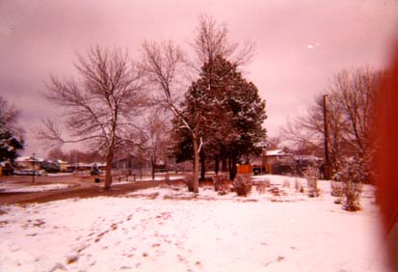(Analyze and compare: identify similarities and differences)
April 3rd
2. Is the study site in the photo more similar to your school, or more different than your school? How did you decide?

(Take measurements: Make appropriate observations given data from GLOBE archives) AND (Analyze and compare: identify similarities and differences)
3. Now look at the photograph labeled April 3rd and the photograph that was taken on May 14th.
Table 1: Comparing photographs from April 3rd and May 14th
Things that are the same about the study site on April 3rd and May 14th | Things that are different about the study site on April 3rd and May 14th
 | .
May 14th
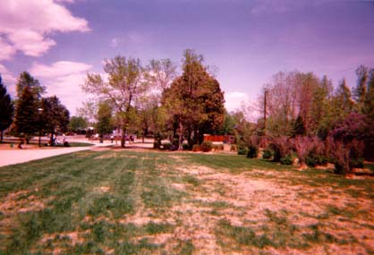
(Interpret GLOBE data: infer patterns and trends)
4. Describe two or more things that you predict will look different between the photograph from May 23rd and a photograph that would be taken three weeks later on June 4th.

(Summarize Data & Communicate Findings: Summarize and report findings)
5. Write a GLOBEmail to your GLOBEpals. Write to them about what they will be doing on June 4th and how that will be the same or different from what you will be doing on that day. Draw a picture that shows your prediction of what their GLOBE school site will look like on June 4th .

