MedlinePlus Development and Support
Statement of Work

Background Information

The National Library of Medicine requires assistance with the development of its Consumer Health Web site, MedlinePlus (http://medlineplus.gov) and MedlinePlus en español (http://medlineplus.gov/spanish/). MedlinePlus provides accurate, authoritative and up-to-date information to the general public, allied health professionals and health information intermediaries such as librarians, nurses and health educators. The focus of this resource is its 740 (and growing) topic pages which contain links to quality government information, especially NLM and NIH resources as well as other high quality information providers. MedlinePlus is not an index of all consumer health information on the Web, rather it contains highly selective links representing the best information in terms of quality, literacy level, authority of authorship, uniqueness and appropriateness for MedlinePlus’ users. MedlinePlus en español is the Spanish version of MedlinePlus with equal content, purpose and selection procedures.

General Personnel requirements include:

- Knowledge of the field of medicine, consumer health, medical terminology and the organization of medical information, including controlled medical vocabularies.
- Requires an understanding of the relationship between professional medical information and consumer information and how healthcare professionals and consumers use each type to meet their information needs.
- Experience evaluating the quality of medical information resources; including:
  - Determining the authority of authors and organizations in various fields of medicine
  - Knowledge of health literacy issues and the ability to evaluate Web-based information for low- and no-literacy
- Experience with Web site technology, including Internet Explorer and e-mail.

Selecting the information displayed on MedlinePlus topic pages is part of “topic review” wherein each link on a topic page is reviewed to ensure it continues to meet quality guidelines and that the topic page sufficiently covers all pertinent aspects of the disease or condition. Each link on a topic page is a “site record”, an individual record containing approximately 20 data fields, in the MedlinePlus database. During topic review links to information may be removed, added or moved to a more appropriate part of the page. Topic review is performed on each topic two times per year.

All work on MedlinePlus, both topic review and site record creation and editing, is reviewed and approved by a senior reviewer before changes are made to the public MedlinePlus pages.

Currently topic review and other aspects of MedlinePlus maintenance are performed partially in-house at NLM and by contract staff. The current contract holders are the Indiana University Ruth Lilly Medical Library in Indianapolis, Indiana and the University of Cincinnati Academic Health Center Library in Cincinnati, Ohio.

Selection Quality Guidelines are available at: http://www.nlm.nih.gov/medlineplus/criteria.html
For more details about MedlinePlus, please see
- MedlinePlus: Building and Maintaining the National Library of Medicine Consumer Health Web Service: http://www.pubmedcentral.nih.gov/articlerender.fcgi?artid=35193
- MedlinePlus FAQ: http://www.nlm.nih.gov/pubs/factsheets/medlineplus.html
- MedlinePlus bibliography: http://www.nlm.nih.gov/medlineplus/bibliography.html

Purpose and Objectives of the Procurement

The major objectives are to procure expert consumer health evaluation services that will continue the growth and development of MedlinePlus. MedlinePlus currently serves over 8 million unique visitors every month. These visitors view over 80 million Web pages of information including the links on MedlinePlus topic pages. Users are primarily laypersons researching health information for themselves or friends and family. The majority of users are within the United States, but MedlinePlus also serves an international community with almost every nation represented by our visitors. The accurate, authoritative and timely information provided by MedlinePlus helps users understand their disease or condition and make decisions about their own healthcare. As a source of trusted medical information to millions of people, knowledge of health information and the principles of medicine, and the strict adherence to quality guidelines is paramount to successfully meeting the objectives of this procurement.

Tasks under this procurement include:
- Topic review: Performing quality review on up to 740 health topics, twice each year
- Maintenance and special projects. Examples:
  - Testing new MedlinePlus back-end software
  - Monitoring designated Web sites (site monitoring) for new or updated content and adding links to MedlinePlus as appropriate.
  - Creating new MedlinePlus topics by identifying content with appropriate depth and breadth to cover the health condition.
  - Editing existing site records to comply with a new database field or procedure
- Topic review and other maintenance of MedlinePlus en español

Additional Tasks may include:
- MedlinePlus Go Local testing and review: Reviewing health service provider records for currency and accuracy as well as appropriate mapping to MedlinePlus topic vocabulary and service terms.
- Spanish translation services for MedLine Plus.

Outcome – If services are successfully provided to NLM than the ultimate implications are better health consequences for MedlinePlus and MedlinePlus en espanol users.

Maintenance of MedlinePlus

Topic review:

Note: Topic review will comprise approximately 75– 85% of the work performed on the contract. Topic review is a performance-based task.

The contractor shall evaluate and review up to 740 topic pages (http://www.nlm.nih.gov/medlineplus/all_healthtopics.html) twice each year, as assigned by NLM. NLM will assign blocks of records and will expect turnaround in two weeks. The
topic review and maintenance and development tasks will be accomplished using many tools including search engines, desktop office suite software, and e-mail. The Contractor under the direction of library staff, analyze current services and make changes to improve those services.

First level review:
For each assigned Health Topic page, the contractor shall recommend deletions of outdated information, changes, updates, corrections, or new site record entries for these pages to maintain appropriate coverage of the overall health topic. The Contractor shall make these recommendations in accordance with the MedlinePlus selection guidelines and using the MedlinePlus procedures manual and input system The Contractor shall report time spent on each topic review via the Medline Plus input system.

The number of site record entries per topic ranges from approximately 15 to 200. The procedures are detailed and complex and the contractor must exercise professional judgment as to the final product based upon knowledge of consumer and medical professional use of health information. The contractor must have experience with consumer level medical terminology and its relationship to Medical Subject Headings (MeSH) and the ability to evaluate consumer health information for biomedical accuracy and authoritativeness to perform this task.

Second level review:
The first level review is submitted to a senior Contractor reviewer via the MedlinePlus input system. The senior reviewer shall perform a quality check and approve or reject the topic using the same criteria and procedures of the first reviewer. The senior reviewer will return topics containing errors or needing improvement to the first reviewer for correction at the Contractor’s expense.

Government review:
After the Second level review the senior contractor reviewer shall submit the completed topic reviews to the Government Project Officer or delegated representative. The Government Project Officer or representative will sample 10-15% of the topic reviews to determine the accuracy of the topic reviews.

The following diagram illustrates the Topic Review Process:

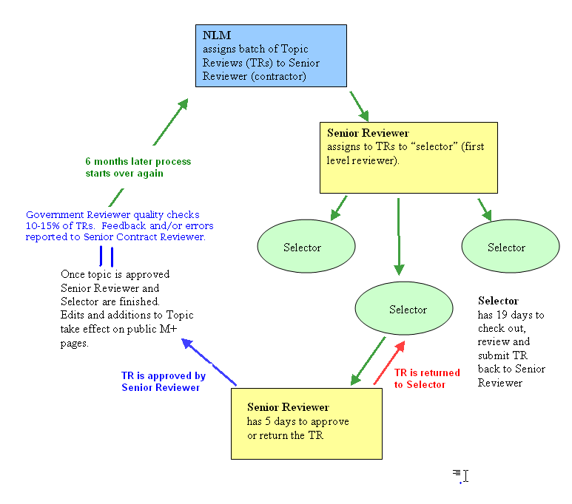
Maintenance and Development

Note: Maintenance and development will make up approximately 15 – 25% of the work performed on the contract. Maintenance and development are labor-hours based tasks and will be issued via separate task orders.

The contractor shall enter or edit groups of MedlinePlus health site records meeting certain criteria such as URL, organization or topic, at the request of NLM staff for changes, updates, corrections, and new entries. The contractor must be able to evaluate consumer health information for biomedical accuracy and authoritativeness and understand standards in the organization of health web sites to perform this task.

Under specific direction from NLM, the contractor shall monitor NIH and other federal Web sites and consumer health Web sites maintained by authoritative medical organizations for new information that meets the inclusion criteria for MedlinePlus.

The contractor shall create new health topic pages at the request of NLM staff. The contractor shall evaluate consumer health information web sites for inclusion on the new health topic page using MedlinePlus procedures and quality guidelines. The contractor may also recommend new topic pages to the NLM project officer for consideration.

The contractor shall undertake special projects at the request of NLM staff. Projects may relate to maintenance of database records; contacting sites using templated emails regarding issues with sites such as lack of dates on pages; reviewing of site records when an organization reorganizes its web site; checking for broken links; and other special needs.

The contractor shall provide quality assurance services as dictated by the procedures, by reviewing newly created or edited site records.

Other
The contractor is responsible for training any new personnel who are employed after the initial NLM training provided upon award of the contract.

Government Responsibility

The project officer will supply background information to the contractor on performing these tasks. The project officer will review and approve all deliverables required in the Statement of Work.

The government will provide initial training of 12 – 16 hours upon award of the contract in Bethesda, Maryland.

Work will be performed offsite. NLM will supply the user accounts to permit access to the database resources necessary for completion of tasks. The contractor must supply a recent model computer with Windows 2000 or Windows XP or newer operating system, broadband or high-speed Internet access, email, Microsoft Excel, and version 6 or higher of the Internet Explorer browser software with Java Runtime plug-in version 1.4.2 or higher and Flash plug-in 7 or higher.

Work to be performed is subject to the approval of the project officer.

Period of Performance

The period of performance will be August 1, 2007 through July 31, 2008 with option for one (1) successive one-year period and five (5) award term periods.

Reporting Requirements and Deliverables

Deliverables include:

Every 2 weeks from award of contract:
- Completed topic reviews, submitted and approved via the MedlinePlus input system within two weeks of assignment
Contractor shall submit a report of work completed every two weeks via e-mail to the project officer. The report should be submitted no later then the COB on Tuesday following the reporting period. This report shall include:
  - Name and number of topic reviews completed (reviewed and approved)
  - Description of special projects completed, and time spent on each
  - Progress updates on ongoing maintenance tasks

Every Six months after award of contract:
- Progress report of Topic review pages including summary of topic reviews. This summary will include corrections for the previous six month period including name of topic reviewer, topic, problem/issue, steps taken to prevent recurrence and improve performance.

As set forth in individual task orders:
- Completion of special projects and maintenance tasks within time frames agreed upon by NLM and contractor

Inspection and Acceptance Requirements

The project officer will check a sample of topic review submittals by the Senior reviewers every two weeks. The project officer will also check site records or other work for quality control and adherence to proscribed procedures.

Performance Indicator for MedlinePlus Topic Reviews:

At 12 months, topic reviews submitted by Senior Contractor Reviewer will be completed accurately with a return rate of no greater than 5%.

Award Term Provision for MedlinePlus Topic Reviews:

After the initial 12 month period, if Contractor’s performance is determined satisfactory and funds are available the Government intends to exercise an option for 12 months. Subsequently, the Contractor may receive a 6 month award term extension for each six months for which the performance indicator (return rate of no more than 5% on the topic reviews) is met. The maximum total period of performance including any options and award terms shall not exceed 7 years.

Security

The contractor shall abide by NLM security guidelines when using NLM systems, using secure passwords known only to individual contractors as necessary and completing annual NIH online security training.

