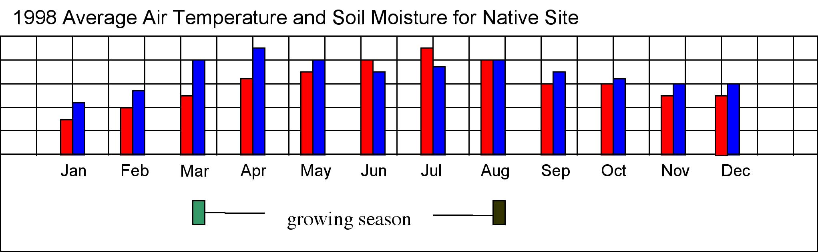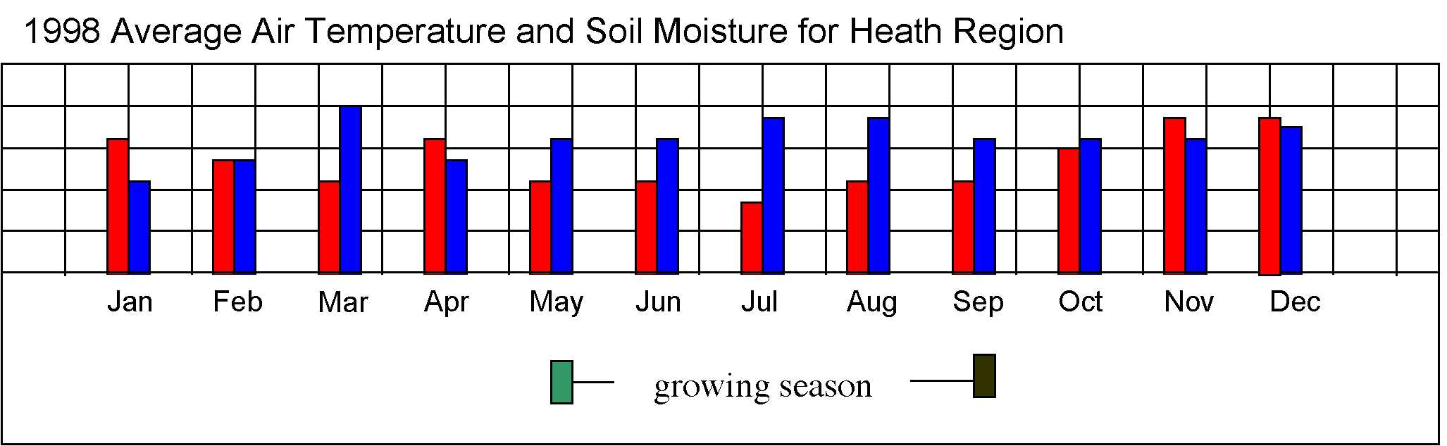

Green up
Brown down
Key
Soil moisture
Air temperature

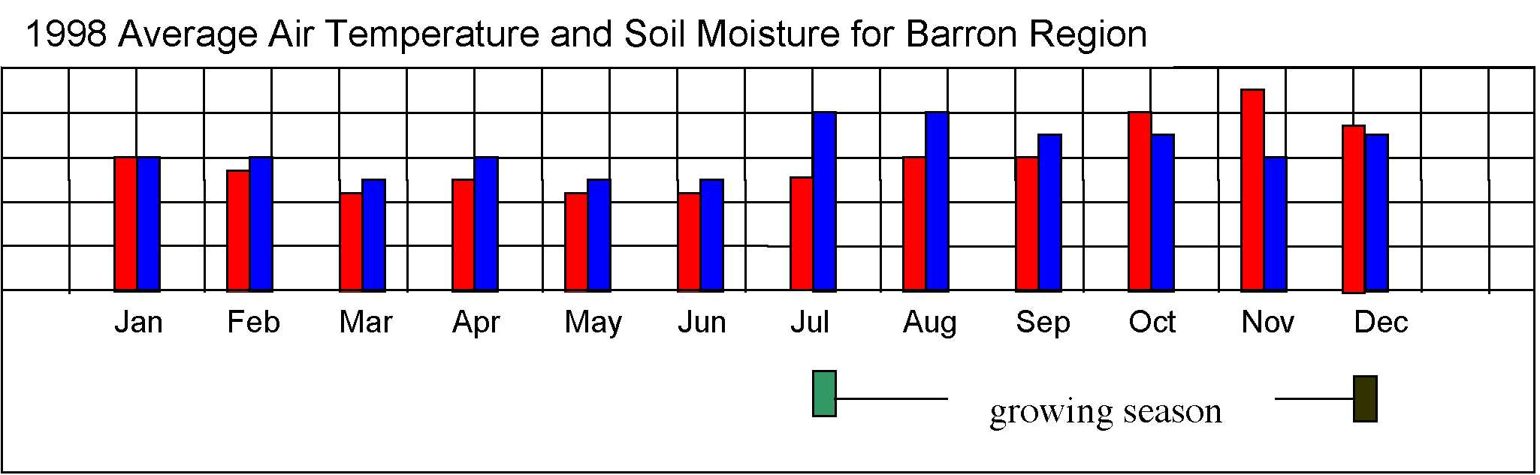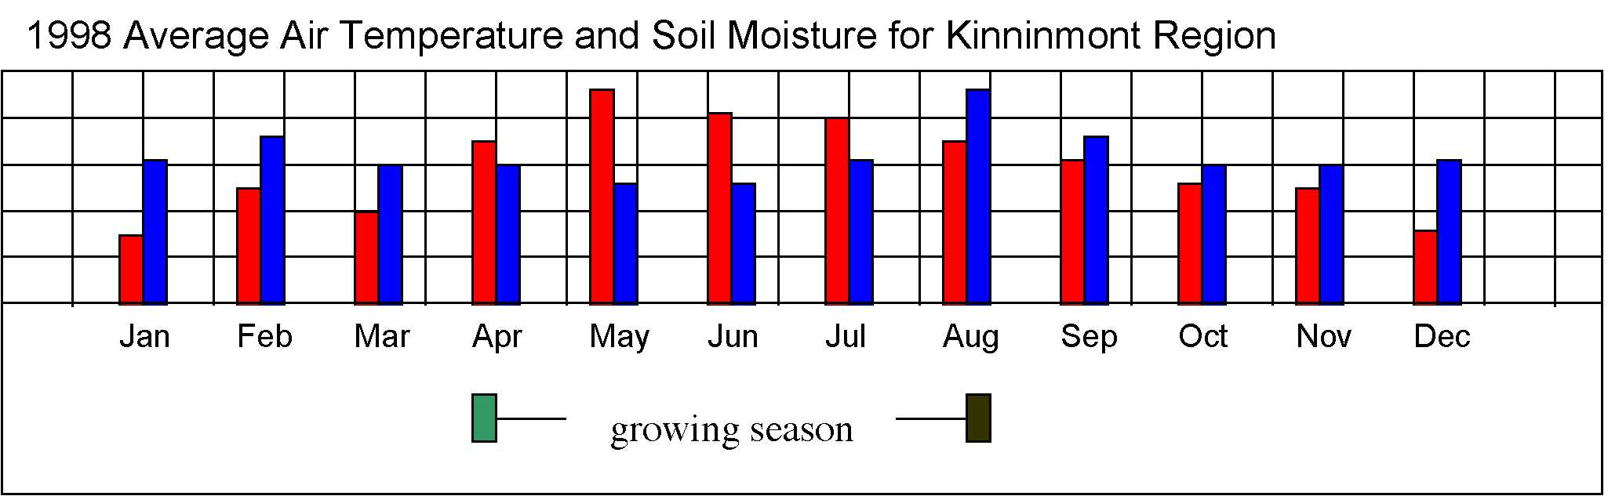

The growing season for a native crop is the amount of time necessary at suitable air temperature and soil moisture levels for growing to occur. In an effort to increase the food supply in overpopulated areas, a group of scientists have proposed trying to plant a crop in several places in the world that have similar environmental and climactic conditions as the area where the crops are native. As a preliminary study, the scientists have been looking for areas that have similar air temperature and soil moisture conditions. Using the graphs and data above and assuming all other conditions are equal,

- answer all of the following questions
- write a short report (about 1 page) that discusses the possibility of planting the new crop in any of the regions - Heath, Barron, or Kinninmont. Make sure you support your conclusions.

- (Plan Investigations: Pose relevant questions) Look at the graph for the native site above. Think of two questions you might ask regarding the data that are related to finding other sites that have similar conditions. A sample question might be “At what point during the year does it look like spring is beginning?” Make sure you also say why you think the answer to your two questions might be helpful to you.

Answers will vary. Questions may include, but are not limited to: “Is this site in the Northern or Southern hemisphere? What is the latitude of this site? What are the units that measure the air temperature and the soil moisture? Are the magnitudes of the graph scales the same for each site? What is the average air temperature and soil moisture during the growing season? What kind of crops/plants are common at each site and how does the timing of the moisture relate to crop/plant growth for these plants? What kind of soil is at each site?

- (Interpret GLOBE Data: Infer patterns, trends) One of the students in your investigation group, Samantha, suggested that finding trends in graphs is sometimes helpful for analysis. Looking at the bar graph for the native site, what happens to the air temperature between January and December?

The air temperature is at its lowest in January. It then slowly rises until it reaches the high point in July. After that, the temperature slowly falls from August through December.

What happens to the soil moisture between January and December?

Soil moisture is peaks during March, April, May and is at its lowest at the end of the year and in Jan/Feb

- (Interpret GLOBE Data: Explain data & relationships) Looking again at the bar graph for the native site, mark where you think each of the four seasons begins and ends. For example, mark “S” for the beginning of spring, “Su” for the beginning of summer, “F” for the beginning of fall, and “W” for the beginning of winter. Make sure you label each of your marks.

What information helped you decide where to put the marks for each season?

The season markers will vary
Students may use the traditional dates of the equinox and solstice to signify the beginning of seasons.
OR
Students may recognize that the equinox and solstice fall mid-season and correspondingly identify each season as beginning 6 – 7 weeks prior to the equinox / solstice.
OR
Students may tie the Spring and Fall seasons directly to “green-up” and “brown-down” and place Summer half way between Spring and Fall and Winter half way between Fall and Spring.

- (Take GLOBE Measurements: Detect errors; Use quality assurance procedures) The air temperature and soil moisture data shown in each of the graphs are monthly averages. To find the monthly averages, data was collected by students taking measurements on each day of the month and then calculated then calculated at the end of each month. Since it is always important to show accurate data in your graphs, what are two possible sources of error you can think of in the above method?

Sources of error include: errors within the original data used to calculate the average; rounding errors during making / reading the graphs; calculation errors made during mathematical manipulation of numbers (i.e. errors during addition, errors during division).

How would you make sure that these errors did not occur if you were taking the measurements and calculating the averages?

These errors can be controlled by: checking the accuracy of the measurements before recording the original data; using accurate graph scales that will allow you to read / plot data with a minimum of error; completing all calculations several times to check for mathematical errors.

- (Interpret GLOBE Data: Explain data & relationships) Another student in your investigation group, James, mentioned that finding relationships between different variables can be a very useful part of analysis. Looking at all four of the graphs on the first page, what can you say about the temperature at the beginning of the growing season for each of the regions? In other words, when the growing season is just beginning in each region, what is happening to the temperature?

The temperature at the beginning of the growing season is on the upswing (except for the Heath region, where the temperature was warmer in the preceding months).

- (Interpret GLOBE Data: Infer patterns, trends; Explain data & relationships) Looking at the graphs for each region, fill in the chart below that compares each region's beginning and ending temperature and soil measurements to that of the native site. Use "+" if the measurement is more than the native site, "-" if the measurement is less than the native site, and "." if the measurement is similar to the native site.
Native Site  Region | Beginning  Temp Soil |  | End  Soil Temp
Heath | - | - | - | -
Barron | • | + | - | -
Kinnimont | + | - | - | +

- (Analyze & Compare GLOBE Data: Identify similarities and differences) Using the table you just created, which of the three possible sites (Heath, Barron, and Kinninmont) looks like it has a growing season most similar to the native site?
Why did you choose the site that you did?

The most similar site would be Barron because it has one characteristic that is similar (air temp at the beginning of the growing season) and the other sites have NO characteristics that are similar to the native site.
None of the sites is similar to the native site. Heath has a growing season that happens despite low air temps, and low soil moisture. Barron has a growing season from May to December, which is very unlike the March to August growing season for the native site (unless Barron is in the southern hemisphere). Kinnimont has the closest time similarities. Its growing season is April to August, but Kinnimont has a higher air temp and lower soil moisture at the beginning of the growing season. This seems very different from the conditions at the native site.

- (Plan Investigations: Specify measurements to investigate) Looking again at how you determined which site was most similar to the native site, list an additional type of data from the GLOBE archives that would be helpful in determining the beginning and ending of each season:

Answers will vary. Additional data from the GLOBE archives that will tell you about the beginning and ending of each season include: bud burst, % canopy cover and senescense.
- (Communicate: Compose reports to explain or persuade) Using the data analysis you have done, write a short report (about 1 page) that summarizes your findings and explains the pros and cons of each site (Heath, Barron, and Kinninmont) based on its similarity to the growing season of the native site. Make sure you discuss additional information that you would need to make a more accurate judgement on each of the sites. Also, be sure to support your conclusions with the data in the graphs and the analyses you have done while answering the questions.

Answers will vary depending on how the student dealt with Q.7. Student responses should include all of the characteristics asked for in the prompt:
- pro’s and con’s of EACH site as compared to native site
- additional info needed at each site to make a more accurate judgment
- use data / information from the graphs
- use information from analyses items 5 & 6

