Financial Trends in Federally insured Credit Unions
January 1 – September 30, 2008

HIGHLIGHTS

This report summarizes the trends of all federally insured credit unions that reported as of September 30, 2008. Change is measured from December 31, 2007.

- Assets increased $48.28 billion or 6.41% to $801.68 billion. This equates to an annualized asset growth rate of 8.55%.
Number of Credit Unions Reporting
 | Federal CUs | State CUs
2002 | 5,953 | 3,735
2003 | 5,776 | 3,593
2004 | 5,572 | 3,442
2005 | 5,393 | 3,302
2006 | 5,189 | 3,173
2007 | 5,036 | 3,065
Sep 2008 | 4,909 | 2,995

- Net Worth increased $3.37 billion or 3.91%. The net worth to assets ratio decreased from 11.43% to 11.16%.

- Earnings, as measured by the return on average assets, decreased from 0.64% to 0.51%.

- Loans increased $33.09 billion or 6.28% (8.37% annualized). The loan to share ratio increased from 83.32% to 83.73%.

- Delinquent loans as a percentage of total loans increased from 0.93% to 1.13%. Delinquent real estate loans as a percentage of total real estate loans increased from 0.67% to 0.95%.

- Net Loan Charge-Offs (annualized) increased $1.51 billion or 58.48%.

- Shares increased $36.47 billion or 5.77%. This represents an annualized share growth rate of 7.69%. The majority of the growth in shares continues to come from share certificates and money market accounts.

- Current members increased by 1.70 million or 1.95% (2.60% annualized).

Overall, federally insured credit unions continued their solid performance in the first nine months of 2008. Loans, shares, and net worth grew; however, the delinquent loan ratio increased 20 basis points and the loan loss ratio increased 24 basis points indicating concerns remain in the credit quality of loan portfolios. While provision for loan and lease losses increased significantly, credit unions achieved favorable operating results. Real estate loans remain the dominant loan category in credit unions, highlighting the need for continued vigilance in underwriting and sound asset-liability management practices.
Total Shares and Deposits | 2007  In Billions | Sep-08  In Billions | %  Change
Insured Shares & Deposits | $561.59 | $598.13 | 6.51%
Uninsured Shares & Deposits | $70.80 | $70.73 | -0.11%
OVERALL TRENDS

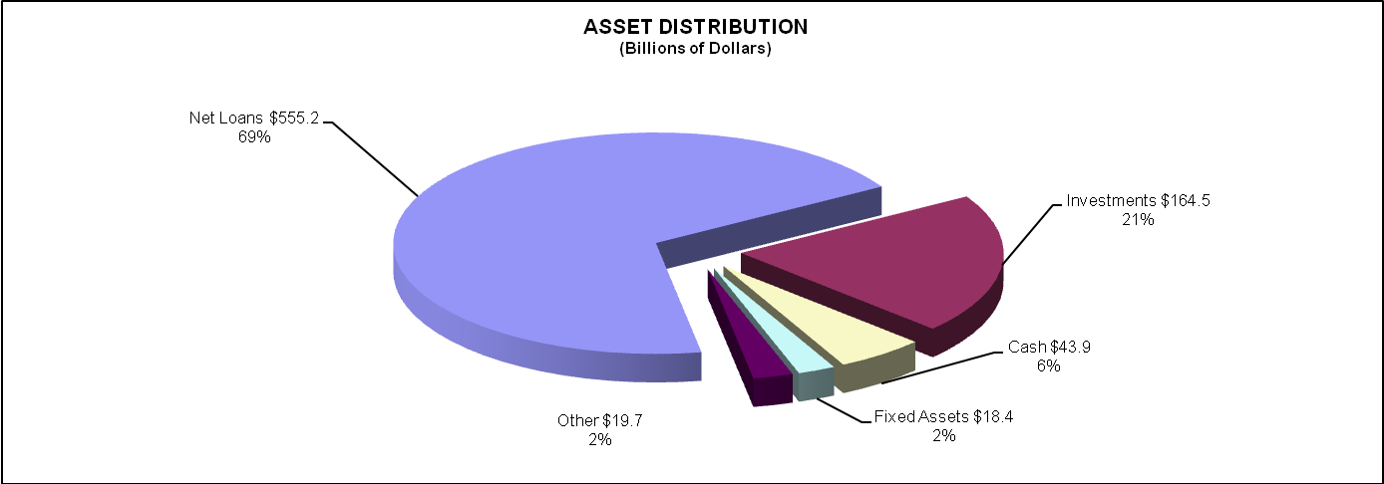
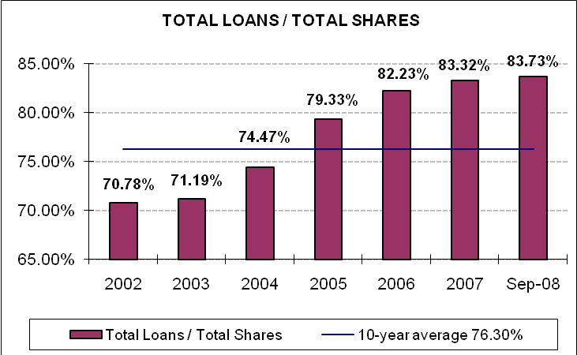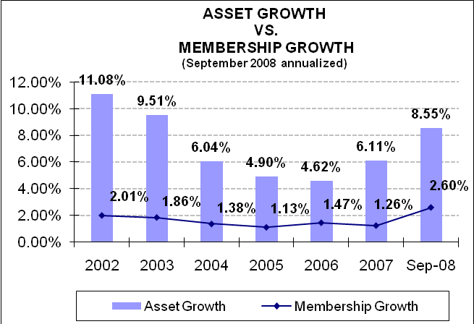
NET WORTH

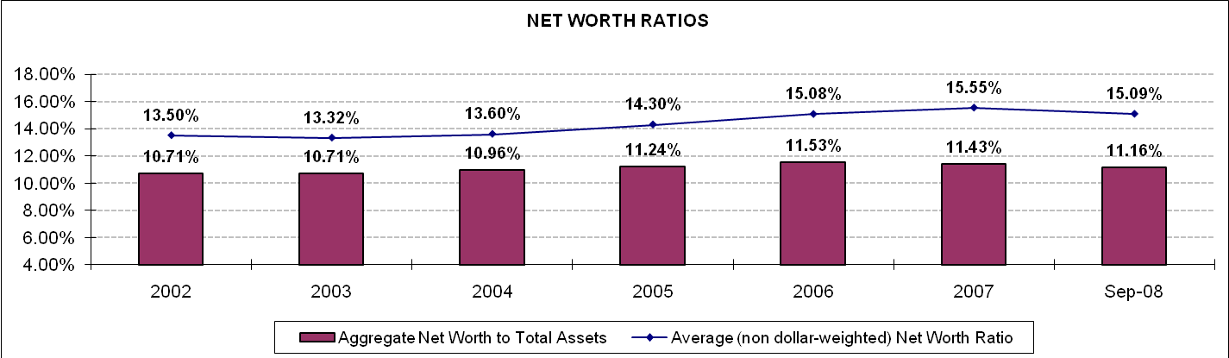
NET WORTH RATIOS
Number of Credit Unions | December  2007 | % of Total | September  2008 | % of Total
7% or above | 7,987 | 98.59% | 7,763 | 98.22%
Net Worth Ratios
6% to 6.99% | 61 | 0.75% | 66 | 0.84%
4% to 5.99% | 32 | 0.41% | 46 | 0.58%
2% to 3.99% | 12 | 0.15% | 15 | 0.19%
0% t0 2.00% | 4 | 0.05% | 11 | 0.14%
Less than 0% | 4 | 0.05% | 3 | 0.04%
 | December 2007  In Billions | September  2008  In Billions | %  Change
Total Net Worth | $86.18 | $89.54 | 3.91%
Secondary Capital | $.031 | $.030 | -2.73%

Net Worth remains strong as total dollars increased $3.37 billion or 3.91% during the first nine months of 2008. The Net Worth Ratio declined to 11.16% as a result of the elevated share growth during the same time period. The number of credit unions subject to Prompt Corrective Action, as a percentage of total credit unions, increased from 1.41% as of December 31, 2007, to 1.78% as of September 30, 2008.
EARNINGS

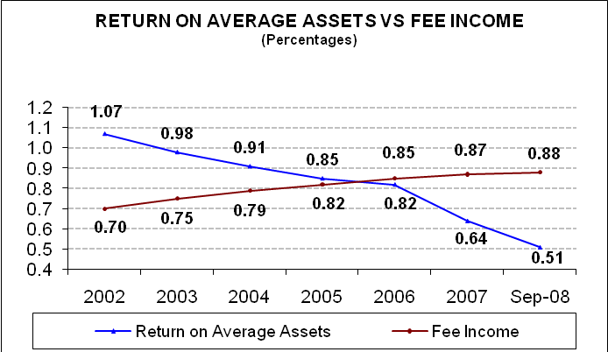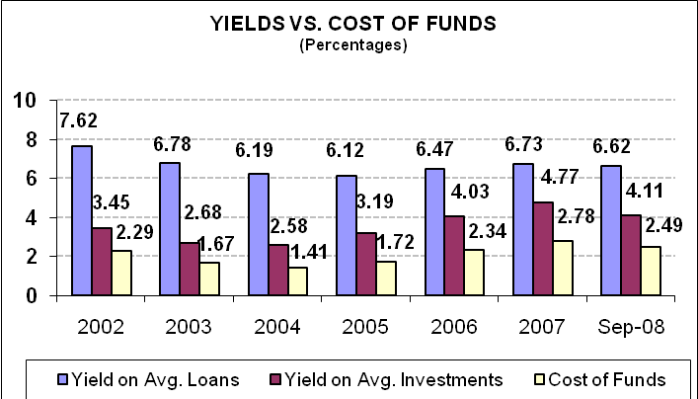
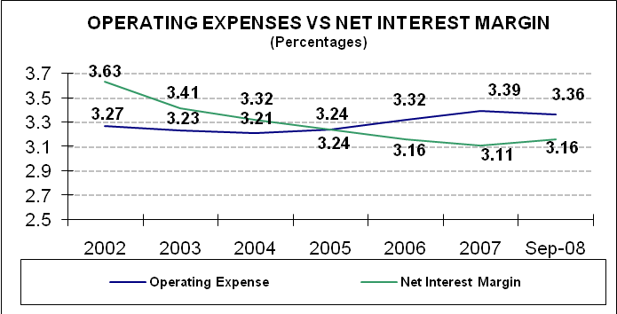The level of earnings declined 13 basis points during the first nine months of 2008. However, the level continues to be effective, covering the cost of operations as well as contributing to the already solid level of net worth. The increasing Provision for Loan & Lease Loss expense continued to rise in relation to average assets and had the largest impact on the reduced Return on Average Assets level.
Ratio  (% Average Assets) | As of  2007 | As of Sep  2008 | Effect on  ROA
Net Interest Margin | 3.11% | 3.16% | + 5bp
+ Fee & Other Inc. | 1.34% | 1.36% | + 2bp
- Operating Expenses | 3.39% | 3.36% | + 3bp
- PLLL | 0.44% | 0.71% | - 27bp
+ Non-Opr. Income | 0.02% | 0.06% | + 4bp
= ROA | 0.64% | 0.51% | - 13bp
LOAN DISTRIBUTION

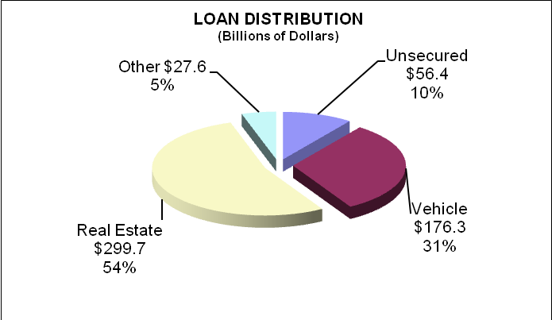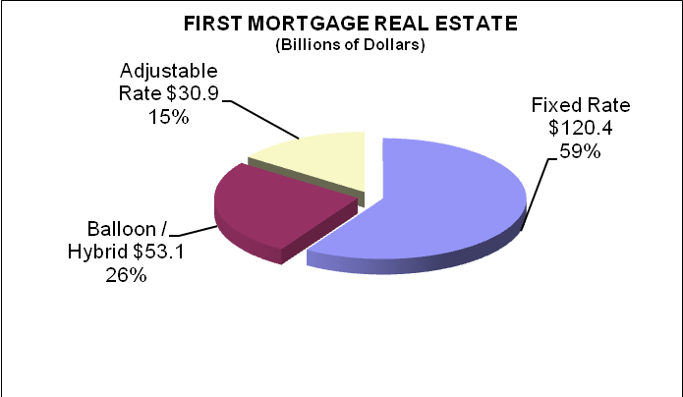
Loan Category | December 2007 Balance  In Billions | % of Total Loans 2007 | September 2008 Balance  In Billions | % of Total Loans  Sep-08 | Growth  In Billions | Growth Rate
Unsecured Credit Card | $30.12 | 5.72% | $31.48 | 5.62% | $1.36 | 4.51%
All Other Unsecured | $24.48 | 4.65% | $24.96 | 4.46% | $0.47 | 1.92%
New Vehicle | $86.89 | 16.49% | $82.20 | 14.68% | -$4.70 | -5.41%
Used Vehicle | $89.11 | 16.91% | $94.05 | 16.79% | $4.95 | 5.55%
First Mortgage Real Estate | $179.97 | 34.15% | $204.38 | 36.50% | $24.42 | 13.57%
Other Real Estate | $91.33 | 17.33% | $95.32 | 17.02% | $3.98 | 4.36%
Leases Rec & All Other | $25.03 | 4.75% | $27.64 | 4.94% | $2.61 | 10.43%
Total Loans | $526.93 |  | $560.03 |  | $33.09 | 6.28%
Loan growth outpaced share growth during the first nine months of 2008 with total loans increasing $33.09 billion, resulting in the loan to share ratio increasing from 83.32% to 83.73%. The growth continues to be fueled by first mortgage real estate. Real estate loans comprise the largest portion of total loans at 53.52%, followed by vehicle loans at 31.47%. During the first nine months, fixed rate first mortgages increased $16.17 billion (15.51%), adjustable rate first mortgages increased $2.04 billion (7.08%), and balloon/hybrid first mortgages increased $6.22 billion (13.26%). Credit unions are reporting $7.47 billion or 3.65% of total first mortgage loans in Interest Only & Optional Payment First Mortgage Loans.
DELINQUENCY TRENDS

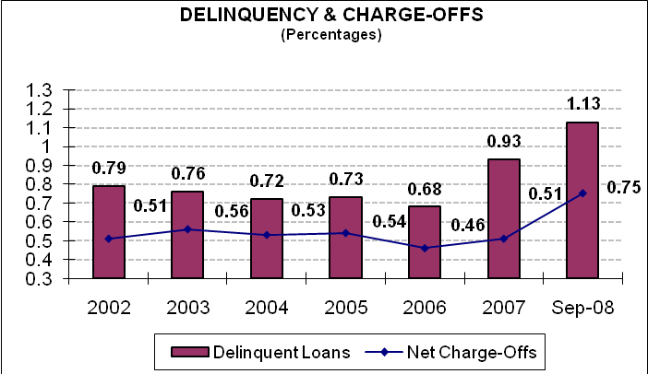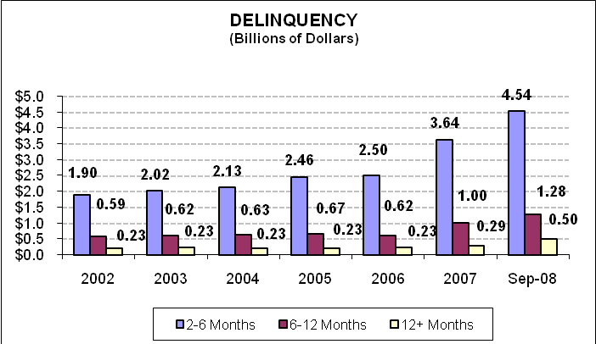
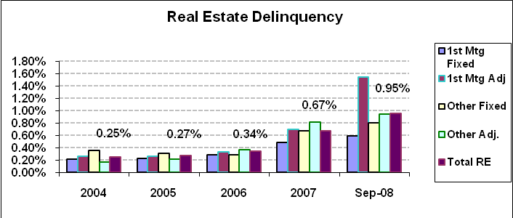
Total Loan Charge-Offs and Recoveries and Outstanding Foreclosed Real Estate | December  2007  In Billions | Sep  2008  In Billions | % Change
Total Loans Charged Off | $3.13 | $4.69* | 49.93%*
Total Loan Recoveries | $0.54 | $0.60* | 9.35%*
Total Net Charge-Offs | $2.58 | $4.10* | 58.48%*
Foreclosed Real Estate | $0.33 | $0.55 | 63.77%
*Annualized

The quality of the loan portfolio deteriorated as noted by delinquency increasing from 0.93% to 1.13% (20 basis points) and the average net charge-off ratio increasing from 0.51% to 0.75% (24 basis points). There are continued signs of stress in the performance of real estate loans, and the increasing real estate delinquency and loan losses are continuing to impact the performance of the overall loan portfolio. Total delinquent real estate loans greater than 2 months increased from 0.67% at year-end 2007 to 0.95% as of September 30, 2008. All real estate delinquency categories increased with the largest being in 1st Mortgage Adjustable Rate and Hybrid/Balloon loans which increased from 0.69% as of year-end 2007 to 1.54% as of September 30, 2008. Other Real Estate Adjustable Rate loans increased 13 basis points, Other Real Estate Fixed increased 12 basis points, and 1st Mortgage Fixed Rate increased 10 basis points.
INVESTMENT TRENDS

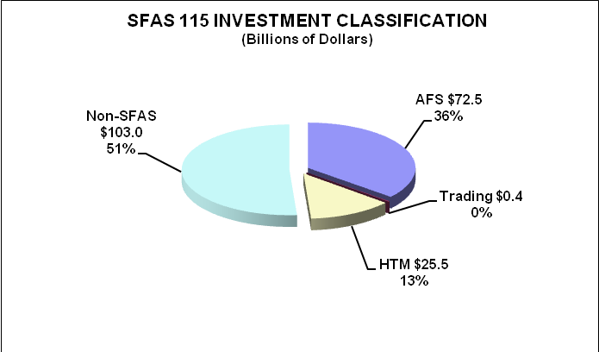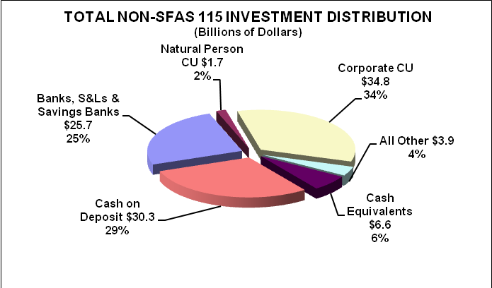

Investment Maturity or Repricing Intervals | December  2007  In Billions | % of Total Investments 2007 | September  2008  In Billions | % of Total Investments  2008
Less than 1 year | $111.62 | 59.39% | $99.97 | 49.65%
1 to 3 years | $46.94 | 24.97% | $56.71 | 28.16%
3 to 5 years | $19.08 | 10.15% | $30.22 | 15.01%
5 to 10 years | $7.57 | 4.03% | $11.19 | 5.56%
Greater than 10 years | $2.75 | 1.46% | $3.27 | 1.63%
Total Investments | $187.96 |  | $201.36
The maturity structure of the investment portfolio remains very short, resulting in a low interest rate risk profile for this portion of the balance sheet. However, it was noted credit unions started to lengthen the maturity structure in this low interest rate environment. Almost 61% of investments are in cash or equivalents, deposits in corporate credit unions, and deposits in other financial institutions.
SHARE TRENDS

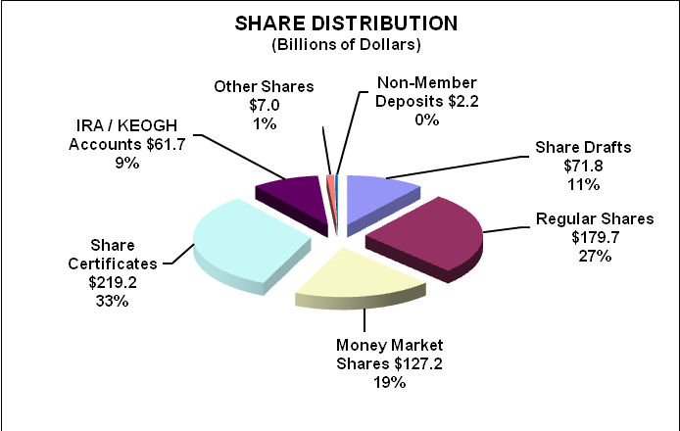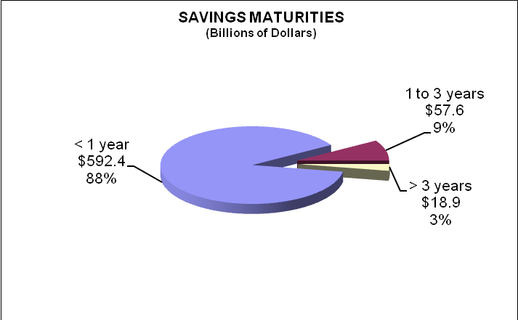
Share Category | December  2007 Balance  In Billions | % of Total Shares 2007 | September  2008 Balance  In Billions | % of Total Shares 2008 | Growth  In Billions | Growth Rate
Share Drafts | $70.95 | 11.22% | $71.82 | 10.74% | $0.87 | 1.22%
Regular Shares | $169.04 | 26.73% | $179.69 | 26.87% | $10.65 | 6.30%
Money Market Shares | $111.16 | 17.58% | $127.21 | 19.02% | $16.06 | 14.44%
Share Certificates | $216.12 | 34.17% | $219.22 | 32.77% | $3.10 | 1.43%
IRA / KEOGH Accounts | $56.91 | 9.00% | $61.72 | 9.23% | $4.80 | 8.44%
All Other Shares | $5.72 | 0.91% | $6.96 | 1.04% | $1.24 | 21.69%
Non-Member Deposits | $2.50 | 0.39% | $2.24 | 0.34% | -$0.25 | -10.14%
Total Shares | $632.40 |  | $668.86 |  | $36.47 | 5.77%
Total shares grew 5.77% or $36.47 billion in the first nine months of 2008. The trend of the movement to rate-sensitive shares continues in 2008 with strong growth in money market shares, IRA/KEOGH accounts and certificates accounting for the majority of the growth. Total share certificates remain the largest category since first exceeding regular shares in 2006.
ASSET LIABILITY MANAGEMENT TRENDS

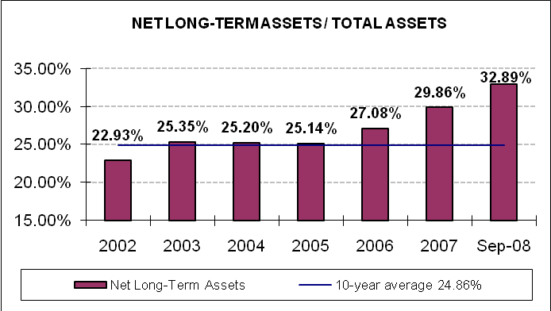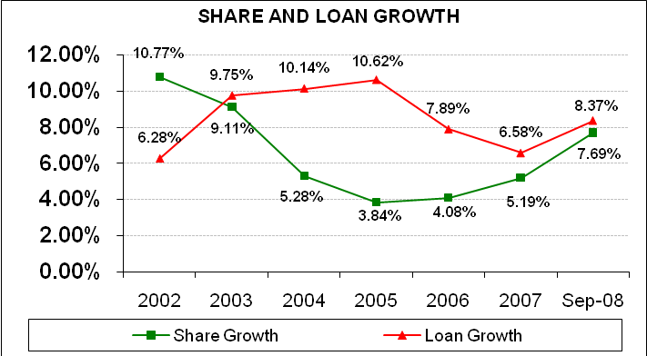
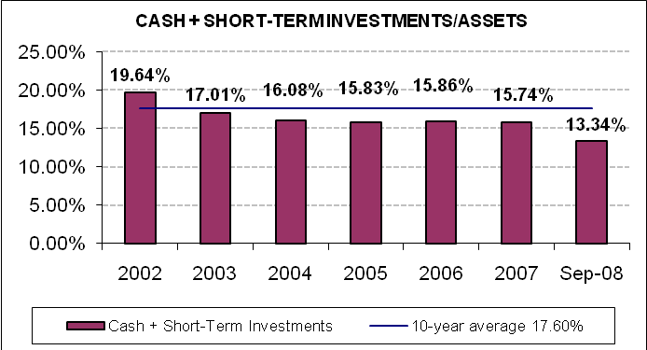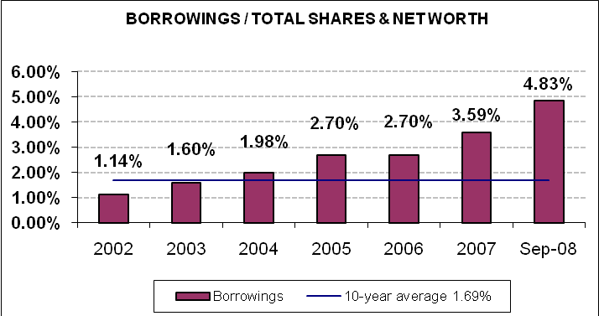
Credit unions’ level of liquidity is tight and in a rising interest rate environment the potential for increasing interest rate and liquidity risk exists. The decrease in cash and short-term investments during the first nine months is due to movement to longer term investments and increased loan growth. The Net Long-term Asset Ratio of 32.89% presents potential interest rate risk exposure, particularly since the majority of the funding for the growth in long-term loans is coming from rate sensitive shares. Credit unions with higher levels of liquidity risk or interest rate risk must maintain diligent risk management procedures.
SUMMARY OF TRENDS BY ASSET GROUP

 | Asset Group  Under $10 million | Asset Group  $10 million to  $100 million | Asset Group  $100 million to  $500 million | Asset Group  Over $500 million
# of Credit Unions | 3,352 | 3,279 | 952 | 321
Total Assets | $12.70 billion | $113.79 billion | $206.04 billion | $469.14 billion
Average Assets | $3.79 million | $34.70 million | $216.43 million | $1.46 billion
Net Worth/Total Assets | 16.48% | 13.13% | 11.61% | 10.35%
Average Net Worth (non dollar-weighted) | 17.80% | 13.73% | 11.63% | 10.92%
Net Worth Growth* | 1.15% | 3.81% | 4.23% | 5.83%
Return on Average Assets | 0.20% | 0.44% | 0.45% | 0.56%
Net Interest Margin/Average Assets | 3.89% | 3.62% | 3.36% | 2.94%
Fee & Other Income/Average Assets | 0.71% | 1.27% | 1.54% | 1.32%
Operating Expense/Average Assets | 4.05% | 4.08% | 3.88% | 2.93%
Members / Full-Time Employees | 442.97 | 390.91 | 343.56 | 382.77
Provision for LLL/Average Assets | 0.41% | 0.41% | 0.60% | 0.84%
Loans/Shares | 67.45% | 72.11% | 81.39% | 88.16%
Delinquent Loans/Total Loans | 2.29% | 1.37% | 1.16% | 1.04%
% of Real Estate Lns Delinquent > 2 Mths | 1.26% | 1.15% | 1.03% | 0.90%
Net Charge-Offs/Average Loans | 0.68% | 0.58% | 0.68% | 0.83%
Share Growth* | 7.41% | 7.76% | 7.49% | 7.35%
Loan Growth* | -3.03% | 3.35% | 6.75% | 10.13%
Asset Growth* | 6.20% | 7.46% | 7.69% | 8.88%
Membership Growth* | -0.71% | 0.43% | 2.14% | 4.89%
Net Long-Term Assets/Total Assets | 8.51% | 23.95% | 33.81% | 35.32%
Cash + Short-Term Invest./Assets | 33.05% | 20.28% | 12.52% | 11.48%
Borrowings/Shares & Net Worth | 0.16% | 0.78% | 2.68% | 7.00%
*Note: The growth trends are based on the same FICUs reporting 12/31/07 and 9/30/08 using assets as of 9/30/08.
There is a distinct difference in the performance among the different asset groups. Net worth ratios are solid among all asset groups with the largest percentages being reported in the under $10 million category. The highest return on average assets, loan growth, membership growth, loan to share ratio, and net charge-offs is noted in the over $500 million asset group.
CORPORATE CREDIT UNIONS
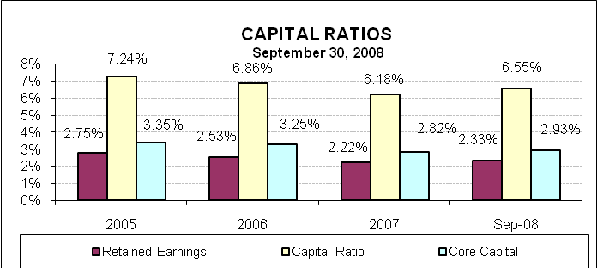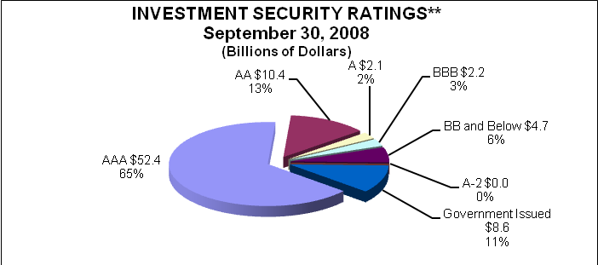
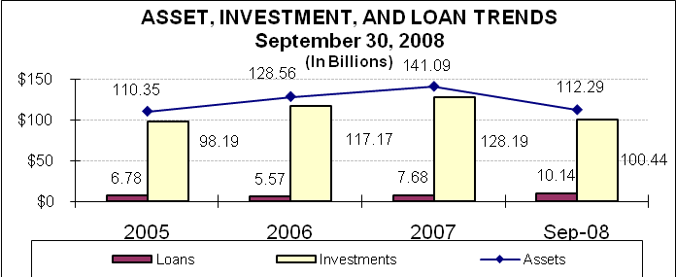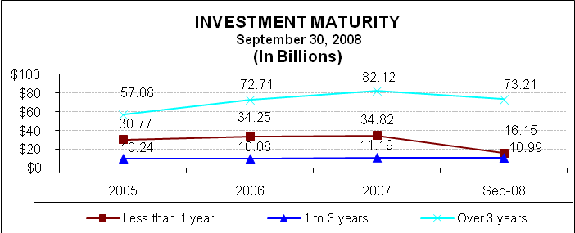
**Ratings listed are from Standards & Poor’s.
System assets decreased by $28.4 billion or -20.18% (-26.90% annualized) during the first nine months of 2008. Capital ratios have increased from the previous year-end due to positive system earnings ratios and the decline in assets. Investments accounted for 89.45% of the assets in the corporate system and mortgage-backed securities made up 50.09% of the total investment portfolio. The market for mortgage-backed securities has been less liquid since July 2007 and the estimated fair value of these securities has declined resulting in higher unrealized losses on available for sale securities (AFS). Corporates are required to comply with generally accepted accounting principles in the Call Reports they file with NCUA and must report and disclose unrealized gains and losses on AFS securities.

As of September 30, 2008, 94% of the securities held in the corporate system were rated investment grade and are performing. The securities rated less than investment grade also continue to perform, with interest and principal payments continuing to be received. The corporate credit union system continues to currently demonstrate the ability to hold investment securities to maturity while continuing to meet anticipated member product and service demands.

The financial results for prior periods may reflect changes when compared to the prior period trend letters due to subsequent call report modifications.
The Return on Average Assets ratio is annualized net income divided by average assets for the period.

