

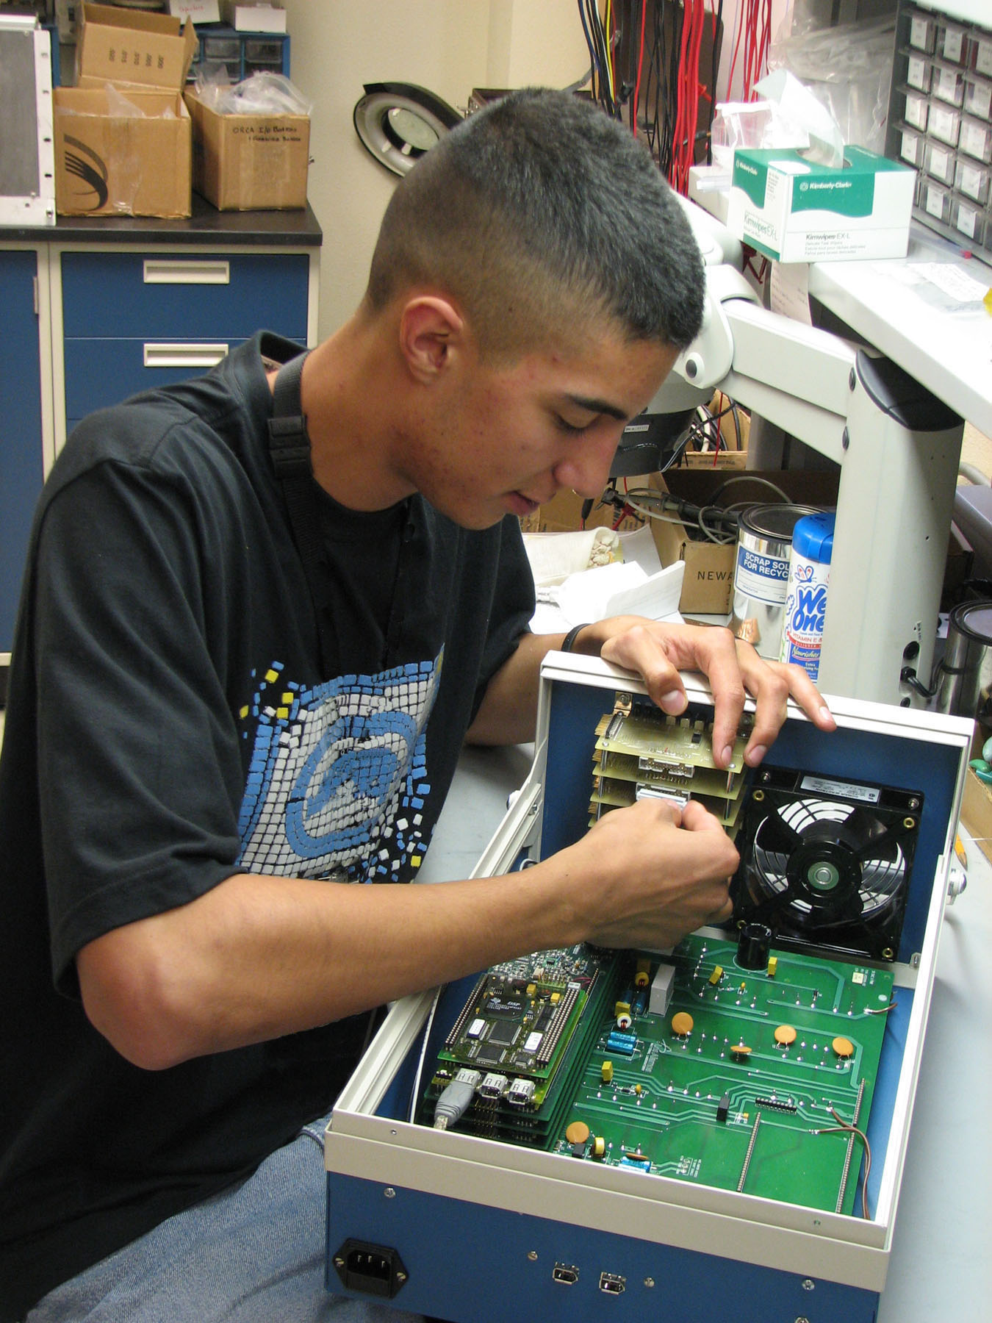
Electro Mechanical
Technician Training Program
Opportunities in
2006 Handbook
Student Programs STB-EPDO
Science, Math, and Engineering

Table of Contents

Electro Mechanical Technician Training Program
What is the Electro Mechanical Technician Training Program? 1
Why Los Alamos National Laboratory Hire Students 1
How Does the EMTP Work ? 1
Appointment Types and Terms 2
EMTP Certificate Curriculum 2
Tuition Reimbursement Policy 3
Student Transcripts 3
Funding for the EMTP –Salary, Participant’s Roles & Commitments 4
Matching Student with Mentor and Hiring 4
Student/Mentor/ Program Coordinator Communications 5
Student Workplan 6
Sample Workplan 7
Preparing for the Student’s Arrival 8
The Students’ First Days at UNM-LA and LANL 8
Work Schedule Options 8
Travel 9
Performance Evaluations 9
End of Program Options 9
LANL Employee Information
General Employment Training (GET) for EMTP Students 10
Annual Security Refresher 10
Initial Computer Security Briefing – Lab Wide 10
Environmental Management System (EMS) Awareness for Workers 11
Substance Abuse Awareness Program for Employees 11
Technical Surveillance Countermeasures (TSCM) 11
Maintaining a Respectful Workplace 11
Site Specific Training 12
Student/Mentor Policy and Procedure (IPP 787.2) 12
Mentor Training 12
Z Numbers 12
Safety and Security 13
Security Clearances 13
Cryptocards 13
Computer Usage 13
E-mail Accounts and Usage 14
Phone Usage 14
Personal Property 14
Government Property 14
Prohibited and Controlled Articles 15
Student Benefits 15
Harassment 15
Sexual Harassment 15
LANL Student Program Resources and Information
Transportation 16
Student Program Contacts 18
Students’ Association 18
Student Program Advisory Council 18
Student News, Student Views 19
Newsbulletin 19
Contacts and Resources Listing 19

Electro Mechanical Technician Training Program

What Is the Electro Mechanical Technician Training Program?
The Electro Mechanical Technician Training Program (EMTP) is a work-study program designed to:
- Develop employability skills in individuals
- Promote the concept of, and provide access to, higher education opportunities for members of the workforce in New Mexico; and
- Create a pool of qualified individuals from which Los Alamos National Laboratory (LANL) can draw for technician positions.

Co-sponsored by LANL and the University of New Mexico–Los Alamos (UNM-LA), this highly successful program has been in existence since 1996.

Upon successful completion of the two-year training program, students are awarded a Certificate in Electro Mechanical Technology. Continued employment at the Laboratory is a possibility, depending on position availability, funding, and positive evaluations. Historically, over 90% of each graduating class has been converted to regular employement status within the Laboratory.

Why Los Alamos National Laboratory Hires Students
Hiring student interns/technicians is an institutional goal for Los Alamos National Laboratory. Hiring students helps LANL develop a talented workforce to meet the current and future needs of this ever-changing organization. These student interns/technicians will become the next generation of experts in their fields.

How Does the EMTP Work?
During the course of the program, a student works under the guidance of Laboratory technical staff or senior technicians. A positive mentoring relationship is critical to the development and success of the student technicians. A portion of the student’s eight-hour workday is spent at UNM–LA attending required academic courses specially designed for and relating to the work of an electro mechanical technician. The students will complete 40 credit hours during the two-year program. The EMTP students are required to maintain a minimum GPA of 2.0. Each student technician assists his/her senior technician or technical staff member (the mentor) with routine tasks and basic projects requiring electro mechanical skills. Students also assist with other related duties as assigned.

Appointment Types and Terms
Students in the EMTP are considered Undergraduate Students (UGS), limited term employees. The appointment is considered conditional for a two-year period. To remain in the program the student must successfully complete the EMTP curriculum, maintain a 2.0 GPA at UNM–LA, and demonstrate successful completion of work assignments at the Laboratory. Failure to do so may result in a probationary period or termination from the program.

Upon graduation, students may be converted to regular Laboratory employment, elect to pursue further education while working as an Undergraduate student (UGS), or seek employment elsewhere. Students electing to pursue further education must comply with the Laboratory’s UGS program requirements. Contact Brenda Montoya for more information on the UGS program (667-4866 or e-mail bmontoya@lanl.gov).

EMTP student assignments may be ended for a variety of reasons, including:
- Failure to maintain a minimum 2.0 GPA (no grade below C allowed)
- Failure to retake courses (at student’s expense) when grades below C are received
- Failure to successfully meet work expectations
- Violation of Laboratory policies, procedures, or regulations
- Inappropriate behavior
- Student elects to initiate termination
- Group budgetary problems

EMTP Certificate Curriculum
All courses are taken at the University of New Mexico – Los Alamos. The academic prerequisites are proficiency at the Math 120 and 106 level (Intermediate Algebra) and the English 100 level. If necessary, developmental classes can be taken during the summer session prior to the start of the program. The course catalog can be viewed on-line at http://www.la.unm.edu/catalog/catalog 2006.

A total of 40 credit hours are earned in the required sequence of courses listed below over the four EMTP semesters. A minimum grade of C (not C-) is required to pass each class,
resulting in an overall GPA of 2.0 or above for the program.

First semester | Second semester | Third semester | Fourth semester
Introduction to Drafting  DRFT 101L | Composition I: Exposition  ENGL 101 | Trigonometry  MATH 123 | Elements of General Chemistry  CHEM 111L
Electromechanical Shop Practice  ELCT 105L | Drafting and Blueprint Reading  DRFT 119 | Introduction to Physics  PHYC 102 | Introduction to Computer Aided Design and Drafting  CT 111
College Algebra  MATH 121 | DC Circuit Analysis  ELCT 101 | AC Circuit Analysis  ELCT 102L | Vacuum Systems  ELCT 114
Problems in College Algebra  MATH 107 |  |  | RF Power Laboratory  ELCT 112L
10 credit hours | 10 credit hours | 11 credit hours | 9 credit hours

Tuition Reimbursement Policy
Tuition reimbursement is made directly to the employee/student with proof of full payment to the school and successful completion (C or better) of coursework. Students complete Form 896, Application for Tuition Assistance (can be viewed online at http://enterprise.lanl.gov/forms/896.pdf ), at the end of the academic semester and forward the form to CT-T&D Tuition Assistance, M589, and attach the original tuition receipts, book receipt, and grade report. Dixie Paternoster (667-0386 or dixie@lanl.gov) can assist the student with this process and answer any questions.

Student Transcripts
Transcripts and attendance records are forwarded at the middle and end of each semester from the UNM-LA advisor to the EMTP Program Coordinator for review.

Students not meeting the criteria for academic success (a required EMTP course dropped, withdrawn, or below a grade of C) do not receive the salary increase and must meet with an EMTP committee (student, mentor, program coordinator, and UNM-LA advisor) to discuss termination or probation. Probation terms can include retaking and passing the failed class(es) at the student’s own expense as soon as the class is offered the following semester or summer, possibly a reduction in work hours to allow for more study time, hiring a tutor to assist with studies, or taking extra classes the next semester. If a student cannot fulfill the program requirements following a period of probation, then termination will be recommended.

Funding for EMTP –Salary, Participant Roles and Commitments
EMTP student salaries begin at the Laboratory’s base UGS salary rate at the time of hiring as determined and posted by Human Resources. Salaries increase at a rate of $0.75 per hour upon successful completion of each academic semester. Future pay increases are never retroactive.

The sponsoring Group management agrees to a two-year commitment to provide funding for a student technician. Group funding covers student salaries (for 40 hours per week and any overtime), job related travel costs, and program costs for tuition, books, and school related fees billed by the University. The Group determines which cost and program codes will provide the funds to cover the EMTP student costs. Sponsoring organizations will not incur any costs until the program commences at the beginning of the first semester. Soon after, student salary costs will commence. Tuition reimbursement costs will not begin until the end of the first semester.

Tuition, books and fees at UNM-LA range between $600-$1,000/semester. Over the two-year period, projected costs would be in the range of $45,000 (approx. $41,000 salary and $4,000 academic costs).

The Education and Postdoc Office (EPDO) is responsible for the role of program coordination and is funded through the Science and Technology Base Programs Office (STBPO). Program coordination funding from the Laboratory (STBPO) also covers administrative tasks incurred at UNM-LA, as well as any associated recruiting costs as per a Laboratory approved contract with UNM-LA.

Matching Student with Mentor, and Hiring
Once the EMTP interviewing committee has selected students for the program based on their academic merits, students must be matched to a mentor. Mentors will review selected students’ resumes and interview students to determine what student best meets their individual needs. When the mentor finds a prospective student, he/she contacts the EMTP Program Coordinator to complete that student’s hiring package which must include the student’s:
- Resume
- Transcripts reflecting current/latest enrollment
- Request for Background Information (form #1817)
- Supplemental Employment Information (form #902)
- Job Demands Worksheet (form #1793)
- Student Workplan
- DOE Approval IF the student is a foreign national (form #982)

Items 1-4 are part of the UNM-LA application. The mentor completes items 5-7. Item 7 is only necessary if the student is not a US citizen.

The EMTP Program Coordinator delivers the complete hiring package to HR for each student.

Student/Mentor/Program Coordinator Communications
The mentor is the primary contact for each EMTP student. The program coordinator should ensure that the mentor has regular contact with his/her student. The mentor is the initial contact regarding work, school, or other issues related to the student’s job performance and/or attendance in the program. The mentor and student make up a team and should be encouraged to field questions whenever the student needs additional instructions or clarification. The student-mentor relationship is crucial to the success of the student.

The goal of EMTP is that the mentor, once familiar with his/her requirements, will provide work that requires less supervision and more initiative and confidence on the part of the student. However, this does not mean that regular communications with the student should cease.

The EMTP Program Coordinator should continually monitor the relationship between the mentor and the student.

If the student has problems performing required projects, the EMTP coordinator should communicate with the student and mentor to determine a course of action. The coordinator’s input will benefit the mentor, the student, the project and the student’s overall experience. The Laboratory’s EMTP Program Coordinator should be kept informed of any problem/solution.

The mentor should use the Student Workplan as a tool for providing clear guidelines and expectations. The coordinator should demonstrate that communications between all parties is open and important to the success of the student, the mentor, and the coordinator.

Student Workplan
The Student Workplan defines the type of work and training that will be accomplished during the student’s appointment. It provides a description of the work assignment and projects, along with the necessary skills and educational background needed to perform the work. The workplan should be used as a tool for both the mentor and the student to establish a clear, mutual, and meaningful educational Laboratory experience. A student workplan can be part of the mentor’s individual development plan and can be used during the employee performance evaluation period.

Workplans are required for all new, returning, and continuing students and must be submitted both on-line at https://spi-internal.lanl.gov/spi/mentor/ and as a printed copy to Human Resources as part of the student hiring package. Returning and continuing student workplans can be completed and submitted beginning October 1 each year (at the beginning of the fiscal year) or as determined by the student start date.

Sample Workplan

Los Alamos National Laboratory
Education Programs

Student Workplan

Student Classification: Post-Baccalaureate WA Position Type: Technical
Student Z Number: 999999 Mentor Z Number: 990990
Student Name: John J. Johnson Mentor Name: George Jetson
School Attending: University of Wisconsin Mentor Phone: 665-0000
Major: Pre-Engineering Mentor Email: gjetson@lanl.gov
Student Email: N/A Group: ISR-1 Division: B
HR Generalist Z #: 0000000 Mail Stop: M888
Anticipated Start Date: 10/01/2006 End Date: 10/01/2007
Description of Work Assignment
This summer, John will be tasked with the following: fabrication of low voltage electronic chassis, stuffing printed circuit boards, desoldering various electronic devices, connectors, and PC boards, wiring of high density electronic connectors, understanding basic electronic logic ICs, fabrication of fiber optic transmitter and receiver circuits, ordering tools, electronic devices and equipment, fab QRC objects as needed.

Required Training: GET, Waste Generation Overview #8477, Haz Com Training #2398, Electrical Injury Mechanisms #16749, LANL electrical safety program #16750, Bloodborne pathogens #7292, Computer security

Recommended Training: Beryllium awarness self study #28340, HRL site specific training, Select agent safety and security requirements

Preparing for the Student’s Arrival
Selecting an appropriate project before the student arrives is important for a positive work experience. Projects should have the following characteristics:
- A defined goal that the student has a reasonable chance of meeting during the appointment (begin with a simple project and progress to more complex projects);
- Sufficient flexibility that the project can be shortened or lengthened depending on the success rate of the student;
- Two to three levels or stopping places; and
- Demonstrable relevance to the bigger picture of the Group/Division.

The Group management can prepare for the student’s arrival by doing the following things:
- Have the mentors peruse the new education website section for mentors at http://int.lanl.gov/education/mentors/index.shtml;
- Have the mentors create and submit a preliminary Student Workplan (form is available on the web at https://spi-internal.lanl.gov/spi/mentor/Logon.asp); and
- Ensure that the student will have the necessary tools to conduct his/her work (i.e., office space, desk, phone, computer, etc.).

The Students’ First Days at UNM-LA and LANL
The students’ first few days are filled with activities helping them to become familiar with the Laboratory. They participate in New Student Orientation and complete the new-hire process with the Human Resources Division. They are informed of available resources as well as site-specific training that may be required before they are authorized to conduct work. They must also complete General Employee Training (GET) before they can officially begin working (see page 10).

Should there be a conflict with UNM-LA classes and Orientation and/or GET, the student needs to let the UNM-LA advisor know of this in advance, so he/she can excuse the student from class(es) without penalty.

Work Schedule Options
All EMTP students are required to put in 80 hours per two-week period with no more than 44 hours in one week. Some of this time is spent at UNM–LA in classes. Students must report to work at the time established by their assigned Group. Students are accountable for a full-week’s worth of time. This means that a student who works a 40-hour week, must either be in class or at the worksite for a total of 40-hours. The same reasoning applies for a 9/80 work schedule (account for 44 hours the first week and 36 hours the second week). Students should be allowed, at the mentor’s/supervisor’s discretion, time to travel to/from class and work (not from home). Generally we find that 10-15 minutes is the maximum time needed to get from the worksite to UNM–LA with 5 minutes to park and walk to class. The student should submit a course and work schedule to his/her mentor, office administrator, and EMTP Program Coordinator at the beginning of each semester.

For example, during the first week, all students are required to work a five-day, Monday-through-Friday, eight-hours-per-day schedule. After the first week, the student may request a different option such as the 9/80-schedule. If the mentor approves, the student’s schedule may be modified. Student employees and mentors should have compatible schedules (5/40 or 9/80 A or 9/80 B).

Travel
Students should not be expected to travel during the school term. Any work related travel should be scheduled during the summer months. All lab travel should be coordinated through the student’s group office prior to departure.

Performance Evaluations
The sponsoring Group will complete an annual evaluation for the EMTP students.
If either the mentor or the student cannot meet the goals and objectives that have been outlined in the Student Workplan and in the EMTP program requirements, Group management may consider a no-fault end to the relationship. Options for no-fault end include: identify and assign a new mentor, possible transition to another organization and mentor, or termination from the program. The mentor should contact and inform the EMTP coordinator for guidance. If a new assignment and mentor cannot be identified, the only alternative available will be to terminate the student from the program.

End of Program Options
Upon completion of the EMTP program, the group may choose to hire the student as a regular employee. However, the Group is not obligated to hire the student at the completion of the program. If the Group has an available position or can fund a new position, the Group may convert the student to regular employee status.

Students may choose to pursue the following options: (1) seek employment with the sponsoring organization, (2) seek employment with another LANL organization, (3) pursue an associate’s degree, (4) pursue further education at a four-year institution, or (5) seek employment outside of the Laboratory.

LANL Employee Information

Training

General Employee Training (GET) – Course #15503
- Requirement Driver: 5480.20A
- Required once
- Target Audience:
  - All new workers who will be on-site for more than 10 workdays in a 12-month period.
  - All workers whose job assignments require unescorted access to nuclear facilities and/or radiological controlled areas.

General Employee Training (GET) is a course that is required of all LANL and contract employees, including students. The student will need to report to the Training and Development Center in White Rock. GET is a full day training course (8:00 am – 5:00 pm). The student is required to complete GET before he/she can be issued a badge and begin working.

Annual Security Refresher – Course #1425
- Requirement Driver: DOE M 470.4-1, Part 2, Section K
- Training Plan #729, Security Education Training
- Required annually
- Target Audience:
  - All LANL L- and Q-cleared badge holders who are “Active” in the Employee Information System (EIS) who have reported productive time (not vacation, extended leave, etc.) in the Time and Effort system within the past 30 days, regardless of the Laboratory employee type (e.g. LANS, contractor, visitor, Postdoc, HS Co-op, UGS, GRA, affiliate, external or guest).

Initial Computer Security Briefing – Lab-wide – Course #9369
- Training Plan #2368, Computer Security Briefing – Unclassified
- Required once
- Target Audience:
  - Anyone who uses Laboratory unclassified or classified computer resources, either onsite or offsite, including federal workers in any branch/agency of the US government, LANS, contractors, subcontractors, students, HS Co-op, UGS ,GRA, external, guests and visitors.
  - Anyone who wants to obtain a Crypto-Card.

Environmental Management System (EMS) Awareness for Workers – Initial Course #32461
- Training Plan #7215, EMS Worker Awareness
- Required once
- Target Audience:
  - All LANL badge holders who are “Active” in the Employee Information System (EIS) who have reported productive time (not vacation, extended leave, etc.) in the Time and Effort system within the past 30 days, regardless of the Laboratory employee type (e.g. LANS, contractor, visitor, Postdoc, HS Co-op, UGS, GRA, affiliate, external or guest).

Substance Abuse Awareness Program for Employees – Course #7863
- Training Plan #458, Lab-wide Substance Abuse Training Plan
- Required once
- Target Audience:
  - All LANL badge holders who are “Active” in the Employee Information System (EIS) who have reported productive time (not vacation, extended leave, etc.) in the Time and Effort system within the past 30 days, regardless of the Laboratory employee type (e.g. LANS, contractor, visitor, Postdoc, HS Co-op, UGS, GRA, affiliate, external or guest).
  - Some subcontract workers whose contract with the Laboratory does not specifically require the subcontractor’s employees to take this course may be exempt from this training.

Technical Surveillance Countermeasures (TSCM) – Course #12890
- Training Plan #3687, Technical Surveillance Countermeasures
- Required annually
- Target Audience:
  - All LANL badge holders who are “Active” in the Employee Information System (EIS) who have reported productive time (not vacation, extended leave, etc.) in the Time and Effort system within the past 30 days, regardless of the Laboratory employee type (e.g. LANS, contractor, visitor, Postdoc, HS Co-op, UGS, GRA, affiliate, external or guest).

Maintaining a Respectful Workplace – Course #34531
- This course is designed to enhance manager’s and supervisor’s knowledge and understanding of various employment laws and policies related to discrimination and harassment prevention. It contains interactive scenarios intended to educate managers about legal responsibilities and to assist in identifying potential problems and resources available to deal with common workplace issues. Content focuses on sexual harassment, and discrimination based on age, gender, race, color, ethnicity, physical or mental disability, sexual orientation, religion, marital status, medical condition and veteran or military status.

Site Specific Training
Individual sponsoring Groups may have specific training requirements necessary for student employees to conduct their jobs. In addition to GET, students may be required to take other training courses such as Rad-Worker I & II, Electrical Safety, Hazwopper, etc. The mentor and Group management should determine the training a student needs to complete prior to and during his/her assignment.

Student Mentoring Policy and Procedure (IPP 787.2)
This new policy was issued in May 2005. The policy standardizes and formalizes the process to select, train, and appoint mentors; and prepare mentorees to work at LANL. This document also clarifies and establishes the responsibilities and requirements for responsible management and supporting organizations. You can view the full policy at: http://policy.lanl.gov/pods/policies.nsf/MainFrameset?ReadForm&DocNum=IPP787&FileName=ipp787.2.pdf .

Mentor Training
Mentors are required to participate in mentor training as part of IPP 787.2. The training courses are available year-round.

New Mentor Training
This initial course is required for staff interested in mentoring students and Postdocs and provides the participants with the knowledge, skills, and requirements to become effective mentors.

Or

Annual Mentor Refresher
This course is an annual requirement for all LANL staff interested in continuing their role as a mentor to a student or Postdoc. By completing this course, mentors will maintain their authorization as a mentor.

Z Numbers
Students will be assigned a Z number. Students normally receive their Z numbers on their first day of employment. A Z number, once assigned, is a permanent attribute of an individual in the Laboratory's personnel database. No person should ever have more than one Z number. Even if someone leaves the Laboratory and returns decades later, the same Z number identifies that person.

Safety and Security
Safety and Security are a primary goal and commitment for all LANL employees in order to have an injury free workplace. The Laboratory is on an aggressive course to ensure that neither people nor the environment are injured while working toward achieving its mission. Students are required to participate in Safety and Security training sessions. See the Safety and Security home pages at http://int.lanl.gov/security/ to learn more. If students think they see unsafe or un-secure work or are uncomfortable about how work is being conducted, they should contact their division safety/security officers or speak with their mentors or team leaders.

Security Clearances
When a security clearance (L or Q) is required, the sponsoring Group management should submit a request and written justification as soon as possible after the selection of a student due to the length of time required for clearance processing. The request is initiated through Personnel Security S-6 (http://int.lanl.gov/security/personnel/). The length of time to acquire a clearance is determined by the level of clearance requested and the personal history of the candidate. More information on clearances can be found at http://int.lanl.gov/security/personnel/clearances/ .

Cryptocards
Cryptocards, also called smart cards or token cards, are necessary to access the LANL network when away from LANL in the USA. Cryptocards are also necessary to access many of the computer services such as Just-in-time (JIT) purchasing, the Electronic Software Delivery (ESD) webpages, and the Enterprise Information Applications (EIA). The EIA page is routinely used to enter weekly attendance and to update Employee Information data such as office location, phone number, e-mail address, pager number, etc. When Group management requests a cryptocard with administrative access for the student, a brief background check is conducted. Once the background check is completed, the student will be required to complete online course #9369 Initial Computer Security Briefing (http://network.lanl.gov/accounts/index.php). The Group management and the student must complete and submit Form 1834 (http://network.lanl.gov/cryptocards/) or call the ICN Accounts Office (665-4444
option 1). Answers to frequently asked questions can be viewed at http://network.lanl.gov/accounts/accounts_faq.php .

Computer Usage
The student is responsible for proper use of any computer system used during work hours. The sponsoring Group will provide a listing of computer system responsibilities at the appropriate time. In general, users are prohibited from using the computer for any work outside of that assigned. Use of the Internet is restricted to that needed to accomplish assigned work. Use of the Internet to access pornographic or gambling sites can result in immediate termination from the Electro Mechanical Technician Training Program and the Laboratory.

In addition, the user must ensure that only authorized Laboratory personnel have access to his/her computer system.

E-mail Accounts and Usage
Once the student has been assigned a Z number, the Group administrator can arrange to have the student’s e-mail account set up. This can happen before the student arrives, if requested. LANL automatically gives students their e-mail addresses. If a student has an email address preference, he/she should inform the mentor or the Group administrator.

Phone Usage
Laboratory telephones may be used only for Laboratory business. Personal calls should be limited and local only. Phone call communications are not monitored but numbers called are and users must sign-off on all long-distance calls. Users must reimburse the Laboratory for any personal long-distance calls (cost plus Laboratory taxes). Cell phones should be used for personal calls. Students should be aware that personal cell phones are not allowed at certain Laboratory sites.

Personal Property
Non-LANL property is any property other than that supplied to or purchased by the Los Alamos National Security, LLC (LANS) under its contract with DOE. Please review the Prohibited and Controlled Articles List. (http://int.lanl.gov/security/documents/security-smart/cp_articles08_06.pdf ). Property owned by employees or affiliates and used at LANL is considered on-site use of non-LANL property. There are strict requirements regarding personal property use on LANL grounds. This includes cell phones, pagers, cameras, PDAs, and laptops.

Government Property
Students are expected to adhere to the Laboratory’s official use only policies regarding appropriate use of computers, LANL telephones, government vehicles, offices and LANL space. For additional information, please see the Misuse of Government Property Guidelines (http://admin-manual.lanl.gov/) under Administration, Employee Responsibility, and Government Property. If the student needs to take government property off site, a request for a Property Removal Pass must be initiated with the Group’s Property Administrator.

Fraud, waste and abuse concerns should be reported to Internal Inquiries (SAFE-IIS12) at 665-6159. Theft, vandalism, threats, or other security concerns should be reported to Special Projects Office at 665-3505. For any other questions about whom to contact at security information use the following: http://int.lanl.gov/security/documents/whomtocall.pdf .

Prohibited and Controlled Articles
Prohibited articles are those not permitted at LANL unless prior approval from the Security Support (SEC-PSS5), 665-7907, has been secured. The following articles are prohibited: any dangerous weapons, explosives or other dangerous instrument or material likely to cause substantial injury to persons or property; alcoholic beverages; controlled substances (e.g., illegal drugs and associated paraphernalia, but not prescription medicine); and other items prohibited by law. Controlled articles are those not permitted in a LANL security area. Controlled articles include personal electronic devices capable of transmitting information and/or data. Examples of controlled articles are: recording equipment (audio, video, optical, or data); cameras (video or still); electronic equipment with a data exchange port cable being connected to automatic information system equipment; radio frequency transmitting equipment; computers and associated media (including laptops and PDAs); and cellular telephones.

Student Benefits
Depending on the type and length of their appointments, students may be eligible for benefits. All benefits questions should be directed to the Benefits Office, 667-1806, benefits@lanl.gov.

Information on benefit plans can be accessed at http://www.lanl.gov/worklife/benefits. Questions regarding vacation, sick leave, and taxes should be directed to the Payroll Team, 667-4594.

Harassment
The Laboratory has very specific policies regarding harassment. Harassment is unacceptable conduct and is prohibited. The Laboratory takes measures to prevent acts of harassment. They involve prompt corrective and/or disciplinary action for any act that violates this policy. Please contact HR-Employee Relations Group, 667-8730, http://www.hr.lanl.gov for more details.

Sexual Harassment
The Laboratory sexual harassment policy prohibits sexual relationships involving subordinates or mentored students. The policy can be found under Employee Responsibilites (AM 711). The related resources available to mentors are HR-DO, 667-1887; the HR generalist for the division; the Employee Assistance Program; and the Ombuds Office.
LANL Student Program Resources

Transportation

LA Bus
LA Bus serves all of Los Alamos County. The bus runs from 6 a.m. to 6 p.m. Several work routes are available on the commuter route schedule. They also have a Demand Response Service (equipped with a wheelchair lift and wheelchair tie-downs), which is available to riders who do not want to wait for a fixed route bus. LA Bus does not operate on weekends or LANL holidays. More information is available at www.labus.org.

Standard Fares
 | Adults | Students, Seniors and Handicapped
Single Ride | $1.25 | $0.75
20 Ride Card | $15.00 | $10.00
Monthly Pass | $25.00 | $20.00

Demand Response Service
Single Ride, townsite | Single Ride, White Rock | 10 Ride Pass
$3.00 or 1 punch on a pass | $5.00 or 2 punches on a pass | $20.00

Taxi Service
LANL provides a free taxi service to all Laboratory sites. This service is available to Laboratory employees during normal work hours (8:30 a.m. to 3 p.m.). Call 667-TAXI (667-8294) to make arrangements. Some destinations may require the use of both the LANL taxi service and LA Bus. Call the taxi service number to see if this will be necessary. You can also contact the taxi service to make arrangements to coordinate with the Park & Ride service provided by All Aboard America! (next page). The summer is a very busy time for the taxi service, so please remember that the taxis are to be used only for official Laboratory business. Taxis will not transport students to their homes or to non-business locations. http://intranet.jci.lanl.gov/dept/ss/tp/ts/

Park-n-Ride
All Aboard America!, in conjunction with the New Mexico State Highway and Transportation Department, operates over 80 daily departures between the following cities:
- Santa Fe and Espanola
- Santa Fe and Los Alamos
- Espanola and Los Alamos
- Albuquerque and Santa Fe and Los Alamos
This service is available for the general public at the following one way fares:
- Santa Fe - Espanola - Los Alamos - $3
- Albuquerque - Santa Fe - $3
- Albuquerque - Los Alamos - $6
Students should visit the website at: http://www.allaboardamerica.com/santafe/parkandride.html to get schedules, pick-up and drop-off locations, days of operations, and monthly pass information. Discounted monthly passes are available.

Shuttle Services

Students needing transportation from/to Albuquerque can contact the following agencies:

Santa Fe Shuttle (from Albuquerque to Santa Fe)
Phone: 1-888-833-2300
Website: http://www.shuttlesantafe.com
Availability: Open 7 days a week
Travel Time: approx. 70 - 75 min.
Hours of Operation: 8:00 a.m. – 8:00 p.m.
Requires 24 hour advance reservation
Cost: $21.00 one-way
$38.00 roundtrip
Destinations: Stops at all hotels

Sandia Shuttle (From Albuquerque to Santa Fe)
Phone: 505-474-5696 888-775-5696
Website: www.sandiashuttle.com
Availability: Open 7 days a week
Travel Time: approx. 70 min.
Hours of Operation: 8:00 a.m. – 8:00 p.m.
Leaves Albuquerque every hour beginning at 8:45
Reservations and Pre-Payment with credit card required
Cost: $25.00 one-way
$45.00 roundtrip
Destinations: Stops at all hotels

* These rates are subject to frequent changes. Please call before making reservations.

Student Program Contacts
The role of the Student Program Office program coordinator is to ensure that students have a rewarding work experience. The UGS coordinator is available to assist mentors and students with needs relating to workplans, mentor/student relationships, policy, exceptions, and other student issues. Please contact the UGS coordinator if you need assistance.

Problems or concerns regarding the EMTP program should be directed to the EMTP Program Coordinator. Academic problems or concerns should be directed to the University of New Mexico-Los Alamos EMTP program advisor.

LANL EMTP Program Point of Contact  Brenda Montoya  667-4866  bmontoya@lanl.gov | UNM–LA EMTP Program Advisor  Yohanna Wiuff  662-0341  ypw@la.unm.edu | Student/Mentor Liaison  STBPO/EPDO  Carole Rutten  665-5194  crutten@lanl.gov

Students’ Association
The LANL Students’ Association (SA) continues to grow and provide resources and activities for all students. Social, educational, and professional development activities are coordinated and can be found on the SA website at http://sa.lanl.gov. It is the intent of SA to obtain representation from all programs, divisions, and groups at the Laboratory that involve students. SA provides a voice for the students and will bring the concerns, opinions, and ideas of the students to the proper groups within LANL. Students must decide their own level of participation, assessing their interests and their time.

Student Programs Advisory Council
The Student Programs Advisory Council (SPAC) is composed of Laboratory employees who advise LANL management on student-related issues and policies. The mission of SPAC is to make sure that every student has a positive experience at LANL. The SPAC website is at http://int.lanl.gov/education/spac/ SPAC meetings are open, and student and mentor involvement is encouraged.
The purpose of SPAC is to:
- Serve as an advocate for the quality of each student’s experience at the Laboratory;
- Monitor the quality and impact of student programs;
- Ensure effective communication regarding programs; and
- Recommend policy changes and initiatives for improvement of Laboratory student programs

Student News, Student Views
“Student News, Student Views,” is an electronic newsletter that is distributed via the student information list serv bi-weekly from June through August and monthly thereafter. It informs students of relevant changes to policies and procedures, distributes information about available scholarships, fellowships or internship opportunities. It informs students of upcoming LANL and student activities. Students should contact cramsey@lanl.gov to be placed on the list serv.

Newsbulletin
The Newbulletin is found at http://int.lanl.gov/news/index.php/fuseaction/nb.main. The LANL events calendar is found on the LANL homepage (http://int.lanl.gov/ ).
Mentor, division-liaison, and student activities are listed.

CONTACTS AND RESOURCES LISTING

TITLE | CONTACT INFORMATION | COMMENTS/NOTES
Badge Office | Phone: 667-6901  Email: badge@lanl.gov | htttp://int.lanl.gov/security/personnel/badge/
Benefits/Compensation Office | Phone: 667-1806  Email: benefits@lanl.gov | http://int.lanl.gov/worklife/benefits/
Bradbury Science Museum | Phone: 667-4444 | http://www.lanl.gov/museum
Business/Payroll Office | Phone: 667-4594 | http://cfo.lanl.gov/accounting/payroll/default.shtml
Diversity Office | Phone: 667-5665 | http://www.lanl.gov/orgs/dvo
Division Human Resources | Name:  Phone:  Email:
Education & Postdoc Office  Student/Mentor Liaison  HS Co-op, UGS, and GRA  Program Coordinator | Name: Carole Rutten  Phone: 665-5194  Email: crutten@lanl.gov  Name: Brenda Montoya  Phone: 667-4866  Email: bmontoya@lanl.gov | http://int.lanl.gov/education
Food (Aramark, Otowi Bldg.) | Phone: 667-3591 | Hours of Operation:  Breakfast: 6:30-10:00  Lunch: 11:00-1:45  http://www.aramarkcafe.com/losalamos/
Housing Office | Name: Vicki Barnett  Phone: 661-2626  Email: housing@lanl.gov | http://financial.lanl.gov/housing/general.shtml
Human Resources Division Office | Phone:667-1887 | http://int.lanl.gov/orgs/hr/contacts/hr-do.shtml
Emergencies  Immediate Danger | Phone: 667-6211  Phone: 911 | fire, unattended bags, etc.  http://int.lanl.gov/security/
Laboratory Operator | Phone: 667-5061  Or dial 0 (zero) | External Web Site:  www.lanl.gov/worldview  Internal Web Site:  http://int.lanl.gov
Los Alamos Medical Center | Phone: 662-4201 | Allergy shots, pharmacy, and emergency care
Medical/Personal Issues  Occupational Medicine  Employee Assistance Program | Phone: 667-7251  Phone: 667-7339 | http://int.lanl.gov/health/eap
Office of Equal Opportunity | Phone: 667-8695 | http://int.lanl.gov/orgs/oeo/index.htm
Ombuds Office | Name: Pavlo Quintana  Phone: 667-9330  Email: pavio@lanl.gov | www.lanl.gov/ombuds/
Research Library | Phone: 667-5809  Email: library@lanl.gov | http:/library.lanl.gov  Starting place for assistance with library needs
Safety and Security Concerns  (ISM) | Phone: 665-7233 | http://int.lanl.gov/safety/
Staff Relations  (Complaints, harassment or violence in the workplace | Phone: 667-8730 | http://www.lanl.gov/orgs/hr/relations/index.shtml
Student Liaison | Name:  Phone:  Email: | Division/Group Resource Person:  (provides direction to appropriate contacts)
Student Mentor | Name:  Phone:  Email: | Primary Contact Person
Taxi | Phone: 667-TAXI  (667-8294) | From lab property to lab property
Travel | Phone: 665-8529 | http://cfo.lanl.gov/accounting/travel/default.shtml
Tuition Reimbursement | Name: Dixie Paternoster  Phone: 667-0386  Email: dixie@lanl.gov | http://int.lanl.gov/orgs/hr/td/tuition.shtml
LANL Weather Updates | Phone: 667-6622  or  877-723-4101 | Lab Closures or Delays  http://weather.lanl.gov/

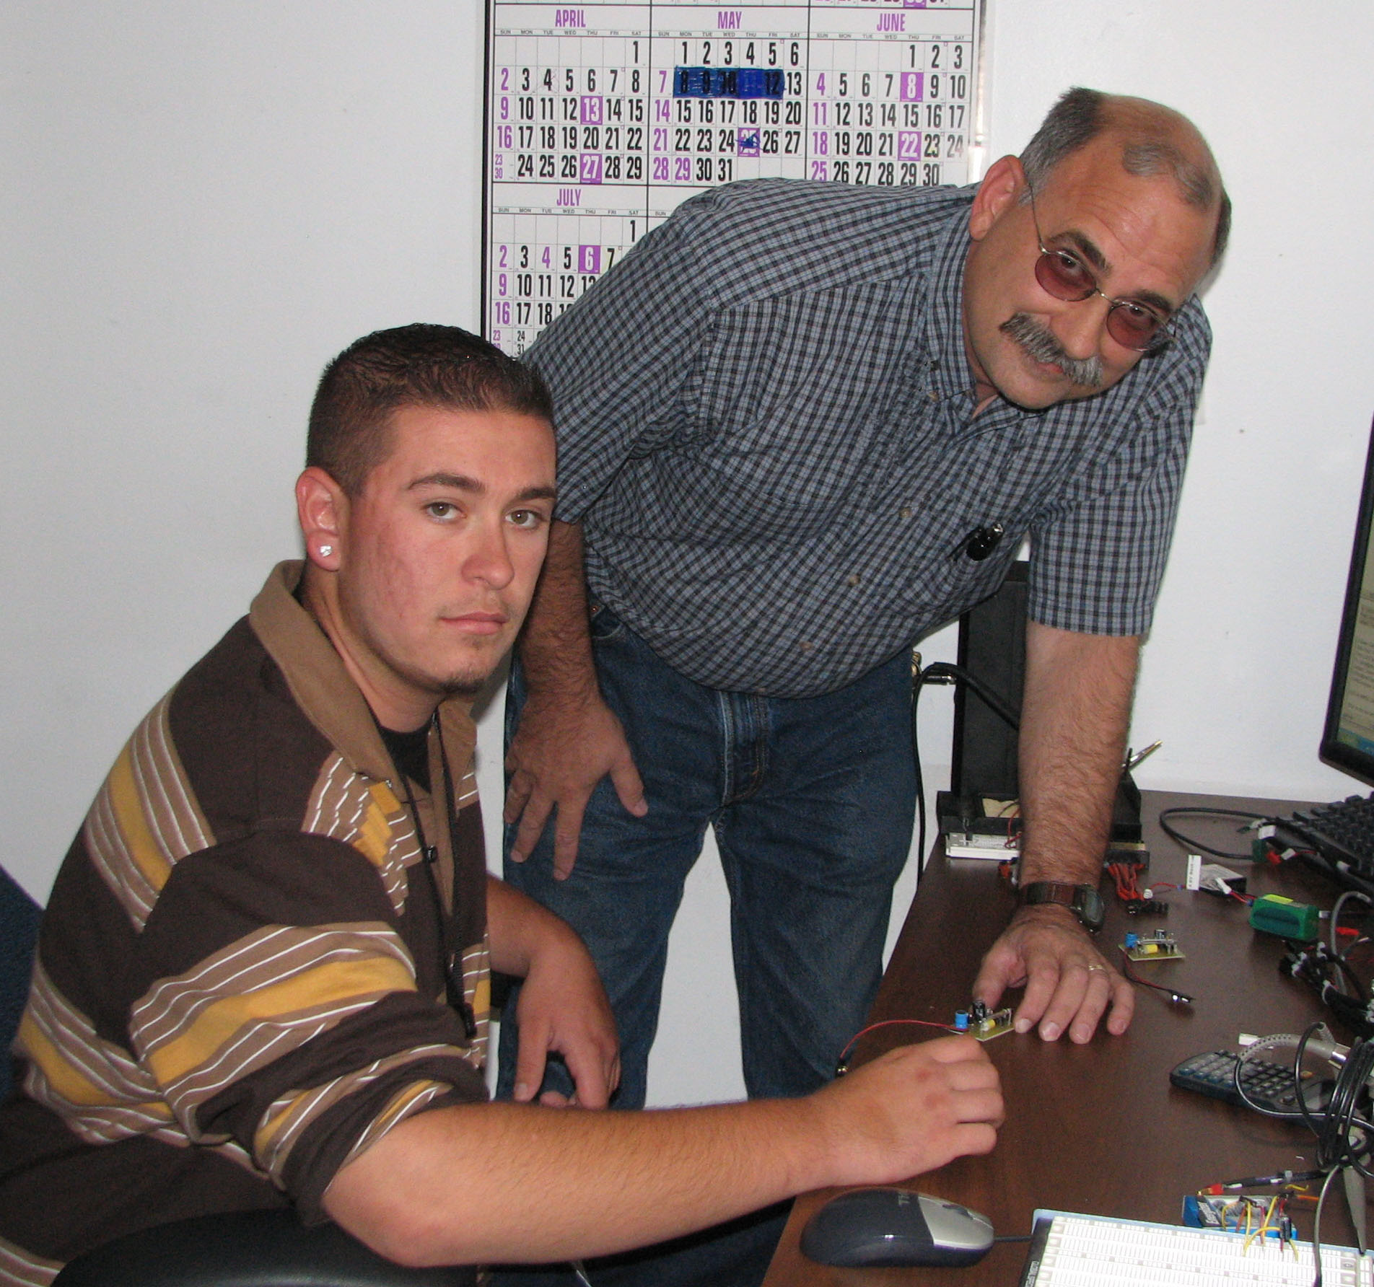
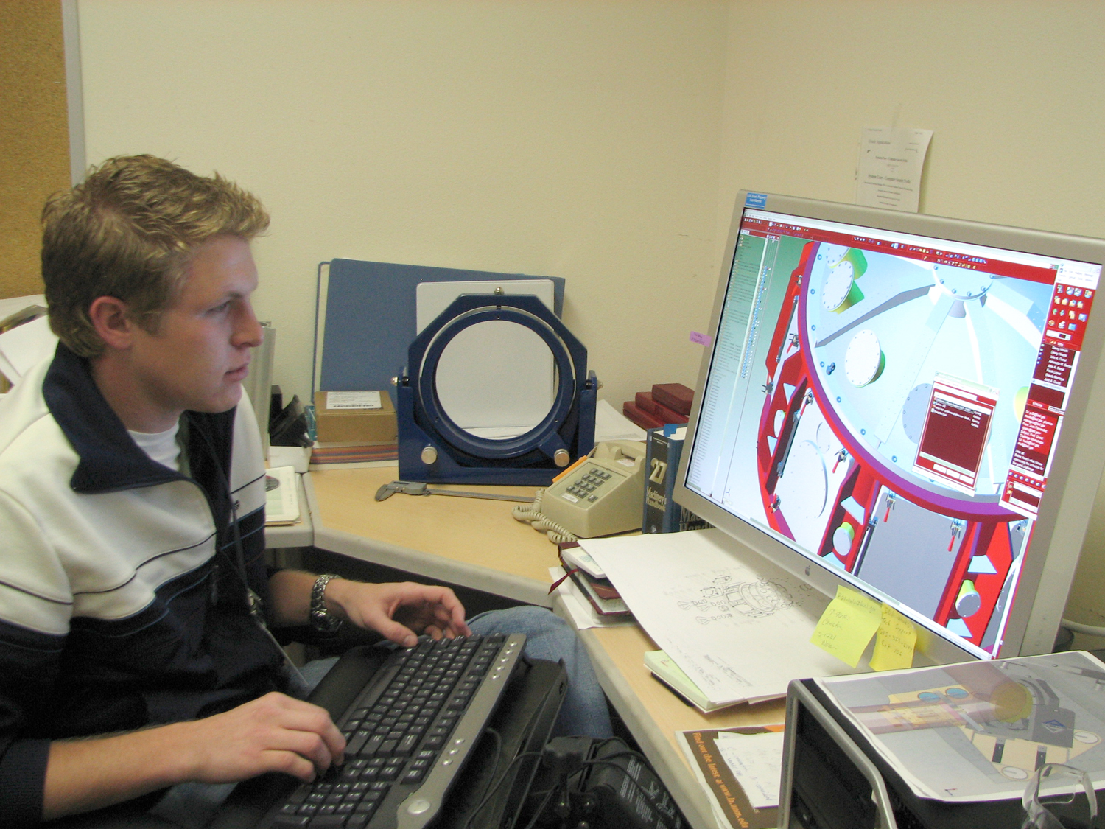
EMTP Coordinator
Brenda Montoya
bmontoya@lanl.gov
667-4866

UNM-LA Coordinator
Yohana Wiuff
ypw@la.unm.edu
662-0341

Student/Mentor Liaison
Carole Rutten
crutten@lanl.gov
665-5194

