XI. Tribal Program

Overview
The Temporary Assistance for Needy Families (TANF) program provides States and Tribes with unprecedented flexibility to design welfare programs to meet the particular needs of families in moving from welfare to work and self-sufficiency.
The 330-plus federally recognized American Indian Tribes in the contiguous 48 States and 13 Alaska entities -- the 12 Alaska Native Regional Nonprofit Associations and the Metlakatla Indian Community of the Annette Islands Reserve -- are designated by the statute as eligible to administer the Tribal TANF (TTANF) program. The number of Tribal TANF grantees has steadily increased since the first three Tribal TANF programs started in July 1997. As of September 30, 2001, 34 Tribal TANF plans covering 172 Tribes and Alaska Native villages had been approved. All programs covered by these plans are fully operational. Twenty-seven of the approved plans involve individual Tribes and seven are multi-Tribal TANF operations. Of the seven multi-Tribal TANF grantees, three are inter-Tribal consortia of Tribes in southern California, three are Alaska Native Regional Nonprofit Associations, and one is in the State of Washington. Some Tribes also operate NEW programs either independently or in conjunction with their TANF programs. A complete list of TANF programs and NEW programs, with grant amounts, is shown in table 11:1.
In addition to the creation of TANF, the Personal Responsibility and Work Opportunity Reconciliation Act of 1996 (PRWORA) replaced the former Tribal Job Opportunities and Basic Skills Training (JOBS) program with the Native Employment Works (NEW) program. The Tribal JOBS Program ended on June 30, 1997. The NEW Program began on July 1, 1997. Funds are appropriated for operation of the NEW Program for FY 1997 through FY 2002. By law, only federally-recognized Tribes and Alaska Native organizations that operated a Tribal JOBS program in FY 1995 are eligible for NEW funding. Seventy-eight Indian Tribes, Alaska Native organizations, and Tribal consortia were eligible to operate NEW programs during the 1999-2000 NEW program year (July 1, 1999 – June 30, 2000). Each of the eligible Tribes operated a program.
Under NEW, Tribes are allowed to use funds for the purpose of operating a program to make work activities available to the population and service area or areas as specified by the Tribe. The NEW program provides funding for Tribes and inter-Tribal consortia to design and administer Tribal work activities that meet the unique employment and training needs of their populations, while allowing States or Tribes to provide other TANF services.
Tribes that administer their own TANF or NEW programs have an unprecedented amount of flexibility to design their programs, define who will be eligible, establish what benefits and services will be available, and develop their own strategies for achieving program goals, including how to help recipients move off of welfare and become self-sufficient. PRWORA also provided Tribes with expanded child care funding and broader authority to administer the child support enforcement program.
Additionally, Tribes can enter into new partnerships with States to ensure that Tribal families receive the support services necessary to become self-sufficient. At the Federal, State, Tribal and community level, existing relationships are being enhanced and new relationships are being forged. Early findings of research conducted by the Washington University School of Social Work and funded by DHHS indicate that "communication, coordination, and collaboration among Tribes, between Tribes and States, and between Tribes and the Federal government have increased."
Indian families that are not served by Tribal TANF programs continue to be served by State TANF programs. Those families served by State TANF programs are subject to the same requirements and are eligible for the same services that the State elects for its population at large.
About 35,000 American Indian families were served by State governments in FY 2000, down from about 40,000 in FY 1999. By September 2001, Tribal TANF programs were serving approximately 17,000 families.
In several States, American Indians continue to constitute a large percentage of the TANF caseload. According to available data, in FY 1999 the percentage of TANF adults who are American Indians was 79.4 percent in South Dakota, 57.5 percent in North Dakota, 46.3 percent in Montana, and 38 percent in Alaska.

Final Rules Governing Tribal Welfare Programs
In February 2000, DHHS published final regulations governing key provisions of the Tribal TANF program. The effective date of this final rule was June 19, 2000.
The Tribal TANF regulations provide Tribes and Tribal consortia with a clear and balanced set of rules for complying with the law's performance goals of moving families into work, time limiting assistance, and promoting parental responsibility. They cover requirements relating to use of funds, program elements, accountability, and data collecting and reporting. Consistent with the statute, the final rules provide Tribes with flexibility to consider such factors as economic conditions and resources available to the Tribe in determining work requirements. They also provide for a process of negotiation with DHHS in establishing time limits on assistance.
In developing their TANF plans, Tribes may design a program to fit their own needs, while taking into consideration such factors as economic conditions, geography, Tribal infrastructure, social and cultural characteristics, and specialized service requirements. Tribes may define such elements of the program as the service area and population (all Indian families within the service area or solely the enrolled members of the Tribe), time limits, benefits, the definition of "family," eligibility criteria, and allowable work activities.
Tribes can also receive direct Federal funding through the NEW program to develop and run welfare-to-work activities that meet the unique employment and training needs of their population, while allowing States to provide other TANF services. These work activities include job search, placement, work experience, on-the-job-training, job creation, and economic development activities. Supportive and job retention services may also be provided.

Current DHHS-Supported Studies of Tribal TANF and NEW Programs
DHHS is currently supporting three major studies of the Tribal TANF and NEW programs.

Welfare-to-work: Monitoring the Impact of Welfare Reform on American Indian Families with Children
- The Washington University School of Social Work (St. Louis, Missouri) is conducting a five-year longitudinal study of the implementation of State and Tribal responses to TANF in Arizona and the impact on Indian families and reservations. The study will be completed in September 2002. Research activities include: document review; site visits; interviews with about 450 former and current welfare families from the Navajo, Salt River, and San Carlos reservations; and consultation with the Inter-Tribal Council of Arizona, Bureau of Indian Affairs, and Arizona Department of Social Security.
- Preliminary findings in the May 2000 project working paper indicate that the rapid decline in welfare caseload at the national and regional levels will not automatically be repeated on Indian reservations. A substantial proportion of respondents reports a serious shortage of job opportunities and support services. They have lower levels of education than the general welfare population, and most of the few who are employed earn below poverty level incomes. Welfare families on reservations generally have not benefited from recent economic prosperity. They face extreme financial hardship and poor living conditions. In order for these families to leave welfare, Federal, State, and Tribal governments must work together to provide job preparation, job opportunities, and support services. Tribal leaders and service providers support the block grant structure with flexibility for Tribes to administer TANF. Tribes lack experience comparable to that of State governments in the administration of welfare programs, and they lack the infrastructure as well as the financial and technical resources necessary to assume welfare programs without the assistance of Federal and State governments.

Experience of Tribal TANF Programs: Problems, Solutions, and Lessons Learned
- Support Services International is conducting this multi-year (October 1999 – April 2002) study to develop national-level information on the experiences of Tribes and families with TANF programs. A telephone survey will be conducted of all Tribal TANF programs funded in 1999 – 2000 and of ten Tribes that have not submitted TANF plans. An on-site in-depth study of approximately nine Tribal TANF programs also will be conducted. Tribal officials, TANF program managers, and program participants will be contacted.
- Goals of the research are to develop:
- information to help Tribes make decisions on initiating TANF programs and to meet needs of policy makers to improve existing programs and develop new programs;
- a decision-support system to help Tribes assess the advantages, disadvantages, and risks of operating a TANF program;
- objective performance measures for use by Tribal TANF programs; and
- a Tribal TANF handbook describing experiences, best practices, and lessons learned.

Evaluation of Welfare-to-Work Programs
- This evaluation is studying the Department of Labor's (DOL) Welfare-to-Work (WtW) programs and programs with which these DOL programs coordinate, including DHHS’s TANF and NEW programs. Its purpose is to assess the effectiveness of these programs. DHHS expects this report to be released some time in the fall of 2002.
- The study of Tribal WtW initiatives will address three broad issues.
- What program models and unique WtW approaches do Tribes develop?
- What activities and services do the Tribal initiatives emphasize?
- How do Tribal initiatives integrate services?

Tribal TANF Grantees
The number of Tribal TANF grantees has steadily increased since the first three Tribal TANF programs started in July 1997. As of September 30, 2001, 34 Tribal TANF plans covering 172 Tribes and Alaska Native villages had been approved, all of which are fully operational. Twenty-seven of the approved plans involve individual Tribes and seven are multi-Tribal TANF operations. Of the seven multi-Tribal TANF grantees, three are inter-Tribal consortia in California, three are Alaska Native Regional Nonprofit Associations, and one is in the State of Washington.
Several TTANF plans are currently under review and will soon be approved. The currently approved TTANF plans and currently pending TTANF plans represent a combined total of 63 TTANF programs involving 204 Tribes/Alaska Native Villages. If all the currently pending proposed TTANF plans are implemented, the total number of TTANF grantees would represent about 41 percent of the estimated number of viable TTANF grantees, and would serve approximately 46 percent of the total estimated number of American Indian (including Alaska Native) families eligible for TANF nationwide. Additionally, several other Tribes, inter-Tribal consortia, and at least one other Alaska Native Regional Nonprofit Association are actively exploring the option of operating a TANF program.

Tribal Family Assistance Funding
The amount of Tribal TANF funding (the Tribal Family Assistance Grant or TFAG) for each program is based on the amount equal to the total Federal payments to the State(s) for FY 1994 attributable to expenditures by the State(s) for AFDC and related services for all Indian families residing in the service area or areas identified by the Tribe pursuant to the statute. Once determined, this amount is subtracted each year from the State TANF grant(s). As of September 30, 2001, Tribal Family Assistance Grants ranged from $77,195 to $31,174,026.
The State TANF block grant program has an annual cost-sharing requirement known as Maintenance-Of-Effort (MOE). This basically means that each State receiving Federal TANF funds must spend an applicable percentage of its own money to help eligible families in ways that are consistent with the purposes of the TANF program. States have the option to provide State funds to Tribal TANF grantees and, at the State's option, count those funds toward their MOE requirement. As of September 30, 2001, 28 Tribal TANF grantees received additional funds from States.

Specific Provisions of Tribal TANF Programs
Each Tribe must submit a Tribal TANF Family Assistance Plan (TFAP) to the Department for review and approval. Although a specific format is not required, TFAPs must include elements specified in the law. The following information is based on approved Tribal TANF plans and amendments as of September 30, 2001. Some of the programs and services included in the TFAPs reflect future plans, rather than fully developed programs and services.

Promoting Stable and Healthy Families
Many Tribal TANF programs are beginning to focus their efforts on bringing families together, reducing family violence, and connecting families to their communities. Tribes are building interventions designed to stabilize and improve the quality of the lives of TANF families. For example:
- as an incentive to become a two-parent family, three Tribal TANF grantees provide additional assistance following the marriage of a TANF recipient; and
- eight Tribal TANF grantees count life skills training and parenting and family strengthening as an allowable work activity.

Time Limiting Assistance
The statute provides a 60-month (or less, at State option) time limit for the receipt of TANF assistance under State TANF programs. To allow for maximum flexibility, under Tribal TANF, time limits for the receipt of TANF assistance are negotiated. The time limits established must be consistent with the purposes of TANF and consistent with the economic conditions and resources available to each Tribe. Each Tribe must also describe any exceptions to the time limit and the percentage of the caseload to be exempt due to hardship as well as the definition of hardship. In establishing this percentage through negotiation with DHHS, the Tribes are setting maximum limits (not goals or projections) for the number or percentage of exemptions that they can grant in the event that it becomes necessary to do so. For example, 25 Tribal TANF grantees apply a 60-month lifetime limit and two Tribal TANF grantees apply a 24 cumulative months within an 84-month consecutive period (same time limit as the State of Oregon).
Most Tribal TANF grantees’ exemption policies fall into the following categories:
- hardship, generally defined by the Tribes as "battered or subject to extreme cruelty", which is defined in section 408(a)(7)(c)(iii) of the Social Security Act (the Act); and
- a mentally or physically disabled parent or caretaker in the family.
The maximum percent of the caseload that can be exempted from the time-limit vary:
- Twenty-seven Tribal TANF grantees exempt 20 percent of the caseload.
- Four Tribal TANF grantees exempt 25 percent of the caseload.
- Two Tribal TANF grantees exempt 30 percent of the caseload.
- One Tribal TANF grantee exempts 35 percent of the caseload.

Promoting Work
The promotion of work is a primary focus of Tribal TANF. To assess a Tribe's level of success in meeting its TANF work objectives, a Tribe that submits a TFAP must negotiate with DHHS minimum work participation requirements that will apply to families that receive Tribal TANF assistance that includes an adult or minor head of household receiving such assistance.
The plan must include the Tribe's proposal for minimum work participation requirements, which includes, for each fiscal year covered by the plan, the Tribe's proposed: (1) work participation rate(s) for all families, or for all families and two-parent families, or for one-parent families and two-parent families; (2) minimum number of hours per week that adults and minor heads of households will be required to participate in work activities; and (3) work activities that count towards meeting these work requirements. Tribes must provide a rationale for their proposals and explain how the proposed work requirements relate to and are justified based on the Tribe's needs and conditions. In addition, the TFAP must include information on penalties against individuals who refuse to engage in required work activities. (See Tables 11:6 through 11:11 for data on aspects of Tribal TANF programs.)

Highlights of Tribal TANF Work Rates
Tribal TANF work rates vary:
- Thirteen Tribal TANF grantees apply a required work rate for two-parent families only.
- Eight Tribal TANF grantees apply a required work rate for all families and for two-parent families, four of which apply the same standard as specified in the Act.
- Four Tribal TANF grantees apply a required work rate for one-parent and two-parent families.
- One Tribal TANF grantee applies a required work rate for one-parent families only.

Highlights of Tribal TANF Work Activities and Support Services
Tribes are using some of the same standard definitions of work that States are using and are adding activities appropriate for their own needs. Work activities described in Tribal plans include:
- job skills, job readiness, and on-the-job training (OJT);
- job search;
- sheltered/supported work;
- work experience/job sampling, internships, and community service;
- subsidized and unsubsidized public and private employment;
- education directly related to employment, including vocational education and GED program participation;
- programs for teen parents in school;
- child care for TANF recipients;
- removal of barriers to employment, including counseling and chemical dependence treatment;
- traditional subsistence activities (hunting, fishing, etc.);
- traditional work activities (pottery and jewelry making, weaving, farming, herding, etc.);
- work involving or supporting traditional cultural activities; and
- credit for reasonable transportation needs (including time spent commuting to and from work or training).
Support services also vary according to Tribes’ needs. Services provided include:
- job search and job placement assistance;
- job counseling;
- personal and family counseling, including domestic violence prevention counseling, financial counseling, and health/hygiene counseling;
- substance abuse counseling and treatment;
- transportation;
- child care;
- initial screening for qualification for related programs and services;
- referrals to other Tribal, State, and local support services and programs;
- health services referrals;
- housing referrals and assistance;
- clothing, tools, and equipment needed for training or to get or retain a job;
- books and supplies for job-related education;
- educational counseling, services, and programs, including Adult Basic Education and GED; and
- traditional cultural support activities.

Initial and Maximum Sanctions for Not Complying with Work Requirements
Tribal TANF plans must also include the Tribe's proposal for its policies in relation to sanctioning those individuals who refuse to engage in work activities. This includes how the Tribe defines "good cause."
- Tribal policies on the first instance of non-compliance are as follows:
- nineteen Tribes impose a partial grant reduction;
- one Tribe imposes a 100-percent grant reduction;
- five Tribes give verbal/written warnings; and
- one Tribe reviews individual responsibility plan for appropriateness.
- Tribal policies on ultimate sanctions are as follows:
- nine Tribes impose a partial grant reduction.
- nineteen Tribes impose a 100-percent grant reduction.

Encouraging Personal Responsibility
Every Tribe requires TTANF applicants and recipients to complete an Individual Responsibility Plan (IRP). Most IRPs include provisions that require:
- cooperation with child support enforcement;
- substance abuse screening/testing;
- school attendance; and
- immunization/health checkups.
Several Tribes require applicants to sign an IRP as a condition of program eligibility. Sanctions for non-cooperation after signing the plan result in immediate termination or benefit reduction.

2000 Tribal TANF Work Participation Rates
It is too early to come to any firm conclusions about the success of Tribal TANF programs in meeting their negotiated work participation rates, for the following reasons:
First, program plans for Tribes were approved for various effective dates. (See Table 11:2.) Under the TANF statute, data reporting is not required until the seventh month of the plan (reflecting an initial 6-month grace period). Thus, the number of months for which data were reported is not the same for all Tribes, making it difficult to make comparisons at this time across all Tribal programs. In addition, Tribal TANF programs did not start until July 1, 1997, and no Tribe was required to report data for any month prior to January 1998. Furthermore, technical system difficulties in transmitting data have led to incomplete data for some Tribes. Finally, some Tribes have, through agreements with States, chosen to use the States’ systems to transmit the data and, in several cases, this has yet to be accomplished.
These same issues, particularly the issue of technical difficulties in transmitting data and the problems with the use of State reporting systems, continue to affect reporting for FY 2000. In addition, there have been ongoing technical difficulties in accessing Tribal data in the State reporting system within the Department. Any conclusions drawn from the data in this report should be made with this in mind.
Tribes have been provided technical assistance on data issues through a series of conferences and on-site visits to the Tribes. Discussions with Federal systems staff have been held to attempt to resolve systems-oriented problems. A new system with more documentation was developed and implemented July 1, 2000.
As noted in the previous report to Congress, all data should still be considered preliminary. However, from the partial data available, it appears that the overall work participation rate for all families in Tribal TANF plans averages about 37 percent. It should also be noted that Tribes are authorized to count work activities that may differ from the State TANF definition of work. For example, hunting, fishing, gathering, and traditional culturally-related activities may be counted as work activities. The inclusion of these more broadly defined work activities could, in some cases, cause data to reflect a higher work activity rate than would otherwise be reported using the much narrower State definitions.
The data as reflected in Table 11:6 show that 1,100 adult TANF recipients were reported as engaged in work activities. Although the total is unduplicated, some of the participants were engaged in more that one work activity. Within this limitation, Table 11:6 also shows that about 32.3 percent of these adults were working in unsubsidized employment, while over eight percent had unpaid work experience and 30 percent were doing job search and job readiness activities.
As shown in Table 11:7, of a total of 1,703 adult TANF recipients reported, 1,130 or 63.3 percent were required to work. An additional 382 or 22 percent were exempt from work and 11.3 percent were either disregarded or deemed working. Table 11:9 indicates that of 2,798 TANF families reported, 1,632 or 58.3 percent were single parent families and 707 or 25.3 percent were child-only cases. Although the average family had 2.1 children, about 30 percent of the families being served had three or more children. And, as shown in Table 11:11 the average age of children served is eight years old, with 28 percent of the total children being five years old or younger.
Tables 11:7 through 11:11 provide additional general Tribal TANF characteristic data for the Tribes reporting. This includes information on adult TANF recipients by relationship to head of household, family type for families in Tribal TANF Programs, and the number of TANF recipient children in the family.

The Native Employment Works (NEW) Program

Background
The JOBS Program ended on June 30, 1997. The NEW Program, which replaced Tribal JOBS, began on July 1, 1997, as authorized by PRWORA. By law, only federally-recognized Tribes and Alaska Native organizations that operated a Tribal JOBS program in FY 1995 are eligible for NEW funding.
The NEW Program provides Tribal grantees with increased flexibility to design programs to make work activities and services available to the populations and service areas the Tribes designate. In designing programs, eligible Tribes consider unique economic, social, and political conditions that exist in the community. NEW Program participants generally have low levels of education and job preparation, and there often are serious shortages of job opportunities and support services on reservations. NEW helps Tribes address these problems.

Statistical Overview of the NEW Program for Program Year 1999-2000
Seventy-eight Indian Tribes, Alaska Native organizations, and Tribal consortia were eligible to operate NEW programs during the 1999-2000 NEW program year (July 1, 1999 – June 30, 2000). Each of the eligible Tribes operated a program. Eighteen of the 78 NEW grantees included their NEW programs as part of their Public Law (P.L.) 102-477 (Indian Employment, Training and Related Services Demonstration Act) demonstration projects. (See Table 11:1.)
NEW grants for each eligible Tribe are restricted by statute to the amount the Tribe received in FY 1994 to operate its Tribal JOBS Program. Annual NEW grant amounts range from $5,187 to $1.75 million. The total amount appropriated annually for NEW grants is $7,633,287. In program year (PY) 1999-2000 (July 1, 1999 through the following June 30), total NEW funding for the 60 NEW grantees that did not consolidate their NEW grants under P.L. 102-477 projects was $6,017,347, and total NEW funding for the 18 NEW grantees that consolidated their NEW grants under P.L. 102-477 projects was $1,615,940. The sizes of the NEW grant awards, excluding those made under the P.L. 102-477 program, were as follows: approximately 11 percent of the grants were less than $10,000; 33 percent of the grants were $10,000 to $50,000; and over 75 percent were less than $100,000.

Clients Served and General Program Outcomes
Most information on NEW programs and clients is based on program data reported by 57 of the 60 NEW grantees that did not consolidate NEW under P.L. 102-477 projects in Program Year (PY) 1999-2000. NEW program data reported by these grantees for PY 1999-2000 is provided in more detail in Tables 11:12 through 11:17. Information on the 18 NEW grantees that consolidated their PY 1999-2000 NEW funding in P.L. 102-477 projects is included later in this chapter, under the heading “Public Law 102-477 Projects with NEW Program Funds Incorporated.”
NEW grantees that did not consolidate their NEW program in a P.L. 102-477 project served a total of 6,940 clients during the 1999-2000 program year (PY), approximately the same number of participants as they served in PY 1998-1999. In PY 1998-1999, the non-477 NEW grantees served a total of 7,089 clients. One reason for the slight decline in the number of participants is that two additional NEW grantees consolidated their programs under P.L. 102-477 projects in PY 1999-2000 and no longer had to report to DHHS. Also, some Tribes increased coordination with States in PY 1999-2000, and State work programs served some Tribal clients.
Forty-four percent of NEW clients completed the program after reaching one or more objectives of their enrollment in PY 1999-2000 (compared to 48 percent in PY 1998-1999). About 17.5 percent of program participants completed the program by entering unsubsidized employment, and 7.4 percent of program participants completed the program after finishing one or more educational or training activities that were objectives of their program enrollment.
More than 1,200 participants entered unsubsidized employment in PY 1999-2000 and the program helped 2,442 participants receive their GED and high school diplomas.
Overall, the NEW Program was effective in meeting the needs of NEW clients, by providing educational activities, job skills training and job readiness activities, and employment activities including community work experience, on-the-job training, job placement, and subsidized and unsubsidized employment. NEW programs also met the needs of NEW clients by providing supportive and job retention services (including transportation assistance, child care, and a variety of pre- and post-employment services), and job creation and economic development leading to job creation.

Client Characteristics
Of the NEW clients served in PY 1999-2000 by non-477 NEW programs, 79 percent were female (compared to 84 percent in PY 1998-1999) and 21 percent were male (compared to 16 percent in PY 1998-1999). Teen parents represented seven percent of the total client population.
Most NEW Program participants also received Bureau of Indian Affairs (BIA) General Assistance (GA) and/or TANF cash assistance. Fifty-four percent of NEW clients received BIA General Assistance program services and 33.4 percent of NEW clients participated (received TANF cash assistance and/or other TANF services) in Tribal or State TANF programs in PY 1999-2000.
NEW programs’ most frequently identified target groups were: TANF recipients; non-custodial parents; and others (BIA/GA recipients, unemployed parents, two-parent and single-parent families, teen parents, etc.) Many participants faced barriers to employment such as lack of transportation, lack of child care, and substance abuse.

NEW Program Activities and Services
PRWORA provided Tribal grantees with NEW Program funding to "make work activities available” to their populations and service areas. In general, grantees continued to network with other service providers and provided work activities and support services tailored to meet the needs of their NEW clients. Working with related programs, flexible NEW programs helped Tribes bridge service gaps and provide coordinated services to their clients.
Some grantees established one-stop centers or moved toward co-locating employment and social services. While traditional work activities were offered, grantees also offered various non-traditional work activities for NEW clients, including a broad array of support activities. Primary program coordination linkages were with community colleges, Head Start and child care programs, TANF offices, and other employment and job development programs.
The most frequently provided NEW Program work activities included job search, work experience, classroom training, other Tribal work activities (volunteer work, employment seminars, and community service), and on-the-job-training. Clients spent their time in a variety of activities. About 46 percent of clients participated in job search in PY 1999-2000 (compared to 19 percent in PY 1998-1999). About 32 percent participated in work experience and/or on-the-job training in PY 1999-2000 (compared to 15 percent in PY 1998-1999). About 23 percent participated in some form of classroom training in PY 1999-2000 (compared to 12 percent in PY 1998-1999), and about 13 percent participated in other Tribal work activities (compared to nine percent in PY 1998-1999).
Support services provided to NEW clients included transportation, child care, job retention and work-related expenses (e.g., equipment, tools, and uniforms), counseling, and medical services. Approximately 19 percent of the program participants received transportation assistance (compared to 32 percent in PY 1998-1999), and 16 percent received child care services in PY 1999-2000 (compared to 24 percent in PY 1998-1999). About 15 percent received assistance to cover job retention and/or work related expenses. Nineteen percent received various types of counseling services in 1999-2000 (compared to 17 percent in PY 1998-1999), and about two percent were provided medical services in PY 1999-2000 (compared to three percent in PY 1998-1999).
A number of NEW grantees also implemented job creation and economic development projects in response to the shortage of jobs on their reservations.

Barriers to Program Implementation
NEW grantees reported a variety of barriers to program implementation. Many NEW grantees reported having inadequate staff and lack of employment opportunities for clients. Others reported a high rate of staff turnover, difficulty in coordinating with State and local TANF offices, the need to update equipment, and a lack of adequate program funding.

Client Barriers
NEW grantees reported that their clients’ most significant barriers to employment remained lack of transportation and child care. In addition, many of the hardest-to-serve clients experienced problems of substance abuse, mental illness, and domestic violence.
Due to the remoteness and isolation of many reservations, obtaining adequate transportation remained the primary barrier for most clients and program operators. Job placement and work activities were often available off reservation, necessitating transportation arrangements. Public transportation is virtually non-existent on most reservations. Other than transportation provided by NEW or other Tribal programs, car pooling, hitchhiking, and Tribal taxi companies were the most common modes of transportation available.

NEW Program Successes and Innovations/Enhancements
A number of NEW grantees attributed their successes to coordination of services in one-stop-shop centers. At these centers, staff perform evaluations for participants to determine the need for services and programs including TANF, NEW, Workforce Investment Act (WIA) programs, child care, food stamps, commodities (food instead of food stamps), Medicaid, and vocational rehabilitation for people with learning disabilities.
NEW grantees were effective in establishing collaboration with many other programs, e.g., with colleges (including Tribal colleges), GED programs, programs funded under WIA, and child care and Head Start programs. A number of NEW grantees were innovative in coordinating activities through inter-agency referrals and networking activities. NEW grantees coordinated employment and training with economic development programs, and they worked closely with educators. They coordinated with other Tribal programs, and with State programs.
Program providers worked with clients to identify barriers and resources so they could effectively put together an employability plan of action specifically designed for each client. Caseworkers met with clients to help them develop individual development plans and resumes.
A number of NEW grantees initiated economic development and job creation projects to provide job opportunities at a livable salary/wage and provide needed services for their communities. For example, one grantee started a gift shop which sells authentic arts and crafts hand-made by Tribal members, and other grantees provided start-up funding for home child care, entrepreneurial training, and Tribal transportation projects.
In response to the severe shortage of child care facilities and providers on their reservations, several grantees trained clients to become child care providers and set up their own businesses. Others worked to have child care facilities expanded or built.
In response to the lack of transportation on their reservations, one grantee started a Native American owned taxicab service and another grantee started a bus service. Not only did the taxi and bus services increase the availability of opportunities for the programs’ clients, they also created jobs for clients.

Public Law 102-477 Projects with NEW Program Funds Incorporated
Public Law 102-477 established a demonstration program to allow Indian Tribes to integrate program services and consolidate administrative functions under federally-funded programs they administer for employment, training, and related services.
Eighteen Tribal grantees incorporated their NEW programs under a P.L.102-477 project in PY 1999-2000. Tribes participating in P.L. 102-477 projects reported to the Bureau of Indian Affairs. They did not provide separate data on NEW; instead, they provided combined totals for all consolidated programs. The 26,369 clients served represent the total number of participants served during this period under all programs consolidated under P.L.102-477 projects. Of these clients served, 4,589 were TANF recipients. Of the clients served under P.L. 102-477 projects in PY 1999-2000, 33 percent entered unsubsidized employment (compared to 45 percent in PY 1998-1999), and 30 percent completed an educational or training activity that was an objective of their program enrollment (compared to 25 percent in PY 1998-1999). Because P.L. 102-477 projects include resources from a number of programs, these percentages are somewhat higher for 477 programs than they are for non-477 NEW programs.
Fifty-two percent of the program participants were female (compared to 51 percent in PY 1998-1999), and 48 percent were male (compared to 49 percent in PY 1998-1999). For unknown reasons, the number of persons between the ages of 14 and 21 increased substantially to 41 percent from 23 percent in PY 1998-1999.
Of the individuals served under P.L.102-477 projects, 54 percent participated in classroom training (compared to 33 percent in PY 1998-1999). Forty-three percent received supportive services, e.g., car repairs and gas vouchers (compared to 19 percent in PY 1998-1999); 15 percent received supportive work services, e.g., counseling and training (compared to 11 percent in PY 1998-1999); and 43 percent received other Tribal services, e.g., uniforms, clothing, shoes, and tools (compared to 34 percent in PY 1998-1999). Nineteen percent of the families served under P.L.102-477 received child care services (compared to 11 percent in PY 1998-1999).

Appendices
Table 11:1 Grant Amounts Awarded to American Indian Entities Administering A Federal TANF or NEW Program Fiscal Year 2000
Table 11:2 Number of Tribes, Effective Dates, Grants, Estimated Caseloads, and State Match
Table 11:3 Tribal TANF Program - Estimated Number of AFDC/TANF Cases with An American Indian in The Assistance Unit in States with A Federally-Recognized Tribe - FY 1992-1999
Table 11:4 Tribal TANF Program - Estimated Number of AFDC/TANF Cases with An American Indian in the Assistance Unit and Maintenance Assistance Dollars For Such Cases in States with A Federally-Recognized Tribe, - FY 1994
Table 11:5 Tribal TANF Program - Changes in Estimated AFDC/TANF Cases with an American Indian Compared to Changes in All Cases in States with A Federally-Recognized Tribe - FY 1994 - FY 1999
Table 11:6 Tribal TANF Program - Adults with Work Activities by Type of Activity - FY 1999
Table 11:7 Tribal TANF Program - Adults by Work Participation Status - FY 1999
Table 11:8 Tribal TANF Program - Adults by Relationship to Head of Household - FY 1999
Table 11:9 Tribal TANF Program - Type of Family Receiving Assistance - FY 1999
Table 11:10 Tribal TANF Program - Number of Families by Number of Children in The Family - FY 1999
Table 11:11 Tribal TANF Program - Age of Children in The TANF Family - FY 1999
Table 11:12 Native Employment Works (NEW) Program - Year 1999-2000 (July 1, 1999 - June, Total Participants Served
Table 11:13 Native Employment Works (NEW) Program Year 1999-2000 (July 1, 1999 - June 30, 2000), Terminations by Reason
Table 11:14 Native Employment Works (NEW) Program Year 1999-2000 (July 1, 1999 - June 30, 2000), Number of Males, Females, Teen Parents, and Adults Served
Table 11:15 Native Employment Works (NEW) Program Year 1999-2000 (July 1, 1999 - 2000), Number of Participants Receiving TANF and BIA/GA, with Barriers to Employment, and Completing High School/GED
Table 11:16 Native Employment Works (NEW) Program Year 1999-2000 (July 1, 1999 - June 30 2000), Number of Participants by Type of Work Activity
Table 11:17 Native Employment Works (NEW) Program Year 1999-2000 (July 1, 1999 - June 30 2000), Number of Recipients by Type of Service
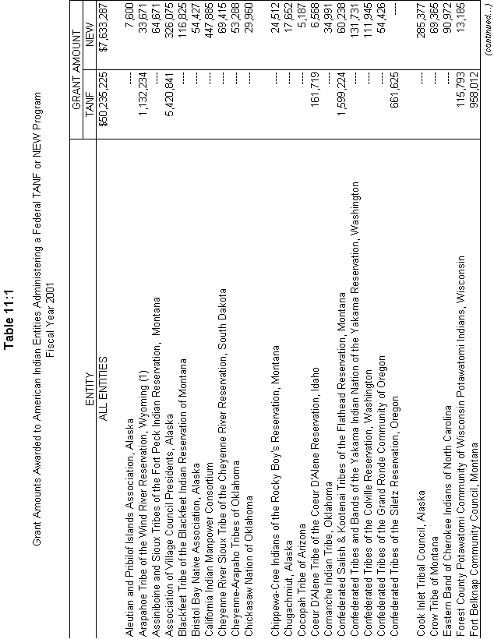
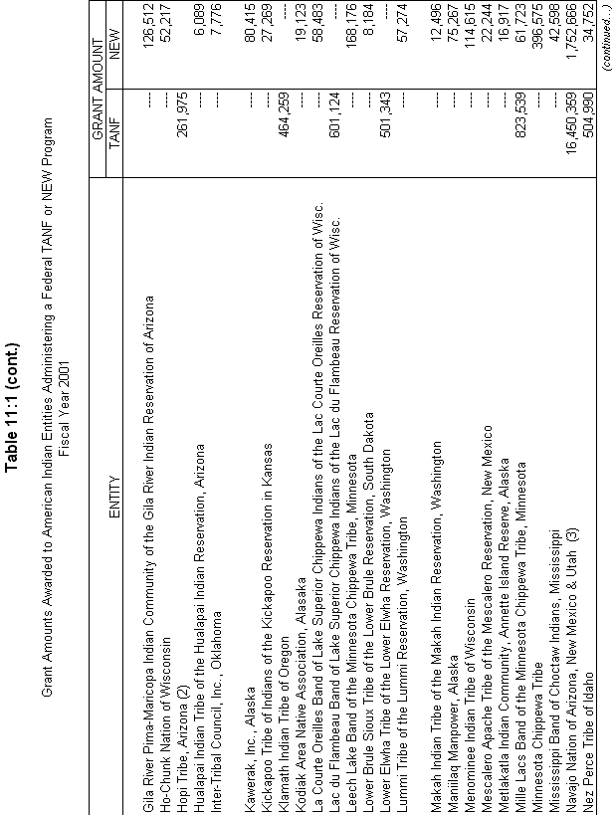
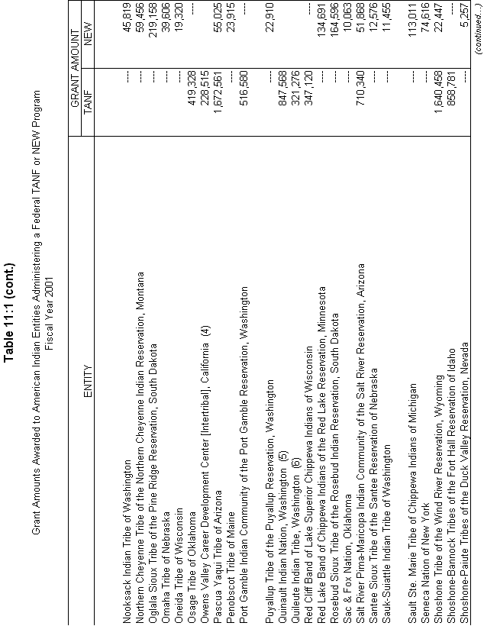
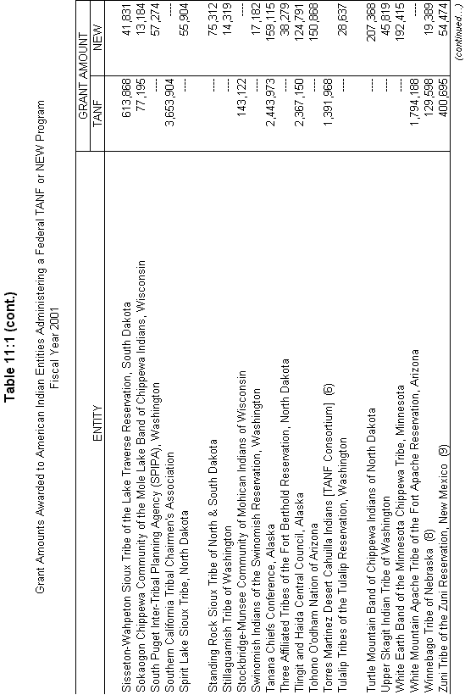
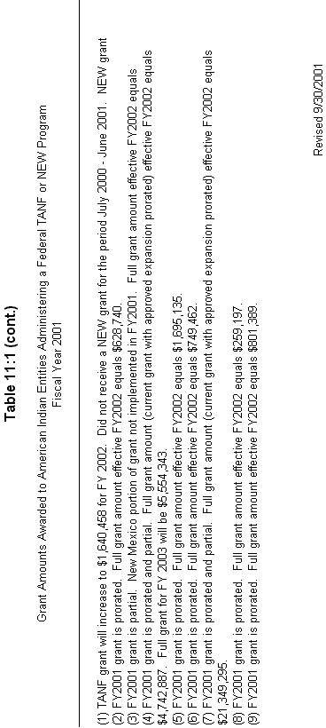
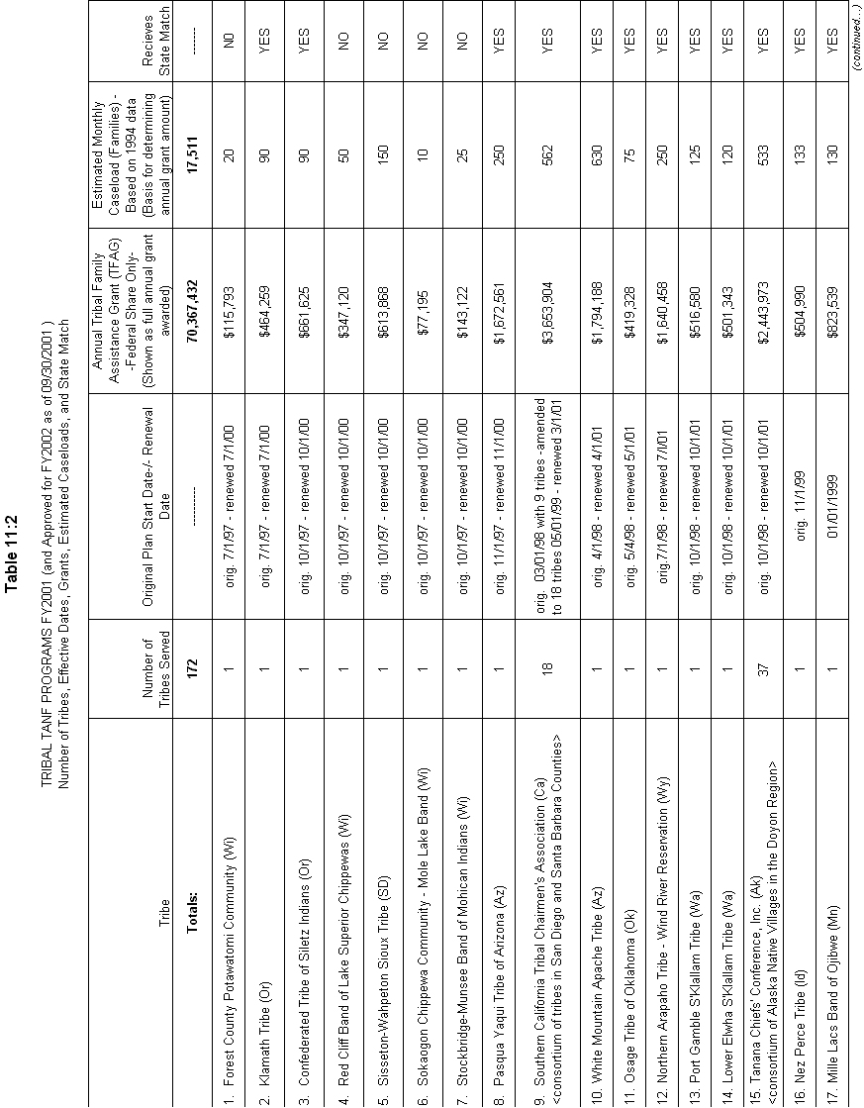
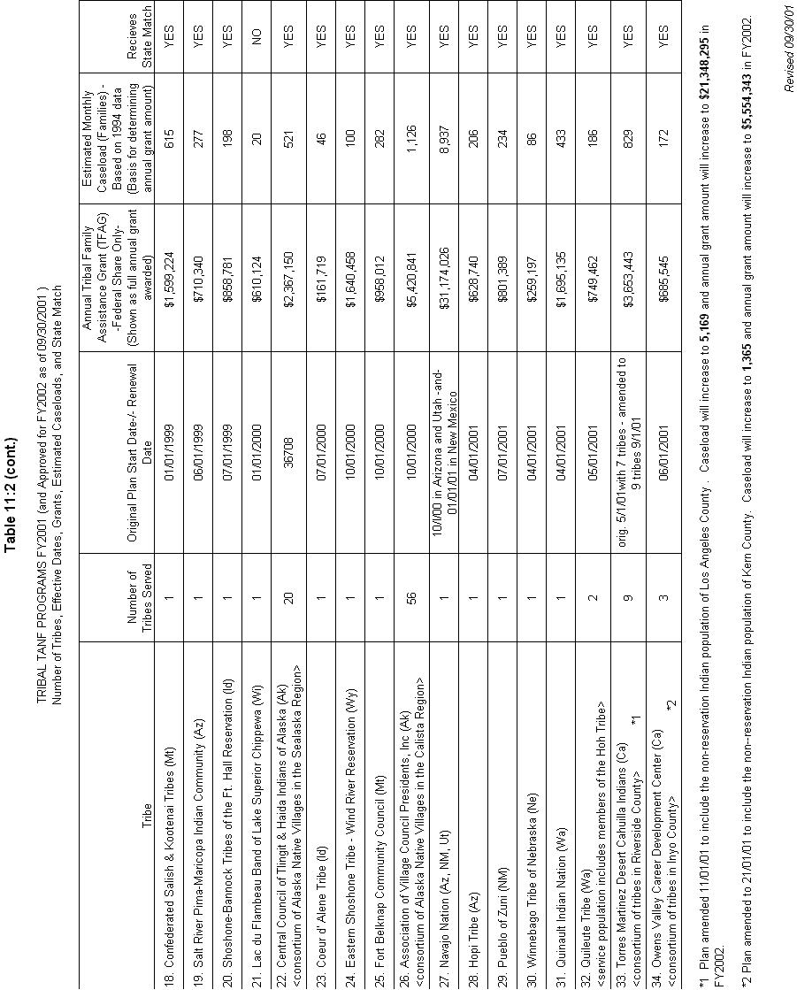
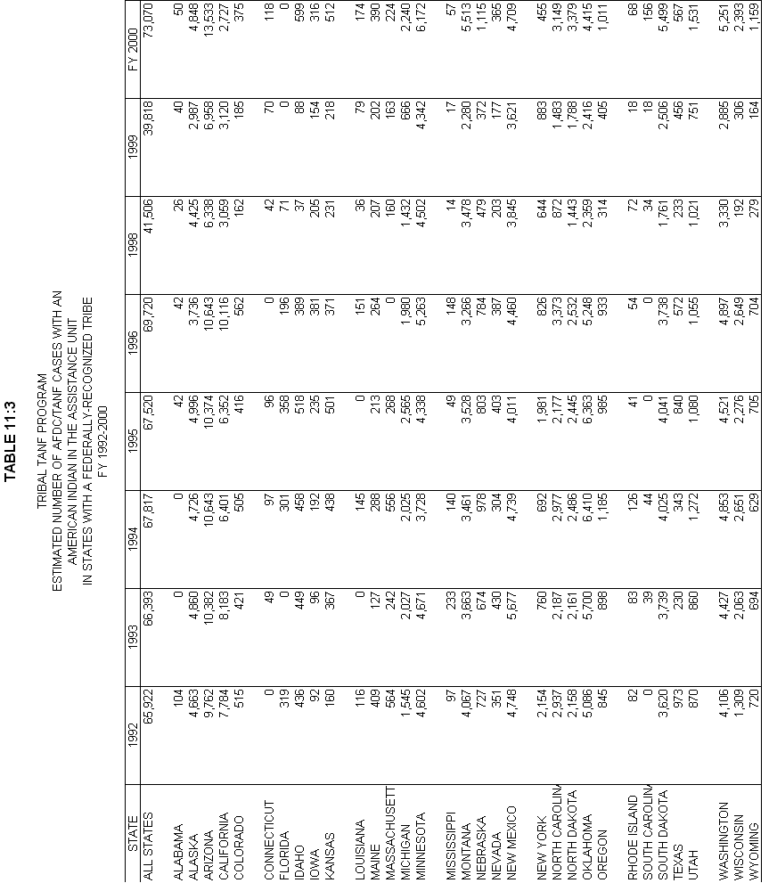
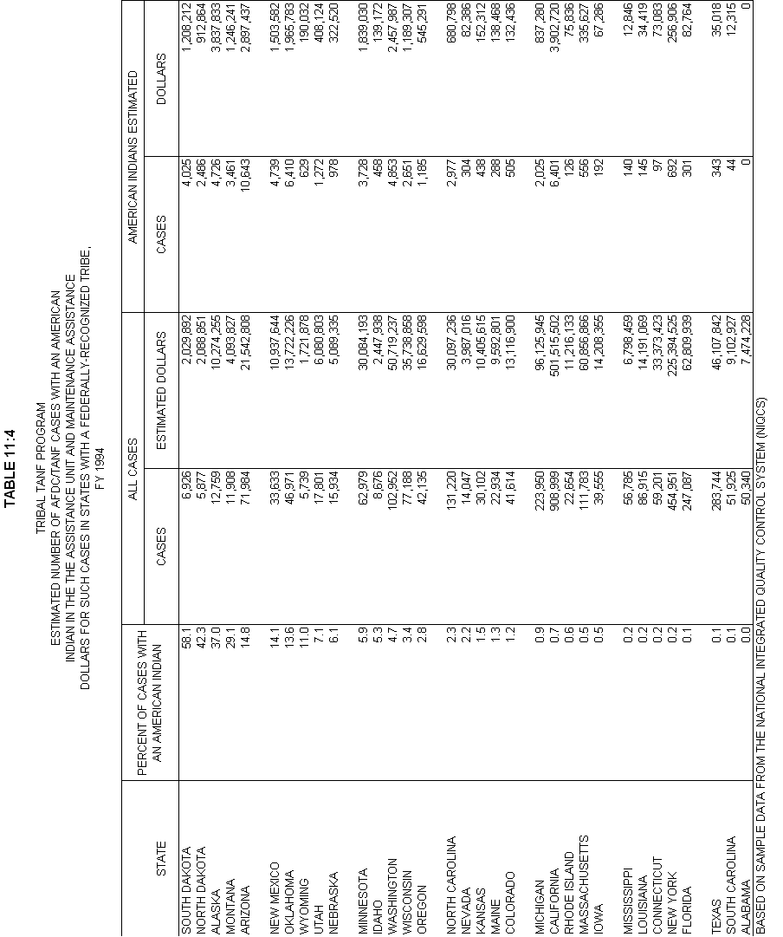
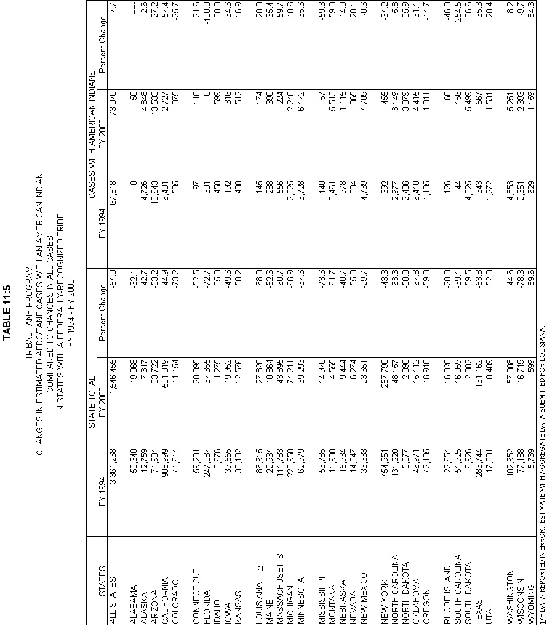
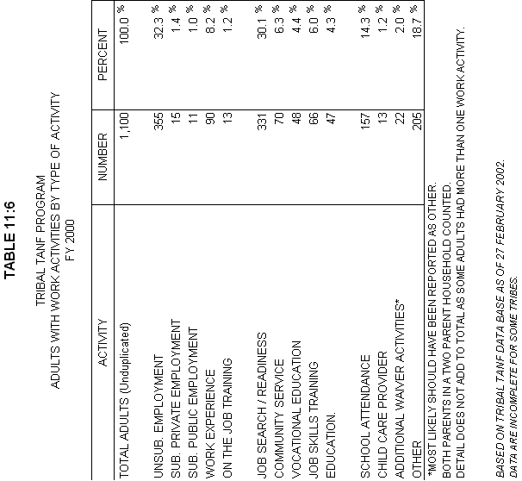
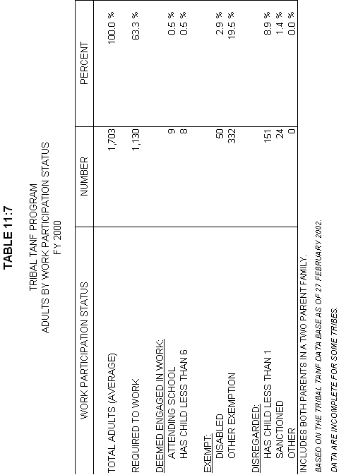
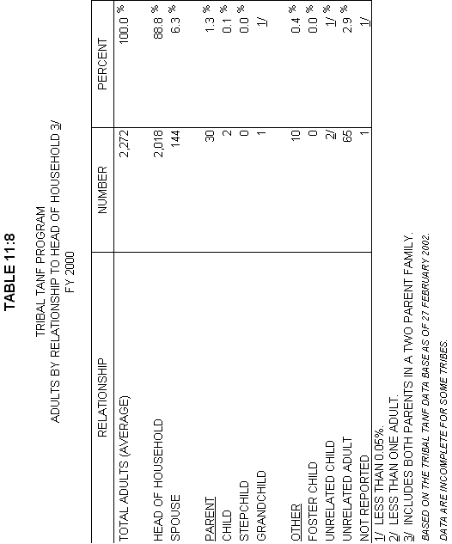
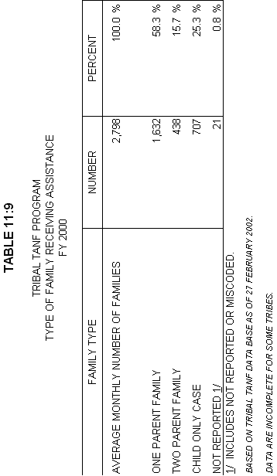
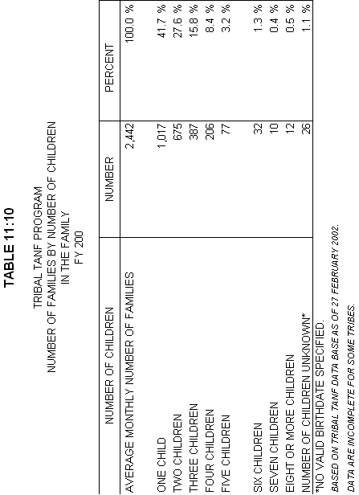
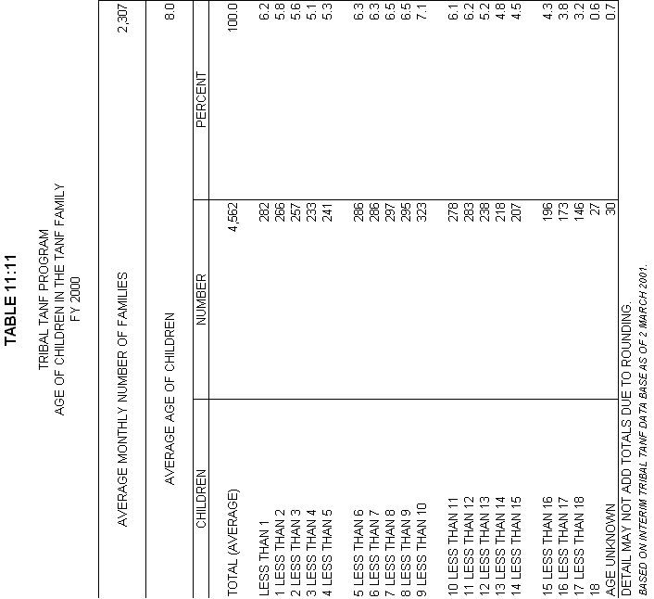
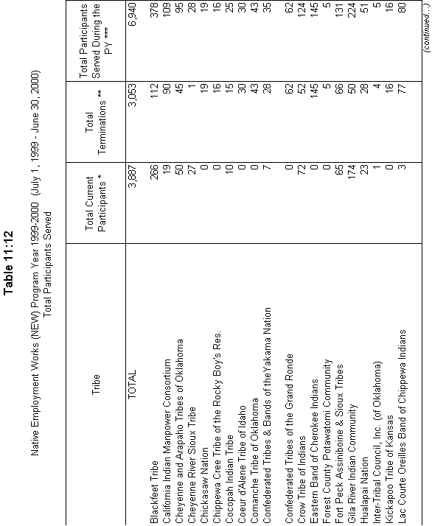
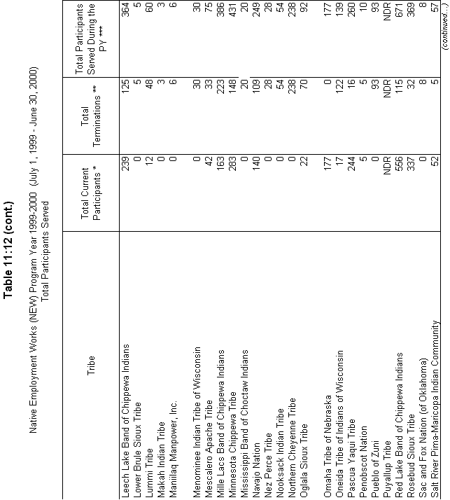
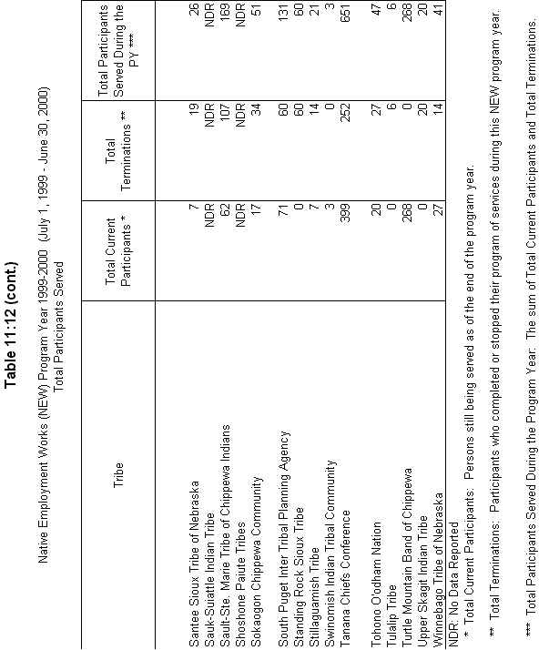
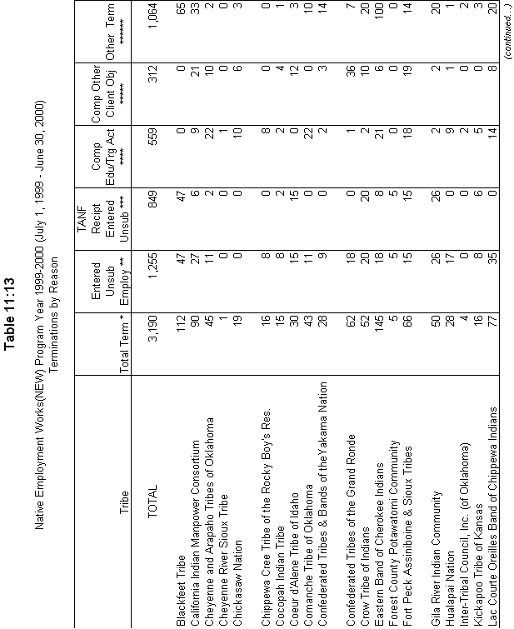
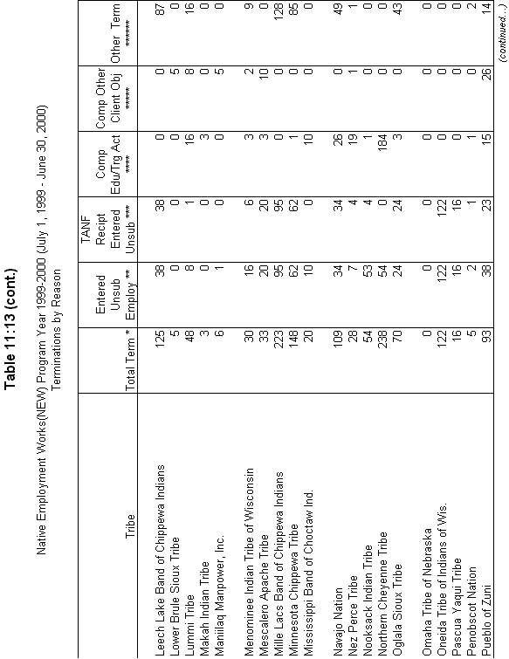
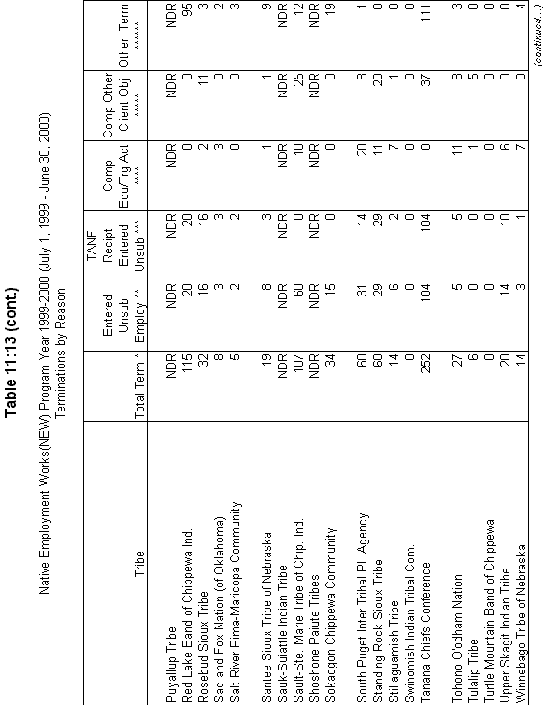
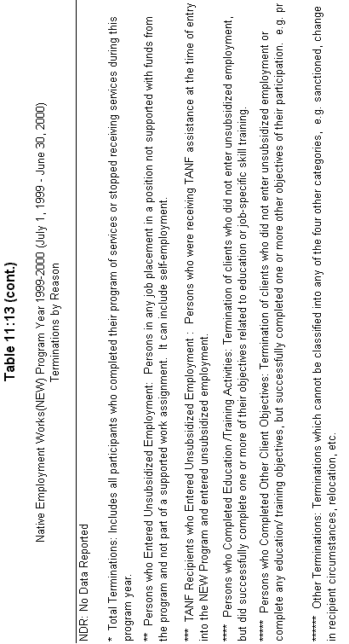
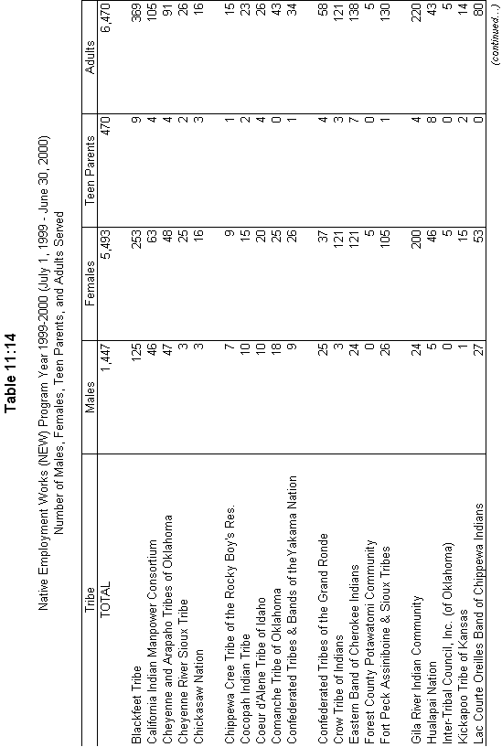
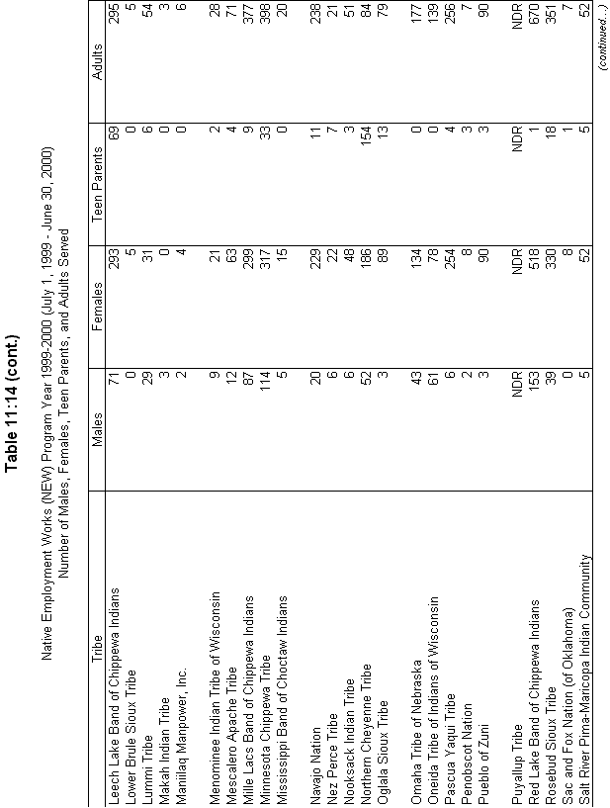
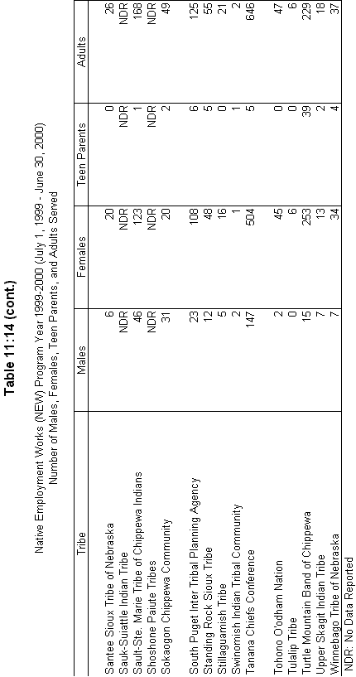
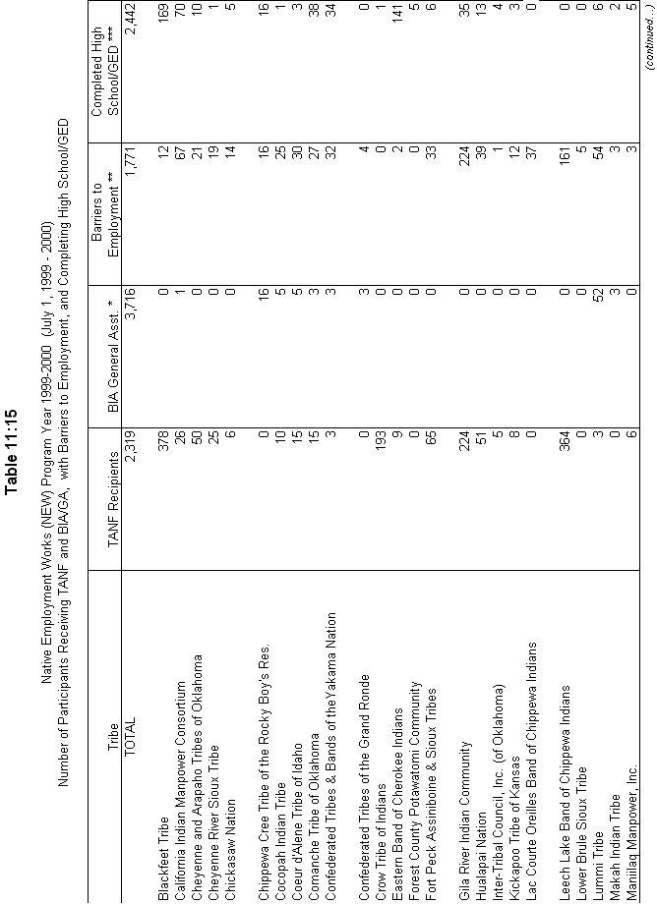
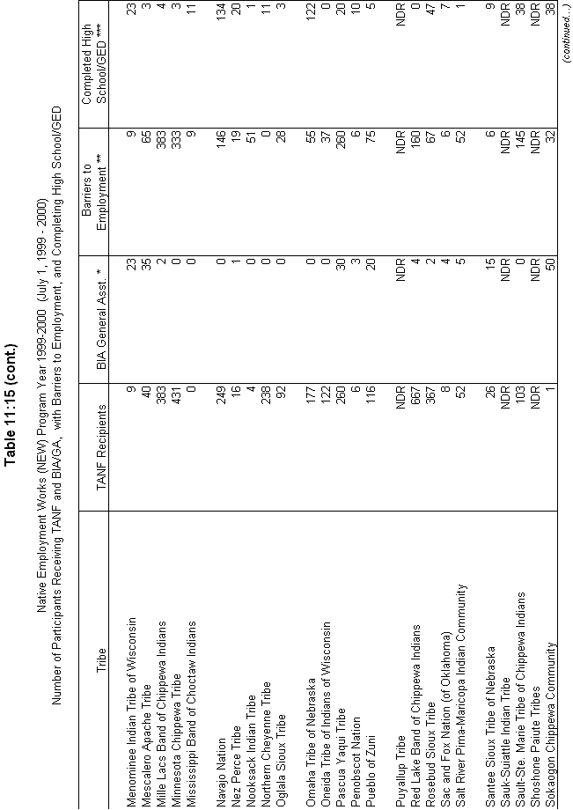
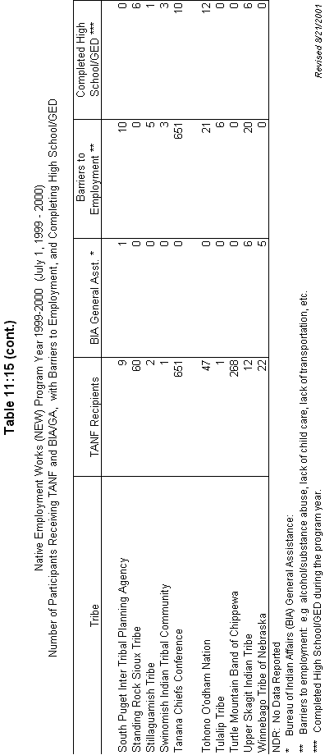
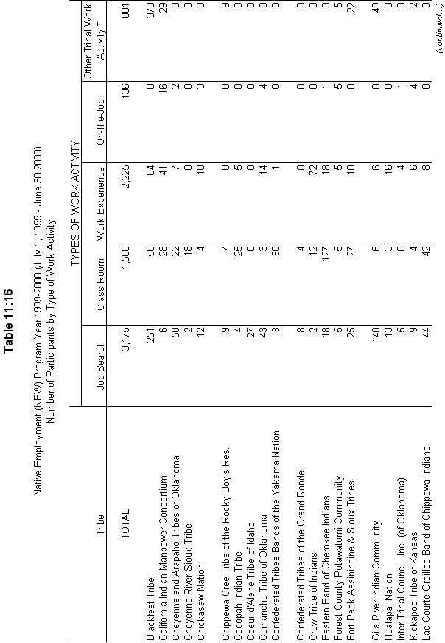
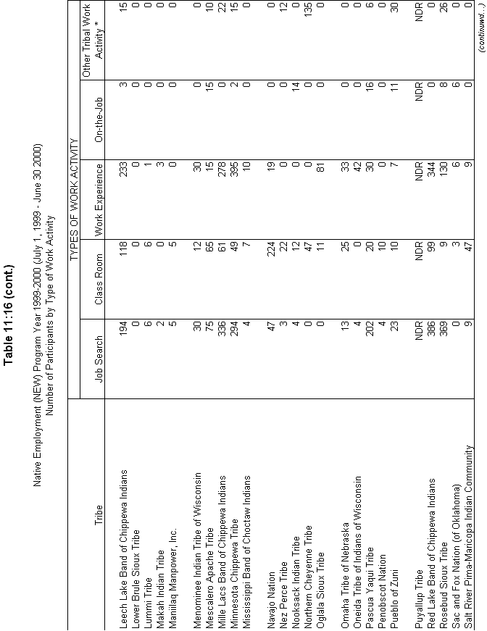
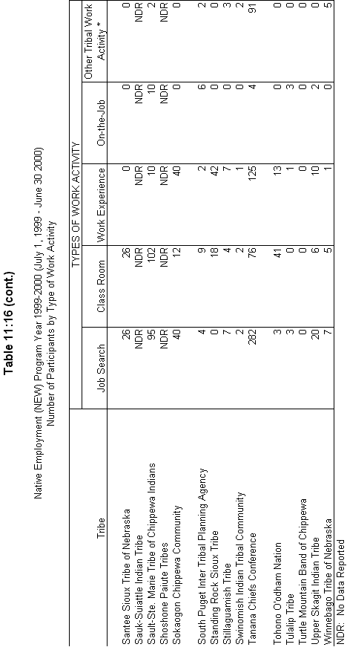
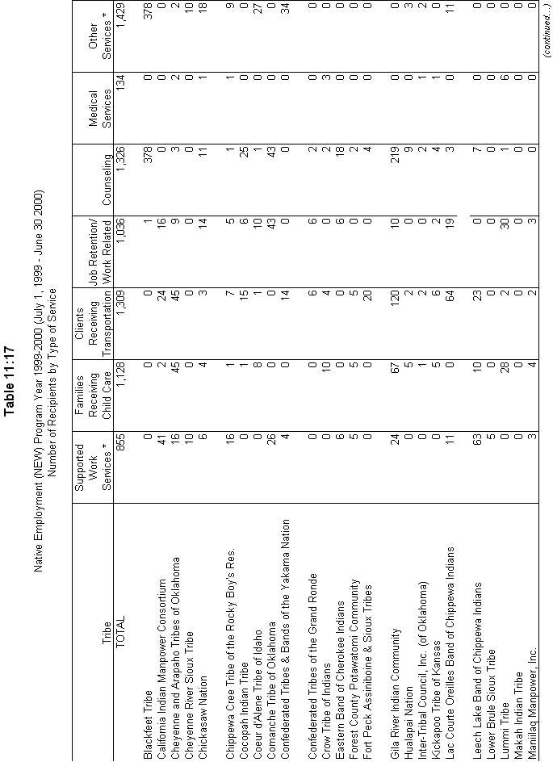
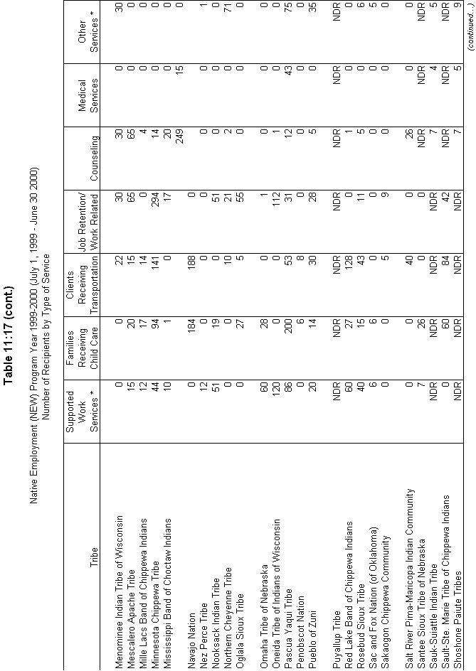
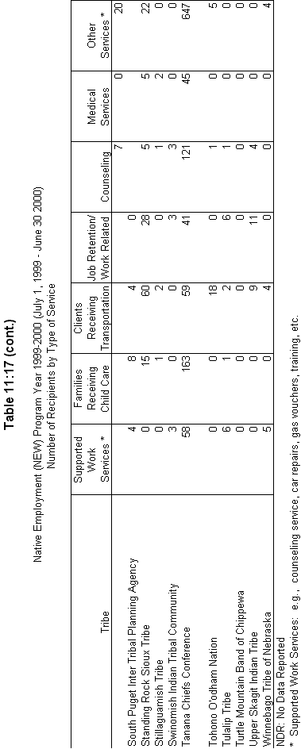

The word "viable" refers to the body of potential applicants that DHHS estimates would have the service population, infrastructure, means, etc., to administer and sustain operation of a TANF program.
The assistance consists of marriage and parenting counseling, marriage bonuses, marriage promotion information, etc.

