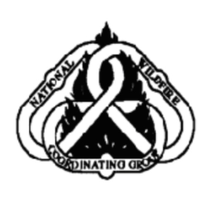
NWCG PRESCRIBED FIRE
GO/NO-GO CHECKLIST

Yes | No | Questions
 |  | Are ALL fire prescription elements met?
 |  | Are ALL smoke management specifications met?
 |  | Has ALL required current and projected fire weather forecast been obtained and are they it favorable?
 |  | Are ALL planned operations personnel and equipment on-site, available, and operational?
 |  | Has the availability of ALL contingency resources been checked, and are they available?
 |  | Have ALL personnel been briefed on the project objectives, their assignment, safety hazards, escape routes, and safety zones?
 |  | Have all the pre-burn considerations identified in the prescribed fire plan been completed or addressed?
 |  | Have ALL the required notifications been made?
 |  | Are ALL permits and clearances obtained?
 |  | In your opinion, can the burn be carried out according to the prescribed fire plan and will it meet the planned objective?

If all the questions were answered "YES" proceed with a test fire. Document the current conditions, location, and results

PMS 421 (1/02)

