Early Childhood
Professional Development
Systems Toolkit

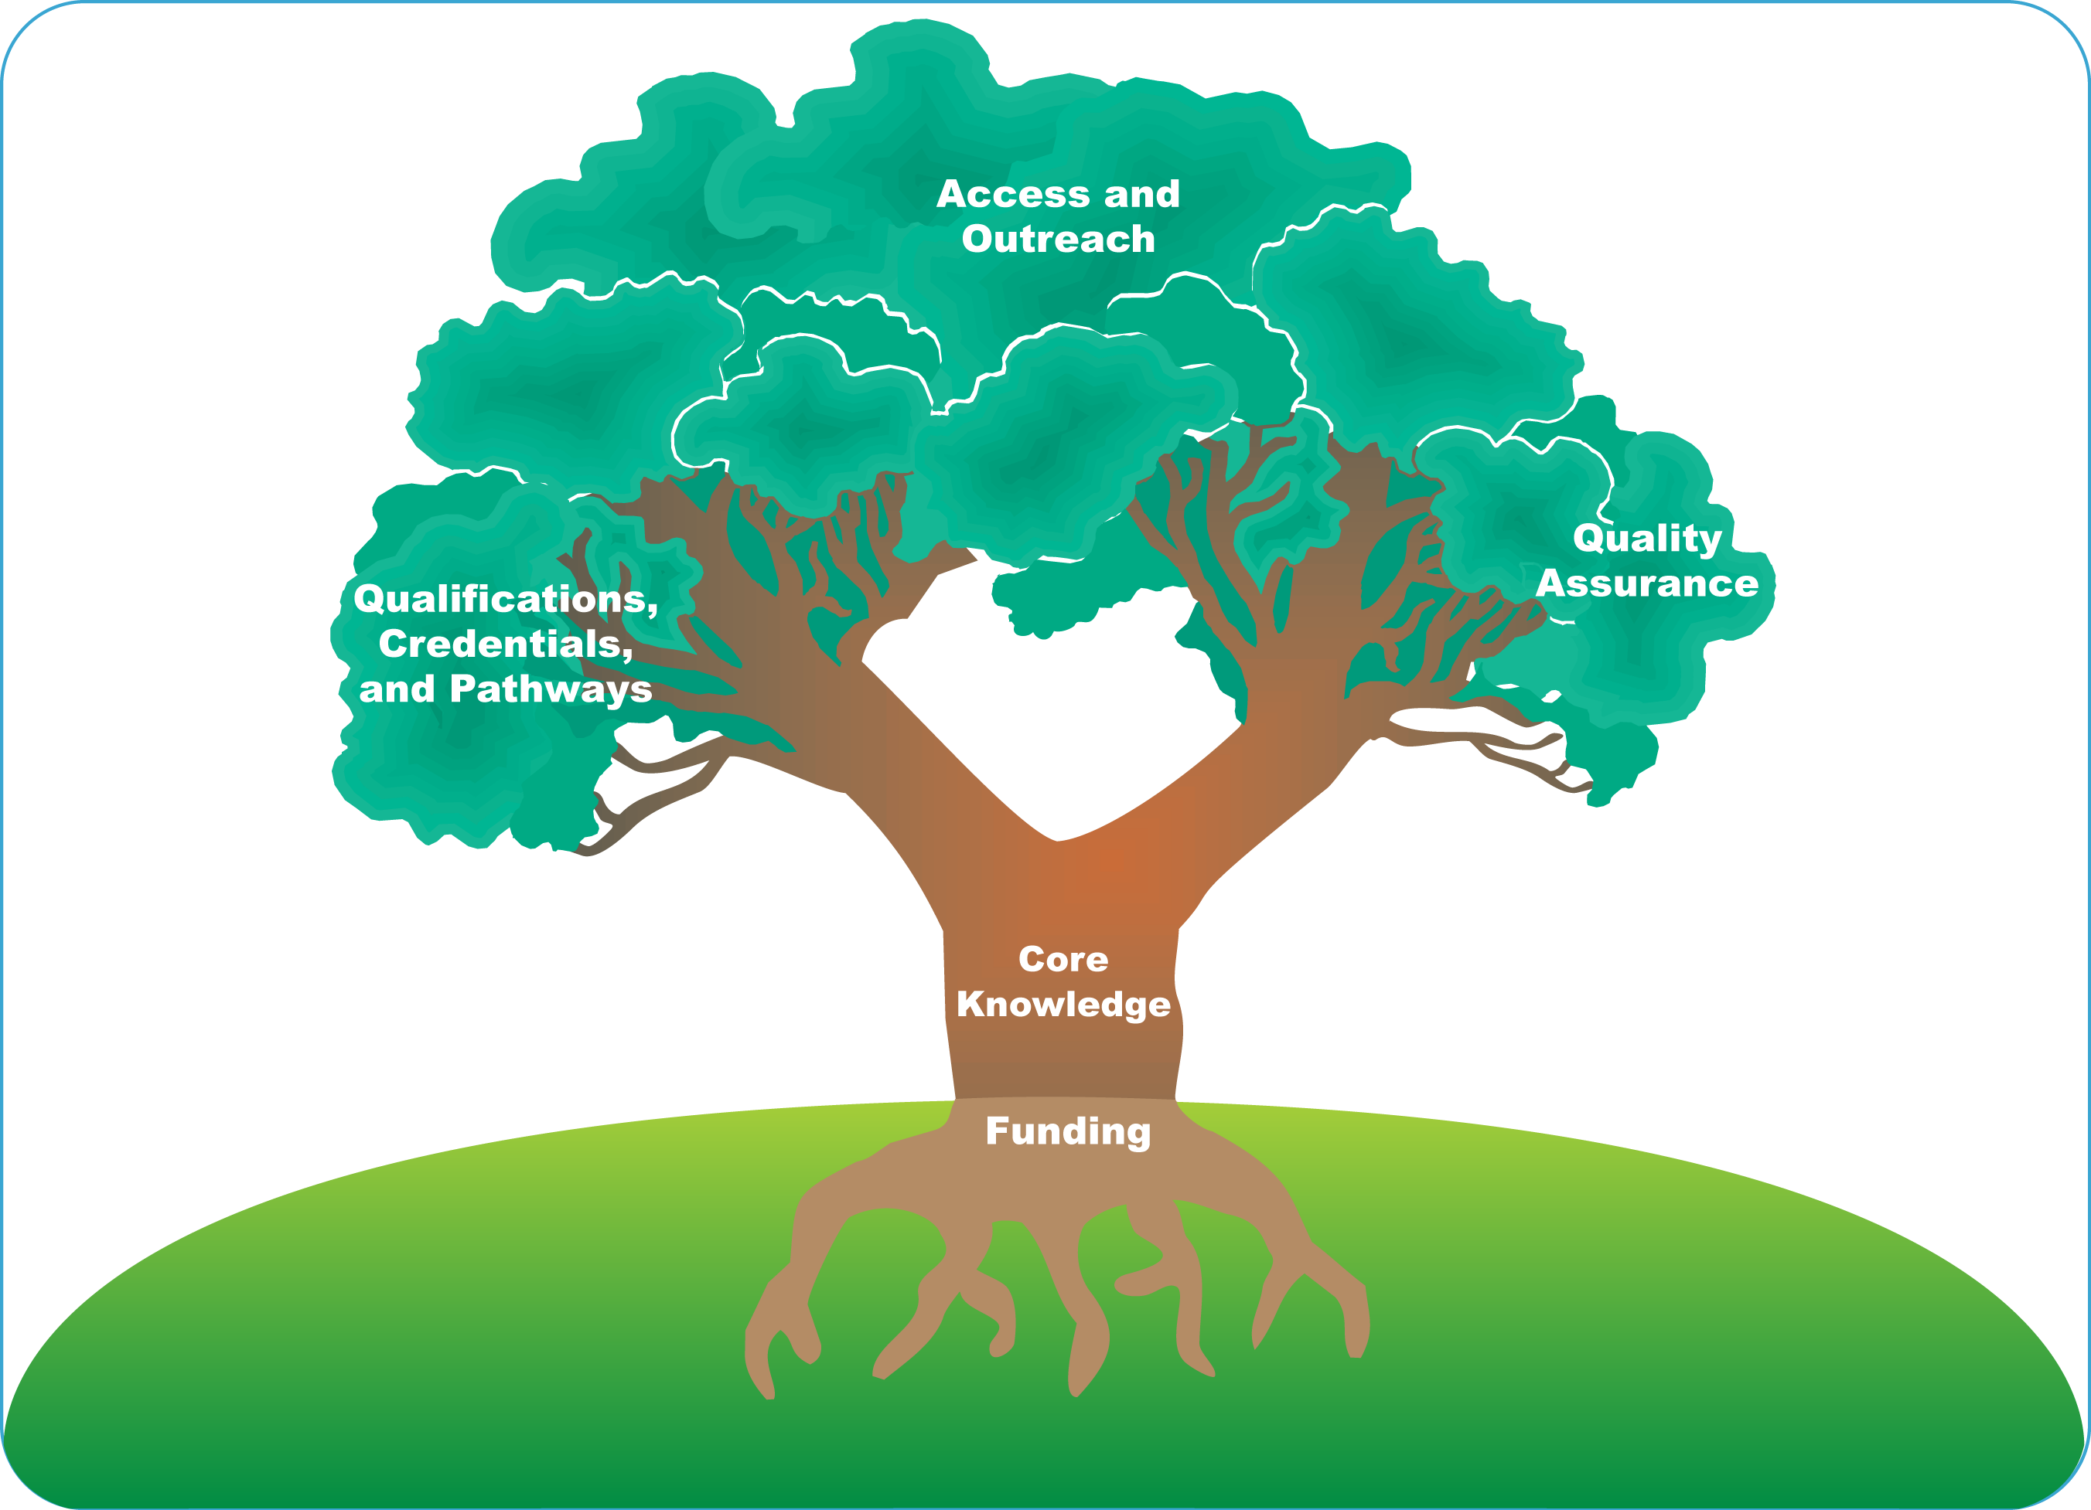

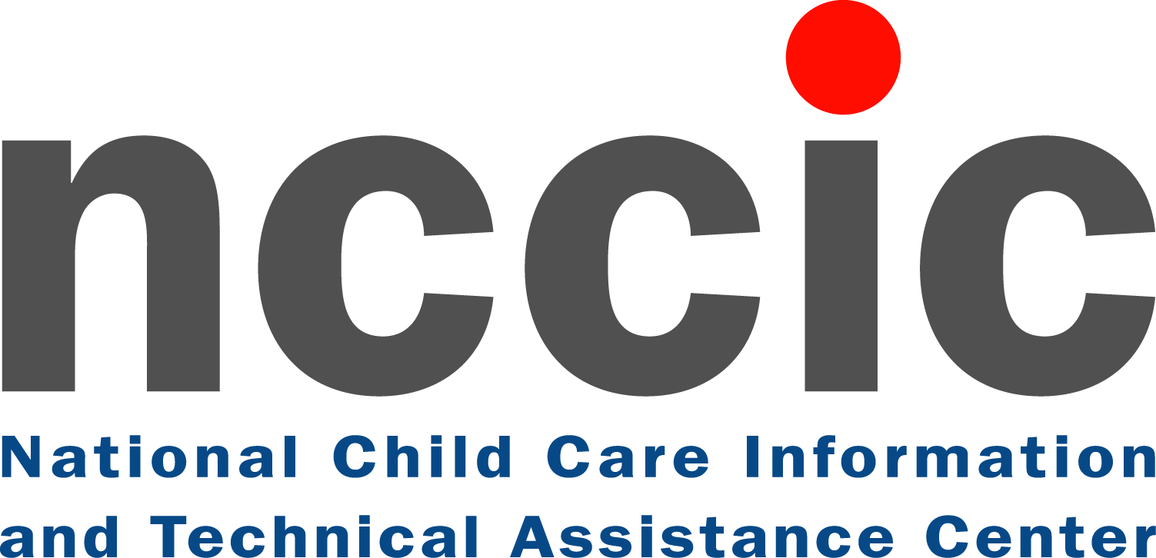


National Child Care Information and
Technical Assistance Center
A Service of the Child Care Bureau
10530 Rosehaven Street, Suite 400
Fairfax, VA 22030
Ph: 800-616-2242
Fax: 800-716-2242
TTY: 800-516-2242
Email: info@nccic.org
Web site: http://nccic.acf.hhs.gov
Child Care Bureau
Office of Family Assistance
Administration for Children and Families
U.S. Department of Health and Human Services
370 L’Enfant Promenade SW
5th Floor East
Washington, DC 20447
Web site: www.acf.hhs.gov/programs/ccb/

