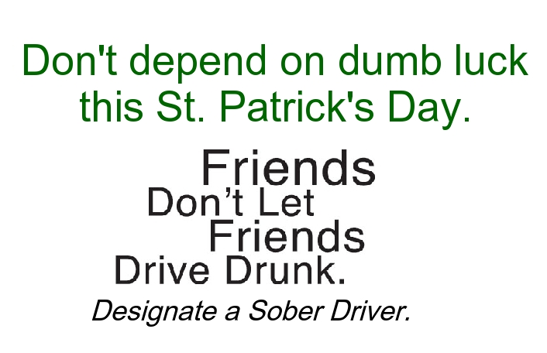
ST. PATRICK’S DAY PLANNER (Social Norming)
SAMPLE NEWS RELEASE
Note: before filling in the names of the Organization and Organization spokesperson, you MUST contact them to obtain their permission to use their names in this press release, and you must get their approval for the language of their quotations, and any changes or additions they may require. Only after this is done should you send out the press release.
FOR IMMEDIATE RELEASE: [Date]
CONTACT: [Name, Phone Number, E-mail]

[Local Leader/Organization] Urges Motorists to Drive Responsibly this St. Patrick’s Day
Designate a Sober Driver Before the Party Begins

[City, State]— [Local Leader/Organization] is urging the public to help keep the streets safe this St. Patrick’s Day by drinking responsibly and designating a sober driver before heading to the local parade or pub. Statistics from the National Highway Traffic Safety Administration show that over the past five years, 851 people lost their lives in motor vehicles crashes during the St. Patrick’s Day holiday. Out of that number, 327 were killed in crashes that involved a drunk driver or motorcycle rider (operator) with a blood alcohol concentration of .08 or higher.

“St. Patrick’s Day is supposed to be a time to celebrate Irish heritage and gather with friends, but it can quickly end in tragedy due to impaired driving,” said [Local Leader]. “If you plan on drinking, don’t rely on luck to keep you safe or to keep you out of trouble. Be responsible and take appropriate precautions.”

[Local Leader/Organization] recommends the following tips:
  - Plan a safe way home before your celebrations begin;
  - If you plan to get a ride home with someone else, designate a sober driver before any drinking begins;
  - If you’re impaired, use a taxi, call a sober friend or family member, or use public transportation so you are sure to get home safely;
- Consider using your community’s Sober Rides program [insert your local Sober Rides specifics here];
  - If you happen to see a drunk driver on the road, don’t hesitate to contact your local law enforcement;
  - And remember, if you know someone who is about to drive or ride their motorcycle while impaired, take their keys and help them make other arrangements to get to where they are going safely.

“Driving impaired or riding with someone who is impaired is an extremely risky thing to do,” said [Local Leader]. “If you plan on using alcohol, plan ahead and look out for your friends too. Remember, friends don’t let friends drive drunk.”

According to NHTSA research, impaired driving remains one of America’s deadliest problems. In 2007, 41,059 people nationwide were killed in motor vehicle crashes. Out of that number 12,998 people were killed in traffic crashes that involved at least one driver or motorcycle rider (operator) with a blood alcohol concentration (BAC) of .08 or higher. To learn more, please visit www.StopImpairedDriving.org.
###

