LADEE Propulsion System Procurement

Statements of Work, Deliverables, Evaluation Factors

Summary
This document describes a two-phase procurement process to purchase the propulsion system for NASA’s Lunar Atmosphere and Dust Environment Explorer (LADEE) spacecraft. LADEE is a NASA-SMD low cost lunar orbiter mission scheduled for launch in late 2011. The procurement process for this propulsion system is a Phased Acquisition under NASA FAR Supplement (NFS) 1817.73. In Phase 1, as few as one or as many as four vendors will be awarded contracts to develop a preliminary design for the propulsion system. In Phase 2, a single vendor will be selected to design and build the propulsion system. The present document consists of this summary, as well as the Statements of Work and Evaluation Factors for both phases. The desired propulsion system, as well as the LADEE spacecraft and mission, are more fully described in the Phase 2 Statement of Work.
To compete for a Phase 1 Award, potential vendors will submit a brief (2-3 pages) Statement of Intent describing their proposed technical approach, capabilities, past performance on similar projects, and cost to develop the proposal. NASA will award Phase 1 contracts based on the Evaluation Factors for the Statements of Intent. NASA plans to award as few as one or as many as four Phase 1 contracts. Phase 1 contracts will be for a firm fixed price of up to $50K each. The product of the Phase 1 contract will be a technical report which meets the requirements of the Phase 1 Statement of Work (below). Phase 1 reports will be due 6 weeks after contract award. NASA will issue letters to successful Phase 1 vendors requesting Phase 2 proposals and a single vendor will be selected based on Phase 2 evaluation factors. The product of the Phase 2 contract will be a spacecraft propulsion system as described in the winning vendor’s proposal for Phase 2. (It is anticipated that the winning vendor’s Phase 2 proposal will be similar to their Phase 1 report.) The Phase 2 contract will be firm fixed price. NASA may award Phase 2 contracts to two vendors (although this is very unlikely), or not award a Phase 2 contract at all. A vendor which did not receive a Phase 1 contract may still compete for Phase 2 by preparing a technical report which meets the requirements of the Phase 1 Statement of Work.
NASA plans to meet the following schedule regarding this procurement:
Dec 11, 2008 Issue synopsis of procurement
Dec 18, 2008 Post draft Statements of Work and Evaluation Factors
Dec 31, 2008 Tentative date to issue solicitation/RFQ
Jan 9, 2009 Solicitation/RFQ
Jan 15, 2009 Receipt of offers for Phase 1
Jan 21, 2009 Phase 1 contracts awarded
March 4, 2009 Deadline for Phase 1 reports
March 18, 2009 Phase 1 reports evaluated by NASA
March 30, 2009 Issue Phase 2 Letter requests for Phase 2 Proposals
April 30, 2009 Phase 2 proposals due
May 22, 2009 Contract Award

Phase 1 Offer/Quotation and Evaluation Factors
Offers/Quotations for Phase 1 contracts shall consist of:
- A summary of the vendor’s proposed design for the LADEE propulsion system.
- A description of the vendor’s capabilities in the area of spacecraft propulsion systems and related fields, and previous performance on propulsion systems for small spacecraft.
- A Firm-Fixed Price Quote (SF 1449) for delivery of Phase 1 Study, Not to exceed $50,000.00.
Offers/Quotations shall be brief and will be evaluated according to the following factors:

Demonstrated capability of the vendor to design and build a spacecraft propulsion system like the one described in the Phase 2 Statement of Work.

Past performance on contracts similar to the LADEE Phase 2 contract.
3. Price

Of the evaluation factors identified above, factors 1, 2, and 3 are approximately equal in importance. Offerors should note that items within either factor, if found to be unsatisfactory, may be the basis for rejection of an offer.

Phase 1: Statement of Work

LADEE Spacecraft Propulsion System

Objective
The objective of this task is to obtain a proposal for the propulsion system for NASA’s Lunar Atmosphere and Dust Environment Explorer (LADEE) spacecraft. The vendor shall write a report which describes a preliminary design for the LADEE propulsion system, including expected performance, cost, and schedule.

Requirements
The Phase 1 report shall include the following items:
- A preliminary design for a small spacecraft propulsion system which meets or exceeds the requirements described in the LADEE Phase 2 Statement of Work. The preliminary design shall:
  - Include an estimate of overall system wet and dry mass and overall delta-v capability for the spacecraft mass specified in the Phase 2 Statement of Work.
  - Identify key components.
  - Include a layout of components and a discussion of compatibility with the NASA propulsion system structure design.
- An estimate for the cost of the propulsion system.
- A schedule for construction of the propulsion system, including a list of components with a lead time of more than one year.
- A description of the main cost, schedule, and technical risks.
- A description of planned teaming and subcontracting arrangements
- A description of past performance on similar contracts.
- A discussion of the impact on cost, schedule, and performance of the following deviations from the LADEE Phase 2 SOW.
  - Compliance with ASM 9100 and with NASA standards vs. vendor’s preferred standards.
  - Delivery of two propulsion systems instead of one.
  - Any other Phase 2 requirement the addition or deletion of which would have, in the vendor’s opinion, a significant effect on cost, schedule, or performance.
- [OPTIONAL] Proposals (including cost estimates) for research or test tasks (or subcontracts) which would reduce risk for the propulsion system. Examples of such tests would include a cold flow testing of components, or long term operations tests. The intent of this clause is to allow vendors to include a spectrum of cost vs. risk in their proposals, if they so choose.

Deliverables
- A report which meets the Phase 1 requirements.

Phase 2: Evaluation Factors
The Phase 2 award shall be made based on the following factors:

Total proposed cost for the spacecraft propulsion system.

Ability of the proposed design to meet the performance requirements given in the Phase 2 Statement of Work.

Technical maturity of components, as indicated by Technology Readiness Level.

Demonstrated capability of the vendor to design and build a spacecraft propulsion system like the one described in the Phase 2 Statement of Work.

Past performance on contracts similar to the LADEE Phase 2 contract.

Adherence to NASA contracting goals. (e.g., degree to which subcontracting plans meet federal goals for small and disadvantaged business set-asides.)

The non-cost evaluation factors above (factors 2-6) are listed in descending order of importance. Combined, factors 2-6 are approximately equal in importance to the cost factor.

Phase 2: Statement of Work

LADEE Spacecraft Propulsion System

Objective
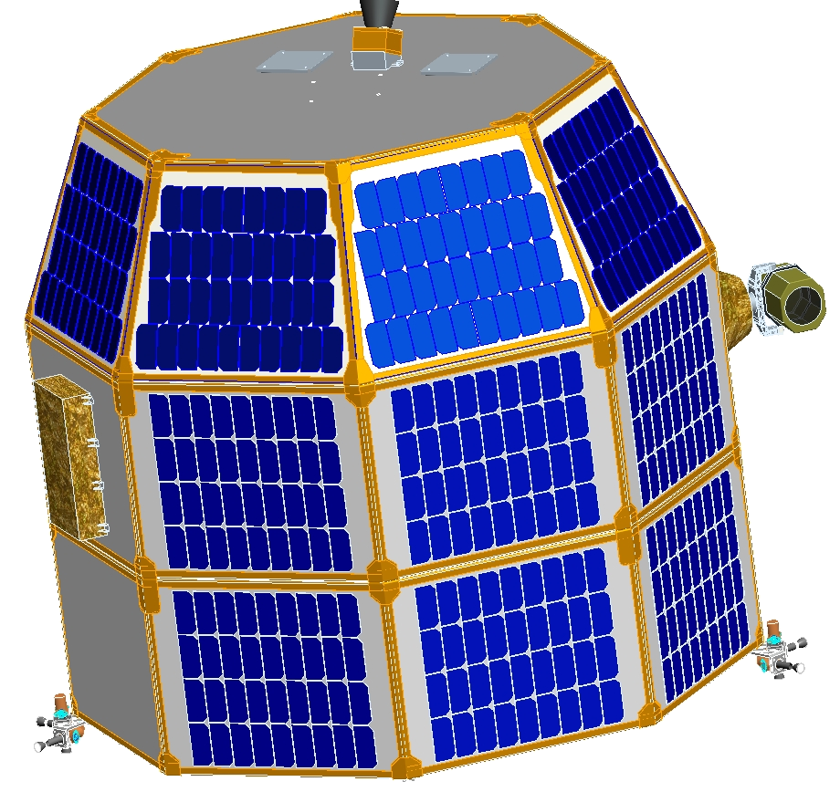
The objective of this task is to obtain a propulsion system for NASA’s Lunar Atmosphere and Dust Environment Explorer, (LADEE) spacecraft. The vendor will design and construct one propulsion system which meets the requirements listed below, integrate the propulsion system into the LADEE spacecraft propulsion structure (provided by NASA), and provide training and technical advice to NASA regarding the operation of the propulsion system.Background
Figure 1. A preliminary drawing of the LADEE spacecraft. Basic structure is an octagon with body-mounted solar panels. The spacecraft is 105.8 cm high, 117.1 cm wide corner-to-corner, and 108.2 cm wide face-to-face. The structure is divided into three “modules”, each of which is 35.3 cm high. The propulsion system is carried in the “extension module” at the bottom of structure.
ACS Cluster with 3 thrusters (1 of 2)
Solar Panel
Generic Science Instrument
Radiator
Generic Science Instrument
LADEE is a small (~150 kg) lunar orbiter planned for launch in late 2011 to early 2012 on a 120 mission to study the tenuous lunar exosphere. It is a low cost mission, intended to cost less that $80 million for the spacecraft before payloads and launch vehicle. LADEE carries several instruments to characterize the exosphere as well as a prototype laser communications payload. The LADEE propulsion system will provide orbit control and three-axis attitude control for the life of the mission. LADEE is derived from the Common Bus concept for low cost missions originated by the Small Spacecraft Office at NASA Ames. Therefore the requirements for the LADEE propulsion system include requirements derived from the Common Bus project.
NASA will be responsible for the design of the LADEE structure, including those parts of the structure which hold the propulsion system. The vendor shall be responsible for the selection of propulsion system components, and for the layout of the propulsion system. Details of the interface between the propulsion system and its supporting structure will be mutually agreed upon by NASA and the vendor.

Requirements
- The propulsion system shall meet the following mass and delta-v requirements. NASA is currently considering two approaches to the propulsion system. The baseline design uses a government-furnished Solid Rocket Motor (SRM) for the Lunar Orbit Insertion (LOI), and a liquid propulsion system for all other maneuvers. An alternative approach, the single-stage design uses a liquid propellant system for all maneuvers. The vendor may propose a propulsion system which addresses the baseline requirements and/or the alternate requirements.
  - Two-Stage Design (Baseline):
    - Background for Mass Requirements: The total mass of the LADEE stack at TLI is 315.2 kg. This mass is determined by the launch vehicle capability and the expected mass of the adapter between LADEE and the launch vehicle. Of the 315.2 kg, 120.1 kg are allocated for the mass of the SRM stage used for LOI. A further 152.6 kg are allocated for the LADEE spacecraft. This mass includes the science payload, the spacecraft structure (including structure to support the propulsion system), and thermal control systems (including any thermal control needed for the propulsion system). Therefore 42.5 kg are available for the wet mass of the propulsion system.
    - Mass Requirement: The overall wet mass of the propulsion system shall not exceed 42.5 kg.
    - Mass Contingency: The 152.6 kg allocated to the non-propulsion mass of the LADEE spacecraft includes 3.8 kg of contingency mass which NASA is holding for the propulsion system. This value is determined by NASA’s standard practices for NASA’s current estimated level of maturity of the propulsion system. NASA may consider releasing some of this contingency mass for designs of a higher maturity level.
    - Performance Requirement:
      - Delta-v of 100 m/s for maneuvers taking place before LOI, with an initial wet mass of 315.2 kg.
      - Delta-v of 245 m/s for maneuvers taking place after LOI, with an initial wet mass of 195.1 kg minus the amount of propellant used for the 100 m/s mentioned above.
  - Single-Stage Design:
    - Background for Mass Requirements: The initial mass available to LADEE at TLI is 316.6 kg. This mass is determined by the launch vehicle capability and the expected mass of the adapter between LADEE and the launch vehicle. Of the 316.6 kg, 181.7 kg are allocated for the LADEE spacecraft. This mass includes the science payload, the spacecraft structure (including structure to support the propulsion system), and thermal control systems (including any thermal control needed for the propulsion system). Therefore 134.8 kg are available for the wet mass of the propulsion system.
    - Mass Requirement: The overall wet mass of the propulsion system shall not exceed 134.8 kg.
    - Mass Contingency: The 181.7 kg allocated to the LADEE spacecraft includes 11.3 kg of contingency mass which NASA is holding for the propulsion system. This value is determined by NASA’s standard practices for NASA’s current estimated level of maturity of the propulsion system. NASA may consider releasing some of this contingency mass for designs of a higher maturity level.
    - Performance Requirement:
      - Delta-v of 1137 m/s for an initial wet mass of 316.6 kg.
- The propulsion system shall consist of an orbit control system (OCS) and an attitude control system (ACS).
  - The OCS shall provide velocity control along one axis for large velocity adjustments.
  - The ACS shall provide three-axis attitude control. The ACS shall also provide velocity control along one axis for fine velocity adjustments.
- The propulsion system shall be able to be activated immediately after separation from the launch vehicle. The propulsion system shall then remain active for no less than 125 days. It is desirable, but not required, for the propulsion system to remain active for up to 365 days. When active, the propulsion system shall be capable of generating thrust for attitude control and/or spacecraft velocity changes at any time.
- The OCS system thrust shall be no less than 2500 N and no greater than 6000 N. The OCS should have a minimum impulse bit no greater than 100 Ns.
- Each ACS thruster shall have a maximum thrust of at least 16 N, and a minimum impulse bit of no greater than 0.12 Ns.
- The propulsion system shall be capable of operating with a guidance, navigation, and control (GN&C) system with a bandwidth of 20 Hz. This requirement shall be deemed satisfied if the sum of the thrust rise time to 90% thrust plus the shutdown response time is less than 20 milliseconds for the ACS thrusters and 50 milliseconds for the OCS thrusters.
- The propulsion system shall be capable of being operated by the LADEE power system (28 VDC, unregulated). The vendor may choose to meet this requirement in one of several ways:
  - The vendor supplies a valve driver unit which operates off the LADEE power system and which communicates with the LADEE main avionics unit via RS-422 or MIL-STD-1553. (Other standards may also be acceptable.)
  - The vendor provides valve voltage and current requirements, and sensor calibration data, for a NASA-designed valve driver unit. The propulsion system mass allotment shall be reduced by 0.2 kg to reflect the extra mass required for the externally-supplied control unit.
  - The vendor may also propose a control system which mixes responsibilities between NASA and the vendor, or may propose components which operate directly off of the LADEE power supply.
- The propulsion system shall physically fit within the LADEE Extension Module as shown in the attached Interface Control Drawing. NASA will work with the vendor to design the structure which holds the propulsion system. NASA will provide the LADEE Extension Module with propulsion system structure to the vendor, and the vendor shall install the propulsion system into the LADEE Extension Module. This work will take place in facilities chosen by the vendor.
- The propulsion system must be completely installed in the LADEE Extension Module by 26th October 2010 in order to support an expected launch date in late 2011 to early 2012.
- The propulsion system shall include pressure and temperature transducers needed for its safe operation.
- The center of gravity offset in the plane normal to the OCS thrust axis of the fueled propulsion system should be minimized. The system should also be designed to minimize center of gravity travel during flight.
- The propulsion system shall have an operating temperature range of at least +10 to +25 °C, and a storage temperature range of at least -35 to +35 °C. NASA will perform a thermal analysis to predict the temperature range to be experienced by the propulsion system, and NASA will install heaters to prevent propellant freezing as necessary.
- The vendor shall identify the reliability of the individual components used in the propulsion system.
- The vendor shall perform the following tests prior to delivery of the propulsion system:
  - System Level Leak Test
  - System Level Functional Electrical System Test
  - Acceptance Test, including Cleanliness Test
- The propulsion system shall conform to the range safety requirements of the NASA Wallops Flight Facility per the Range Safety Manual (RSM-2002) Rev A For Goddard Space Flight Center (GSFC)/Wallops Flight Facility (WFF), dated November 3, 2006.
- The government reserves the right to have in-plant representation at the vendor's facility and at all major subcontractor sites, or sites where manufacturing, performance/verification testing or operations are being performed. This government representation may be by NASA or by their designated representatives. The vendor shall ensure that government access privileges are included in any subcontractor or supplier contract.
- The vendor shall query the Government-Industry Data Exchange Program (GIDEP) Alert database as necessary to ensure that product is not procured or delivered containing known failure-prone materials or components. For the products applicable to this SOW, the vendor should participate in the reporting and identification of GIDEP Alerts in accordance with NPR 8735.1A, Procedures for Exchanging Parts, Materials, and Safety Problem Data Utilizing the Government-Industry Data Exchange Program and NASA Advisories.
- The government reserves the right to review vendor's plan for qualifying each significant new sub-contractor. The government reserves the right to review vendor's qualification results for each significant new or existing sub-contractor. The government reserves the right to perform audits in sub-contractor facilities. Before execution, the government reserves the right to review contracts to sub-contractors to ensure that all pertinent technical requirements from this contract have been included.
The government reserves the right to attend and participate in vendor's technical reviews, project status meetings, and test readiness reviews. The government reserves the right to witness inspections and tests performed by vendor and its sub-contractors.
- The vendor shall identify calibration and metrology standards and equipment accuracy used to support acceptance testing of the propulsion system.

Deliverables

- A Preliminary Design Package.
- Interface Control Drawings of Propulsion Components to Propulsion Structure
- One (optionally two) complete integrated propulsion system(s). The required structure of the Extension Module will be supplied and delivered to the vendor by NASA.
- A user guide detailing system specifications and operational procedures. This report shall furthermore include:
  - Information on the performance and the methods to measure it
  - Information about the calibration standards and metrology used
  - Information on the reliability of all components used
- A test report including the results of the Functional Electrical Test and the Leak Test.
- A test report documenting the procedure and the results of the Acceptance Test.

Applicable Documents
[1] Interface Drawing of Extension Module 9sp-060c-m004
[2] STEP File with the CAD Model of the Extension Module (FILENAME.stp)
[3] Eastern and Western Range (EWR) 127
[4] Wallops Flight Facility (WFF) Range Safety Manual (RSM-2002) Rev. A
[5] Aerospace Standard (AS) 9100
[6] NASA-STD-4003: Electrical Bonding for NASA Launch Vehicles, Spacecraft, Payloads, and Flight Equipment
[7] NASA-STD-8739.1A, Staking and Conformal Coating of Printed Wiring Boards and Electronic Assemblies, March 2008
[8] NASA-STD-8739.2, Surface Mount Technology, August 1999
[9] NASA-STD-8739.3, Soldered Electrical Connections, January 2001
[10] NASA-STD-8739.4, Crimping, Interconnecting Cables, Harnesses, and Wiring, February 1998
[11] NASA-STD-8739.5, Fiber Optics Terminations, Cable Assemblies, and Installation, February 1998
[12] NASA-STD-8739.7, Electrostatic Discharge Control (Excluding Electrically Initiated Explosive Devices), December 1997
[13] MIL-STD-461E, Control of Electromagnetic Interference, August 1999
[14] MIL-STD-1540E, Test Requirements for Launch & Space Vehicles, December 2002

