Global Precipitation Measurement

(GPM) Project

Brushless DC Motor Specification for

GPM Reaction Wheel Assembly


Goddard Space Flight Center
Greenbelt, Maryland
National Aeronautics and
Space Administration

This Page Intentionally Left Blank.

SIGNATURE PAGE

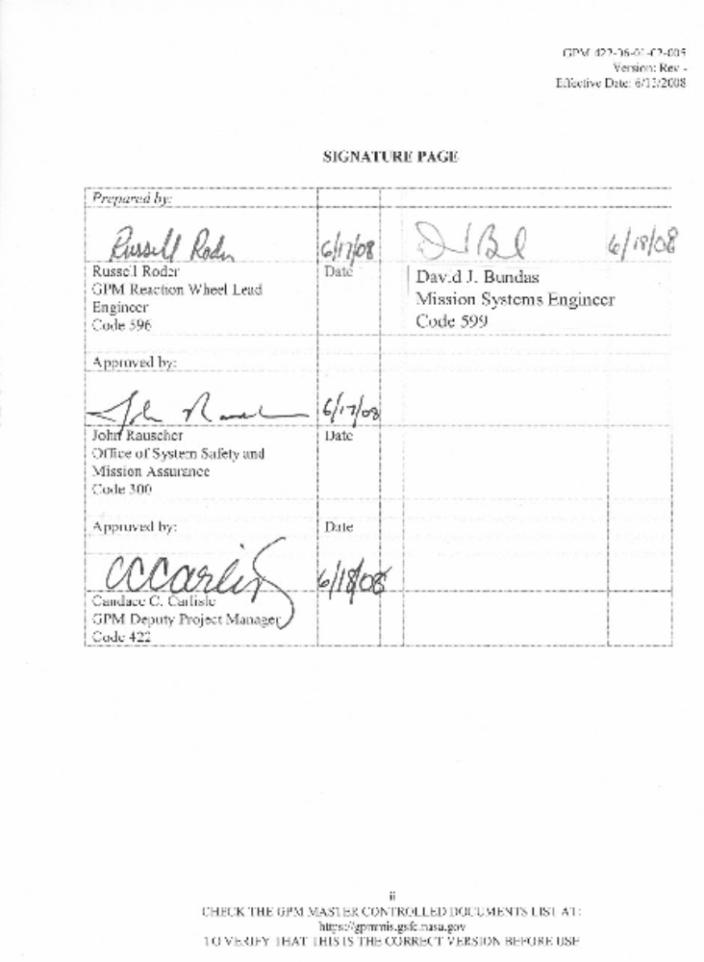

This Page Intentionally Left Blank.

CHANGE RECORD PAGE

CCR # | CCR DATE | MOD # | MOD DATE | Description | Section Affected
061 | 06/13/2008 | NA | NA | Baseline RWA Spec | All

This Page Intentionally Left Blank.

TABLE OF CONTENTS

SECTION page PAGE
1.0 Scope 1
2.0 Applicable Documents 1
3.0 Requirements 1
3.1 Electronics Assemblies 1
3.2 Flight Quality 1
3.3 Radiation 1
3.4 Prohibited Metal Finishes 1
3.5 Stator Dimensions 1
3.6 Rotor Dimensions 2
3.7 Operating Voltage 3
3.8 Poles 3
3.9 Rotor 3
3.10 Magnets 3
3.11 Windings 3
3.12 Maximum Cogging Torque 3
3.13 Operating Point 3
3.14 Commutation 3
3.15 Stator Laminations 3
3.16 Temperature 4
3.17 Materials 4
3.18 Iron Mass 4
3.19 Lead Wire Length 4
3.20 Winding Configuration 4
3.21 Thermistor 4
3.22 Random Vibration Levels 5
3.23 Static Loads 5
3.24 Mechanical Shock 5
4.0 Quality Assurance 1
4.1 Inspection System 1
4.2 Electrostatic Discharg 1
4.3 Hardware Handling, Cleaning, and Packaging 1
5.0 Testing 1
6.0 Documentation 1
6.1 Design Parameters 1
6.2 Test Results 1
6.3 Rotor Shaft Diameters 1
6.4 Electrical 1
6.5 Drawings 1
6.6 Identification 1
6.7 Material Certifications 1
6.8 Parts List 2
6.9 Traceability and Data Retention 2
6.10 Materials and Processes (M&P) 2
7.0 Handling, Storage, Packaging, Preservation, and Delivery 1

This Page Intentionally Left Blank.

Scope

This specification is for a brushless DC motor to be used in flight hardware on the Global Precipitation Measurement (GPM) Mission. The motor shall consist of a rotor and stator to be supplied unhoused. The stator shall have a set of Hall effect sensors for commutation, which shall be mounted on a printed wiring board (PWB).

This Page Intentionally Left Blank.

Applicable Documents

The following documents of the latest issue form a part of this specification to the extent
specified herein. Where differences occur between this specification and the following
documents, the requirements of this specification shall prevail.

Specifications

SAE AS 22759/11 Wire, Electrical, Fluro Polymer-Insulated, Extruded TFE, Silver-Coated Copper Conductor, 600 Volt

ANSI/ISO/ASQ Q9001-2000 Quality Management Systems

EEE-INST-002 Instructions for EEE Parts Selection, Screening, Qualification, and Derating

422-40-01-004 Global Precipitation Measurement (GPM) Mission Assurance Requirements (MAR)

GD2072088 Shaft, Rotor for Flight Reaction Wheel

NASA-STD-8739.4 Crimping, Interconnecting Cables, Harnesses, and Wiring

ANSI/ESD S20.20 ESD Association Standard for the Development of an Electrostatic Discharge Control Program

This Page Intentionally Left Blank.

Requirements

Electronics Assemblies
Electronics assemblies shall be governed by the Workmanship Requirements in the GPM MAR. Thus, PWB coupons shall be submitted to the GSFC Materials Engineering Branch (MEB) or a GFSC/MEB approved laboratory for evaluation and approval before population of flight boards.

Flight Quality
Flight Unit parts shall be selected and processed in accordance with the requirements of EEE-INST-002. The quality level requirement is level 2 or better as defined by EEE-INST-002. Exceptions require approval by the GPM project Parts Control Board (PCB), which is established by GSFC.

Radiation
All parts shall be selected to meet their intended application in the on-orbit GPM radiation environment. The GPM PCB shall inform the Contractor of any required radiation testing. Test plans and reports for parts that require radiation testing shall be submitted to the GSFC GPM project radiation engineer for review and approval.

Prohibited Metal Finishes
Pure tin (Sn), cadmium (Cd), and zinc (Zn) shall not be used as an internal or external finish on any EEE parts and associated hardware.

Stator Dimensions
Stator dimensions shall comply with Figure 1 below.

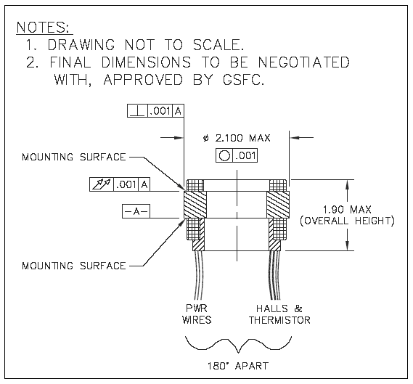
Figure 3-1. Stator Mechanical Dimensions

Rotor Dimensions
See GSFC drawing GD2072088 for rotor dimensions.

Tabulations of actual dimensions of the fabricated motors shall be provided as follows:

- Measurements shall be in inches and to four (4) decimal places.
- Measurements shall be identified by the serial number of the motor.
- Measurement #1 shall be the diameter of the bearing surface (the section called out as .3936-.3937) in Zone B2.
- Measurement #2 shall be the diameter of the bearing surface in Zone B3, near the section with the nominal diameter of .625.
- Measurement #3 shall be the diameter of the bearing surface in Zone B3, near the threaded end of the rotor shaft.

Operating Voltage
The operating voltage for the motor shall be a range from +19.5 to +33.5 VDC.

Poles
The motor shall have 8 poles.

Rotor
The rotor shall be designed to eliminate axial magnetic forces

Magnets
The rotor magnets shall be covered by a protective material.

Windings
The stator windings shall be covered by a protective material.

Maximum Cogging Torque
The maximum cogging torque shall be 0.008 N*m peak-to-peak.

Operating Point
The operating point for the motor shall be the following (@ 22 ˚C, +19.5 V)

- Minimum Load Torque Output – 0.33 N*m
- Minimum Speed – 210 rad/sec
- Maximum Current – 6.0 A
- Maximum Sum of Hysteresis Drag and Eddy Current Torques @ Speed – 0.01 N*m
- Any excess performance capability above what is required at the operating point shall be used to increase the Minimum Speed

Commutation
Three Hall effects sensors shall be located in the stator. The Hall effect devices used shall be Optek part number OMH-3075S and shall be supplied by the Contractor. The Hall effect sensors shall have an alignment error of no more than five degrees (5˚) electrical. The Hall effect sensors shall be spaced 120° electrical apart.

Stator Laminations
The stator laminations shall be designed to minimize hysteresis and eddy current losses through material choice and lamination thickness. Hysteresis and eddy current losses shall be no larger than those that would result from the use of laminations made of Carpenter 49 alloy with a thickness of 0.006 in.

Temperature
The motor shall operate in an environment from -40°C to 80°C with an air pressure of no more than 1x10⁻⁵ Torr.

Materials
All materials and processes shall be defined by standards and specifications and shall be identified in the Materials and Processes Lists for approval. A material or process that does not meet the requirements of the GPM MAR for stress corrosion cracking, corrosion resistance, vacuum outgassing, toxicity, flammability, etc., or meets the requirements above but is used in an unconventional application, shall be considered a noncompliant material. The proposed use of a noncompliant material requires that appropriate forms [e.g. Materials Usage Agreement (MUA)] be submitted to GSFC for approval prior to their use. The materials and processes lists shall be approved by GSFC before fabrication.

Wire, cable, and exposed surfaces of connectors shall meet the requirements of this document and be reported on materials usage lists. All other standard and nonstandard
Electrical, Electronic, and Electromechanical (EEE) parts shall be exempt from reporting on materials lists, however they must be included in the EEE Parts Identification List for review.

Iron Mass
The stator shall contain no more than 0.15 kg of iron.

Lead Wire Length
The lead wire shall be 18” or longer from the motor. The wire type shall be SAE AS 22759/11. Refer to NASA-STD-8739.4, “Crimping, Interconnecting Cables, Harnesses, and Wiring,” for workmanship requirements, e.g. bend radii, for this material.

Winding Configuration
The winding shall have a delta configuration.

Thermistor
The thermistor shall be located in the stator. The thermistor used shall be GSFC part number S-311-P18-07T101 and shall be supplied by the Contractor.

Random Vibration Levels
The motor assembly shall survive and meet the design parameters after experiencing the acceleration spectral density levels below for a duration of two (2) minutes. This testing will be performed after the motor has been incorporated into an assembled reaction wheel.
Table 3-1. Random Vibration Levels
Axis | Frequency | Limit Level
X, Y, Z | 20 Hz  20-50 Hz  50-800 Hz  800-2000 Hz  2000 Hz | 0.026 g²/Hz  +6 dB/octave  0.16 g²/Hz  -6 dB/octave  0.026 g²/Hz
Overall |  | 14.1 G_{rms}

Static Loads
The motor assembly shall survive and meet the design parameters after experiencing static loads of 20 G’s in any individual axis (X, Y, or Z) or any combination of all three axes. This testing will be performed after the motor has been incorporated into an assembled reaction wheel.

Mechanical Shock
The motor assembly shall be capable of withstanding the maximum shock environment shown in the figure below, after which the hardware must be capable of meeting its performance criteria. This testing will not be performed until after the motor has been incorporated into an assembled reaction wheel. At the discretion of the GPM project, testing may be deferred to an even higher level of spacecraft assembly. The shock environment depicted below is the input at the spacecraft-to-reaction wheel mechanical interface.
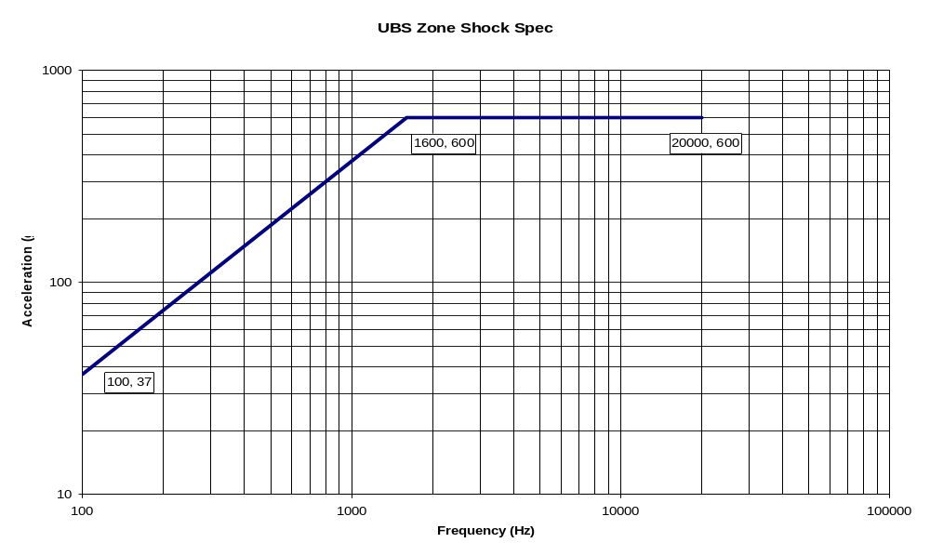
Figure 3-2. Mechanical Shock Environment

This Page Intentionally Left Blank.

Quality Assurance

Inspection System
All motors shall be built to an approved Quality Management System that is compliant with ANSI/ISO/ASQ Q9001-2000 (or equivalent). This program shall be documented in a Quality Management Manual. The Manual shall contain, among other things, procedures regarding material certifications, inspections, and the documentation, reporting, and review of failures. The Manual shall be made available to GSFC upon request. GSFC shall be notified of any changes to the QA program.

Electrostatic Discharg
The Contractor shall document and implement an ESD Control Program suitable to protect ESD-sensitive components at all levels of assembly and integration in accordance with the requirements of ANSI/ESD S20.20.

Hardware Handling, Cleaning, and Packaging
The handling of flight hardware shall be performed by qualified personnel in accordance with approved procedures that address cleaning, handling, packaging, shipping containers, and bagging. Compatible packaging shall be selected so that hardware is not contaminated or otherwise degraded during shipping or storage. All personnel working on flight hardware shall be certified as having completed the required training and competency certifications prior to handling any flight hardware. This includes, but is not limited to, workmanship, clean room, and ESD awareness courses.

This Page Intentionally Left Blank.

Testing
All motors shall be tested to a GSFC-approved procedure written by the manufacturing Contractor. Measurements shall be made in SI units. Test shall be conducted at or near the operating point temperature specified in Section 3.9. This procedure shall be delivered to the GPM Project for review and approval 2 weeks before running the test. This procedure shall contain at least the following:

- Visual Inspection
- Dielectric Test
- Insulation Resistance Test
- Measure Terminal Resistance
- Measure Inductance
- Measure Hysteresis Drag Torque
- Measure Eddy Current Torque
- Measure Cogging Torque
- Measure Back EMF constant
- Measure Hall effect sensor alignment
- Record identifying information for all precision measurement equipment (PME) used in testing and its compliance to NIST calibration standards

This Page Intentionally Left Blank.

Documentation

Design Parameters
The motor design parameters shall be delivered 1 month after receipt of contract. Parameters shall be in SI units. These parameters shall contain at least the following:

- Torque Sensitivity
- Motor Constant
- No Load Speed
- Voltage Constant
- Terminal Resistance
- Terminal Inductance
- Hysteresis Drag Torque
- Eddy Current Torque
- Winding Wire Size

Test Results
The motor testing results of Section 5.1 shall be delivered with the motors.

Rotor Shaft Diameters
The measurements of the rotor shafts, as outlined in Section 3.2.1, shall be delivered with the motors.

Electrical
The motor wiring diagram and commutation logic shall be delivered 1 month after receipt of contract.

Drawings
A drawing package of mechanical dimensions and electrical diagrams of the stator and rotor shall be approved by GSFC before fabrication begins.

Identification
Each unit shall be identified by a unique serial number. The results of the testing in Section 5.1 shall include the serial number of the unit under test.

Material Certifications
Copies of the appropriate material certifications shall be delivered with the motors.

Parts List
The Contractor shall submit a list of identified EEE parts to the GSFC PCB for approval, prior to manufacturing of flight hardware. The parts list must be submitted in electronic readable format (pdf, Excel, etc.).

The Contractor shall maintain a Project Approved Parts List (PAPL), and only parts that have been approved by the GSFC PCB shall be listed in the PAPL. An As Built Parts List (ABPL) shall be maintained and submitted to GSFC upon completion of flight hardware, which identifies parts previously listed on the PAPL which are actually used in flight hardware. The ABPL shall include the following information: part description, manufacturer, lot date code, CAGE code, and quantities. Provisions shall be in place to find quantity used and provide traceability to box or board location through build paperwork.

Traceability and Data Retention
The Contractor shall have the capability to retrieve historical records of EEE parts from initial procurement and receipt through storage, kitting, assembly, test, and final acceptance of the deliverable product. The Contractor shall have a method in place for the retention of data generated for parts tested and used in flight hardware. All quality records, DPA or other parts analysis reports, and test data shall be retained through the end of the contract and shall be provided to GSFC upon request.

Materials and Processes (M&P)
M&P forms shall be delivered as required by the GPM MAR.

This Page Intentionally Left Blank.

Handling, Storage, Packaging, Preservation, and Delivery

Products shall be stored, preserved, marked, labeled, packaged, and packed to prevent loss of marking, deterioration, contamination, excessive condensation and moisture, or damage during all phases of the program. Stored and stocked items shall be controlled in accordance with documented procedures and be subject to quality surveillance.

Contractor is responsible for providing an acceptable shipping container that protects the hardware appropriately.

By executing the act of product shipment, the supplier certifies that the product complies with all specification requirements. Prior to shipping, quality assurance personnel shall ensure that:

- Fabrication, inspection, and test operations have been completed and accepted.
- All products are identified and marked in accordance with requirements
- The accompanying documentation has been reviewed for completeness, identification, and quality approvals.
- Packaging and marking of products are adequate to ensure safe arrival and ready identification at their destinations.

The Contractor has the responsibility for any damage incurred during shipment.

This Page Intentionally Left Blank.

APPENDIX A. ABBREVIATIONS AND ACRONYMS

Abbreviation/ Acronym | DEFINITION
ABPL | As-Built Parts List
ANSI | American National Standards Institute
ASQ | American Society for Quality
CAGE | Commercial and Government Entity
CVCM | Collected Volatile Condensable Mass
DC | Direct Current
EEE | Electrical, Electronic, and Electromechanical
EMF | Electromotive Force
ESD | Electrostatic Discharge
GPM | Global Precipitation Management
GSFC | Goddard Space Flight Center
ISO | International Organization for Standardization
MAR | Mission Assurance Requirements
MEB | Materials Engineering Branch
M&P | Materials & Processes
NIST | National Institute of Standards and Technology
PAPL | Project-Approved Parts List
PCB | Parts Control Board
PME | Precision Measurement Equipment
SI | International System
TLM | Total Loss of Mass
VDC | Voltage Direct Current

