Filter Manifold Assembly
Additional Flight Requirements/Specifications

Below are the additional flight specifications and requirements that the flight filter manifold design will be required to meet. The numbering scheme for the flight requirements in this section follows the numbering scheme from EM requirement document GRC-TVC-SPEC-007. It is recommended that the vendor review the EM filter manifold assembly requirement document, GRC-TVC-SPEC-007 prior to reviewing these flight requirements.

3.1.1 System Interface Definition

3.1.1.2 Filter Manifold Assembly Orientation

Filter manifold assembly shall be fully operational independent of orientation in a +/- 5g environment.

3.2 Characteristics

3.2.4 Environmental Requirements

The Filter manifold assembly shall conform to the natural and induced environment design requirements specified in this section and documents cited herein. In most cases, verification of specification conformance shall be carried out as delineated in CxP 70036, Constellation Program Qualification and Acceptance Testing Requirements.
All system pressure monitoring devices are considered part of the Filter manifold assembly and therefore shall meet the environmental requirements specified in this document.

3.2.4.1 Flight Environment

The following environments are applicable to the flight operational performance requirements of the Filter manifold assembly both individually and in any feasible combination. The Filter manifold assembly shall be capable of meeting the operating performance requirements specified herein after exposure to any feasible combination of the following conditions.

3.2.4.1.1 Atmospheric Pressure Levels according to CxP 70023

3.2.4.1.2 Temperature Levels according to CxP 70023

3.2.4.1.3 Humidity 16 to 100% RH per CxP 70023

3.2.4.1.4 Random Vibration Random vibration levels according to CxP 72169

See Table 17 and Table 18 below for random vibration environment in radial, tangential and longitudinal directions:

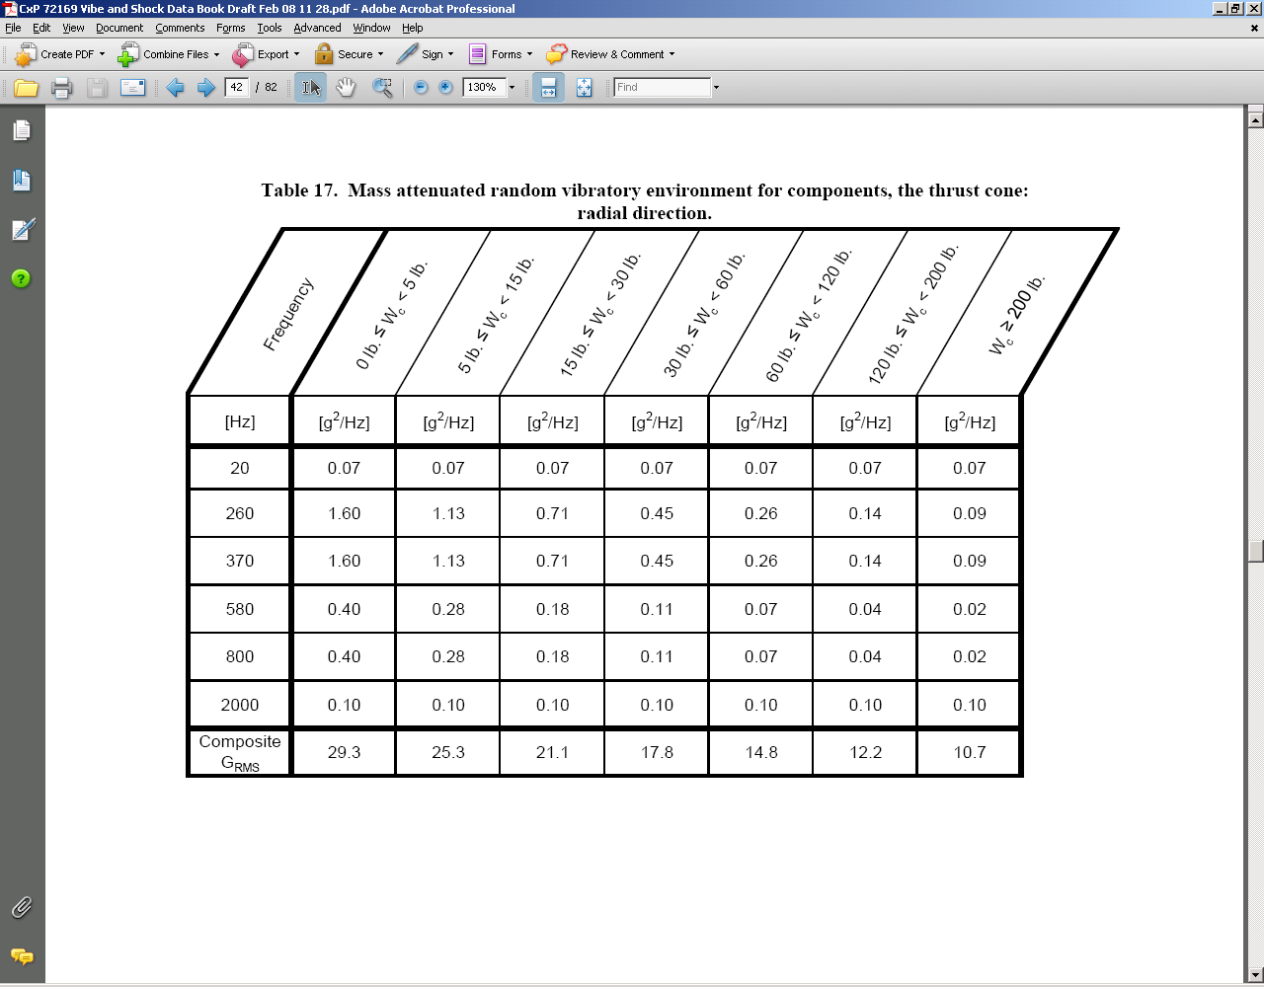

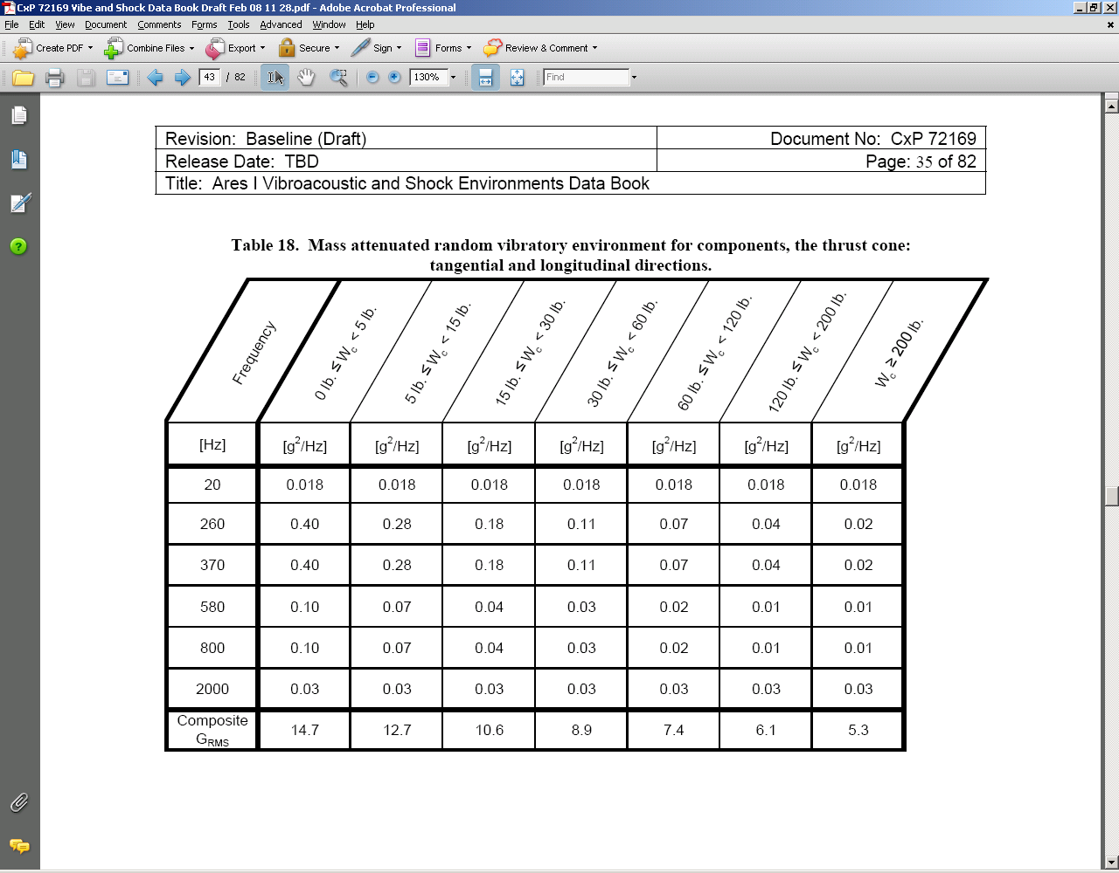

Exposure time is TBD seconds for each axis.

3.2.4.1.5 Acceleration ± 5 g (TBR) all axes for a minimum of TBD minute duration in each direction along each orthogonal direction

3.2.4.1.6 Transient Vibration Sinusoidal vibration from 5 to 35 (TBR) Hz at ± 0.25g and at the sweep rate of 1 octave/minute for TBD min. duration

3.2.4.1.7 Altitude The Filter manifold assembly shall operate from sea level to 492,126 feet (150 km)

3.2.4.1.8 Shock Shock levels according to CxP 72169

See Figure 37 and Table 36 below for shock environment in radial, tangential and longitudinal directions. The number of applications is TBD in each axis for a total of TBD applications

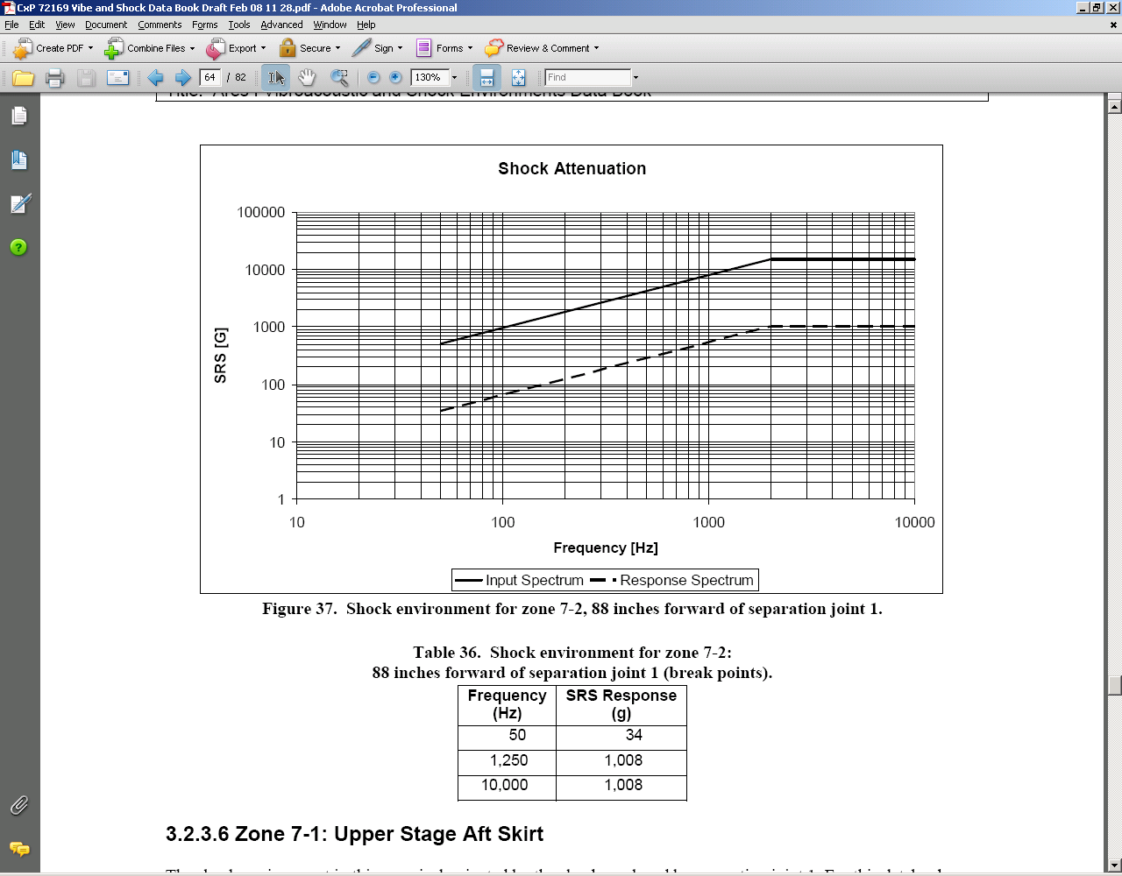

3.2.4.1.9 Thermal Shock The following thermal shock shall occur during flight: Filter Manifold stabilized at 50 °F and then subjected to a 36 °F/minute temperature increase until filter manifold reaches 250 °F.

3.2.4.2 Checkout Environment

The following environments are applicable to the installed performance requirements of the Filter manifold assembly both individually and in any feasible combination. The Filter manifold assembly shall perform as specified in Section 3 of this specification during and after exposure to these checkout environments.

3.2.4.2.1 Atmospheric Pressure Levels according to CxP 70023

3.2.4.2.2 Temperature Levels according to CxP 70023

3.2.4.2.3 Humidity 16 to 100% RH per CxP 70023

3.2.4.2.4 Sand and Dust (TBR) As encountered in desert and ocean beach areas, equivalent to 140-mesh silica flour with particle velocity up to 500 feet per minute and a particle density of 0.25 gram per cubic foot

3.2.4.2.5 Salt Fog (TBR) Levels according to CxP 70023

3.2.4.2.6 Rain (TBR) Maximum of 19 in. in 24 hr. Period including short period extremes of 4 in. for 1 hr.

3.2.4.2.7 Hail (TBR) Hail (nominal) diameter equals 0.30 in. with a fall velocity of TBD ft/sec, and a density of TBD pieces per sec.

3.2.4.2.8 Shock
Bench Handling: As specified in MIL-STD-810, Method 516.1, Procedure V (TBR)

Basic Design: A 20g terminal saw-tooth pulse as specified in MIL-STD-810, Method 516.1, Procedure I (TBR)

4.0 Verification/Quality Assurance (QA)

4.1 General Requirements

The Filter manifold assembly shall be processed per SAE AS9100.

The contractor shall submit a written Verification and Validation Plan to the Government for approval. Vendor shall also meet CxP 70059, [Constellation Program] Integrated Safety, Reliability and Quality Assurance Requirements

4.1.1 General Verification Guidelines and Criteria

The contractor will use the following general guidelines in developing a verification program that shall satisfy the requirements of this specification:

  - Verification of transportation packaging performance shall be accomplished by analysis whenever possible. When verification by analysis cannot be accomplished, then testing shall be performed per the requirements in NPR6000.1.

- Where new materials or existing materials under new conditions are to be used, adequate testing shall be performed to statistically identify material property values.
- Application of non-destructive evaluation techniques shall be verified.

- Verification shall be structured to verify the full range of the design requirements under the specified environments.

- Wherever practical and technically sound, accelerated life test techniques shall be utilized.

- Testing shall be conducted at the most cost effective level of assembly.

- All verification test specimens shall be processed through specified acceptance testing prior to verification test.

- Where redundancy in design exists, each redundancy shall be verified through normal output sources designed for that purpose.

4.1.2 Methods of Verification

Each performance and design requirement specified in Section 3 of this requirements document shall be verified by inspection, analysis, and/or test defined as follows:

4.1.2.1 Inspection

Verification by inspection is the process of determining compliance to requirements by the review of drawings, data, by examination (visual or visual with aid of NDE) of the item using standard quality control methods, without the use of special laboratory procedures. Inspection also includes evaluation of planning for assurance that considerations are made in the plan to address requirements. This is particularly applicable to the development phase.

4.1.2.2 Analysis

Verification by analysis is the process of utilizing analytical techniques to verify that the requirements are satisfied. Verification by analysis may be used when verification by test is not possible, introduces significant risk into the item, or is not cost effective. Analysis in conjunction with limited testing is an acceptable method where conditions dictate.

4.1.2.3 Test

Verification by test is a method in which technical means such as the use of special equipment, instrumentation, simulation techniques, and the application of established principles and procedures are used for the evaluation of components to determine compliance to requirements. Testing shall be selected as the primary verification method when analytical techniques do not produce adequate results. Tests may be used to support analytical techniques and to evaluate large range requirements where test of all conditions is not feasible or cost effective. The analysis of data derived from tests is an integral part of the test program and should not be confused with analysis defined in previous specification sections. Tests shall be used to determine quantitative compliance to requirements and produce quantitative results.

4.1.3 Verification Phasing

The verification of filter manifold will be structured coincident to the three main program phases, 1) Development, 2) Qualification and 3) Acceptance. The Verification matrix shown in Table VII identifies the phase and verification method for each of the requirements of section 3, 4, and 5.

4.1.3.1 Development
This phase of the verification coincides with the development of the hardware prior to the Critical Design Review (CDR). This verification will establish feasibility of the proposed concepts to satisfy the design prior to authorization to make the flight qualification unit and begin qualification testing. The CDR package will constitute a large portion of the verification data for this phase.

4.1.3.2 Qualification

This phase of verification will coincide with the fabrication and testing of the qualification unit which will verify suitability of the post CDR baseline design with the requirements of this specification under the comprehensive environments and loads defined for the preflight ground and flight operations. The purpose here is to verify that the design meets the requirements of the specification. The first article (qualification unit) acceptance and the qualification test reports will constitute a large portion of this verification package.

4.1.3.3 Acceptance

The acceptance phase of verification will be performed on articles fabricated in accordance with the post qualification design baseline. The acceptance verification will be a subset of the qualification verification implemented in accordance with a cost effective and timely effort to assure compliance with the design baseline. The purpose being to verify that the hardware produced is in compliance with the design baseline. Each article produced will have a unique acceptance verification data package though the content will be similar or identical for each.

4.1.4 Test Conditions

4.1.4.1 Standard Test Conditions

Environmental standard test conditions for tests required by this specification shall be made at an atmospheric pressure of 28.5 plus 2 or minus 4.5 inches of Hg at a temperature of 73 plus or minus 18ºF and at a relative humidity of 50 plus or minus 30 percent.

4.1.4.2 Test Tolerances

Test tolerances shall meet test tolerances in CxP 70036 CEQATR, Table 3-1

4.1.4.3 Measuring Instrumentation

Measuring Instrumentation used in tests shall comply with requirements within CxP 70036 CEQATR.

4.1.5 Test Responsibility and Location

The seller shall be responsible for the performance of all inspections and tests, and shall be responsible for implementing any quality assurance requirements. Except as otherwise noted, the seller may use his own facilities, government furnished facility, or any commercial laboratory acceptable to the buyer. The buyer reserves the right to perform any of the inspections necessary to ensure conformance to the requirements of Section 3, 4, and 5.

4.2 Conformance Verification

4.2.1 Development

Development verification will be composed primarily of analyses and inspections of drawings and plans for the implementation of the development program. The development verification provides evidence that the proposed concept is in conformance to requirements and that plans and processes will assure quality control assurance against workmanship or material deficiencies. If the contractor builds and tests prototypes or engineering models in lieu of or to support the analyses these tests shall be performed in the sequence which provides assurance that the test results are representative of the article performance under the test conditions and are repeatable. It is advantageous that these tests and inspections shall be performed in a manner and under conditions, which simulate end use to the highest degree practicable however reasonable extrapolation of test results via analytical techniques is appropriate and allowed. Development verification shall include those tests that are mutually agreed upon between NASA and the vendor.

4.2.1.1 Inspections for Design Compliance

Inspection in the development phase will constitute a review of data presented as evidence that the conceptual design meets or at least addresses all of the requirements identified for verification at this phase of the project. Since the design will be immature, pre CDR, a complete compliance to a baseline design is not expected. It is however necessary for the data package to address all requirements particularly those associated with design features and functions. Assurance that the proposed concept is feasible will be goal of this activity. Alternative methods to be pursued as risk abatement are acceptable however each of the alternate concepts shall have feasibility for all requirements.

4.2.1.2 Inspections for Process Compliance

Inspections of the processes to be implemented in the Qualification and Acceptance phases will be performed to verify that the necessary level of quality control is provided to assure compliance and repeatability. All development phase verification requirements denoted as inspections in TABLE TBD Shall be addressed in the data package.

4.2.1.3 Development Analyses

The analyses provided for verifications will provide a high level of confidence that the proposed concept will result in compliance with requirements. Since the design is immature analyses may not be based on a final design configuration, however the risks associated with configuration changes must be quantified.
4.2.1.4 Development Tests

No specific development tests are required. Tests on prototypes or engineering models may be used to add validity to the analyses provided for development verification. Tests will be evaluated to a high level of scrutiny with respect to applicability to the proposed concept and its configuration. The controls and processes used in the test will also be subject to a high level of scrutiny.

4.2.2 Qualification
Qualification shall be performed in the sequence specified in TABLE V on all deliverable Qualification assemblies. This verification demonstrates conformance of the design to the entire range of end item requirements. Pre test inspections and functional tests will be used to provide quality control assurance against workmanship or material deficiencies for the test article. These pre Qualifications tests and inspections will include all planned Acceptance verification. These tests and inspections shall be performed in a manner and under conditions, which simulate end use to the highest degree practicable, affordable and feasible with the understanding that the Qualification article may be used up at the end of the Qualification program. The sequencing provided in the table and the Qualification test planning will take this life limited aspect into consideration with the assumption that only one Qualification unit will be used in the program. The degree, duration, and number of tests and pre/post test inspections shall be sufficient to provide assurance that the quality required is present prior to and maintained throughout the verification activity. Qualification verification shall comply, at a minimum, with the requirements within CxP 70036 CEQATR. In addition the contractor shall identify and perform those other pre Qualification tests deemed necessary by the contractor to ensure successful evaluation of the test item.

Test | Suggested Sequence | Applicable Requirement Document/Paragraph | Remarks
Functional/Performance | 1  (*) See remarks for sequencing details | CxP 70036, Section 4.2 | (*)Performance test should be the first and last test conducted for the baseline qualification test program. Functional test should be performed prior to and after each environmental test except for the first and last
Proof | 2 | CxP 700135, Section 5.2.3
Leak | 3 | CxP 70036, Section 4.7
Shock | 4 | CxP 70036, Section 4.10 | All except functional and operational shock
Random Vibration | 5 | CxP 70036, Section 4.8
Sinusoidal Vibration | 6 | CxP 70036, Section 4.17
Acceleration | 7 | CxP 70036, Section 4.14
Thermal cycling (TBR) | 8 | CxP 70036, Section 4.5 | Evaluation required
Thermal Vacuum | 9 | CxP 70036, Section 4.4
Thermal Gradient (TBR) | 10 | CxP 70036, Section 4.6 | Evaluation required
Climatic (TBR) | 11 | CxP 70036, Section 4.13 | Evaluation required
Life | 12 | CxP 70036, Section 4.11
Post Test Inspection | 13 |  | Includes verification of remaining life
Burst | 14 | CxP 700135, Section 5.2.3

TABLE V Preliminary Qualification Test Sequence

4.2.2.1 Qualifications Inspections

Qualification inspections shall be used to verify that the qualification unit is in compliance with the baseline design, manufacturing and procurement requirements as defined in the drawings and specifications. Inspections shall be made to the process paperwork to assure that all quality assurance provisions have been implemented in the test program procedures. All test equipment used in the test program will be inspected to assure compliance with the test program plans and procedures.

4.2.2.2 Qualification Analyses

Analyses used as part of Qualification shall provide undisputable evidence that the design is in compliance with the requirements of this specification. If necessary, analysis combined with test results may be combined to provide this evidence. Every aspect of, and the entire range of environments and loads will be addressed by analysis or an actual test. Analyses will be traceable to the paragraphs of this specification and the specific revision level of the design drawings and related documentation.

4.2.2.3 Qualification Tests

4.2.2.3.1 Qualification Test Hardware

Qualification test hardware shall be of the same configuration as the delivered flight hardware. All Qualification testing shall be performed on a single serial number unit unless otherwise necessary based on life requirements and otherwise approved by NASA. Spare or additional qualification units may be incorporated into the test program as provided by the statement of work to mitigate risk due to loss of unit, i.e. unrecoverable failure of the qualification unit, during testing, and only with the written approval of NASA.

4.2.2.3.2 Performance Tests

The functional performance tests on the Filter manifold assembly shall be tested in flight configurations and under flight environments. As a minimum these tests shall include nominal, and worst case environment functional tests to establish/verify compliance with the requirements within this document as well as the requirements of paragraphs 4.2.2.3.3 thru 4.2.2.3.15 below.

4.2.2.3.3 Proof Test

Filter manifold assembly shall comply with proof pressure testing requirements according to CxP 700135, Section 5.2.3.

4.2.2.3.4 Leak Test

Filter manifold assembly shall comply with leak testing requirements according to CxP 700036, Section 4.7.

4.2.2.3.5 Shock Test

Filter manifold assembly shall comply with shock testing requirements according to CxP 700036, Section 4.10. Test levels shall be as specified in CxP 72169, Para.3.2.2.7.

4.2.2.3.6 Random Vibration Test

Filter manifold assembly shall comply with random vibration testing requirements according to CxP 700036, Section 4.8. Test levels shall be as specified in CxP 72169, Para. 3.1.2.7. Qualification durations shall be [TBD] seconds. The Acceptance Vibration Test (AVT), Qual for Acceptance Vibration Tests (QAVT), and Qual Test shall be run in three orthogonal axes, one of which shall be in the Launch direction. QAVT should be run [TBD] times.

4.2.2.3.7 Sinusoidal Vibration Test

Filter manifold assembly shall comply with sinusoidal vibration testing requirements according to CxP 700036, Section 4.17. As part of random vibration verification, run one sine sweep survey in each of three orthogonal axes from 5 to 2000 Hz at 0.25g, max, at 1 octave/minute max.

4.2.2.3.8 Acceleration Test

Filter manifold assembly shall comply with acceleration testing requirements according to CxP 700036, Section 4.14. when subjected to the induced vehicle acceleration loads defined in CxP 72067 ARES-I System Structural Dynamics, Loads and Model Data Book in each of the three orthogonal directions.

4.2.2.3.9 Thermal Cycle Test (TBR)

Filter manifold assembly shall comply with thermal cycle testing requirements according to CxP 700036, Section 4.5. The minimum and maximum thermal cycle qualification test temperatures shall be -40 °F and 275 °F respectively, or 20 °F beyond the minimum and maximum acceptance thermal cycle test temperatures.

4.2.2.3.10 Thermal Vacuum Test

Filter manifold assembly shall comply with thermal vacuum testing requirements according to CxP 700036, Section 4.4. The minimum and maximum thermal cycle qualification test temperatures shall be -40 °F and 275 °F respectively, or 20 °F beyond the minimum and maximum acceptance thermal vacuum test temperatures.

4.2.2.3.11 Thermal Gradient Test (TBR)

Filter manifold assembly shall comply with thermal gradient testing requirements according to CxP 700036, Section 4.6. The minimum and maximum thermal gradient qualification test temperatures shall be TBD, or 20 °F beyond the minimum and maximum acceptance thermal gradient test delta temperature of TBD.

4.2.2.3.12 Climatic Test (TBR)

Filter manifold assembly shall comply with climatic testing requirements according to CxP 700036, Section 4.13.

4.2.2.3.13 Life Test

Filter manifold assembly shall comply with life testing requirements according to CxP 700036, Section 4.11.

4.2.2.3.14 Post Test Inspection

Disassemble and visually inspect the Filter manifold assembly. Record any evidence of degradation, contamination, and/or excessive wear.

4.2.2.3.15 Burst Test

Filter manifold assembly shall comply with burst testing requirements according to CxP 700135, Section 5.2.3.

4.2.3 Acceptance

Acceptance verification shall be performed in the sequence specified in TABLE VI on all deliverable assemblies. This verification demonstrates conformance to requirements and provides quality control assurance against workmanship or material deficiencies. These tests and inspections shall be performed in a manner and under conditions, which simulate end use to the highest degree practicable without damage to the assemblies. The degree, duration, and number of tests and pre/post test inspections shall be sufficient to provide assurance that the quality required is present prior to and after Acceptance verification. Acceptance verification shall comply, at a minimum, with the requirements within CxP 70036 CEQATR. In addition the contractor shall identify and perform those other tests deemed necessary by either the contractor or NASA to ensure successful operation of the deliverable assemblies.

Test | Suggested Sequence | Applicable Requirement Document/Paragraph | Remarks
Functional/Performance | 1  (*) See remarks for sequencing details | CxP 70036, Section 4.2 | (*) Performance test should be the first and last test conducted for the baseline qualification test program. Functional test should be performed prior to and after each environmental test except for the first and last
Proof Pressure | 2 | CxP 700135, Section 5.2.3
Leak | 3 | CxP 70036, Section 4.7 | Leak check shall be done anytime a functional or performance test is required
Random Vibration | 4 | CxP 70036, Section 4.8
Thermal Cycling | 5 | CxP 70036, Section 4.5
Thermal Vacuum | 6 | CxP 70036, Section 4.4
Thermal Gradient (TBR) | 7 | CxP 70036, Section 4.6
Depressurization/Re-pressurization | 8 | CxP 70036, Section 4.12
EMC | 9 | CxP 70080

TABLE VI - Acceptance Verification Sequence

4.2.3.1 Examination of Product

Each Filter manifold assembly shall be carefully examined to determine conformance to the assembly requirements of this specification prior to commencement of testing. Particular attention shall be given to manifold performance, weight, workmanship, finish, dimensions, construction, cleanliness, identification markings, traceability level, and that certified materials and processes have been used.

4.2.3.2 Performance Tests

The functional performance tests on the Filter manifold assembly shall be tested in flight configurations and under flight environments. As a minimum these tests shall include nominal, and worst case environment functional tests to establish/verify compliance with the requirements within this document as well as the requirements of paragraphs 4.2.3.3.3 thru 4.2.3.3.15 below.

4.2.3.2.1 Proof Test

Filter manifold assembly shall comply with proof pressure testing requirements according to CxP 700135, Section 5.2.3.

4.2.3.2.2 Leak Test

Filter manifold assembly shall comply with leak testing requirements according to CxP 700036, Section 4.7.

4.2.3.2.3 Random Vibration Test

Filter manifold assembly shall comply with random vibration testing requirements according to CxP 700036, Section 4.8. Test levels shall be as specified in CxP 72169, Para. 3.1.2.7. The Acceptance Vibration Test (AVT), Qual for Acceptance Vibration Tests (QAVT) shall be run in three orthogonal axes, one of which shall be in the Launch direction. QAVT should be run [TBD] times.

4.2.3.2.4 Thermal Cycle Test

Filter manifold assembly shall comply with thermal cycle testing requirements according to CxP 700036, Section 4.5. The minimum and maximum thermal cycle acceptance test temperatures shall be -20 °F and 255 °F respectively, or 31 °F beyond the minimum and maximum temperatures of TBD that were derived analytically

4.2.3.2.5 Thermal Vacuum Test

Filter manifold assembly shall comply with thermal vacuum testing requirements according to CxP 700036, Section 4.4. The minimum and maximum thermal vacuum acceptance test temperatures shall be -20 °F and 255 °F respectively, or 31 °F beyond the minimum and maximum temperatures that were derived analytically.

4.2.3.2.6 Thermal Gradient Test (TBR)

Filter manifold assembly shall comply with thermal gradient testing requirements according to CxP 700036, Section 4.6. The minimum and maximum acceptance thermal gradient test delta temperature shall be TBD.

4.2.3.2.7 Depressurization/Re-pressurization Test

Filter manifold assembly shall comply with depressurization/re-pressurization testing requirements according to CxP 700036, Section 4.12.

4.2.3.2.8 EMC Test

Filter manifold assembly shall comply with EMC testing requirements according to CxP 70080.

4.2.4 Verification Evaluation Matrix
Requirements shall be verified according to Table VII below.

 |  |  | A=Analysis T=Test D=Demonstration I=Inspection
 |  |  | Method
Section No. | Section/Requirement Title | Phase | N/A | A | T | D | I
3.0 | Requirements |  | X
3.1 | Item Definition |  | X
3.1.1 | System Interface Definition |  | X
3.1.1.1 | Item Configuration | Qualification |  |  |  |  | X
3.1.1.2 | Orientation | Qualification |  | X
3.1.1.2.1 | Mounting | Qualification |  |  |  |  | X
3.1.1.3 | Hydraulic Interfaces | Qualification |  |  |  |  | X
3.1.1.3.1 | Hydraulic Fluid Type | Qualification, Acceptance |  |  | X |  | X
3.1.1.4 | Electrical Interface |  | X
3.1.1.4.1 | Electrical Power | Qualification, Acceptance |  |  | X
3.1.1.4.2 | Connectors | Qualification, Acceptance |  |  |  |  | X
3.1.1.4.3 | Elimination for Misconnection | Qualification |  | X |  |  | X
3.1.1.5 | Interface with Acutator DCU | Qualification |  |  | X
3.1.1.6 | Thrust Cone Interface | Qualification, Acceptance |  | X |  |  | X
3.1.1.6.1 | Captive Fasteners | Qualification, Acceptance |  |  |  |  | X
3.2 | Characteristics |  | X
3.2.1 | Performance |  | X
3.2.1.1 | Life Requirements |  | X
3.2.1.1.1 | Life Cycle | Qualification |  | X | X
3.2.1.1.2 | Shelf Life | Qualification |  | X
3.2.1.2 | Fluid Operating Temperature Range | Qualification |  | X | X
3.2.1.3 | Pressure | N/A | X
3.2.1.3.1 | Rated Steady State Operating Pressure | Qualification, Acceptance |  | X | X
3.2.1.3.2 | Transient Operating Pressure | Qualification |  | X | X
3.2.1.3.3 | Pressure Pulsations | Qualification |  | X | X
3.2.1.4 | Leakage | Qualification, Acceptance |  | X | X
3.2.1.5 | Rated Flow | Qualification |  | X | X
3.2.1.6 | Fluid Cleanliness | Qualification, Acceptance |  | X | X
3.2.1.7 | Factors of Safety |  | X
3.2.1.7.1a | Factors of Safety - Proof | Qualification, Acceptance |  |  | X
3.2.1.7.1b | Factors of Safety - Burst | Qualification |  |  | X
3.2.1.7.2a | Factors of Safety - Proof | Qualification, Acceptance |  |  | X
3.2.1.7.2b | Factors of Safety - Burst | Qualification |  |  | X
3.2.1.8 | High Pressure Relieve Valve |  | X
3.2.1.8a | HPRV Cracking Pressure | Qualification, Acceptance |  |  | X
3.2.1.8b | HPRV Reseat Pressure | Qualification, Acceptance |  |  | X
3.2.1.8c | HPRV Poppet Chatter | Qualification |  |  | X
3.2.1.8d | HPRV Leakage | Qualification, Acceptance |  |  | X
3.2.1.8e | HPRV Rated Flow | Qualification |  |  | X
3.2.1.8f | HPRV Cycle Life | Qualification |  |  | X
3.2.1.9 | Hydraulic System Filter Element Assembly | Qualification |  |  | X
3.2.1.10 | Hydraulic Pump and Case Drain Filter Element Assembly | Qualification |  |  | X
3.2.1.11 | Check Valves |  | X
3.2.1.11a | Cracking Pressure | Qualification, Acceptance |  |  | X
3.2.1.11b | Reseat Pressure | Qualification, Acceptance |  |  | X
3.2.1.11c | Poppet Chatter | Qualification |  |  | X
3.2.1.11d | Leakage | Qualification, Acceptance |  |  | X
3.2.1.11e | Rated Flow | Qualification |  |  | X
3.2.1.11f | Cycle Life | Qualification, Acceptance |  |  | X
3.2.1.12 | Pressure Monitoring Devices | N/A | X
3.2.1.12.1 | Power Characteristics | Qualification |  |  | X
3.2.1.12.2 | Under-voltage Protection | Qualification |  | X | X
3.2.1.12.3 | Pressure Transducer Calibration | Acceptance |  |  | X
3.2.1.12.4 | Pressure Transducer Accuracy | Acceptance |  |  | X |  | X
3.2.1.12.5 | Pressure Transucer Repeatability | Acceptance |  |  | X
3.2.1.12.6 | Pressure Transducer Pressure Range | Acceptance |  |  | X
3.2.1.12.7 | Pressure Transducer Response Time | Acceptance |  |  | X
3.2.1.12.8 | Pressure Switch |  | X
3.2.1.12.8.1 | Load Capability | Acceptance |  |  | X
3.2.1.12.8.2 | Pressure Range | Acceptance |  |  | X
3.2.1.12.8.3 | Set-Point | Acceptance |  |  | X
3.2.1.13 | Surface Wear | Qualification, Acceptance |  | X |  |  | X
3.2.1.14 | Vacuum Capability | Qualification |  |  | X
3.2.1.15 | Additional Filter manifold assembly Features/Characteristics | Qualification |  |  |  |  | X
3.2.2 | Physical Characteristics |  | X
3.2.2.1 | Envelope | Qualification |  |  |  |  | X
3.2.2.2 | Weight | Qualification |  |  | X
3.2.2.3 | Center of Gravity (CG) & Moments of inertia | Qualification |  | X
3.2.2.4 | High Pressure Relief Valve Type | Qualification |  |  |  |  | X
3.2.2.5 | Check Valve Type | Qualification |  |  |  |  | X
3.2.2.6 | System Hydraulic Filter Element Assembly Type | Qualification |  |  |  |  | X
3.2.2.7 | Hydraulic Pump Case Drain Filter Element Assembly Type | Qualification |  |  |  |  | X
3.2.2.8 | Fluid Port Type | Qualification |  |  |  |  | X
3.2.2.8.1 | Fluid Port Sizes | Qualification |  |  |  |  | X
3.2.2.8.2 | Instrumentation Port Size/Type | Qualification |  |  |  |  | X
3.2.2.9 | Fluid Fitting Type | Qualiifcation |  |  |  |  | X
3.2.2.10 | Retention Method for Fittings/Fasteners | Qualification, Acceptance |  |  |  |  | X
3.2.2.10.1 | Lockwiring | Qualification, Acceptance |  |  |  |  | X
3.2.3 | Maintenance/Safety Features |  | X
3.2.3.1 | Maintenance | Qualification, Integrated Systems/ACO, Prelaunch Checkout |  | X |  |  | X
3.2.3.2 | Safety | Qualification |  | X |  |  | X
3.2.4 | Environmental Requirements |  |  |  | X
3.2.4.1 | Flight Environment | Qualification |  |  | X
3.2.4.1.1 | Pressure | Qualification |  | X | X
3.2.4.1.2 | Temperature | Qualification |  |  | X
3.2.4.1.3 | Humidity | Qualification |  |  | X
3.2.4.1.4 | Random Vibration | Qualification |  |  | X
3.2.4.1.5 | Acceleration | Qualification |  |  | X
3.2.4.1.6 | Transient Vibration | Qualification
3.2.4.1.7 | Altitude | Qualification
3.2.4.1.8 | Shock | Qualification |  |  | X
3.2.4.1.9 | Thermal Shock | Qualification |  |  | X
3.2.4.2 | Checkout Environments |  | X
3.2.4.2.1 | Pressure | Qualification |  | X | X
3.2.4.2.2 | Temperature | Qualification |  |  | X
3.2.4.2.3 | Humidity | Qualification |  |  | X
3.2.4.2.4 | Sand and Dust (TBR) | Qualification |  |  | X
3.2.4.2.5 | Salt Fog (TBR) | Qualification |  |  | X
3.2.4.2.6 | Rain TBR | Qualification |  |  | X
3.2.4.2.7 | Hail (TBR) | Qualification |  |  | X
3.2.4.2.8 | Shock | Qualification |  |  | X
3.2.4.3 | Transportation and Storage |  |  |  | X
3.2.5 | Transportability | Qualification |  | X
3.2.5.1 | Transportation with J-2X Engine | Qualification |  | X
3.2.5.2 | Transportation with Stacked Vehicle | Qualification |  | X
3.3 | Design and Construction |  | X
3.3.1 | Mechanical Design |  | X
3.3.1.1 | Materials, Parts and Processes | Qualification |  | X |  |  | X
3.3.1.1.1 | Metals | Qualification |  |  |  |  | X
3.3.1.1.1.1 | Corrosion Protection | Qualification |  |  |  |  | X
3.3.1.1.2 | Electrical Wire | Qualification |  |  |  |  | X
3.3.1.1.2.1 | Wire Cabling, Crimping and Harnessing | Qualification, Acceptance |  | X | X |  | X
3.3.1.1.3 | Lubrication | Qualification |  |  |  |  | X
3.3.1.1.4 | Non-metallic Parts | Qualification |  | X |  |  | X
3.3.1.1.5 | Castings | Qualification |  |  |  |  | X
3.3.1.1.6 | Welding | Qualification |  |  |  |  | X
3.3.1.1.7 | Soldering | Qualification |  |  |  |  | X
3.3.1.1.8 | Surface Treatment | Qualification |  |  |  |  | X
3.3.1.1.9 | Component Cleanliness/Component Cleaning Process | Qualification, Acceptance |  | X | X |  | X
3.3.1.1.10 | Forgings |  |  |  |  |  | X
3.3.1.1.11 | Contamination Control | Qualification |  | X |  |  | X
3.3.1.2 | Parts Standardization | Qualification |  | X |  |  | X
3.3.1.2.1 | Threads and Fasteners |  |  |  |  |  | X
3.3.1.2.1.1 | Screw Threads |  |  | X
3.3.1.2.1.2 | Fasteners and Self-locking Devices | Qualification |  |  |  |  | X
3.3.2 | Electromagnetic Compatibility and Electrical Design |  | X
3.3.2.1 | Electromagnetic Compatibility | System |  |  | X
3.3.2.2 | Electrical Bonding | Qualification, Acceptance |  |  | X
3.3.2.3 | Insulation Resistance | Qualification, Acceptance |  |  | X
3.3.2.4 | Load Isolation | Qualification, Acceptance |  |  | X
3.3.2.5 | EEE Part Selection Derating and EEE Parts Management | Qualification |  | X
3.3.2.6 | Electrostatic Discharge | Qualification, Acceptance |  |  | X
3.3.3 | Structural Design | Qualification |  | X | X
3.3.3.1 | Pressure Monitoring Devices | Qualification |  | X | X
3.3.4 | Mechanism Design | Qualification, Acceptance |  |  | X
3.3.5 | Fracture Control | Qualification |  | X | X
3.3.6 | Human Factors | Qualification, Acceptance |  |  |  |  | X
3.4 | Identification and Marking |  | X
3.4.1 | Identification of Parts | Qualification, Acceptance |  |  |  |  | X
3.4.2 | Nameplates | Qualification |  |  |  |  | X
3.4.3 | Port Marking | Qualification |  |  |  |  | X
3.4.4 | Electrical Connector Marking | Qualification |  |  |  |  | X
3.5 | Traceability | Qualification |  |  |  |  | X
3.5.1 | Traceability Classification | Qualification |  |  |  |  | X
3.5.1.1 | Serial Traceability (T_{S}) | Qualification |  |  |  |  | X
3.5.1.1.1 | Serial Traceability Criteria | Qualification |  |  |  |  | X
3.5.1.2 | Lot Traceability (T_{L}) | Qualification |  |  |  |  | X
3.5.1.2.1 | Lot Traceability Criteria | Qualification |  |  |  |  | X
3.5.1.3 | Exempt from Traceability (E) | Qualification |  |  |  |  | X
3.6 | Interchangeability | Qualification |  | X |  |  | X
3.7 | Reliability (TBR) | TBD |  | X | X

TABLE VII - Requirements Traceability/Verification Matrix (TBR)

