NDA/Supplement #: 21-213
Drug: Mevacor™ OTC 20 mg
Sponsor: MERCK
Study: Label Comprehension Study
Study Report Date: August 2004
Reviewer: Laura Shay, RN, MS, C-ANP
Reviewing Division: HFD-560

Background

A label comprehension study was conducted for nonprescription lovastatin 20 mg in June 2003. This study was conducted following a number of qualitative and quantitative pilot studies. The sponsor states that the label used in this label comprehension study incorporates the NCEP ATP III cholesterol treatment guidelines, advice and guidance from an academic panel of lipid experts, and feedback from FDA (specifically the June 5, 2002 Advice Letter). This label comprehension study was conducted using the package label (carton back panel) that was studied in the Mevacor OTC consumer behavior study (actual use study) Protocol 084 (CUSTOM). The consumer behavior study was in progress when the label comprehension study began. The label studied was submitted in the August 25, 2004, NDA resubmission.

Objectives

Primary Objective

- Determine the percent of respondents who demonstrate that they comprehend the Mevacor OTC package label used in the CUSTOM study by being able to correctly answer questions about specific elements as well as apply their understanding to “scenarios” that combine multiple elements.

Secondary Objectives

- Determine how well respondents correctly respond to questions designed to try to measure self-selection.
- Evaluate the results among low literacy respondents.
- Evaluate the results among a combined subgroup of non-Caucasian respondents.

Key factors on the label the sponsor considered to be most important for consumers to understand:

- Comprehension of what condition the product is to be used for (Q7);
- Scenarios that describe combinations of age, gender, cholesterol levels, risk factors, and other factors that should alert respondents to talk to their doctors before using the product or to not use it at all (Q21);
- Other medical conditions or medications that require consultation with a health care professional prior to product use or preclude use (Q22 and Q23);
- Dosage information (Q27 and Q28);
- Scenarios that address comprehension of the timing for follow-up cholesterol testing (Q35);
- Scenarios that explore comprehension of the goal message (Q37); and
- Scenarios that describe events that might occur during product usage that should indicate that they need to stop using the product and/or talk with a doctor (Q38).

Other factors evaluated:

- Active ingredient in the product (Q8);
- Scenarios that address prerequisites for using the product, specifically diet, exercise, and appropriate time frame for testing cholesterol in order to decide whether or not to use the product (Q19);
- Understanding that a person’s cholesterol level will go back up if someone stops using the product (Q31 and Q32); and
- Understanding that evening is the best time of day to take it (Q33 and Q34).

Methodology

Study Design

The study was a “one-cell study” design with a question-answer format conducted through a structured interview.

Sampling

The sample was a convenience sample recruited from shopping malls. Respondents were screened in 25 geographically and demographically dispersed malls across the country. The representative sample was recruited first followed by the recruitment of additional low-literacy subjects in 17 of the 25 screening sites. No additional recruiting was required to augment the numbers of Caucasian or non-Caucasian subjects. Subjects selected to participate in the study were considered “cholesterol-concerned respondents”. To determine if a respondent was “cholesterol-concerned” the screener showed the respondent a concept board for Mevacor OTC (without price or any label specific information) and asked how likely they would be to consider using it. Respondents who gave one of the first three responses in the 5-point scale (definitely, probably, might, might not, probably not, definitely not) were invited to participate in the study. All subjects were given the Rapid Estimate of Adult Literacy in Medicine (REALM) test in order to determine the total number of low-literate subjects. Those who missed 6 or more words in the REALM test (corresponding to an 8th grade reading level or lower) were classified as low-literate. Respondents who were able to participate the day of the screening received $20. Respondents who had to return on another day received an additional $5 to compensate for the travel expense.

The following is the “Concept Board” used to screen for “cholesterol-concerned” respondents: 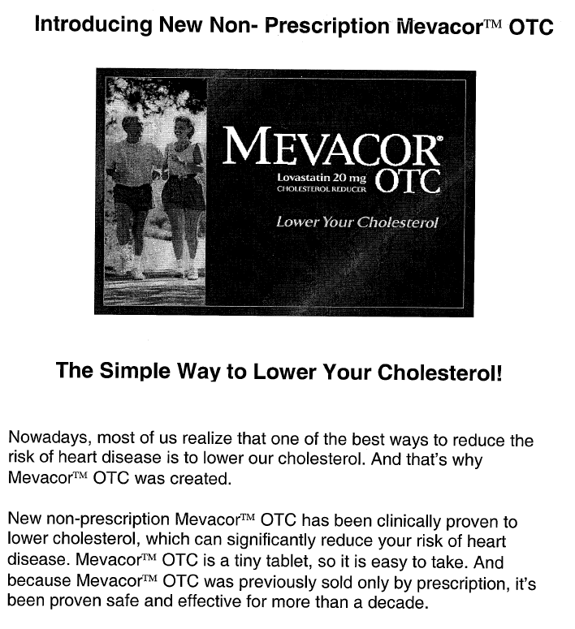
Comment:

The concept board did not provide specific inclusion or exclusion criteria for the study or specifics on the label so it would not have introduced bias into the label comprehension study.

Data collection

Study respondents were placed alone in a private room with an empty package of Mevacor OTC. They were instructed to review the package for as long as they needed (generally about 5 minutes). The respondents were then interviewed using the Mevacor OTC package as a reference. Respondents were asked several times during the procedure if they needed time to re-read the package label or get up and stretch their legs. Each interview averaged less than 45 minutes.

The Interview Questionnaire

The interview questionnaire contained 81 questions. The interview questions are in the attachment at the end of this review. This review will concentrate only on the results of those questions designed to evaluate comprehension. Several of the “questions,” in fact, are statements or instructions read to the respondents by the interviewer, not questions. For example, questions 1-3 on the questionnaire stated the following:

- Before we continue, I’d like you to read and sign this nondisclosure agreement.
- During the rest of this interview, I will be showing you a package being developed for MEVACOR™OTC. You will have whatever time you feel you need to thoroughly review this package, and then we will go through a series of questions that will help us to see how the package is doing in communicating product information.
- This is the actual package that will be used for this product when it is available in stores. This package contains no medicine or anything else, so please do not open it.

The sponsor states that an attempt was made to address all the communication elements on the package label, however, because the label contains a lot of information, efforts were made via the study and questionnaire design to try to minimize respondent fatigue. The sponsor described this process as the following:

- Each respondent received 1 of 2 possible versions of the questionnaire, which were randomly chosen by the interviewer at the time of the interview:
-Each respondent saw half of the total number of selection scenarios (5 of the 10 total scenarios; Q21).
-Each respondent saw about half of the total number of real pre-existing conditions (3 or 4 of the total 7: Q23).
- While open-ended responses from respondents can be enlightening, it is very time consuming to collect and difficult to evaluate and summarize. Therefore, open-ended questions were focused on the most critical information.
-Reasons for wrong self-selection decisions were, however, captured by asking several general questions (Q77-81).
- Respondents were asked, several times during the procedure, if they needed time to re-read the package label or get up and stretch their legs.
- If respondents did not have the time to do the study when they were approached in the mall, they could make an appointment for another time.

The flow of the interview questions were described by the sponsor as the following:

- What is the product used to treat
- What is the active ingredient in the product
- Self-selection series
- Pre-usage scenarios: diet, exercise, cholesterol test issues
- Selection scenarios: age, gender, other health information
- Medication scenarios
- Information on product use: what is the product suppose to do to LDL cholesterol, doses per day, tablets per dose, consequences of stopping medication after starting to use it, when during the day to take the product
- Over-time usage scenarios: if/when to get cholesterol test after starting the medication, understanding of cholesterol goal, de-selection issues regarding medical conditions and prescription medications
- Personal information: medical history and conditions, demographics
- Exploration of reasons for inappropriate self-selection

Data analysis

Five cohorts were analyzed: (1) total representative sample, (2) Caucasian, (3) non-Caucasian,
(4) non-low-literacy, and (5) low-literacy.

Primary analysis was conducted on the percent of respondents in the total representative sample who gave “correct plus acceptable” and “correct” responses. The “representative” sample did not include respondents who were augmented for low literacy. The total low literacy group (those in the representative sample plus the augmented respondents) was compared to the remaining respondents in the representative sample (“non-low literacy subgroup”). The total non-Caucasian subgroup was compared to the remaining respondents in the total representative sample (“Caucasian subgroup”). The sponsor determined that a response was considered “acceptable” if it did not specifically adhere to the label directions but would pose no potential safety risk. In addition, many of the “acceptable” responses involve talking with doctor. The sponsor submitted the following table to outline the response classifications:
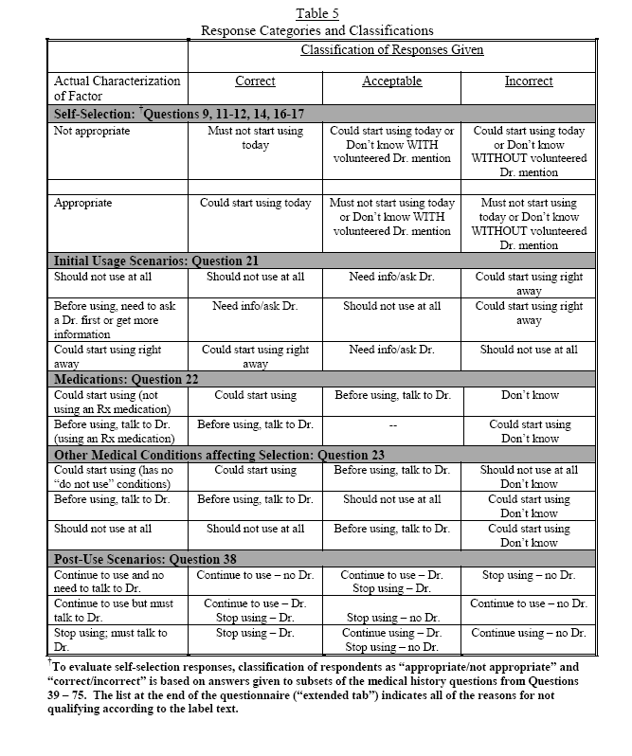
Self-selection was analyzed in the 5 cohorts. This was accomplished by the following: Each respondent’s self-reported medical history, medical conditions, demographics, and knowledge of their own cholesterol numbers (Q50-75) were analyzed against their response to the questions about whether or not it would be appropriate to start using this drug (Q9-17). Subjects who self-selected incorrectly were questioned further in an attempt to understand the reasons for their inappropriate response (Q77-81).

Because each questionnaire contained half of the total number of selection scenarios (5 of the 10 total scenarios; Q21) and half of the total number of real pre-existing conditions (3 or 4 of the
total 7; Q23) the sponsor described the analysis of their data in the following way: “As noted in “Overall Design”, some questions were answered by only half of the total sample. With this in mind, the following table was created (Table 4: Confidence intervals at various sample sizes). It is based on the confidence interval for a normal approximation to the binomial distribution, to indicate statistical precision associated with responses of 50%. The formula was used is:
p + Z √ p(1-p)”
n
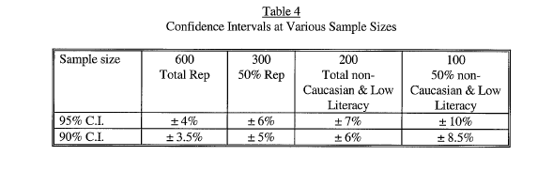

Comments on the Methodology:

The FDA statistician will be reviewing the statistical plan for this study. His results were not available at the time of this review.

The sponsor did not provide specific inclusion or exclusion criteria for the study. The only eligibility criterion described by the sponsor was that they included subjects who were considered “cholesterol-concerned respondents”. There was no mention of visual or language requirements as an inclusion or exclusion criteria, even though potential study participants were asked if they wore reading glasses.

The objectives are appropriate to evaluate label comprehension and self-selection, however, the ability to self-select should be listed as a primary not a secondary objective.

Prompting the respondent to re-read the label is not naturalistic. It would be have been more appropriate to determine if consumers were able to grasp the appropriate information in order to use the product safely and effectively by referring to the label at their own discretion without being prompted.

The sponsor indicated that there is a lot of information on the label. In a naturalistic setting, a consumer would need to read and understand all the important communication objectives on the label in order to self-select appropriately and use the product correctly. The sponsor states that because there is a lot of information on the label they designed the study to minimize fatigability during the research session. What we do not know from this study is how fatiguing a consumer would find reading the label in its entirety.

The flow of the questions do not appear to bias the response. Overall the questions appear to be well written and non-leading.

Results

Sample

A total of 696 respondents were recruited from the 25 geographic locations. The following tables show the breakdown of the sample according to cohort, geographic location, age, and gender.

Sample size of each cohort:

Total representative sample | 696
Total low-literacy in the representative sample | 111
Total number of augmented low-literate* | 92
Total number of non-low literate | 493
Total non-Caucasian from the representative sample | 207
Total Caucasian from the representative sample | 489
* In order to have an adequate number of low-literate respondents, additional low-literate respondents were recruited. Therefore, it is important to note that in all the tables, the total low-literacy sample and the total non-low literacy sample will not equal the total representative sample.

Geographical Locations:

Atlanta | 25 | Philadelphia | 31
Bridgeport | 32 | Phoenix | 21
Chicago | 24 | San Diego | 25
Colorado Springs | 36 | Tampa | 33
Dallas | 22 | Boston | 30
Fresno | 24 | Buffalo | 35
Greensboro | 27 | Cleveland | 23
Houston | 19 | Peoria | 22
Livingston | 19 | Portland | 23
Los Angeles | 31 | San Antonio | 40
Nashville | 40 | Springfield | 17
Hicksville | 31 | Washington DC | 16
Orlando | 50

Sample Proportion by Age and Gender:

 | Men | Women
Total % | 44 | 56
Age as % of Total Gender:
18-34 | 25 | 24
35-44 | 23 | 21
45-54 | 21 | 21
55 and older | 30 | 35
% Age Breakdown of 55 and Older | Men/Women
55-59 | 10.6
60-64 | 7.8
65-69 | 5.2
70-74 | 2.7
75 or older | 4.9
55 or older unspecified | 1.6

Comment:

Approximately half the study participants were under age 45. The product is labeled for use in men 45 and older and women 55 and older. Because the sample contains a large number of younger participants it is not possible to generalize these results to the target population. In addition, less than 10% of participants were older than 65. This age group often has more difficulty acquiring information on OTC labels, especially when the print is small. Therefore testing larger numbers in this age group is important.¹

The following are the results of this label comprehension study. The results are presented in relation to the corresponding study objective or key communication factors. As previously mentioned, not all “questions” in the questionnaire are really questions, therefore only the bonafide questions designed to evaluate comprehension will be reviewed. Tables with a table number identifier (e.g. Table 14) are tables submitted by the sponsor. Tables without a table number identifier are the reviewer’s summaries of data submitted by the sponsor.

¹ Wogalter, MS, & Vigilante, WJ. 2003. Effects of label format on knowledge acquisition and perceived readability by younger and older adults, Ergonomics, 46(4), 327-344.
- Comprehension of what condition the product is used for

Q7: “First, what is MEVACOR™OTC used to treat?”

 | Total | Caucasian | Non-Caucasian | Non-Low Literacy | Low  Literacy
Sample size | 696 | 485 | 207 | 585 | 203
 | N % | N % | N % | N % | N %
Correct* | 686 99 | 478 99 | 204 99 | 578 99 | 198 98
*Open ended question. The correct answers included: high cholesterol, reduce cholesterol, lower cholesterol, treat bad cholesterol, treat LDL, for cholesterol. Incorrect answers included: treat high blood pressure and prevent heart attack.

Comment:

Results indicate that most of the respondents understood the indication for Mevacor OTC.

- Active ingredient in the product

Q8: What is the active ingredient in MEVACOR™OTC?

 | Total | Caucasian | Non-Caucasian | Non-Low Literacy | Low  Literacy
Sample size | 696 | 485 | 207 | 585 | 203
 | N % | N % | N % | N % | N %
Correct* | 641 92 | 446 92 | 191 92 | 554 95** | 171 84**
*Open ended question. Correct answers included: lovastatin or lovastatin 20 mg.
**Statistically significant difference at a 95% C.I. between Non-Low literacy and Low Literacy group

Comment:

Results indicate that a substantial majority of the respondents understood that lovastatin is the active ingredient in Mevacor OTC.

- Scenarios that describe combinations of age, gender, cholesterol levels, risk factors and other factors that should alert respondents to talk to their doctors before using this the product or to not use it at all

- Other medical conditions or medications that require consultation with a health care professional prior to product use or preclude use

Data for these communication objectives are combined in the following tables (Tables 15-19) supplied by the sponsor for Questions 21-23.

Scenarios for Question 21:
Answer choices: This person could start using right away; before using, this person needs to ask a doctor or get more information; this person should not use at all; or don’t know.

- Francine is 61 years old. Before using MEVECOR™OTC, her LDL “bad” cholesterol is 150. Her mother had a heart attack at age 59. Assume Francine has no other reasons not to use this product today. (correct=could start using right away, acceptable=needs to ask a doctor first or get more information)
- Jane is 60 years old. Before using MEVACOR™OTC, her LDL “bad” cholesterol is 115. She has high blood pressure. She is not taking any prescription medicines. Assume Jane has no other reasons not to use this product starting today. (correct= needs to ask a doctor first or get more information, acceptable=this person should not use at all)
- Kathleen is 58 years old. She doesn’t know her LDL “bad” cholesterol or her HDL “good” cholesterol numbers. Her father had a heart attack when he was 47. Assume Kathleen has no other reasons not to use this product starting today. (correct= needs to ask a doctor first or get more information, acceptable=this person should not use at all)
- Steve is 47 years old. Before using MEVACOR™OTC, his LDL “bad” cholesterol is 140. His HDL “good” cholesterol is 33. Assume Steve has no other reasons not to use this product starting today. (correct=could start using right away, acceptable=needs to ask a doctor first or get more information)
- Victor is 59 years old. Before using MEVACOT™OTC, his “bad” cholesterol is 145. His HDL “good” cholesterol is 32. Recently he had a muscle pain side effect taking cholesterol lowering medicine and had to stop using it. Assume Victor has no other reasons not to use this product starting today. (correct=this person should not use at all, acceptable= needs to ask a doctor first or get more information)
- Brenda is 68 years old. Before using MEVACOR™OTC, her LDL “bad” cholesterol is 156. Her father had a heart attack at the age of 50. Assume Brenda has no other reasons not to use this product starting today. (correct=could start using right away, acceptable=needs to ask a doctor first or get more information)
- Carol is 72 years old. Before using MEVACOR™OTC, her LDL “bad” cholesterol is 250. She has high blood pressure. She is not taking any prescription medicines. Assume Carol has no other reasons no to use this product starting today. (correct=this person should not use at all, acceptable= needs to ask a doctor first or get more information)
- David is 46 years old. Before using MEVACOR™OTC, his LDL “bad” cholesterol is 145. His HDL “good” cholesterol is 32. Assume David has no other reasons not to use this product starting today. (correct=could start using right away, acceptable=needs to ask a doctor first or get more information)
- Laurie is 45 years old. Before using MEVACOR™OTC, her LDL “bad” cholesterol is 155. She has high blood pressure. She is not taking any prescription medicines. Assume Laurie has no other reasons not to use this product starting today. (correct= needs to ask a doctor first or get more information, acceptable=this person should not use at all)
- Rob is 68 years old. Before using MEVACOR™OTC, his LDL “bad” cholesterol is 160. His father had a heart attack at the age of 45. Rob is allergic to lovastatin. Assume Rob has no other reasons not to use this product starting today. (correct=this person should not use at all, acceptable= needs to ask a doctor first or get more information)

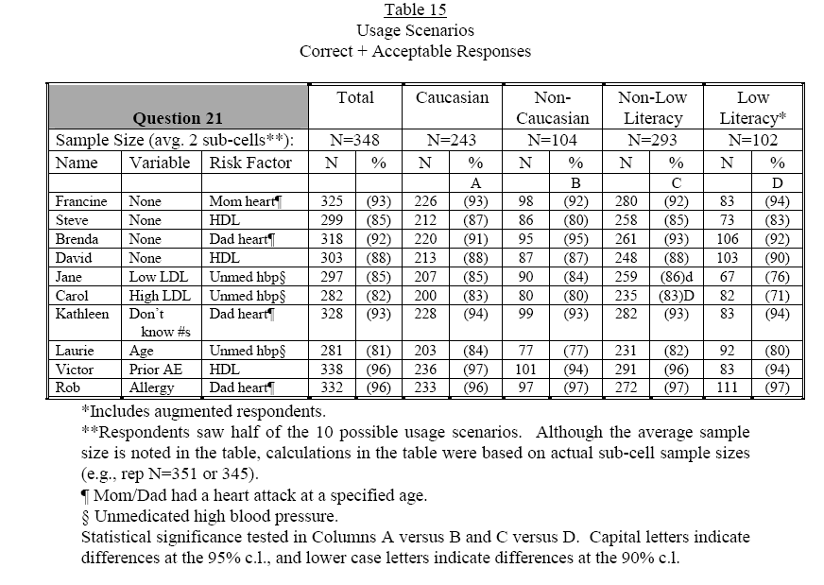

Comment:

Some percentages and numbers in this sponsor’s table do not appear to add up. This is also true for some of the other sponsor tables that follow in this review.
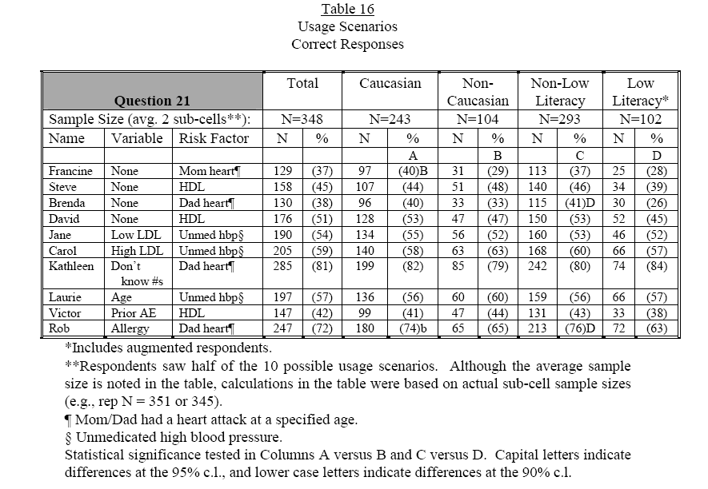
Comments:

These scenarios represent the section of the label called “How to decide if MEVACOR™OTC is right for you”. The sponsor stated that this section of the label is based on the ATP-III guidelines for determining risk for coronary artery disease. The intent is for the consumer to read the 4 columns in this section of the label in sequence and, using this information, determine if they should or should not take Mevacor OTC.

Table 16 provides data for only correct responses to these scenarios. The range of respondents who answered correctly was 26-82 % with an average of 52.6%. According to the questionnaire, a correct response for Laurie, who is 45 years old, is “before using, this person needs to ask a doctor first or get more information.” This response should not have been considered correct. The correct response should have been “this person should not use at all” because Laurie is less than 55 years of age. If we adjust the data to reflect the correct response, only 84 of the 348 respondents answered correctly. This corresponds to 24% of the total which is less than half of the 57% reported in Table 16 above.

According to the questionnaire, a correct response for Jane, whose LDL cholesterol is only 115, is “before using, this person needs to ask a doctor first or get more information.” This response should not have been considered correct. The correct response should have been “this person should not use at all” because Jane’s LDL cholesterol is less than 130. If we adjust the data to reflect the correct response, only 107 of the 348 respondents answered correctly. This corresponds to 31% of the total which is well below the 54% reported in Table 16 above.

Table 15 provides the results when the acceptable results are added to the correct results. This increases the range to 71-97% with an average of 88.7%. In most cases, the acceptable response was “needs to ask a doctor first or get more information”. Because this one answer combined two discretely different actions “ask a doctor” or “get more information”, it is possible that respondents defaulted to this answer because it provided them with several options. If the two options were separate choices, the acceptable results may have been different given that Kathleen was the only scenario requiring more information.

The sponsor has analyzed the data for these scenarios and others in such a way that simply by random guessing, respondents could end up with a correct or acceptable answer 50% of the time. This reviewer does not see validity in this analytical approach which falsely elevates the appearance of comprehension.

In both tables there were few differences between cohorts.

Scenarios for Question 22:
Answer choices: This person could start using right away; before using, this person needs to ask a doctor first; or don’t know.

- Al is using a nonprescription cough drop for a mild cough. (correct=this person could use right away)
- Sara takes a prescription medicine to lower her cholesterol. (correct=before using, this person needs to ask a doctor first)
- Doug takes a prescription medicine for his ulcer. (correct= before using, this person needs to ask a doctor first)
- Lisa has developed a case of hemorrhoids and has started to use Preparation H for it. (correct= this person could use right away)
- Linda takes a nonprescription fiber laxative for regularity this. (correct=person could use right away)
- Warren is taking a prescription medicine for an infection. (correct= before using, this person needs to ask a doctor first)

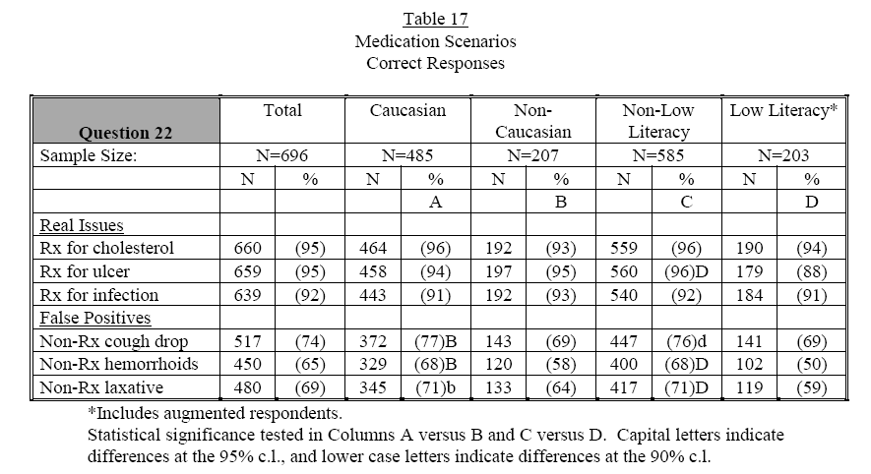

Comment:

These scenarios represent the “Warnings” section of the label under the subsection “Ask your doctor or pharmacist before use if you are taking”. Table 17 provides the data for correct answers to these scenarios. The results indicate that the respondents understood the need to ask a doctor or pharmacist before taking Mevacor OTC if someone is on a prescription medication (88-95%). However it appears that the respondents were unclear on how to handle situations not specified on the label. In all the scenarios associated with the use of specific types of non-prescription medications, only 50-77% understood that these medications did not preclude them from starting Mevacor OTC “right away”.

Scenarios for Question 23:
Answer choices: This person could start using right away; before using, this person needs to ask a doctor first; this person should not use at all; or don’t know.

- Peter gets gas from over-eating once in a while. (correct=this person could start using right away, acceptable=before using, this person needs to ask a doctor first)
- Barbara has liver disease. (correct=this person should not use at all, acceptable= before using, this person needs to ask a doctor first)
- Luke had a stroke several years ago. (correct= before using, this person needs to ask a doctor first, acceptable= this person should not use at all)
- John has occasional constipation. (correct=this person could start using right away, acceptable=before using, this person needs to ask a doctor first)
- Amanda’s triglycerides are 450. (correct= before using, this person needs to ask a doctor first, acceptable= this person should not use at all)
- Helen is breast-feeding. (correct=this person should not use at all, acceptable= before using, this person needs to ask a doctor first)
- Bill was camping in the woods and got a case of poison ivy. (correct=this person could start using right away, acceptable=before using, this person needs to ask a doctor first)
- Alice is pregnant. (correct=this person should not use at all, acceptable= before using, this person needs to ask a doctor first)
- Mary had a heart attack last year. (correct= before using, this person needs to ask a doctor first, acceptable= this person should not use at all)
- Cindy has diabetes. (correct=this person should not use at all, acceptable= before using, this person needs to ask a doctor first)

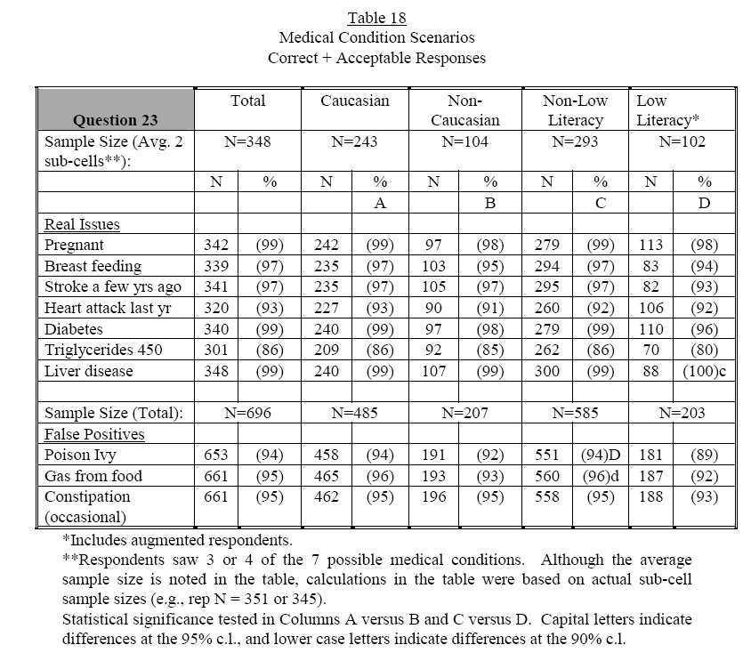

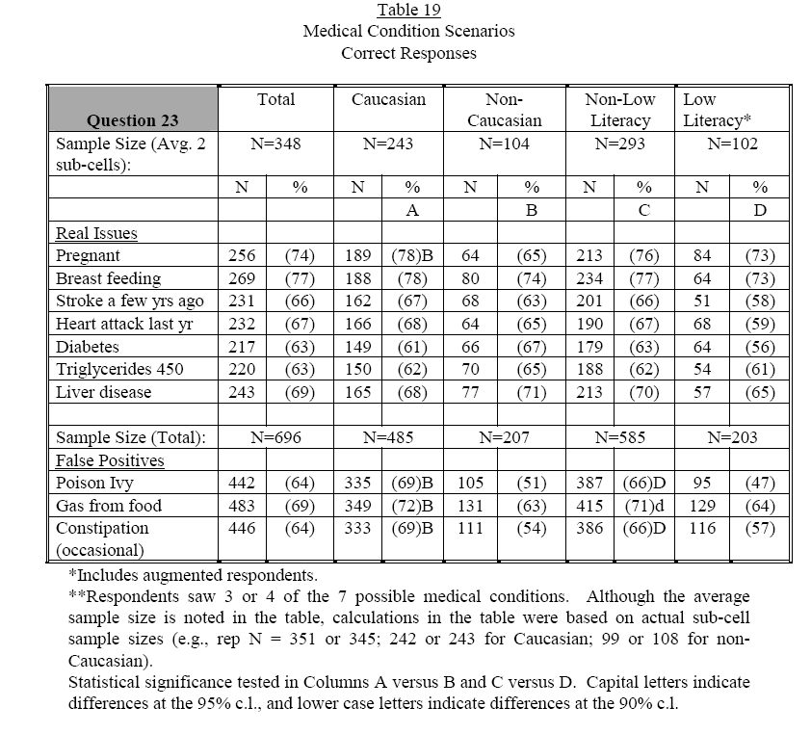
Comments:

These scenarios represent the section of the label under Warnings. The scenarios included specific medical contraindications listed on the label under the following subheading:

- “Do not use if” (these scenarios include: liver disease, pregnant, and breast feeding)
- “Do NOT use unless directed by your doctor if you have”(these scenarios include stroke, high triglycerides 200-900 mg/dl, heart attack, and diabetes)

Medical problems not contraindicated on the label were also included in the scenarios (gas from food, poison ivy, and constipation.)

The range of correct responses to the scenarios that represent the subheading “Do not use if” (these scenarios include: liver disease, pregnant, and breast feeding) was 65-78%. No where under this subheading does it direct the consumer to “ask a doctor”. Thus, the sponsor’s plan to count this choice as “acceptable” is not appropriate. It is impossible to know from a label comprehension study if respondents would “ask a doctor”. The fact that most of the respondents who answered incorrectly deferred to the response “before using, this person needs to ask a doctor first” may have been the result of the multiple choice format. The use of open-ended questions would have provided better insight into the respondent’s ability to comprehend the important information listed in the Warnings section of the label.

The sponsor refers to “real issues” as those medical contraindications listed on the label and refers to “false issues” as those medical conditions not listed on the label as contraindications. Table 19 provides data for only correct responses to these scenarios. The range of respondents who answered the “real issues” correctly was 56-78% with an average of 67.3%. The range of respondents who answered the “false issues” correctly was 47-72% with an average of 63%. There was a statistically significant difference between the low-literacy and non-Caucasian cohorts and their respective comparator controls. Both scored lower for the “false issues”. Table 18 provides the “acceptable” results plus the correct results. This increases the range to 80-100% for the “real issue” responses with an average of 95% and 89-96% for the “false issue” responses with an average of 94%. In all cases, the “acceptable” response was either “before using, this person needs to ask a doctor first” or “this person should not use at all”.

- Scenarios that address prerequisites for using the product, specifically diet, exercise, and appropriate time frame for testing cholesterol in order to decide whether or not to use the product:

Scenarios for Question 19a and 19b:
Answer choices: true, false, or don’t know

- Alan has never had his cholesterol tested. He does not need to have his cholesterol tested before starting to use MEVACOR™OTC.
  - Ben has been swimming laps regularly and watching his diet. His cholesterol has not gone down. It’s okay for him to use MEVACOR™OTC.
  - Doris got her cholesterol tested without fasting first. It’s okay that she is using these numbers to help decide if MEVACOR™OTC is right for her.
  - Janet had her cholesterol tested 2 months ago. It’s okay that she is using these numbers to help decide if MEVACOR™OTC is right for her.
  - Melanie does not need to try a healthy diet before starting MEVACOR™OTC because MEVACOR™OTC will lower her cholesterol in place of the diet.
  - Sam had his cholesterol tested 2 years ago. It’s okay that he is using those numbers to help decide if MEVACOR™OTC is right for him.

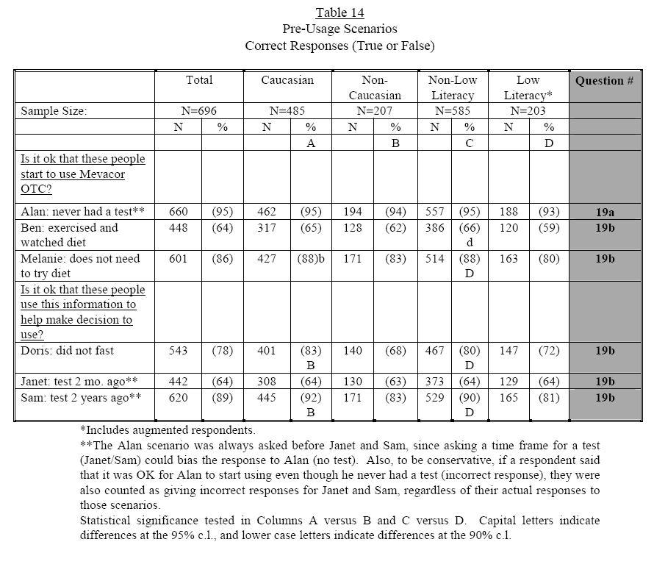
Comments:

Responses to these scenarios that address the prerequisites for using this product (diet, exercise, and appropriate time frame for testing cholesterol) were mixed. The respondents scored well (81-95%) in their understanding that not having a cholesterol test or having one taken 2 years ago is inadequate. The concept for the need to have a fasting cholesterol was not well understood across all groups (68-78%) with the Non-Caucasian group scoring the lowest (68%).

Perhaps the reason the respondents answered so poorly (59-65%) to the scenario “Ben has been swimming laps regularly and watching his diet. His cholesterol has not gone down. It’s okay for him to use MEVACOR™OTC,” was because it was poorly written. This scenario provided inadequate information upon which to base this decision (e.g., his cholesterol levels and other risk factors). Therefore, an incorrect answer in this case was not necessarily the wrong answer.

Respondents answered correctly 80-86% to the scenario regarding the need to try eating a healthy diet before starting MEVACOR™OTC (Melanie). Although this percentage demonstrates a fairly good understanding of this concept, this reviewer would hope for better comprehension of this point. None of the questions in this label comprehension study address the need to continue eating a healthy (specifically a low fat) diet when using Mevacor OTC.

- Scenarios that address comprehension of the timing for follow-up cholesterol testing

Scenarios for Question Q35
Answer choices: Get a cholesterol test now, get a cholesterol test after a few more weeks, no need to get a cholesterol test anytime soon, or don’t know.

Connie has been taking MEVACOR™OTC for 4 weeks
Dan has been taking MEVACOR™OTC for 8 weeks

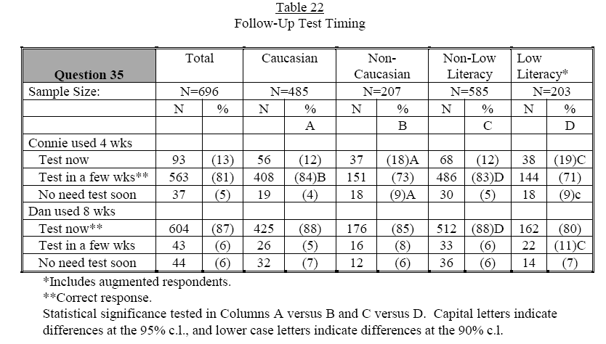
Comment:

There were two scenarios in this question. These addressed when cholesterol levels should be re-checked. These scenarios only provide information that respondents understood not to have their cholesterol checked at 4 weeks and that they should have their cholesterol checked in 8 weeks. Having only two scenarios limited the ability to determine if respondents understood the concept of when to have the cholesterol levels re-checked. Question 27 addresses this issue further, however only in relation to exactly 6 weeks as it is described in the label. Whether or not respondents understood that cholesterol needs to be re-checked at all is not addressed in either question. Including the answer choice “does not need to have his or her cholesterol re-checked” or creating an open-ended question would have provided important information to help determine whether or not respondents understood this concept.

Scenarios for Question Q37: Question A for these scenarios communicates what the appropriate time is to get a repeat cholesterol test.
Answer choices: Yes, Know, or Don’t Know

- After taking MEVACOR™OTC for 6 weeks, Eddie got a follow-up LDL test. His LDL test was 115. A-Did Eddie get a follow-up LDL at the appropriate time?
- After taking MEVACOR™OTC for 3 weeks, Kevin got a follow-up LDL test. His LDL test result was 137. A-Did Kevin get a follow-up LDL test at the appropriate time?
- After taking MEVACOR™OTC for 6 weeks, Sophie got a follow-up LDL test. Her LDL result was 158. A- Did Sophie get a follow-up LDL test at the appropriate time?

 | Total | Caucasian | Non-Caucasian | Non-Low Literacy | Low  Literacy
Sample size | 222 | 161 | 60 | 190 | 71
Correct | N % | N % | N % | N % | N %
Eddie | 206 93 | 151 94 | 55 92 | 178 94 | 62 87
Sample size | 246 | 172 | 72 | 207 | 71
Correct | N % | N % | N % | N % | N %
Kevin | 196 80 | 141 82 | 54 75 | 169 82 | 52 73
Sample size | 228 | 152 | 75 | 188 | 61
Correct | N % | N % | N % | N % | N %
Sophie | 191 84 | 132 87 | 58 77 | 161 86 | 49 80

Comment:

According to responses to Eddie and Sophie, it appears that the respondents understood that having a cholesterol re-checked at 6 weeks is correct (77-94%). According to responses to Kevin, the respondents had lower comprehension in understanding that having a cholesterol checked at 3 weeks is incorrect (73-80%). This difference may be the result of having the words “Test at 6 weeks” clearly displayed on the label in bold print and underlined, whereas the label does not mention what or what not to do at 3 weeks.

- Questions and scenarios that explore comprehension of goal message

Q26: “First, what is MEVACOR™OTC supposed to do to a person’s LDL Cholesterol?

 | Total | Caucasian | Non-Caucasian | Non-Low Literacy | Low  Literacy
Sample size | 696 | 485 | 207 | 585 | 203
 | N % | N % | N % | N % | N %
Correct* | 684 98 | 479 99 | 201 97 | 576 98 | 198 97
*Open ended question. The correct answers included: lowers LDL/Bad cholesterol/reduces it, lowers LDL/Bad cholesterol to below 130/129 or below, keep it down, miscellaneous lowers LDL/Bad cholesterol comments.

Comment:

Results indicate that most of the respondents understood how Mevacor OTC should affect the LDL cholesterol.

Scenarios for Question Q37: Question B for these scenarios communicates understanding of cholesterol goal.
Answer choices: Yes, Know, or Don’t Know

- After taking MEVACOR™OTC for 6 weeks, Eddie got a follow-up LDL test. His LDL test was 115. Did Eddie’s follow-up LDL test fall to the right level or not?
- After taking MEVACOR™OTC for 3 weeks, Kevin got a follow-up LDL test. His LDL test result was 137. Did Kevin’s follow-up LDL test fall to the right level or not?
- After taking MEVACOR™OTC for 6 weeks, Sophie got a follow-up LDL test. Her LDL result was 158. Did Sophie’s follow-up LDL test result fall to the right level or not?

 | Total | Caucasian | Non-Caucasian | Non-Low Literacy | Low  Literacy
Sample size | 222 | 161 | 60 | 190 | 71
Correct | N % | N % | N % | N % | N %
Eddie | 192 86 | 144 89 | 48 80 | 166 87 | 58 82
Sample size | 246 | 172 | 72 | 207 | 71
Correct | N % | N % | N % | N % | N %
Kevin* | 11 4 | 6 3 | 5 7 | 9 4 | 2 3
Sample size | 228 | 152 | 75 | 188 | 61
Correct | N % | N % | N % | N % | N %
Sophie | 148 65 | 105 70 | 42 56 | 128 68 | 33 54
*The responses for Kevin to question (B) were few because respondents who answered question (A) correctly (73-82%) were not asked question (B).

Comment:

Results from these scenarios indicate that respondents understood when LDL cholesterol decreased to the goal range with 80-90% correct responses to Eddie. They did not understand, as well, when LDL cholesterol did not reach the goal range (54-70% correct responses for Sophie).

- Scenarios that describe events that might occur during product usage that should indicate a need to stop using the product and /or talk with a doctor

Scenarios for Question Q37: Question C for these scenarios communicates what an individual should do based on their cholesterol results:

- After taking MEVACOR™OTC for 6 weeks, Eddie got a follow-up LDL test. His LDL test was 115. Which statement on this card best describes what Eddie should do next?
  - Continue to use MEVACOR™OTC and does not need to talk to a doctor.
  - Continue to use MEVACOR™OTC but must talk to a doctor.
  - Stop using MEVACOR™OTC. Does not need to talk to a doctor.
  - Stop using MEVACOR™OTC. Must talk to a doctor.
  - Don’t know

Eddie | Total | Caucasian | Non-Caucasian | Non-Low Literacy | Low  Literacy
Sample size | 222 | 161 | 60 | 190 | 71
 | N % | N % | N % | N % | N %
Correct | 131 59 | 104 65 | 27 45 | 118 62 | 31 44
Net Correct* | 194 87 | 144 89 | 50 83 | 167 88 | 58 82
*Net correct answers included:
  - Continue to use MEVACOR™OTC and does not need to talk to a doctor. (correct)
  - Continue to use MEVACOR™OTC but must talk to a doctor. (acceptable)
  - Stop using MEVACOR™OTC. Must talk to a doctor. (acceptable)
- After taking MEVACOR™OTC for 3 weeks, Kevin got a follow-up LDL test. His LDL test result was 137. Which statement on this care best describes what Kevin should do next?
  - Continue to use MEVACOR™OTC and does not need to talk to a doctor.
  - Continue to use MEVACOR™OTC but must talk to a doctor.
  - Stop using MEVACOR™OTC. Does not need to talk to a doctor.
  - Stop using MEVACOR™OTC. Must talk to a doctor.
  - Don’t know

Kevin | Total | Caucasian | Non-Caucasian | Non-Low Literacy | Low  Literacy
Sample size | 246 | 172 | 72 | 207 | 71
 | N % | N % | N % | N % | N %
Correct* | NA* | NA* | NA* | NA* | NA*
*NA (not applicable): If respondents answered the first question (question A) in this scenario correctly (No) “Did Kevin get a follow-up LDL test at the appropriate time, or not?” they were not asked this question. Therefore, not answering this question is considered correct.
- After taking MEVACOR™OTC for 6 weeks, Sophie got a follow-up LDL test. Her LDL result was 158. Which statement on this care best describes what Sophie should do next?
  - Continue to use MEVACOR™OTC and does not need to talk to a doctor.
  - Continue to use MEVACOR™OTC but must to talk to a doctor.
  - Stop using MEVACOR™OTC. Does not need to talk to a doctor.
  - Stop using MEVACOR™OTC. Must talk to a doctor.
  - Don’t know

Sophie | Total | Caucasian | Non-Caucasian | Non-Low Literacy | Low  Literacy
Sample size | 228 | 152 | 75 | 188 | 61
 | N % | N % | N % | N % | N %
Correct | 77 34 | 56 37 | 21 28 | 70 37 | 12 20
Net Correct* | 164 72 | 116 76 | 48 64 | 141 75 | 40 66
*Net correct included any of the following answers:
  - Stop using MEVACOR™OTC. Must talk to a doctor. (correct)
  - Continue to use MEVACOR™OTC but must to talk to a doctor. (acceptable)
  - Stop using MEVACOR™OTC. Does not need to talk to a doctor. (acceptable)

Comment:
Respondents did poorly with these scenarios. A respondent had a 3 out of 5 (60%) chance of randomly providing an “acceptable” answer to these questions. The range for correct responses was 20-65%. The range for acceptable plus correct responses was 64-89%. The respondents scored poorly in their understanding of what to do if the LDL does decrease to goal (below 130). The range of correct responses for reaching goal (Eddie who’s LDL was 115), was 44-65%.

The range of correct responses for not reaching goal (Sophie who’s LDL was 158), was even worse,20-37%. One of the answers for Sophie is “Stop using MEVACOR™OTC. Must talk to a doctor.” Asking your doctor may have been the answer chosen by many respondents if they did not know because they may have been embarrassed to admit that they did not know the answer. An open ended question would have been a better way to test comprehension of this concept. The non-Caucasian and low-literacy cohorts scored lower then the Caucasian and non-low literacy cohorts. What someone like Kevin, who may have had a borderline post-treatment LDL should do, was not really addressed.

Scenarios for Question Q38:
Answer choices: Continue to use Mevacor OTC and does not need to talk to a doctor; Continue to use Mevacor OTC, but must talk to a doctor; Stop using Mevacor OTC, does not need to talk to a doctor; Stop using Mevacor OTC, must talk to a doctor; or Don’t know.

- Diane has been taking MEVACOR™OTC for several weeks. She didn’t do any unusual physical activity and isn’t feeling sick but she has started to feel pain in her leg muscles. (correct= Stop using Mevacor OTC, must talk to a doctor, acceptable= Continue to use Mevacor OTC, but must talk to a doctor, acceptable= Stop using Mevacor OTC, does not need to talk to a doctor)
- Ellen has been taking MEVACO™OTC for several weeks. She took Tums for indigestion that she got from eating spicy foods. (correct= Continue to use Mevacor OTC and does not need to talk to a doctor, acceptable= Continue to use Mevacor OTC, but must talk to a doctor, acceptable= Stop using Mevacor OTC, must talk to a doctor)
- Harry has been taking MEVACOR™OTC for several weeks. He got caught in the rain and developed a mild cold. (correct= Continue to use Mevacor OTC and does not need to talk to a doctor, acceptable= Continue to use Mevacor OTC, but must talk to a doctor, acceptable= Stop using Mevacor OTC, must talk to a doctor)
- Bob has been taking MEVACOR™OTC for several weeks. One day he was digging in his garden and the next day his shoulders ached. (correct= Continue to use Mevacor OTC and does not need to talk to a doctor, acceptable= Continue to use Mevacor OTC, but must talk to a doctor, acceptable= Stop using Mevacor OTC, must talk to a doctor)
- Paul has been takin MEVACOR™OTC for several weeks. He was given a prescription antibiotic medicine for pneumonia. (correct= Continue to use Mevacor OTC, but must talk to a doctor, correct= Stop using Mevacor OTC, must talk to a doctor, acceptable= Stop using Mevacor OTC, does not need to talk to a doctor)
- Theresa has been taking MEVACOR™OTC for several weeks. At her yearly physical,
she was diagnosed with kidney disease. (correct= Continue to use Mevacor OTC, but must talk to a doctor, correct= Stop using Mevacor OTC, must talk to a doctor, acceptable= Stop using Mevacor OTC, does not need to talk to a doctor)

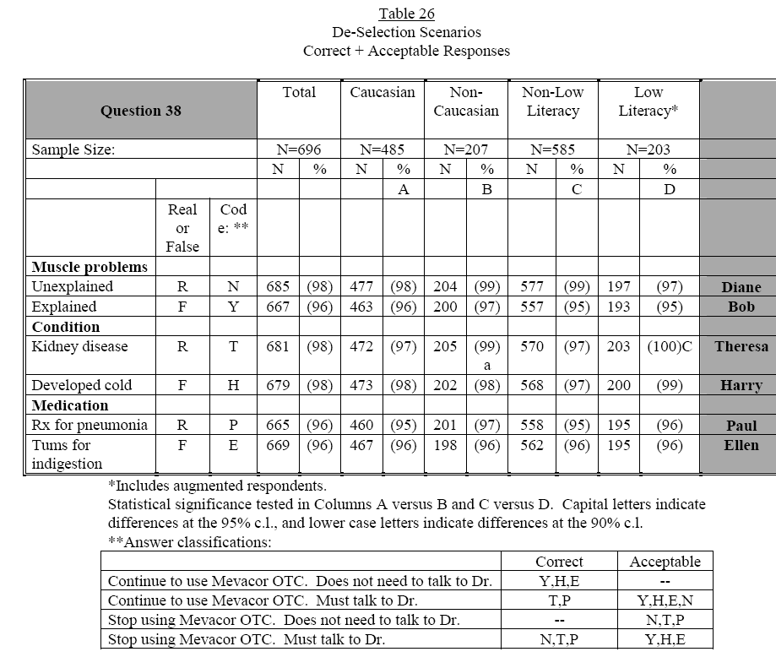

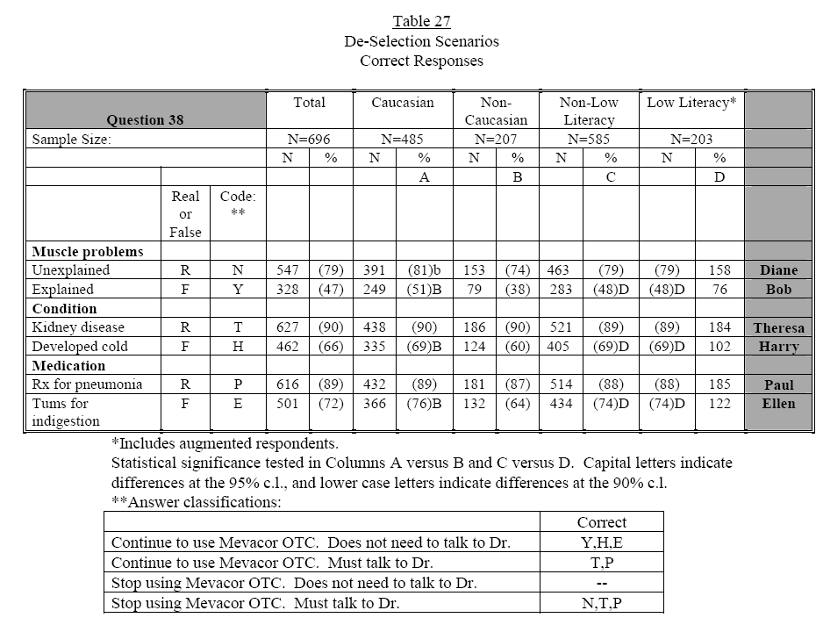
Comments:

The respondents also have a 3 out of 5 chance of having an “acceptable” response in these scenarios or a 60% chance of randomly succeeding. The range of correct responses for unexplained muscle pain was 74-81% with an increase to 97-99% when “acceptable” and correct responses were added together. It is incorrect to consider the response to “Continue to use Mevacor OTC, but must talk to a doctor” acceptable when individuals are instructed on the label to stop taking Mevacor OTC if they have unexplained muscle pain. The fact that respondents had lower percentages of correct scores for explained muscle pain (38-51%) indicates that most of the respondents did not understand the difference between explained and unexplained muscle pain.

Even when confronting “a person develops a cold” scenario, consumers defaulted to the “talk to a doctor” options. Only 60-69% answered correctly (they do not need to talk to a doctor). This raises further question if respondents are picking any answer that contains wording “talk to your doctor” because it is a “safe response” rather than responding “I don’t know”.

The scores for correct answers went up (87-89%) in response to being prescribed medicine for pneumonia. This may be because the correct answer to this question contained “talk to a doctor”. Again, this may reflect a “safe response” and may not provide the necessary information to determine label comprehension

Overall, respondents understood that that Mevacor OTC does not need to be stopped if an individual develops kidney disease but they must talk to a doctor with 89-90% answering correctly.

- Dosage information (Q27-Q30)

- Understanding that evening is the best time of the day to take the drug (Q33 and Q34)

- Understanding that a person’s cholesterol level will go back up if someone stops using the product (Q31-32)

The sponsor supplied the following table which addresses all of these communication objectives:

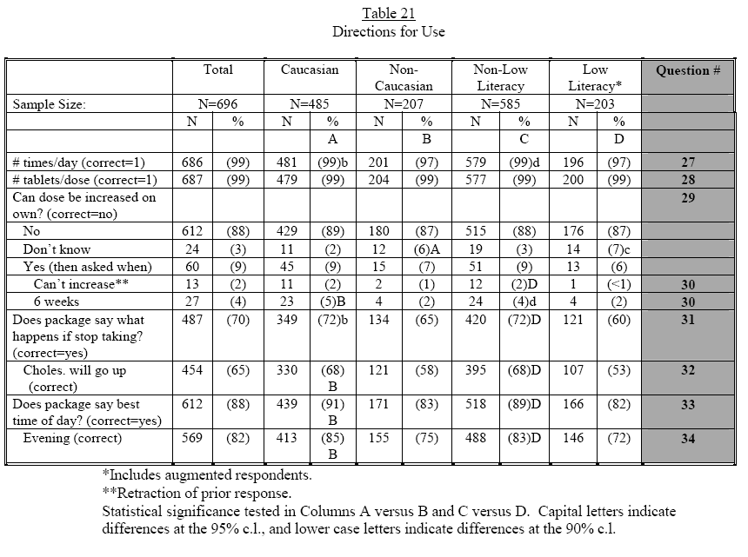
Comment:

Respondents demonstrated a good understanding of these concepts: the number of times a day Mevcacor OTC should be taken (97-99% had a correct response; the time of day it should be taken (82-91% had a correct response); and the number of tablets a day that it should be taken (99% had a correct response). Overall the respondents appeared to understand that they should not increased their dose on their own(87-89% had a correct response). The respondents had a poor understanding of what will happen if they stop taking Mevacor OTC (53-68%). This appears partly due to their inability to find this concept on the label. The number of respondents able to find this information on the label was only 60-70%. The low-literacy cohort had significantly lower scores.

- Determine how well respondents correctly respond to questions to try to measure self-selection (Q 9-13 were analyzed with responses to Q39-50).

Q9: Using the package information as the basis for your answer, could you, yourself, start to use MEVACOR™OTC today, or not? (Answer choices: I could start using MEVACOR™OTC today, I must not start using MEVACOR™OTC today, or Don’t know.
Q10: What specific information on the package helped you decide that you (probe for answer given in question 9)
]Q11: Assuming you were interested in trying MEVACOR™OTC, is there anything that you personally would do before starting to use it, or not? (Answer choices: yes, no, wouldn’t use the product, don’t know)
Q12: what would you do? What else?
Q13: How likely is it that you would talk to your doctor about MEVACOR™OTC before starting to use it? (Answer choices: very likely, somewhat likely, not too likely, not at all likely, or don’t know)
Q39: Age
Q40: Ever had heart disease such as a heart attack, angina, heart bypass surgery, or a balloon angioplasty for your heart? Every had any kind of stroke, including mini-strokes and transient ischemic attacks know as TIAs? Currently have diabetes or high blood sugar?
Q41: Do you currently have liver disease such as hepatitis, or other liver problems?
Q42: Are you, yourself, allergic to lovastatin, which is the active ingredient in MEVACOR®?
Q43: Are you pregnant?
Q44: Are you currently practicing any method of birth control?
Q45: Are you breast feeding a baby?
Q46: Are you taking any prescription drugs to lower you blood lipids, cholesterol or triglycerides?
Q47: Are you currently taking any other prescription medicines, that is, medicines that have been prescribed by a doctor?
Q49: Are you currently taking any of the prescription medicines that are listed on this card?
Q50: Are you currently taking 1000 milligrams or more of niacin in order to lower cholesterol or not?

Per Agency request, the following table supplied by the sponsor provides data on the number of respondents who self-selected correctly, acceptably, or incorrectly based on their self-reported medical history and demographics:

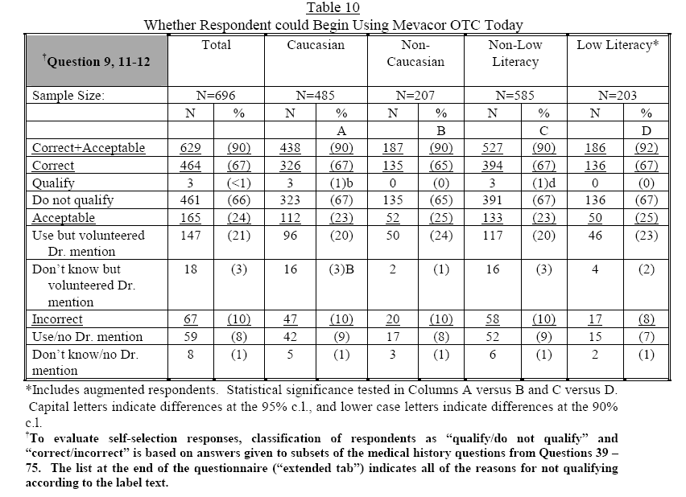

Comments:

Of the total respondents, only 67% self-selected correctly. The responses in each cohort were similar (65-67%). This percentage increases to 90% when “acceptable” responses are added to correct responses. Acceptable responses include: Can start MEVCAOR™OTC today (Q9) but volunteered that they would ask their doctor when asked further (Q11-12), and Don’t know (Q9) but volunteered that they would ask their doctor when asked further (Q11-12). If a respondent does not correctly comprehend the label but volunteers that he or she would “ask a doctor” their response should not be considered “acceptable”. The fact that a participant volunteered, in response to a probing question, that he or she would “ask a doctor” is reflective of a behavior not measurable in this study and not the ability to comprehend a label.

The sponsor supplied separate tables containing data for respondents who reported having medical conditions or other contraindications listed on the label. The tables are presented in three sections according to the subheadings in which they appear under the Warnings section of the label. To assist in clarity of the review, the exact wording as it appears on the label will also be presented.

The first subheading under the Warnings section of the label is: “Do not use if”
- Liver Disease: Do NOT use if you have liver disease.
- Do NOT use if you had any muscle pain, weakness or tenderness from taking a cholesterol-lowering medicine.
- Pregnant or breast-feeding: Do NOT use if you are pregnant or breast-feeding.
- Allergic to lovastatin: Do NOT use if you know you are allergic to lovastatin or the inactive ingredients in this medicine, as listed below.

The following tables supplied by the sponsor provide data for respondents who self-selected correctly, acceptably, or incorrectly based on reported medical conditions for which the label states “Do not use if”. These medical conditions in the tables include liver disease, allergy to lovastatin, pregnancy, breast feeding, or muscle problem from a prior cholesterol medication.
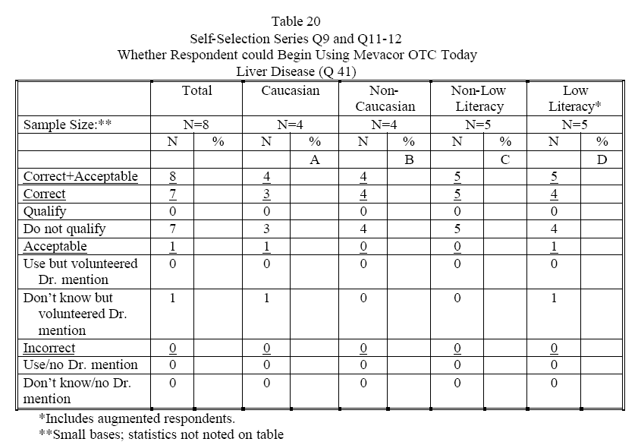

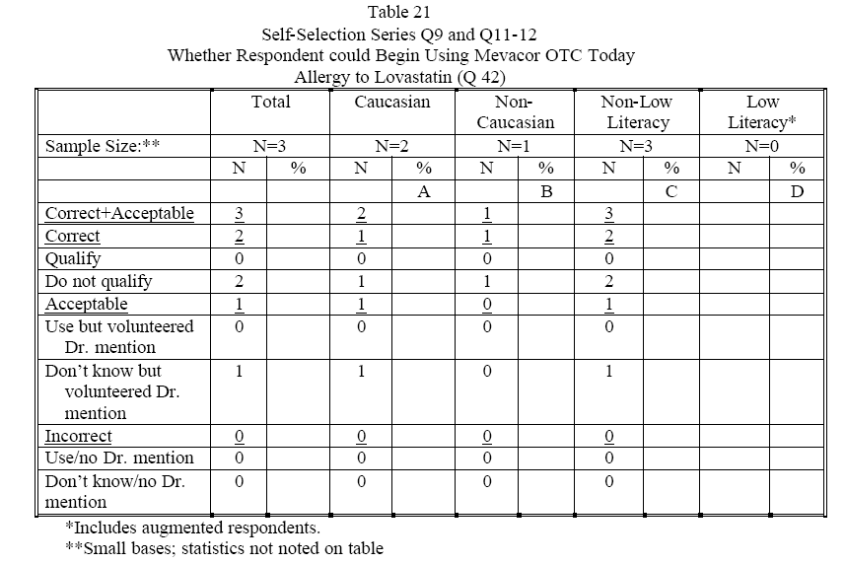

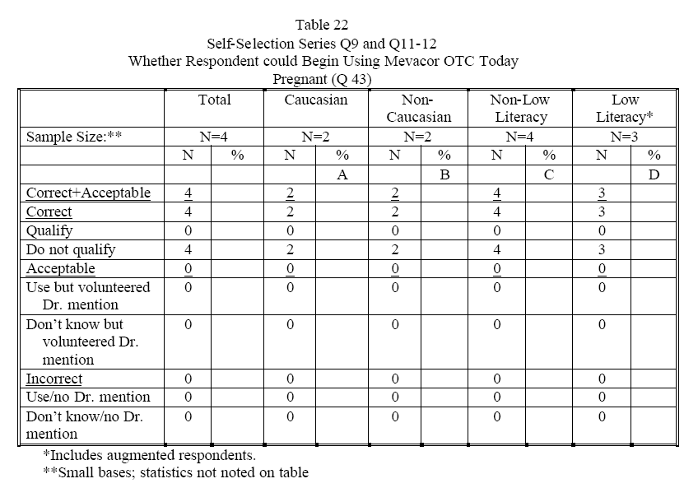

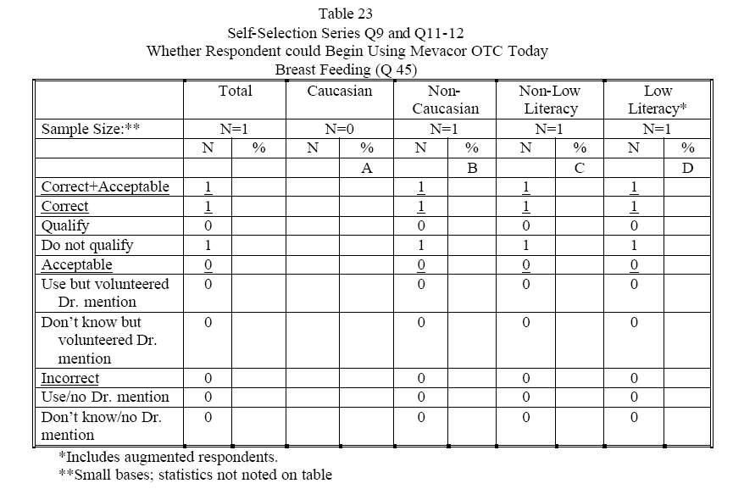

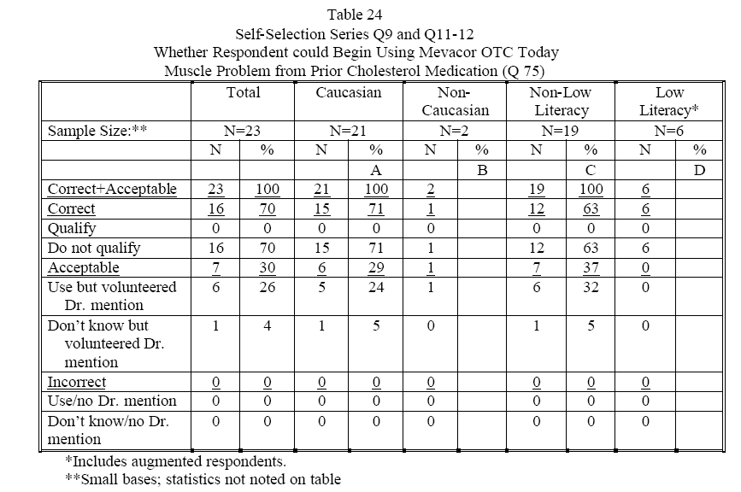
Comments:

Liver disease: The total number of respondents reporting that they had liver disease was 8. Of these 8 respondents 7 answered correctly that they should not take Mevacor OTC. The one that did not answer correctly answered he/she did not know if he/she could take Mevacor OTC and volunteered that he/she would ask a doctor.

Allergy to lovastatin: The total number of respondents reporting that they had an allergy to lovastatin was 3. Of these 3 respondents, 2 answered correctly that they should not take Mevacor OTC. The one that did not answer correctly did not know if he/she could take Mevacor OTC and volunteered that he/she would ask a doctor.

Pregnancy: The total number of respondents reporting that they were pregnant was 4. Of these 4 respondents, all 4 answered correctly that they should not take Mevacor OTC.

Breast feeding: One respondent reported she was breast feeding. She answered correctly that she should not take Mevacor OTC.

Muscle problem from prior cholesterol medication: The total number of respondents reporting that they had a muscle problem from prior cholesterol medication was 23. Of these 23 respondents 16 (70%) answered correctly that they should not take Mevacor OTC. Six of the 7 that did not answer correctly answered they could use Mevacor OTC and volunteered that they would ask a doctor. One respondent did not know and did not volunteer to ask a doctor.

The number of respondents who had one of the medical conditions contraindicated on the label was small. This limits the ability to comment, however the trend towards correct responses was good. All the respondents who answered incorrectly volunteered that they would ask a doctor.. The question used to elicit this answer was Q12: What would you do? What else? This probing question was a follow up to question (Q11): Assuming you decided you were interested in trying Mevacor™OTC, is there anything that you personally would do before starting to use it, or not; answer choices: yes, no, wouldn’t use product, or don’t know. Because the respondents answered an open ended question, the answers provide some insight into the respondent’s decision making process. However, it is important to note that nowhere under the Warning subheading Do not use if does it state “ask a doctor”

The second subsection under the Warnings section of the label is: “Ask your doctor or pharmacist (study personnel) before use if you are taking”
- Any prescription medicine: If you are taking any prescription medicine, ask your doctor or study personnel before taking MEVACOR™OTC. Certain drugs can interact with MEVACOR™OTC and can increase the possibility of side effects.
- Other cholesterol-lowering medicine: DO NOT substitute MEVACOR™OTC for your prescription or non-prescription cholesterol-lowering medicine without talking to your doctor.
- New Prescriptions: Tell your doctor you are taking MEVACOR™OTC before you begin taking any new prescription medicine.

The following tables supplied by the sponsor provide data for respondents who self-selected correctly, acceptably, or incorrectly based on reported medication use that the label states “Ask your doctor or pharmacist before use if you are taking”. These tables include: currently taking a prescription drug for cholesterol, taking other prescription medications, or on > 1000 mg Niacin for cholesterol (non-prescription cholesterol-lowering medicine*):

Comment:

*This is an incorrect statement in the questionnaire; Niacin is also a prescription product.
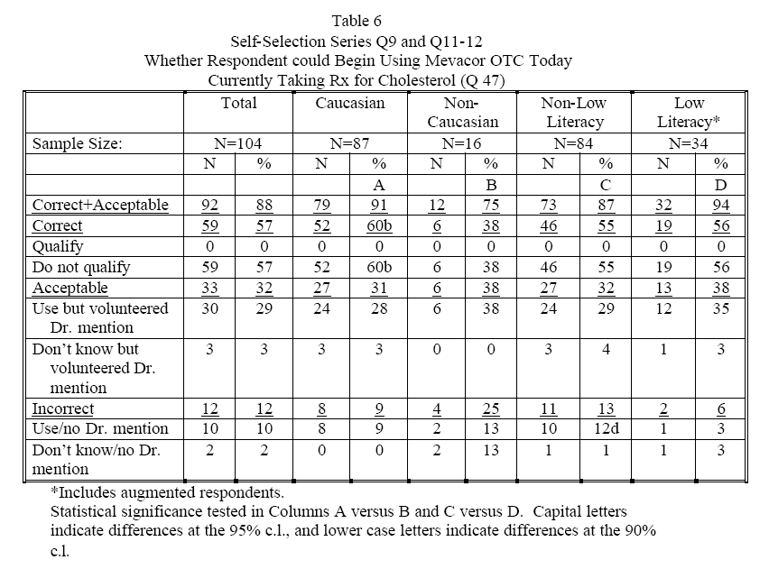

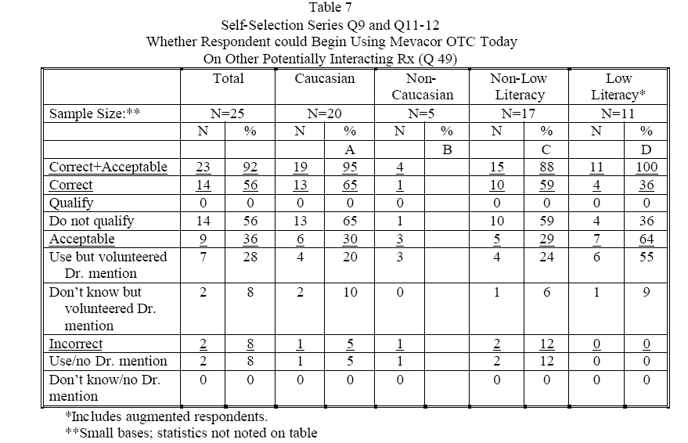

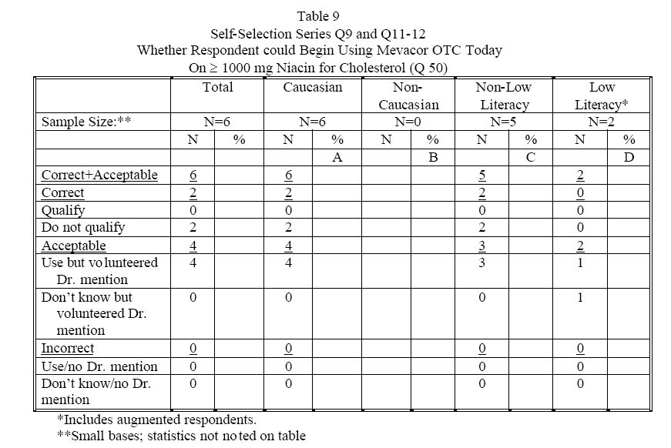
Comment:

Currently taking a prescription drug for cholesterol: The total number of respondents reporting that they are currently taking a prescription drug for cholesterol was 104. Of these 104 respondents 59 (57%) answered correctly that they should not take Mevacor OTC. Thirty three (32%) were considered to have “acceptable” answers with 30 (29%) stating that they could use the product but volunteered would talk to a doctor before starting Mevacor OTC and 3 (3%) stating that they didn’t know but volunteered that they would speak to a doctor before stating Mevacor OTC. The correct plus acceptable responses equaled 92 (88%). Twelve (12%) of the respondents answered incorrectly.

Taking other prescription medications: The total number of respondents reporting that they are taking other prescription medications was 25. Fourteen (56%) answered correctly that they should not take Mevacor OTC. Nine (36%) were considered to have “acceptable” answers with 7 (28%) stating that they could use the product but volunteered to talk to a doctor before using Mevacor OTC. Two (8%) stated they did not know but volunteered that they would speak to a doctor before using Mevacor OTC. The correct plus acceptable responses equaled 23 (92%). Two (8%) of the respondents answered incorrectly.

On > 1000 mg Niacin for cholesterol: The total number of respondents reporting that they are taking Niacin for cholesterol was 6. Of these 6 respondents 2 answered correctly that they should not take Mevacor OTC. Four respondents were considered to have “acceptable” answers with all 4 stating that they could use the product but volunteered would talk to a doctor before starting Mevacor OTC. The correct plus acceptable responses equaled 6 (100%).

For all of these contraindications the label states a person should ask a doctor or pharmacist before taking Mevacor OTC. Given that this statement appears on the label, it is reasonable to consider answers acceptable if the respondent volunteered that they would speak to a doctor before taking this product.

Of interest is the fact that 104 (15%) of the respondents reported that they were taking prescription medication for cholesterol. It could be assumed that they have more knowledge about cholesterol lowering agents than the other respondents. If their results were analyzed as a separate cohort, would they have a higher percentage of correct answers? The sponsor did not provide this information.

The third subheading under the Warnings section of the label is: “Do Not use unless directed by your doctor if you have”
- very high LDL”bad” cholesterol 171-400 mg/dl
- high triglycerides 200-900 mg/dl
- healthy HDL “good” cholesterol 60-200 mg/dl
- had a stroke
- ever had heart disease (heart attack or angina)
- diabetes

The following tables supplied by the sponsor provide data for respondents who self-selected correctly, acceptably or incorrectly based on reported medical conditions that the label states “Do not use unless directed by your doctor if you have”. These tables include: heart disease, stroke, and diabetes:

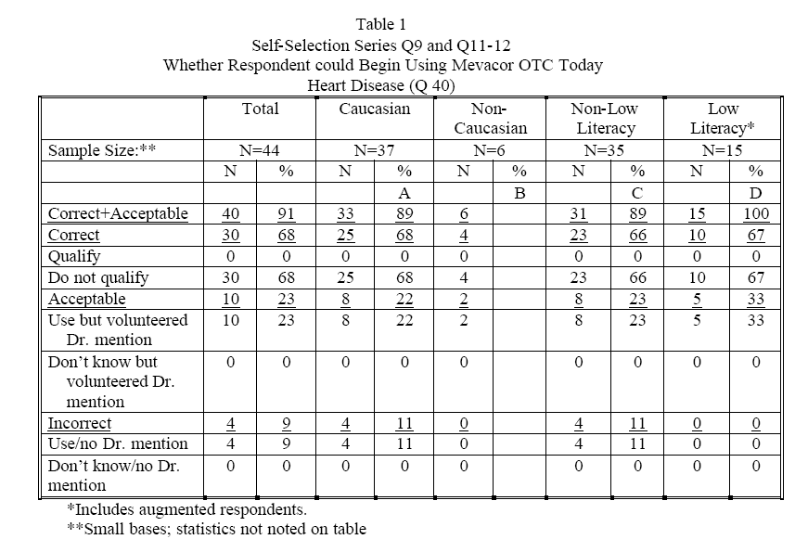

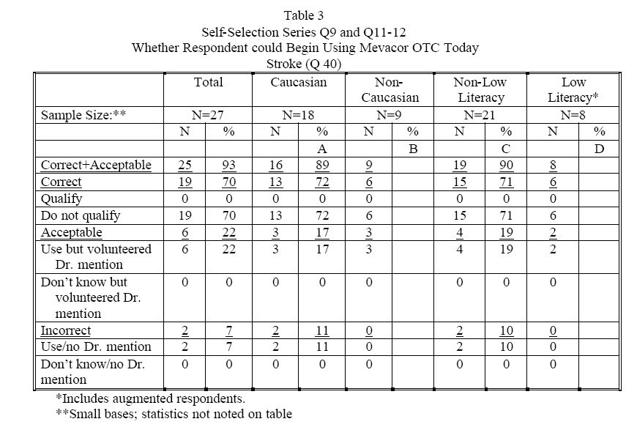
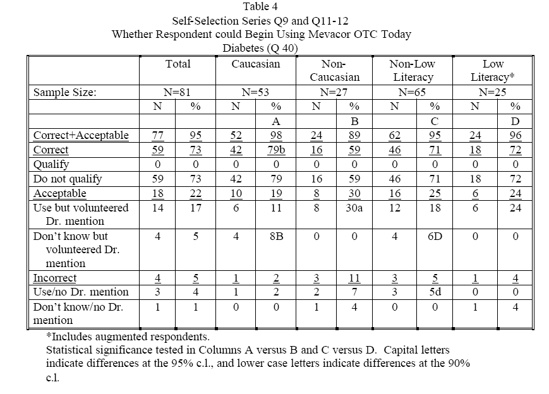

Comments:

This section of the label does not direct the consumer to ask a doctor before taking Mevacor OTC. This section of the label specifically states not to take Mevacor OTC unless directed by a doctor if a consumer has any of the listed medical conditions. Although the sponsor’s “acceptable” response (asking a doctor before taking this product) may be considered a similar answer, it does not indicate consumer understanding that this product should only be used under the direction of a doctor. Therefore asking a doctor before taking this product should not be considered an acceptable answer.

Heart disease: The total number of respondents reporting that they have heart disease was 44. Of these 44 respondents 30 (68%) answered correctly that they should not take Mevacor OTC. Ten (23%) were considered to have “acceptable” answers with all of them stating that they could use the product but volunteered would talk to a doctor before starting Mevacor OTC. The correct plus acceptable responses equaled 40 (91%). Four (9%) of the respondents answered incorrectly.

Stroke: The total number of respondents reporting that they have had a stroke was 27. Of these 27 respondents 19 (70%) answered correctly that they should not take Mevacor OTC. Six (22%) were considered to have “acceptable” answers with all of them stating that they could use the product but volunteered would talk to a doctor before starting Mevacor OTC. The correct plus acceptable responses equaled 25 (93%). Two (7%) of the respondents answered incorrectly.

Diabetes: The total number of respondents reporting that they have diabetes was 81. Of these 81 respondents 59 (73%) answered correctly that they should not take Mevacor OTC. Eighteen (22%) were considered to have “acceptable” answers. Fourteen (17%) stated that they could use the product but volunteered totalk to a doctor before starting Mevacor OTC. Four (5%) stated that they did not know but volunteered that they would speak to a doctor before taking Mevacor OTC. The correct plus acceptable responses equaled 77 (95%). Four (5%) of the respondents answered incorrectly.

Mevacor OTC is indicated for women age 55 or older and for men age 45 and older. The following tables supplied by the sponsor provide data for respondents who self-selected correctly, acceptably or incorrectly based on age:
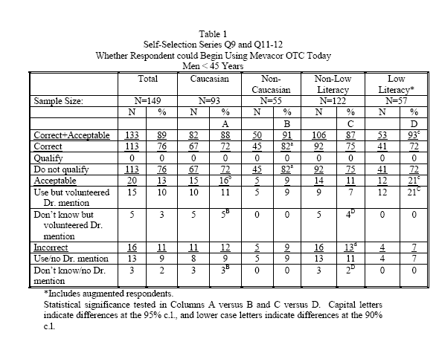
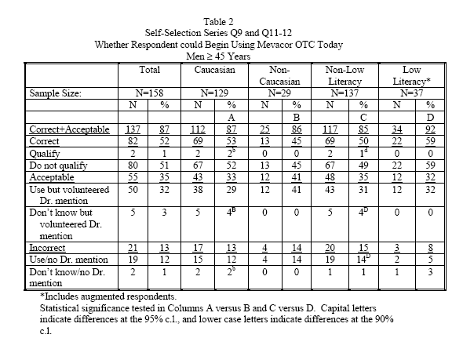

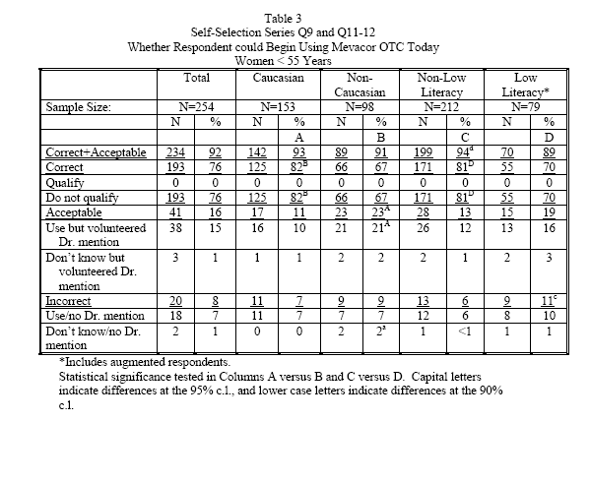

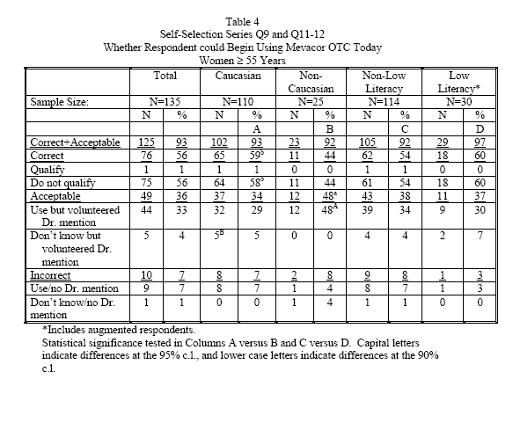

Comments:

Four hundred three male and female respondents were younger than the target age to take Mevacor OTC. Seventy-two to 82% of them made a correct self-selection decision based on age.
The total number of respondents in the target age range was 293. Forty-four-60% of them made a correct self-selection decision based on age

The fact that about half of the respondents in the appropriate age range did not understand that they could take this product may be the result of where the age information is located on the label. This could also be due to difficulties that an older population has in acquiring information on OTC labels, especially when the print is small as previously mentioned.¹

Self-section errors based on age for in the younger female population is of particular concern due to the Pregnancy Category X status of lovastatin.

¹ Wogalter, MS, & Vigilante, WJ. 2003. Effects of label format on knowledge acquisition and perceived readability by younger and older adults, Ergonomics, 46(4), 327-344.

The total number of respondents who stated they could use Mevacor OTC right away (Q10) was 209. The following table provides data on those who responded correctly when all self-selection categories were analyzed against the medical history questions (Q39-75)

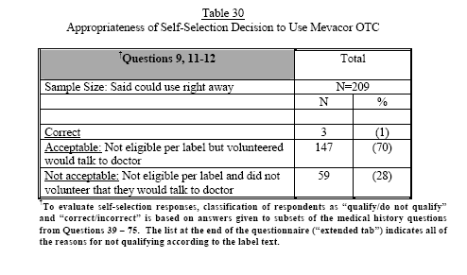

Comment:

This table reveals that only 1% of the respondents who stated that they could use Mevacor OTC right away self-selected correctly. It is concerning that the sponsor relies on “acceptable” answers, which involves talking to a doctor, as criteria for comprehension. This is not consistent with the concept of OTC self-selection. These “acceptable” answers push Mevacor OTC into a quasi prescription drug status.

The sponsor describes that the following table represents the 33 respondents who stated that the only reason for not being able to start taking Mevacor OTC “today” was because they did not know their cholesterol numbers (Q10). The respondents were then asked whether they could start using Mevacor OTC if their numbers were in the appropriate range (Q14). Table 13 provides the results of this analysis:
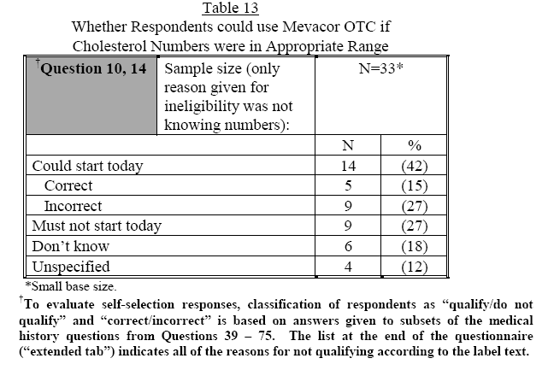
Comment:

Of the 14 (42%) respondents who said they could start using Mevacor OTC today if they knew that their cholesterol numbers were in the appropriate range, only 5 (15%) were correct based on their medical information. This suggests a poor ability of respondents to properly self-select based on the information on the label.

The following statement and table submitted by the sponsor describes the sponsor’s attempt to understand why respondents self-selected incorrectly:

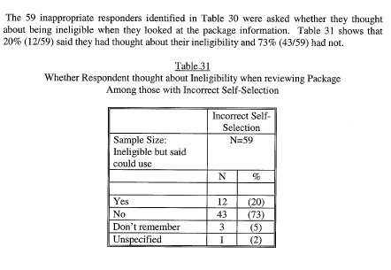
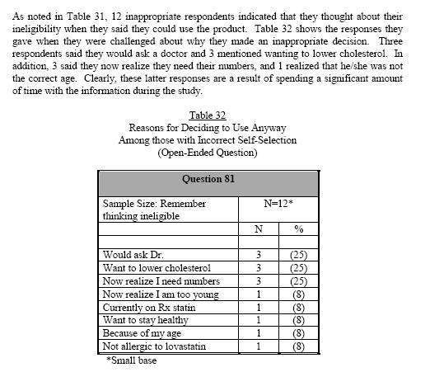

Comment:

It is difficult to make any comments based on these findings given the small sample size (12). It is unclear why the sponsor did not ask more respondents this question. According to Table 30. 59 respondents self-selected incorrectly and an additional 147 respondents gave the wrong answer but said they would check with a doctor. Questioning a larger sample size may have provided useful information.

Summary

Taking into account only “correct” responses, and not “acceptable” respondents demonstrated reasonable comprehension of the following communication objectives:

- Comprehension of what condition the product is to be used for
- Dosage information
- Active ingredient in the product
- Understanding that evening is the best time of day to take it
- Scenarios that address prerequisites for using the product, specifically diet, exercise, and appropriate time frame for testing cholesterol in order to decide whether or not to use the product
- Other medications (good comprehension for prescription medications; poor comprehension for non-prescription medications) that require consultation with a health care professional prior to product use or preclude use.
- Scenarios that address comprehension of the timing for follow-up cholesterol testing

Taking into account only “correct” responses and not “acceptable” responses, all respondents demonstrated lower comprehension of the following communication objectives:

- Determine how well respondents correctly respond to questions designed to try to measure self-selection. Ninety nine percent of all the respondents who reported that they could start Mevacor OTC right away, selected incorrectly.
- Other medical conditions that require consultation with a health care professional prior to product use or preclude use
- Scenarios that describe events that might occur during product usage that should indicate that they need to stop using the product and/or talk with a doctor
- Scenarios that describe combinations of age, gender, cholesterol levels, risk factors, and other factors that should alert respondents to talk to their doctors before using the product or to not use it at all
- Understanding that a person’s cholesterol level will go back up if someone stops using the product
- Scenarios that explore comprehension of the goal message

One percent of the respondents who stated they could use Mevacor OTC “right away” actually self-selected correctly for all communication objectives. Ninety-nine percent of all the respondents who reported that they could start Mevacor OTC right away, self-selected incorrectly because of an incorrect response for at least one communication objective.

Of final note, several of the tables supplied by the sponsor had incorrect number of respondents in some of the columns and incorrect percentage calculations; however, they were relatively insignificant and did not impact the outcome of this review.

