Video Script

- TITLE: Human Rights Violations PSA

- PREPARED FOR: HRV/PSA Awareness Campaign

- PRODUCER: Cheryl Bond-Nelms

- DRAFT: 13th

- DATE: 11/09/2007 – 12/04/2007 – 12/06/2007 – 12/19/07 – 01/03/2008 – 02/07/2008 – 02/11/2008 – 02/12/2008 – 2/13/2008 – 3/4/08 – 3/27/2008 - 4/2/2008 – 5/1/2008

NOTES: Copy shortened to fit the :30 requirement

HUMAN RIGHTS VIOLATIONS PSA – FINAL VERSION

KHMER ROUGE, CAMBODIA 1975 – 1979
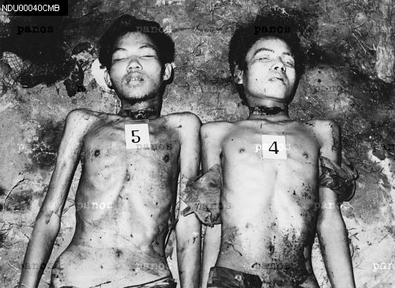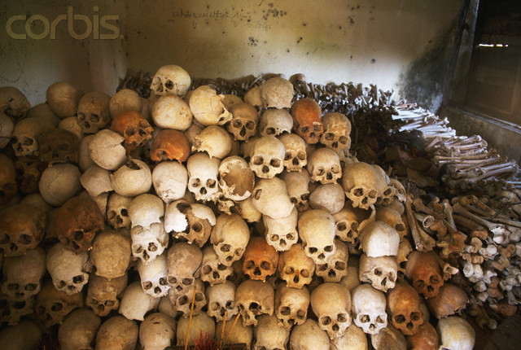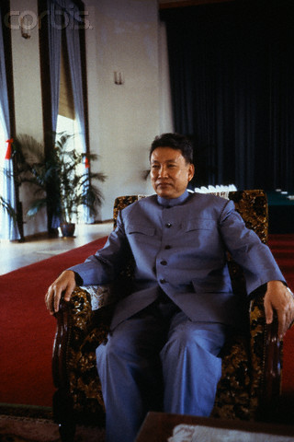
00032135 Cambodia Two Killed CR001405 Pro.corbis Cambodia Skulls 42-18827857 Cambodia Pol Pot Leader
Panos Pro.corbis

NARRATION: I AM SILENCED BY VIOLENCE … MURDERED IN MASS.

LIBERIA 1989 – 1999

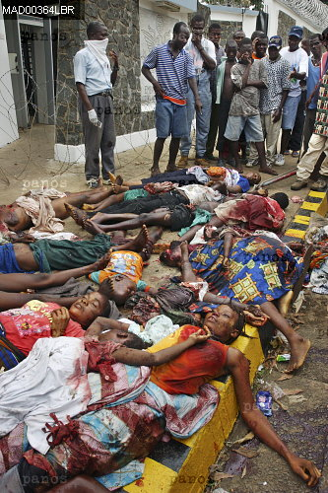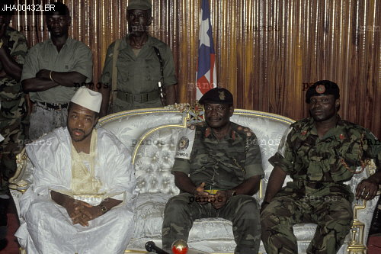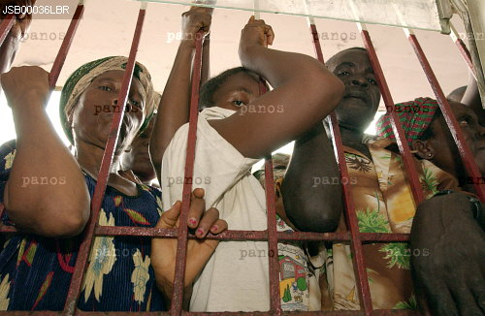
00018922 Liberia Street 00040025 Liberia Charles Taylor 00022154 Liberia Jailed People
Murders
Panos Panos Panos

NARRATION: THE INNOCENT VICTIM OF HUMAN RIGHTS VIOLATIONS.

BOSNIAN WAR 1992 – 1995

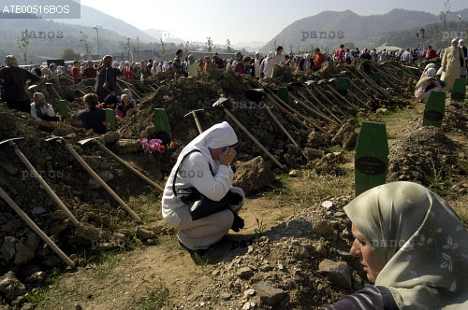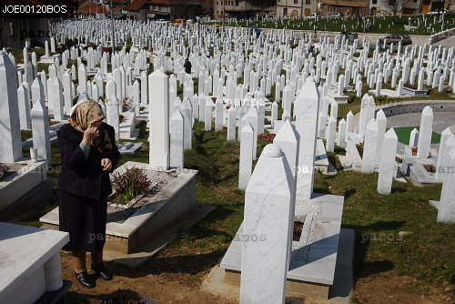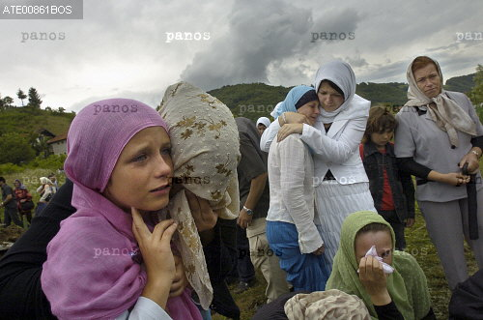
00020398 Bosnia Crying in Open 00033233 Bosnia Cemetry 00035689 Bosnia Women Mourners
Graves
Panos Panos Panos

NARRATION: EACH YEAR THOUSANDS OF PEOPLE SEEK SAFE HAVEN IN THE UNITED STATES …

DARFUR, SUDAN 2003 – PRESENT

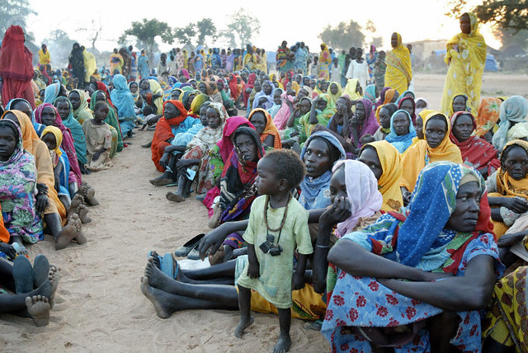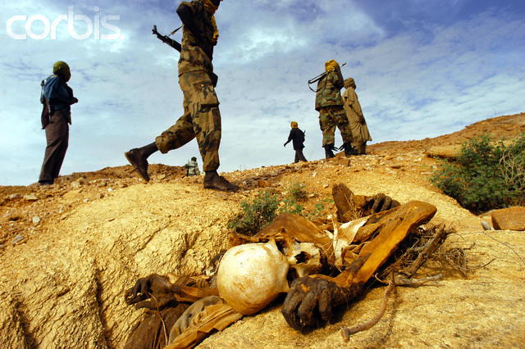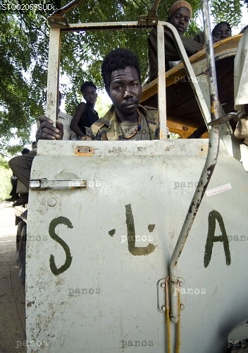
42-16016918 Pro.corbis Darfur Displaced DWF15-882836 Pro.corbis Darfur Solders/Dead Body 00053830 Darfur SLA People Panos

NARRATION: BUT THE U.S. WILL NOT SHELTER HUMAN RIGHTS VIOLATORS.

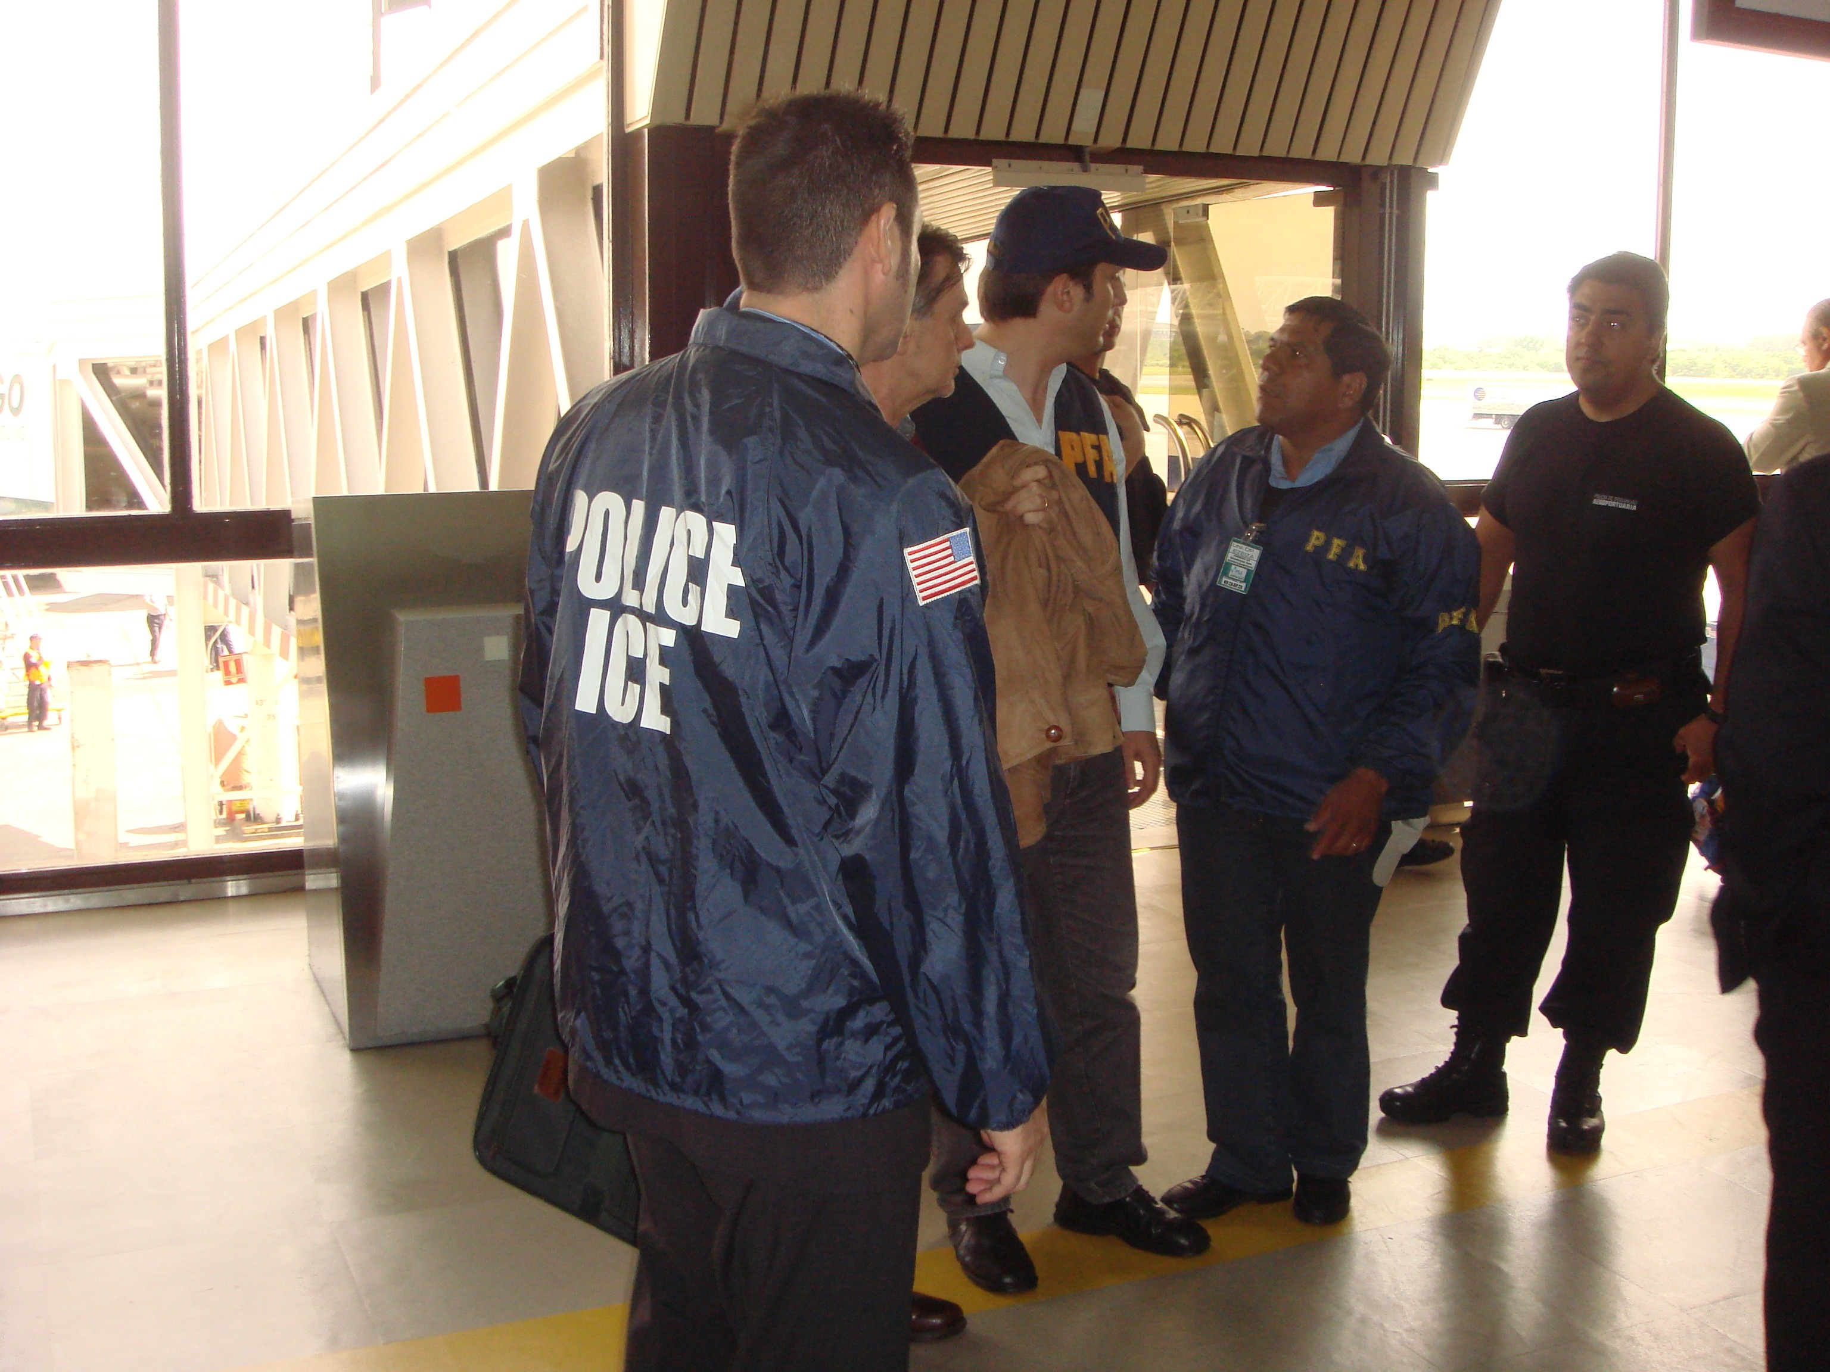

NARRATION: ICE INVESTIGATES AND SEEKS THE PROSECUTION AND REMOVAL OF HUMAN RIGHTS VIOLATORS FOUND IN THE U.S.

IMMIGRATION AND CUSTOMS ENFORCEMENT



NARRATION: IF YOU HAVE INFORMATION ON A PERSON WHO COMMITTED THESE CRIMES,
CALL THE ICE TIP LINE AND REPORT IT.
1-866-347-2423
YOU MAY REMAIN ANONYMOUS.

