Press Office
U.S. Department of Homeland Security
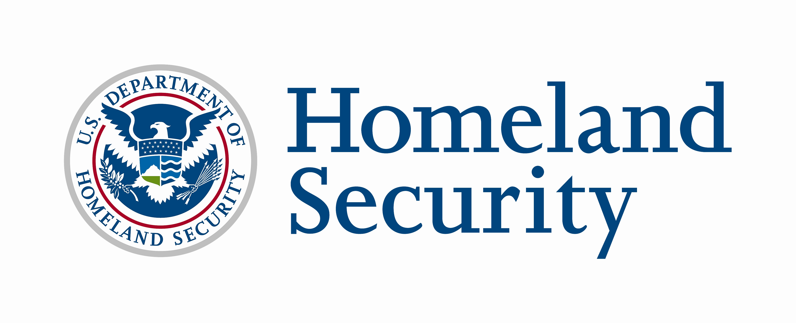
Fact Sheet

July 31, 2008
Contact: DHS Press Office, 202-282-8010

NATIONAL PREPAREDNESS MONTH 2008

National Preparedness Month (NPM) is sponsored by the U.S. Department of Homeland Security’s (DHS) Ready Campaign. NPM is held each September and is designed to encourage Americans to take simple steps to prepare for emergencies in their homes, businesses and communities.

- September 2008 is the fifth annual NPM. The month will focus on important preparedness steps including:
  - Get an Emergency Supply Kit
  - Make a Family Emergency Plan
  - Be Informed
  - Get Involved

- NPM Coalition membership is open to all public and private sector organizations. It is free to join with a commitment to spread the emergency preparedness message during the month of September. Groups can register to become a NPM Coalition Member by visiting ready.gov and clicking on the NPM banner.

- As of July 31, 2008, more than 2,100 organizations have signed up as NPM Coalition Members.

- In 2007, the Ready Campaign partnered with more than 1,800 organizations, including national, regional, state and local government organizations to highlight the importance of public emergency preparedness throughout September.

- During the month, Coalition Members share preparedness information with their members, customers, employees and communities. A few examples of the events that took place in 2007 include:
  - Be Ready Camp: In Alabama, the state’s Be Ready Alabama Campaign coordinated youth “Be Ready Camps” focused on building preparedness skills and a “Be Ready Sunday” for faith-based organizations across the state to deliver preparedness messages. In addition, there was also a statewide event called “Be Ready Day,” which educated and trained individuals on preparing for emergencies, volunteer opportunities in the communities and first responders’ preparedness and response capabilities.
  - Essay Contest: The Farmington Hills, Michigan Emergency Preparedness Commission held its inaugural Emergency Preparedness Essay Contest for fifth and eighth grade students. Essays focused on how families can take steps to prepare for emergencies and included tips for creating an emergency supply kit, taking shelter and becoming knowledgeable about first aid and severe weather conditions.
  - Celebrate Diversity National Neighborhood Day: Neighbors in the Los Angeles, CA West Adams Neighborhood Council area, including Vineyard Recreation Center, CLASS Parks and JBAC-LA Block Club hosted a "Celebrate Diversity National Neighborhood Day." More than 350 stakeholders enjoyed the Street Festival and Health Fair at Vineyard Recreation Center.
  - Business Preparedness Roundtable: In Ohio, Columbus' Mayor Michael Coleman hosted a business preparedness roundtable discussion. Approximately 15 businesses participated in the discussion, along with numerous representatives from state agencies who attended as observers to better understand how they can support businesses in preparing and recovering from a disaster.

- Ready is a national public service advertising campaign produced in partnership with The Advertising Council that is designed to educate and empower Americans to prepare for and respond to emergencies, including natural disasters and potential terrorist attacks.

- The Campaign’s Web sites (ready.gov and listo.gov) and toll-free numbers (1-800-BE-READY and 1-888-SE-LISTO) provide Americans with free emergency preparedness information.

- Citizen Corps brings together community, emergency and government leaders to involve community members in emergency preparedness, planning, mitigation, response and recovery. More than 2,200 state, local, tribal and territorial governments in all 56 states and U.S. territories have formed Citizen Corps Councils, and every day new Councils are formed in communities around the country. These Councils enable collaborative planning between government and civic leaders and provide localized support for: outreach and educational efforts to the public; training and exercises that effectively integrate emergency responders, volunteers with a response role, and the general public; and volunteer programs that augment the full range of emergency response services. For more information about Citizen Corps, visit citizencorps.gov.

