Form Approved: OMB No. 0910-0498; Expiration Date: 3/31/09
Department of Health and Human Services  Food and Drug Administration |  |  | SUPPLEMENTARY INFORMATION  NON-CLINICAL RESEARCH USE ONLY CERTIFICATE
1. Requestor Information
 | Name |  |  |  | Address
 | Firm
 | Telephone number | FAX number |  | Firm Tax ID code |  | Email address
2. Manufacturer Information
 | Firm |  |  |  | Address (P.O. Box not acceptable)
 | Registration number (if applicable)
3. List Product(s), Material(s), or Component(s) to be exported for non-clinical research use only.
4. List country(ies) for which the Certificates are requested.
5. Should the country destination be listed on the certificate? (Note: CDRH does not list a specific country on a certificate.)
Yes No Indicate the total number of certificates requested:
CBER instructions begin on page 3. |  |  |  |  | CDRH instructions begin on page 4.

Department of Health and Human Services  Food and Drug Administration | EXPORTER’S CERTIFICATION STATEMENT  “NON-CLINICAL RESEARCH USE ONLY CERTIFICATE”  for CBER
FIRM NAME

As the responsible official or designee of the company named above, I hereby certify to the United States Food and Drug Administration that these non-clinical research use product(s), material(s), or component(s) are to be used for non-clinical research use only. The product(s), material(s), or component(s) will not be used in the prevention, treatment, or diagnosis of human disease. These non-clinical research use only materials will be labeled in accordance with 21 CFR 809.10(c)(2)(i) or 21 CFR 312.160, as appropriate, and exported as they are presently being sold or offered for sale in the United States. I further certify that these non-clinical research use only materials will comply with the due diligence requirements in 21 CFR 312.160, where applicable.
SIGNATURE |  | DATE
NAME AND TITLE

Making or submitting false statements on any documents submitted to FDA may constitute violations of the United States Code Title 18, Chapter 47, Section 1001 with penalties including up to $250,000 in fines and up to 5 years imprisonment.

Department of Health and Human Services
Food and Drug Administration

EXPORT CERTIFICATION
Submission Requirements for Requesting Certificates for
Exporting Products to Foreign Countries (for CBER)

Background
Firms exporting products from the U.S. are often asked by foreign customers or foreign governments to supply a certification relating to products subject to the Federal Food, Drug, and Cosmetic Act and other acts the Food and Drug Administration (FDA) administers. Under the FDA Export Reform and Enhancement Act of 1996 (the Act), FDA is authorized to issue certificates for drugs, animal drugs, and devices within 20 days of receipt of a request for such a certificate. A fee of up to $175 may be charged for each certificate issued. In addition to issuing export certificates for approved or licensed products, the FDA will also issue export certificates for unapproved products that meet the requirements of Sections 801(e) or 802 of the Act.
General Instructions
• The “Certificate to Foreign Government” is for the export of products legally marketed in the United States. Certificate requests should include the information listed in Supplementary Information – Certificate to Foreign Government Requests (PDF, Text). Please ensure that the Exporter’s Certification Statement is signed by a responsible official of the exporting firm and is enclosed with the certificate request. Please ensure that the appropriate Exporter Certification Statements for Certificate to Foreign Government Requests for Human Cells, Tissues, and Cellular and Tissue-Based Products (procured prior to May 25, 2005, or on or after May 25, 2005) is signed by a responsible official of the exporting firm and is enclosed with the certificate request.
• The “Certificate of Exportability” is for the export of products not approved for marketing in the United States (unapproved products) that meet the requirements of Sections 801(e) or 802 of the Act. Certificate requests should include the information listed in Supplementary Information – Certificate of Exportability Requests (PDF, Text). Please ensure that the Exporter’s Certification Statement is signed by a responsible official of the exporting firm and is enclosed with the certificate request.
• The “Certificate of a Pharmaceutical Product” conforms to the format established by the World Health Organization (WHO) and is intended for use by the importing country when the product in question is under consideration for a product license that will authorize its importation and sale or for renewal, extension, amending or reviewing a license. WHO Certificate requests should include the information listed in Supplementary Information – Certificate of a Pharmaceutical Product Requests (PDF, Text). Please ensure that the Exporter’s Certification Statement is signed by a responsible official of the exporting firm and is enclosed with the certificate request.
• The “Non-clinical Research Use Only Certificate is for the export of a non-clinical research use only product, material, or component that is not intended for human use which may be marketed in, and legally exported from the United States under the Federal, Food, Drug and Cosmetic Act. Certificate requests should include the information listed in Supplementary Information – Non-clinical Research Use Only Certificate Requests (PDF, Text). Please ensure that the Exporter’s Certification Statement is signed by a responsible official of the exporting firm and is enclosed with the certificate request.
• Please type certificate requests or print clearly.
• In most cases, one product will be listed per certificate. However, products that were approved under the same PLA/BLA, NDA, PMA or 510(k) application or similar unapproved products may be listed on the same certificate based on the available space for a one page certificate. Certificate requests for listing multiple products will be evaluated on a case-by-case basis.
• If information is omitted in the application by the requester or if clarification is needed on the supplied information, the requester will be contacted via telephone or FAX. If the requester does not provide the necessary information within 48 hours, the request for certificates will be returned and will need to be resubmitted for FDA review.
• Questions may be directed to the Import/Export Team at 301-827-6201.
• Send the request and supporting documents to:
Food and Drug Administration
Center for Biologics Evaluation and Research
Office of Compliance and Biologics Quality
Division of Case Management
1401 Rockville Pike, Attention: HFM-624
Rockville, MD 20852-1448
or via FAX at 301-594-0940
• On October 1, 1996, CBER was given the authority to charge $175 for the first two certificates and $85 for any subsequent certificates issued for the same product(s) in response to the same certificate request. Please do not submit a check with your request, as FDA will bill you quarterly for issued certificates.
• You may enclose a completed FEDEX form to expedite the return of Certificates.
Issuance of a “Certificate to Foreign Government”, “Certificate of Exportability” or “Certificate of a Pharmaceutical Product” will not preclude regulatory action by FDA, if warranted, against products covered by the Certificate.
A “Certificate to Foreign Government”, “Certificate of Exportability” or “Certificate of a Pharmaceutical Product” is issued by FDA solely for export purposes and may not be used for domestic advertising.

Department of Health and Human Services
Food and Drug Administration
INSTRUCTIONS FOR REQUESTS FOR
NON-CLINICAL RESEARCH USE ONLY CERTIFICATE
(for CDRH)
1. Complete the “Exporter’s Certification Statement” and the “Supplementary Information Sheet.” Please ensure that you sign the Exporter’s Certification Statement on your firm’s letterhead.  2. Using the attached example (Attachment I), prepare on plain white 8 ½” x 11” bond paper, the Non-Clinical Research Use Only Certificate (print margin one inch, top margin two inches, 44 lines per page). You may also submit this information on a CD or disk using Microsoft Word or compatible software.  3. If more than three products/materials to be included on the Certificate, provide a typed list of products/materials (please provide complete products/materials description as it appears on the labeling) on consecutively numbered 8 ½” x 11” sheets of paper (Attachment J). Do not submit catalogs or catalog pages.  4. Each request is limited to a total of 100 pages, including the Certificate. If your need exceeds the 100 page limit, you must request additional certificates. For example, if you request a certificate with 9 attachment pages (for a total of 10 pages), you may request up to 1 original and 9 subsequent certificates.  5. Enclose a self-addressed stamped envelope or FEDEX envelope large enough to accommodate the requested Certificate(s).  6. Send the request and supporting documents to:  Food and Drug Administration  Center for Devices and Radiological Health  Office of Compliance  Attention: HFZ-307  9200 Corporate Boulevard  Rockville, MD 20850 | 7. Clearly mark on the outside of the envelope containing the request as a “Request for Certificates.” If you have any questions, please call 240 276-0132 or email exportcert@cdrh.fda.gov.  8. CDRH has the authority to charge $175 for the first certificate and $15 for any subsequent certificates issued for the same product(s) in response to the same request. Please do not submit a check with your request, as FDA bill quarterly.  9. If information is omitted in the application by the requester or if clarification is needed on the supplied information, the requester will be contacted via email, telephone, or FAX. If the requester does not provide the necessary information within 48 hours, the request for certificates will be returned and will need to be resubmitted for FDA review.  10. Issuance of a “Certificate to Foreign Government” or “Certificate of Exportability” will not preclude regulatory action by FDA, if warranted, against products covered by the Certificate.  11. A “Certificate to Foreign Government” or “Certificate of Exportability” is issued by FDA solely for export purposes and may not be used for domestic advertising.

instructions for Requests of Non-clinical Research Use Only Certificates (for CDRH) (Continued)
ATTACHMENT I

E X A M P L E
Certificate No.
NON-CLINICAL USE RESEARCH ONLY CERTIFICATE
In order to allow the importation of United States products into foreign countries, the U.S. Food and Drug
Administration (FDA) certifies the following information concerning the product(s), materials(s), or component(s) to be exported listed below:
NAME OF PRODUCT(S)/MATERIAL(S) NAME OF MANUFACTURER, ADDRESS
(GENERIC NAME IF APPLICABLE)
The product(s), material(s), or component(s) described above and the plant(s) where it is produced are subject to the jurisdiction of the FDA under the Federal, Drug, and Cosmetic Act (FD&C Act). FDA does not routinely inspect non-clinical research use product(s), material(s), or component(s), since these products are not subject to current good manufacturing practice requirements.
FDA does certify that the above product(s), material(s), or component(s) may be marketed in, and legally exported from, the United States of America at this time.
Regulatory Policy and Systems Branch
Office of Compliance
Center for Devices and Radiological Health
This certificate expires 24 months
from the date notarized.
COUNTY OF MONTGOMERY
STATE OF MARYLAND
Subscribed and sworn to before me this day of month year.

Signature
instructions for Requests of Non-clinical Research Use Only Certificates (for CDRH) (Continued)
ATTACHMENT J

EXAMPLE OF ATTACHMENT PAGE(S)
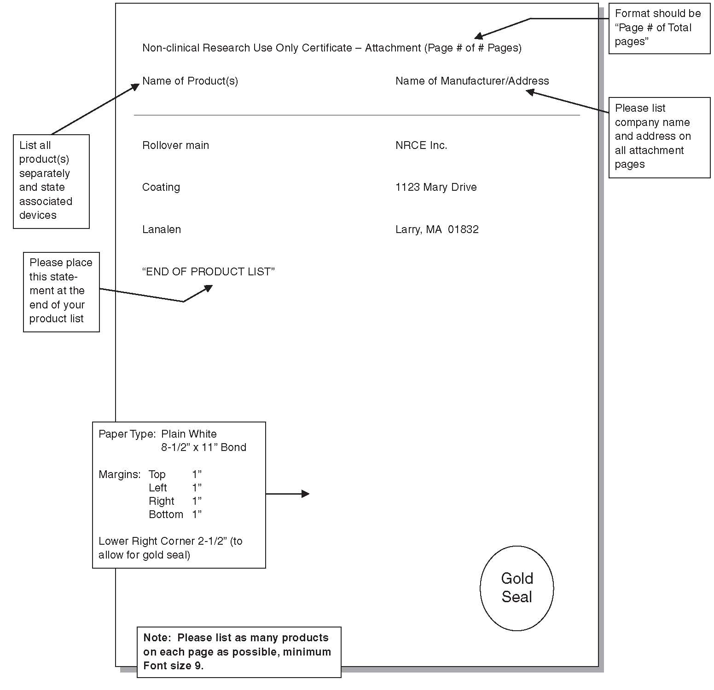

Paperwork Reduction Act Statement
Public reporting burden for this collection of information is estimated to average 1 hour per response, including the time for reviewing instructions, searching existing data sources, gathering and maintaining the data needed, and completing and reviewing the collection of information. Send comments regarding this burden estimate or any other aspect of this collection of information, including suggestions for reducing this burden, to the applicable address below.

Food and Drug Administration  Center for Biologics Evaluation  and Research  1401 Rockville Pike  Rockville, MD 20857 | Food and Drug Administration  Center for Devices and  Radiological Health  9200 Corporate Boulevard  Rockville, MD 20850
An agency may not conduct or sponsor, and a person is not required to respond to, a collection of information unless it displays a currently valid OMB control number.

