Harpers Ferry NHP News Release

Harpers Ferry National Historical Park
P.O. Box 65
Harpers Ferry, WV

304-535-6748 phone
304-535-6244 fax
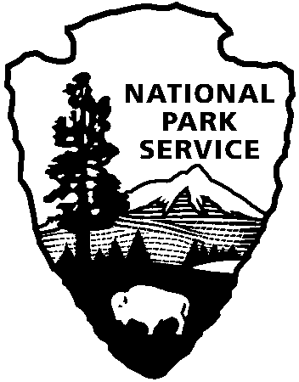
National Park Service
U.S. Department of the Interior

Release date:
Contact(s):
Phone number:
Date:
Release code:
Summer Jobs for Youth with the Youth Conservation Corps

Harpers Ferry National Historical Park’s Youth Conservation Corps (YCC) is looking for energetic 15 through 18 year old male and female students of all social, economic, ethnic and racial backgrounds to enjoy a summer working in the park.

Maintenance and interpretation positions are available for work in this 8-week program from June 24 through August 18. Actual work schedules, of 7 ½ hour to 8 hour work
days, will vary according to job assignment. Salary is $5.15 per hour.

Positions available include:

Maintenance/Grounds, Roads and Trails: Monday-Friday 7 a.m. to 3 p.m.
Students will work with maintenance staff on several manual labor projects using simple hand tools. Projects may include: vegetation removal, wayside installation, worm fence construction, and trail improvements.

Interpretation/Living History: Wednesday-Sunday 9 a.m. to 6 p.m.
Students wear 19th century costumes and work directly with the living history staff in park exhibits and programs telling visitors about the park’s history.

Interpretation/Education: Monday-Friday 8:30 a.m. to 5:00 p.m.
Students assist in the preparation, development and delivery of education programs to students who visit the park.

Interpretation/Visitor Services: Wednesday-Sunday 8:00 a.m. to 5:00 p.m.
Students assist the Visitor Services staff with information and orientation for visitors, answering telephones, handling book sales and providing written information and handouts as requested.

To quality, each student must be a U.S. citizen, have a social security card and have no history of serious criminal or anti-social behavior. He/she must have transportation and be able to work the assigned schedule for the program in which he/she is interested. Each student must also be able to work at least 7 of the 8 weeks.

Applications are due April 20, 2007 and are available on the web at http://www.nps.gov/hafe/parknews/ycc-summer-employment.htm or by calling Harpers Ferry NHP 304-535-6230. Applications are to be mailed to: Harpers Ferry NHP, Attn: YCC Coordinator, P.O. Box 65, Harpers Ferry, WV 25425

Immediately
Marsha B. Wassel
304-535-6748
April 9, 2007
xx-xx
Subject here

