Harpers Ferry NHP News Release

Harpers Ferry National Historical Park
P.O. Box 65
Harpers Ferry, WV

304-535-6748 phone
304-535-6244 fax
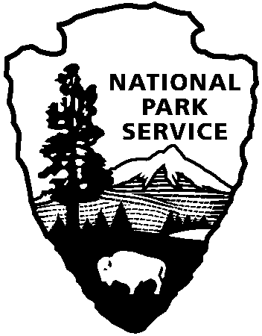
National Park Service
U.S. Department of the Interior

Release date:
Contact(s):
Phone number:
Date:
Release code:
I Will Follow Them To the Death: Sheridan’s Soldiers 1864

On Saturday and Sunday, August 4-5, 2007, Harpers Ferry National Historical Park will present I Will Follow Them To the Death: Sheridan’s Soldiers 1864. This living history program with the 11th New Jersey military living history group will demonstrate Union army garrison duties such as guard mount parade; searching and arresting spies, deserters, and traitors; processing prisoners of war; searching citizens; and maintaining military security in a occupied enemy town. Costumed volunteers and staff will interpret civilian life under harsh military rule.

Harpers Ferry, important militarily, suffered constant occupation and action throughout the American Civil War. In August of 1864, Harpers Ferry became the launching point for Union General Philip Sheridan's Shenandoah Valley Campaign, whose primary object was to seek and destroy Confederate forces under the command of Confederate General Jubal Early. A secondary objective was to destroy the food supplies in the Shenandoah Valley that provided sustenance to the Army of Northern Virginia. Harpers Ferry served as both a base of operations and supply center during this campaign. Sheridan successfully completed both objectives. His work was so thorough that one soldier remarked, “a crow would be well advised to take its own provisions if it intended to fly across the valley.”

Special programming and exhibits will be open to the public from 12:00 noon to 4:00 p.m. on Saturday, and from 12:00 noon to 4:00 p.m. on Sunday. For further details, call the Information Center at 304-535-6029.

Immediately
Marsha B. Wassel
304-535-6748
July 27, 2007
xx-xx
Subject here

