Harpers Ferry NHP News Release

Harpers Ferry National Historical Park
P.O. Box 65
Harpers Ferry, WV

304-535-6748 phone
304-535-6244 fax
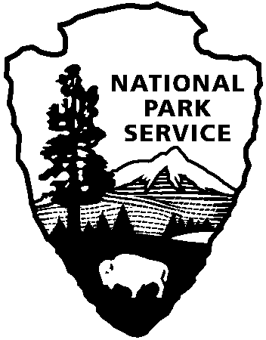
National Park Service
U.S. Department of the Interior

Release date:
Contact(s):
Phone number:
Date:
Release code:
John Brown: Beyond the Gallows
In October 1859, John Brown, the fiery abolitionist, raided the Harpers Ferry Armory. Although the raid failed, it polarized the nation on the question of slavery. Now, both sides, pro and anti slavery, were willing to resort to violence. Compromise between these factions became impossible, resulting in an “irrepressible conflict.”

On October 7, 2006, Harpers Ferry National Historical Park will present “John Brown: Beyond the Gallows.” Focusing on the time from the capture of Brown on October 18, 1859 to his execution on December 2, 1859, the program presents Harpers Ferry as a town under martial law, living in fear of other attacks or slave insurrection. Military and civilian living history volunteers and park staff will portray the many reactions of the town’s citizens.

Brown was 59 years old when he led his “Provisional Army” of 16 whites and 5 blacks, at Harpers Ferry. His plan was to seize the guns from the United States Armory and Arsenal and execute raids throughout the slave-holding south, forcing an end to slavery.

The night of October 16, 1859, Brown and 19 of his men crept into town; took control of the armory, arsenal and U.S. Rifle Works; and rounded up several hostages. On October 17, Brown and his men battled townspeople and local militia companies before they were finally forced to take refuge in the armory’s fire engine house, today known as John Brown’s Fort. On the morning of October 18, Colonel Robert E. Lee, in immediate command of a detachment of U.S. Marines, ordered Lt. J.E.B. Stuart to the door of the engine house, offering one last chance to surrender. Brown refused. Twelve Marines stormed the building, captured Brown and the remaining raiders, and freed the hostages. Brown’s raid ended thirty-six hours after it had begun.

Taken to the jail and courthouse in nearby Charles Town, he was charged with murder, conspiracy to lead a slave rebellion, and treason. Found guilty on all three charges, Brown was sentenced to be hanged on December 2, 1859.

The story of John Brown’s Raid and the nationally significant response to it is an essential part of American history. It hastened the Civil War and the emancipation of African Americans. We still live with the legacy of John Brown’s Raid today. His raid failed, but Brown succeeded in focusing the nation’s attention on the issue of slavery.

For additional information, please call the park Visitor Center at 304-535-6029.

- - M O R E - -
Immediately
Marsha B. Wassel
304-535-6748
September 29, 2006
xx-xx
Subject here

Schedule of Events

12:00 Our Fallen Heroes Join this tribute to the Mayor and the first townsperson killed.

12:30-1:00 Defenders of Hearth and Home Join this state and local militia military drill as they prepare to respond to future attacks.
1:00-2:00 At All Times Ready Discover how the U.S. Marines captured John Brown.

1:00-3:00 Reacting to the Raid Join a family and children’s program investigating the reaction to the raid by news correspondents.

2:00-3:00 John Brown’s Guilty Land Join this ranger-guided tour.

3:00-4:00 Darling Nelly Grey Listen to a mid-century musical chronicle of freedom, struggles, and our American ancestry by the Indiana Brass Band.

4:00-4:30 At All Times Ready Discover how the U.S. Marines captured John Brown.

7:00-8:00 John Brown: Beyond the Gallows Join this lantern-lit walking tour that includes first person scenes of reaction to Brown’s Raid and the future of Civil War.

