U.S. Department  of Transportation  Federal Aviation  Administration | Advisory  Circular

Subject: AIRCRAFT ARRESTING SYSTEMS ON CIVIL AIRPORTS | Date: 12/20/2006  Initiated by: AAS-300 | AC No: 150/5220-9A  Change:

PURPOSE. This Advisory Circular (AC) contains the Federal Aviation Administration (FAA) standards and recommendations for the installations of aircraft arresting systems on civil airports not owned or operated by the U.S. Department of Defense (DOD).

CANCELLATION. This AC cancels AC 150/5220-9, Aircraft Arresting Systems for Joint Civil/Military Operations, dated April 6, 1970.

APPLICABILITY. FAA recommends the information contained in this AC be used on civil airports. For federally obligated civil airports, the standards and recommendations contained in this AC are mandatory. For certificated airports, the standards and recommendations in this AC satisfy the requirements of Title 14, Code of Federal Regulations (CFR), Part 139, Certification of Airports. This AC does not describe Engineered Materials Arresting Systems (EMAS). For guidance on EMAS, see AC 150/5220-22, Engineered Materials Arresting Systems (EMAS) for Aircraft Overruns.

- PURPOSE OF AIRCRAFT ARRESTING SYSTEMS. The military installs and maintains aircraft arresting systems when certain military operations are authorized at civil airports. Aircraft arresting systems serve primarily to save lives by preventing aircraft from overrunning runways in cases where the pilot is unable to stop the aircraft during landing or aborted takeoff operations. They also serve to save aircraft and prevent major damage.

INSTALLATION OF ARRESTING SYSTEMS.
- Aircraft arresting systems must be installed according to the latest official criteria of the military aircraft operational need. In most cases, the criteria can be found in Air Force Instruction (AFI) 32-1043, Managing, Operating, and Maintaining Aircraft Arresting Systems.
b. Airport management may request an FAA determination on the effect the location and use of the arresting system will have on the operation of navigation aids serving the airport. At the request of airport management, the military will submit plans in sufficient detail to the appropriate FAA Airports Regional or Airports District Office for review.
c. FAA must find, prior to the installation of the arresting system, the location and use of the system will have no adverse effect on the safe operation of the airport and the navigation aids serving the airport. In addition, the FAA determination must state that the criteria in this AC and AC 150/5300-13, Airport Design, are satisfied to the extent practicable. FAA will provide its determination to both the military and airport management.
d. Airport management must provide written permission to the DOD service component or major command headquarters to install the aircraft arresting system at the agreed-upon location.
e. Inspection, general maintenance, certification, and operation of the aircraft arresting system must be detailed in a Letter of Agreement (LOA) between the military proponent and airport management. The LOA should also include provisions to change/upgrade the system based on any change to the military mission or operating requirements. In addition, the LOA should outline any requirements for decommissioning and removing the system, including restoration of the area to current runway safety area standards. There is no specified format for this LOA between the military and airport management. At Part 139-certificated airports, this LOA must be included in the Airport Certification Manual (ACM).

GENERAL INFORMATION.
- The location of the aircraft arresting system on a civil airport is considered fixed by its function. To the extent practicable, the frangibility requirements found in Part 139 must be satisfied. In situations where some components of the aircraft arresting system cannot satisfy frangibility requirements, the safe and proper operation of these components, and only these components, will take precedence over the frangibility requirements. When the arresting system is installed according to U.S. Military criteria, it will not be viewed as a violation of Part 139.

- The airport design criteria found in AC 150/5300-13 should be followed to the extent practicable. Grading and site layout criteria in the immediate area of the arresting system will follow the guidance in AFI 32-1043. For example, a 1-vertical to 30-horizontal ground gradient can be used for the backfill area around the fairlead beam of a BAK-12 Aircraft Arresting System, as described in AFI 32-1043.

- PERMANENT INSTALLATIONS. Permanently installed arresting systems should only be allowed when there is a valid military requirement (normally based on the type of military aircraft assigned at the airport). This requirement should be documented in an LOA between the DOD service component or major command headquarters and the airport owner. At a Part 139-certificated airport, the LOA must be included in the ACM. When the arresting system is no longer needed at an airport, it should be removed, and the runway safety area should be restored to the current FAA airport design standards.

TEMPORARY ARRESTING GEAR INSTALLATION.
- IN A RUNWAY SAFETY AREA (RSA). The threshold needs to be moved or relocated to provide the required safety area between the arresting gear and the threshold if the runway is to remain open to civil aircraft for the amount of time the temporary installation is in place. During this period, the new threshold will need to be marked and lighted in the following manner:
    - Mark the threshold bar with a painted white bar in the grass on each side of the new or relocated threshold. (This can be made from plywood sheets or equivalent materials on each side of the runway to provide an 8-foot by 24-foot threshold bar to satisfy this requirement.)
    - Install yellow painted chevron(s) before the threshold bars on each side of the runway. (This can be made from plywood sheets or equivalent materials. Each chevron can consist of three 4-foot by 8-foot sheets of plywood with one sheet cut diagonally in half to form the point of the chevron. The chevrons will also need to be securely anchored to the ground. Anchoring can be done with spikes.)
    - Cover the Runway Distance Remaining Signs (DRSs) for the opposite direction from the relocated threshold.
    - Place any Precision Approach Path Indicators (PAPIs), Visual Approach Slope Indicators (VASIs), Runway End Identification Lights (REILs), or approach lights systems for the relocated runway threshold end out of service.
    - If night operations will be conducted on the runway, install threshold/runway end lights at the relocated threshold.
    - Adjust the yellow caution zone runway edge lights for the opposite direction to accommodate the new threshold (if applicable).
    - Place runway centerline lights for the opposite direction out of service.

    - Cover or place out of service the runway edge lights and threshold/runway edge lights in the relocated area. If the relocated area will be used for taxiing operations at night, taxiway reflectors will need to be installed.
    - Airport management should coordinate with the FAA offices (Air Traffic, Flight Standards, and Airports District Office) to determine the effect the temporary arresting equipment will have on civil aircraft operations.

EXCEPTION. The runway threshold does not need to be relocated if a Mobile Aircraft Arresting System (MAAS or a BAK-12) is installed in accordance with the following:
(1) The fairlead beam installation is used, and the MAAS energy absorbers are located outside the RSA.
(2) To the extent practicable, all arresting system components within the RSA are below grade and covered, and the deck sheaves are covered, ramped, and compacted to a 30 to1 (horizontal to vertical) ratio. Nothing in this subparagraph is intended to compromise the safe use or proper maintenance of any arresting system component located in the RSA.
(3) The aircraft arresting cable is removed when not required for military operations.

9. NOTICE REQUIREMENT FOR ALL INSTALLATIONS. Airports where aircraft arresting systems are installed should include the type, number, and location of arresting system(s) in the Airport Data System [Airport/Facility Directory (A/FD) or Flight Information Publications through the FAA Form 5010-1, Airport Master Record, and/or Notice to Airmen (NOTAM) systems].

10. RUNWAY PAVEMENT MARKING. The location of a permanent aircraft arresting system that crosses operational runway pavement will be identified by a series of reflective circles 10 feet (3.05 meters) in diameter and painted solid yellow (striated marking will not be allowed) on the runway. The circles will be 15 feet (4.57 meters) apart on centers and extend the full width of the runway. The middle two circles will straddle the runway centerline. See Figure 1. When interference occurs with any runway markings, except for runway designation markings, the runway markings may be interrupted with a clearance of 1 foot (0.30 meters) to the edge of the discs. If possible, the aircraft arresting system should be located to avoid any runway marking interference. All other runway markings are to be in compliance with AC 150/5340-1, Standards for Airport Markings.
Figure 1. Arresting System Runway Pavement Marking.

11. ARRESTING SYSTEM SIGNAGE.

Figure 2. Arresting Gear Marker (AGM). AGMs have characteristics of Runway Distance Remaining Signs but with a yellow circle 39 inches (1 meter) in diameter on a black background.
- Purpose. Arresting Gear Markers (AGMs) identify arresting gear pendant cables or systems on the operational runway surface. See Figure 2.

- Installation. Arresting pendant cables must be identified by AGMs on both sides of the runway. The AGMs are located in line with the pendant cable +/-10 feet (3 meters) and equidistant from the runway edge. Where Distance Remaining Signs (DRSs) (Figure 3) are installed along a runway, locate the AGMs in line with the DRSs, except where the pendant cable is within 20 feet (6 meters) of a DRS. In this case, relocate the AGM 5 feet (1.5 meters) outboard of the DRS. The distance indicated is to the inside edge of the marker. If the arresting gear is in the stopway or runway safety area, signs are not allowed but obstruction lights are required. (This is a common requirement for the BAK-15.) Markers are oriented perpendicular to the runway centerline. Typical installation of an AGM is shown in Figure 4.
- Message. The AGM has a yellow translucent circle approximately 39 inches (1 meter) in diameter facing both runway directions.
- Dimensions. The AGMs are double faced, internally lighted, with retroreflective message faces that meet the color and reflectivity requirements of ASTM D 4956, Type I Sheeting. AGMs are similar to Size 4 Runway Distance Remaining Signs, as described in AC 150/5345-44, Specifications for Runway and Taxiway Signs. Additionally, the AGM should meet the wind-load and frangibility requirements of an L-858B sign. The spacing, stroke, and shape of legend characters, numerals, and symbols must be in accordance with Appendix 1 of AC 150/5345-44. A Size 4 sign has a marker panel height of 48 inches (1220 millimeters) and overall mounting height of 54 to 60 inches (1370 to 1520 millimeters). As with the DRS, the AGM should provide at least 12 inches (30 centimeters) of clearance between the top of the sign and any part of the most critical aircraft expected to use the runway when the aircraft wheels are at the pavement edge.

Figure 3. Runway Distance Remaining Sign (DRS). A DRS is Type L-858B, with a white legend on a black background and conforming to AC 150/5345-44, Size 4, Style 2 or 3.
- Electrical. The AGM installation must be compatible with the existing airfield electrical system. The AGMs should be powered from the same source and circuit as DRSs.

12. REFERENCES. Please refer to the current versions of the following documents. FAA ACs are available at http://www.faa.gov/airports_airtraffic/airports/resources/advisory_circulars/. Air Force Instructions are available at http://www.e-publishing.af.mil/.
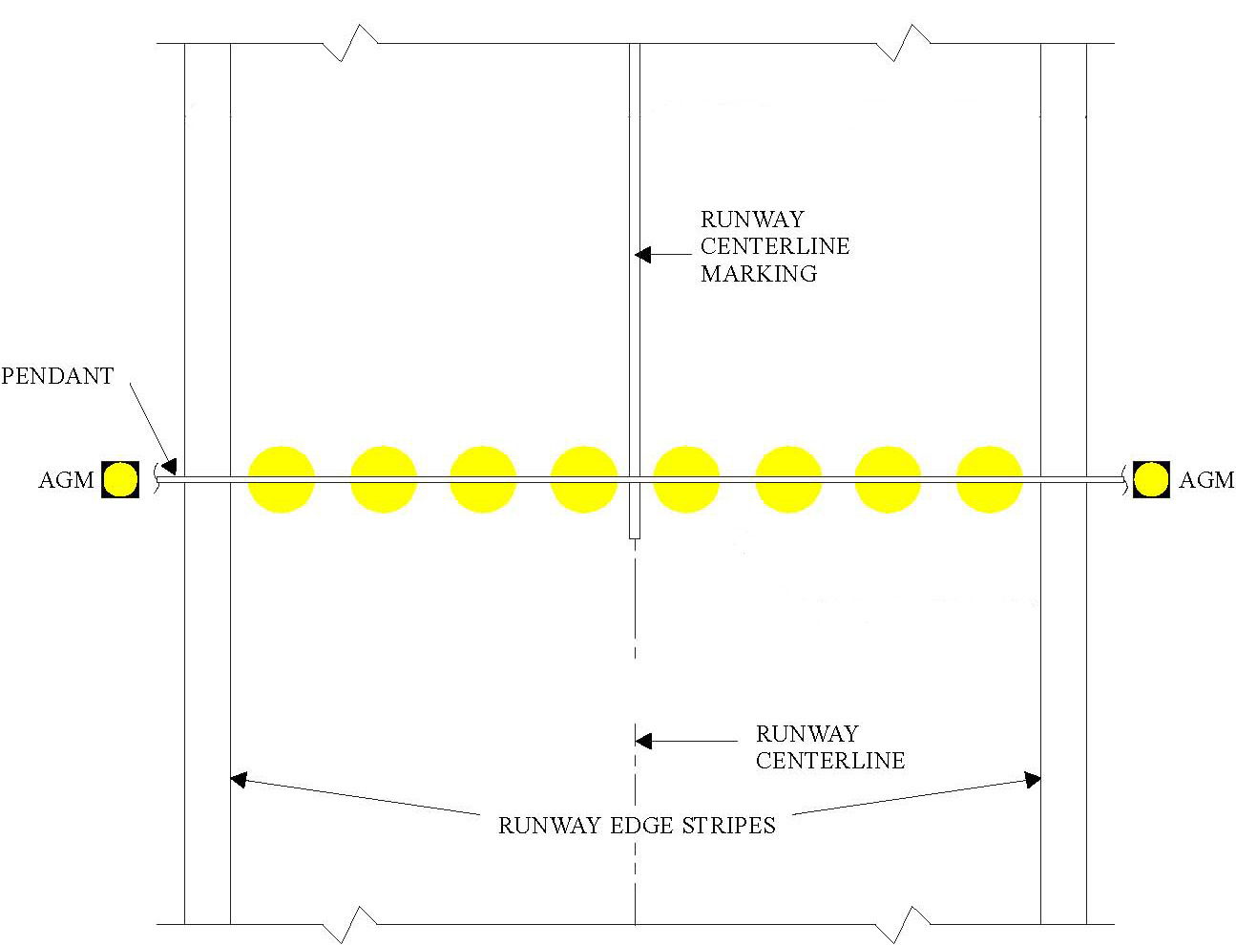
Figure 4. Arresting Gear Marker (AGM) Configuration. Install the AGM the same distance from the runway centerline as the DRSs. If a DRS is within 20 feet (6 meters) of an AGM, install the AGM an additional 5 feet (1.5 meters) outbound from the runway centerline. (Refer to Paragraph 11b.)
- Title 14, Code of Federal Regulations (CFR), Part 139, Certification of Airports (http://ecfr.gpoaccess.gov/).
- Air Force Instruction 32-1043, Managing, Operating, and Maintaining Aircraft Arresting Systems.
- Advisory Circular 150/5300-13, Airport Design.
- Advisory Circular 150/5340-1, Standards for Airport Markings.
- Advisory Circular 150/5340-18, Standards for Airport Sign Systems.
- Advisory Circular 150/5345-44, Specification for Taxiway and Runway Signs.



David L. Bennett
Director, Airport Safety and Standards

This page intentionally left blank.

APPENDIX 1. TYPES OF AIRCRAFT ARRESTING SYSTEMS
This Appendix is provided for informational purposes only.
(Refer to AFI 32-1043, Attachment 2, for additional detailed information.)

1. General Information. Aircraft arresting systems consist of engaging devices and energy absorbers. Engaging devices are net systems, such as BAK-15; disc-supported pendants (hook cables); and cable support systems, such as BAK-14 and the Type H, that raise the pendant to the battery position or retract it below the runway surface. Energy absorbing devices are ships’ anchor chains, rotary friction brakes (such as BAK-12), or rotary hydraulic systems.

2. E-5 Hook Cable Arresting System. This unidirectional emergency arresting system is a U.S. Navy design and designation (Figure A1-1). This system uses several shots of ships’ anchor chain as the energy absorber, but these systems are never connected with a barrier (net). For the Navy or Marine Corps, these systems can have from 1 to 4 disc-supported hook cables, with designations of E-5 and E-5 Mod 1 through E-5 Mod 3. Obtain further technical information on the Navy configuration of this system from the Naval Air Warfare Center, Lakehurst, NJ. The location of the E-5 system can be either on the runway or on the blast pad depending on mission requirements.
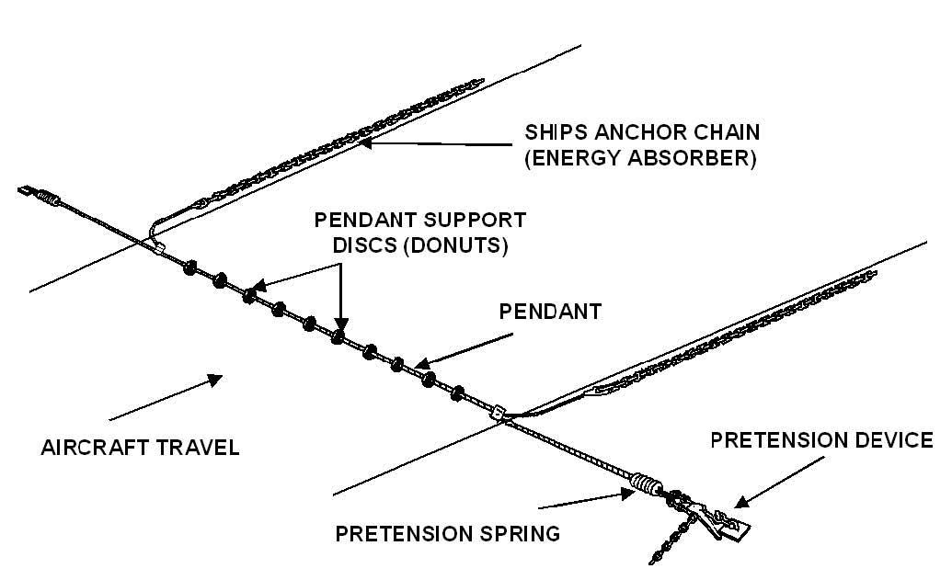
Figure A1-1. E-5 Hook Cable Arresting System.

3. BAK-12. The BAK-12 (Figure A1-2) is the standard USAF operational aircraft arresting system. This bidirectional system employs two energy absorbers. Each absorber consists of two multi-disc rotary friction brakes mounted on either side of the purchase-tape reel on a common shaft. The energy absorbers are located on opposite sides of the runway, connected to a 1.25-inch (32-millimeter) disc-supported pendant by the purchase tape. Ideally, the energy absorbers should be in a below-grade pit with a minimum split distance of 50 feet (15.24 meters). (Split distance is a measurement taken between the lead-on sheave of the fairlead beam or deck sheave and the energy absorber.) Split distances of up to 300 feet (91 meters) are acceptable for all BAK-12 installations.
- Originally, BAK-12 energy absorbers were fitted with a 60-inch purchase-tape storage reel. This design allowed the maximum energy expected to be imparted during an aircraft engagement to dissipate within a runout of 950 feet (290 meters) plus the length of the aircraft. Designers have since improved the BAK-12 to meet the demands of heavier and faster aircraft
- The standard BAK-12 is configured for cross-runway separations of up to 200 feet (61 meters) (distance between fairlead beams or deck sheaves). Dual BAK-12 systems are special-purpose installations configured to accommodate high-energy engagements of aircraft ranging from 60,000 to 140,000 pounds (27,200 to 63,500 kilograms). These configurations consist of four BAK-12 energy absorbers arranged in pairs on either side of the runway.
- A BAK-12 can be located anywhere on the runway or in the safety area depending upon the military mission requirements.
4. Cable Support Systems.
a. The BAK-14 hook cable support system (Figure A1-3) is a bidirectional hook cable (pendant) support system used in conjunction with the BAK-12, or a comparable arresting system to engage and safely stop a hook-equipped aircraft. It provides the means to support the pendant at least 2 inches above the runway surface while giving air traffic control (ATC) the means to lower the pendant below the surface of the runway to prevent damage to low-undercarriage aircraft, the pendant, and the pavement below the pendant during trampling. These systems can accommodate runway widths of 150, 200, and 300 feet (46, 60, and 90 meters). The control side BAK-12 pit or protective shelter and foundation must be expanded to house the compressed air and control systems needed to operate this supplemental system.
b. The Type H hook cable support system (Figure A1-4) is a bidirectional hook cable support system that can be used in conjunction with any type of energy-absorbing device. It provides a means to raise a cable at least 2 inches above a runway surface or lower it below the runway surface in less than 1.5 seconds. It can be supplied to accommodate runway widths of 150, 200, and 300 feet (46, 60, and 90 meters). A radio remote control system provides ATC the means to operate the system and to monitor its operational status.

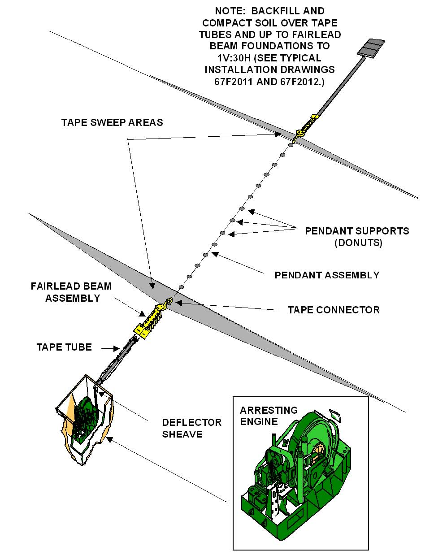

Figure A1-2. BAK-12 Aircraft Arresting System.

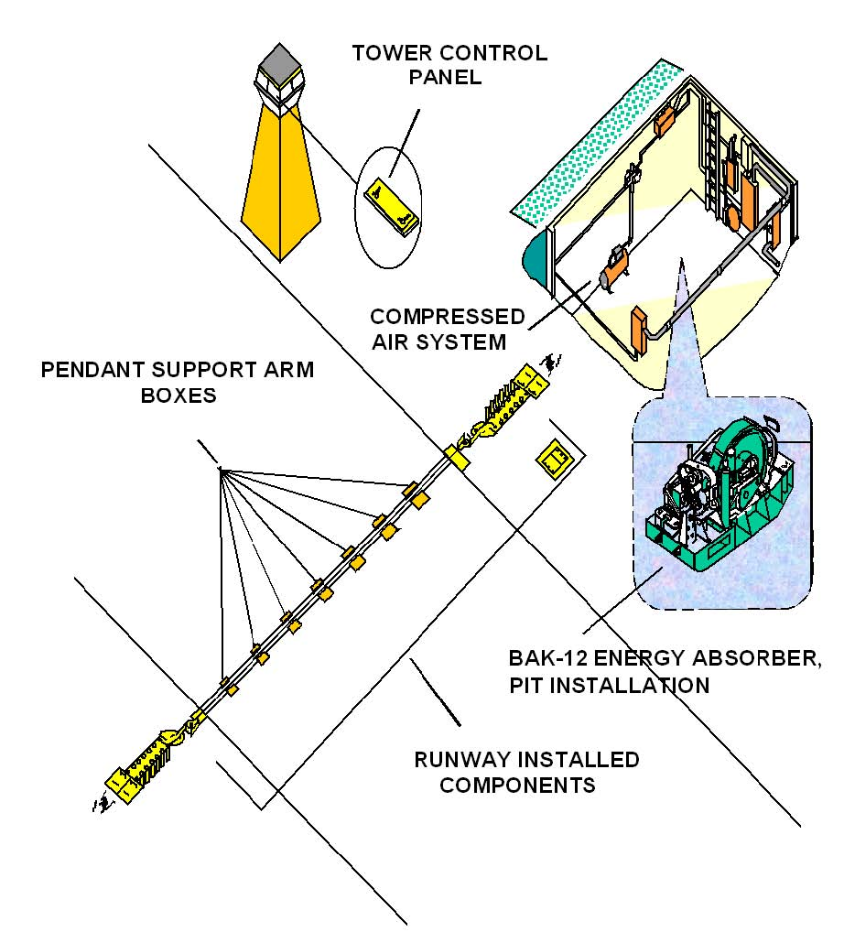

Figure A1-3. BAK-14 Cable Support System.
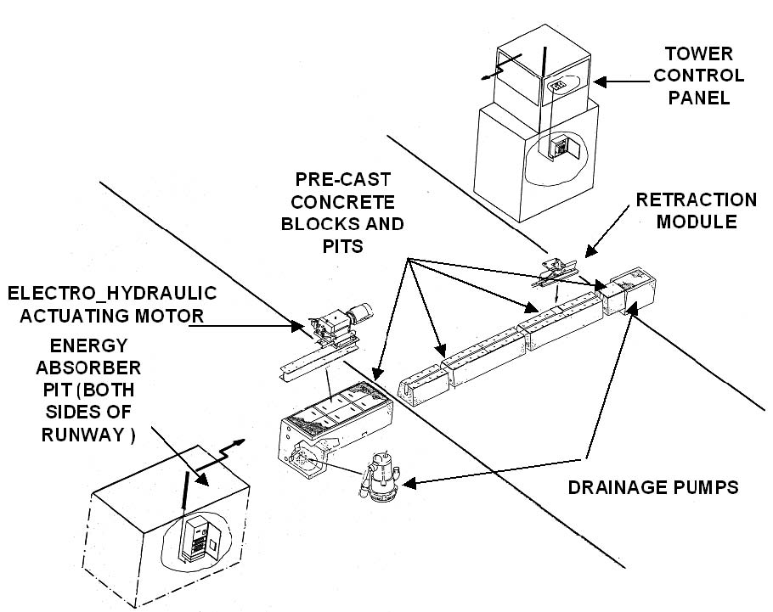
Figure A1-4. Type H Hook Cable Support System.

5. Mobile Aircraft Arresting System (MAAS).
a. The MAAS (Figure A1-5) is essentially a BAK-12 aircraft arresting system mobilized through installation on a specially developed trailer. It is configured for a maximum aircraft runout of 990 feet (302 meters). This system was initially developed and tested to accommodate recovery of fighter aircraft returning to a battle-damaged airfield.
Such cases require rapid deployment and installation and may require that only the minimum essential anchoring hardware be installed to accommodate the above scenario. When installed for this purpose, the MAAS is installed using a 19-stake anchoring scheme. This configuration is limited to unidirectional engagement capability with a maximum aircraft weight and speed of 40,000 pounds (18,144 kilograms) at 150 knots.
b. The MAAS can be upgraded to accommodate bidirectional engagements with the full capacity of a standard BAK-12 aircraft arresting system. This is accomplished by increasing the total number of stakes used to anchor the system from 19 to 31, extending the runout to 1,200 feet (366 meters), and synchronizing the system for higher brake pressure.

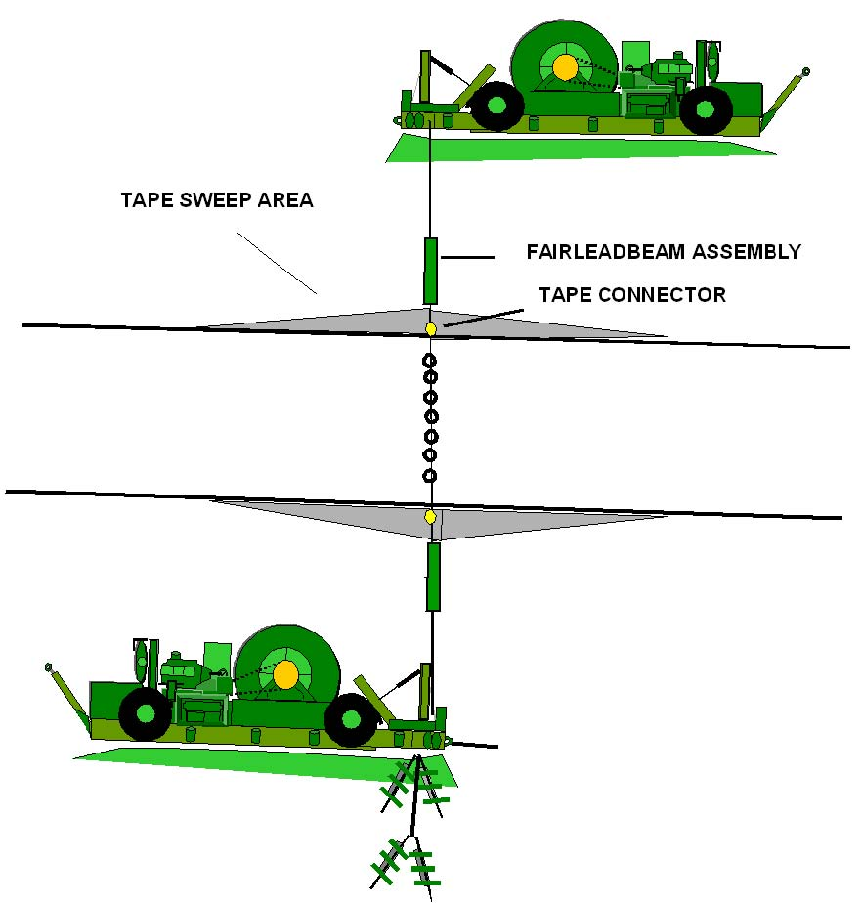
Figure A1-5. Mobile Aircraft Arresting System (MAAS) in Set-Back Configuration.

(Title) (Title)

APPENDIX 2. TYPICAL INSTALLATION PHOTOGRAPHS

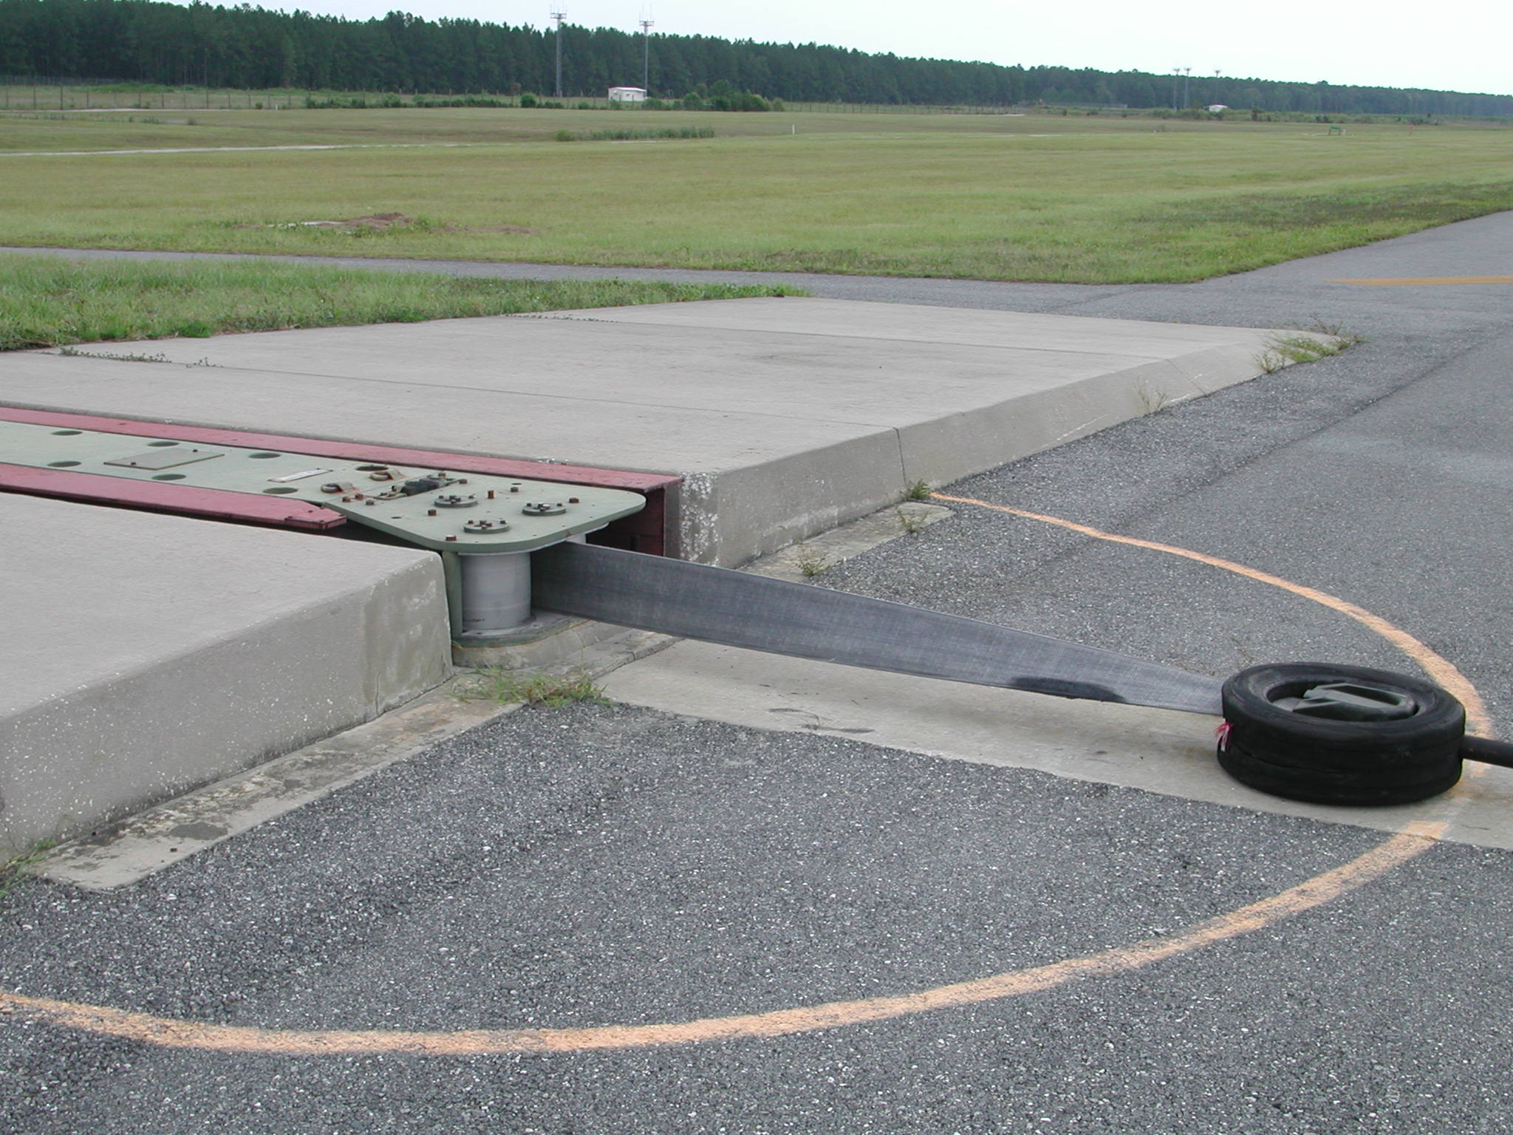
Figure A2-1. Close-up view of the Fairlead Beam and Deck Sheave.

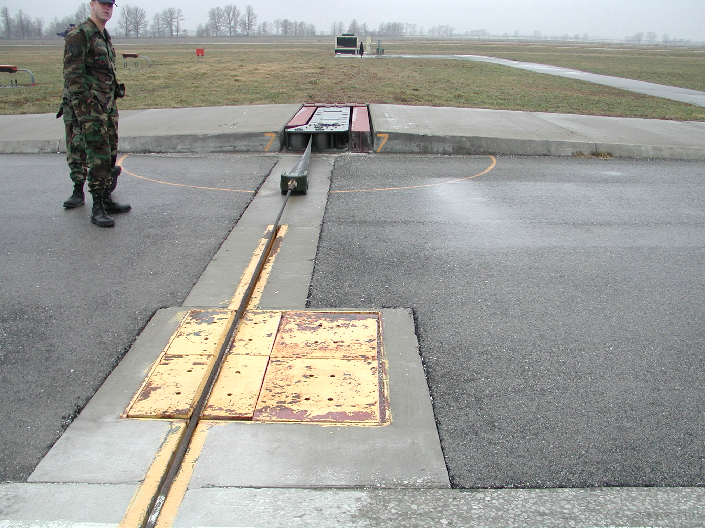
Figure A2-2. Front view of the Fairlead Beam and Deck Sheave.

Figure A2-4. Arresting Barrier Fairlead Beam – diagonal view.

Figure A2-3. Arresting Barrier Fairlead Beam – longitudinal view.

