External Dose Estimates from NTS Fallout

External Radiation Exposure to the Population of the Continental U.S. from Nevada Weapons Tests and Estimates of Deposition Density of Radionuclides That Could Significantly Contribute to Internal Radiation Exposure via Ingestion

Harold L. Beck

Report to the National Cancer Institute in fulfillment of
P.O. #263-MQ-909853

June 30, 1999 (revised Nov. 1, 1999)

Abstract

This report provides estimates of the external radiation exposure and whole-body effective dose received by residents of the continental U.S. during the period 1951-1962 from weapons tests carried out at the Nevada Test Site (NTS). Estimates are given on a county- by-county basis for each test and for each year of testing. The average committed population dose from all NTS tests was about 0.5 mSv, about equivalent to 1-2 years of external radiation exposure from natural background. Residents of the counties immediately downwind from the NTS incurred much higher doses, in excess of 3 mSv, while the residents of the Far West, Pacific Northwest and Southeast received lower than average exposures. The tests and radionuclides that contributed the most exposure are discussed, as well as the dependence on fallout time of arrival. The most exposed individuals were outdoor workers; the least exposed were persons who spent most of their time indoors in heavily constructed buildings.

The deposition of radionuclides that contribute to internal radiation exposure via the ingestion pathway was also calculated on a county-by-county and test-by-test basis. The general pattern of deposition, tests contributing the most to the deposition, deposition density versus distance from the NTS, and the differences in deposition between radionuclides are discussed. In general the deposition of long-lived radionuclides such as Sr-90 and Cs-137 was about a factor of 20 less than that from “global fallout” from high- yield weapons tests carried out in the Pacific and Soviet Union. However, the deposition of short-lived isotopes such as I-131 was greater than from “global fallout.”

Introduction

In response to a request by Congress to the CDC and NCI to investigate the impact on the U.S. population from weapons tests, the NCI contracted with the author of this report to:

“Prepare crude estimates of the doses from external irradiation received by the American people as a result of the above-ground tests carried out at the Nevada Test Site. These dose estimates would be:
- based on a review of the readily available open literature and information; it is not expected that sophisticated computer models should be developed or used for this purpose. For the purposes of this assessment, the extensive database of Iodine-131 that was prepared by NCI in the framework of the nationwide NTS fallout study could be used;
- averaged over large regions of the continental U.S., with indications on how the high-risk populations would be identified. However, if feasible, primary calculations should be carried out on a county-by-county basis, and averaged only for presentation purposes;
- calculated separately for the most important radionuclides produced in nuclear weapons tests. Those would include, but would not be limited to Te-I-132, Ba-La-140, Zr-Nb-95, Cs-137, and Np-239;
- provided in terms of average whole-body dose for gamma irradiation and of dose to the skin for beta irradiation.
- calculated by year and summed over all NTS tests, with a comparison to the published UNSCEAR latitudinal averages for all tests.

2. Provide a list of references regarding: (1) the history of nuclear weapons testing at the NTS; (2) the production of important radionuclides during those tests; (3) the networks of fallout measurements; (4) the assessment of the activities deposited on the ground; (5) the vertical migration of fallout radionuclides into deeper layers of soil; and (6) the assessment of the doses from external irradiation.

- Identify reports that could be declassified. Examples of such reports are those that would provide the fission and total yields, and those that would greatly facilitate the estimation of doses due to the plutonium isotopes.”

This report, along with an associated electronic database, is presented in fulfillment of the above scope of work.

As per the scope of work, this report relies heavily on previous studies of NTS fallout, e.g., NCI (1997); Hicks (1982, 1990); Church et al. (1990); Beck et al. (1990, 1996). Exposure rates and deposition densities were calculated for about 60 of the approximately 100 atmospheric tests conducted at the NTS. These 60 tests accounted for over 95% of the total I-131 produced (NCI, 1997) and corresponded to the majority of tests for which total I-131 deposition was estimated by the NCI (1997) in their study of I-131 exposure to the American people from NTS fallout. A few tests considered in the NTS study for which only local fallout estimates were estimated were not treated in this study. The tests considered in this report are listed in Table 1. Table 1 also gives some specific information about each test that was used in the calculations described later in this report.

The basic starting point for the estimates in this report were the daily I-131 deposition density estimates and associated uncertainty estimates from NCI (1997). All calculations for this report were carried out separately for each county (and sub-county as defined in NCI (1997), Appendix 2, and then summed to provide estimates on a test-by-test, annual, and total NTS basis. The total exposure and deposition density for other nuclides was calculated from the NTS I-131 deposition densities by using the relationships calculated by Hicks (1981) for each NTS shot. Besides the total free-in-air exposure rate from gamma emitters, provided by the Hicks data, estimates were also made of the annual whole body effective dose, the beta-ray dose to the skin from radionuclides in the surface soil, and the 50y committed effective dose. The radionuclides that contributed most to both gamma and beta-ray exposure were identified.

Deposition densities were estimated on a county-by-county basis for each test for the radionuclides listed in Table 2. These radionuclides were determined by Ng et al. (1990) to account for over 90% of the potential dose from ingestion in the ORERP (Church et al., 1990) study. A database (in Excel) containing the estimated deposition density of each radionuclide listed for each test on a county-by-county basis was provided to NCI earlier in partial fulfillment of this contract. The database containing these deposition density estimates and associated uncertainty estimates will be used by the NCI to estimate internal radiation doses due to ingestion of contaminated food. The patterns of total deposition for some of the longer-lived nuclides are discussed in this report and the total deposition of various radionuclides is compared to that from the "global” fallout resulting from the high-yield tests carried out in the Pacific and in the USSR.

In addition to the references provided in the text of this report, an additional reading list is provided in fulfillment of item 2 of the scope of work. A list of data that is presently classified but if unclassified would be useful in improving the estimates made in this report and allowing similar estimates to be made for weapons tests conducted outside the U.S. is also included in fulfillment of item 3.

The next section of this report describes in detail the methodology used to calculate exposure and deposition densities.

Table 1: Tests considered in this study

Test | Test Date | yield (kT) | Type | Cs-137/  Sr-90 | % Cs-137 from Pu* | Pu-240/  Pu-239 | Pu-241/  Pu-239 | Cs-137/  Pu*
BAKER-1 | 1/28/51 | 8 | air | 1.79 | 72% | 0.027 | 0.0006 | 5
Baker-2 | 2/2/51 | 8 | air | 1.79 | 72% | 0.026 | 0.0005 | 5
BAKER | 10/28/51 | 4 | air | 2.50 | 100% | 0.033 | 0.0011 | 4
CHARLIE | 10/30/51 | 14 | air | 1.16 | 18% | 0.028 | 0.0010 | 20
DOG | 11/1/51 | 21 | air | 1.27 | 31% | 0.028 | 0.0010 | 12
EASY | 11/5/51 | 31 | air | 1.24 | 28% | 0.036 | 0.0011 | 13
SUGAR | 11/19/51 | 1 | surface | 1.06 | 3% | 0.001 | 0.0000 | 316
UNCLE | 11/29/51 | 1 | crater | 1.06 | 3% | 0.001 | 0.0000 | 299
ABLE | 4/1/52 | 1 | air | 1.06 | 3% | 0.001 |  | 142
BAKER | 4/15/52 | 1 | air | 1.06 | 3% | 0.001 |  | 144
CHARLIE | 4/22/52 | 31 | air | 1.27 | 31% | 0.051 | 0.0028 | 11
DOG | 5/1/52 | 19 | air | 1.28 | 32% | 0.035 | 0.0012 | 11
EASY | 5/7/52 | 12 | tower | 1.27 | 31% | 0.024 | 0.0005 | 24
FOX | 5/25/52 | 11 | tower | 1.27 | 31% | 0.024 | 0.0006 | 24
GEORGE | 6/1/52 | 15 | tower | 1.27 | 31% | 0.026 | 0.0015 | 24
HOW | 6/5/52 | 14 | tower | 1.26 | 30% | 0.027 | 0.0005 | 24
ANNIE | 3/17/53 | 16 | tower | 1.28 | 32% | 0.025 | 0.0010 | 23
NANCY | 3/24/53 | 24 | tower | 1.27 | 31% | 0.028 | 0.0012 | 23
RUTH | 3/31/53 | 0 | tower | 1.06 | 3% | 0.000 |  | 306
DIXIE | 4/6/53 | 11 | air | 1.27 | 31% | 0.022 | 0.0006 | 12
RAY | 4/11/53 | 0 | tower | 1.06 | 3% | 0.000 |  | 292
BADGER | 4/18/53 | 23 | tower | 1.34 | 38% | 0.034 | 0.0011 | 19
SIMON | 4/25/53 | 43 | tower | 1.12 | 12% | 0.027 | 0.0006 | 60
ENCORE | 5/8/53 | 27 | air | 1.16 | 17% | 0.052 | 0.0028 | 20
HARRY | 5/19/53 | 32 | tower | 1.21 | 24% | 0.038 | 0.0018 | 29
GRABLE | 5/25/53 | 15 | air | 1.04 | 0% | 0.001 |  | 833
CLIMAX | 6/4/53 | 61 | air | 1.11 | 11% | 0.034 | 0.0009 | 33
WASP | 2/18/55 | 1 | air | 1.77 | 71% | 0.055 | 0.0036 | 5
MOTH | 2/22/55 | 2 | tower | 1.77 | 70% | 0.078 | 0.0065 | 9
Test | Test Date | yield (kT) | Type | Cs/Sr | % Cs-137 fromPu* | Pu-240/239 | Pu-241/239 | Cs/Pu*
TESLA | 3/1/55 | 7 | tower | 2.42 | 98% | 0.019 | 0.0003 | 8
TURK | 3/7/55 | 43 | tower | 1.20 | 23% | 0.033 | 0.0008 | 32
HORNET | 3/12/55 | 4 | tower | 1.38 | 43% | 0.058 | 0.0036 | 16
BEE/ESS | 3/22/55 | 9 | tower/crater | 1.42 | 46% | 0.085 | 0.0071 | 13
APPLE/WASP' | 3/29/55 | 17 | tower/air | 1.16 | 18% | 0.025 | 0.0006 | 40
POST | 4/9/55 | 2 | tower | 2.47 | 99% | 0.019 | 0.0005 | 8
MET | 4/15/55 | 22 | tower | 1.03 | -1% | 0.007 | 0.0001 | 10000
APPLE2 | 5/5/55 | 29 | tower | 1.06 | 4% | 0.031 | 0.0008 | 186
ZUCCHINI | 5/15/55 | 28 | tower | 1.11 | 10% | 0.032 | 0.0008 | 69
BOLTZMANN | 5/28/57 | 12 | tower | 1.51 | 53% | 0.079 | 0.0060 | 12
WILSON | 6/18/57 | 10 | balloon | 1.29 | 33% | 0.082 | 0.0065 | 9
PRISCILLA | 6/24/57 | 37 | balloon | 1.07 | 5% | 0.011 |  | 74
HOOD | 7/5/57 | 74 | balloon | 1.12 | 12% | 0.067 |  | 27
DIABLO | 7/15/57 | 17 | tower | 1.22 | 26% | 0.062 |  | 26
KEPLER | 7/24/57 | 10 | tower | 2.37 | 96% | 0.072 | 0.0054 | 7
OWENS | 7/25/57 | 10 | balloon | 2.44 | 98% | 0.070 | 0.0047 | 3
SHASTA | 8/18/57 | 17 | tower | 1.19 | 22% | 0.057 |  | 30
DOPPLER | 8/23/57 | 11 | balloon | 1.26 | 30% | 0.070 | 0.0046 | 11
SMOKY | 8/31/57 | 44 | tower | 1.08 | 6% | 0.006 |  | 136
GALILEO | 9/2/57 | 11 | tower | 2.19 | 90% | 0.075 | 0.0050 | 7
WHEELER/  (+COULOMB) | 9/6/57 | 1 | balloon/  surface | 1.04 | 0% | 0.038 |  | 785
LAPLACE | 9/8/57 | 1 | balloon | 1.07 | 6% | 0.000 |  | 72
FIZEAU | 9/14/57 | 11 | tower | 1.43 | 47% | 0.063 | 0.0040 | 14
NEWTON | 9/15/57 | 12 | balloon | 2.46 | 99% | 0.072 | 0.0058 | 3
WHITNEY | 9/23/57 | 19 | tower | 1.41 | 45% | 0.073 |  | 14
CHARLESTON | 9/28/57 | 12 | balloon | 1.29 | 33% | 0.074 |  | 10
MORGAN | 10/7/57 | 8 | balloon | 1.23 | 26% | 0.077 | 0.0063 | 12
SEDAN | 7/6/62 | 104 | crater | 2.44 | 98% | 0.063 |  | 8
SMALLBOY | 7/14/62 | 20 | surf tower | 2.51 | 100% | 0.065 | 0.0056 | 8
*Estimated-see text

Table 2: Radionuclides for which deposition densities were calculated

Nuclide Half life (parent), d

Sr-89 52
Sr-90,Y-90* 10400
Sr-91 0.4
Y-91m (=0.65 * Sr-91) *
Y-91 59
Y-93 0.4
Zr-97, Nb-97* 0.7
Zr-95, Nb-95* 64
Nb-97m (=0.96 * Zr-97) *
Mo-99 2.8
Tc-99m (=0.96 * Mo-99) *
Tc-99 7.8E7
Ru-103, Rh103m* 39
Ru-105, Rh-105m* 0.2
Rh-105 1.5
Ru-106, Rh-106* 368
I-131 (from NCI, 1997) 8
Te-132 3.3
I-132 (=1.03 * Te-132) *
I-133 0.9
I-135 0.3
Cs-136 13
Cs-137 11000
Ba-140 13
La-140 1.7
Ce-141` 32.5
Ce-143 1.4
Pr-143 14
Ce-144, Pr-144* 284
Nd-147 11
Pm-147 956
Np-239 2.36
Pu-239 24131 y
Pu-240 6569 y
Pu-241 14.4 y
Am-241 430 y

* in equilibrium with parent

Methodology

Deposition Densities

The deposition densities of the nuclides listed in Table 2 were calculated from the corresponding NCI estimates of I-131 deposition density. The daily geometric mean (GM) I-131 deposition densities and corresponding geometric standard deviations (GSD) were decay corrected back to H+12 hours. The ratio of the H+12 h I-131 value, which includes the I-131 that grew in from precursors (NCI, 1997), to the ratio of each of the radionuclides in Table 2, as a function of fallout arrival time, was calculated using Hicks (1981). The H+12 h I-131 value for each day of fallout was then multiplied by the appropriate ratio for a time of arrival corresponding to that day to obtain the respective deposition density.

Because the fallout estimates based on gummed-film data were decay corrected to the midpoint of the day of sampling and the test detonations were generally near the beginning of the sampling period (Beck, 1984), fallout arriving on the same day as sampling was assumed to have a time of arrival of 0.5 d, on the second day 1.5 d, etc. Generally, only about 10 days of data had to be considered for a given shot, although a few shots produced significant fallout for periods of up to two weeks. Daily deposition densities were calculated only for short-lived nuclides (half lives less than 30 d). For longer-lived nuclides, the ratio to H+12 h I-131 did not vary significantly over the first several weeks of fallout and thus their total test deposition could be calculated directly from the sum of the daily I-131 depositions.

The daily deposition densities were then summed to obtain a total test deposition density. Since the I-131 deposition densities were given as geometric means with a GSD, it was necessary to first transform the GM to a mean and the GSD to a variance before summing, using standard transformations as discussed in NCI (1997). After the means and variances were summed, the results were transformed back to geometric means and GSDs, assuming the sum of lognormally-distributed distributions is itself approximately lognormally-distributed (see NCI, 1997). The Excel spreadsheet database which accompanies this report contains both the mean values and the GM values. For the long-lived radionuclides, the deposition densities were calculated by multiplying the summed I-131 deposition density by the appropriate ratio for that test from Hicks’ data. No additional uncertainty was assumed due to use of the Hick’s calculated isotope ratios. Because of the large GSDs associated with the I-131 deposition data, any small additional error in Hicks’ data would have a negligible effect on the error in the deposition densities.

Besides, the individual test values, the deposition densities for each test series (year of testing) and for all NTS tests were obtained by summing the individual test results in a similar manner. The short-lived nuclide deposition densities for radionuclides that did not contribute significantly to external dose were not summed to obtain annual or total values. It was assumed that for these short-lived nuclides, the exact week of deposition would be required to make reasonable estimates of ingestion dose. If annual sums are desired for these radionuclides, it is a fairly simple task to obtain them since the GM to mean transformed values are provided in the accompanying database.

A detailed example of the calculation of the deposition density of Cs-137 and Ba-140 for a representative county for a representative test is given in Appendix 1.

Plutonium isotopes were also contained in the fallout from Nevada weapons tests. Pu isotopes do not contribute to external exposure and contribute in only a minor way to ingestion exposure. The main hazard from Pu is generally via the inhalation pathway. However, the inhalation pathway has been shown to not have been a significant contributor to population exposure from NTS testing (Church et al., 1990). Because of the generally high degree of interest by the public in Pu contamination, deposition densities of Pu-239, 240 and 241, and of Am-241 which is a decay product of Pu-241 are also estimated in this report. However, only crude estimates can be made for individual tests since Hicks does not provide any estimates of relative Pu deposition. The ratios of Pu to Cs-137, Sr-90, etc. are still classified (see Appendix 3). The reason for the classification still being in place is that knowledge of such ratios would allow one to estimate the fission efficiency of individual tests. However, one can still roughly estimate Pu deposition densities for individual tests by assuming an average ratio of Pu/Cs-137 deposition density from Pu fission based on observed environmental measurements, if one can estimate the relative amounts of fission due to Pu-239 versus U-235 for each test.

In Table 1, we list the ratio of Cs-137/Sr-90 activity (Hicks, 1981) and the Pu-240/239 and Pu-241/239 atom ratios for each test (Hicks and Barr, 1984). Table 3 presents the fission yields for Pu and U-235 for a fission neutron spectrum and for a thermal neutron spectrum.

Table 3: Fission yields for Cs-137 and Sr-90 (England and Ryder, 1994)

Nuclide U-235_{f} U-235_{th} Pu-239_{f} Pu-239_{th}
Cs-137 6.22 6.19 6.58 5.50
Sr-90 5.46 5.78 2.05 2.10
Cs/Sr (atom) 1.14 1.07 3.21 2.62
Cs/Sr (activity) 1.06 1.00 3.00 2.44
Observed ratio 1.04 2.5

Note that the Cs/Sr ratios in Table 1 range from a value of 1.04 to 2.5. Based on the fission yields in Table 3, one can infer that the Cs/Sr ratio of 1.04 represents shots where the fission was entirely from U-235, while the ratio of 2.5 represents fission entirely from Pu-239. It is assumed that for these low-yield tests essentially none of the fission was from high-energy neutrons and that for at least most of the tests, no other fissionable material was used. As can be seen, both U-235 and Pu-239 fueled most of the tests. Based on Hick’s calculations, the tests inferred to be all U-235 also correspond to those that produced no Am-241 (Hicks, 1981) and exhibited very low Pu-240/239 atom ratios and little Pu-241 (Table 1), consistent with a pure U-235 weapon. (A small amount of Pu will be produced from Np-239 decay even in a pure uranium device since Np-239 is produced by the activation of U-238). Assuming only a mixture of Pu and U-235 as fuel, one can then derive equation 1) for the fraction f of Cs-137 activity that resulted from Pu-239 fission for each shot:

f = 1.71 * (x – 1.04) / x where x is the Cs/Sr activity ratio from Table 1. (1)

Using the Cs/Sr activity ratios from Hicks, given in Table 1, one can then estimate the fraction of the Cs-137 produced that was from Pu-239 fission for each shot from Equation 1, above. This fraction is given in the fifth column of Table 1.

Since these were tests, it is expected that the fission efficiency, and thus the ratio of Cs-137 to Pu-239 from Pu fission probably varied considerably from shot to shot. However, if we choose a reasonable estimate for the mean for all tests and assign a conservative error estimate, we can make rough estimates of Pu deposition which, while possibly significantly in error for a given shot, should provide reasonable total deposition values when summed over all shots. A Cs/Pu ratio of 4 was thus adopted for tests where all the fission was from Pu. Using this ratio then results in the crude estimates of total Cs/Pu for each test shown in the last column of Table 1. The choice of this particular ratio is somewhat arbitrary but seems to provide estimates of Cs/Pu reasonably consistent with measurements of Cs-137/Pu-239+240 in NTS fallout (Krey and Beck, 1981).

An uncertainty corresponding to a GSD of 1.5 was assigned to reflect the large uncertainty in this mean efficiency estimate and the likely large variability from test to test. Using this formulation, Pu-239+240 and Pu-241 deposition densities in fallout were estimated for each test, test series, and for all NTS fallout. (Note that for tower and surface shots, since Pu is a refractory material, according to Hicks (1982, 1990) only ½ of the Pu from tower and surface shots would be deposited outside the immediate vicinity of the NTS. Thus the Pu deposition estimates for these shots were multiplied by ½). Because of the large uncertainty, the Pu deposition estimated for a particular county for any particular test has a large uncertainty (GSD ≅ 2- 4), resulting both from the large uncertainty in the NCI I-131 deposition density estimates as well as the large uncertainty in fission efficiency. However, the sums over all tests have smaller uncertainty (GSD ≅ 1.5-2.0) and are believed to present a reasonable exposition of the total Pu deposition
across the U.S. from NTS testing. Accurate estimates of Pu deposition from particular tests will only be possible if additional information on the Cs/Pu ratios for particular tests is eventually unclassified and thus the Pu results presented in this report should be treated as only preliminary crude estimates.

Some additional Pu-239 is generated from the decay of Np-239. Np-239 is formed by the activation of U-238, present in all U fueled weapons and possibly also in Pu-fueled devices as a tamper. Hicks (1981) provides estimates of Np-239 for each shot and these were used to estimate the Pu-239 that would remain after the Np-239 had decayed. This Pu-239 contribution is included in the estimates of Pu-239 in this report. For devices partially or totally fueled by Pu, this contribution is small. However, for U fueled devices it is the only source of Pu in the fallout. Np-239 is also a significant contributor to external radiation exposure rates during the first few days after detonation.

Pu-241 was also estimated from the Pu-239+240 estimate and the reported 241/239 atom ratios. At this time most of the Pu-241 deposited has decayed into Am-241 with a resultant Am-241 activity equal to the ratio of Pu-241/Am-241 half-lives (see Table 2).

External Radiation Exposure

Hicks (1981) calculated the relative exposure rate versus time for each NTS test using deposition to exposure rate conversion factors published by Beck (1980). The conversion factors used by Hicks assume the radioactivity was distributed in the soil with a relaxation length of about 0.1 cm for all times (the relaxation length is defined as the depth at which an exponentially decreasing activity falls to 1/e of the value at the surface). This value was chosen since even fresh fallout is attenuated somewhat as a result of surface roughness (Jacob et al., 1986; Eckerman and Ryman,1993). However, it is well established (UNSCEAR, 1993, NCRP, 1999, Miller et al., 1990; Gale et al., 1964) that radionuclides penetrate deeper into the soil with time. Data from the Chernobyl accident indicates that that even after a few weeks, a relaxation length of 1 cm is not uncommon (Likhtariov et al., 1996; UNSCEAR, 1993), particularly in areas with typical rainfall levels. After a few months, measurements have generally shown that the distribution reaches about a 3-cm relaxation length before the penetration begins to slow and asymptote (Beck, 1966; UNSCEAR, 1988; Miller and Helfer, 1985). However, for heavily watered areas, relaxation lengths of up to 6-7 cm have been observed (Miller et al., 1990; Beck and Krey. 1980).

Because, as will be shown later, most of the radiation exposure occurred during the first few weeks, the use of a 0.1-cm relaxation length by Hicks (1981) for all time intervals had only a small impact on the total integral exposure. However, in this report, an attempt was made to use a somewhat more realistic model. The 0.1 cm relaxation length used by Hicks was maintained for the first 20 d after detonation, but from 20 d to 200 d, a relaxation length of 1 cm was used, while for times greater than 200 days, a relaxation length of 3 cm was used. The corresponding deposition-density to exposure conversion factors for each of these relaxation lengths are from Beck (1980). Although a gradually increasing relaxation length would be more physically realistic, the fact that most of the exposure occurs in the first 20 d, did not warrant the considerable effort that would be entailed in calculating dose rates using a continuously-variable relaxation length.

Since the penetration into the soil would be slower in more arid regions, maintaining the 0.1 cm relaxation length for the first 20 d provides a slightly conservative estimate of the exposure for sites with greater precipitation and early fallout arrival times. Table 4 illustrates the dependence of the exposure rate in air on the various relaxation lengths. Note that the exposure rate is reduced by about 1/3 as the activity penetrates to a relaxation length of 1 cm and about ½ as the activity penetrates to a relaxation length of 3 cm from 0.1 cm. This accentuates the importance of the first few weeks after a test with respect to total external radiation exposure to an even greater degree than previous calculations based only on radionuclide decay.

Table 4: Exposure rate (R/h per mCi/km²) versus relaxation length for selected fission products (Beck, 1980)

Nuclide Relaxation length (cm)
0.1 1 3
Zr-95 1.20E-02 7.94E-03 5.63E-03
Ru-103 7.85E-03 5.25E-03 3.58E-03
Rh-106 3.37E-03 2.25E-03 1.56E-03
Te-132 3.38E-03 2.29E-03 1.54E-03
Cs-137 9.29E-03 6.15E-03 4.32E-03
Ce-141 1.09E-03 7.25E-04 4.92E-04
Ce-144 2.53E-04 1.70E-04 1.16E-04
Np-239 2.56E-03 1.75E-03 1.17E-03

Since Hicks already calculated exposure rate versus time for the first 0-20 days using a relaxation length of 0.1 cm, his results for 0.5-20 d were adopted directly and fit to a function of the form at^{-x}. This function was then integrated to obtain the total exposure from TOA to 20 d, where TOA is the time of arrival in days. In all cases the correlation coefficient for the fit over the period 0.5-20 d was greater than 0.99. The variation in the exponent from shot to shot also turned out to be quite low (x = 1.109  0.022). To obtain the integral from 20 d to the end of the year, the subsequent year, and to 50y, the Hicks’ data for nuclides that contribute to the exposure at those times were entered into a spreadsheet. The variation with time from 20 d on was calculated directly from the appropriate Bateman equations that account for ingrowth of precursors and radioactive decay. By using the appropriate analytical formulae normalized to Hicks’ data at 20 d, it was possible to integrate analytically over the various intervals of interest. Note that due to the change in depth profile at 200 d, integration had to be done by first integrating from 20 d to 200 d (or to the end of the first year if less than 200 d) and then from 200 d to the end of the year.

Thus for each test, the total exposure was obtained for the year of the test, the next year, and finally for a total period from fallout time-of-arrival to 50 y. Hicks’ calculations were normalized to unit exposure rate at H+12 h, which corresponds to a particular value of effective I-131 deposition density at H+12 h. Thus the ratio of the effective I-131 deposition for each day calculated by the NCI (1997) was multiplied by the appropriate normalized exposure integral to obtain the actual exposure for that interval and time-of-arrival. The individual daily estimates were then summed to obtain annual and 50y committed exposure estimates for each test, test series, and for all NTS tests. Again, no additional uncertainty was assigned for the exposure estimates since the error in the deposition density estimate dwarfs the estimated error in exposure rate estimates. The uncertainty in normalized integral exposure for a particular day is estimated to be at most 10-20%, due primarily to variations in the depth profile from site to site. The errors in the conversion factors themselves are thought to be less than 5% (Beck, 1980).

A detailed example of the calculation of total exposure for a representative county for a representative test is given in Appendix 1.

Because the NCI deposition data are given for a particular day, the exposure estimates for sites where the fallout arrived very early (less than 12 h) are underestimated in this report. The exposure rate falls very rapidly during the first few hours (see Table 5) and thus the integral is very sensitive to arrival time for short arrival times. For this report it was assumed that the fallout that occurred on the day of the test occurred at H+12 h (H + 0.25 h for the 1952 tests due to a different gummed-film sample interval). Thus, for those sites where significant fallout occurred prior to H+12 h, the data presented here may be significantly in error (up to 50% too low). This is illustrated by Table 5, which gives the exposure rate and integral exposure versus time for a typical test. However, the exposure rates and external doses for close-in sites have been calculated in great detail for each community (Anspaugh and Church, 1990; Henderson and Smale, 1990; Thompson et al., 1990) and these dose estimates should be used in lieu of those in this report.

Table 5 also gives the fraction of the exposure occurring in various time intervals. One can see that that the exposure rate falls off rapidly with time and that over 80% of the exposure occurs in the first 20 d for an arrival time of 12 h. Thus only a small fraction of the total exposure (about 1% as shown later) is incurred in the year(s) after the test occurred unless the tests were very late in the year, particularly for locations where the fallout arrived within a day or two. The drop-off in exposure rate was of course accentuated by the penetration of the activity into the soil with time. Previous calculations that did not take this penetration into consideration overestimated the total exposure. Note that the common assumption of a t^{-1,2} decay rate and no penetration would imply only about 50% of the dose being incurred in the first 20 d!. The difference results not as much from the greater penetration with time but more to the fact that the exposure rate drops off much more rapidly than t^{-1.2} after 20 d (Hicks, 1981).

Table 5: Relative Exposure rate and total exposure versus time of arrival (TOA)*

TOA, d Exposure rate, mR/h Total Exposure (50 y), mR
0.25 2.1 53
0.5 1.0 45
1.5 0.30 33
2.5 0.17 27
3.5 0.12 24
5.5 0.071 20
10.5 0.035 14
20 0.015 6
*values are for shot HARRY but are similar for all tests.

The exposures calculated in this report are generally based on estimates or measurements of radionuclide deposition densities and conversion factors from deposition density to exposure rate. Very few actual measurements of exposure were made outside the immediate vicinity of the NTS. However, for states immediately downwind from the NTS, all available data was used to estimate deposition densities including actual exposure rate measurements if any (Beck and Anspaugh, 1991; Beck, 1996). The conversion factors relating deposition density to exposure rate in air have been validated in many studies and as mentioned previously are believed to be accurate to better than 5% for a given depth distribution (NCRP, 1999).

Whole Body Effective Dose

In order to calculate the whole-body dose from the free-in-air exposure data, one must first convert exposure to dose in air by multiplying by a factor of 0.875 rad/R. Then, to convert to dose in tissue and account for shielding by the body, one must convert from rads in air to rem (or in S.I. units, Gy to Sv). In this report we chose to follow the ICRP guidelines (ICRP, 1991) and estimate the effective whole body dose that weights the effects on various organs in a proscribed manner. The UNSCEAR (1993) recommends a factor of 0.75 ± 0.05 to convert from Gy to Sv for adults. This is similar to average values recommended by the ICRP and others (NCRP, 1999). This factor of course varies with the energy of the radiation and the orientation with respect to radiation incidence (NCRP, 1999, Eckerman and Ryman, 1993). However, a value of 0.75 is a reasonable average for fission products (NCRP, 1999). The net conversion from exposure in air to effective dose is thus about 0.875 * 0.75 = 0.66 for adults. Calculations using computer phantoms have indicated that the effective dose to young children is about 30% higher (NCRP, 1999).

Thus the dose to adults exposed outdoors is about 2/3 of the outdoor exposure. However, most people spend most of their time indoors and thus their exposure is reduced greatly due to attenuation of the radiation by building materials. The amount of shielding (i.e. the shielding factor) will depend on the type of structure. In general, based on a review of the available literature, it is estimated that heavily constructed buildings made of brick or concrete will provide a shielding factor of about 0.2 ± 20% (1 s,d,) while lightly constructed buildings will provide a shielding factor of about 0.4. ± 20% (NCRP, 1999). These estimates are fairly conservative and allow for a small amount of radioactivity that may be tracked into the home from contamination of shoes, etc. Assuming that on average most persons spend about 80% of their time indoors (UNSCEAR, 1993; NCRP, 1999) with an average shielding factor of 0.3, their whole body effective dose would be 0.66 * (0.2 + 0.8 * 0.3) = 0.29 x Outdoor exposure. However, the UNSCEAR estimated that persons who work outdoor spend on average only 40% of their time indoors and the most exposed outdoor worker spends only about 30% of his/her time indoors. The NRC (1977) made a similar estimate of 40% of time spent indoors for the maximum exposed individual. Assuming only 30% indoors in a lightly shielded structure for the maximum exposed outdoor worker, the dose to the most exposed individuals would be
0.66 * (0.7 + 0.3 * 0.4) = 0.54 x Outdoor exposure or almost twice that of the average exposure. Conversely, the UNSCEAR (1993) estimated indoor workers spend only about 10% of their time outdoors while other estimates indicate some individuals spend even less time outdoors. Assuming 5% as a reasonable estimate for the least exposed individual living in a well shielded house and/or working in a well shielded building, the minimum exposed individual would receive a dose of about 0.66 * (0.05 + 0.95 * 0.2) = 0.16 x outdoor exposure, or about ½ that of the average dose.

Thus the actual dose to any individual can range by about a factor of four depending on the amount of time spent outdoors and the type of structure the individual lives and works in. The dose to children could be about 30% higher than that for adults for the same fraction of time outdoors. In this report, all calculations of dose are based on the average exposure given above and estimates for any individual should be adjusted up or down based on the above discussion.

Note that no additional uncertainty has been incorporated in the dose estimates in this report above that for the uncertainty in the underlying deposition density estimates that were used to estimate exposure. However, using a S.D of ± 20% for the shielding factors, ± 0.05 for the conversion from rad to rem, and 0.8 ± 0.05 for the fraction of time spent indoors by an average individual implies that the uncertainty (one S.D.) in the average conversion from exposure to dose of 0.3 is about 0.04, or about 10%. Even for the sum over all tests, the uncertainty (GSD) in the outdoor exposure in a given county averages about 1.3 (GSD). Thus, this additional uncertainty in converting to dose can be ignored provided one adjusts their individual dose estimate for time spent outdoors on average, particularly during the first few weeks after each test.

Beta Skin Dose

All of the exposures and doses discussed above refer to exposure to gamma radiation from the fission products deposited onto the ground. However almost all of the gamma emitting radionuclides also emit beta rays and a number of fission products emit beta rays but no gamma rays. Because of their low penetrating power, beta rays are attenuated rapidly in soil and even in air and thus contribute little to whole-body radiation exposure (Eckerman and Ryman, 1993; NCRP, 1999). However beta rays can contribute to the dose to skin, particularly in the days immediately following fallout before the activity has penetrated more deeply into the soil. Because the beta radiation is so sensitive to the actual depth distribution in the soil, only a very crude estimate can be made of the dose. Thus the beta skin dose has been estimated only for a single test, HARRY. The variation in beta dose from test to test is expected to be negligible compared to the variation due to variations in depth distribution (penetration rate) in the soil.

Besides the beta radiation itself, the beta rays produce a small amount of gamma radiation via bremsstrahlung (Eckerman and Ryman, 1993). This gamma radiation, although only a small fraction of the energy of the beta ray itself, can produce a small whole-body exposure and add to skin dose. Furthermore, it is generally the only way a beta emitter can irradiate body organs other than the skin. In order to account for both beta radiation itself as well as the accompanying bremsstrahlung, we have used the dose factors calculated by Eckerman and Ryman (1993) to estimate doses to skin for the deposition densities of the various fission products reported in Hicks (1991). Unfortunately, however, Eckerman and Ryman (1993) do not separate out beta and gamma dose contributions in their tabulated results and also did not calculate values for exponentially decreasing concentrations in soil. Thus the beta dose for beta-gamma emitters for a 1 cm slab source was inferred by plotting their doses for pure beta emitters versus their total energy of emitted betas and using this curve to estimate the beta doses from beta-gamma emitters. The dose for a source with a 0.1-cm relaxation length, corresponding to the distribution used for gamma rays for the first 20 days, was then estimated. For this estimate, it was assumed that all the activity is contained in a 0.144 cm thick slab, corresponding to the mean depth of a 0.1 cm relaxation length exponential distribution and that any activity from depths greater than that would not contribute significantly due to attenuation. Thus the skin dose values from Eckerman and Ryman (1993) for a 1-cm slab with 1 Bq/cm³ were multiplied by a factor of 5.3 to correspond to the concentration in a 0.144-cm slab for a deposition density of 1 nCi/m² with a 0.1 cm relaxation length.

The beta skin dose from fallout distributed with a 0.1-cm relaxation length was then calculated to be about 25-50% of that from a plane source on the soil surface, depending on the age of the fallout. The early fallout contains a greater fraction of higher energy beta rays and thus the attenuation in soil is lower. The results of these calculations are presented in the next section and compared to the gamma ray exposure results.
Results

Fallout Deposition

The total deposition density of Cs-137 from all NTS tests examined through 1962 is shown in Figure 1. The pattern of deposition is similar to that for I-131, shown in Figure 2 (from NCI, 1997) although, due to its long half life, the drop-off in activity in the eastern U.S. is less than that for I-131. Deposition densities range from less than 5 mCI/km² in the western and northwestern states to over 20 near the NTS. As for the I-131 deposition, the regional and local variations are due to variations in precipitation, which is the main fallout mechanism at distances remote from the test site. The well documented elevated region in northern New York State was due to heavy thunderstorm activity during passage of the cloud from shot SIMON in April, 1953 (NCI, 1997; Beck et al., 1990). The deposition density patterns for most of the other radionuclides covered in this report were in general intermediate to the patterns for Cs and I, with any differences reflected by the differences in respective half lives.

The deposition density data for each test for all covered nuclides is contained in the database accompanying this report. However, the patterns for Sr-90 and Pu-239+240 vary somewhat from those for Cs-137 and I-131due to the differences in Sr and Pu production as a function of the device fuel. Figure 3 shows the ratio of total Cs-137 to total Sr-90..Figure 4 is for the ratio of Cs-137 to Pu-239+240. Note that the Cs to Sr ratio varies from about 0.8 to 1.9 with relatively low Sr deposition in Idaho, western Montana, western Nevada and the S.E. states and relatively higher Sr deposition relative to Cs in areas of the Midwest. The differences, of course, reflect the fact that the fallout in different regions resulted from different test(s). The Cs/Pu ratios, shown in Figure 3 vary from 3 to over 50. The highest relative Pu deposition was in counties near the NTS. However, areas in the mountain states, eastern NM and the Midwest exhibited generally low relative Pu deposition. For most of the country, the Cs to Pu activity ratio was about 10-20. As discussed previously, the Pu estimates in this report for any particular county are very uncertain and should be viewed only as illustrative of the variations across the country due to the varying tracks of Pu-fueled tests versus U-235-fueled tests. The number of counties within each range is shown in parenthesis in the figure captions.

Figure 5 shows the fraction of the total Cs-137 deposition in the continental U.S. resulting from each test series. The 1957 Plumbbob series deposited 35% of the total Cs followed by the 1953 Upshot Knothole series (23%). Of course the fraction of the total deposition in a particular year for any particular county will differ from this distribution due to the varying fallout tracks during different years. (The maps shown later of external exposure versus year reflect the relative annual depositions of fission products in each area). The ten tests depositing the most Cs in the continental U.S. are shown in Figure 6, while Figure 7 shows comparable data for the population-weighted deposition density.

Two tests from the 1953 UPSHOT-KNOTHOLE series deposited the most Cs-137 (SIMON and HARRY). HARRY also deposited the most I-131 (NCI, 1997). The comparable plot for the tests resulting in the highest population-weighted deposition density differs somewhat from the total deposition. Foe example, HARRY’s impact on a population-weighted basis was much less than for total deposition, reflecting the fact that the fallout tracks and deposition patterns for each test differed, sometimes significantly (NCI, 1997; Beck et al., 1990).

The total amount of Cs-137 deposited in the continental U.S. from all tests was 62500 Ci. The total deposition for a number of other selected radionuclides is shown in Table 6.

The total deposition density was calculated for several radionuclides in order to compare with the deposition from “global” fallout as reported by UNSCEAR (1993). For this purpose, the calculated values for each county were weighted by population and then summed. Because of the sharp gradations in deposition from west to east, and the higher populations in the eastern U.S., these population-weighted values are slightly less than the mean unweighted deposition obtained by dividing the total deposition by the total area of the continental U.S. However, they are a fairer indicator of the impact the deposition had with respect to both external and internal population doses. The resulting population-weighted deposition densities for the U.S. are given in Table 6 and compared with corresponding estimates by UNSCEAR for the 40-50 degree latitude band of the northern hemisphere

Table 6: Total deposition and population-weighted mean deposition density of selected radionuclides for NTS fallout and “global” fallout.

Nuclide Total Deposition Population weighted Deposition density (kCi) (nCi m²)
NTS NTS “global fallout”**
Cs-137 62.5 6.9 140
Sr-90 49.2 5.3 87
Zr-95 5900 680 1030
Ru-103 11500 1240 760
Ba-140 37600 3900 620
Ce-141 13500 1460 570
Ce-144 1070 123 1300
Ru-106 635 71 650
Sr-89 9000 980 540
I-131 40100 5200 513
Pu-239+240 3.6# ~0.42 1.6
Pu-241 14.6 ~1.6 20

**for 40-50 degree latitude band, # About 5% of total is from the decay of Np-239.

Thus for the long-lived radionuclides, NTS fallout contributed only about 5% of the total deposition. The deposition of short-lived radionuclides such as Sr-89, Ba-140 and I-131 was several times that of “global” fallout. These results are consistent with the fact that although the total fission yield of NTS tests was only about 1 MT, compared to about 150 MT for tests outside the U.S., most of the debris from the large thermonuclear tests outside the U.S. was injected into the stratosphere. According to the UNSCEAR (1993), the average residence time for this stratospheric debris before re-entering the troposphere and depositing is about 1 y. This delay in fallout coupled with a more uniform deposition over the entire globe accounts for the reduced impact of global fallout and in particular the very much-reduced short-lived activity relative to the amounts produced.

Another factor contributing to the greater deposition per unit yield in the continental U.S. of NTS tests is the fact that tests detonated near the ground, either on the surface or from relatively low towers, deposit a large fraction of their debris locally and regionally compared to tests detonated higher in the atmosphere. Figure 8 compares the cumulative Cs-137 deposition versus distance from the NTS as a fraction of that produced for various types of tests. Figure 9 compares the deposition as a fraction of the total deposited in the U.S. From Figure 8, one sees that less than 10% of the activity produced in an air burst deposits within 4,400 km (or within the continental U.S.) compared to about 45% for tower and surface shots. Balloon-borne devices deposited 30% in the U.S., less than tower shots but much more than air bursts. (The height of detonation for balloon shots was generally on the order of 500 m compared to ~100-200 m for tower shots (Beck, 1984)). For all NTS tests, 34% of the Cs-137 produced deposited in the continental U.S. In terms of the total deposited in the U.S., all types of tests deposited the same approximate fraction of their total U.S. deposition at distances greater than 2,000 km. However, tower shots, as expected, deposited a greater fraction very close to the NTS, while air bursts seemed to deposit a greater fraction from 1,500-2,500 km.

Overall, air bursts deposited only about 8% of the total activity produced within the continental U.S., consistent with the UNSCEAR estimate of an average tropospheric residence time of 30 d. assuming a cross-country transit time of about 4 d on average.

The estimates of total deposition and fractional deposition discussed above of course rely upon the accuracy of the underlying I-131 deposition densities calculated by interpolating a relatively small number of gummed film measurements and weighting interpolated values by measured precipitation (NCI, 1997). However, most of the random uncertainty in total deposition is averaged out when summing over a large number of tests, days per test, and counties. The calculated propagated uncertainty in total deposition is less than 5% (GSD < 1.05). This assumes of course that there is no large systematic error and that the daily deposition estimates are not correlated. The values for a particular day are correlated with values for nearby counties since that is the basis of the kriging method used (see NCI, 1997), however, results from one day to another and one test to another should not be correlated.

Exposure and Dose

The geographical distribution of total whole-body effective dose from all NTS tests for a typically exposed individual (80% indoors, 0.3 shielding factor) is shown in Figure 10. The specific mean and GM free-in-air exposures for each county for each test, year, and total NTS are included in the database that accompanies this report. The interested reader can estimate his/her exposure and dose by multiplying by the appropriate indoor/outdoor and shielding factor correction factor as discussed in the previous section. As expected, the dose pattern is similar to the I-131 deposition pattern presented in NCI (1997) since the exposure rate is closely related to the deposition of short-lived radionuclides. The most exposed were individuals who lived in states immediately downwind from the NTS. However, pockets of higher and lower exposures occurred throughout the U.S. as a result of the uneven deposition of fallout and the variation in tracks of the many tests that contributed. The geographical distribution of doses varied significantly from year to year as shown in Figures 11-16. As can be seen, the 1952 TUMBLER-SNAPPER series impacted areas to the north of the NTS more than did the tests in other years, while the fallout from the 1955 TEAPOT series was concentrated in the center of the U.S. The 1957 Plumbbob series accounted for much of the exposure to residents of ND, MN and surrounding areas.

The relative impact of various test series was investigated by calculating the population exposure, i.e. the product of the exposure for a given county multiplied by its population, and then summing over all counties. The population exposure versus year of exposure is given in Table 7.

Table 7: Population exposure and per capita exposure versus year of exposure.

Year Annual 50 y Committed per capita
-------10⁶ person-R---------- mR
1951 2180 2250 13
1952 5040 5310 31
1953 6320 6630 39
1954* 56 0.34
1955 3930 4170 24
1956* 37 0.23
1957 6730 7530 41
1958* 275 1.7
1962 1570 1640 9.7

Total NTS 26400 27900 162 (49 mrem), 171 committed

*From previous years fallout.

The uncertainty in the above calculated population exposures was less than 1.1 (GSD) for all years except 1951 and 1962. The GSD for 1951 was 1.2 due to the large uncertainty in the I-131 deposition density estimates for some of the early Ranger series tests. The GSD for the 1962 fallout, which was due mainly to the SEDAN cratering shot, is very large, 1.8, again due to very uncertain estimates of I-131 deposition. The population exposure for each year includes that from fallout in that year plus from fallout in the previous year, if any. The per capita exposure of 162 mR corresponds to an average whole body effective dose of about 0.5 mSv (50 mrem), for the years of testing, about what an average person would receive from natural background radiation in 1-2 years depending on the area of the country. Residents of some counties near the NTS received doses in excess of 3 mSv (300 mrem) while residents of the extreme Western and Northwestern states and some Midwestern counties received average doses less than 0.25 mSv (25 mrem). The committed (50 y) dose from all NTS tests is about 5 % higher than the dose received during the testing years. In contrast, the UNSCEAR, 1993, has estimated the population-weighted per capita dose from external radiation from “global” fallout in the latitude band 40-50 degrees to be about 1 mSv. Twenty-five tests accounted for over 80% of the population exposure but no single test accounted for greater than 7%. The ten top contributors that account for about 50% of the population exposure are shown in Figure 17. Again, the impact of the SEDAN shot is very uncertain (GSD = 1.8) while the GSD of the population exposures for the other 9 tests are all in the range 1.1-1.3.

A large number of fission products are produced in a nuclear explosion. However, only a relatively few account for most of the external exposure. Different radionuclides contribute significantly to the exposure rate at different times and thus determination of the most important radionuclides with respect to total exposure depends on the time of arrival of the fallout. Table 8 shows the largest contributors to total integrated exposure (% of total integrated exposure from nuclide and decay products) for several different times of fallout arrival. The data are for shot HARRY but vary only slightly from shot to shot with volatile nuclide contribution being greater for tower and surface shots as opposed to air bursts. However, as shown earlier, the surface and tower shots account for most of the radiation exposure to the population of the continental U.S. As can be seen, at early arrival times the short-lived iodine isotopes contribute relatively more to the exposure while after a few days, I-132, Ba-140, Zr-Nb-95 and Ru-103 dominate. I-132 is a major contributor even for later arrival times. Note that by contrast, most of the external dose from “global” fallout was due to the longer-lived nuclides, with Cs-137 accounting for about 50% of the exposure and Ru-103, Ru-106, Ce-Pr-144 and Zr-Nb-95 most of the remainder (UNSCEAR, 1993). In contrast, these nuclides contribute only small amounts to the integral dose from NTS fallout.

Figures 18 through 22 show the fraction of the total dose from all NTS tests that resulted from Te-I-132, Ba-La-140, Zr-Nb-95, Np-239, and Ru-103, respectively. Note that as expected from the dependence on arrival time shown in Table 8, the shorter-lived nuclides such as Np-239 (2.4 d) have a larger impact close to the NTS while the relative contribution of nuclides with relatively long half lives such as Zr-95 (64 d) is much greater at large distances from the NTS. Because of this strong dependence on time of fallout arrival, the radionuclide composition accounting for the total exposure varies significantly with distance from the NTS.

Table 8: Percentage of total integral exposure contributed by various fission products as a function of fallout arrival time

TOA= 0.5 d 2.5d 5d

Nuclide (%) (%) (%)

Te-I-132 23 27 20
Ba-La-140 21 35 43
I-133 13 3 <1
Np-239 6 6 4
Zr-Nb-95 6 10 14
Zr-Nb-97, 97m 6 1 <1
I-135 5 <1 <1
Ru-103 3 6 7
I-131 3 4 4

The doses discussed above are from gamma irradiation. Table 9 presents the estimates of the ratio of beta skin dose to whole body gamma dose outdoors for shot HARRY as a function of time of arrival of fallout. This ratio is about 2 for fallout shortly after the test but falls to about 1.0 after a few days. The ratio of dose rates is about 5 at early times and falls to about 1 at about 5d. Note that it has been assumed that the beta dose can be neglected after 20 days. The activity is then assumed to be distributed with a relaxation length of 1 cm, deep enough to reduce the beta-ray flux to a negligible level. The beta dose estimates determined here are in reasonable agreement with previous results. For example the ICRU (1977) estimated the beta skin dose rate from a plane source of fission products to be about 8-16 times the total effective dose. The ratio of dose rates for a 0.1 cm relaxation length for early arrival times is about 3-5 from Table 9. Dose rate ratios calculated for a plane source for the same beta spectrum (HARRY) ranged from about 7-11 over the first 2-3 days, with the higher value, that likely corresponds better to the beta ray spectrum assumed by the ICRU, corresponding to earlier arrival times. Only a relatively few nuclides emitting higher energy beta rays contribute significantly to the dose: Rb-88, Sr-91, Y-92, Y-93, Sb-128, Te-129, I-132. I-133, I-135, Ce-143, and Pr-145. The relative contributions of each to the total dose depended on fallout time-of -arrival.

The actual impact of beta exposure is of course even less than the ratios in Table 9. The average individual would be exposed to beta radiation only for the 20% of time spent outdoors, resulting in an actual beta skin dose to gamma whole body dose ratio of about 0.2-0.4. Furthermore, since the radio-sensitivity of the skin is generally accepted to be much lower than for other organs, even the beta dose to the most exposed individuals who spend up to 70% of their time outdoors can be considered insignificant compared to their whole-body gamma exposure.

Two sources of beta radiation exposure might be significant in some cases. One is the direct deposition of radioactivity onto the skin during cloud passage. The second is contamination to the skin from children playing in contaminated soil, both from soil adhering to the skin as well as due to a closer proximity to the source. The former case is only of significance to individuals living close to the test site and was considered by Henderson and Smale (1990), in the ORERP study. Neglecting the dose from soil adhering to the skin, the dose to a child playing on the ground would probably be about a factor of two higher than that to a standing adult due to the closer proximity to the source plane. However, this would still probably not constitute a significant exposure. A more significant exposure route would likely be direct ingestion of soil (NCRP, 1999).

Table 9: Beta ray skin dose divided by whole body gamma dose as a function of fallout time of arrival-shot HARRY

Time of arrival, d dose rate ratio integrated dose ratio*
0.5 4.8 1.9
1.5 3.0 1.3
2.5 1.5 1.1
5.5 1.1 0.8
10.0 0.7 0.4

*100% outdoors

Summary and Conclusions

Fallout from atmospheric tests at the NTS resulted in an average external radiation exposure of about 0.5 mSv to the population of the U.S., about half of that incurred from “global” fallout from the large-scale testing outside the U.S. However, residents in the states immediately downwind from the NTS received much higher exposures while the exposures in the Western and Northwestern U.S. and some areas of the Midwest and Southeast were much less than the average. Most of this exposure occurred with the first 3 weeks of each test and was due to relatively short-lived radionuclides. In contrast, the exposure from “global” fallout occurred over a much greater span of time (1952-62) and primarily from a few long-lived radionuclides. Thus the dose rate was more uniform with time. Almost the entire whole-body effective dose to the population was from gamma rays emitted by fission products deposited on the ground. The actual dose received by any individual depended on the fraction of time he/she spent outdoors during the first few weeks after fallout and the degree of shielding provided by his/her dwelling. The most exposed individuals at any particular location would have been outdoor workers or others who spent most of their day outdoors. Beta radiation from fission products in the surface soil did result in additional dose to the skin when outdoors. However, this contribution was not large enough to be considered an important component of total fallout radiation exposure except perhaps for children who played in the soil for significant intervals of time.

The deposition of fission products contributed to internal radiation exposure via ingestion as well as external exposure. The deposition densities of all nuclides that could contribute significantly to ingestion doses were calculated for this study although the internal doses via ingestion will be treated in a separate report. It is noteworthy that the deposition of long-lived nuclides was much less than from global fallout, while the deposition of short-lived radionuclides was generally higher. About 1/3 of the fission products produced by the roughly 1 MT of NTS explosions was deposited within the continental U.S. Surface shots and shots conducted on towers produced much more fallout in the U.S. per unit yield than air bursts.

The annex to this report, in the form of Excel spreadsheet files, gives the calculated deposition densities of all the radionuclides considered for each test for each county of the U.S. The free-in-air exposure resulting from each test and test series is also tabulated for each county. By accessing the data for their particular county of residence for any given year(s) and applying the appropriate correction factor to convert from exposure to dose by adjusting for the actual fraction of time spent outdoors, the interested reader can estimate his/her whole body dose from NTS fallout.

Three appendices follow. Appendix 1 provides a detailed example of the calculation of deposition density and exposure for a representative county to illustrate the calculational procedure. The other two appendices are included to satisfy the scope of work given in the introduction of this report. The first is a bibliography of additional references on weapons testing in Nevada and assessments thereof. The second discusses the need for declassification of documents that might improve our ability to assess the impact of fallout from weapons testing, both within the U.S. and outside the U.S., on the American population.
References

Anspaugh, L.R. and Church, B.W. Historical estimates of external gamma exposure and collective external gamma exposure from testing at the Nevada test site. 1.Test Series through Hardtack II, 1958. Health Physics 51:35-51; 1986.
Beck, H.L., Environmental gamma radiation from deposited fission products, 1960-1964. Health Physics 12:313-322, 1966.
Beck, H.L. Exposure rate conversion factors for radionuclides deposited on the ground. US Dept. of Energy report EML-378. NTIS, Springfield, VA, 1980.
Beck, H.L. Estimates of fallout from Nevada weapons testing in the western United States based on gummed-film monitoring data. U.S. Department of Energy report EML-433. Environmental Measurements Laboratory, New York, October 1984.
Beck, H.L. and Krey, P.W. Cesium-137 inventories in undisturbed Utah soils-interim report on radionuclides in soils of populated areas. . U.S. Department of Energy report EML-375. . Environmental Measurements Laboratory, New York, June 1980.
Beck, H.L., I.K. Helfer, A. Bouville, and M. Dreicer. Estimates of fallout in the western U.S. from Nevada weapons testing based on gummed-film monitoring data. Health Phys. 59(5): 565-570; 1990.
Beck, H.L. Reconstructing source terms from environmental data. Proceedings of the Thirty-First Annual Meeting of the National Council on Radiation Protection and Measurements. Proceedings No. 17, pp. 79-91. NCRP, Bethesda, MD, 1996.
Beck, H.L. and L.R. Anspaugh. Development of the County Data Base: Estimates of exposure rates and times of arrival of fallout in the ORERP Phase-II area. Comparison with cumulative deposition-density estimates based on analyses of retrospective and historical soil samples. U.S. Department of Energy report DOE/NV-320; 1991.
Church, B.W.; Wheeler, D.L.; Campbell, C.M.; Nutley, R.V.; Anspaugh, L.R. Overview of the Department of Energy's Off-Site Radiation Exposure Review Project (ORERP). Health Phys. 59:503-510; 1990.
Eckerman, K. and Ryman, J.C. Dose Coefficients for external exposure to radionuclides distributed in air, water and soil, Federal Guidance report 12. USEPA, Washington; 1993.
England, T.R. and Ryder, B.F., Evaluation and Compilation of Fission Product Yields, 1993. Las Alamos National Laboratory report LA-UR-94-3106 (ENDF-349); 1994.
Gale, H.J., Humphrey’s, D.L.O., and Fisher, E.M.R. The weathering of caesium 137 in Soil. Nature 201, 257.;1964.
Henderson, R.W.; Smale, R.F. External exposure estimates for individuals near the Nevada Test Site. Health Phys. 59(5):715-721; 1990.
Hicks, H.G. Results of calculations of external radiation exposure rates from fallout and the related radionuclide composition. Livermore, CA: Lawrence Livermore National Laboratory; UCRL-53152, parts 1-8; 1981.
Hicks, H.G. Calculation of the concentration of any radionuclide deposited on the ground by off-site fallout from a nuclear detonation. Health Phys. 42:585-600; 1982.
Hicks, H.G., Report on Plutonium Isotopic Ratios, Reporters transcript of ninth dose assessment Advisory group Meeting, Feb. 17, 1984, Vol II, USDOE Nevada Operations Office, 1984 (CIC #41989); 1984.
Hicks, H.G. Additional calculations of radionuclide production following nuclear explosions and Pu isotopic ratios for Nevada Test Site events. Health Phys. 59(5):515-523; 1990.
Hicks, H.G.and D.W.Barr. Nevada Test Site atom ratios: 240Pu/239Pu and 241Pu/239Pu, Univ. CA Radiation Laboratory, UCRL-53499/1; Feb. 1984.
ICRP. International Commission on Radiological Protection., 1990 Recommendations of the International Commission on radiological protection, ICRP Pub. 60, Annals of the ICRP 21, Pergamon Press, Elmsford, NY; 1991.
ICRU. Dosimetry of External Beta Rays for Radiation Protection. Report of the International Commission on Radiation Units and Measurements, ICRU-56. ICRU, Bethesda, MD;1997.
Jacob,P., Paretzke, H.G., Rosenbaum, H. and Zankl, M. “Effective dose equivalent for photon exposures from plane sources on the ground”, Radiat. Prot. Dos. 14 (4), 299-310; 1986.
Krey, P.W. and Beck, H.L. The distribution throughout Utah of 137Cs and 239+240Pu from Nevada Test Site detonations. USDOE report EML-400. NTIS; 1981.
Likhtariov, I, Kovgan, L.,Novak, D., Vavilov. S, Jacob, P, and Paretzke, H.G.. Effective doses due to external radiation from the Chernobyl accident for different population groups of Ukraine. Health Physics 70. 87-98; 1996.
Miller, K.M. and Helfer, I.H.. In situ measurements of Cs-137 inventory in natural terrain, p 243-252 in Environmental Radiation ’85, Proceedings of the 18th topical Symposium of the Health Physics Society. Health Physics Society, McLean, Va.; 1985.
Miller, K.M., Kuiper, J.L. and Helfer, I.K. Cs-137 fallout depth distributions in forest versus field sites-implications for eternal gamma dose rates, J. Env. Radio. 12, 23, 1990.
National Cancer Institute. Estimated exposures and thyroid doses received by the American people from Iodine-131 in fallout following Nevada atmospheric nuclear bomb tests; October 1997.
NCRP. Recommended Screening Limits for Contaminated Surface Soil and Review of Factors Relevant to Site-Specific Studies. National Council on Radiation Protection and Measurements report. #129. NCRP, Bethesda, MD; 1999.
Ng, Y.C.; Anspaugh, L.R.; Cederwall, R.T. ORERP internal dose estimates for individuals. Health Phys. 59:693-713; 1990.
NRC. US Nuclear Regulatory Commission. Calculation of Annual Doses from Routine Releases of Reactor Effluents for the Purpose of Evaluating Compliance with 10 CFR Part 50, Appendix I. Regulatory Guide 1.109, rev. 1. USNRC, Washington; 1977.
Thompson, C.B.; McArthur, R.D.; Hutchinson, S.W. Development of the Town Data Base: Estimates of Exposure Rates and Times of Fallout Arrival Near the Nevada Test Site. Springfield, VA: National Technical Information Service; DOE/NVO-374; 1994.
UNSCEAR. United Nations Scientific Committee on the Effects of Atomic Radiation. Report to the General Assembly. United Nations report. E.88.IX.7. United Nations. New York; 1988.
UNSCEAR. United Nations Scientific Committee on the Effects of Atomic Radiation. 1993 Report to the General Assembly, with scientific annexes. UN pub. E.94.IX.2. United Nations, New York; 1993.

Appendix 1: Example of Calculation Procedure

In this appendix, the calculation of the deposition density of Ba-140 and of Cs-137 for a particular arbitrarily chosen county, St. Louis (FIPS=29189), from shot HARRY, 5/19/53, is shown in detail. The calculation of the total external exposure for St. Louis County resulting from shot HARRY is also illustrated.

DEPOSITION DENSITY

All calculations start with the measured effective I-131 reported by the NCI (1997). These measured I-131 values (mCi/km²) for St. Louis County for various days after the detonation (TOA) are shown in the second column of Table A1. As discussed in the text a TOA of 1.5 d refers to fallout on the second day after the detonation or in this case on 5/20/53, etc. The corresponding GSD reported in NCI (1997) is given in column 3. The effective I-131, denoted as I-131*, is just the measured value decayed back to H+12 h (column 5). The effective I-131 includes the contributions of I-131 that will subsequently grow in from Te-131 and Te-131m since these contributions are included in the reported measured I-131 (NCI, 1997).

In order to calculate the corresponding Ba-140 and Cs-137 for each day with I-131 deposition it is necessary to know the ratios of Ba-140/I-131* for each of these days. These values, from Hicks (1981) are given in columns 5 and 6, respectively. Note that the values in the Hicks Tables (Ci/km²) for all nuclides are normalized to a unit exposure rate of 1 mR/h at H+12 h. In each case the value of Ba-140 or Cs-137 for the particular TOA was obtained from the Hicks (1981) Table for test HARRY and divided by the corresponding I-131* H+12 h value from Hicks for test HARRY, .819 mCi/km². The latter value was obtained from the tabulated values for test HARRY for I-131, Te-131, Te-131m at H+12 h (I-131* =[ I-131 *193 h + Te-131m * 30 h + Te-131 * 0.417 h] / 193h ) and represents the total I-131 at H+12h plus the I-131 that will subsequently grow in from Te-131 and Te-131m.

Table A1: Measured I-131 deposition density (mCi/km²), ratios of Ba-140 and Cs-137 to I-131*, and calculated Ba-140 and Cs-137 deposition densities (mCi/km²).
TOA, d | I-131 | GSD | I-131* | Ba-140/I* | Ba-140 | Cs-137/I* | Cs-137
0.25 | 0 |  |  | 0.85 |  | 0.00121
0.5 | 0 |  |  | 0.83 |  | 0.00121
1.5 | 20 | 2 | 21.8 | 0.78 | 17.0 | 0.00121 | 0.026
2.5 | 16 | 2 | 19.0 | 0.74 | 14.1 | 0.00121 | 0.023
3.5 | 50 | 2.5 | 64.8 | 0.70 | 45.3 | 0.00121 | 0.078
4.5 | 8 | 2 | 11.3 | 0.66 | 7.5 | 0.00121 | 0.014
5.5 | 16 | 1.5 | 24.6 | 0.63 | 15.5 | 0.00121 | 0.030
6.5 | 16 | 1.5 | 26.8 | 0.59 | 15.8 | 0.00121 | 0.032
7.5 | 0 |  |  | 0.57 |  | 0.00121
8.5 | 0 |  |  | 0.54 |  | 0.00121
9.5 | 0 |  |  | 0.51 |  | 0.00121
10.5 | 0 |  |  | 0.48 |  | 0.00121

Multiplying the Ba-140/I-131* and Cs-137/I-131* by the measured I-131* provides the estimated GM deposition densities of Ba-140 and Cs-137 for each day of fallout. Since the uncertainty in the Hicks (1981) ratios of deposition densities is assumed to be minor compared to the larger uncertainty in the measured deposition densities, the GSD for Ba-140 and Cs-137 are assumed to be the same as that for the corresponding measured I-131.

In order to calculate the total Ba-140 and Cs-137 deposition densities for this county from shot HARRY, one must sum the daily values. However, one cannot sum GM values so one must first convert each daily GM to the corresponding mean. As discussed in NCI (1997), the conversion is given by mean, m = GM * exp (0.5 * s²⁾ where s² = ln (GSD). The corresponding variance, var = m² = [exp (s² ) –1]. Table A2 gives the calculated means and variances for the days with fallout.

Table A2: mean and total deposition densities (mCi/km²).

 | Ba-140 |  |  | Cs-137
TOA | GM | mean | var | GM | mean | var
1.5 | 17.0 | 21.6 | 288.4 | 0.0264 | 0.0335 | 0.000694
2.5 | 14.1 | 17.9 | 197.4 | 0.0230 | 0.0292 | 0.000528
3.5 | 45.3 | 69.0 | 6258 | 0.0784 | 0.119 | 0.0187
4.5 | 7.45 | 9.48 | 55.4 | 0.0137 | 0.0174 | 0.000186
5.5 | 15.5 | 16.8 | 50.7 | 0.0298 | 0.0323 | 0.000187
6.5 | 15.8 | 17.2 | 52.8 | 0.0325 | 0.0353 | 0.000222
SUM: |  | 152 | 6903 |  | 0.267 | 0.0205
GM = |  | 134 |  |  | 0.235
GSD = |  | 1.7 |  |  | 1.7

The mean of the total deposition density of Ba-140 is thus 152 mCi/km² with a variance of 6003. As discussed in NCI (1997), the sum of lognormally-distributed distributions can themselves be assumed to be approximately lognormally distributed with a GM given by GM = m / SQRT [1 + var / m² ] and a GSD given by GSD = exp [SQRT (ln {1 + var / m² )}. Using these equations, the GM Ba-140 deposition density for this county for shot HARRY is thus 134 mCi/km² with a GSD of 1.7. The corresponding Cs-137 deposition density is 0.235 with a GSD of also 1.7.

In a similar manner, the deposition densities resulting from all other tests conducted in 1953 were calculated and the total Ba-140 and Cs-137 deposition densities from all 1953 (UPSHOT-KNOTHOLE) tests obtained by summing the means and variances of the individual test results. To obtain the total deposition density from all NTS tests, the means and variances calculated for each test series were summed. These sums are provided in the database that accompanies this report along with the calculated conversions to GM and GSD for each test, test series, and NTS totals.

Exposure

The calculation of free-in-air exposure again starts with the measured I-131* values and the I-131* value per mR/h at H+12 h (= 819 mCi/km²) for HARRY given in Hicks (1981). The exposure rate at any time t is given by the deposition density at time t in mCi/km² multiplied by a dose rate conversion factor R / h per mCi /km² taken from Beck (1980). As discussed in the text, these conversion factors are a function of the assumed depth distribution. For t < 20 d, a depth distribution with a relaxation length of 0.1 cm was assumed. This was the value used in Hicks (1981) for all times. For t > 20 d < 200 d, a relaxation length of 1 cm was assumed in this report, and for > 200 d, a relaxation length of 3 cm. The conversion factors for Ba-140, La-140 and Cs-137 for each relaxation length are given below:

Table A3: Conversion factors from deposition density to exposure rate, R / h per mCi /km²

Nuclide RL =0.1 cm RL- 1 cm RL = 3 cm
Ba-140 2.41E-03 1.62E-03 1.10E-03
La-140 3.33E-02 2.28E-02 1.60E-02
Cs-137 9.28E-03 6.15E-03 4.32E-03

In order to calculate the total exposure rate as a function of time from TOA to the end of the year, and to 50 y after detonation for a particular test, it is necessary to sum the exposure rates per unit I-131* from each of a large number of radionuclides contributing to the total exposure rate at any particular time, multiply this total by the measured I-131* deposition density, and then integrate the total from all nuclides over the period of interest. For the first 20 d after detonation, a very large number of nuclides contribute to the exposure rate (>100). Since Hicks already calculated the total exposure rate per unit I-131* for this period for a range of t, it was not necessary to attempt to recalculate and tabulate the individual radionuclide exposure rates for this period. They can be obtained directly from the Hicks (1981) tables if desired. The exposure rates versus time per unit I-131* for the first 20 d as reported in Hicks (1981) for shot Harry are given below (The reported exposure rates have been normalized to unit deposition density of I-131* by dividing by 819.

Table A4: Exposure rate versus time of arrival for test HARRY per mCi /km² I-131*

TOA (h) | mR/h
18 | 7.84E-04
21 | 6.57E-04
24 | 5.54E-04
48 | 2.50E-04
120 | 9.83E-05
240 | 4.54E-05
480 | 1.81E-05

In order to calculate the total exposure from any particular time of arrival (TOA) to 20 d after detonation, the exposure rates in Table A4 were fit to a function of the form a t^{-b} for the period 12 h to 20 d (480 h). The results of this fit for test HARRY was a = 5.62E-04; b=-1.0958 with a correlation coefficient r² of 0.9995. The integral from any time TOA to 20 d is then a t ^{–b} dt = [0.4602/ (0.0958)] [TOA^{-0.0958} –20^{-0.0958}]. The resultant total integral exposures from TOA to 20 d for various TOA are given in the second column of Table A5 below. Note that this formulation actually assumes a 0.1-cm relaxation length for times TOA to 20 d rather than for a period totaling 20 d after deposition. This is reasonable, however. As the time of arrival of fallout increases due to increasing distance of the fallout cloud from the NTS, a greater fraction of the deposition is due to washout from precipitation (NCI, 1997). This wet deposition resulted in greater penetration into the soil than that from the dry deposition that occurred near the NTS at early arrival times.

The exposure rate from 20 d post detonation to 200 d could not be taken from the Hicks (1981) tables directly since we use an exposure rate conversion factor that assumes a 1- cm relaxation length. However, the number of radionuclides contributing significantly to the total exposure during this period is much smaller (about 24). It was thus possible to use the actual time variation of the deposition density for each of these radionuclides multiplied by the appropriate dose rate factor from Beck (1980) to calculate the integral exposure for each for the desired interval. For example: the exposure rate for Cs-137 for the period 20 d to 200 d is given by:

I (t) R/d = Cs(20 d) mCi /km² * 6.15E-03 R / h per mCi /km² * 24 h/d * exp(- * (t-20 d) ),

where Cs(20 d) is the deposition density of Cs-137 (per unit I-131*) at 20 d after detonation, from Hicks (1981) and  = ln (2) / T_{1/2}.

The integral from 20 d to 200 d is thus:

I (mR) = Cs (20 d) * 6.15E-03 * 24 * 1/ * [1 –exp (-180 * )]/ 1000.

The half life of Cs-137 is 11000 d (Table 2). The exposure rates of the other radionuclides contributing to the exposure rate during this period were calculated in a similar manner. Note that for a few radionuclides that grow in from precursors (e.g. Nb-95 from Zr-95), the activity versus time is a function of the parent activity and the analytical relationship is sometimes more complicated than that for a single radionuclide. The daughter to parent activity for these nuclides is given by D/P =  (T_{1/2 p})/(T_{1/2p} - T_{1/2 d}) * [1 – exp (-_{d} – _{p}) t], where  is the number of daughter atoms produced per parent decay and the subscripts p and d stand for parent and daughter, respectively. This equation is easily integrated to provide the integral exposure of the daughter activity in a manner similar to that for the parent as described above. (If the daughter half life is short compared to that of the parent the activity of the daughter is approximately equal to that of the parent at all times, and the exposure rate is just the parent activity multiplied by the exposure rate conversion factor for the daughter).

Since HARRY was detonated on the 139th day of the year (May 23), there were 226 d remaining in the year 1953. The total exposure for the year from a deposit on day TOA was thus the sum of the exposures from TOA-20 d, 20-200d and 200-226 d. For the last 26 days, the calculation was similar to that for 20-200 d except that the integration was from 200 d to 226 d and the deposition densities from 200-226 d were multiplied by the exposure rate conversion factors for a 3 cm relaxation length, rather than for a 1-cm relaxation length. For the year 1954, and for the remainder of the 50 y period for which the exposure was calculated, only a few radionuclides contributed to the exposure. Again, the integrated doses were calculated individually for each as shown above for Cs-137, integrating over the appropriate time interval.

Table A5 gives the final integrated exposure for each of the time intervals of interest, TOA-20 d, 20-200 d, the entire year (1953), 1954, 1955 – 50 Y, and the total = TOA - 50 Y. By multiplying each of these normalized exposure values by the corresponding measured I-131* for each day with fallout (from Table A1), one obtains the mean and GM exposures for St. Louis County for test HARRY shown in Table A6, along with the corresponding variances and GSDs. Again, the means are calculated from the measured GM, as described previously for the deposition density calculations, and then summed to obtain the total exposure resulting from all days of fallout. The total exposure from all tests in the year 1953, and from all NTS tests, was calculated in a similar manner by summing the mean exposures from each test.

Table A5: Integral exposure from time of arrival to 20 d, 20 d to end of year, 1953, 1954, TOA-50 y, per unit I-131* deposition density (mR per mCi/km2)
TOA | TOA-20 d | 20 d- 226 d | 1953 | 1954 | 1955-50Y | TOA-50 Y
0.25 | 0.0551 | 0.008108 | 0.0632 | 0.000404 | 0.001255 | 0.0649
0.5 | 0.0448 | 0.008108 | 0.0529 | 0.000404 | 0.001255 | 0.0545
1.5 | 0.0297 | 0.008108 | 0.0379 | 0.000404 | 0.001255 | 0.0395
2.5 | 0.0233 | 0.008108 | 0.0314 | 0.000404 | 0.001255 | 0.0330
3.5 | 0.0192 | 0.008108 | 0.0273 | 0.000404 | 0.001255 | 0.0290
4.5 | 0.0162 | 0.008108 | 0.0243 | 0.000404 | 0.001255 | 0.0260
5.5 | 0.0139 | 0.008108 | 0.0220 | 0.000404 | 0.001255 | 0.0237
6.5 | 0.0120 | 0.008108 | 0.0201 | 0.000404 | 0.001255 | 0.0218
7.5 | 0.0104 | 0.008108 | 0.0185 | 0.000404 | 0.001255 | 0.0202
8.5 | 0.0090 | 0.008108 | 0.0171 | 0.000404 | 0.001255 | 0.0188
9.5 | 0.0078 | 0.008108 | 0.0159 | 0.000404 | 0.001255 | 0.0176
10.5 | 0.0067 | 0.008108 | 0.0148 | 0.000404 | 0.001255 | 0.0165

Table A6: Total exposure from HARRY for St. Louis County, mR

 | ------------- For 1953-------------- |  |  | --------- -TOA - 50 Y ---------------
TOA | GM | mean | var | GM | mean | var
1.5 | 0.83 | 1.05 | 0.68 | 0.86 | 1.10 | 0.74
2.5 | 0.60 | 0.76 | 0.36 | 0.63 | 0.80 | 0.39
3.5 | 1.77 | 2.69 | 9.52 | 1.88 | 2.85 | 10.71
4.5 | 0.27 | 0.35 | 0.08 | 0.29 | 0.37 | 0.09
5.5 | 0.54 | 0.59 | 0.06 | 0.58 | 0.63 | 0.07
6.5 | 0.54 | 0.59 | 0.06 | 0.58 | 0.63 | 0.07
SUM: |  | 6.02 | 10.75 |  | 6.39 | 12.07
GM = |  | 5.28 |  |  | 5.68
GSD = |  | 1.7 |  |  | 1.7

Although the exposure contribution from each radionuclide was not estimated separately in the database accompanying this report, the exposure from all tests for a few specific radionuclides was calculated from the corresponding deposition densities and used to prepare the data shown in Figures 18 through 22. These figures illustrate the fraction of the total exposure from these particular radionuclides. The mean deposition densities of each radionuclide for each test and test series is provided in the database and can be used to estimate exposures for a particular year from any particular radionuclide by multiplying by an appropriate dose rate conversion factor from Beck (1980).

Appendix 2: Additional Reading

- The history of nuclear weapons testing at the NTS:

Anders R.M., Holl, J.M., Buck, A.L. and Dean, P.C., The United States nuclear weapons program. A summary history. US Dept. of Energy report. DOE/E5-0005 (draft), March, 1983.
Frieson, H.N. A perspective on atmospheric nuclear tests in Nevada. Nevada Operations Office report. NVO-296; Aug. 1985.
Joint Committee on Atomic Energy. The nature of radioactive fallout and its effects on man, Congressional hearings transcript; 1997.
Joint Committee on Atomic Energy. Fallout from nuclear weapons tests, Congressional Hearings transcript; May, 1959)
U.S. Dept. of Energy. Announced United States Nuclear Tests, July 1945 through December, 1987. Nevada Operations Office report. NVO-209, Rev. 8; 1988.

(2) The production of important radionuclides during those tests:

Environmental Contamination from Weapons Tests. USAEC report. HASL-42; 1958.
Hicks, H.G. Radiochemical data collected on events from which radioactivity escaped beyond the borders of the Nevada test range complex. Lawrence Livermore National Laboratory report. UCRL-52934; Feb. 1981.
Radiological Health Data. U.S. Dept of Health, Education and Welfare, Public Health Service. Monthly reports, 1958+
Public Health Service. “Tabulation of findings, radiation surveillance network,” available from CIC, Las Vegas.
Schoengold, C.R., DeMarre, M.E., McDowell, E.M., Radiological effluents released from announced U.S. continental tests: 1961 through 1988. U.S. Dept. of Energy Nevada Operations Office report. DOE/NV-317; May, 1990.
USAEC, Health and Safety Laboratory Fallout Quarterly Reports, 1958-.

- The networks of fallout measurements:

Bouville, A. and Beck, H.L. The HASL gummed-film network and its use in the reconstruction of doses resulting from nuclear weapons tests. Environ. Intl; in press.
Eisenbud, M. An Environmental Odyssey. People, Pollution, and Politics in the Life of a Practical Scientist, University of Washington Press, Seattle and Washington, 1990.
Harley, John H., A Brief History of Long-Range Fallout, in Health and Safety Laboratory report HASL-306, Environmental Quarterly, July 1, 1976, pp I-3 to I-1.

- The assessment of the activities deposited on the ground:

Bouville, A., M. Dreicer, H.L. Beck, W.H. Hoecker, and B.W. Wachholz. Models of radioiodine transport to populations within the continental U.S. Health Phys. 59(5): 659-668; 1990.
Bouville, A. Reconstructing doses to downwinders from fallout. Proceedings of the Thirty-First Annual Meeting of the National Council on Radiation Protection and Measurements. Proceedings No. 17, pp. 171-189. NCRP, Bethesda, MD, 1996.
Whicker, F.W. Environmental pathway analysis in dose reconstruction. Proceedings of the Thirty-First Annual Meeting of the National Council on Radiation Protection and Measurements. Proceedings No. 17, pp. 93-106,. NCRP, Bethesda, MD, 1996.

- The vertical migration of fallout radionuclides into deeper layers of soil:

See references in text.

- The assessment of the doses from external irradiation:

Beck, H.L.; Krey, P.W. Radiation exposure in Utah from Nevada nuclear tests. Science 220:18-24; 1983.
Lloyd, R.D.; Gren, D.C.; Simon, S.L.; Wrenn, M.E.; Hawthorne, H.A.; Lotz, T.M.; Stevens, W.; Till, J.E. Individual external exposures from Nevada Test Site fallout for Utah leukemia cases and controls. Health Phys. 59(5):723-737; 1990.
Simon, S.L.; Till, J.E.; Lloyd, R.D.; Kerber, R.L.; Thomas, D.C.; Preston-Martin, S.; Lyon, J.L.; Stevens, W. The Utah leukemia case-control study: dosimetry methodology and results. Health Phys. 68(4):460-471; 1995.
Haskell, E.H., I.K. Balliff, G.H. Kenner, P.L. Kaipa, and M.E. Wrenn. Thermoluminescent measurements of gamma-ray doses attributable to fallout from the Nevada Test Site using building bricks as natural dosimeters. Health Physics 66, 380-391; 1994.

Appendix 3: Classified Data That Could be of Use in Assessing Fallout Impact on U.S. Population

The ability to estimate fallout deposition from NTS shots was made possible by the calculations of Hick based on cloud measurements of the relative production of the various fission products from each test. The composition of debris is very dependent on the spectrum of neutrons produced in the device and the composition of the fuel. Similar data for tests carried out by the U.S. and U.K. in the Pacific as well as for tests carried out in the Soviet Union will be required to allow comparable estimates of fallout deposition to be made for tests carried out outside the U.S. Such data, if available, is classified.
Also classified is the fraction of the total yield of individual shots that resulted from fission versus fusion. Again, this information will be needed to make reasonable estimates of deposition and resultant doses from tests held outside the U.S. In some cases, even the exact value of the total yield is classified. Since tritium is a byproduct of fusion, any information on the amount of tritium released from a particular test is probably also classified.

For the NTS tests, the efficiencies of fission are classified as well as any information that would allow one to infer those efficiencies, such as ratios of Cs-137/Pu activity. Thus the amounts of residual (unfissioned) Pu in the fallout had to be inferred as discussed in this report. The resultant crude estimates of Pu deposition thus have relatively large uncertainty compared to the deposition of fission products.
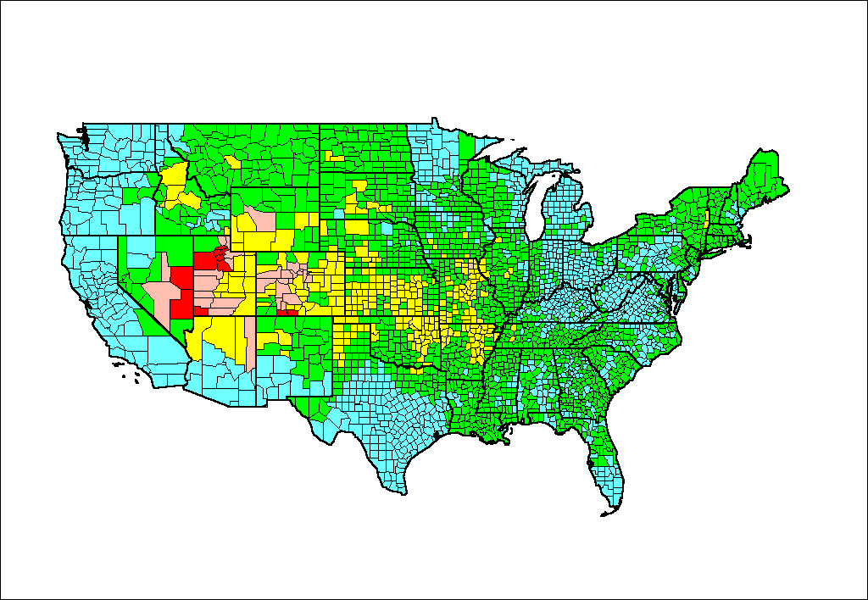
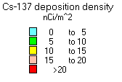
Figure 1. Cs-137 deposition density due to all NTS tests.

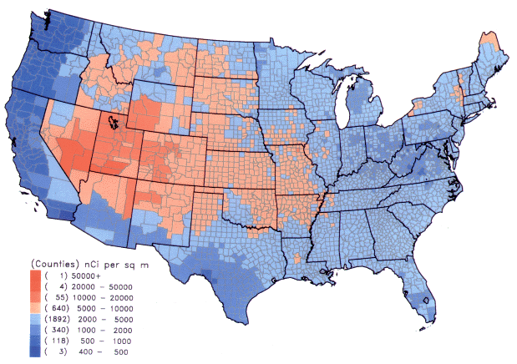

Figure 2. I-131 deposition density due to all NTS tests.
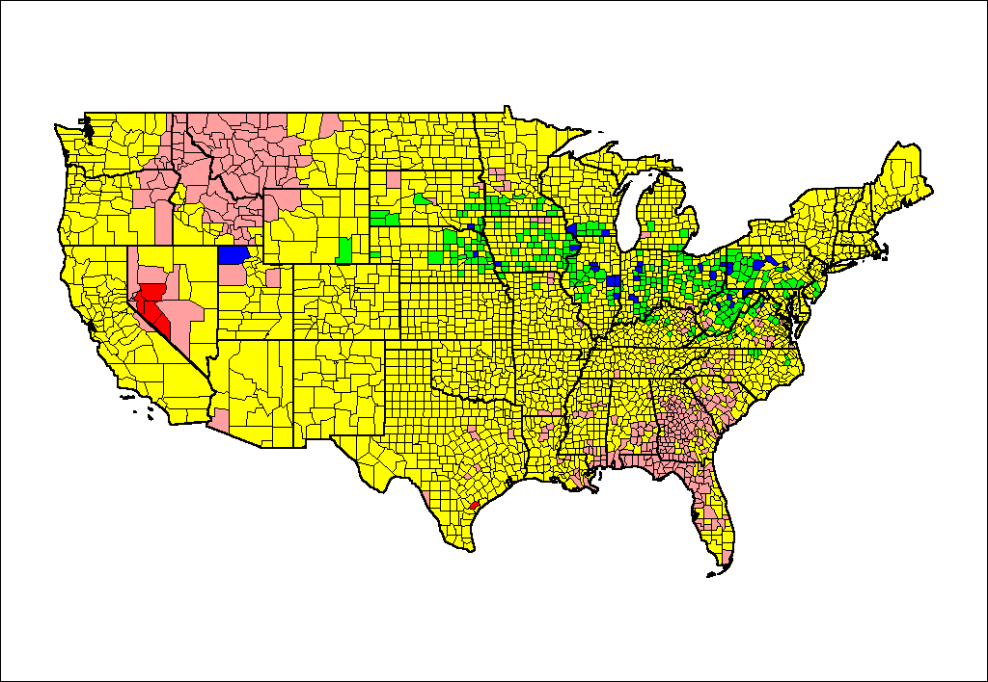
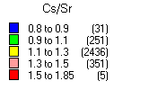
Figure 3. Ratio of Cs-137 to Sr-90 deposition density from all tests. Number of counties in each group shown in parenthesis.

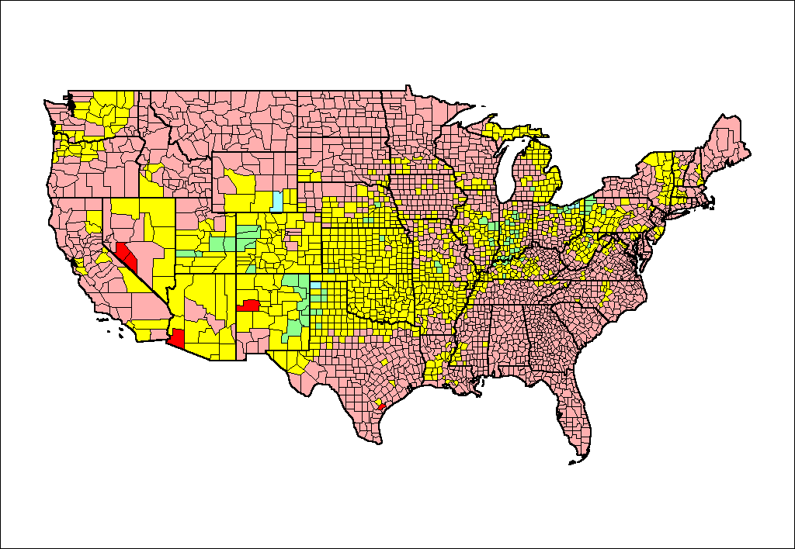
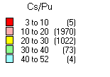
Figure 4. Estimated ratio of Cs-137 to Pu-239+249 deposition density. Number of counties in each group shown in parenthesis.

Figure 5. Fraction of total Cs-137 deposition from each test series.

Figure 6. Ten tests depositing the greatest amounts of Cs-137 in the continental U.S.

Figure 7. Ten tests producing the greatest population-weighted Cs-137 deposition density.

Figure 8. Cumulative Cs-137 deposition relative to total produced versus distance from the NTS.

Figure 9: Cumulative Cs-137 deposition relative to total deposited in the U.S. versus distance from the NTS.

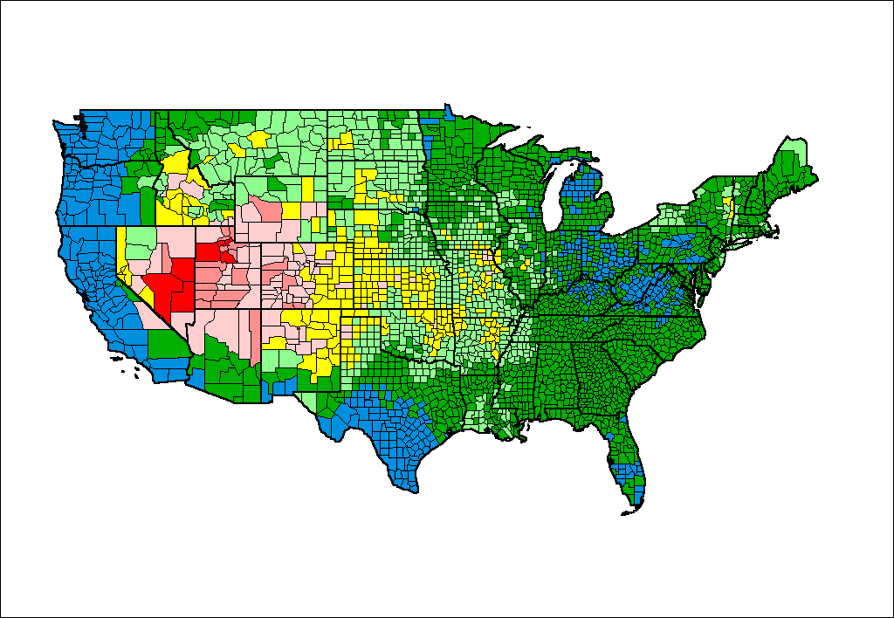
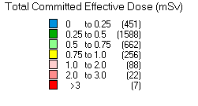
Figure 10: Total dose to average exposed individual from all tests. Number of counties in each group shown in parenthesis.
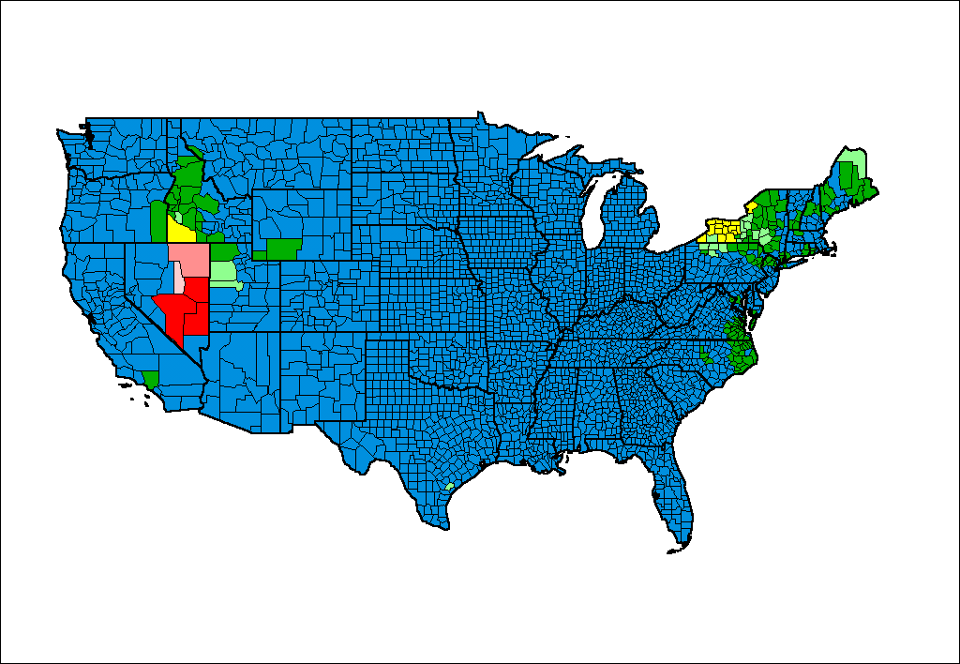
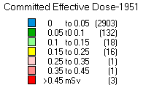
Figure 11. Dose to average exposed individual from tests in 1951. Number of counties in each group shown in parenthesis.

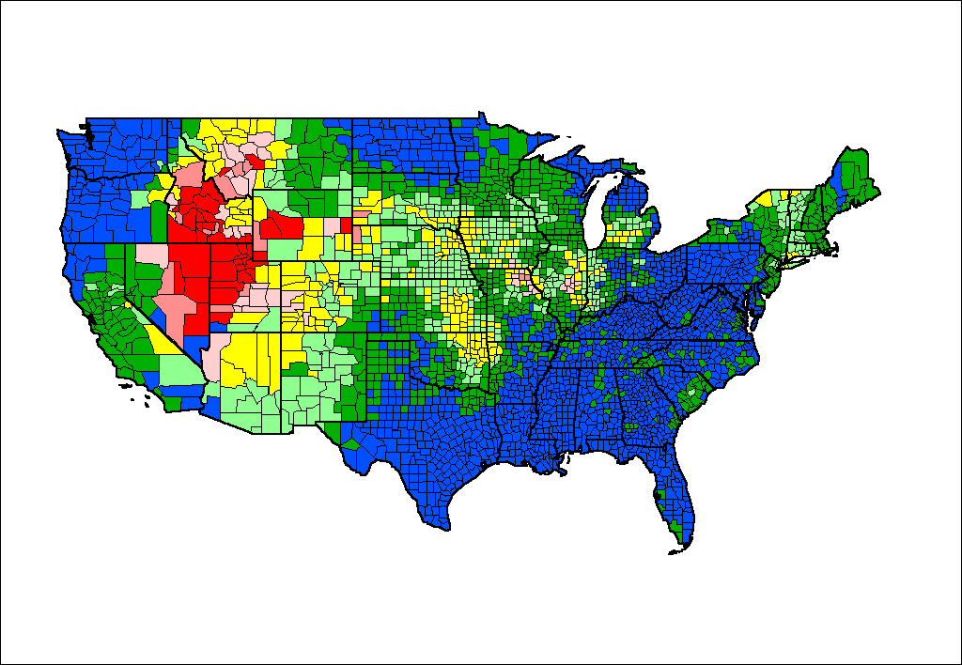
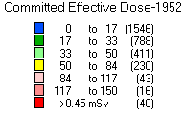
Figure 12. Dose to average exposed individual from tests in 1952. Number of counties in each group shown in parenthesis.
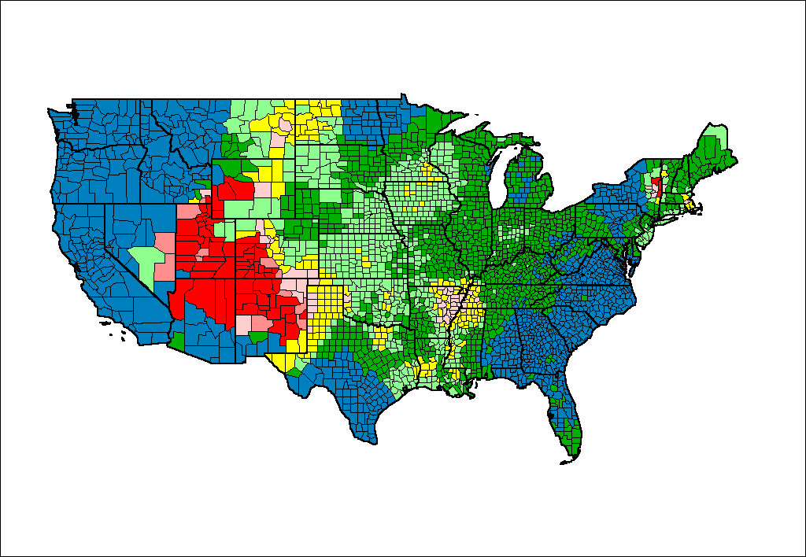
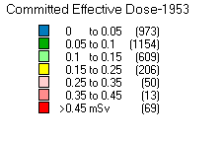
Figure 13. Dose to average exposed individual from tests in 1953. Number of counties in each group shown in parenthesis.

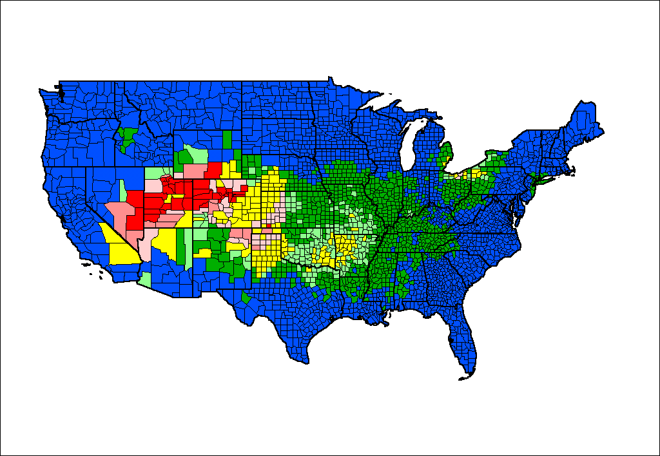
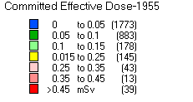
Figure 14. Dose to average exposed individual from tests in 1955. Number of counties in each group shown in parenthesis.
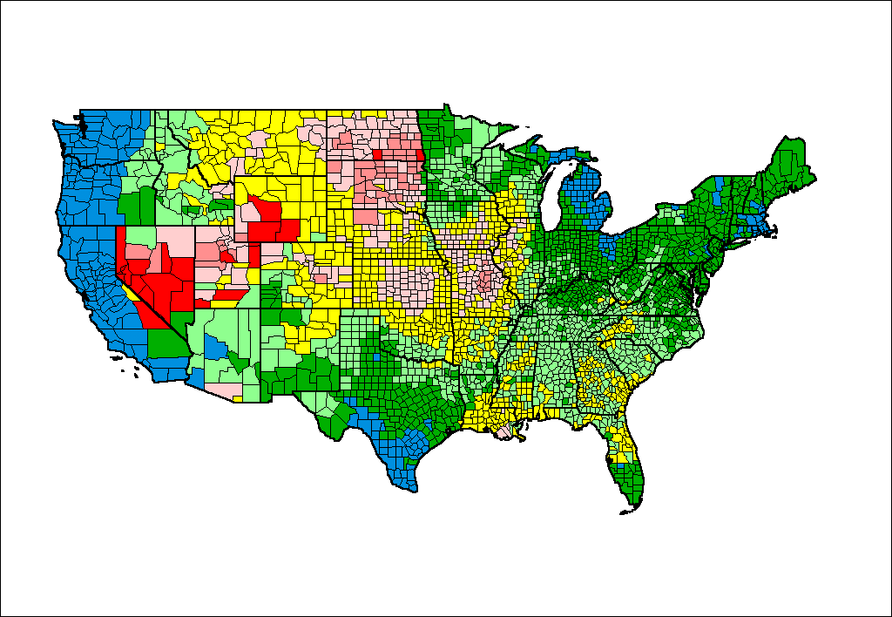
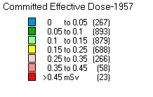
Figure 15. Dose to average exposed individual from tests in 1957. Number of counties in each group shown in parenthesis.

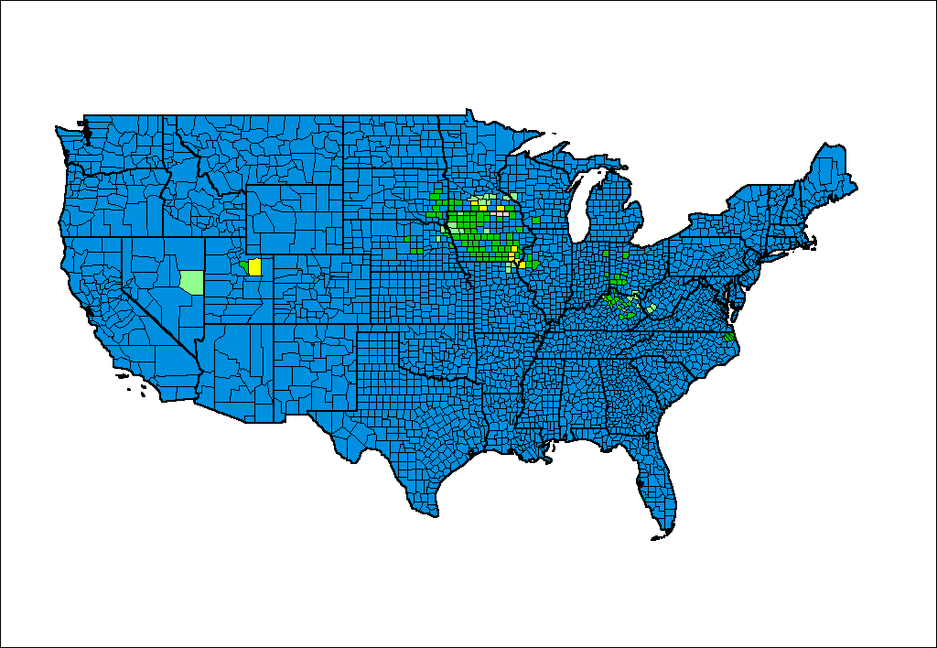
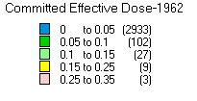
Figure 16. Dose to average exposed individual from SEDAN and Smallboy. Number of counties in each group shown in parenthesis.
Figure 17. Ten tests with the greatest contributions to total population exposure. The value for SEDAN is much more uncertain than that for the other tests.
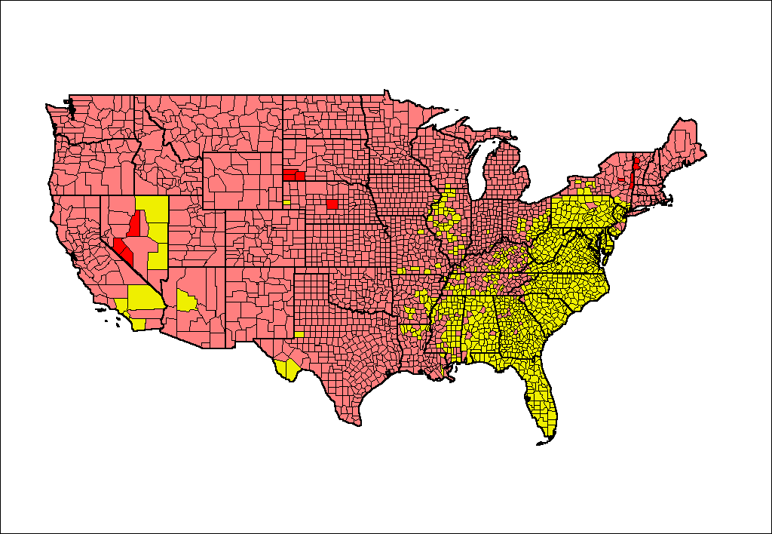
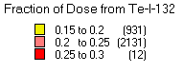
Figure 18. Fraction of total dose from Te-I-132. The number of counties in each group is shown in parenthesis.
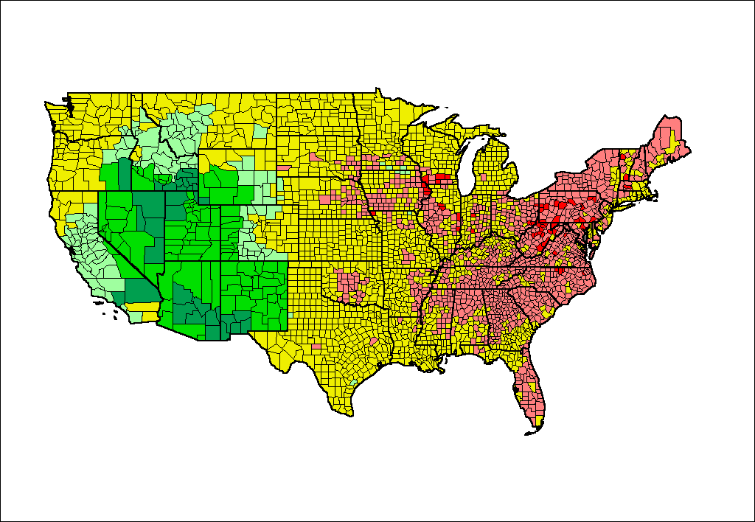
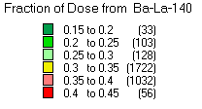
Figure 19. Fraction of total dose from Ba-La-140. The number of counties in each group is shown in parenthesis.
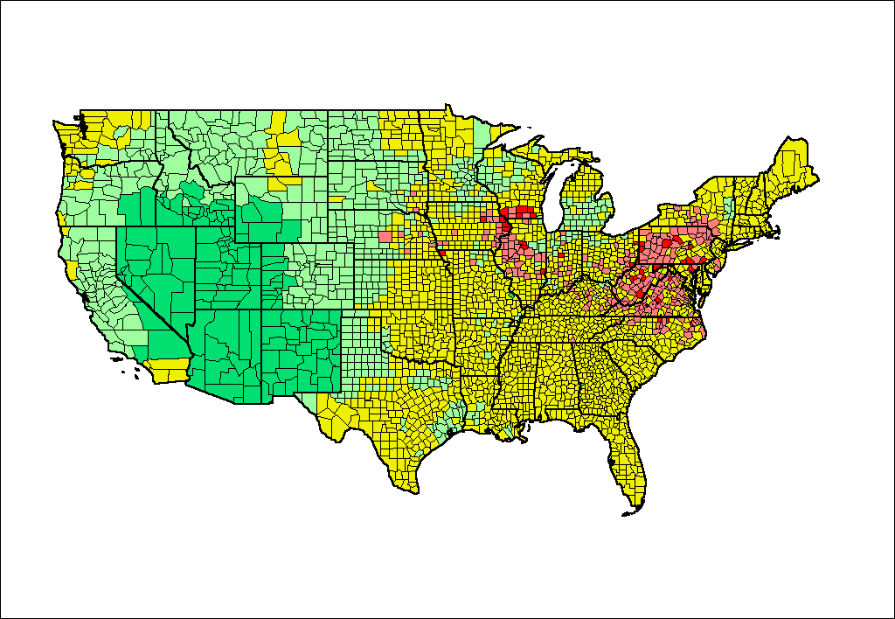
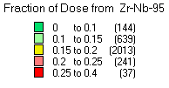
Figure 20. Fraction of total dose from Zr-Nb-95. The number of counties in each group is shown in parenthesis.
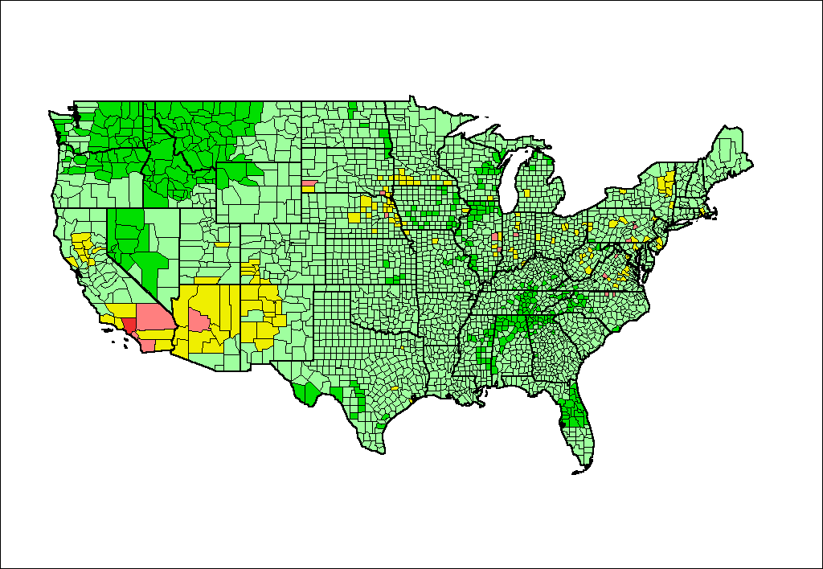
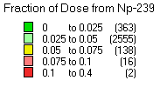
Figure 21. Fraction of total dose from Np-239. The number of counties in each group is shown in parenthesis.
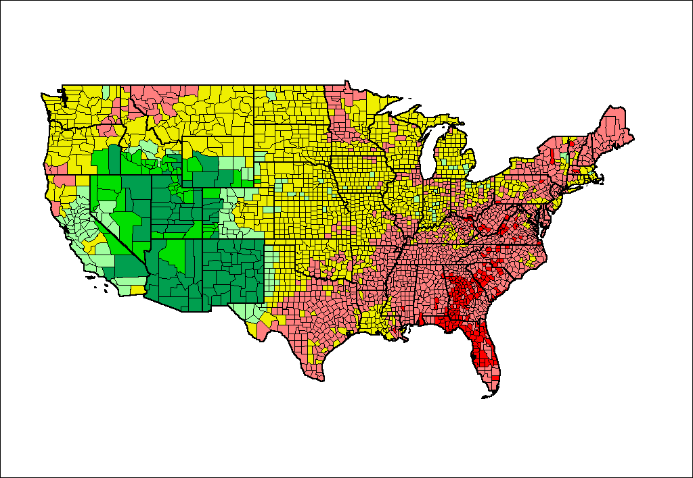
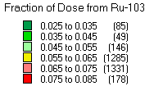
Figure 22. Fraction of total dose from Ru-103. The number of counties in each group is shown in parenthesis.

(The very low Np-239 values given by Hicks for some shots that apparently used very little Pu, suggests that U-233 may have been used in a few tests.)
Note that the county Pu deposition-density estimates for a particular are correlated since the uncertainty in Cs/Pu (or I-131/Pu) is the same for all counties for a given test. Thus the uncertainty in the Pu deposited in the U.S. from a given test will have minimum uncertainty of GSD=1.5. This correlation was accounted for in calculating the total Pu deposition for the U.S. discussed later in this report.

