NEWSS NEWS

NORTHEASTERN WEED SCIENCE SOCIETY Newsletter
August 2006

Comments from the President
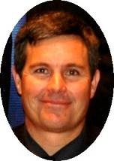

Bill Curran
NEWSS President

The program for the 61st annual meeting at the Renaissance Harborplace in Baltimore is quickly coming to together. This is an excellent venue right on the inner harbor of Baltimore within close proximity to great restaurants, shopping, the Baltimore Aquarium, ESPN Zone, etc. Jerry Baron, with IR-4 Rutgers is our 2007 Program Chair and along with the Executive Committee, Section Chairs, and others in the society, has been working hard at developing some excellent symposia. This year’s program should offer some new activities and opportunities to our membership, so mark your calendar for January 2 through 5, 2007 and submit a paper title by Sept. 8, 2006 and plan to participate (see Hilary’s call for papers).

61st Annual NEWSS Meeting, January 2-5, 2007
Renaissance Harborplace Hotel
202 East Pratt Street / Baltimore, MD 21202
Phone (410) 986-4861; Fax (410) 783-9676
Toll-free Renaissance Reservations – (800)468-3571
http://marriott.com

The 24th Annual NEWSS Collegiate Weed Contest was held on August 1, 2006 at DuPont’s Stine-Haskell Research facility near Newark, DE. DuPont’s Pat Reardon and Greg Armel along with a host of other volunteers organized and lead an excellent contest. There were a total of 44 university students from six universities on 16 teams along with four FFA students participating at this year’s collegiate contest. We had about 60 volunteers helping with this always challenging contest, but the students and volunteers did a great job and once again, it proved to be a positive experience for all. Congratulations to the NC State graduate team for their first place win, Cornell University for second place, and the Penn State graduate team for third place. Among the undergraduate teams, Guelph teams took both first and second place and the Penn State team placed third. Individual awards went to Virender Kumar from Cornell with the first place graduate award, Wesley Everman from NC State came in second, and John Willis from Virginia Tech took home third place. The undergrads from Guelph dominated the individual awards with Adam Pfeffer, Chrissie Schill, and Jim Burns taking first, second and third places in the undergrad division. The collegiate weed contest is an important activity for the NEWSS and really helps bring students, university faculty and staff, public sector employees, and the industry together for a very rewarding experience. We have not yet identified a host for the 2007 contest, so if you are interested in hosting, helping, or have location ideas, we would love to hear from you.

Finally, at the August Executive Committee meeting that followed the collegiate contest, the Draft NEWSS Future Committee report was discussed. The current draft (dated June 10, 2006) is posted on the NEWSS website for your review. The Future Committee’s work and what this generates is part of a multi-year strategic planning process that begins with some tactical assessment of what our members think are good about the NEWSS and what should be done differently. For the annual meeting, we would like to develop a survey tool that could help assess what you think is important for our society and how should we change over the 3 to 5 years. The Future Committee report determined a number of issues and opportunities including identifying our current general society makeup and objectives, opportunities for growth, recommended structure and content for the annual meeting, composition/responsibilities of the Executive Committee and Section Chairs, society management and potential collaboration with others, and some income/product opportunities that we might investigate. Over the next few months we will work at developing a survey to help us assess how the membership feels about these issues and opportunities to can help guide us into the future. We certainly look forward to hearing your thoughts and opinions. Most importantly, plan to attend the annual meeting and let your opinion be heard!

Deadlines! Deadlines!
Title Submission: September 8, 2006

Award Nominations: September 15, 2006

Nomination for Vice-President: September 30, 2006

Abstract/Key Word Submission: October 20, 2006

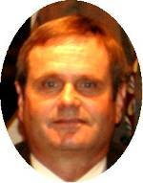
Call for Vice-President and NEWSS Awards Nominations
Tim Dutt
Past President

The Executive Committee is requesting nominations from the membership for the NEWSS office of Vice-President. The Vice-President serves as chairperson of the program committee and automatically succeeds to the offices of President-Elect, President and Past-President. Nominees for Vice-President will have been members of NEWSS for at least three years. By general rule, the Vice-President elected at the 2007 Annual Business Meeting should be selected from members who are employed in the public sector (University, Federal, State, etc.). Send nominations to the nominating committee chairman by September 30, 2006:
Scott Glenn – Chair
NEWSS Nomination Committee
University of Maryland
Plant Science & Landscape Architecture (PSLA)
2102 Plant Sciences Building
University of Maryland
College Park, MD 20742
Phone: 301 405-1331
Fax: 301 314-9041
E-mail: sglenn@umd.edu

This is the last call for nominations for the following 2007 NEWSS awards:
Distinguished Member
Award of Merit
Outstanding Educator
Outstanding Researcher

Please nominate deserving members by the deadline of September 15, 2006. Complete the attached award nomination form and send to Tim Dutt, Awards Committee Chairperson, at the following address:
Tim Dutt
8482 Redhaven Street
Fogelsville, PA 18051
610-285-2006
tedutt@ptd.net
(Click on above icon for 2006 Nomination Form)

62st Annual Meeting (2008)

Renee Keese
NEWSS President - Elect

The 2006 weed contest was very successful – thanks to all the volunteers and the efforts put in by the students. We are still in need of a contest host for 2007. Several universities and industries have been contacted about hosting the contest and we are awaiting their decision. Another possibility would be to have a joint contest with the NCWSS (North Central) or SWSS (Southern). The response from NCWSS was very favorable regarding a joint contest that possibly could be held in Ohio or Michigan, or they come east and attend ours. They have no date or location set for next year either. We will keep seeking a host for the 2007 contest.

The 2008 NEWSS annual meeting will be in Philadelphia, PA, at the Sheraton Society Hill. We are still in discussion with groups who may be interested in meeting with us at this location. Addition details about the 2008 meeting will be highlighted in upcoming newsletters.

2006 Annual Meeting Program


Jerry Baron
NEWSS Vice President

The theme for the January 2007 meeting in Baltimore, MD will be Expanding our Weed Science Horizons. Because New Year’s Day falls on Monday in 2007, the Committee meeting start on Tuesday afternoon, January 2 and the full program on Wednesday, January 3 with adjournment by noon on Friday, January 5. The program will be somewhat different from past programs. Wednesday starts with the Poster Session with the rest of the day for an expanded general session. This general session will include the traditional Presidential Address plus several talk from people in academia, industry and government on various topics such as who is going to train the next generation of weed scientist, the economic impact of weeds as well as a panel discussion on Government Influence in Weed Science: Legislation, Regulation and Science Funding. During this General Session we have reserved time to open the dialogue on the recommendations of the NEWSS Futures Committee. Also included in the General Session is an Awards Luncheon. There will be the Graduate Student Mixer in the evening on Wednesday.

Thursday will consist of the traditional breakout sessions. There will be no general symposium this year. Late in the afternoon with be the NEWSS Business Meeting followed by the Social Mixer. Friday is being reserved for workshop and symposiums. We have scheduled several exciting topics including a symposium focusing on new and innovative herbicides compounds for turf and how they impact golf course maintenance, an invasive weeds symposium with the theme of reforesting invaded riparian corridors, and a horseweed biology/ecology symposium to lead to better ways of managing this troublesome biotype. There may be room for one additional symposium.

On behalf of the Executive Committee, we hope you plan on joining us at the meeting in Baltimore and participating by providing a paper or poster. Please see Hilary Sander’s article on the instructions for Call for Papers. Please feel free to contact me or any member of the Program Committee if you have any ideas or suggestions for discussion groups or workshops that would add to the sectional breakouts.
*Click on address below to find a listing of Program Committee members and their contact information.
http://www.newss.org/society.php

NEWSS Website Update


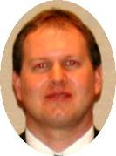
Hilary Sandler
Editor
and
Dwight Lingenfelter
Public Relations

We successfully moved the NEWSS web site to host server, A Small Orange, in February 2006. The change in host server has provided great cost savings to the society (fees of $5 per month instead of $50 per month with our previous server). Updates and management have been under the (part-time) efforts of Robert Dickerson from Penn State University. Rob has been working on the development of the title and abstract submission forms, which should be up and running at the time of publication of this newsletter. The web site is still a work in progress and we are working hard to improve the site every day, so please bear with us. Our main focus in recent weeks has been to make workable title and abstract submissions forms. We are appreciative of Rob’s efforts thus far and plan for him to continue assisting the Society as we make a transition to a more permanent arrangement.

Submitting Titles & Abstracts in 2006

Hilary Sandler
Editor

As mentioned elsewhere in this newsletter, we have switched to a new host server, A Small Orange. Thus, the web site looks a bit different this year. We hope you will find the title and abstract process simple to use. It is a bit different than last year, so please try the following steps when you are ready to submit your title.

If you know of someone who is not a member who would like to submit a paper, please have them contact me at hsandler@umext.umass.edu or (508)295-2212 x21 so that we can get them the correct paperwork.

SIGN-IN. Go to the home page of the web site (http://www.newss.org) and sign in as a member using the password, “NEWSS2006”.

SUBMIT TITLE. Simply follow the site’s instructions for submission. Select your preference for paper section (Ornamentals, Biology and Ecology, etc.). Enter the title and authors’ names in the spaces provided. Be sure to use the pull-down menus at the right to indicate member status and to indicate if an author is the presenter or not. It is critical that we know which papers will be competing in the graduate student contest, so please be sure to indicate this on the title submission form. For the September 8th deadline, fill in the title, authors, and affiliations (type in as it would appear in the final abstract). Try to make sure you have everything as you want it before submitting. Click on the ”Submit” button when you have entered all the information. There is no way to view your title prior to submission other than what you see on the screen. If you make an error, you must submit a new form. If I see multiple forms have been submitted by the same author, I will assume the most recent one is the correct one, unless told otherwise.

SUBMIT ABSTRACT. Sign into the member portion of the web site as above and click on the link to submit an abstract. Scroll down to the part of the window and click anywhere in the area designated to hold the abstract. Cut and paste your abstract in the box provided. There is no need to include the title and authors in the “cut and paste” portion since the correct information has already been entered in the boxes at the top of the page. I would recommend making all changes prior to pasting into the submission form. NOTE: If you have changed authors (added or deleted) or made a title change, please send me an email (hsandler@umext.umass.edu and one to jbaron@aesop.rutgers.edu ) to alert us to the change.

ACTION SUMMARY: For the September title deadline, type in title, authors’ info, section preference and submit. For the October abstract deadline, enter author information as indicated, cut and paste abstract, select keywords and submit.

BROWSER ISSUES. We believe the submission process works fine with Internet Explorer. If you are using browsers other than IE and seem to be having difficulty getting things to work, please let me know.

Graduate Student Report

Jacob Barney
Graduate Student Rep

I would first like to congratulate all of the participants, and especially the winners, at the Collegiate Weed Contest held in Newark, DE. I was impressed by the turn out, and encouraged by the enthusiasm that exists in our field. I hope you continue to participate and encourage new students to join in future years.
I am looking towards the annual meeting in Baltimore for themes for the mixer. I have some ideas, but would encourage you to submit any thoughts you have as well.
I am nearing the end of my term as your GSR and continue to search for an interested individual to take my place on the NEWSS Executive Board. The responsibilities are few, and the rewards are great! As GSR, you have the opportunity to have a voice for the graduate students in our society in the decisions made by the governing body of the society. Specific responsibilities include articles for the newsletters, electronic survey after the weed contest, organizing a theme and speakers for the mixer at the annual meeting, and attending board meetings (conference call in March, day after weed contest, October at site of annual meeting, and at annual meeting). Travel expenses related with traveling to the October board meeting are now covered by the society. This experience has allowed me the opportunity to witness the workings of our society and make numerous contacts with colleagues. I strongly encourage any students interested to contact me. You can serve for either two or three years.
I will be sending a survey regarding the weed contest to all of you who participated soon – watch your email.

Washington D.C. Report
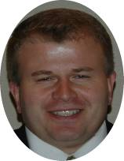
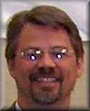
Dan Kunkel
Legislative Committee
and
Lee Van Wychen
Director of Science Policy

Weed Science Research Funding- House Agriculture Appropriations

The House of Representatives (House) passed their FY2007 Agriculture Appropriations Bill on May 24. The House budget for USDA has a lot of good news and a little bad news for weed science compared to the Administration’s budget proposal. Given the extremely tight budgetary conditions here in DC, weed science has a lot to be thankful about. It’s now up to the Senate to pass their version of the Agriculture Appropriations bill which should happen a week or two after the Memorial Day recess.

THE GOOD NEWS: In the House Agriculture Appropriations Bill, the FY2007 USDA Cooperative State Research, Education, and Extension Service (CSREES) budget for the National Research Initiative (NRI) competitive grants program is $190 million, an increase of $8,830,000 above the amount available for FY2006. The Administration’s budget proposed to move the USDA CSREES Section 406 Programs into the NRI, but the House Ag Appropriators wanted to keep the Section 406 Programs where they are. Section 406 Programs include the Regional Pest Management Centers, Crops at Risk from the Food Quality Protection Act (FQPA) Implementation; FQPA Risk Mitigation Program for Major Food Crop Systems; and the Methyl Bromide Transition Program.

MORE GOOD NEWS:
- For payments under the Hatch Act, the House of Representatives provided an appropriation of $183,275,000, an increase of $6,306,000 above the amount available for FY2006 and an increase of $6,355,000 above the President’s budget request. This funding level represents a 3 percent increase above the FY2006 funding level and the first time since FY1999 that funding has increased for the Hatch Act.

- For cooperative forestry research (McIntire-Stennis), the House provides an appropriation of $22,668,000, an increase of $660,000 above the amount available for FY2006 and an increase of $685,000 above the budget request. This funding level represents a 3 percent increase above the FY2006 funding level and is also the first increase in this program since FY1999.

- The House Appropriations Committee provided increases or level funding for 4 USDA CSREES special grant programs for agricultural research on improved pest control. Among these programs, IR-4 increased $108,000 over FY2006 to $10.79 million, the IPM program increased $174,000 over FY2006 to $2.57 million, and the Pest Management Alternatives Program (PMAP) remained level to FY2006 funding levels at $1.42 million.

- The House also increased appropriations for the Smith Lever Act Sections 3(b) and 3(c) by $7.5 million for a total budget outlay of $281.4 million in FY2007. On average, Smith-Lever formula funds account for about 30% of a state’s total funding for extension programs.

- Under the USDA Agriculture Research Service (ARS), the House provided an increase of $100,000 for a total of $525,745 in FY2007 for expanded research on invasive aquatic weeds carried out at Ft. Lauderdale, Florida.

- The House Appropriations Committee provided $425,000 for the New England Center for Invasive Plants in Connecticut, Vermont, and Maine. This is a new award in FY2007. The goal is to develop a multi-state, interdisciplinary research program to address the problems caused by invasive species that are important to New England and the nation. There are five main goals: (A) development of non-invasive, sterile landscape plants; (B) assessment of the ecological impact of invasive plants and ecological evaluation of new ‘‘super-sterile’’ cultivars; (C) assessment of the economic impact of invasive species in New England; (D) development of alternative native crops; and (E) public education and outreach efforts to limit and control invasive species. More than 12 faculty members at the University of Connecticut, University of Vermont, and University of Maine will be involved in this project. The total estimated amount contributed by the three universities in the form of faculty salary and associated fringe benefits based on the faculty time commitment to this project is $40,000 per year. In addition, no indirect costs will be charged to the project. The indirect cost of this project is about $66,300. Thus, the total amount contributed to this project from non-federal sources is more than $100,000.

THE BAD NEWS: President Bush’s budget proposed a new USDA program for invasive species that included $9.9 million for competitive grants to private groups for eradication and control of invasive species through the use of new and innovative methodologies. Unfortunately, the House Agriculture Appropriators did not include any money in the USDA budget for this initiative nor did they include the $15 million appropriation authorized in the 2004 Noxious Weed Control and Eradication Act. The House Agriculture Appropriations bill also directs the USDA ARS to terminate the Poisonous Plant Research Laboratory in Logan, UT, for a savings of $1,400,757. However, I’m sure Senator Bennett (R-UT), Agriculture Appropriations Chair, will have something to say about this.

Weed Science Research Funding- House Appropriations for the Department of the Interior, Environment, and Related Agencies

The House Appropriation bill for the Department of the Interior (except the Bureau of Reclamation), the Environmental Protection Agency (EPA), and for other related agencies, including the Forest Service was passed by the House on May 18, 2006. Under the Land Resources section in the Bureau of Land Management (BLM), the House Appropriations Committee recommends $187 million for land resources, $350,000 above the president’s budget request, but $382,000 below the FY2006 enacted level. The BLM is responsible for the multiple use management, protection, and development of minerals, timber, rangeland, fish and wildlife habitat, and wilderness on about 261 million acres of the Nation’s public lands as well as management of 700 million additional acres of Federally-owned subsurface mineral rights. The BLM is the second largest supplier of public outdoor recreation in the Western United States. Changes from the President’s budget request include increases of $500,000 in range management for invasive species work; $400,000 in forestry as a general increase; and $250,000 in riparian management to work on the Santa Ana River wash project, CA.

The Fish and Wildlife Service (FWS) received $1.3 billion in the House bill, a decrease of $55 million from the FY2006 enacted amount and $2 million below the president's request. The largest decreases would be in construction (zero funds would be provided, down from $30 million last year), and state and tribal grants, which would be funded at $50 million, down $17.5 million from FY2006. Other FWS subtotals include $80.5 million for the Cooperative Endangered Species Conservation Act, down slightly from fiscal 2006, and $36.6 million for the North American Wetlands Conservation Fund.

As the Nation's largest water, earth, and biological science and civilian mapping agency, the U.S. Geological Survey (USGS) collects, monitors, analyzes, and provides scientific understanding about natural resource conditions, issues, and problems. The House appropriated $986 million for the USGS, up $16 million from FY2006.

The House appropriated $7.566 billion to EPA, which is a decrease of $58.5 million below the FY2006 level. However, in the EPA’s Office of Science and Technology, pesticide licensing of new pesticides increases $303,000 to $2.7 million over FY2006 and pesticide review / re-registration increases $340,000 to $2.8 million. The Science and Technology account funds all EPA research carried out through grants, contracts, and cooperative agreements with other Federal agencies, States, universities, and private business, as well as in-house research. The EPA Environmental Programs and Management account encompasses a broad range of abatement, prevention, and compliance activities. The House Appropriations committee passed a $2.5 decrease for pesticide licensing activities in the Environmental Programs and Management section compared to FY2006 allocation, but is an increase of $4.5 million over Administration’s budget request of $118.3 million for FY2007.

The House Appropriation’s committee recommended that the EPA’s Pesticide Safety Education Program should continue to be funded at $1.2 million in FY2007 using the services of the USDA CSREES. Furthermore, the House commends the Agriculture Container Recycling Council for its development of a voluntary program for recycling agricultural and professional specialty pesticides containers. This program has facilitated the proper disposal of millions of plastic pesticide containers at no cost to farmers. The EPA has been developing regulations on this recycling and, to ensure the program remains a viable, free service that is available to agricultural producers, the House Appropriations Committee expects EPA to issue a final rulemaking on the recycling of high density polyethylene pesticide containers within 60 days of enactment of this Act.

The U.S. Forest Service (USFS) manages 192 million acres of public lands for multiple use Nationwide, including lands in 44 States and Puerto Rico, and cooperates with States, other Federal agencies, Tribes and others to sustain the Nation’s forests and grasslands. The National Forest System (NFS) includes 155 National forests, 20 National grasslands, 20 National recreation areas, a National tallgrass prairie, 6 National monuments, and 6 land utilization projects. While USFS policy is authorized by the House and Senate Agriculture Committees, funds are appropriated through the House and Senate Appropriations Subcommittee for the Department of the Interior, Environment, and Related Agencies.

The House Appropriations Committee recommends $280 million for forest and rangeland research, an increase of $12.5 million above the President’s budget request and $2.6 million above the FY2006 enacted level. Within the National Forest System (NFS) account, the House recommends $180 million for vegetation and watershed management, an increase of $148,000 above the FY2006 funding level.

Salt Cedar and Russian Olive Control Demonstration Act

On May 2, 2006, the House of Representatives passed H.R. 2720, the Salt Cedar and Russian Olive Control Demonstration Act. The Senate version of this bill, S. 177 now waits approval in that chamber. H.R. 2720 would authorize the appropriation of $20 million in FY2006 and $15 million for each of fiscal years 2007 through 2010. Of this, not more than 15 percent shall be used to pay for administrative costs to carrying out the program. H.R. 2720 directs the Secretary of the Interior, acting through the Commissioner of Reclamation and the Director of the U.S. Geological Survey, to carry out a salt cedar (Tamarix spp) and Russian olive (Elaeagnus angustifolia) assessment and demonstration program to: (1) assess the extent of the infestation by salt cedar and Russian olive trees in the western United States; (2) demonstrate strategic solutions for the long-term management of such trees and the reestablishment of native vegetation; and (3) assess economic means to dispose of biomass created as a result of removal of those trees. H.R. 2720 also directs the Secretary of Interior and the Secretary of Agriculture to enter into a memorandum of understanding for the administration of such program.

H.R. 2720 would limit the costs of the assessment phase to $4 million, would limit the identification and documentation of strategies for long-term management at $2 million, would limit demonstration projects to $7 million, and would limit the analysis of the biomass disposition phase to $3 million. Work done on federal land would receive 100 percent funding while work done on private land would require a minimum of 25 percent cost share of the federal grant dollars.

The 2007 Farm Bill and NIFA

There is a possibility that the 2002 Farm Bill may be extended another year into 2008 or even extended indefinitely without reauthorization next year. Many people feel the 2002 Farm Bill is as good as it gets for agriculture. There are many factors at play including World Trade Organization (WTO) negotiations and politics.

Several different proposals exist to reorganize/restructure federal agricultural research funding. The USDA Research, Education and Economics task force found that America’s inadequate funding of agriculture research puts the nation’s farmers at a disadvantage from foreign competitors. One key recommendation from the task force suggested establishing a National Institute for Food and Agriculture (NIFA) at the USDA which would supplement ongoing research by providing all agriculture researchers additional funds through a competitively awarded grant program. On May 10, Sen. Talent (R-MO) was joined by cosponsors Harkin (D-IA), Bond (R-MO) and Lugar (R-IN) in introducing the NIFA Act of 2006 (S. 2782).

The amount of funding going into research to improve profitability on farms, economic growth and jobs in rural America, consumer well-being, and conservation of natural resources has remained flat for roughly two decades. USDA’s task force noted that the amount of funding designated for competitively awarded, peer-reviewed agriculture grants is outpaced 100 to 1 by the National Institutes of Health. NIFA would increase funds available for food and agriculture research in addition to the current available resources at USDA-ARS and CSREES.

Some agricultural research coalitions support NIFA and others are cautiously following the developments, which is the WSSA’s position at this point. Stakeholder buy-in will be the key especially from USDA ARS and CSREES. It is safe to say there will be no action on S. 2782 this Congress beyond a possible hearing and informal debate among stakeholders. The bill’s sponsors and supporters view introduction of the legislation as laying the groundwork for consideration during next year’s anticipated reauthorization of the farm bill.

Maxwell and Gopinath Speak on Capitol Hill and at USDA about Economic Impact of Invasive Weeds

On May 5, the WSSA along with the Council on Food, Agricultural and Resource Economics (C-FARE) co-hosted 2 one hour briefings on Capitol Hill and USDA to highlight federally funded research for invasive weeds. The title of the seminar was “Researching Invasive Weeds: Tools for Policy Makers”. Dr. Bruce Maxwell (WSSA) and Dr. Munisamy Gopinath (C-FARE) presented preliminary work from research funded by the USDA Economic Research Service (ERS) Program of Research on the Economics of Invasive Species Management (PREISM) program, and other federally funded competitive grants.

Dr. Maxwell, Montana State University, discussed his work on developing and integrating tools for assessing the impacts of invasive plants for prioritization on federal lands. Dr. Maxwell’s project developed a GIS-based decision support system for management planners based on economic tradeoff analysis.

Dr. Munisamy Gopinath, Oregon State University, analyzed the role of stakeholders’ interest and input in explaining cross-state differences in noxious weed regulations. In particular, his work identified the trade-offs which consumers, environmentalists, and seed and commodity producers face in their decision to support or oppose noxious weed regulations.

Derr Visits DC for CoFARM/BESC Congressional Visits Day

On March 14 and 15, 2006, WSSA Vice President Jeff Derr represented the WSSA at the Coalition on Funding Agricultural Research Missions (CoFARM) - Biological and Ecological Sciences Coalition (BESC) program in Washington D.C organized to generate congressional support for the agricultural and biological sciences. Over 50 scientists from other scientific societies including the American Institute of Biological Sciences (AIBS), the Tri-Societies (ASA-CSSA-SSSA), and the Ecological Society of America (ESA) participated in this two day event.

Unfortunately, I could not join Dr. Derr for this event as it conflicted with the WSWS meeting in Reno, NV. However, Jeff was generous enough to write the following report of his activities on March 14 and 15:
On the first day, we were briefed on the 2007 federal budget for agricultural and biological research funding. Several prominent people provided their perspectives on the science budget which included: Kei Koizumi, Budget Analyst, American Association for the Advancement of Science (AAAS); Jim Collins, Assistant Director for Biology, National Science Foundation (NSF) Biology Directorate; Anna Palmisano, Deputy Administrator, Competitive Programs, USDA CSREES; Dan Byers, Deputy Chief of Staff, Office of Science and Technology Policy (OSTP); and David Goldston, Chief of Staff, House Science Committee. There also was a congressional visits training workshop conducted by Adrienne Sponberg. In the evening, a reception was held to honor the contributions for Reps. Vern Ehlers (R-MI) and Rush Holt (D-NJ), two congressmen who have supported science research funding.

The next day, we attended a CoFARM-sponsored breakfast with Dr. Pearson, former USDA Deputy Undersecretary for Research, Education, and Economics, Dr. Ed Knipling, USDA-ARS Administrator, Colien Hefferan, USDA-CSREES Administrator, Rob Hedberg, former WSSA DSP now with USDA CSREES, and other USDA officials. They spoke on the National Research Initiative (NRI), Hatch Act funding, and funding for ARS and ERS, among other issues. I then went on three congressional visits with Paul Bradley, a student representing the Virginia Institute of Marine Science (VIMS), and Mike Neff, representing the American Society for Horticultural Science (ASHS). We were grouped by state, our group focusing on Virginia, for our Capitol Hill visits. Surprisingly, we were able to meet with Rep. Jo Anne Davis (R-VA), who represents the Williamsburg area of Virginia. When we make these congressional visits, we need to highlight issues that are of interest to that individual representative. For Rep. Davis, who has cancer, funding for organic production and health benefits of fruits and vegetables were of interest to her. We also met with Brent Robinson, her legislative assistant. We then met with Carrie Breig, legislative assistant for Rep. Jim Moran (D-VA), who represents the Fairfax area in northern Virginia. Finally, we met with Tack Richardson, legislative assistant for Senator John Warner (R-VA). Tack was interested in the impact of invasive weeds on military installations because Sen. Warner chairs the Senate Armed Services Committee. Tack asked me for figures on the economic impact of weeds on military bases. What surprised me, though, about our discussions with Tack was his mention of National Invasive Weed Awareness Week (NIWAW) and that he had met some NIWAW 7 participants. It appears that making these Hill visits does have an impact.

I feel it was good to be there representing WSSA, since there were representatives from the entomology, plant pathology, crop/soil science, and horticulture societies, among others. Although I enjoyed meeting with representatives from organizations comprising BESC, it did make it more difficult getting across points with congressional staffers. While Mike Neff (ASHS) and I were talking about crop production and invasive plants issues that would be funded by USDA, Paul Bradley spoke about things like funding for NOAA, oyster research, and other issues, and mentioned that VIMS receives their funding primarily from NSF. In my mind, if would be preferable if agricultural representatives had separate visits from the BESC representatives, since it would allow for a more focused visit. This is important since we only had about 15 minutes to spend with the staffers and it is hard to talk about potential funding for weeds, crops, fish, oysters, weather, etc… in that time frame. I feel WSSA should continue sending representatives to CoFARM sponsored events.

EPA to Provide Financial Support for Conferences, Workshops and/or Meetings

I listed this news article in the last WSSA News and I am going to list it again. The EPA announced that it will provide financial support for Conferences, Workshops and/or Meetings on EPA mission related issues which include: 1) protecting human health and safeguarding the natural environment; 2) advancing the scientific and technical research that promotes environmental protection; 3) exploring current and emerging issues of importance to environmental protection; and/or 4) encouraging collaboration among the nation’s best scientists and engineers in academia, business and nonprofit research institutes.

The EPA expects $750,000 will be available in grant funds through 25 awards. Applications for grant funding will be due and approved on a quarterly basis through January 18, 2007. Eligible Applicants include city, county and state governments, public and private institutions of higher education and certain nonprofit organizations. Details are posted at http://www.epa.gov/ord/grants_funding/pdfs/BAA_conferences_011806.pdf - EPA Contact: Michael Bender at 202 564 6829; e-mail: Bender.Michael@EPA.gov

Lee Van Wychen, Ph.D.
Director of Science Policy
The National and Regional Weed Science Societies
900 2nd St. NE, Suite 205
Washington, DC 20002
Lee.VanWychen@WeedScienceOrgs.com
work: 202-408-5388
fax: 202-408-5385

WSSA Report
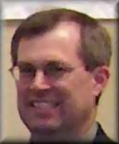
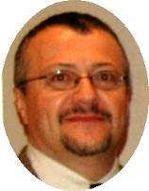
Jeff Derr
WSSA Vice-President
and
Toni DiTommaso
WSSA Representative

Annual Meeting
The 2007 WSSA annual meeting will be held in San Antonio at the Hyatt Regency Riverwalk February 5-8, 2007. This is a nice hotel right in the middle of Riverwalk, an area of restaurants, hotels, and shops along the San Antonio river. The hotel is very close to the Alamo. See http://sanantonioregency.hyatt.com/hyatt/hotels/index.jsp for more details on local attractions.
Registration fees for the 2007 annual meeting will remain at 2006 levels except rates for students, which will drop to $75 instead of $180 to 280 to encourage student attendance. Member registration will be $250 early preregistration, $350 mid-preregistration, and $405 on site. There will be an invasive plants workshop with a nonmember registration fee of $50. There will be another statistical workshop for $150. The website for title and abstract submission will open in September. Check the WSSA website (http://www.wssa.net/) for details. WSSA has signed a contract with a new firm, Oasis, to handle title and abstract submission.
There will be four symposia at the San Antonio meeting:

1. Graduate Student Symposium: Employment Opportunities for Weed Scientists and How to Make Yourself more Marketable. Organizers: John Willis, 2 hour symposium followed by a sponsored luncheon meeting for students.
2. Nursery Stock vs. Invasive Plant: Which is it, and why do we care? Organizers: Alan Tasker and Nelroy Jackson
3. Using Emerging Technologies to Study Weed Biology: an educational forum. Organizers: James V. Anderson and Wun S. Chao.
4. Integrated Weed Management Revisited. Organizer: Debanjan Sanyal.

There also will be a Vegetable Roundtable organized by the Horticulture section and Fred Salzman. Russ Wallace will lead a Leafy Greens Vegetable Tour of the Wintergarden region of Texas.

Other WSSA News
The 2008 WSSA annual meeting will be February 4-7, 2008 at the Marriott in Chicago on the Magnificent Mile. The International Weed Science Society meeting will be June 23-27, 2008 in Vancouver, Canada. WSSA will host this event and the Canadian Weed Science Society will provide local arrangements.
The WSSA website is currently undergoing revision. Plans are to go live with the new site in October.
The WSSA board is moving forward with plans to develop a new journal, one devoted to invasive plants. This journal would compliment Weed Science and Weed Technology, but reach out to a somewhat different audience than those two journals. A business plan is currently being developed and should be completed by November.
Rhonda Green has left Allen Marketing and Management. She has worked with WSSA on meeting planning for about eight years.
The WSSA board recently held a tactical planning session. Some of the projects to be undertaken include developing a list of funding opportunities for weed scientists, developing a weed science glossary in three languages (English, French, Spanish), initiation of an E-extension project, increasing the number of education and teaching articles submitted to Weed Technology, increased professional development for members, improved public awareness of Weed Science and WSSA, increased interaction with Federal Agencies, and develop of a membership brochure on the society. This is an ambitious agenda for WSSA but one that will benefit its members and the discipline of Weed Science.

Instructions for Contributors to the
2006 NEWSS Proceedings

Hilary Sandler
Editor

PAPERS RECEIVED AFTER DEADLINE WILL NOT APPEAR IN THE 2007 PROCEEDINGS.
INSTRUCTIONS ARE THE SAME REGARDLESS OF ELECTRONIC OR MAIL SUBMISSIONS.

GENERAL INFORMATION

Authors may publish abstracts or full-length papers in the Proceedings. Papers should be pertinent to the general area of weed science and should reflect the content of the presentation given at the meeting. At least one author must be a current member of the Northeastern Weed Science Society. Papers submitted after the established deadline will be published in the following year’s proceedings. Proceedings will be distributed at the meeting. Abstracts and papers must be received by Friday October 20, 2006.

GRADUATE STUDENTS: Please be sure to mark the appropriate label in the pull-down menu on the web site (as to whether you are presenting in the contest or not). When preparing the program, it is critical that we know which papers will be included in the graduate student paper and poster competition and which will not.

PREPARATION OF ABSTRACTS AND PAPERS

Please use Arial font, 12 point. Do not use bold fonts at any place in abstracts or full-length papers.

Format: Title (all CAPS), authors (initials and last name) and authors’ affiliations. Graduate student presenters should be identified by an asterisk following their name with a corresponding notation at the bottom of the abstract (see above). Title, author name(s), and author affiliation(s) should be left justified. Do not include the state abbreviation if state name appears in company or university name. The heading ABSTRACT should be centered as in the following example:

WEED RESPONSE TO CULTIVATION. J.P. Smith, H.L. Kim, B.W. Jones, Univ. of Delaware, Newark; and I.M. Weeder, Cornell Univ., Ithaca, NY.

ABSTRACT

(Body of Abstract)

In the body of full-length papers, center and capitalize all section headings (do not use underline or bold in the headings) including abstract, introduction (justification/rationale), procedures, results and discussion, and literature cited. In full-length papers, insert tables and figures in text, rather than at end of paper.

Titles: Titles should contain no more than 100 characters. Avoid using trade names, herbicide chemistry, or scientific names in titles unless essential for clarification. If the title exceeds one line, use a single space between lines.

Page limitations:

Abstracts: One page of text is permitted with a second page allowed for presentation of a table or figure. Use single spacing for the entire text. Those submitting only an abstract are encouraged to include a table if publication elsewhere is not intended.

Full-length papers: Five pages are allowed with tables and figures included in the text. Use single spacing for the entire text. A charge of $25 per page will be levied for papers exceeding the five-page limit. All excess page charges must accompany the manuscripts to the editor. Payment should be in the form of a check made out to the Northeastern Weed Science Society. A receipt will be supplied if requested.

All manuscripts:

Tables: Margins for tables and graphs must be within those specified by typing instructions. Reduced copies of tables and graphs may be used, but must be as clear as originals for acceptable printing.

Herbicide names: If a common name has not yet been approved by WSSA, use the code number. Check the Weed Science Society of America’s website http://www.wssa.net (click Weed Control, then Herbicide Names) for the current list of approved chemical and common names. Herbicide trade names may be used as long as accompanied by appropriate common name. If use of a trade name is required to properly identify product, at first mention, use the appropriate common name, immediately followed by trade name in parenthesis. Herbicide trade names are acceptable for clarification of pre-packaged mixtures. Abstracts- omit chemical names and use only common names. Full-length Papers- at the first mention of an herbicide, except in the title or abstract, give its approved common name or other designation first and follow it with the full chemical name in parentheses or in brackets if there are parentheses within the chemical name. Use only the common name or code name thereafter.

Plant and animal names: In either abstracts or full- length papers, at the first mention of a crop, weed, or other organism in the text (not the title) give the common name, followed by the approved scientific name. The scientific name should be italicized and in parentheses (use additional parentheses if there are parentheses within the scientific name). Give the genus, species, and authority for the binomial. Include the cultivated variety of a crop plant if known and indicate it by enclosing it in single quotes. Example: Corn (Zea mays L. ‘Dixie 18’). For cultivar names that are registered trade names, insert (R) after the name. For approved common and scientific names of weeds, see the WSSA web site. Click on Weed Photos and Info and then on Common/Latin Names. After the first mention, use only the common names. The term “tolerance” is not used by WSSA. Plants are considered either resistant or susceptible (i.e., triazine-resistant smooth pigweed or glyphosate-resistant soybeans)

Abbreviations: Use abbreviations as shown in the “Herbicide Handbook” or as used in one of the previous year’s issues of Weed Science. Abbreviations often causing trouble that are acceptable for NEWSS use (although not in agreement with the CBE Style Manual) include two-letter abbreviations for states, Ci for curie, M for molar (do not abbreviate mole), L for liter, ppmw for parts per million by weight, ppmv for parts per million by volume, ae for acid equivalent, and ai for active ingredient. Do not place a period after an abbreviation in the text. Do not start a sentence with an abbreviation. All abbreviations not shown in Weed Science should be introduced in parentheses immediately after the first use of the word. Example: cation exchange capacity (CEC). Do not use a hyphen for the preposition “to”; or an “x” for the preposition “by”, except in tables or figures. Write “1 to 3” rather than “1-3” and “100 by 20” rather than “100 x 20”.

Numbers: Use Arabic numbers for all numbers with two or more digits and for all measurements such as time, weight, or degrees except when the number is the first word in a sentence. Spell out numbers when they are the first word in a sentence or when they are less than 10 and not measurements, except when in a series in which one figure has two or more digits. Report only significant numbers.

Measurements and units: It is acceptable to report measurements in English or metric units. It is best to report units in the system in which the study was actually conducted. In laboratory studies, express concentration of acids and bases in normality (N) and of herbicide and salt solutions in molarity (M) rather than ppm. Use ml rather than cc for all measurements of volume.

Footnotes: Number footnotes consecutively throughout the manuscript except for tables that are handled separately. Do not put acknowledgments in footnotes.

Trade names: Use trade names of such items as equipment only when necessary to describe the materials or methods adequately. Capitalize trade names. Footnote names with the address of the supplier only if the supplier is not commonly known.

Full-Length Papers Only:

Acknowledgments: All acknowledgments should be in a separate section immediately following the Results and Discussion.

Literature cited: List citations alphabetically and use the authors and date of publication (in parentheses) in the text. Each citation should include names of all authors, year of publication, complete title, publication, volume number, and inclusive pages, in that sequence. When two or more authors are listed, initials should follow the last name for the first author, but the initials should precede the last name of other authors (see detailed instructions in the CBE Style Manual). Do not leave a space between the period after each initial and the next letter. Books, bulletins, and other similar publications should show as the last entry the number of pages in the publication. Theses, letters, or other communications or publications not normally available in libraries should appear as text footnotes and not in the Literature Cited section.

INDEXING – KEY WORDS

Authors are asked to identify a few key words for each of their abstracts or papers. This can be done at the NEWSS website http://www.newss.org. Log in using the password “NEWSS2006”, and then access the Title and Abstract option. The key words are used to make an index to the Proceedings. Please be thoughtful when choosing keywords and only list those that are necessary. Capitalize all key words and state noun first, followed by modifier as shown in the following examples: Maple, red or Corn, sweet. Do not show the authority for binomials. Key words will be indexed into the following two groups.

-Author Name(s): last name, followed by initials.

-Main Subject Index (includes herbicides, weeds, crops, non-crops and subjects). List both common and scientific name(s) for weeds, crops, and non-crop plants.

When listing chemical(s), use WSSA-approved common names, or code number only if no approved name is available. Use trade names for pre-packaged mixtures only. Check WSSA’s website http://www.wssa.net (click Weed Control, then Herbicide Names) for the current list of approved chemical and common names.

SUBMISSION INSTRUCTIONS

Go to the NEWSS web site at http://www.newss.org and enter the password “NEWSS2006” at the appropriate prompt. Follow the instructions on the web site for both title and abstract submission.

Carefully Review titles, abstracts and papers prior to submission. Once you submit on the web site, you cannot make a correction to that submission. You will need to submit a new form in order to correct mistakes. If you have submitted multiple copies, please alert the editor (hsandler@umext.umass.edu or 508-295-2212 x21). I will assume the most recent submission is the correct one unless told otherwise.

Please follow instructions and observe the announced deadline (Sept 8 for titles; Oct. 20 for abstracts).

MAILING INSTRUCTIONS

Please use the web site submission if possible. If this is not working, please email abstracts and list of key words to the email address below. If electronic submission is not available, mail an original (Fax will not be accepted) and one copy of the abstract or full-length paper, list of keywords on a separate page, and excess page charges (if applicable) to the NEWSS Editor.

Hilary Sandler
UMass Cranberry Station
P.O. Box 569
East Wareham, MA 02538
hsandler@umext.umass.edu

All copies should be mailed flat. Use cardboard on top and bottom when mailing to prevent damage.

NOTE: All authors who experience trouble on the web site and/or prefer to submit abstracts by email or snail mail are welcome to do so. However, please observe the October 20 2006 deadline!

Complete the key word list for each paper at the website http://www.newss.org. Sign in by using the password. Text files (and tables created in Word and Excel) can be cut and pasted directly into web site or sent as an email attachment. Upon receipt, files will be printed and if re-formatting is required, authors will be notified for corrections or for a hard copy.

2005 NEWSS Collegiate Weed Contest

Greg Armel
Contest Coordinator

The Northeastern Weed Science Society student contest was held at DuPont’s Stine Haskell Research Center in Newark, DE on August 1, 2006. A total of 44 graduate and undergraduate students participated from six universities. The universities represented at the contest were North Carolina State, Virginia Tech, Penn State, Cornell, Guelph, and Nova Scotia Ag College. Students participated in four contest segments including weed identification, unknown herbicide identification, sprayer calibration, and farmer problems. Greg Armel and Pat Rardon of DuPont Crop Protection organized the overall contest event while the specific contest segments were lead by Susan Rick (unknown herbicide identification), Jonathan Clark (weed identification), Pat Rardon (farmer problems), and Ray Kaczmarcyzk (sprayer calibration). Over 60 volunteers, including faculty, staff, students, extension educators, and industry sales and research representatives helped with the contest as judges, farmers, scorekeepers, and general event coordinators.

DuPont continued many of the new ideas instituted at the 2005 contest in Landisville, PA. For example, we continued the “specific characteristics multiple choice” problems for basic science characteristics of each unknown herbicide and weed biology characteristics for each weed identification problem from the 2005 contest. We also made attempts to continue the farmer problem trend set last year by including a variety of problems that were not just centered around agronomic crops, but on a variety of issues that plague many different types of growers. The farmer problem scenarios included invasive weeds in Christmas trees and apple orchards, irrigation issues in peppers, perennial weed control in corn, herbicide misapplication and drift in soybean, invasive aquatic weeds in ponds, weed control in mixed legume/grass pastures, broadleaf weed control in newly established alfalfa, and control of herbicide resistant weeds in oats.
DuPont also added a few experimental updates of our own to the contest to help us better facilitate the event. Due to the overall complexity of the Stine Haskell site we added a new group of volunteers to the contest this year. These new volunteers were called group guides and each of the 16 university teams was assigned a DuPont group guide to chaperone them around to each of the 4 contest events. This idea, brought to fruition by Marc Ruggiero of DuPont, allowed for better transition of students between sites helping us keep inline with the contest schedule. A second improvement was updating the unknown herbicide information to include the most up to date facts regarding herbicide mode/site of action. This unknown herbicide update provided additional knowledge to our students regarding the basic sciences of herbicides used in the North East region. Last but certainly not least, Raymond Forney and Cortney Timmons of DuPont incorporated a Future Farmers of America (FFA) component to the contest. Four FFA students competed in a modified version of the contest in order to educate them about the discipline of Weed Science. It is our hope that this event continues as we see this as a unique opportunity to support FFA while also encouraging new leaders in agriculture to consider a future in Weed Science.

Hosting the contest this year brought back to me many found memories of past events. It is our hope at DuPont Crop Protection that many aspects of the 2006 contest will provide fond memories for those of you who participated this year. From Jim Bone’s Georgia barbeque to Jim Collin’s talk on the future of Crop Protection to the intense 100+ degree weather to the unique atmosphere of the banquet at Uncle Bob’s Western Saloon there were plenty of things that immediately jump out to me when I try to recall the contest. I am sure in addition to these aspects of the contest each of you will have your own unique memories of the day’s events that you can share with others. On behalf of DuPont Crop Protection, I would like to thank all of the students, coaches, and volunteers who helped make this event a success and who in turn helped build memories for us all to cherish.

The overall results were as follows:

Graduate Division

1st place team: North Carolina State University (Wesley Everman, Adam Hixson)
2nd place team: Cornell (Virender Kumar, Rachel Shuler, Kristine Averill)
3rd place team: Penn State (Joe Dauer, Steven Mirsky, Atila Deak, Nick Hebrock)

1st place individual: Virender Kumar- Cornell
2nd place individual: Wesley Everman- North Carolina State University
3rd place individual: John Willis- Virginia Tech

Undergraduate Division

1st place team: Guelph (Chrissie Schill, Gerald Pynenburg, Jim Burns, Andrew Chisholm)
2nd place team: Guelph (Joel Hemingway, Adam Pfeffer, Blair Scott, William Judge)
3rd place team: Penn State (Lindsay Spangler, Jennifer Bechtel, Genny Christ)

1st place individual: Adam Pfeffer- Guelph
2nd place individual: Chrissie Schill- Guelph
3rd place individual: Jim Burns- Guelph

Currently, there are no volunteers to host the 2007 Northeastern Weed Science Society contest. The NEWSS board and DuPont Crop Protection would like to challenge all universities, agribusinesses, and government organizations to consider hosting the event next year. Please contact Bill Curran or Renee Keese if you are interested in hosting this very important event for the society.

Sprayer Calibration Event

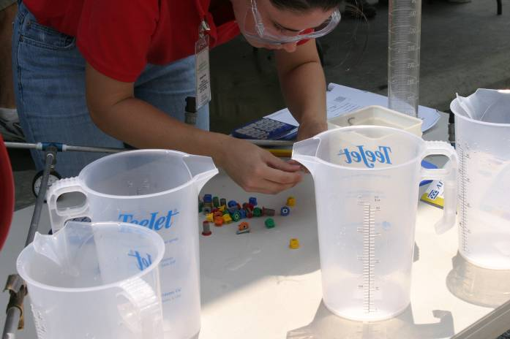

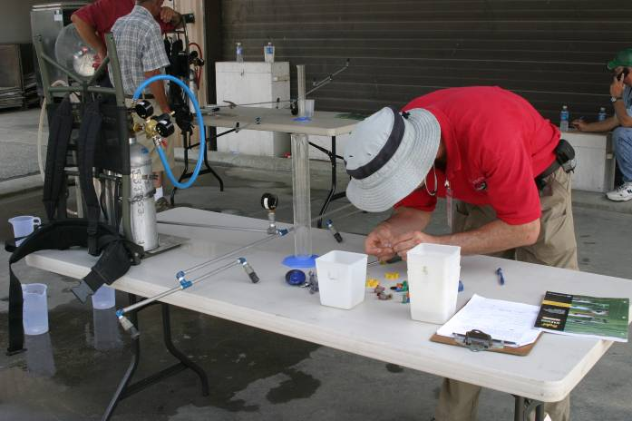

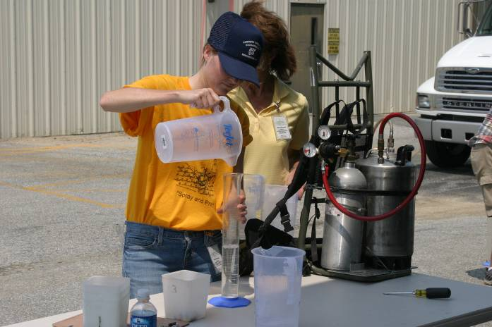

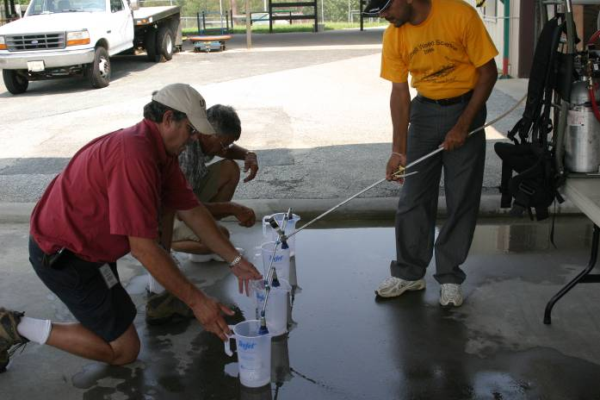

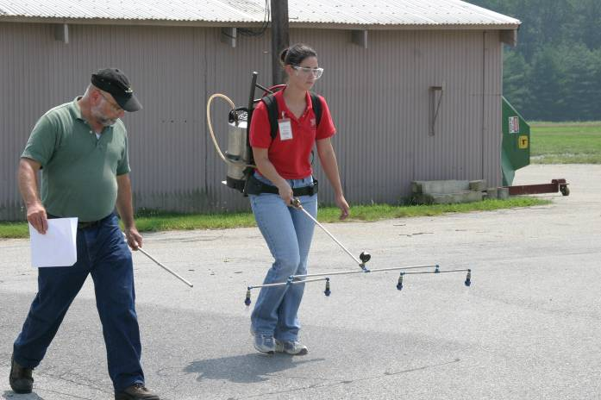

Grower Problem Event

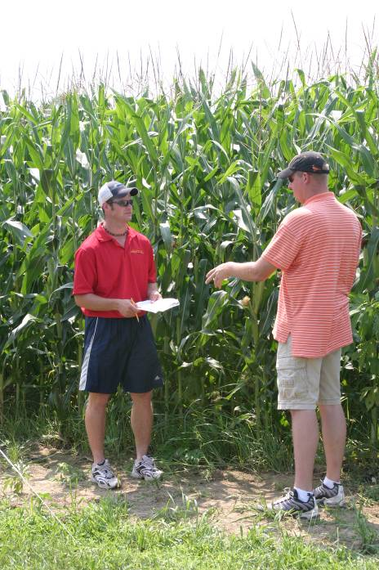

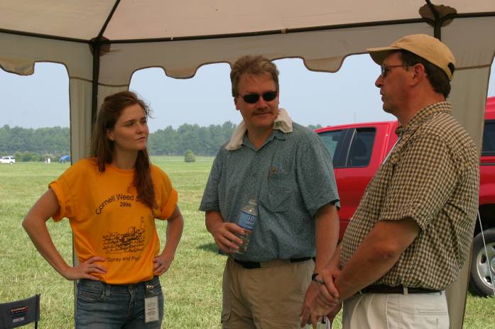

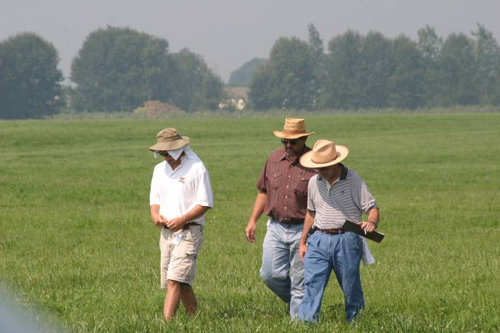

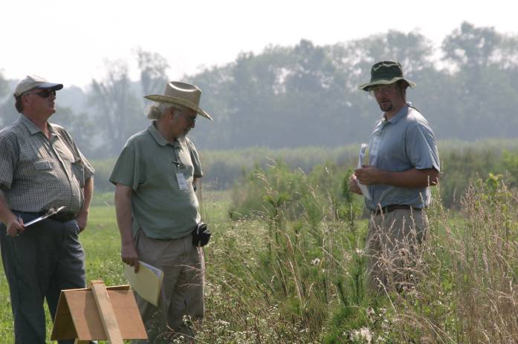

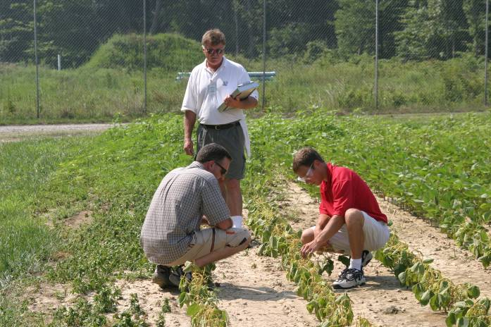
Weed Identification Event

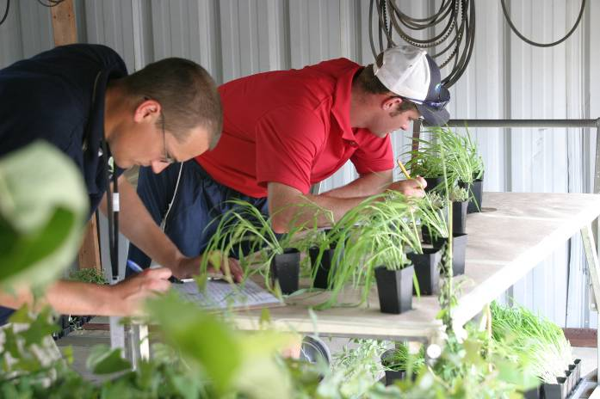

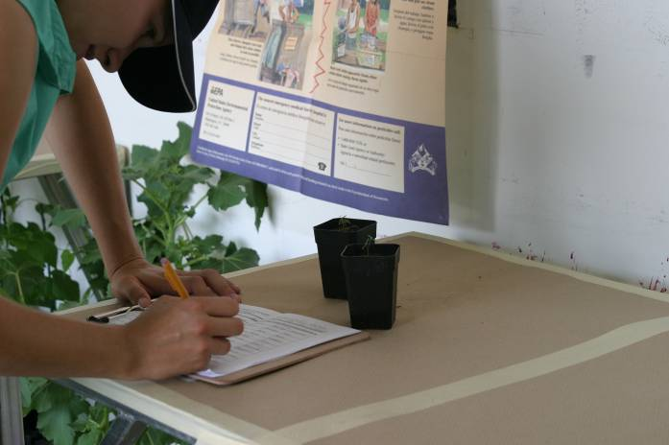

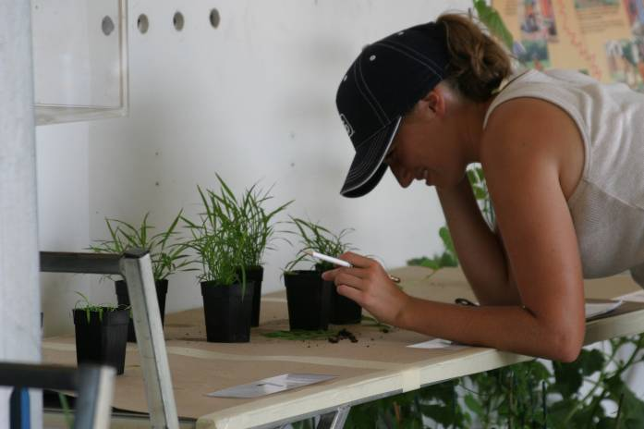

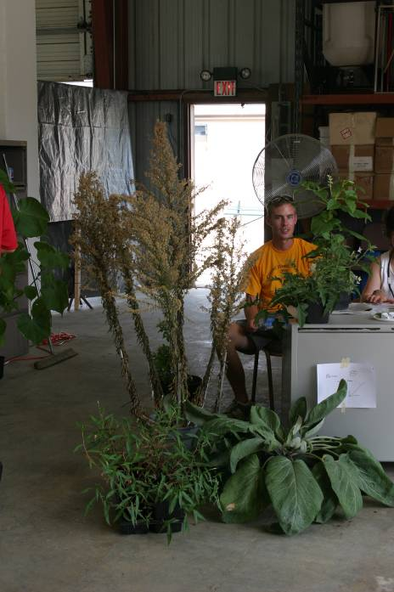

Herbicide Identification Event

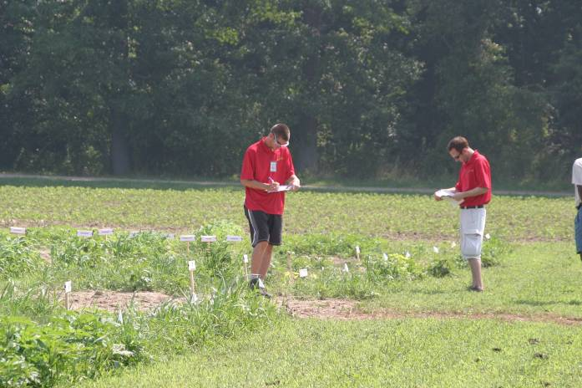

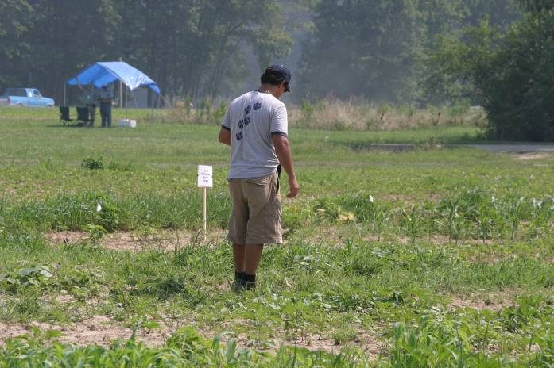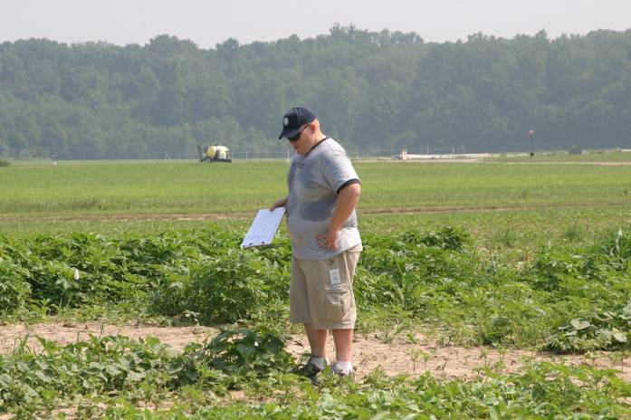

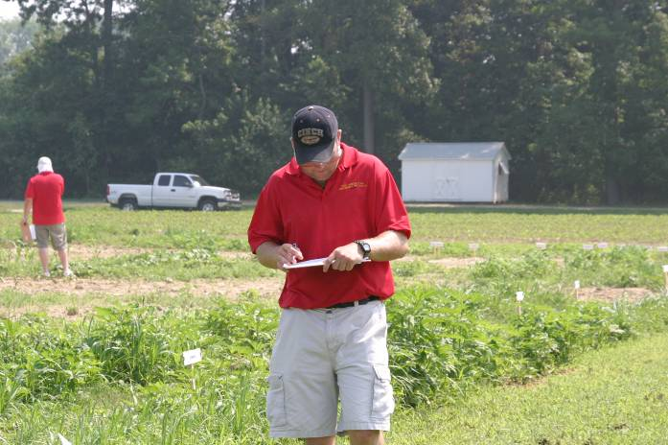

Calibration Examination

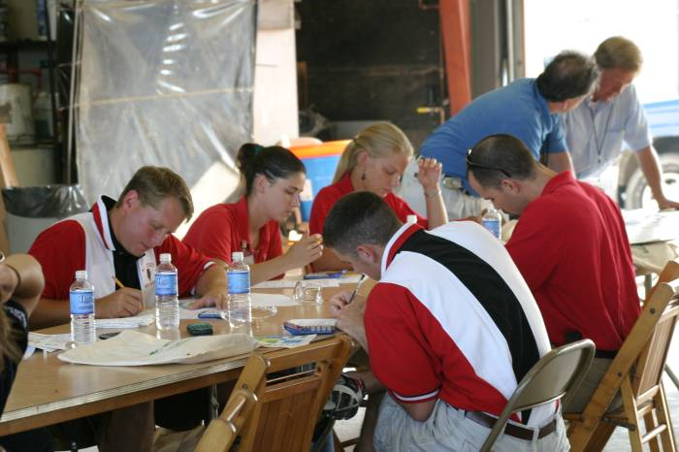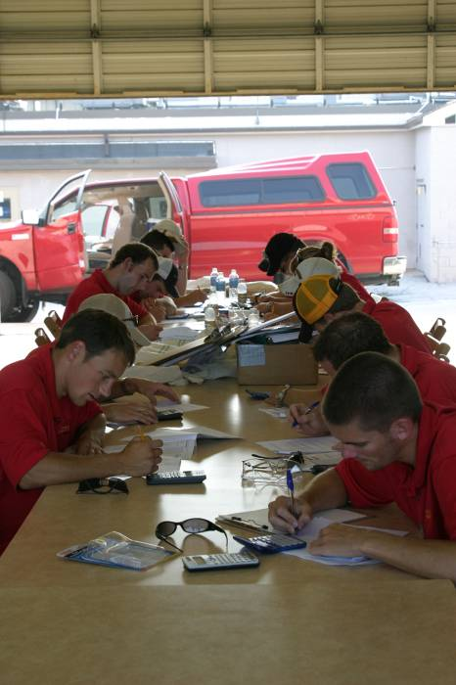

Candid Photos during the Contest

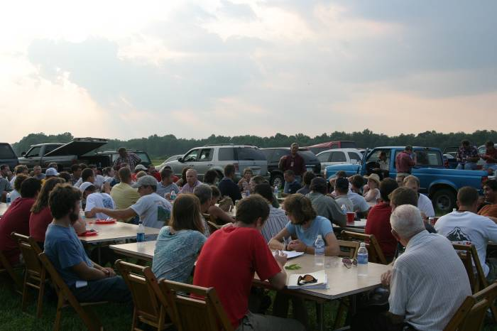

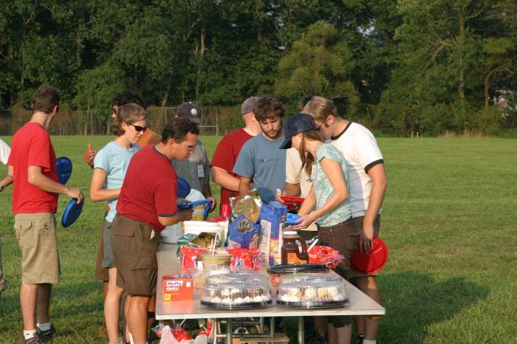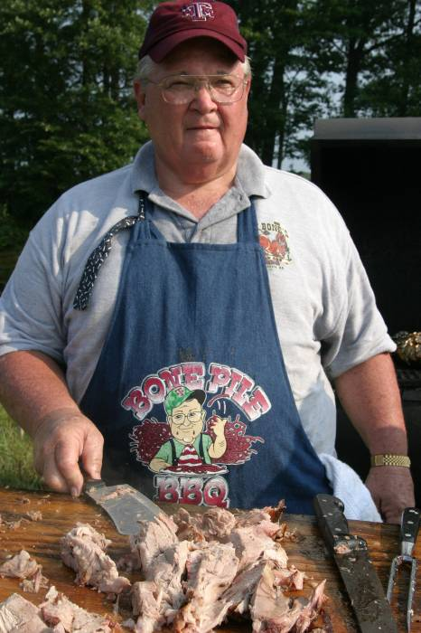

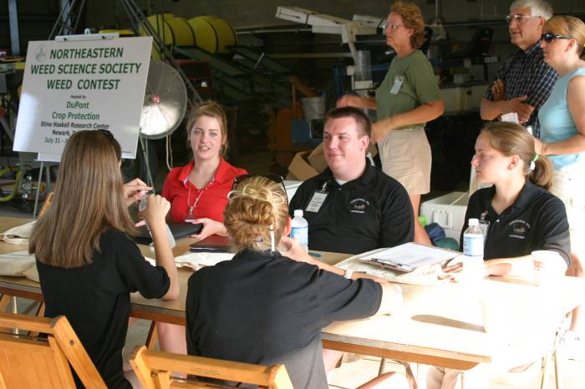

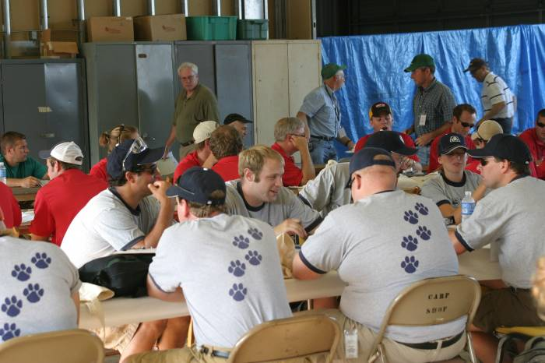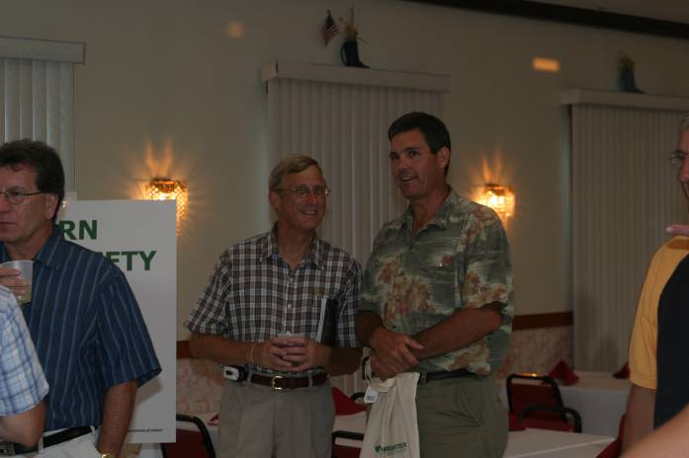

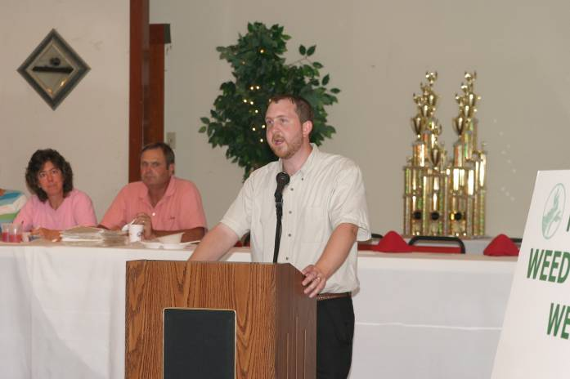

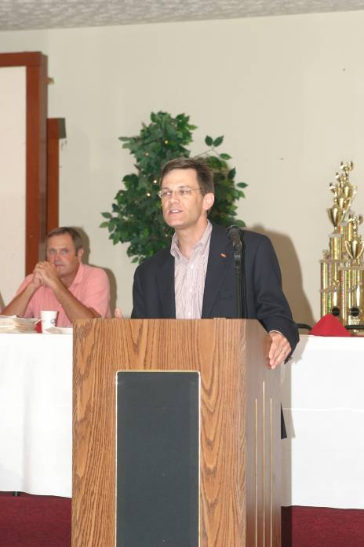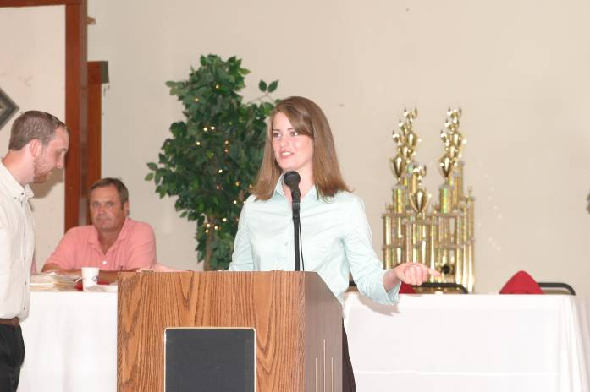

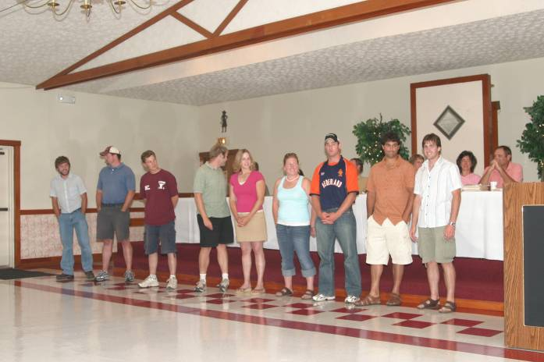
(Photos courtesy of Dr. Dan Vincent, DuPont)

Photos of contest winners will be included in the November issue of NEWSS News!

NEWSS Constitution – Proposed Changes
Jeff Derr

During a review of the NEWSS Constitution, I realized we do some things differently now than in years past. I am proposing the following changes to the Constitution. These changes will require a vote by the membership, which could be accomplished during the business meeting of the annual meeting. Please read my proposed changes, and see if they adequately address our current procedures.

ARTICLE III – MEMBERSHIP

Section 2.

Old version:

Active Members are Individuals who are interested in Weed Science and who have remitted their annual dues to the Society. Active Members may attend the Annual Meeting, hold office, present papers on the Program, and will receive the Supplement to the Proceedings and any Newsletters.

Proposed version:

Section 2.

Active Members are Individuals who are interested in Weed Science and who have remitted their annual dues to the Society. Active Members may attend the Annual Meeting, hold office, vote on society issues, present papers on the Program, and will receive society news disseminated by the Executive Committee.

Article V - OFFICERS
Old version:

Section 1.

The Officers of the Society shall be President, President-Elect, Vice President and Secretary-Treasurer.

Section 2.

The President, President-Elect, and Vice President shall hold Office beginning at the close of the Business Meeting at which they are installed and shall remain in Office until the close of the next Business Meeting of the Society. The President, President-Elect and Vice President shall not be eligible to hold the same Office a second time. The Secretary-Treasurer shall hold Office beginning at the close of the Business Meeting at which he/she is installed and shall hold Office until the Secretary-Treasurer-Elect is installed into Office. The Secretary-Treasurer shall hold this Office for not more than five years.

Proposed version:

Section 1.

The Officers of the Society shall be President, President-Elect, Vice President, immediate Past- President, and Secretary-Treasurer.

Section 2.

The President, President-Elect, Past-President, and Vice President shall hold Office beginning at the close of the Business Meeting at which they are installed and shall remain in Office until the close of the next Business Meeting of the Society. The President, President-Elect and Vice President shall not be eligible to hold the same Office a second time. The Secretary-Treasurer shall hold Office beginning at the close of the Business Meeting at which he/she is installed and shall hold Office until the Secretary-Treasurer-Elect is installed into Office. The term for the Secretary-Treasurer shall be five years, the first year as Secretary-Treasurer-Elect, and the last year to train the Secretary-Treasurer-Elect.

Article VI – ELECTION OF OFFICERS
Old version:

Section 1.

B. The Nominating Committee will canvass the Membership by mail and nominate at least one and no more than two Candidates for the Office of Vice President. Nominees for Vice President will have been Members of the Northeastern Weed Science Society for at least three years prior to election. The Vice President shall automatically succeed to the Office of President-Elect. The President-Elect shall automatically succeed to the Office of President. The Nominating Committee shall nominate at least one candidate for Secretary-Treasurer one year prior to the time the latter Office is to be vacated so that the incoming Secretary-Treasurer can serve a one year apprenticeship as Secretary-Treasurer-Elect. Candidates for Secretary-Treasurer-Elect shall have been Members of the Society for at least three years prior to election.

Proposed version:

Section 1.

B. The Nominating Committee will canvass the Membership and nominate at least one and no more than two Candidates for the Office of Vice President. Nominees for Vice President will have been Members of the Northeastern Weed Science Society for at least three years prior to election. The Vice President shall automatically succeed to the Office of President-Elect. The President-Elect shall automatically succeed to the Office of President. The Nominating Committee shall nominate at least one candidate for Secretary-Treasurer one year prior to the time the latter Office is to be vacated so that the incoming Secretary-Treasurer can serve a one year apprenticeship as Secretary-Treasurer-Elect. Candidates for Secretary-Treasurer-Elect shall have been Members of the Society for at least three years prior to election.

ARTICLE VII – EXECUTIVE COMMITTEE

Old version:

Section 2.

The Executive Committee shall be composed of the following members: President, immediate Past-President, President-Elect, Vice President, Secretary-Treasurer, and Chairs of the following: Sustaining Membership, Research, Editorial, Public Relations, WSSA Representative and other permanent Committees which may be needed for the operation of the Society.

Proposed version:

Section 2.

The Executive Committee shall be composed of the following members: President, immediate Past-President, President-Elect, Vice President, Secretary-Treasurer, and Chairs of the following: Sustaining Membership, Research, Editorial, Public Relations, WSSA Representative, Graduate Student Representative, and other permanent Committees which may be needed for the operation of the Society.

Article IX - AUDITING OF ACCOUNTS
Old version:

Accounts of the Secretary-Treasurer and others entrusted with funds shall be audited annually. The Auditor's Report shall accompany the Secretary-Treasurer's Report and be mailed to all Members of the Society.

Proposed version:

Accounts of the Secretary-Treasurer and others entrusted with funds shall be audited annually. The Auditor's Report shall accompany the Secretary-Treasurer's Report and be made available to all Members of the Society.

Article X - PUBLICATIONS
Old version:

Section 2.

The Northeastern Weed Science Society Newsletter shall be prepared by the Secretary-Treasurer in consultation with the Public Relations Representative and sent to all Members of the Northeastern Weed Science Society. The frequency of this Publication will be determined annually by the Executive Committee.

Proposed version:

Section 2.

The Executive Committee shall make arrangements for the preparation and distribution of a newsletter to all Members of the Northeastern Weed Science Society. The frequency of this Publication will be determined annually by the Executive Committee.

Bhowmik Awarded Fulbright Fellowship!

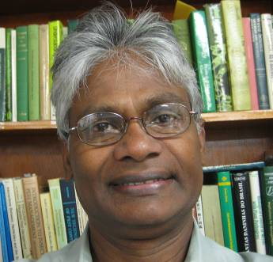
Prasanta C. Bhowmik, Professor of Weed Science, Department of Plant, Soil, and Insect Sciences, has been awarded a Fulbright Fellowship for spring 2007. He will travel to Bangladesh to lecture on weed ecology and management in various agro-ecosystems in Bangladesh at Sher-e-Bangla Agricultural University in Dhaka. Two courses (undergraduate and graduate) will be taught during the second semester from January to June, 2007.

The Fulbright Program is sponsored by the Bureau of Educational and Cultural Affairs of the United States Department of State, and is designed to increase mutual understanding between the people of the United States and the people of the over 150 countries that currently participate in the Fulbright Program. Each year, the program sends many U.S. faculty and professionals abroad. Grantees lecture and research in a wide variety of academic and professional fields.
CONGRATULATIONS PRASANTA !!!

WSSA Undergraduate Research Award-2007

The Weed Science Society of America has developed an Undergraduate Student Research Grant designed to encourage and involve exceptional undergraduates in agricultural research. Interested faculty members are encouraged to identify potential award candidates and discuss the possibility of sponsoring a research project. Awards may be used as a stipend, for research budget expenses (travel, supplies, etc.), to defer fees, to defray living expenses for summer research, or any combination of these items.

AWARD: | Up to $1000 for support of undergraduate research to be conducted over a minimum of one quarter/semester during 2007. This award may be used to defray the cost of research supplies or as a stipend. Support of a faculty sponsor is required. Awards will be made to the student, to be administered by the faculty sponsor's department.
APPLICANT: | The applicant is an undergraduate student with a strong interest in Weed Science. Students majoring in all related disciplines may apply.
TO APPLY: | Applicants should prepare a 2-3 page research proposal including name, address, phone number, title, objective, experimental approach, discussion, budget and references. The discussion section of the proposal should describe the expected results and their possible significance to Weed Science. The student should provide a cover letter in which general academic and career goals are discussed. A copy of the student’s academic transcripts must also be provided.
FACULTY  SPONSOR: | Any faculty member who is actively engaged in Weed Science research is qualified to be a sponsor. The faculty sponsor should review the research proposal with special attention to the budget; the distribution of funds should be approved by both the student and sponsor. In addition, the sponsor should provide a letter of reference including a statement of his/her willingness to supervise the proposed research and to provide needed space, equipment and supplies above those requested in the proposal. The sponsor is encouraged to assist the student in presenting his/her results at a regional Weed Science Meeting.
HOW TO  APPLY: | The completed proposal, academic transcripts, cover letter and faculty letter of support should be forwarded to: Dr. John Jachetta, Dow AgroSciences, 9330 Zionsville Road, Indianapolis, IN 46268-1054; Phone: (317) 337-4686, Fax (317) 337-4649, E-mail: jjjachetta@dow.com. Proposals should be received no later than November 10, 2006. Funding decisions will be made by January 26, 2007 and presented at the 2007 WSSA National Meeting General Session.

Job Announcement
Position Title: Assistant/Associate Research Professor
Area of Specialization: Weed Science/Agronomy
Department: Delta Research and Extension Center
Departmental Contact: Dr. Dan Poston

Position Open Date: June 14, 2006
Position Close Date: Open until filled
Position Category: Faculty
Position Type: Regular
12-month/9-month: 12 month
Salary: Determined by market and commensurate with qualifications and experience.
Tenure track status: Non Tenure-track
Work location: Off-campus
Restricted Clause: Position is contingent on availability of funding
Requisition Number: 2389
Posted on line at: https://www.jobs.msstate.edu

Position Function:
The Mississippi Agricultural and Forestry Experiment Station of Mississippi State University is seeking a weed scientist/agronomist for the Delta Research and Extension Center in Stoneville, MS to develop a Delta-wide weed control and agronomic research program in cotton. Research efforts will be focused on the development of profitable cotton production systems for major Delta soil types. Areas of emphasis will include weed control, harvest aids, and plant growth regulators. Evaluation of programs that further enhance and support the cotton industry from an agronomic and weed control viewpoint will be considered an important aspect of the position.

Essential Duties and Responsibilities:
- Conduct in-depth research to develop economically viable weed management and harvest aid systems for the Mississippi Delta.
- Evaluate the performance and profitability of commercially available transgenic cotton cultivars (i.e. Roundup Ready Flex varieties) and investigate the long term sustainability of glyphosate only weed control systems.
- Monitor, confirm, and develop control strategies for glyphosate resistant weed biotypes.
- In cooperation with other discipline-specific scientists, conduct agronomic and plant growth regulator research for the development of optimum cotton production systems.
- Work closely with Extension specialists and agents to establish cotton production, weed control, and harvest aid systems for the Mississippi Delta.
- Transfer research information and technology to clientele via appropriate methods that may include electronic publications, experiment station and/or Extension bulletins.
- Develop and publish peer-reviewed publications based on cotton production research.

Minimum Qualifications:
- Earned doctorate in Weed Science/Agronomy or closely related Plant Science discipline.
- Experience in crop production, experimental design, statistical analysis, and modern agricultural production practices.
- Ability to develop crop production recommendations from research data.
- Excellent written and verbal communication skills to interact effectively with producers, consultants, faculty, Extension staff, and the general public.
- Ability to secure extramural funding to support research program.

Preferred Qualifications:
- Previous job experience in cotton production and working knowledge of computer applications in research.

Instructions for Applying: Submit application, cover letter, and resume on line. Official transcripts and three letters of recommendation must be mailed to: Dr. Joe Street, Head, Delta Research and Extension Center, P.O. Box 197, Stoneville, MS 38776. Candidates should complete the Personal Data Information Form on-line.

NEWSS Website:
www.newss.org
(click here for title submissions and other society information)

