EMERGENCY PROCEDURES FOR NIH PERSONNEL
At the NIH, many emergency procedures exist as policies, or are available on the various emergency services websites. In order to provide a concise, readily available and user friendly synopsis of important emergency procedures, the Division of Emergency Preparedness and Coordination, Office of Research Services, has developed this “Emergency Procedures” summary for NIH employees. It is intended to outline the types of emergencies that may be encountered at the NIH, and identify the steps, in simple “bulleted” or “checklist” formats, employees should take in order to protect themselves, and their co-workers, when experiencing an emergency situation.

The following emergency conditions are listed in this summary:

- Reporting suspicious persons or activities
- Lockdown situations
- Suspicious packages or objects
- Bomb threats
- Evacuations
- Building evacuations
- Emergency evacuation routes for the Bethesda campus
- Specific evacuation procedures for persons with various disabilities
- Fire emergencies
- Threatening or violent behavior

Reporting Suspicious Persons or Activities
If you or someone you know witnesses a crime, it is important to report it immediately after the incident occurs. The chances of catching the perpetrator will be much greater than if you wait even just a few minutes. Because officers cannot be everywhere at once, they need your help. Your special efforts regarding prompt and accurate reporting of these incidents can help keep our facilities safer for everyone. Below is a set of guidelines on reporting suspicious persons or activity.
When you call to report suspicious persons or activity, remember the four W's - Who, What, When and Where.
  - Who is the suspicious person? (Get a description of the person if they are unfamiliar to you.)
  - What is the suspicious activity?
  - When did the incident occur or is it still taking place?
  - Where is the suspicious person/activity?
Remember - a crime is never solved unless someone reports it!
  - Call the Emergency Communications Center (ECC) at 911 or 9-911 (off campus) immediately.
  - Tell the dispatcher your name, where you are calling from and if possible the phone number from which you are calling.
  - Give all the information you have on the incident and/or person to the dispatcher.
  - Do not hang up until the dispatcher is finished with his/her questions. Officers may need more information from you to enable them to properly handle the call. When the police arrive, identify yourself and ensure that they do not have any other questions for you.
Some things to remember when you see a crime or suspicious person:
  - Do not try to handle the problem yourself.
  - Do not delay reporting the incident.
  - Do not leave the location from which you are reporting the incident unless you are in danger. The dispatcher may need to get more information from you.
What is a suspicious person or activity?
  - Obviously, not everything you see is suspicious. You must learn what is normal for the campus before you can report anything abnormal. For example, a person walking across campus is not necessarily suspicious. However, a person walking through a building corridor attempting to open each office door is suspicious.
Lockdown Situations

Lockdowns protects employees from a threat inside or outside the building when it may be more dangerous to leave the building by directed evacuation than to stay in a secured room. A dangerous person could be someone with a legitimate purpose on site (employee, authorized visitor, contractor) or an unauthorized visitor. Lockdowns are used when it is safer to stay in an area that can be secured than it would be to move through the building where the potential threat may be encountered. Example: An armed intruder is in the building.

Procedures for Lockdown:
- Lock or barricade doors or openings and windows and pull shades immediately.
- Call 911 (on campus) or 9-911 (off campus) immediately.
- Keep employees away from the doors and windows and move to an area that will provide cover.
- Maintain a calm environment by remaining calm yourself and reassuring employees that everything possible is being done to return the situation to normal.
- If a gunshot or an explosion is heard, immediately have everyone lay down on the floor.
- Remain in the secured work area until notified to evacuate, unless there is a greater risk to your safety by remaining in your current location.

Suspicious Packages or Objects
If you receive or discover a suspicious package or foreign device, do not touch it, tamper with it, or move it. Dial 911 or 9-911(off campus) immediately and report it.
Move people away from suspicious object. Do not move or attempt to open the package. Do not investigate too closely. Do not cover or insulate the package.
Suspicious packages are not limited to those delivered by a commercial or U.S. postal carrier. Any of the following characteristics have been designated by the U.S. Post Office and the Department of Alcohol, Tobacco, and Firearms as indicators of suspicious packages:
- Lumps, bulges, or protrusions on package
- A lopsided or heavy-sided package or excessive masking tape
- Handwritten addresses or labels from companies (check to see if the company exists and if they sent a package or letter)
- Packages wrapped in string
- Excess postage on small packages or letters
- No postage or uncanceled postage
- Handwritten notes, such as, "To Be Opened in the Privacy of," "Confidential," "Your Lucky Day Is Here," "Prize Enclosed"
- Restrictive markings such as "confidential" or "personal"
- Improper spelling of common names, places, or titles
- Generic or incorrect titles. Titles with no name attached
- Leaks, stains, or protruding wires, string, tape, etc.
- Hand delivered or "dropped off for a friend" packages or letters
- No return address or a pretend return address
- Foreign mail, air mail, and special-delivery packages
- Any letter or packages arriving before or after a phone call from an unknown person asking if the item was received

Bomb Threat

Threat by Telephone (printable version available: http://ser.ors.od.nih.gov/emergency_prep.htm)
- Do not hang up. Remain calm.
- Take the caller seriously. Assume the threat is real.
- If you have caller ID, look for originating number.
- Do not use cell phone, two-way radio, or any wireless communication device, as it can act as a trigger for an explosive device.
- Have a coworker call 911 or 9-911 (off campus) on another line. If you are alone, after the call is disconnected by the caller, do not hang up the phone. Press *57 first and then hang up the phone. (This procedure will "capture" the phone line so that the phone company can trace it), then call 911 or 9-911 to report the threat.
- Ask questions using the following checklist as a guide.

Bomb Threat Checklist (Did caller provide any of this information?)
- When is the bomb going to explode?  - Where is it right now?  - What does it look like?  - What kind of bomb is it?  - What will cause it to explode?  - Did you place the bomb? Why?  - What is your name?  - What is your address?  - Exact wording of threat  - Did the caller state their name?  - Number from which call originated  - Male or female  - Race  - Age  - Name of person who answered the call  - Number at which call was received  - Time  - Date  - Additional comments | Caller's Voice
 | calm  angry  excited  slow  soft  loud  laughter  crying | normal  distinct  slurred  nasal  stutter  lisp  raspy  deep |  | ragged  clearing throat  deep breathing  cracked voice  disguised  accent  familiar
 | Background Sounds
 | street noises  animal noises  clear  static  music  house noises  motor  other |  | office machinery  factory machinery  voices  public address system  local  long distance  booth
 | Threat Language
 | well spoken  foul  irrational |  | incoherent  taped  message read by threat maker

Evacuations
Before an emergency, determine the nearest exit to your location, the safest route to follow, and alternate exits. Building evacuation routes are posted in campus buildings. Leave the immediate area, but remain available to emergency personnel. If time permits during an evacuation, secure your workplace and take personal items such as keys, purse, medication and glasses.

Evacuation of a Building
- Walk, do not run.
- Do not use elevators.
- Seek out people with special needs and provide assistance if necessary. Normally, aides will be assigned.
- Gather outside at your designated building staging area, where your supervisor should account for all personnel.
- Wait for instructions from the fire department, police, or other individual in charge, before returning to your building.

Campus Emergency Evacuation Routes
The campus crisis plan organizes sections of the campus into emergency evacuation routes in the event of a crisis affecting the whole campus or a section of campus. Identify your route by finding your building location on the chart or see map on the next page.
All the roads into the NIH would be used to evacuate the campus, with the exception of South Drive at Rockville Pike (medical Center Metro), which would allow two-way traffic to accommodate emergency response vehicles. Employees should be aware of alternate routes away from the campus and practice using them. Carpool and vanpool members should make communication arrangements prior to an emergency situation, and should meet at their vehicle to expedite their evacuation.
Off-Campus Emergency Evacuations
For off-campus facilities, listen to the local radio stations and follow the directions of County Police for further directions. Check out the link below for information from Montgomery County on Emergency & Disaster Preparedness, Safety in Our Neighborhood as well as a link that allows you to sign up for “Alert Montgomery”. Montgomery County can use the Roam Secure Alert Network to contact you during a major crisis emergency. It can deliver important emergency alerts, notifications and updates to: email accounts, cell phone, text pager, blackberry and wireless PDA.
http://www.montgomerycountymd.gov/firtmpl.asp?url=/content/firerescue/index.asp

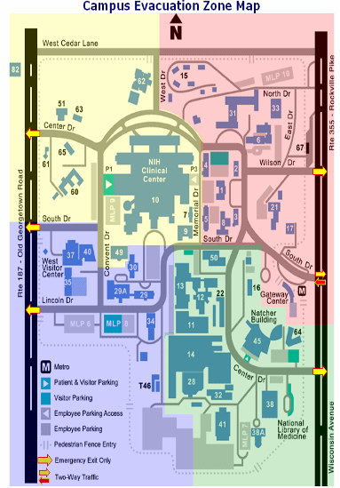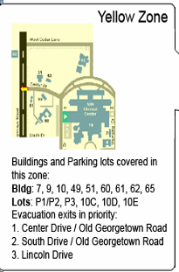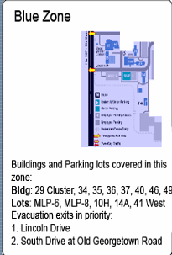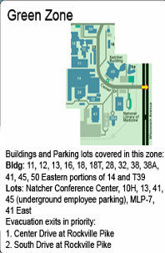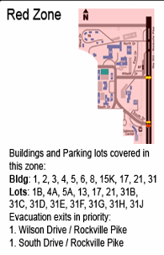

Evacuation for People with Disabilities
The most important factor in emergency safety is advanced planning. After an evacuation is ordered:
- Do not use elevators, unless authorized to do so by police or fire personnel. Elevators can fail during a fire or a major earthquake.
- If the situation is life threatening, call 911 or 9-911(off campus).
- Check on people with special needs during an evacuation. A buddy system, where people with disabilities arrange for volunteers to alert them and assist them in an emergency, is a good method.
- Always ask someone with a disability how you can help before attempting any rescue technique or giving assistance. Ask how he or she can be best assisted or moved and whether there are any special considerations or items that need to come with the person.

Blindness or Visual Impairment
- Offer to lead them out of the building to safety.
- Give verbal instructions about the safest route or direction using compass directions, estimated distances, and directional terms.
- Do not grasp a visually impaired person's arm. Ask if he or she would like to hold onto your arm as you exit, especially if there is debris or a crowd.
- Give other verbal instructions or information (e.g., elevators cannot be used).

Deafness or Hearing Loss
- Get the attention of a person with a hearing disability by touch or eye contact. Clearly state the problem. Gestures and pointing are helpful, but be prepared to write a brief statement if the person does not seem to understand.
- Offer visual instructions to advise of the safest route or direction by pointing toward exits or evacuation maps.

Mobility Impairment
- It may be necessary to clear the exit route of debris (if possible) so that the person with a disability can move out or to a safer area.
- If people with mobility impairments cannot exit, they should move to a safer area, for example:
  - elevator lobby
  - most stairwells
  - an office with the door closed, which is a good distance from the hazard
- Notify police or fire personnel immediately about any people remaining in the building and their locations.
- Police or fire personnel will decide whether people are safe where they are and will evacuate them as necessary.

Fire Emergencies

If You Discover a Fire
- Manually activate the fire alarm system.
- If you have time and can safely get to a phone, call 911 or 9-911(off campus) to provide more details.
- Immediately exit the building, using the stairs and closing doors behind you. Do not use elevators.

Using a Fire Extinguisher
If you have been trained and it is safe to do so, you may fight small, contained fires with a fire extinguisher.
Fire Extinguisher Instructions
P |  | Pull safety pin from handle
A |  | Aim at base of fire
S |  | Squeeze the trigger handle
S |  | Sweep from side to side at base of fire

Once Alarm Is Activated
- Walk to the nearest exit closing doors between you and the fire.
- Assist people who have special needs. Notify the OEC (Occupant Emergency Coordinator) outside the building of any disabled personnel who are still inside the building.
- Notify fire personnel if you suspect someone is trapped inside the building.
- Gather at designated building assembly area. Do not attempt to reenter the building until instructed to do so by the fire department or police.

If Trapped in a Room
- Place cloth material around or under the door to prevent smoke from entering the room.
- Close as many doors as possible between you and the fire.
- Be prepared to signal to someone outside from a window if possible.

If Caught in Smoke
- Drop to hands and knees and crawl toward exit.
- Stay low, as smoke will rise to ceiling level.
- Hold your breath as much as possible.
- Breathe shallowly through nose, and use a filter such as a shirt or towel.
Prepare yourself in advance; know where to go and how to get there. If your work station is located in an office, know exactly how many doors you have to pass along your evacuation route before you reach the nearest exit door. This tip is very helpful if you encounter heavy smoke. When heavy smoke is present, the exit signs may be obscured by the smoke. If you know how many doors you have to pass, you can crawl or crouch low with your head thirty to thirty-six inches from the floor (watching the base of the wall) and count out the number of doors you pass until you reach the exit door, even if you can't see the exit sign.
Your own common sense is the finest safety device ever developed. Above all use your head.

Threatening or Violent Behavior*
Threats may be statements of intention or expressions of strong emotion. They can be indirect or direct, verbal or nonverbal. Shaking a fist or pounding the desk, throwing things, and showing a weapon are all examples of nonverbal threats. Verbal threats may be indirect expressions of frustration or anger directed toward a person or office or they may be direct statements of the intention to harm. These situations are complex, and it is not expected that individuals will be able to assess whether the threat is serious and might actually lead to harm. However, it is expected that employees consider any threat or display of hate as potentially serious.
Most people who commit violent acts exhibit warning signs. It is important to take seriously any behaviors or words that imply threat and consult appropriate people to assess the risk and plan interventions.
- If the threat is immediate, leave the situation if possible and call 911 or 9-911(off campus). If threats or bizarre behavior indicate possible danger, personal safety is the top priority.
For an angry or hostile customer or coworker:
  - Stay calm.
  - Listen attentively.
  - Maintain eye contact.
  - Be courteous. Be patient. Be respectful.
  - Keep the situation in your control.
- If shouting, swearing, and threatening, continues:
  - Signal a coworker or supervisor, that you need help (have a prearranged code or alarm system).
  - Do not make any calls yourself.
  - Have someone call the police.
- If someone is threatening you with a gun, knife, or other weapon:
  - Stay calm. Quietly signal for help using an alarm or code system.
  - Maintain eye contact.
  - Stall for time.
  - Keep talking--but follow instructions from the person who has the weapon.
  - Don't risk harm to yourself or others.
  - Never try to grab the weapon.
  - Watch for a possible chance to escape to a safe area.
*Adapted from Federal Protective Service U.S. General Services Administration guideline.
For more detailed information on emergency conditions, and the associated procedures that should be followed, please contact the Division of Emergency Preparedness and Coordination at (301) 496-1985, or visit the website at http://ser.ors.od.nih.gov/emergency_prep.htm


September 2007

