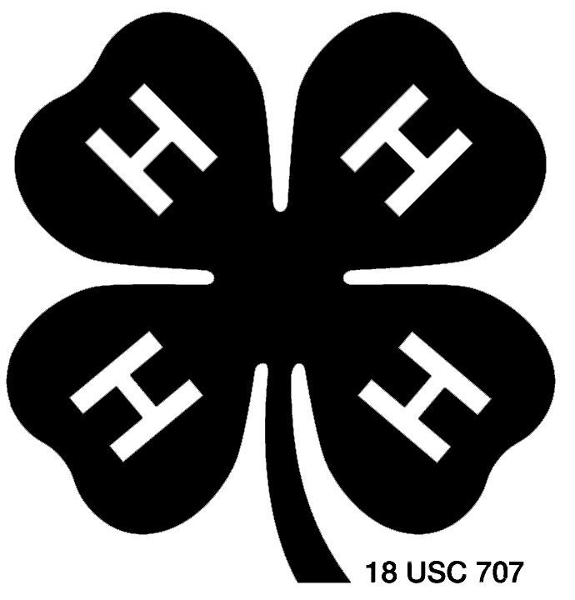 4-H Food Preservation Record

The 4-H Food Preservation Record is a summary of your project for the current 4-H year.

To use this record: Download and save this Microsoft Word file to a folder on your computer (File/Save As/). Give the document a name that you will recognize.

To fill in data: Click your cursor on the gray box where you want to add information. When the gray field becomes highlighted, type your entry. You may type as many lines as you want. Using the gray “fillable” boxes helps the page formatting stay the same.

To add more rows to a table: Keep the last row empty. Highlight the last (empty) row in the table.
PC: Copy the row (CTRL C or Edit/Copy on the menu bar) then paste (CTRL V or Edit/Paste on the menu bar).
Mac: Copy the row (Command C or Edit/Copy on the menu bar) then paste (Command V or Edit/Paste on the menu bar).
Then, repeat the Paste command to add as many new rows as you need.

To add page breaks: There are page breaks between some of the tables of the record sheet. You may add page breaks between pages and/or parts of the record. Click to place your cursor where you want to add a break.
PC: On the menu bar, click Insert, click Page Break from the new menu, and click OK.
Mac: On the menu bar, click Insert, choose Break, then click Page Break.

Save your document frequently.
PC: Click File/Save on the menu bar or press CTRL S.
Mac: Click File/Save on the menu bar or press Command S.

We also recommend that you save a backup copy of the document somewhere in addition to your hard drive (such as on a zip disk, CD, or jump drive).

4-H Food Preservation Record

Name Boy Girl Grade in school Year born
(first) (last) (year)
Club name Leader County

Year in 4-H Year in this project Date project started Date project closed
(mo/day/year) (mo/day/year)
A record is part of your 4-H project. Keep your record neat, clean, and up-to-date. If you need help, ask your parents or leader.

Things I Hope to Do and Learn This Year

New Ways I Used What I Preserved in Meals or Snacks

Ways I Shared What I Learned

What I Did in Food Preservation
(Check all that apply.)
Boiling Water Canning (fruit, tomato)
Pressure Canning (meat, poultry, fish, vegetable, tomato)
Drying (fruit, vegetable, meat, herbs, leathers, other)
Pickling (fermented, quick, relish, fruit)
Jams, Jellies, and Preserves (regular, low sugar, freezer)
Freezing (fruit, vegetable, meal, main dish)

New Skills I Learned in Food Preservation
(List and explain some new skills from the methods you checked above.)

Amounts of Food Preserved
Date | Food | Amount | Method of preserving  (Include raw or hot pack; type of dehydrator; type of pressure gauge, pressure and altitude) | Processing time

