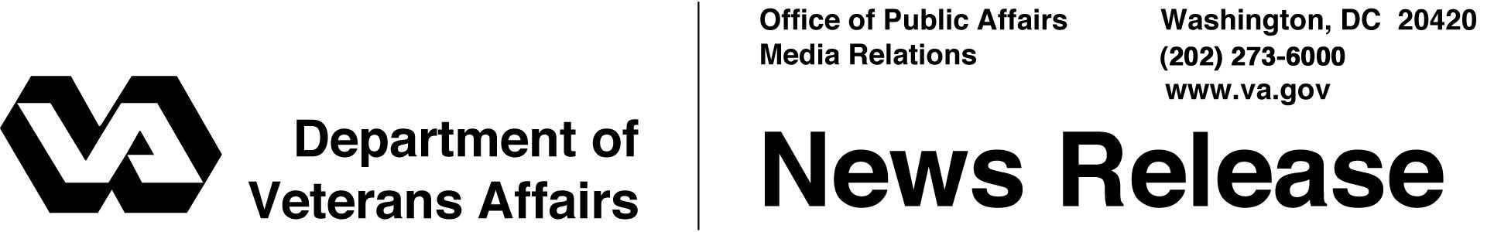

FOR IMMEDIATE RELEASE
November 21, 2003

VA Distributes 2004 Insurance Dividends
WASHINGTON - The Department of Veterans Affairs (VA) today announced its distribution of more than $517 million in dividends to 1.5 million active policyholders of veterans' life insurance.
Over the next year, veterans will receive payments on the anniversary date of their policies, with the specific dividend amount varying according to age, type of insurance, and length of time the policy has been in force. Veterans will automatically receive their annual dividend through one of the nine payment options available to them.
Dividends cover only veterans with government life insurance policies who served between 1917 and 1956. Veterans who were discharged after 1956 are covered by VA term insurance programs that do not pay dividends.
The dividends represent a return of trust fund earnings on the premiums paid by policyholders throughout the years. They reflect the fact that veterans are living longer than originally predicted. Dividends are also attributable to the higher than expected yields earned by the trust funds from investments in U.S. government securities.
Only those with policies that have been kept in force when premiums were required are eligible for the payout. Inaccurate notices periodically surface in the veterans community suggesting that those who have not maintained insurance are eligible for a special dividend if they contact VA, but this is false. Dividends are automatically sent to eligible policyholders.
The largest group receiving 2004 payments will be 1.2 million veterans of World War II with National Service Life Insurance ("V") policies. Total payments are expected to reach $416.8 million.

- More -
Insurance Dividends - 2/2/2/2

Dividends totaling $1.8 million will be paid to about 11,000 veterans holding U.S. Government Life Insurance ("K") policies.
Nearly 200,000 Korean War era veterans who have maintained Veterans Special Life Insurance ("RS" and "W") policies can expect to receive dividends totaling $83.9 million.
Veterans from the World War II era who hold Veterans Reopened Insurance ("J", "JR" and "JS") policies, currently numbering nearly 53,000, will share a $14.7 million dividend.
Although VA administers a special life insurance program for disabled veterans and a program offering mortgage life insurance coverage, neither pays dividends.
For current active-duty service members and reservists, VA supervises a contract with a private carrier to underwrite Servicemembers' Group Life Insurance. No dividends are paid on Servicemembers' Group Life Insurance.
Veterans who have questions about their policy may call the VA Insurance toll-free number at 1-800-669-8477, may send an e-mail to VAinsurance@vba.va.gov, or may visit the web site at www.insurance.va.gov.

# # #

People wishing to receive e-mail from VA with the latest news releases and updated fact sheets can subscribe at the following Internet address:
http://www.va.gov/opa/pressrel/opalist_listserv.cfm

