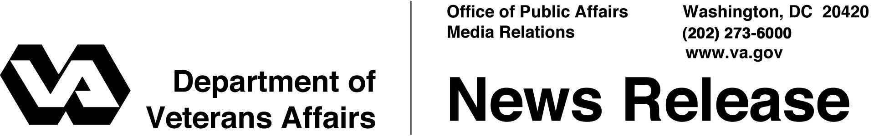

FOR IMMEDIATE RELEASE
October 23, 2002

British Secretary of State for Health Visits VA
WASHINGTON – The Right Honorable Alan Milburn, M.P., Britain’s Secretary of State for Health, met with senior Department of Veterans Affairs (VA) officials here today to discuss VA health care programs and U.S. benefits for veterans.
“VA is proud of the quality of health care we provide to our veterans,” said Secretary of Veterans Affairs Anthony J. Principi. “As America’s largest health care system, VA shares many of the same challenges the United Kingdom faces in providing quality care and containing costs.”
In addition to meeting with Secretary Principi, Milburn discussed health care issues with Dr. Robert H. Roswell, under secretary for health. He also toured the VA hospital in Washington, D.C. With a $22 billion health care budget for fiscal year 2002, VA treated more than 4 million people at more than 1,200 sites of care.
“We are pleased to share information about our veterans health programs with Secretary Milburn,” said Secretary Principi.
Milburn is in Washington for the Commonwealth Fund conference on health and for meetings with Secretary of Health and Human Services Tommy G. Thompson. The Commonwealth Fund is a New York City-based private foundation established in 1918 to support independent research on health and social issues.

# # #

People wishing to receive e-mail from VA with the latest news releases and updated fact sheets can subscribe at the following Internet address:
http://www.va.gov/opa/pressrel/opalist_listserv.cfm

