Value Added Dairy Information
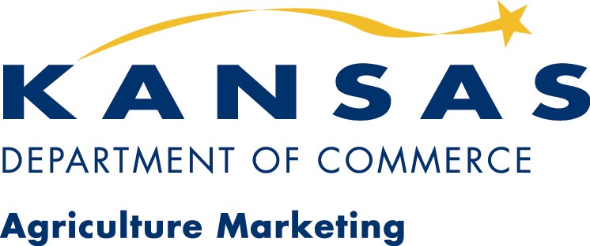

Websites for Information

The Small Dairy Resource Book
http://www.sare.org/handbook/dairy/dairyrb.pdf
Sustainable Agriculture Research and Education (SARE) of the USDA

This publication contains information about small- scale dairy processing, resources for information regarding production (including extension publications no longer listed with land grant universities) and both internet and published source material for those interested in further processing of dairy products.

The Specialty Cheese Market
http://www.foodmap.unl.edu/report_files/The_Specialty_Cheese_Market.pdf
Food Processing Center – University of Nebraska – Lincoln

This paper summaries the changes tastes and preferences of consumers regarding cheeses, the impact of changing demographics and eating habits, and the effects of divergent ethnic groups and cultures on the consumption patterns for cheese in the U.S.

Building a Specialty Cheese Plant
http://www.foodmap.unl.edu/report_files/Specialty_Cheese_Plant.pdf
Food Processing Center – University of Nebraska – Lincoln

Another publication from the University of Nebraska that specifically deals with costing various pieces of equipment for cheese processing, including new and used.

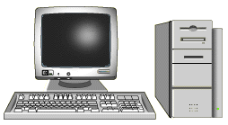

Demand for Organic and Conventional Milk
http://agecon.lib.umn.edu/cgi-bin/pdf_view.pl?paperid=2259
USDA-Economic Research Service
University of Arizona, Department of Agriculture and Resource Economics

This paper is a nationwide overview of consumer preferences for fluid milk products, both conventional and organic. Using scanner data from retail outlets, it outlines specific milk components and the resulting influence on consumer demand.

A Study of Marketing Issues with Organic Milk
http://www.agmrc.org/dairy/info/ksuorgdairy.pdf
Kansas Department of Commerce & Housing, Agriculture Marketing Division

This is a summary publication of a master’s thesis sponsored by KDOCH and USDA to determine demand for conventional and organic fluid milk products in the Kansas City Metro Area.

Questions You Should Answer Before Starting a New Dairy Processing Enterprise
http://www.cpdmp.cornell.edu/
Department of Agriculture, Resource and Managerial Economics, Cornell University

A basic listing of the issues dealing with starting a value added venture processing dairy products.

Ways to Add Value to Farm Milk
http://aem.cornell.edu/special_programs/hortmgt/pubs/smartmkt/stephenson5-00.PDF
Cornell Program on Dairy Markets & Policy, Cornell University

This is a basic overview of marketing ideas and techniques to enhance milk and milk product value.

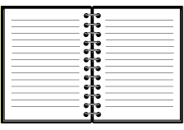

Value Added Dairy Operations
The following is a listing of current value-added operations in the United States. The list is not intended to be all-inclusive:

Longmont Dairy Farm Inc.
Longmont, Colorado
http://www.longdairy.com/

Royal Crest Dairy
Denver, Colorado
http://www.royalcrestdairy.com/

Hartzler Family Dairy Inc.
Wooster, Ohio
http://www.hartzlerfamilydairy.com/

Oberweis Dairy
North Aurora, Illinois
http://www.oberweisdairy.com/

Organic Valley
Lavarge, Wisconsin
http://www.organicvalley.com/

Brown Cow Country Market
Brogue, Pennsylvania
http://www.thebrowncow.net/

South Mountain Creamery
Middletown, Maryland
http://www.southcreamery.com/

Meadow Creek Dairy, LLC
Galax, Virginia
http://www.meadowcreekdairy.com/

Dairy Processing Equipment Dealers
The following listing is from the Food Processing Center – University of Nebraska – Lincoln

Shier Equipment Company
14459 S. 65th W. Avenue
Sapulpa, Oklahoma 74066
(918) 321-3151
www.schiercompany.com

Kusel Equipment Company
820 West Street
Watertown, WI 53094
(920) 2612-4112
www.kuselequipment.com

Ullmer’s Dairy Equipment Inc.
8628 Brown County Line Road
Pulaski, WI 54162
(920) 822-8266

Damrow Equipment Company
196 Western Avenue
Fond du Lac, WI 54936
(920) 922-1500
www.damrow.com

APV/Invensys
5100 River Road
Schiller Park, Il 60176
(952) 927-4912
www.apv.invensys.com

W.M. Sprinkman Co.
4334 Courtney Street
P.O. Box 390
Franksville, WI 53126
www.sprinkman.com

International Machinery Exchange
214 N. Main
Deerfield, WI 53531
(608) 764-5481
www.imexchange.com

Stoelting Co.
502 Highway 67
Kiel, WI 53042
(920) 894-7029
www.stoelting.com

Scherping Systems
P.O. Box 10
Winstead, MN 55395
(320) 485-4401
www.scherpingsystems.com

Note: This listing is provided for information purposes only. The State of Kansas, nor the Kansas Department of Commerce & Housing, nor any of their employees, makes any warranty, expressed or implied, or assumes any legal liability or responsibility for the accuracy, completeness, or usefulness of the information contained herein.

