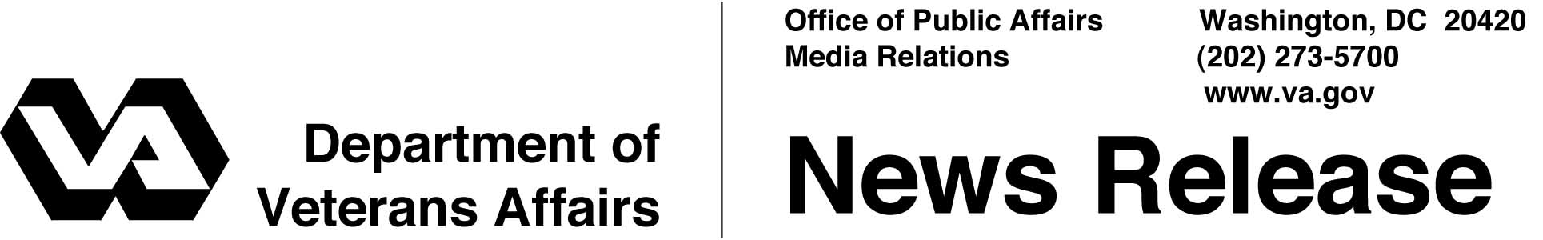

FOR IMMEDIATE RELEASE
December 14, 2001

VA Receives Top Government Ethics Award
WASHINGTON — The Department of Veterans Affairs (VA) Office of General Counsel has received the Outstanding Ethics Program Award from the office that oversees all federal agencies' employee ethics programs. VA is the largest agency ever to receive the award.
"In VA, observing ethical rules is a foundation for the excellence we strive for in serving our nation's veterans," said Secretary of Veterans Affairs Anthony J. Principi.
The Office of Government Ethics, an executive branch agency that examines the ethics activities of all federal agencies, found the complexity and scope of ethical issues facing VA's employees made the department's track record particularly impressive.
The ethics office decided that VA fulfilled all requirements under the Ethics in Government Act and the Ethics Reform Act. These laws cover programs that administer financial disclosure rules, provide training on ethics and counsel employees.
Amy Comstock, director of the ethics office, presented the award Dec. 13. Comstock praised VA's "ethically active leadership" and cited a "multitude of complex and difficult ethics issues" that face VA lawyers, especially arising in VA's health care system.
"As the President reminded us immediately after assuming office, knowing and living up to the ethics rules are matters of keeping faith with the American people," Principi said. He credited the work of VA lawyers and recognized the support of human resources staff and managers.
VA's ethics programs are managed by its legal organization, the Office of General Counsel, including 23 regional offices that share responsibility to review financial

- More -
VA Ethics Award – 2

disclosure reports from 5,000 employees, provide training and counsel employees personally on ethical conduct. All political appointees, senior executives and many managers receive ethics training annually.
VA ethics activities are uniquely challenging both because of the complexities of the department's missions and because of the many outside activities and financial interests of its administrative and professional employees. Examples include: business dealings of VA physicians who serve as faculty members at affiliated universities; professional activities of VA experts who are engaged for speaking and consultation, along with related travel supported by professional and commercial organizations; and conflicts of interest that may arise from VA procurements in many markets.
VA has the largest centralized ethics program in the federal government. Some large agencies segment their ethics programs. While other agencies received the award this year, Comstock emphasized that the scope and complexity of VA's programs far exceed any others.
VA is the second largest federal department, with 219,000 employees.

# # #

