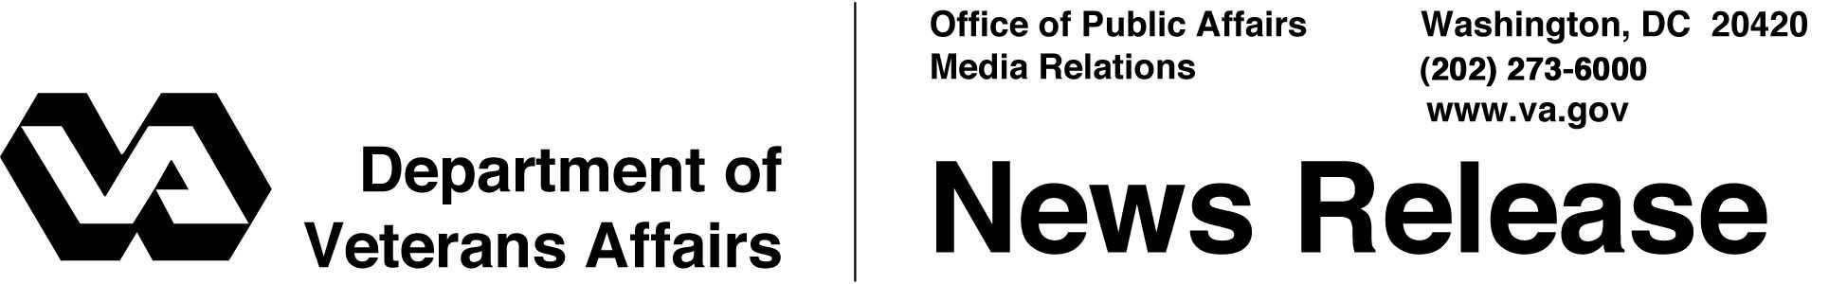

FOR IMMEDIATE RELEASE
July 25, 2002

VA Marks Korean War 50th Anniversary
WASHINGTON – Vice President Richard Cheney joined Secretary of Veterans Affairs Anthony J. Principi in a special presentation today as part of the 50th anniversary of the end of the Korean War.
Twenty-five Korean War veterans received the Republic of Korea Korean War Service Medal. The veterans were relatives or friends of VA Central Office employees.
"In Korea were written some of the most notable moments in military history," Vice President Cheney said. "The medals presented recognize the virtues of duty, honor and service in the care of freedom."
The service medal was originally offered by the Republic of Korea in 1951 to United Nations forces serving in Korea and adjacent waters. At the time U.S. law prohibited the U.S. military from wearing medals issued by foreign governments. Congress changed that in 1954, but by then most U.S. service members eligible for the medal had returned home.
“I am pleased to recognize American soldiers who stepped forward to defend democracy no matter the personal cost,” said Secretary of Veterans Affairs Anthony J. Principi. “The Korean government reissued the service medal to bestow gratitude and recognition on American service men and women who so richly deserve it.”
Other officials present included retired Air Force Maj. Gen. Nels Running, director of the Department of Defense 50th Anniversary of the Korean War Commemoration Committee, and Maj. Gen. Young Han Moon, defense attaché of the Embassy of the Republic of Korea.

- More -
Korean War 2/2/2/2

To wear this medal on U.S. military uniforms, U.S. military personnel must have served between the outbreak of hostilities, June 25, 1950, and the date the armistice was signed, July 27, 1953; been on permanent assignment or on temporary duty for 30 consecutive days or 60 non-consecutive days; and performed their duty within the territorial limits of Korea, in the waters immediately adjacent to or in aerial flight over Korea participating in actual combat operations or in support of combat operations.
To apply for the service medal, veterans must provide a copy of their discharge paper, commonly known as a "DD-214," or a corrected version of that document, a "DD-215." National Guard members must provide their statement of service equivalent, "NGB Form 22."
For more information on the 50th Anniversary of the Korea War, go to http://korea50.mil.

# # #

Korean War Service Medal Honorees

Alonzo Angevine
Clinton, Md.

Lester J. August
Woodbridge, Va.

Washington Bailey, Sr.
Willingboro, NJ

Willie Bailey
Orlando, FL

Russell Bender
Mechanicsville, Md.

John J. Brady
Charlotte Hall, Md.

John C. Clarkson
Fayetteville, NC

Thomas L. Cobb
Springfield, Va.

Ismael Colon
Carolina, Puerto Rico

Joseph Downey*
Rockaway, NY

Willie Dozier
Hampton, Va.

Edward Dryburgh*
Tonawanda, N.Y.

Arthur Freed
Sun Lakes, Ariz.

Richard. H. Golterman
Savannah, Ga.

Marion Howie*
Waldorf, Md.

Arnold Luoma*
Ironwood, Mich.

William Moxley*
Huntington, Md.

Sedric W. Melidosian
Philadelphia, Pa.

Vernon Mullenger
Woodbridge, Va.

James Novack*
Altoona, Pa.

Jesse A. Pardue
Selma, Ala.

Jerry H. Ramsey
Largo, Md.

Lyle Raun*
Webster City, Iowa

Charles Shank
Lebanon, Pa.

Donald Taylor
Chesapeake, Va.

*Medal was accepted by relative or friend of the deceased veteran.

# # #

