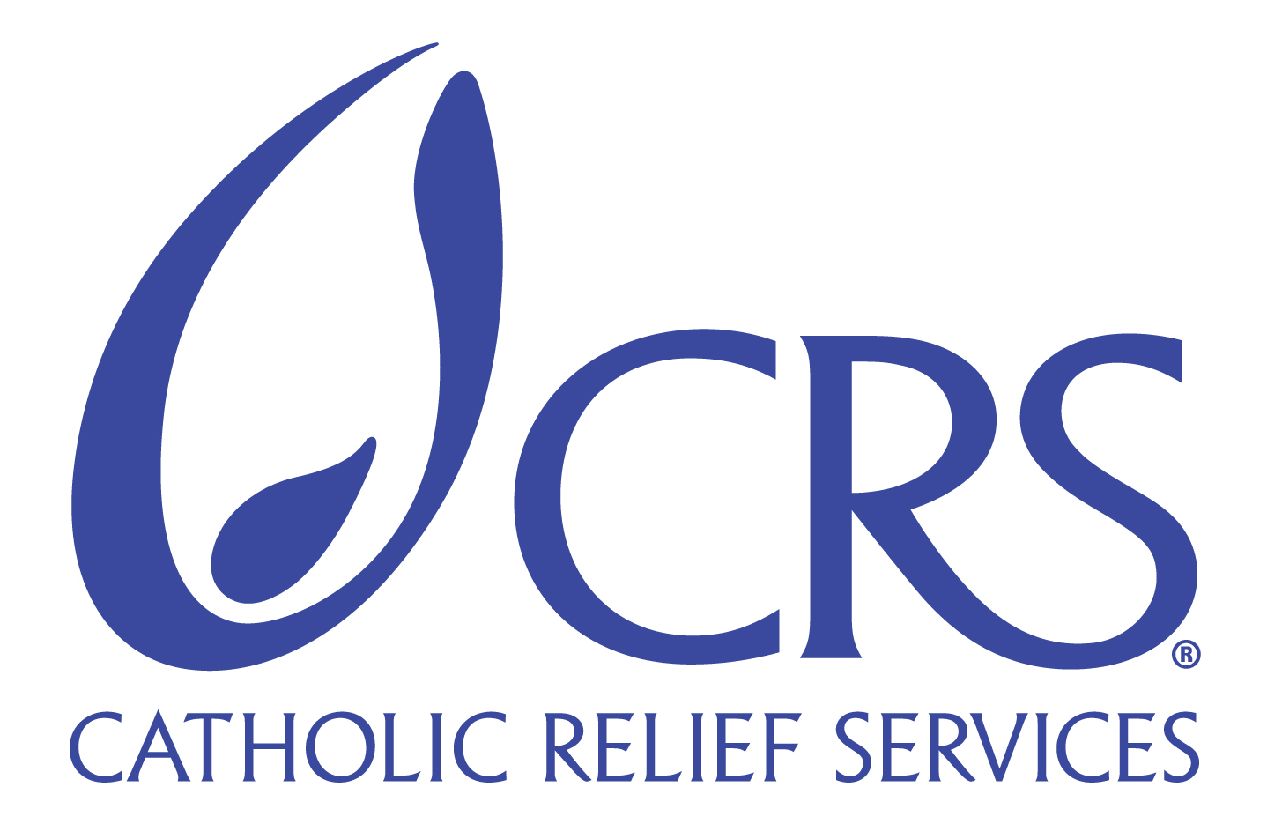

By

Annemarie Reilly, Chief of Staff

of

CATHOLIC RELIEF SERVICES

WRITTEN TESTIMONY

Before

THE HOUSE COMMITTEE ON AGRICULTURE

SUBCOMMITTEE ON SPECIALTY CROPS, RURAL DEVELOPMENT AND FOREIGN AGRICULTURE

Mike McIntyre, North Carolina, Chairman

on

May 10, 2007

Good afternoon Chairman McIntyre, Ranking Member Musgrave, and members of the Subcommittee. Thank you for calling this hearing and for providing Catholic Relief Services the opportunity to share our insights based on our long experience of delivering and programming food aid for long-term development and emergencies.

My name is Annemarie Reilly, Chief of Staff for Catholic Relief Services (CRS). Operating in 98 countries around the world, CRS is the international development and relief agency of the U.S. Catholic Conference of Bishops. We represent the 65 million members of the U.S. Catholic community in a partnership with Food For Peace that has expressed the goodwill and compassion of the American people for more than half a century. The reforms we propose will improve our ability to reduce chronic hunger, unlocking the power of food security aid.

According to the World Food Program, more than 850 million people on our planet are suffering from chronic hunger. The American people should be proud that the US government, through PL480 Title II resources, is the largest food aid donor in the world. These programs assist millions of people living on the edge to meet their daily food needs while also strengthening their livelihood systems to help them to help themselves over time.

For example, with five years investment of Title II food and funds, CRS worked through a local partner to reverse severe environmental degradation and improve the livelihoods of 570 poor households in Legedini, a rural community in eastern Ethiopia. Through support provided by USAID and CRS, this community has been able to use small-scale irrigation to grow marketable vegetables. They have also used this investment to develop small livestock herds and increase sales of milk, improve water and sanitation management, increase the engagement of women in microenterprise, and improve the nutritional content of family meals. Participants in a women’s group have begun to save and to invest their savings in business activities that diversify their assets. One woman, Nuria Umere, has been able to purchase an ox, a cow and seven goats, and she is able to send one of her three children to school and help her husband meet their household food needs. The success of this program is a direct result of the effective combination of food aid to meet immediate needs and cash to support complementary livelihood support activities.

Title II resources are used to set up feeding programs in desperately poor communities around the world and are often coupled with agriculture projects, village banking schemes or other livelihoods enhancement efforts. Social safety net programs feed orphan-headed households and people who are too old or too sick to function in the local economy. Title II also provides food for maternal/child programs that combine food aid with prenatal and postnatal education and support. This is only a small sample of the variety of programs Title II supports to fight chronic hunger. Title II programs are extremely important to the families, communities and even nations that they serve.

Although these are significant efforts, there remains a huge unmet need. According to Food For Peace, the US government feeds only about 50 to 70 million of those 850 million chronically hungry people. We don’t expect the US government to feed all of the world’s hungry. CRS is working on recommendations for improvements to the Food Aid Convention, due to be renegotiated, which could ensure that more resources will be made available worldwide to fight hunger. We also invest significant private resources and funding from other donors to support livelihood systems that address chronic food needs. But given the enormity of the hunger program, more must be done. Yet, more and more of our Title II resources are being diverted away from programs that address chronic hunger in order to fund an increasing number of emergencies around the world.

Catholic Relief Services and other private voluntary agencies are very supportive of the US government stepping up to the plate to address emergencies, but not at the expense of the chronically hungry. We are offering some proposals to continue this vital work in responding to food emergencies, while at the same time protecting resources for programs that address chronic hunger and the underlying causes of that hunger.

As you are well aware, current law requires that 75% of Title II food aid resources be devoted to development (non-emergency) programs. Over the past several years, however, the Administration has consistently used the emergency provision to waive the 75% rule. The program percentages have now been reversed as development food aid programs are diminished or eliminated in many countries so that about 75% of commodities are used for emergencies year to year, while only about 25% remain for development.

I. Recommendations from CRS, CARE, Save the Children, Mercy Corps

We believe that the Bill Emerson Humanitarian Trust (BEHT) has played an important role in responding to acute hunger. Our first recommendation is that with some adjustments the Emerson Trust could become an invaluable tool in addressing food emergencies. Catholic Relief Services, along with our PVO colleagues CARE, Mercy Corps and Save the Children, propose that Congress change both the way the Bill Emerson Humanitarian Trust is used and the way it operates. When Title II emergency resources have been exhausted in a given fiscal year, additional emergency funding would automatically come from the Emerson Trust. We also propose that the resources available for emergencies be increased to 50% of Title II. Using the Emerson Trust first as an emergency back-up will also protect non-emergency developmental programs.

Of course, to make this system work, we need to ensure that the Emerson Trust is replenished in a timely fashion. Catholic Relief Services is currently drafting specific proposed fixes for the Emerson Trust that would make it a more effective component in the food aid arsenal in our fight against global hunger. The current mechanism for realizing the benefits of the Emerson Trust is cumbersome, the underlying authority is vague, long-term availability is uncertain, and the legal and policy constraints on accessing the Trust may conflict with long-term economic development goals. The Emerson Trust is in need of reform and the overall goal of such reform should be to make it a reliable source of food resources in emergency situations and one that may be accessed easily to mitigate the detriment to planned non-emergency development funding under Title II.

CRS is working with others to design three significant changes to the Bill Emerson Humanitarian Trust: (1) the orderly liquidation of current stocks in the Emerson Trust, so that it will hold only cash to acquire commodities as needed; (2) establishing a true trust by allowing the cash to be invested in conservative short-term instruments; and (3) providing limited authority to Commodity Credit Corporation to replenish the Emerson Trust in a fiscal year.

Second, it is our position that if more cash were available through Title II, we would have greater flexibility in carrying out our programs to fight world hunger, both chronic and in emergency settings. The real causes of global food insecurity and hunger are complex and cannot be solved over the long term by the provision of food assistance alone. Responding more appropriately means that additional resources in the form of cash, both within and outside of Title II, are essential to support a variety of targeted activities that can more effectively address the root causes of vulnerabilities and risks that afflict hungry and food insecure populations. Current Section 202 (e) law permits a small percentage of Title II to be used for program logistics, management and related costs. However, these allowable uses do not go far enough to serve as an effective critical cash support mechanism. Section 202(e) needs to be amended to allow greater flexibility in the use of the funds to include administrative, management, technical and program related costs to enhance the effectiveness of Title II commodities. The percentage of funding in an expanded Section 202(e) also needs to be increased to no less than 25% of the Title II program levels.

We could more flexibly use commodities and/or cash in Title II by using language patterned after the McGovern/Dole Food for Education and Child Nutrition Program. The McGovern/Dole Food for Education and Child Nutrition Program addresses the issue of cash resources with simple language that allows for a mix of commodities and cash for implementers to use to carry out the program. This has worked well as implementers are discouraged from monetizing commodities because it is much easier and more cost effective to use cash.

II. Additional Recommendations from CRS

The third recommendation for fighting chronic hunger is that the Congress must appropriate adequate funds for Title II. The consistent under-funding of Title II has required the annual passage of supplemental appropriations bills to cover some of the shortfall. These kinds of piecemeal appropriations for food through supplemental appropriations are disruptive to well-planned developmental programs and hamper emergency response.

Repeatedly, Title II export shipments are bunched together early in a fiscal year with the result that delays occur and shipping costs increase due to the increased demand for vessel space. One of the reasons for this “bunching” of shipments is that availability of funds for a fiscal year is not often known early enough to allow for efficient programming commitments and planning of purchases. Under our proposal, the Administrator can rely on the availability of CCC funds to contract for commodities and freight to meet programming needs in the next fiscal year prior to the actual enactment of an appropriation. Of course, CCC would be reimbursed promptly from the Title II appropriation or continuing resolution when it becomes available.
Fourth, we ask that Congress appropriate a realistic annual target of $2 billion per year for Title II. Furthermore, we propose that a minimum of $600 million or 50% of total Title II resources, whichever is greater, be dedicated exclusively to development food aid to address chronic hunger – in a word, to put this money for developmental food aid in a “safe box.” The $2 billion figure is consistent with the U.S. share of annual needs for the last several years. Sufficient funding up front would simplify programming in the field, eliminate delays and extra storage and transportation expenses, and ensure more effective and dependable links with partners who look to the U.S., above all others, for life-saving aid. Designated funding would guarantee that we don't lose the fight against chronic hunger by diverting almost all food aid to emergency uses.
Fifth, CRS supports the Administration's request for flexibility in the use of a portion of the Title II budget for local or regional purchase of food. CRS endorses and undertakes the local purchase of commodities as a cost-effective tool for some emergency and non-emergency programs, when analysis of markets indicates it is feasible. CRS also engages in the use of vouchers to promote beneficiary acquisition of local food. CRS believes local purchase is an option worthy of congressional support in situations where it can bolster local food security and/or contribute to faster and more appropriate response to an emergency. It can be a more effective and efficient use of American resources.
In conclusion, I want to once again thank you Chairman McIntyre and all members of the subcommittee for holding this hearing to respond to the needs of the hungry throughout the world. Our proposed changes to US food aid programs are a sincere effort to help make a great program even greater. By adopting these recommendations CRS, and other organizations that implement U.S. international food assistance programs, can better promote food security, alleviate hunger, and save lives.

Thank you, Mr. Chairman. I would be pleased to respond to any questions that the Committee may have.

