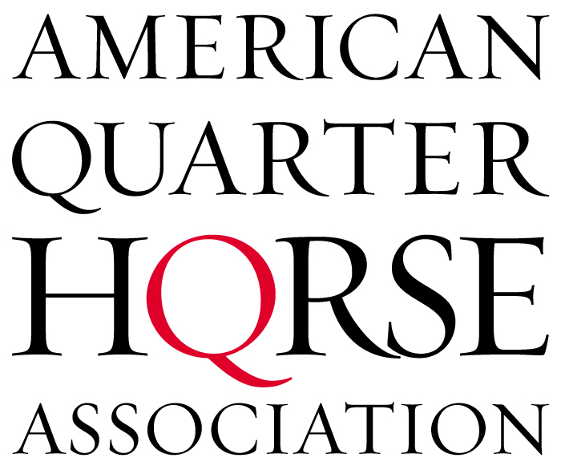

Testimony of American Quarter Horse Association, Leslie Vagneur Lange
to the
House Agriculture Committee, Subcommittee on Livestock, Dairy and Poultry

Good morning. My name is Leslie Vagneur Lange. I am a national director for the American Quarter Horse Association from my home state of Colorado. I am a professional horsewoman and judge for the American Quarter Horse industry. It is my hope and that of AQHA’s that by providing this testimony, common sense legislation can be addressed that will not adversely affect horses, owners or the industry at large.

There are many examples of people who believe they are working for positive changes – yet they are, in fact, irreparably damaging the agriculture industry. Threats received by Colorado’s beloved, century-old National Western Stock Show & Rodeo and protests at rodeos across the country by militant animal rights groups are just a few examples. Today, I want to focus on what has occurred recently as a result of the closure of the only three horse-processing facilities in the United States.

The American Quarter Horse Association, the largest United States-based equine breed registry and membership organization, represents a broad base of members who are involved in many different areas of the horse industry. From ranchers to recreational riders and from racing enthusiasts to horse show competitors, AQHA’s membership of nearly 345,000 is more diverse than at any other point in its history. The primary concern of these members, my fellow directors and staff at the Association is ensuring that the welfare of the horse is paramount to all other considerations. AQHA has strict rules governing animal welfare and its charitable arm, the American Quarter Horse Foundation, has funded more than $6 million in research that benefits all horses. AQHA has actively opposed a ban on horse slaughter and in March, by unanimous vote, the 150-member board of directors reaffirmed its opposition to a ban because of the unintended consequences it already is having on all horses.

I want to address three key areas that AQHA brought up early on in its opposition to a ban on slaughter. Before doing so, I want the record to reflect that AQHA does not favor slaughter as a way of dealing with America’s unwanted horses. However, the Association’s board does recognize that the processing of unwanted horses is currently a necessary aspect of the equine industry. It provides a USDA supervised humane euthanasia alternative for horses that might otherwise continue a life of discomfort and pain, or inadequate care or abandonment. Some have publicly mischaracterized AQHA as not being for the horse, and that couldn’t be further from the truth. If it wasn’t for the horse, AQHA would not exist.

Additionally, it also has been improperly stated that the majority of horses that go to slaughter are American Quarter Horses. To be accurate, the processing facilities do not know the breeds of horses. Countless horses are listed as “Quarter-type,” which could include non registered horses of any breed and horses of other breeds that simply look like an American Quarter Horse. To state that the majority are American Quarter Horses is factually incorrect and unverifiable.

Because it’s likely that AQHA will be accused of overbreeding, I also want to briefly address that point. As a breed registry, the Association's primary role is to record the pedigrees of American Quarter Horses. It is not AQHA's role to restrict a breeder's right to breed their horses. In fact, courts have ruled that in certain cases it is a restraint of trade for the Association to do so.

However, AQHA does work to educate horse owners through many ways, including stories about responsible breeding and stewardship in the Association's publications, on its Web site and through various seminars. AQHA is very concerned about responsible breeding and ownership so that no horse ever ends up an unwanted horse.

AQHA registers about 160,000 horses annually. The value of registration with AQHA means that the overwhelming majority of horses recorded with the Association are highly marketable and worth far more than unregistered horses, so those horses find employment as show horses, race horses and recreational mounts.

Also, I believe it’s important to note that we asked that horses be classified as livestock for very important reasons. What we see occurring with horses is alarming, and to those of us in this industry, it appears some are taking steps to change that classification. Horses are not companion animals like dogs and cats, and I know this committee recognizes the importance of having horses classified differently. As citizens, we rely on you, the knowledgeable lawmakers who understand the agriculture industry, to make decisions based on sound reasoning – not emotion, propaganda or exaggerated claims.

Animal rights activists seem to think that all animals, including horses, live idyllic pastoral lives until they slip quietly into sleep and then death. Unfortunately, that naïve view does not match the realities of life with horses. Horses can and do suffer injuries that might require euthanization. At times, horses suffer chronic lameness or pain. Old horses’ teeth become so worn and smooth that they can no longer eat and if left to pasture, they slowly starve to death. In many of those cases, the most humane response, the response that is required of us as horse owners and lovers is to euthanize the horse. It is heartbreaking, but it is necessary and it’s the right thing to do.

However, by eliminating processing, the courts and the federal government, if Congress passes Senate bill (S. 311) or House bill (H.R.503), remove a humane end-of-life choice for many horse owners.

In many states and counties in the United States, there are limited options for euthanization and carcass disposal. Water and sanitation regulations often prevent a horse owner from burying an animal on his or her property. Many communities lack adequate facilities or landfills to handle large animals like horses. There are far fewer rendering facilities taking horses. Horses euthanized by lethal injection must be treated as toxic because of potential impact on wildlife, yet most veterinarians do not have the facilities to dispose of horses.

With that, the three areas I want to comment on are:

- Long-term care for horses versus abandonment
- Funding for enforcement and an equine welfare system versus creating hardships for owners with bottom-end unemployable horses
- How the industry is handling the unwanted horse issue without the government reacting to animal rights activists or celebrities who are out of touch

Long-Term Care vs. Abandonment
Because of successful court challenges from the Humane Society, earlier this year the nation’s three horse processing facilities were closed. AQHA and many others in the agriculture industry warned that if this were to occur without addressing long-term care solutions, some horses would needlessly suffer.

Their owners would not have a way to sell a horse they no longer wanted or could afford to keep. Horses can become unwanted for different reasons or owners’ circumstances can change. Regardless of what those reasons are, an unwanted horse is a burden rather than a joy to its owner.

As examples of the problems that have been created:

- In April, AQHA took a call from an irate salebarn owner in Utah who found himself in possession of a handful of horses that the owner had abandoned when he couldn’t even get the consignment fee for them in the auction. The salebarn owner made it clear that the horses were not his problem and would not be kept;

- The Association received a call from a farm and ranch store in Mississippi that was approached to help supply feed for 70 horses that were abandoned;

- An AQHA member from Montana mailed pictures of a 3-year-old gelding that died of starvation because its owner simply walked away;

- Last month we learned of a plea agreement in Maryland that was reached in an animal abuse case at a supposed “rescue” facility where 75 horses were seized; and

- In my home state of Colorado, we recently learned of 23 horses that were locked in a barn and abandoned. The owner, someone I knew from years ago, told authorities he could no longer afford to take care of the horses because of rising prices and plummeting value.

Certainly, all owners should care for all their animals properly. Unfortunately, not all do often because they can no longer afford to.
These examples echo most of what has come into AQHA’s public policy department since we allowed out-of-touch people and organizations to shut down the three slaughter facilities. While many business owners and animal lovers have a soft spot for these abandoned horses now, at some point, the gravy train is going to run dry. Horses are already becoming victims.

Activists and misguided legislation circulating around Washington relating to horse slaughter already are having a harmful impact on the very animal meant to be protected. Additionally, legislation that does not establish standards of care that horse rescue facilities must meet is not doing what’s best for the agriculture community or America’s magnificent horse.

ECONOMICS AND FUNDING
Whether or not we want to admit it, economics comes into play. The slaughter market determines the base or floor price for horses. When that bottom falls out or is forcibly removed as it has been with the closing of the three slaughter plants, it simply stands to reason that it will adversely affect the horse industry and the horses themselves.

In 1986, Congress passed legislation that dramatically impacted the horse industry and weakened its contributions to the U.S. economy. It took years for the industry to recover and, in fact, it never did recover to the levels of the pre-1986 era. According to the 2005 American Horse Council study, “The Economic Impact of the Horse Industry on the United States,” the horse industry has a direct economic impact of $32 billion and supports 435,000 full-time jobs.

I make my living off the horse industry, and even at the upper end where I train and compete, owners are beginning to feel the effects of the bottoming of the horse industry. When the floor is removed, the entire industry begins to fall, and as we’re seeing, values are beginning to decline.

The other economic issue deals with how we are going to care for some 90,000 horses each year now entering the equine welfare system. By most assessments, it would take an additional 2,700 bona-fide rescue facilities to care for America’s unwanted horses. Already, Congress has cut funding for BLM horses because of the tremendous cost they have become to taxpayers. Where will the money come from to care for these horses?

By providing only the most basic care of hay, feed and water, which we conservatively estimate at $1,900 per year per horse, it will cost $171 million to care for 90,000 unwanted horses displaced as a result of banning horse slaughter in the United States. That figure does not include any veterinary or farrier care. Additionally, if Washington is going to legislate a ban on horse slaughter, it should explore ways to provide shelters such as those we have for dogs and cats, where owners can divest themselves of unwanted horses, and where they can be properly cared for.

Staff at AQHA called the hometowns of each of the members of this Subcommittee. Of 18 municipalities contacted, only one had the facilities necessary to take in abandoned or impounded horses. We have a long way to go.

As a result of the closing of the nation’s processing facilities, today there are more horses on the market, causing the value of most horses to plunge. Low prices have consequences. Reduced prices put horses into the hands of people without the financial resources to provide proper care, which leads to neglect. It also can drive owners to abandon or neglect horses. Those owners who had a horse worth $800 to $1,200 now have one worth much less and won’t pay a veterinarian to euthanize; a rendering facility to take the body away; or to have the animal buried somewhere. Slaughter is not pretty, but it does provide a humane, economical way for an owner to relinquish an unwanted horse.

AN INDUSTRY ISSUE
The option of sending a horse for processing at one of the United States’ three plants must remain available to those who need it, so long as measures ensuring humane transportation and treatment of horses are in place. Thanks to members of the House Agriculture Committee, those rules exist today, and in the United States, we protect the dignity of even the most unwanted or unusable horse by enforcing laws concerning transportation to and care at slaughter facilities. People I know have shipped horses into Mexico and Canada as a result of the recent closing of the United States’ slaughter facilities. Once an animal is taken outside our borders, we lose our standards of care. And with gas prices continuing to rise, for states that don’t border Canada or Mexico, abandoned, unwanted horses will soon become the norm because sadly the economics just don’t work in the horse’s favor.

But for those who believe that slaughter must be outlawed, the good news is that the industry is addressing the issue without government intervention. For people who are serious about helping America’s unwanted horses and putting real action to work, there is the Unwanted Horse Coalition.

The Unwanted Horse Coalition, which AQHA helped establish in 2005, is working to eliminate America’s unwanted horses. The goal of UHC is not to pay for the care of unwanted horses but to reduce the number and improve their welfare. Ultimately, it’s the industry’s hope that there will be no more unwanted horses in America. Through education and hard work, we are addressing this problem without creating inadvertent problems like this ban has.

Ladies and gentlemen of this Subcommittee, I love horses, and I love how good the agriculture industry has been to me. If you’re serious about helping horses and the good people who make their livelihood off the livestock industry, I hope you will do what’s right to end this problem. It’s not about passing laws that have unintended consequences. It’s about being realistic, doing what is right for horses and feasible for taxpayers.

Thank you for your time today.
Curriculum Vitae
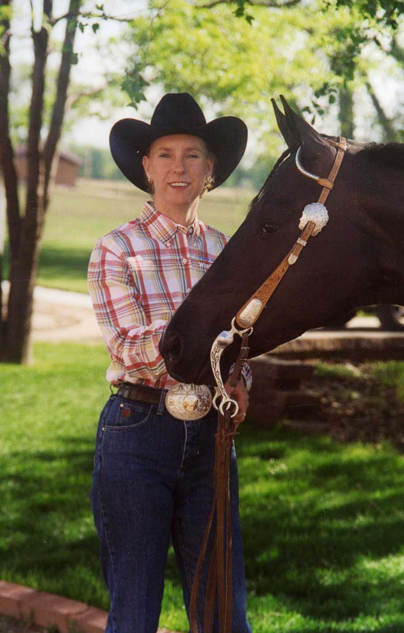
Leslie Vagneur Lange
2140 Fern Avenue
Greeley Colorado 80631
970-352-3758 • tandlqh@aol.com

Occupation
- Owner and operator T & L Quarter Horses LLC, Greeley, Colorado

Equine Industry Specialty/Experience
- Training horses professionally for 25 years
- Training all-around, western riding and hunter under saddle horses
- Prepare horses for competition in open, amateur and youth ranks
- Credentialed judge in American Quarter Horse Association and
National Snaffle Bit Association

Memberships
- American Quarter Horse Association (National Director)
- American Paint Horse Association
- Appaloosa Horse Club
- United States Equestrian Federation
- Rocky Mountain Quarter Horse Association (Director)
- American Quarter Horse Association of Professional Horsemen
- National Snaffle Bit Association (National Director)
- National Reining Horse Association
- National Western

Industry Clinician
- 2006-07 AQHA Judges Workshop instructor – trail, western riding
- 2002-03 AQHA Judges Workshop instructor – showmanship/horsemanship/trail
- 2000-01 AQHA Judges Workshop instructor – western riding
- 1998-99 AQHA Judges Workshop instructor – showmanship/horsemanship/hunter
under saddle/hunt seat equitation
- 1996 AQHA Judges Workshop instructor – hunter under saddle

Honors / Awards
- 2003 AQHA Professional Horsewoman of the Year
- Rider of multiple AQHA World Championship titles in western and English classes
- Trainer of AQHA/Bayer Select World Show Champion
- Trainer of American Quarter Horse Youth Association World Champions
- Trainer of multiple American Paint Horse Association World Champions

Education
- Bachelor of Arts, Business Agriculture – Colorado State University

Personal
- Married to husband Tom since 1994

