Testimony of
Rick L. Schwein
Senior Vice President
Grain Millers, Inc.
Eden Prairie, MN

On behalf of the
North American Millers’ Association

Before the
House Agriculture Committee

Subcommittee on General Farm Commodities and
Risk Management

Crop Provisions of the
Farm Security and Rural Investment Act of 2002

April 26, 2007

Thank you Chairman Etheridge, Congressman Moran and members of the subcommittee. I am Rick Schwein, senior vice president of Grain Millers, Inc. Grain Millers is a privately owned processor headquartered in Eden Prairie, a suburb of Minneapolis, Minnesota.

Grain Millers owns and operates two mills in the US – St. Ansgar, Iowa and Eugene, Oregon as well as a mill in Canada. We are one of the world’s largest suppliers of milled oat products to the food industry. We produce oat meal, oat bran and oat flour for use by most of the major US food manufacturers. We pack private label and branded hot cereals and process and blend wheat, barley and rye to meet the growing demand for whole grain and organic products. Our products are used throughout North America as well as exported to both Central and South America.

I have been in the grain and milling industry for more than 30 years and am here today representing the North American Millers' Association, of which I am the current chairman. NAMA is the trade association representing 48 companies that operate 170 wheat, oat and corn mills in 38 states. Their collective production capacity exceeds 160 million pounds of product each day, more than 95 percent of the total industry production.

Where we are today

Oats
2006 oat production was a mere 107 million bushels, the lowest since USDA began keeping records in 1866, shortly after President Lincoln created the Department of Agriculture. There are just too many reasons for growers to plant something else.

To illustrate the decline, consider that the US produced 384 million bushels of oats in 1986. That would fill a train stretching from Fargo to St. Louis. A train filled with last year’s production would stretch from Fargo to 30 miles short of Minneapolis.

This dramatic production loss has led directly to the major relocation of the oat milling industry over the past 15 years. Since the early 1990’s, a number of millers have ceased operations in the US entirely. Most of that processing capacity has moved to Canada, taking hundreds of industry jobs with it.

North American Oat Acreage, 1975

North American Oat Acreage, 2006
Source: Informa Economics

Wheat
US wheat production is headed in the same direction as oats. US wheat plantings the last three years were the lowest since 1972. The area planted to wheat has dropped by 18 million acres, or 24 percent, in just 10 years.

In Kansas, the decline in land planted to wheat is equivalent to the entire production from its four largest producing counties. It’s as if farmers in those top four counties just stopped growing wheat. In North Dakota, the decline is equal to the nine largest producing counties getting out of wheat production completely.

Not too many years ago the thought that the US would import cereal grains was unthinkable. Now, however, food oats consumed in the US are nearly 100 percent imported.

Likewise, in most years, US production of hard red spring wheat for bread and durum wheat for pasta are insufficient to meet total usage (aggregate of domestic consumption, exports, seed and reasonable carryover) and millers must rely on imports to augment the US crop.

Those imports have caused regrettable friction between millers and growers. As millers, our first choice is always to buy American grain when possible. But I can tell you today, imports of wheat and oats into the US will continue and, absent action by Congress, will likely increase.

How did we get here?

There are multiple reasons for the precipitous declines in wheat and oat production, but I will focus this testimony on these three principal factors: federal farm programs, the Conservation Reserve Program and the agronomic advantages of competing crops.

Federal farm programs – Through the current programs, Uncle Sam is loudly telling growers “Don’t plant wheat or oats!” At the same time the US government is encouraging them to grow other crops like corn and soybeans, which hardly need encouragement given the President’s biofuels mandate.

At least with corn and soybeans it is obvious there are major markets for those crops. We save particular disdain for program payments that have provided huge incentives for growers to stop growing crops the US consumes, principally wheat and oats, in favor of crops like field peas and lentils, for which the domestic demand is insignificant relative to our consumption of cereal grains. We assume this was an unintended consequence of the last farm bill.

These programs are bad policy on so many levels, if one wants to criticize them, it’s hard to know where to start. They spend taxpayer dollars to encourage the production of crops that the US does not consume in any significant amount at the expense of crops we do. The market price for them is so low (no surprise, since they are unwanted in the US) they are mostly attractive as cheap protein sources for foreign meat and poultry producers.

The combined US production of dry peas and lentils has increased by an amazing 950,000 acres in just five years. To be clear, we oppose programs that distort the market for any crop, but I say only half in jest that, if the US government wants to pile crazy incentives on crops perhaps the target ought to be food crops this country needs.

Conservation Reserve Program – Since 1986 the CRP has idled as much as 36 million acres, concentrated in traditional wheat and oat growing regions. Some of that land is highly erodible, never should have been planted to crops in the first place, and should remain in some conservation program. However, a major share of the CRP could be farmed in environmentally sustainable ways, especially with modern low or no till practices.

Agronomic advantages of competing crop – Traditionally, wheat was the best crop option for growers on the Great Plains. Corn and soybeans that generated higher returns in the Corn Belt were not suited to the arid climate of the Plains, nor were they suited for the shorter growing season of the northern plains.

In recent years, however, genetic advances in corn and soybeans have changed that equation. Corn varieties flourish in the Plains growing regions, as do short season soybeans that mature before the early frosts of the northern Plains.

In short, now that producers CAN grow corn and soybeans in those regions, they ARE growing them. Government policies have made it desirable, but agronomics have made it possible.

Table 1: Crop Yield Growth Compared, 1930-06

Source: Informa Economics

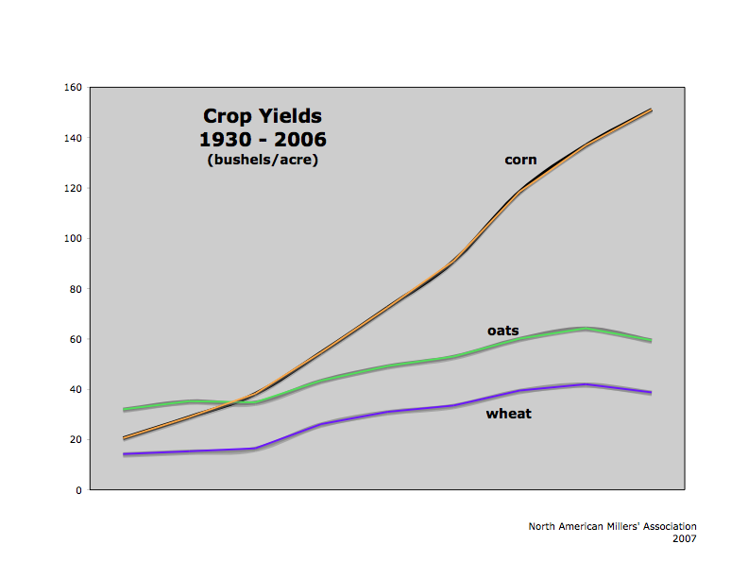

Ironically, demand for oat and other whole grain products is rising. Many companies are continuing to invest in processing capacity in the US. My employer, for example, is investing $20 million to expand the capacity of its mill in Iowa. Regrettably, the oats for that Iowa mill will be grown in Canada.

Recommendations

Farm program – As Congress writes the next farm bill, it has an opportunity to breathe life into these vital strategic industries. For whatever amount of money Congress decides is necessary for a safety net for growers, we implore you to find mechanisms for distributing that money in ways that do not distort their planting decisions. We must end up with a farm bill that allows the market to determine what crops are planted.

Wheat and oat millers are willing to compete with processors of competing crops to encourage farmers to plant more of the cereal grains we need. But we cannot compete with the treasury of the US Government.

Conservation Reserve Program – NAMA supports retaining environmentally sensitive land in a conservation program. However, probably two-thirds of the 36 million acres currently enrolled in the CRP could be farmed without sacrificing environmental goals, especially through low and no tillage farming practices that have evolved since the CRP’s inception in 1986.

At the same time, the US’ environmental goals can be best met by focusing conservation dollars on waterway filter strips and similar areas which provide the best return on investment. Also, CRP rules must be changed to add flexibility so that growers can respond to market signals without extreme penalties, as is currently the case. Failure to significantly reform CRP will mean that reducing our dependence on foreign oil may result in increased dependence on foreign grain.

For decades we have known that growing corn after corn after corn is not desirable for either environmental or disease and insect management reasons. Yet that’s exactly what is being encouraged.

Another benefit of releasing a substantial portion of the CRP is that it would be an excellent way to respond to the need for land to produce organic grains, which on a percentage basis is the fastest growing segment of the industry.

Research – Wheat and oat yields lag behind other crop options, especially corn and soybeans. And, with each passing year, the lag for wheat and oats gets more pronounced.

Wheat and oat research is nearly all federally funded, at a combined total of about $50 million annually. Compare that with private corn research efforts where multiple companies each invest more than one million dollars every day. No surprise then that wheat and oat yields lag behind, and that disadvantage widens each year.

Summary
It is the height of irony that the US government, through the 2005 US Dietary Guidelines, encourages consumers to eat more grains but at the same time is very directly discouraging growers from producing those same grains.

NAMA believes Congress has a major opportunity to improve conditions for the wheat and oat industry, from grower through end consumer. This can be achieved by reforming the CRP to allow sustainable acres back into production, reforming the farm program to reduce government-caused distortions of production decisions and investing in research to give growers better crop options.

Thank you very much for this chance to share our views. If you have any questions I am happy to answer them.

For additional information contact:
Jim Bair
Vice President
North American Millers’ Association
    - Ext. 14
jbair@namamillers.org
Rick L. Schwein
Senior Vice President
Grain Millers, Inc.

Rick L. Schwein is Senior Vice President for Grain Millers, Inc. headquartered in Eden Prairie, Minnesota. He is also the President of Grain Millers Canada Corp.
Grain Millers operates three mills throughout North America providing both conventional and organic oat, wheat, corn and barley products to food processors throughout the continent.
Prior to joining Grain Millers, Rick was President of La Crosse Milling Company for 10 years after enjoying a 16-year career with General Mills, Inc. in purchasing and grain merchandising functions. Rick is an honors graduate of Michigan State University and has more than 30 years of grain and milling experience.
He has been active in the industry having served on the Executive Committee, and as current chairman, of the North American Millers’ Association. He is a former member of the Chicago Board of Trade as well as the Minneapolis Grain Exchange.
