ATTACHMENT 4: M&TE Optional Calibration Labels
5006-4  M&TE Optional Calibration Labels |  |   Records Use only
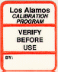 | Verify Before Use (orange border). The item must be calibrated by the user before quality-or safety-affecting activities are conducted.
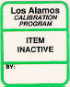 | Item Inactive (green border). The item is intended for measurements but is not in use at the present time.
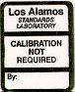 | Calibration Not Required (black border) The item is not relied on for measurement data. When necessary, output parameters of these items are monitored by calibrated equipment.
 | Calibration Expired (black on red). The item has been previously calibrated and has exceeded its expiration
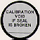 | Calibration Void If Seal Is Broken (black on silver). The item has externally accessible adjustments that, if disturbed, will invalidate the calibration. The label is attached so that any attempt to adjust the item will break the seal.
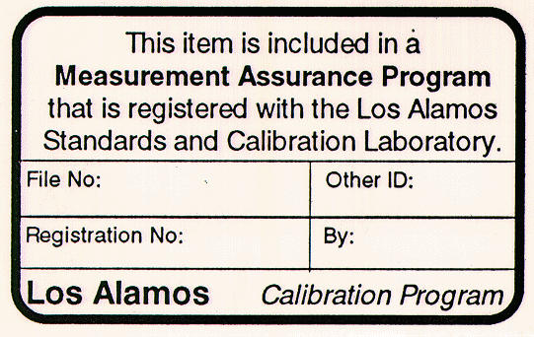 | Measurement Assurance Program (black border). The item is included in a formal measurement assurance program (a quality control program that calibrates an entire measurement system).

